AI ACADEMY · WORKBOOK · ai-5/5

Composing layers
Project: Image-pattern Network Investigation

01. Recall and choose your starting point
Try the recall before opening notes. Then use a different colour or a labelled second line to correct your explanation.

Activation functions
Without opening the old lesson, explain one key idea from Activation functions. Give an example and a mistake that the idea helps you avoid.

My remembered idea, example and correction
________________________________________________________________
________________________________________________________________
________________________________________________________________

Dot products and weighted sums
Without opening the old lesson, explain one key idea from Dot products and weighted sums. Give an example and a mistake that the idea helps you avoid.

My remembered idea, example and correction
________________________________________________________________
________________________________________________________________
________________________________________________________________

02. Practise with fading help
Use W2: Repair a dimension mismatch for Composing layers. Record the answer once; the lesson and workbook refer to the same attempt.
Given inputs | Procedure I chose | Middle steps | Result and check

The step I completed without help, and the hint I needed
________________________________________________________________
________________________________________________________________
________________________________________________________________

03. Individual reasoning check
Use the worked case for Composing layers. Proposed explanation: “The second hidden unit receives the first hidden unit output”. Decide whether this explanation is supported. Point to the step or supplied fact that decides; explain your repair if needed.

My explanation before partner discussion
________________________________________________________________
________________________________________________________________
________________________________________________________________
________________________________________________________________

04. Independent transfer case

Independent case: Compose a new network independently
A new model takes [u, v]. Compute a = ReLU(u + v - 3), b = ReLU(u - v), then q = a + 2b - 1. Trace both inputs [2, 1] and [1, 2], including scores before ReLU. Apply class 1 when q >= 0. State the hidden and output vector sizes.

My independent explanation, trace and limits
________________________________________________________________
________________________________________________________________
________________________________________________________________
________________________________________________________________
________________________________________________________________
________________________________________________________________
________________________________________________________________
Attempt this case before feedback. Record any help. Earlier examples below are further practice; a case already practised with feedback cannot establish fresh transfer.

05. W1 Trace the second worked case
For x = [1, 3], write both scores, both ReLU activations and y using the lesson model.

My reasoning and evidence
________________________________________________________________
________________________________________________________________
________________________________________________________________
________________________________________________________________
________________________________________________________________
________________________________________________________________

06. W2 Repair a dimension mismatch
A revised hidden layer returns [h1, h2, h3]. The output layer still has weights [2, -1]. Explain the mismatch and what must be specified before calculation.

My reasoning and evidence
________________________________________________________________
________________________________________________________________
________________________________________________________________
________________________________________________________________
________________________________________________________________
________________________________________________________________

07. W3 Use a revealing order check
Compare hidden vectors for x = [4, 1] and x = [3, 0]. Which input reveals a bug that swaps h1 and h2 but keeps output weights unchanged? Give correct and swapped outputs for that input.

My reasoning and evidence
________________________________________________________________
________________________________________________________________
________________________________________________________________
________________________________________________________________
________________________________________________________________
________________________________________________________________

08. W4 Compose a new network independently
A new model takes [u, v]. Compute a = ReLU(u + v - 3), b = ReLU(u - v), then q = a + 2b - 1. Trace both inputs [2, 1] and [1, 2], including scores before ReLU. Apply class 1 when q >= 0. State the hidden and output vector sizes.

My reasoning and evidence
________________________________________________________________
________________________________________________________________
________________________________________________________________
________________________________________________________________
________________________________________________________________
________________________________________________________________
________________________________________________________________
________________________________________________________________

09. W5 Explain information loss
Use the lesson model to verify h and y for [0, 1] and [0, 2]. Could a fixed later layer receiving only h distinguish the two original inputs?

My reasoning and evidence
________________________________________________________________
________________________________________________________________
________________________________________________________________
________________________________________________________________
________________________________________________________________
________________________________________________________________

10. Project checkpoint and reflection
Add a labelled composing layers evidence sheet to Image-pattern Network Investigation. Show how you can trace how one layer supplies the next layer inputs. Use the supplied fictional case and keep its inputs, intermediate steps, calculation or prediction, and limitation. Connect this record to last week’s record; a matching answer without a trace is insufficient.

My project change, supporting evidence and remaining limit
________________________________________________________________
________________________________________________________________
________________________________________________________________
________________________________________________________________
________________________________________________________________
________________________________________________________________

11. Feedback, return check and learning record
Evidence | My record
Worked alone / hint / model
First step I repaired and why
New case checked later; date and result
What I can now explain without notes
One remaining question
Revisit this idea with your teacher after a delay. Familiarity is different from explaining and using it on a changed case.

12. Pictorial case practice: Composing layers
Compose two hidden detectors before one output instead of skipping a layer.
For input [u, v], h1=ReLU(u-2), h2=ReLU(v-1), y=h1-h2. Input [4, 3].
All inputs and outcomes in this worked example are invented classroom data; no real model run is claimed.
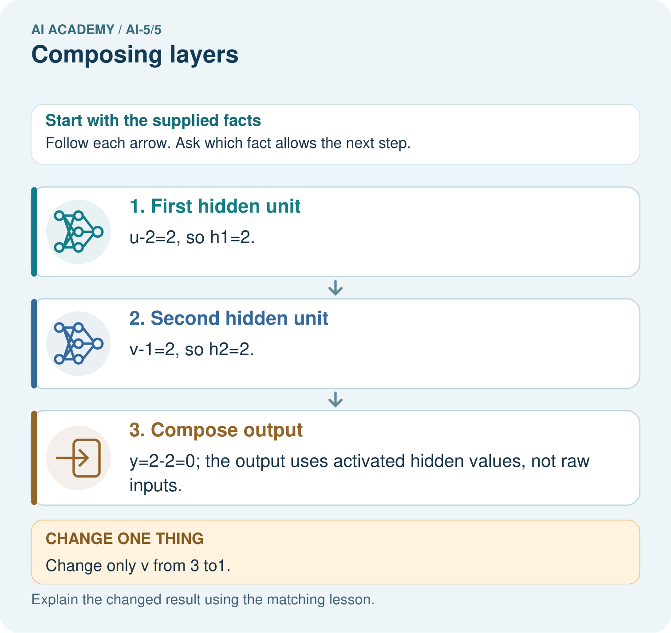
What intermediate value explains the changed output? Point to the relevant step in the picture, then write the changed result and the rule or evidence that supports it.

My picture-based explanation and changed-case prediction
________________________________________________________________
________________________________________________________________
________________________________________________________________
________________________________________________________________
________________________________________________________________
________________________________________________________________
Support used: alone / hint / worked example. This record is practice evidence.
Project connection: For your Image-pattern Network Investigation, save the input, procedure, observed result and limitation of this check. Label this worked example as practice; use a different, previously unreviewed case when checking independent understanding.

13. Project portfolio milestone
Project: Image-pattern Network Investigation
Current milestone: Frame the need. Name the user, the problem, allowed inputs and a safe simple starting method.
For your Image-pattern Network Investigation, save the input, procedure, observed result and limitation of this check. Label this worked example as practice; use a different, previously unreviewed case when checking independent understanding.
Evidence to keep | My record
This week’s input and deciding step
Prediction and actual result (or labelled paper trace)
One change since the previous checkpoint and why
One error or limit and the next test

Explain what this week adds to your project. Reuse last week’s record rather than starting again.
________________________________________________________________
________________________________________________________________
________________________________________________________________
________________________________________________________________
________________________________________________________________

14. Supported practice and learning evidence
Use this supported practice once, in the browser or on paper. Keep the reserved independent assessment for a separate first attempt before teacher feedback.
Compose two hidden detectors before one output instead of skipping a layer.

Practice 1: explain the deciding evidence
Which labelled step matches this detail? y=2-2=0; the output uses activated hidden values, not raw inputs.
1. Compose output
2. Second hidden unit
3. First hidden unit

My selected conclusion, deciding fact and explanation
________________________________________________________________
________________________________________________________________
________________________________________________________________
________________________________________________________________
________________________________________________________________
Hint if needed: Read the steps in the pictorial case. Match the supplied detail to the stage that performs or records it.
After your attempt, compare with the supported explanation: Compose output y=2-2=0; the output uses activated hidden values, not raw inputs. Composition means one layer’s result becomes the next layer’s input. Compute both hidden units before combining them. At [4,3], their equal outputs cancel. Lowering only the second input removes its positive hidden contribution, so subtracting it no longer reduces the output. The final subtraction must use activated hidden values rather than the raw measurements.

Practice 2: explain the deciding evidence
Changed-case practice: Change only v from 3 to1. Which conclusion is supported by the supplied facts?
1. h1 stays2, h2 becomes0, y becomes2.
2. We can decide the result without examining the changed input or the procedure.
3. This one example guarantees correct results for every future input.

My selected conclusion, deciding fact and explanation
________________________________________________________________
________________________________________________________________
________________________________________________________________
________________________________________________________________
________________________________________________________________
Hint if needed: Use the changed condition and the deciding step in the pictorial trace. The answer must say what follows from those facts.
After your attempt, compare with the supported explanation: h1 stays2, h2 becomes0, y becomes2. The second hidden unit’s preactivation reaches0 while the first unit is unchanged.

Repair a missing building block
Review Activation functions (ai-5/4). Goal: Trace identity ReLU and sigmoid on a numerical score. Short practice: Which original inputs cannot be distinguished by this network’s final output? Point to the relevant step in the picture, then write the changed result and the rule or evidence that supports it.. Return to this week and explain what you changed.
Review Dot products and weighted sums (ai-5/2). Goal: Calculate a dot product by matching feature positions. Short practice: Which connection explains why more right brightness lowers this score? Point to the relevant step in the picture, then write the changed result and the rule or evidence that supports it.. Return to this week and explain what you changed.

Predict, run and debug
The browser lab lets you edit the supported Python examples already included in this lesson. Predict first, run, inspect the actual output or error, change one input, then run again. Keep code, predictions, actual results and a reasoned revision together. On paper, label your result as a trace rather than an execution.

Keep your completed work
Use Download completed work in the hosted lesson to export your answers, reflections, practice feedback and code-run evidence. Open the HTML copy to read or print it. Drafts stay in this browser when storage is available; clear drafts on a shared device.

What I repaired, the evidence I kept and the next test
________________________________________________________________
________________________________________________________________
________________________________________________________________
________________________________________________________________
________________________________________________________________

