AI ACADEMY · WORKBOOK · ai-5/9

Slopes and local change
Project: Image-pattern Network Investigation

01. Recall and choose your starting point
Try the recall before opening notes. Then use a different colour or a labelled second line to correct your explanation.

Loss functions
Without opening the old lesson, explain one key idea from Loss functions. Give an example and a mistake that the idea helps you avoid.

My remembered idea, example and correction
________________________________________________________________
________________________________________________________________
________________________________________________________________

Forward passes by hand
Without opening the old lesson, explain one key idea from Forward passes by hand. Give an example and a mistake that the idea helps you avoid.

My remembered idea, example and correction
________________________________________________________________
________________________________________________________________
________________________________________________________________

Bias terms and decision boundaries
Without opening the old lesson, explain one key idea from Bias terms and decision boundaries. Give an example and a mistake that the idea helps you avoid.

My remembered idea, example and correction
________________________________________________________________
________________________________________________________________
________________________________________________________________

02. Practise with fading help
Use W2: Check a symmetric estimate for Slopes and local change. Record the answer once; the lesson and workbook refer to the same attempt.
Given inputs | Procedure I chose | Middle steps | Result and check

The step I completed without help, and the hint I needed
________________________________________________________________
________________________________________________________________
________________________________________________________________

03. Individual reasoning check
Use the worked case for Slopes and local change. Proposed explanation: “Divide by the step only”. Decide whether this explanation is supported. Point to the step or supplied fact that decides; explain your repair if needed.

My explanation before partner discussion
________________________________________________________________
________________________________________________________________
________________________________________________________________
________________________________________________________________

04. Independent transfer case

Independent case: Estimate a new curve independently
Let J(a) = (a + 1) squared. At a = 1 use step 0.25 to find the symmetric slope. Compare J(1) with J(0.9), then explain why moving to -4 does not follow safely from the slope clue.

My independent explanation, trace and limits
________________________________________________________________
________________________________________________________________
________________________________________________________________
________________________________________________________________
________________________________________________________________
________________________________________________________________
________________________________________________________________
Attempt this case before feedback. Record any help. Earlier examples below are further practice; a case already practised with feedback cannot establish fresh transfer.

05. W1 Measure an interval slope
For L(w) = (w - 2) squared, calculate the average slope from w = 0 to w = 2. Compare it with the local slope at w = 2.

My reasoning and evidence
________________________________________________________________
________________________________________________________________
________________________________________________________________
________________________________________________________________
________________________________________________________________
________________________________________________________________

06. W2 Check a symmetric estimate
At centre w = 0, use step 0.5. Calculate L(-0.5), L(0.5) and the symmetric slope.

My reasoning and evidence
________________________________________________________________
________________________________________________________________
________________________________________________________________
________________________________________________________________
________________________________________________________________
________________________________________________________________

07. W3 Challenge a large step
Starting at w = 3, compare loss after moving to 2.9 and after moving to -1. Both moves decrease w.

My reasoning and evidence
________________________________________________________________
________________________________________________________________
________________________________________________________________
________________________________________________________________
________________________________________________________________
________________________________________________________________

08. W4 Estimate a new curve independently
Let J(a) = (a + 1) squared. At a = 1 use step 0.25 to find the symmetric slope. Compare J(1) with J(0.9), then explain why moving to -4 does not follow safely from the slope clue.

My reasoning and evidence
________________________________________________________________
________________________________________________________________
________________________________________________________________
________________________________________________________________
________________________________________________________________
________________________________________________________________
________________________________________________________________
________________________________________________________________

09. W5 Limit zero slope evidence
For F(w) = (w squared - 1) squared, compare F(0) and F(0.1). Does zero local slope at zero prove a minimum?

My reasoning and evidence
________________________________________________________________
________________________________________________________________
________________________________________________________________
________________________________________________________________
________________________________________________________________
________________________________________________________________

10. Project checkpoint and reflection
Add a labelled slopes and local change evidence sheet to Image-pattern Network Investigation. Show how you can calculate an average rate of change over a stated interval. Use the supplied fictional case and keep its inputs, intermediate steps, calculation or prediction, and limitation. Connect this record to last week’s record; a matching answer without a trace is insufficient.

My project change, supporting evidence and remaining limit
________________________________________________________________
________________________________________________________________
________________________________________________________________
________________________________________________________________
________________________________________________________________
________________________________________________________________

11. Feedback, return check and learning record
Evidence | My record
Worked alone / hint / model
First step I repaired and why
New case checked later; date and result
What I can now explain without notes
One remaining question
Revisit this idea with your teacher after a delay. Familiarity is different from explaining and using it on a changed case.

12. Pictorial case practice: Slopes and local change
Use a local slope to propose a small move rather than claiming every move helps.
Toy loss J(a)=(a-2)². At a = 0, use symmetric step 0.5.
All inputs and outcomes in this worked example are invented classroom data; no real model run is claimed.
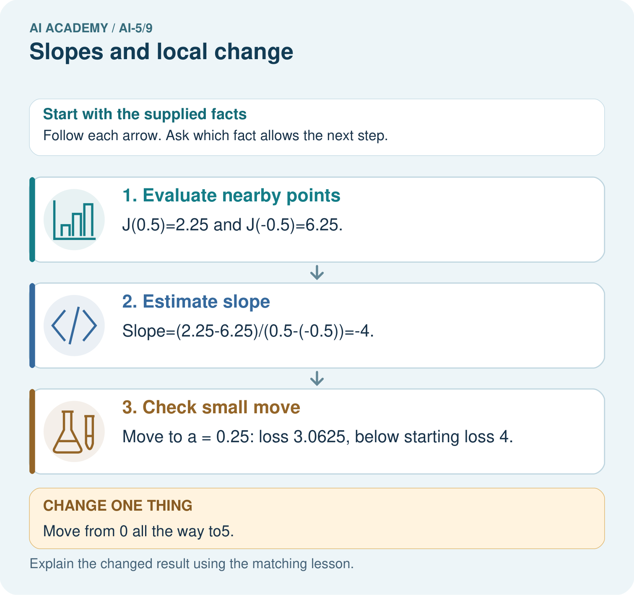
Which calculation disproves “any increase helps”? Point to the relevant step in the picture, then write the changed result and the rule or evidence that supports it.

My picture-based explanation and changed-case prediction
________________________________________________________________
________________________________________________________________
________________________________________________________________
________________________________________________________________
________________________________________________________________
________________________________________________________________
Support used: alone / hint / worked example. This record is practice evidence.
Project connection: For your Image-pattern Network Investigation, save the input, procedure, observed result and limitation of this check. Label this worked example as practice; use a different, previously unreviewed case when checking independent understanding.

13. Project portfolio milestone
Project: Image-pattern Network Investigation
Current milestone: Make a transparent first version. Keep a trace of how one input becomes an output; explain the rule or learned component.
For your Image-pattern Network Investigation, save the input, procedure, observed result and limitation of this check. Label this worked example as practice; use a different, previously unreviewed case when checking independent understanding.
Evidence to keep | My record
This week’s input and deciding step
Prediction and actual result (or labelled paper trace)
One change since the previous checkpoint and why
One error or limit and the next test

Explain what this week adds to your project. Reuse last week’s record rather than starting again.
________________________________________________________________
________________________________________________________________
________________________________________________________________
________________________________________________________________
________________________________________________________________

14. Supported practice and learning evidence
Use this supported practice once, in the browser or on paper. Keep the reserved independent assessment for a separate first attempt before teacher feedback.
Use a local slope to propose a small move rather than claiming every move helps.

Practice 1: explain the deciding evidence
Which labelled step matches this detail? Move to a = 0.25: loss 3.0625, below starting loss 4.
1. Check small move
2. Estimate slope
3. Evaluate nearby points

My selected conclusion, deciding fact and explanation
________________________________________________________________
________________________________________________________________
________________________________________________________________
________________________________________________________________
________________________________________________________________
Hint if needed: Read the steps in the pictorial case. Match the supplied detail to the stage that performs or records it.
After your attempt, compare with the supported explanation: Check small move Move to a = 0.25: loss 3.0625, below starting loss 4. A slope describes how the loss changes near the current parameter. The symmetric calculation compares equal small moves on either side. Its negative result suggests a small increase may help at zero. It does not promise every increase helps: jumping to five passes the optimum at two and produces a larger loss. Check the new loss after each proposed step.

Practice 2: explain the deciding evidence
Changed-case practice: Move from 0 all the way to5. Which conclusion is supported by the supplied facts?
1. We can decide the result without examining the changed input or the procedure.
2. Loss becomes9, exceeding the starting4.
3. This one example guarantees correct results for every future input.

My selected conclusion, deciding fact and explanation
________________________________________________________________
________________________________________________________________
________________________________________________________________
________________________________________________________________
________________________________________________________________
Hint if needed: Use the changed condition and the deciding step in the pictorial trace. The answer must say what follows from those facts.
After your attempt, compare with the supported explanation: Loss becomes9, exceeding the starting4. A negative local slope suggests increasing a locally, not that every positive jump decreases loss.

Repair a missing building block
Review Loss functions (ai-5/8). Goal: Calculate per-example squared error and mean squared error. Short practice: Why must the report name the chosen loss? Point to the relevant step in the picture, then write the changed result and the rule or evidence that supports it.. Return to this week and explain what you changed.
Review Forward passes by hand (ai-5/6). Goal: Record scores and activations in dependency order. Short practice: Why should feedback identify h before correcting only y? Point to the relevant step in the picture, then write the changed result and the rule or evidence that supports it.. Return to this week and explain what you changed.
Review Bias terms and decision boundaries (ai-5/3). Goal: Calculate a weighted score with a bias term. Short practice: Is B positive under the original or changed model? Point to the relevant step in the picture, then write the changed result and the rule or evidence that supports it.. Return to this week and explain what you changed.

Predict, run and debug
The browser lab lets you edit the supported Python examples already included in this lesson. Predict first, run, inspect the actual output or error, change one input, then run again. Keep code, predictions, actual results and a reasoned revision together. On paper, label your result as a trace rather than an execution.

Keep your completed work
Use Download completed work in the hosted lesson to export your answers, reflections, practice feedback and code-run evidence. Open the HTML copy to read or print it. Drafts stay in this browser when storage is available; clear drafts on a shared device.

What I repaired, the evidence I kept and the next test
________________________________________________________________
________________________________________________________________
________________________________________________________________
________________________________________________________________
________________________________________________________________

