AI ACADEMY · WORKBOOK · ai-5/10

Gradients with a numerical check
Project: Image-pattern Network Investigation

01. Recall and choose your starting point
Try the recall before opening notes. Then use a different colour or a labelled second line to correct your explanation.

Slopes and local change
Without opening the old lesson, explain one key idea from Slopes and local change. Give an example and a mistake that the idea helps you avoid.

My remembered idea, example and correction
________________________________________________________________
________________________________________________________________
________________________________________________________________

Parameters and architecture
Without opening the old lesson, explain one key idea from Parameters and architecture. Give an example and a mistake that the idea helps you avoid.

My remembered idea, example and correction
________________________________________________________________
________________________________________________________________
________________________________________________________________

Activation functions
Without opening the old lesson, explain one key idea from Activation functions. Give an example and a mistake that the idea helps you avoid.

My remembered idea, example and correction
________________________________________________________________
________________________________________________________________
________________________________________________________________

02. Practise with fading help
Use W2: Catch a denominator error for Gradients with a numerical check. Record the answer once; the lesson and workbook refer to the same attempt.
Given inputs | Procedure I chose | Middle steps | Result and check

The step I completed without help, and the hint I needed
________________________________________________________________
________________________________________________________________
________________________________________________________________

03. Individual reasoning check
Use the worked case for Gradients with a numerical check. Proposed explanation: “The gradient is one scalar”. Decide whether this explanation is supported. Point to the step or supplied fact that decides; explain your repair if needed.

My explanation before partner discussion
________________________________________________________________
________________________________________________________________
________________________________________________________________
________________________________________________________________

04. Independent transfer case

Independent case: Check a new example independently
Use x = 3, target 2 and y = wx + b at w = 0, b = 1. With step 0.1, calculate both numerical partials. Compare with [2 times residual times x, 2 times residual].

My independent explanation, trace and limits
________________________________________________________________
________________________________________________________________
________________________________________________________________
________________________________________________________________
________________________________________________________________
________________________________________________________________
________________________________________________________________
Attempt this case before feedback. Record any help. Earlier examples below are further practice; a case already practised with feedback cannot establish fresh transfer.

05. W1 Recover a gradient
For the lesson model at w = 1 and b = 1, calculate prediction, residual, loss and gradient.

My reasoning and evidence
________________________________________________________________
________________________________________________________________
________________________________________________________________
________________________________________________________________
________________________________________________________________
________________________________________________________________

06. W2 Catch a denominator error
A w probe has losses 1.44 and 0.64 at 0.9 and 1.1 with b fixed. A learner divides their difference by 0.1. Correct the result.

My reasoning and evidence
________________________________________________________________
________________________________________________________________
________________________________________________________________
________________________________________________________________
________________________________________________________________
________________________________________________________________

07. W3 Separate a direction from a coordinate
Starting at [w, b] = [1, 0], both coordinates move by plus or minus 0.1 together. Compute the symmetric slope and explain why it is not either partial derivative.

My reasoning and evidence
________________________________________________________________
________________________________________________________________
________________________________________________________________
________________________________________________________________
________________________________________________________________
________________________________________________________________

08. W4 Check a new example independently
Use x = 3, target 2 and y = wx + b at w = 0, b = 1. With step 0.1, calculate both numerical partials. Compare with [2 times residual times x, 2 times residual].

My reasoning and evidence
________________________________________________________________
________________________________________________________________
________________________________________________________________
________________________________________________________________
________________________________________________________________
________________________________________________________________
________________________________________________________________
________________________________________________________________

09. W5 Recognise a corner
Compute the symmetric difference of ReLU at zero with step 0.1. Explain why this does not prove a derivative exists there.

My reasoning and evidence
________________________________________________________________
________________________________________________________________
________________________________________________________________
________________________________________________________________
________________________________________________________________
________________________________________________________________

10. Project checkpoint and reflection
Add a labelled gradients with a numerical check evidence sheet to Image-pattern Network Investigation. Show how you can estimate one partial derivative while other parameters stay fixed. Use the supplied fictional case and keep its inputs, intermediate steps, calculation or prediction, and limitation. Connect this record to last week’s record; a matching answer without a trace is insufficient.

My project change, supporting evidence and remaining limit
________________________________________________________________
________________________________________________________________
________________________________________________________________
________________________________________________________________
________________________________________________________________
________________________________________________________________

11. Feedback, return check and learning record
Evidence | My record
Worked alone / hint / model
First step I repaired and why
New case checked later; date and result
What I can now explain without notes
One remaining question
Revisit this idea with your teacher after a delay. Familiarity is different from explaining and using it on a changed case.

12. Pictorial case practice: Gradients with a numerical check
Check each coordinate of a gradient while holding the other parameter fixed.
Model y=2w+b, target 3. At [w, b]=[1, 0], y = 2, residual y-target=-1; loss is residual².
All inputs and outcomes in this worked example are invented classroom data; no real model run is claimed.
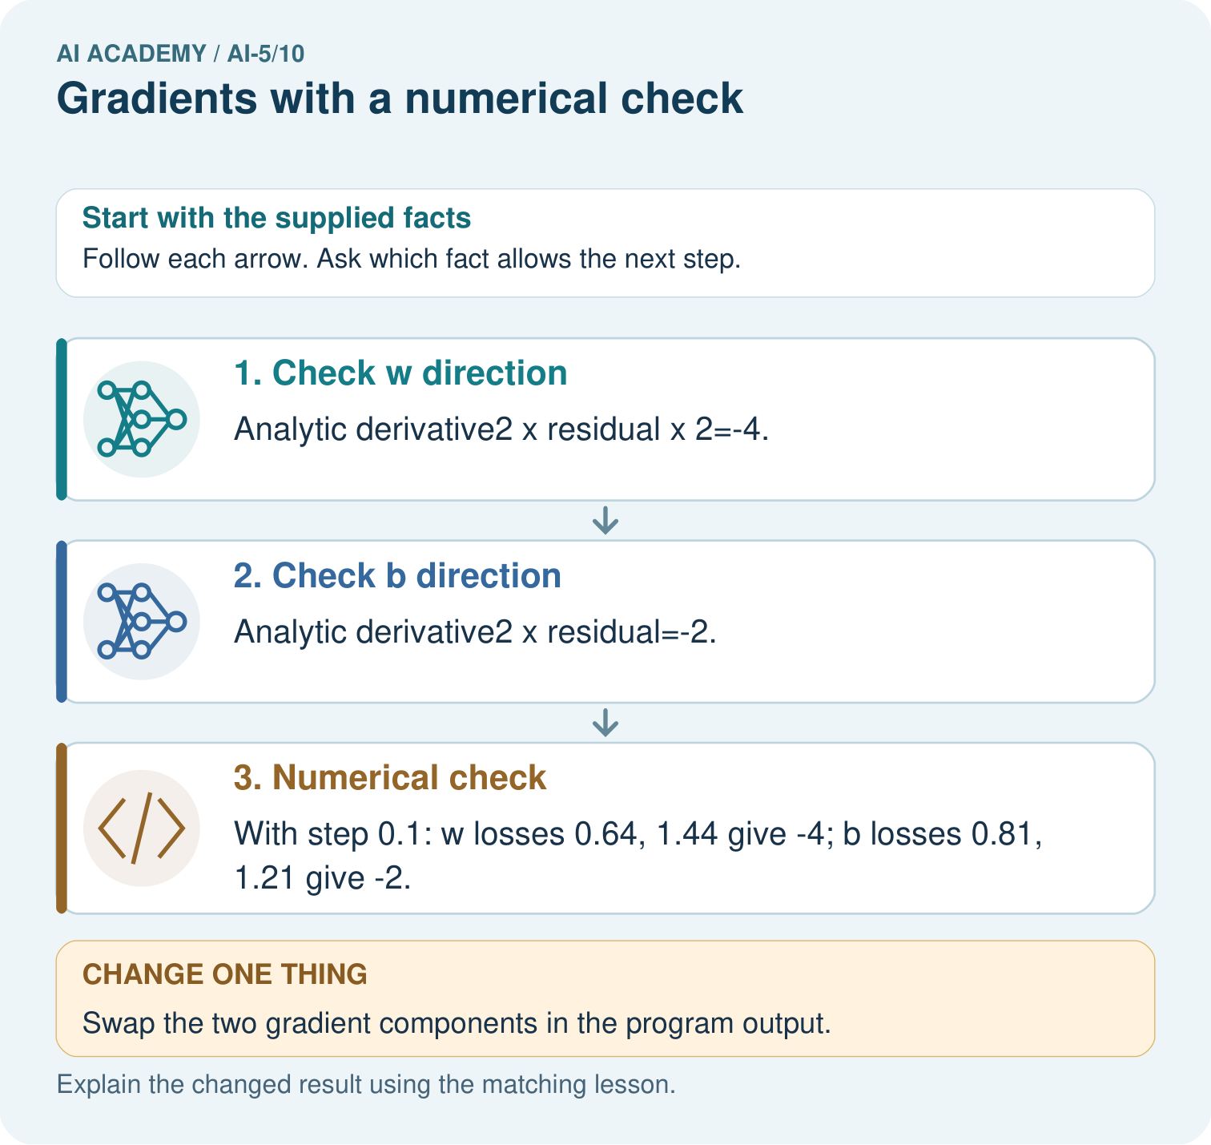
Why should the numerical checks perturb one coordinate at a time? Point to the relevant step in the picture, then write the changed result and the rule or evidence that supports it.

My picture-based explanation and changed-case prediction
________________________________________________________________
________________________________________________________________
________________________________________________________________
________________________________________________________________
________________________________________________________________
________________________________________________________________
Support used: alone / hint / worked example. This record is practice evidence.
Project connection: For your Image-pattern Network Investigation, save the input, procedure, observed result and limitation of this check. Label this worked example as practice; use a different, previously unreviewed case when checking independent understanding.

13. Project portfolio milestone
Project: Image-pattern Network Investigation
Current milestone: Make a transparent first version. Keep a trace of how one input becomes an output; explain the rule or learned component.
For your Image-pattern Network Investigation, save the input, procedure, observed result and limitation of this check. Label this worked example as practice; use a different, previously unreviewed case when checking independent understanding.
Evidence to keep | My record
This week’s input and deciding step
Prediction and actual result (or labelled paper trace)
One change since the previous checkpoint and why
One error or limit and the next test

Explain what this week adds to your project. Reuse last week’s record rather than starting again.
________________________________________________________________
________________________________________________________________
________________________________________________________________
________________________________________________________________
________________________________________________________________

14. Supported practice and learning evidence
Use this supported practice once, in the browser or on paper. Keep the reserved independent assessment for a separate first attempt before teacher feedback.
Check each coordinate of a gradient while holding the other parameter fixed.

Practice 1: explain the deciding evidence
Which labelled step matches this detail? With step 0.1: w losses 0.64, 1.44 give -4; b losses 0.81, 1.21 give -2.
1. Numerical check
2. Check b direction
3. Check w direction

My selected conclusion, deciding fact and explanation
________________________________________________________________
________________________________________________________________
________________________________________________________________
________________________________________________________________
________________________________________________________________
Hint if needed: Read the steps in the pictorial case. Match the supplied detail to the stage that performs or records it.
After your attempt, compare with the supported explanation: Numerical check With step 0.1: w losses 0.64, 1.44 give -4; b losses 0.81, 1.21 give -2. A gradient lists the slope for each parameter, in a declared order. Changing w by a small amount changes the prediction twice as much as changing b by the same amount. That explains the different derivative magnitudes. Perturb one coordinate while holding the other fixed, then compare the numerical slope with its analytic counterpart.

Practice 2: explain the deciding evidence
Changed-case practice: Swap the two gradient components in the program output. Which conclusion is supported by the supplied facts?
1. This one example guarantees correct results for every future input.
2. The coordinate-wise numerical check exposes the mismatch.
3. We can decide the result without examining the changed input or the procedure.

My selected conclusion, deciding fact and explanation
________________________________________________________________
________________________________________________________________
________________________________________________________________
________________________________________________________________
________________________________________________________________
Hint if needed: Use the changed condition and the deciding step in the pictorial trace. The answer must say what follows from those facts.
After your attempt, compare with the supported explanation: The coordinate-wise numerical check exposes the mismatch. The w perturbation changes y twice as strongly as the same b perturbation.

Repair a missing building block
Review Slopes and local change (ai-5/9). Goal: Calculate an average rate of change over a stated interval. Short practice: Which calculation disproves “any increase helps”? Point to the relevant step in the picture, then write the changed result and the rule or evidence that supports it.. Return to this week and explain what you changed.
Review Parameters and architecture (ai-5/7). Goal: Distinguish architectural choices from parameter values. Short practice: How many new parameters did that one hidden unit add? Point to the relevant step in the picture, then write the changed result and the rule or evidence that supports it.. Return to this week and explain what you changed.
Review Activation functions (ai-5/4). Goal: Trace identity ReLU and sigmoid on a numerical score. Short practice: Which original inputs cannot be distinguished by this network’s final output? Point to the relevant step in the picture, then write the changed result and the rule or evidence that supports it.. Return to this week and explain what you changed.

Predict, run and debug
The browser lab lets you edit the supported Python examples already included in this lesson. Predict first, run, inspect the actual output or error, change one input, then run again. Keep code, predictions, actual results and a reasoned revision together. On paper, label your result as a trace rather than an execution.

Keep your completed work
Use Download completed work in the hosted lesson to export your answers, reflections, practice feedback and code-run evidence. Open the HTML copy to read or print it. Drafts stay in this browser when storage is available; clear drafts on a shared device.

What I repaired, the evidence I kept and the next test
________________________________________________________________
________________________________________________________________
________________________________________________________________
________________________________________________________________
________________________________________________________________

