AI ACADEMY · WORKBOOK · ai-5/13

Batching and epochs
Project: Image-pattern Network Investigation

01. Recall and choose your starting point
Try the recall before opening notes. Then use a different colour or a labelled second line to correct your explanation.

Training a small network
Without opening the old lesson, explain one key idea from Training a small network. Give an example and a mistake that the idea helps you avoid.

My remembered idea, example and correction
________________________________________________________________
________________________________________________________________
________________________________________________________________

Gradients with a numerical check
Without opening the old lesson, explain one key idea from Gradients with a numerical check. Give an example and a mistake that the idea helps you avoid.

My remembered idea, example and correction
________________________________________________________________
________________________________________________________________
________________________________________________________________

Parameters and architecture
Without opening the old lesson, explain one key idea from Parameters and architecture. Give an example and a mistake that the idea helps you avoid.

My remembered idea, example and correction
________________________________________________________________
________________________________________________________________
________________________________________________________________

02. Practise with fading help
Use W2: Repair a stale gradient for Batching and epochs. Record the answer once; the lesson and workbook refer to the same attempt.
Given inputs | Procedure I chose | Middle steps | Result and check

The step I completed without help, and the hint I needed
________________________________________________________________
________________________________________________________________
________________________________________________________________

03. Individual reasoning check
Use the worked case for Batching and epochs. Proposed explanation: “One epoch always means one update”. Decide whether this explanation is supported. Point to the step or supplied fact that decides; explain your repair if needed.

My explanation before partner discussion
________________________________________________________________
________________________________________________________________
________________________________________________________________
________________________________________________________________

04. Independent transfer case

Independent case: Test order on a new case independently
Use A = (1, 1), B = (2, 0), h = ReLU(x), y = vh, v = 0 and rate 0.1. Train with size 1 for one epoch in A then B order, then restart at 0 and reverse the order. Show gradients and parameter values. Compare the final values.

My independent explanation, trace and limits
________________________________________________________________
________________________________________________________________
________________________________________________________________
________________________________________________________________
________________________________________________________________
________________________________________________________________
________________________________________________________________
Attempt this case before feedback. Record any help. Earlier examples below are further practice; a case already practised with feedback cannot establish fresh transfer.

05. W1 Count a partial batch
For 10 rows, batch size 4 and three epochs, retaining the final batch, list batch lengths and count total updates and example visits.

My reasoning and evidence
________________________________________________________________
________________________________________________________________
________________________________________________________________
________________________________________________________________
________________________________________________________________
________________________________________________________________

06. W2 Repair a stale gradient
For A then B separately in the lesson, a learner computes both gradients at v = 0, then applies them to get v = 2. Explain the error and give the correct final value.

My reasoning and evidence
________________________________________________________________
________________________________________________________________
________________________________________________________________
________________________________________________________________
________________________________________________________________
________________________________________________________________

07. W3 Combine unequal batches
At one frozen model, batches of sizes 3 and 1 have mean squared errors 2 and 10. Find the full MSE and explain why the average of 2 and 10 is wrong.

My reasoning and evidence
________________________________________________________________
________________________________________________________________
________________________________________________________________
________________________________________________________________
________________________________________________________________
________________________________________________________________

08. W4 Test order on a new case independently
Use A = (1, 1), B = (2, 0), h = ReLU(x), y = vh, v = 0 and rate 0.1. Train with size 1 for one epoch in A then B order, then restart at 0 and reverse the order. Show gradients and parameter values. Compare the final values.

My reasoning and evidence
________________________________________________________________
________________________________________________________________
________________________________________________________________
________________________________________________________________
________________________________________________________________
________________________________________________________________
________________________________________________________________
________________________________________________________________

09. W5 Audit an epoch claim
A program processes 11 rows using size 4 and drops the last incomplete batch. How many examples did it visit and how many updates occurred? What must its report disclose?

My reasoning and evidence
________________________________________________________________
________________________________________________________________
________________________________________________________________
________________________________________________________________
________________________________________________________________
________________________________________________________________

10. Project checkpoint and reflection
Add a labelled batching and epochs evidence sheet to Image-pattern Network Investigation. Show how you can distinguish an example a batch an update and an epoch. Use the supplied fictional case and keep its inputs, intermediate steps, calculation or prediction, and limitation. Connect this record to last week’s record; a matching answer without a trace is insufficient.

My project change, supporting evidence and remaining limit
________________________________________________________________
________________________________________________________________
________________________________________________________________
________________________________________________________________
________________________________________________________________
________________________________________________________________

11. Feedback, return check and learning record
Evidence | My record
Worked alone / hint / model
First step I repaired and why
New case checked later; date and result
What I can now explain without notes
One remaining question
Revisit this idea with your teacher after a delay. Familiarity is different from explaining and using it on a changed case.

12. Pictorial case practice: Batching and epochs
Show why an epoch’s example order can matter for single-example updates.
Toy y=wx, rate 0.1, squared loss, start w = 0. Training A=(x = 1, target 2), B=(x = 2, target 0).
All inputs and outcomes in this worked example are invented classroom data; no real model run is claimed.
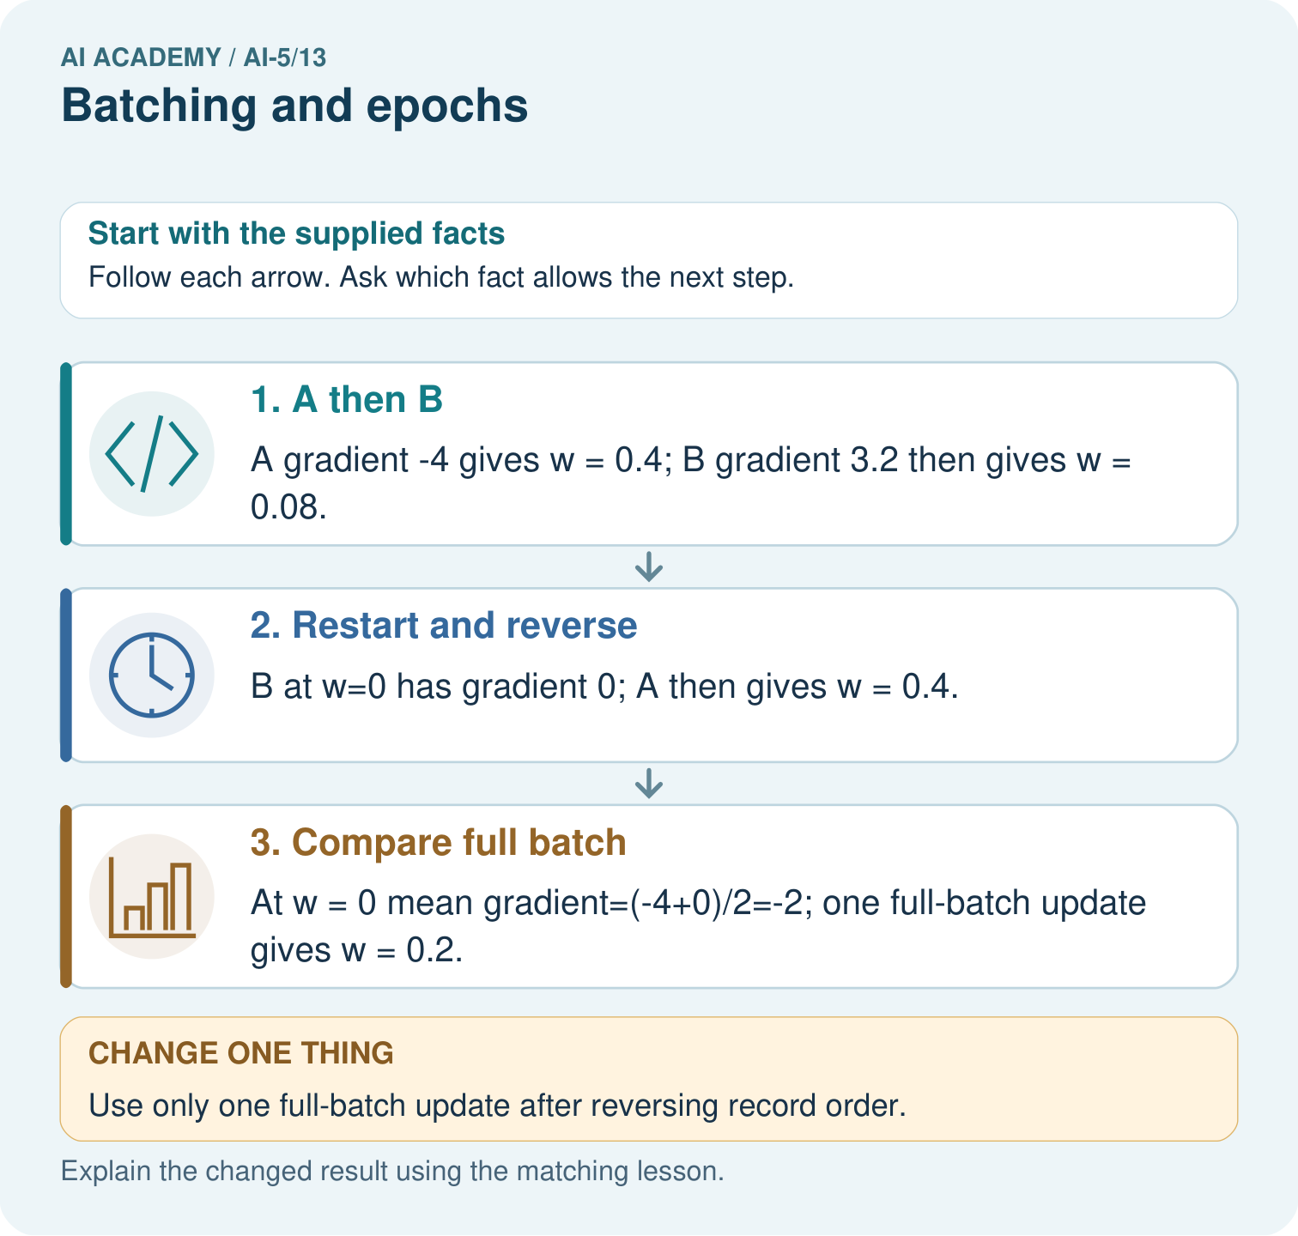
Why do the single-example orders finish at different weights? Point to the relevant step in the picture, then write the changed result and the rule or evidence that supports it.

My picture-based explanation and changed-case prediction
________________________________________________________________
________________________________________________________________
________________________________________________________________
________________________________________________________________
________________________________________________________________
________________________________________________________________
Support used: alone / hint / worked example. This record is practice evidence.
Project connection: For your Image-pattern Network Investigation, save the input, procedure, observed result and limitation of this check. Label this worked example as practice; use a different, previously unreviewed case when checking independent understanding.

13. Project portfolio milestone
Project: Image-pattern Network Investigation
Current milestone: Test changed cases. Keep normal, boundary and failure cases; compare expected and observed results.
For your Image-pattern Network Investigation, save the input, procedure, observed result and limitation of this check. Label this worked example as practice; use a different, previously unreviewed case when checking independent understanding.
Evidence to keep | My record
This week’s input and deciding step
Prediction and actual result (or labelled paper trace)
One change since the previous checkpoint and why
One error or limit and the next test

Explain what this week adds to your project. Reuse last week’s record rather than starting again.
________________________________________________________________
________________________________________________________________
________________________________________________________________
________________________________________________________________
________________________________________________________________

14. Supported practice and learning evidence
Use this supported practice once, in the browser or on paper. Keep the reserved independent assessment for a separate first attempt before teacher feedback.
Show why an epoch’s example order can matter for single-example updates.

Practice 1: explain the deciding evidence
Which labelled step matches this detail? At w = 0 mean gradient=(-4+0)/2=-2; one full-batch update gives w = 0.2.
1. Restart and reverse
2. A then B
3. Compare full batch

My selected conclusion, deciding fact and explanation
________________________________________________________________
________________________________________________________________
________________________________________________________________
________________________________________________________________
________________________________________________________________
Hint if needed: Read the steps in the pictorial case. Match the supplied detail to the stage that performs or records it.
After your attempt, compare with the supported explanation: Compare full batch At w = 0 mean gradient=(-4+0)/2=-2; one full-batch update gives w = 0.2. A single-example update changes the weight before the next example’s gradient is calculated. Reversing the example order can therefore change the path. A full-batch update computes both gradients at the same starting weight and averages them before changing that weight. The distinction is when the update occurs, not whether the examples have different labels.

Practice 2: explain the deciding evidence
Changed-case practice: Use only one full-batch update after reversing record order. Which conclusion is supported by the supplied facts?
1. The updated weight remains 0.2.
2. We can decide the result without examining the changed input or the procedure.
3. This one example guarantees correct results for every future input.

My selected conclusion, deciding fact and explanation
________________________________________________________________
________________________________________________________________
________________________________________________________________
________________________________________________________________
________________________________________________________________
Hint if needed: Use the changed condition and the deciding step in the pictorial trace. The answer must say what follows from those facts.
After your attempt, compare with the supported explanation: The updated weight remains 0.2. The same mean of the two starting gradients is unchanged by their order.

Repair a missing building block
Review Training a small network (ai-5/12). Goal: Trace repeated forward loss gradient and update steps. Short practice: Which parameter changed, and which part was not trained? Point to the relevant step in the picture, then write the changed result and the rule or evidence that supports it.. Return to this week and explain what you changed.
Review Gradients with a numerical check (ai-5/10). Goal: Estimate one partial derivative while other parameters stay fixed. Short practice: Why should the numerical checks perturb one coordinate at a time? Point to the relevant step in the picture, then write the changed result and the rule or evidence that supports it.. Return to this week and explain what you changed.
Review Parameters and architecture (ai-5/7). Goal: Distinguish architectural choices from parameter values. Short practice: How many new parameters did that one hidden unit add? Point to the relevant step in the picture, then write the changed result and the rule or evidence that supports it.. Return to this week and explain what you changed.

Predict, run and debug
The browser lab lets you edit the supported Python examples already included in this lesson. Predict first, run, inspect the actual output or error, change one input, then run again. Keep code, predictions, actual results and a reasoned revision together. On paper, label your result as a trace rather than an execution.

Keep your completed work
Use Download completed work in the hosted lesson to export your answers, reflections, practice feedback and code-run evidence. Open the HTML copy to read or print it. Drafts stay in this browser when storage is available; clear drafts on a shared device.

What I repaired, the evidence I kept and the next test
________________________________________________________________
________________________________________________________________
________________________________________________________________
________________________________________________________________
________________________________________________________________

