AI ACADEMY · WORKBOOK · ai-5/14

Learning rate experiments
Project: Image-pattern Network Investigation

01. Recall and choose your starting point
Try the recall before opening notes. Then use a different colour or a labelled second line to correct your explanation.

Batching and epochs
Without opening the old lesson, explain one key idea from Batching and epochs. Give an example and a mistake that the idea helps you avoid.

My remembered idea, example and correction
________________________________________________________________
________________________________________________________________
________________________________________________________________

Updating parameters
Without opening the old lesson, explain one key idea from Updating parameters. Give an example and a mistake that the idea helps you avoid.

My remembered idea, example and correction
________________________________________________________________
________________________________________________________________
________________________________________________________________

Loss functions
Without opening the old lesson, explain one key idea from Loss functions. Give an example and a mistake that the idea helps you avoid.

My remembered idea, example and correction
________________________________________________________________
________________________________________________________________
________________________________________________________________

02. Practise with fading help
Use W2: Explain a crossing for Learning rate experiments. Record the answer once; the lesson and workbook refer to the same attempt.
Given inputs | Procedure I chose | Middle steps | Result and check

The step I completed without help, and the hint I needed
________________________________________________________________
________________________________________________________________
________________________________________________________________

03. Individual reasoning check
Use the worked case for Learning rate experiments. Proposed explanation: “Crossing the minimum means divergence”. Decide whether this explanation is supported. Point to the step or supplied fact that decides; explain your repair if needed.

My explanation before partner discussion
________________________________________________________________
________________________________________________________________
________________________________________________________________
________________________________________________________________

04. Independent transfer case

Independent case: Compare a new objective independently
Use J(a) = (a - 1) squared with gradient 2(a - 1), start a = 0 and two updates. Restart for each rate 0.25, 0.5 and 1. Compute the two new a values and losses for each run. Identify the result supported after two updates.

My independent explanation, trace and limits
________________________________________________________________
________________________________________________________________
________________________________________________________________
________________________________________________________________
________________________________________________________________
________________________________________________________________
________________________________________________________________
Attempt this case before feedback. Record any help. Earlier examples below are further practice; a case already practised with feedback cannot establish fresh transfer.

05. W1 Trace slow progress
For rate 0.05, start v = 0 and compute two updates and their training MSE values using the lesson objective.

My reasoning and evidence
________________________________________________________________
________________________________________________________________
________________________________________________________________
________________________________________________________________
________________________________________________________________
________________________________________________________________

06. W2 Explain a crossing
At rate 0.3 the first update gives v = 3, past the minimum at 2. Calculate the next v and loss. Has the first crossing proved divergence?

My reasoning and evidence
________________________________________________________________
________________________________________________________________
________________________________________________________________
________________________________________________________________
________________________________________________________________
________________________________________________________________

07. W3 Preserve an update after rescaling loss
Replace MSE by the sum of squared errors on the two training pairs. Which rate reproduces the MSE run at rate 0.3? Explain using gradients.

My reasoning and evidence
________________________________________________________________
________________________________________________________________
________________________________________________________________
________________________________________________________________
________________________________________________________________
________________________________________________________________

08. W4 Compare a new objective independently
Use J(a) = (a - 1) squared with gradient 2(a - 1), start a = 0 and two updates. Restart for each rate 0.25, 0.5 and 1. Compute the two new a values and losses for each run. Identify the result supported after two updates.

My reasoning and evidence
________________________________________________________________
________________________________________________________________
________________________________________________________________
________________________________________________________________
________________________________________________________________
________________________________________________________________
________________________________________________________________
________________________________________________________________

09. W5 Find an unfair comparison
Run A starts v = 0 with full-data batches for four updates. Run B starts at the final A value, changes both rate and batch size, then compares final training losses. Can the difference be attributed only to rate? Propose a repair.

My reasoning and evidence
________________________________________________________________
________________________________________________________________
________________________________________________________________
________________________________________________________________
________________________________________________________________
________________________________________________________________

10. Project checkpoint and reflection
Add a labelled learning rate experiments evidence sheet to Image-pattern Network Investigation. Show how you can run a controlled comparison of learning rates. Use the supplied fictional case and keep its inputs, intermediate steps, calculation or prediction, and limitation. Connect this record to last week’s record; a matching answer without a trace is insufficient.

My project change, supporting evidence and remaining limit
________________________________________________________________
________________________________________________________________
________________________________________________________________
________________________________________________________________
________________________________________________________________
________________________________________________________________

11. Feedback, return check and learning record
Evidence | My record
Worked alone / hint / model
First step I repaired and why
New case checked later; date and result
What I can now explain without notes
One remaining question
Revisit this idea with your teacher after a delay. Familiarity is different from explaining and using it on a changed case.

12. Pictorial case practice: Learning rate experiments
Compare learning rates with identical starting loss and update counts.
Loss J(a)=(a-4)²; gradient 2(a-4); start a = = 0. Compare two updates at rates0.25 and 0.75.
All inputs and outcomes in this worked example are invented classroom data; no real model run is claimed.
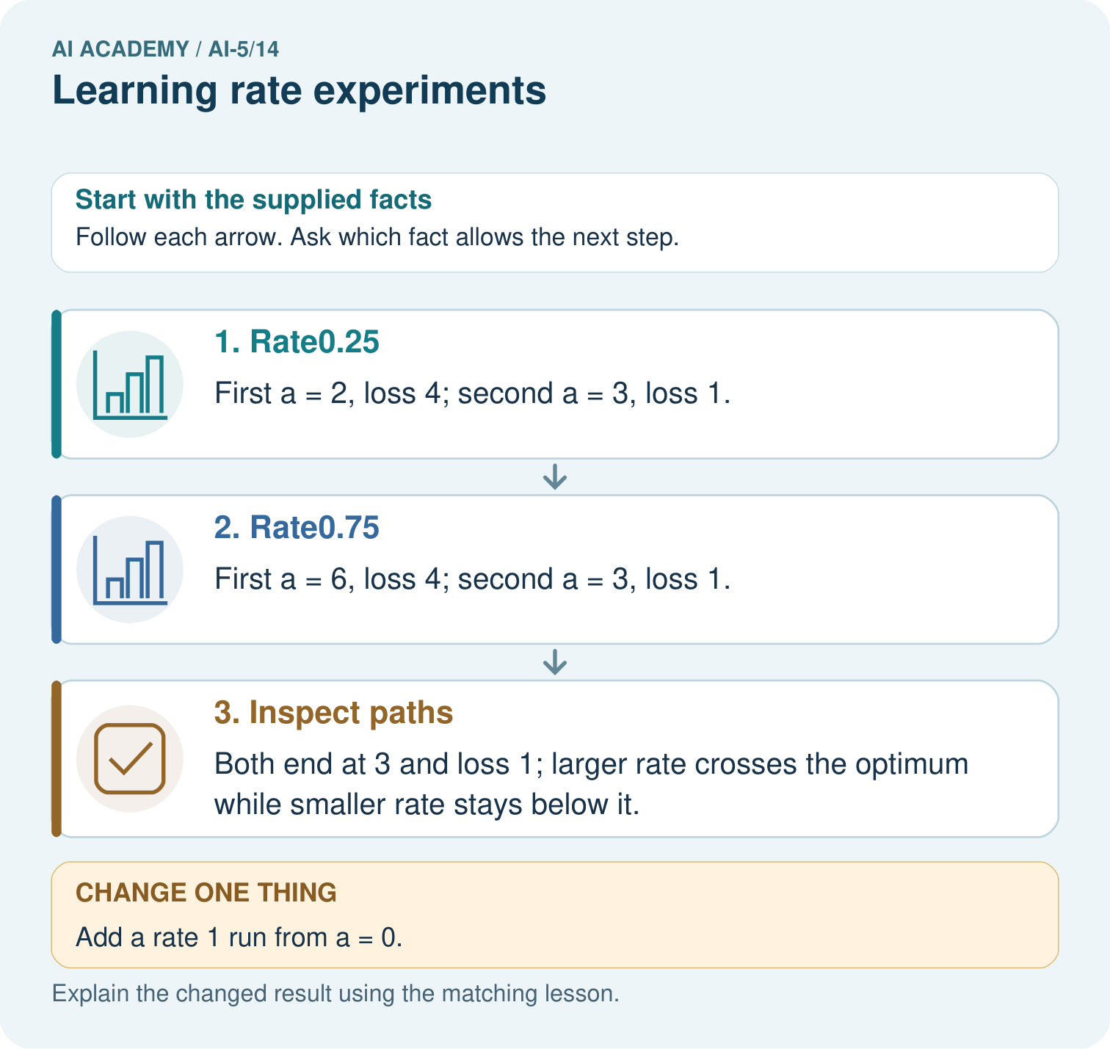
What should a fair rate comparison hold fixed? Point to the relevant step in the picture, then write the changed result and the rule or evidence that supports it.

My picture-based explanation and changed-case prediction
________________________________________________________________
________________________________________________________________
________________________________________________________________
________________________________________________________________
________________________________________________________________
________________________________________________________________
Support used: alone / hint / worked example. This record is practice evidence.
Project connection: For your Image-pattern Network Investigation, save the input, procedure, observed result and limitation of this check. Label this worked example as practice; use a different, previously unreviewed case when checking independent understanding.

13. Project portfolio milestone
Project: Image-pattern Network Investigation
Current milestone: Test changed cases. Keep normal, boundary and failure cases; compare expected and observed results.
For your Image-pattern Network Investigation, save the input, procedure, observed result and limitation of this check. Label this worked example as practice; use a different, previously unreviewed case when checking independent understanding.
Evidence to keep | My record
This week’s input and deciding step
Prediction and actual result (or labelled paper trace)
One change since the previous checkpoint and why
One error or limit and the next test

Explain what this week adds to your project. Reuse last week’s record rather than starting again.
________________________________________________________________
________________________________________________________________
________________________________________________________________
________________________________________________________________
________________________________________________________________

14. Supported practice and learning evidence
Use this supported practice once, in the browser or on paper. Keep the reserved independent assessment for a separate first attempt before teacher feedback.
Compare learning rates with identical starting loss and update counts.

Practice 1: explain the deciding evidence
Which labelled step matches this detail? Both end at 3 and loss 1; larger rate crosses the optimum while smaller rate stays below it.
1. Inspect paths
2. Rate0.25
3. Rate0.75

My selected conclusion, deciding fact and explanation
________________________________________________________________
________________________________________________________________
________________________________________________________________
________________________________________________________________
________________________________________________________________
Hint if needed: Read the steps in the pictorial case. Match the supplied detail to the stage that performs or records it.
After your attempt, compare with the supported explanation: Inspect paths Both end at 3 and loss 1; larger rate crosses the optimum while smaller rate stays below it. Keep the starting parameter and update budget identical to compare rates fairly. Rate one-quarter approaches the optimum from below; rate three-quarters crosses it and comes back. Their final losses happen to match after two updates, despite different paths. Rate one repeatedly overshoots by the same distance, so using the correct gradient alone does not ensure improvement.

Practice 2: explain the deciding evidence
Changed-case practice: Add a rate 1 run from a = 0. Which conclusion is supported by the supplied facts?
1. This one example guarantees correct results for every future input.
2. We can decide the result without examining the changed input or the procedure.
3. Its path is 8 then 0, with loss 16 at both steps.

My selected conclusion, deciding fact and explanation
________________________________________________________________
________________________________________________________________
________________________________________________________________
________________________________________________________________
________________________________________________________________
Hint if needed: Use the changed condition and the deciding step in the pictorial trace. The answer must say what follows from those facts.
After your attempt, compare with the supported explanation: Its path is 8 then 0, with loss 16 at both steps. The update alternates across4 without reducing the initial loss.

Repair a missing building block
Review Batching and epochs (ai-5/13). Goal: Distinguish an example a batch an update and an epoch. Short practice: Why do the single-example orders finish at different weights? Point to the relevant step in the picture, then write the changed result and the rule or evidence that supports it.. Return to this week and explain what you changed.
Review Updating parameters (ai-5/11). Goal: Apply a learning rate to an ordered gradient. Short practice: Why must new loss be recomputed rather than assumed smaller? Point to the relevant step in the picture, then write the changed result and the rule or evidence that supports it.. Return to this week and explain what you changed.
Review Loss functions (ai-5/8). Goal: Calculate per-example squared error and mean squared error. Short practice: Why must the report name the chosen loss? Point to the relevant step in the picture, then write the changed result and the rule or evidence that supports it.. Return to this week and explain what you changed.

Predict, run and debug
The browser lab lets you edit the supported Python examples already included in this lesson. Predict first, run, inspect the actual output or error, change one input, then run again. Keep code, predictions, actual results and a reasoned revision together. On paper, label your result as a trace rather than an execution.

Keep your completed work
Use Download completed work in the hosted lesson to export your answers, reflections, practice feedback and code-run evidence. Open the HTML copy to read or print it. Drafts stay in this browser when storage is available; clear drafts on a shared device.

What I repaired, the evidence I kept and the next test
________________________________________________________________
________________________________________________________________
________________________________________________________________
________________________________________________________________
________________________________________________________________

