AI ACADEMY · WORKBOOK · ai-5/19

Learned representations
Project: Image-pattern Network Investigation

01. Recall and choose your starting point
Try the recall before opening notes. Then use a different colour or a labelled second line to correct your explanation.

Debugging shapes and gradients
Without opening the old lesson, explain one key idea from Debugging shapes and gradients. Give an example and a mistake that the idea helps you avoid.

My remembered idea, example and correction
________________________________________________________________
________________________________________________________________
________________________________________________________________

Regularisation and early stopping
Without opening the old lesson, explain one key idea from Regularisation and early stopping. Give an example and a mistake that the idea helps you avoid.

My remembered idea, example and correction
________________________________________________________________
________________________________________________________________
________________________________________________________________

Batching and epochs
Without opening the old lesson, explain one key idea from Batching and epochs. Give an example and a mistake that the idea helps you avoid.

My remembered idea, example and correction
________________________________________________________________
________________________________________________________________
________________________________________________________________

02. Practise with fading help
Use W2: Prove an information loss for Learned representations. Record the answer once; the lesson and workbook refer to the same attempt.
Given inputs | Procedure I chose | Middle steps | Result and check

The step I completed without help, and the hint I needed
________________________________________________________________
________________________________________________________________
________________________________________________________________

03. Individual reasoning check
Use the worked case for Learned representations. Proposed explanation: “Two hidden values preserve both input measurements”. Decide whether this explanation is supported. Point to the step or supplied fact that decides; explain your repair if needed.

My explanation before partner discussion
________________________________________________________________
________________________________________________________________
________________________________________________________________
________________________________________________________________

04. Independent transfer case

Independent case: Audit a new representation independently
A different layer uses g = [ReLU(width - height - 1), ReLU(height - width - 1)]. Encode [4, 3] and [3, 4]. State their targets for width strictly greater than height. Can any deterministic head receiving only g classify both correctly?

My independent explanation, trace and limits
________________________________________________________________
________________________________________________________________
________________________________________________________________
________________________________________________________________
________________________________________________________________
________________________________________________________________
________________________________________________________________
Attempt this case before feedback. Record any help. Earlier examples below are further practice; a case already practised with feedback cannot establish fresh transfer.

05. W1 Trace new inputs
Encode [8, 3], [3, 8] and [4, 4] with the lesson layer. Apply its prediction rule and explain the square boundary.

My reasoning and evidence
________________________________________________________________
________________________________________________________________
________________________________________________________________
________________________________________________________________
________________________________________________________________
________________________________________________________________

06. W2 Prove an information loss
Give the hidden vectors and areas for [4, 2] and [5, 3]. Explain why increasing only the complexity of a deterministic area head cannot make both exact predictions correct.

My reasoning and evidence
________________________________________________________________
________________________________________________________________
________________________________________________________________
________________________________________________________________
________________________________________________________________
________________________________________________________________

07. W3 Compare another encoding
The alternative representation is s = width + height. Use [4, 2] and [2, 4] to decide whether s alone always supports the wider-than-height task.

My reasoning and evidence
________________________________________________________________
________________________________________________________________
________________________________________________________________
________________________________________________________________
________________________________________________________________
________________________________________________________________

08. W4 Audit a new representation independently
A different layer uses g = [ReLU(width - height - 1), ReLU(height - width - 1)]. Encode [4, 3] and [3, 4]. State their targets for width strictly greater than height. Can any deterministic head receiving only g classify both correctly?

My reasoning and evidence
________________________________________________________________
________________________________________________________________
________________________________________________________________
________________________________________________________________
________________________________________________________________
________________________________________________________________
________________________________________________________________
________________________________________________________________

09. W5 Repair and qualify a claim
For h = [2, 0] and s = 8, recover width, height and area. Does this algebra prove that a training program learned the representation or that it will work well on noisy measurements?

My reasoning and evidence
________________________________________________________________
________________________________________________________________
________________________________________________________________
________________________________________________________________
________________________________________________________________
________________________________________________________________

10. Project checkpoint and reflection
Add a labelled learned representations evidence sheet to Image-pattern Network Investigation. Show how you can trace an input through a hidden representation and a decision rule. Use the supplied fictional case and keep its inputs, intermediate steps, calculation or prediction, and limitation. Connect this record to last week’s record; a matching answer without a trace is insufficient.

My project change, supporting evidence and remaining limit
________________________________________________________________
________________________________________________________________
________________________________________________________________
________________________________________________________________
________________________________________________________________
________________________________________________________________

11. Feedback, return check and learning record
Evidence | My record
Worked alone / hint / model
First step I repaired and why
New case checked later; date and result
What I can now explain without notes
One remaining question
Revisit this idea with your teacher after a delay. Familiarity is different from explaining and using it on a changed case.

12. Pictorial case practice: Learned representations
See when a representation preserves a distinction and when it destroys it.
Toy input [left, right]; representation h=[ReLU(left-right), ReLU(right-left)]. A=[5, 2]; B=[2, 5]; target is left-brighter versus right-brighter.
All inputs and outcomes in this worked example are invented classroom data; no real model run is claimed.
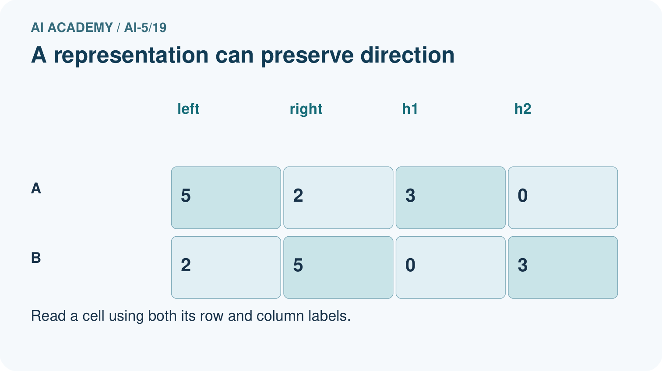
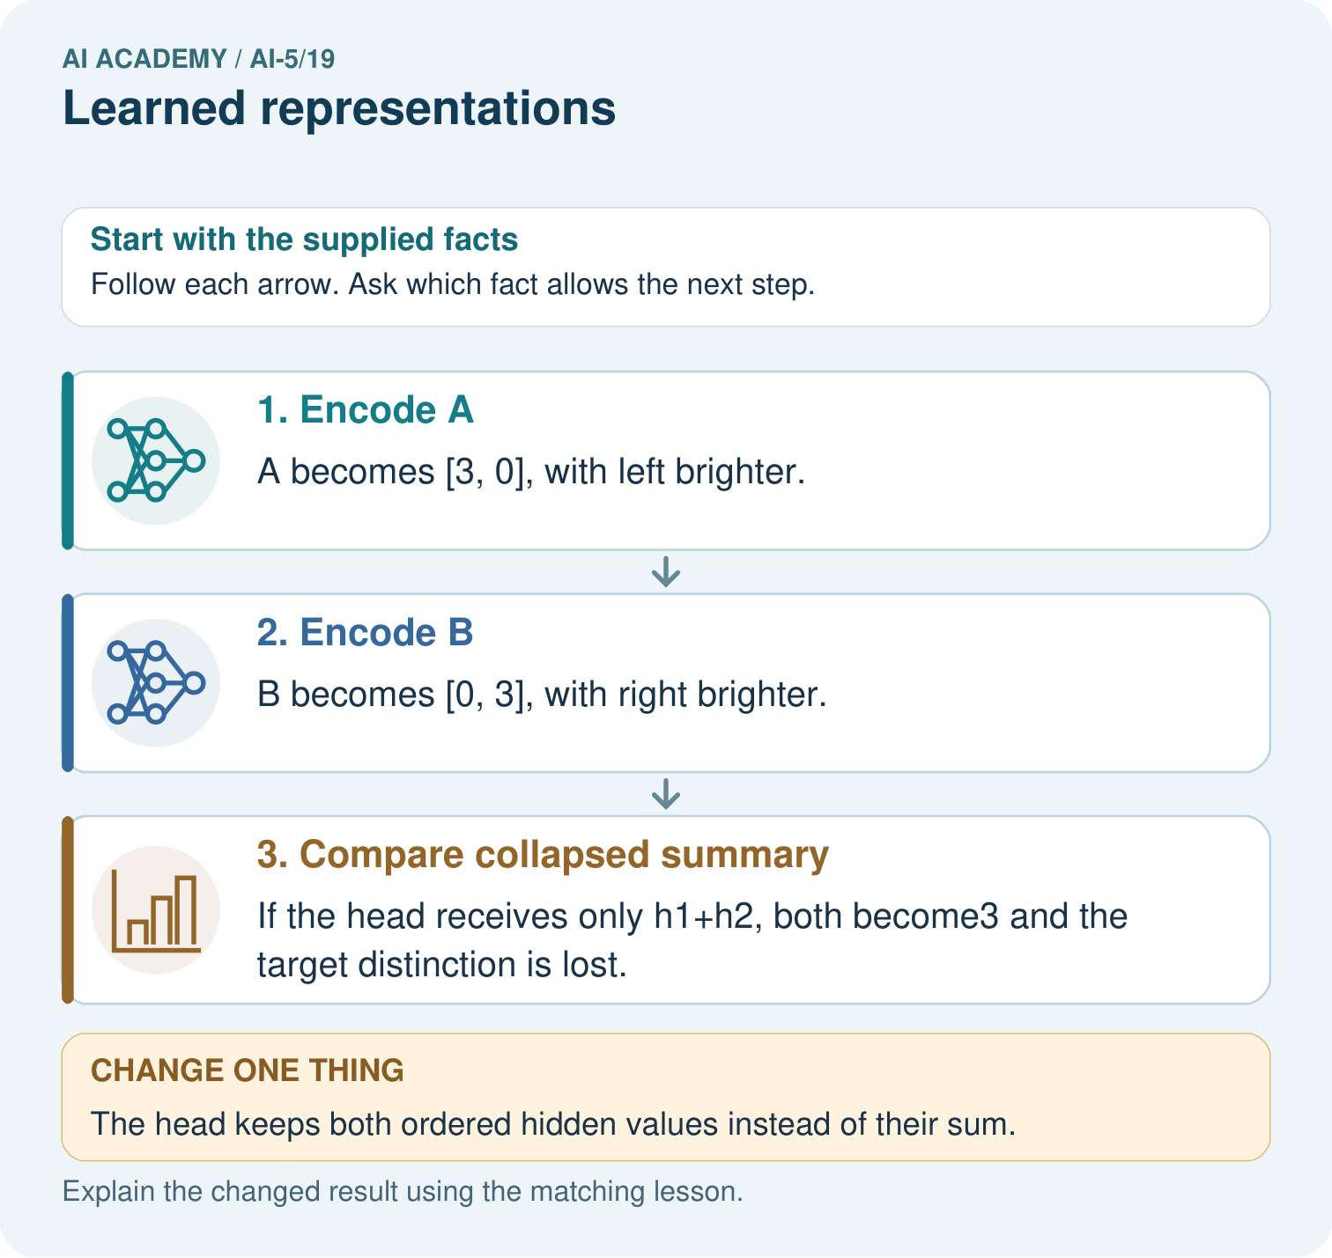
Why can no deterministic head using only the sum classify both correctly? Point to the relevant step in the picture, then write the changed result and the rule or evidence that supports it.

My picture-based explanation and changed-case prediction
________________________________________________________________
________________________________________________________________
________________________________________________________________
________________________________________________________________
________________________________________________________________
________________________________________________________________
Support used: alone / hint / worked example. This record is practice evidence.
Project connection: For your Image-pattern Network Investigation, save the input, procedure, observed result and limitation of this check. Label this worked example as practice; use a different, previously unreviewed case when checking independent understanding.

13. Project portfolio milestone
Project: Image-pattern Network Investigation
Current milestone: Evaluate and revise. Compare with your starting method, explain errors and record a justified revision.
For your Image-pattern Network Investigation, save the input, procedure, observed result and limitation of this check. Label this worked example as practice; use a different, previously unreviewed case when checking independent understanding.
Evidence to keep | My record
This week’s input and deciding step
Prediction and actual result (or labelled paper trace)
One change since the previous checkpoint and why
One error or limit and the next test

Explain what this week adds to your project. Reuse last week’s record rather than starting again.
________________________________________________________________
________________________________________________________________
________________________________________________________________
________________________________________________________________
________________________________________________________________

14. Supported practice and learning evidence
Use this supported practice once, in the browser or on paper. Keep the reserved independent assessment for a separate first attempt before teacher feedback.
See when a representation preserves a distinction and when it destroys it.

Practice 1: explain the deciding evidence
Which labelled step matches this detail? If the head receives only h1+h2, both become3 and the target distinction is lost.
1. Encode B
2. Encode A
3. Compare collapsed summary

My selected conclusion, deciding fact and explanation
________________________________________________________________
________________________________________________________________
________________________________________________________________
________________________________________________________________
________________________________________________________________
Hint if needed: Read the steps in the pictorial case. Match the supplied detail to the stage that performs or records it.
After your attempt, compare with the supported explanation: Compare collapsed summary If the head receives only h1+h2, both become3 and the target distinction is lost. A hidden representation decides which distinctions remain available to an output head. These two hidden coordinates preserve whether the left or right side is brighter. Adding them discards that direction and gives both examples the same scalar. A deterministic head cannot assign different labels to identical inputs; retain the distinction or change the task.

Practice 2: explain the deciding evidence
Changed-case practice: The head keeps both ordered hidden values instead of their sum. Which conclusion is supported by the supplied facts?
1. This one example guarantees correct results for every future input.
2. We can decide the result without examining the changed input or the procedure.
3. It can distinguish [3, 0] from [0, 3] in this example.

My selected conclusion, deciding fact and explanation
________________________________________________________________
________________________________________________________________
________________________________________________________________
________________________________________________________________
________________________________________________________________
Hint if needed: Use the changed condition and the deciding step in the pictorial trace. The answer must say what follows from those facts.
After your attempt, compare with the supported explanation: It can distinguish [3, 0] from [0, 3] in this example. The representation retains the direction of brightness difference when coordinates stay separate.

Repair a missing building block
Review Debugging shapes and gradients (ai-5/18). Goal: Check dimension contracts before computing a layer. Short practice: What should a debugging record pair with every gradient value? Point to the relevant step in the picture, then write the changed result and the rule or evidence that supports it.. Return to this week and explain what you changed.
Review Regularisation and early stopping (ai-5/16). Goal: Separate a weight penalty from prediction error. Short practice: Why should the penalty value not be reported as validation error? Point to the relevant step in the picture, then write the changed result and the rule or evidence that supports it.. Return to this week and explain what you changed.
Review Batching and epochs (ai-5/13). Goal: Distinguish an example a batch an update and an epoch. Short practice: Why do the single-example orders finish at different weights? Point to the relevant step in the picture, then write the changed result and the rule or evidence that supports it.. Return to this week and explain what you changed.

Predict, run and debug
The browser lab lets you edit the supported Python examples already included in this lesson. Predict first, run, inspect the actual output or error, change one input, then run again. Keep code, predictions, actual results and a reasoned revision together. On paper, label your result as a trace rather than an execution.

Keep your completed work
Use Download completed work in the hosted lesson to export your answers, reflections, practice feedback and code-run evidence. Open the HTML copy to read or print it. Drafts stay in this browser when storage is available; clear drafts on a shared device.

What I repaired, the evidence I kept and the next test
________________________________________________________________
________________________________________________________________
________________________________________________________________
________________________________________________________________
________________________________________________________________

