AI ACADEMY · WORKBOOK · ai-5/22

Pooling and spatial information
Project: Image-pattern Network Investigation

01. Recall and choose your starting point
Try the recall before opening notes. Then use a different colour or a labelled second line to correct your explanation.

Convolution as a local operation
Without opening the old lesson, explain one key idea from Convolution as a local operation. Give an example and a mistake that the idea helps you avoid.

My remembered idea, example and correction
________________________________________________________________
________________________________________________________________
________________________________________________________________

Learned representations
Without opening the old lesson, explain one key idea from Learned representations. Give an example and a mistake that the idea helps you avoid.

My remembered idea, example and correction
________________________________________________________________
________________________________________________________________
________________________________________________________________

Regularisation and early stopping
Without opening the old lesson, explain one key idea from Regularisation and early stopping. Give an example and a mistake that the idea helps you avoid.

My remembered idea, example and correction
________________________________________________________________
________________________________________________________________
________________________________________________________________

02. Practise with fading help
Use W2: Prove that location can be lost for Pooling and spatial information. Record the answer once; the lesson and workbook refer to the same attempt.
Given inputs | Procedure I chose | Middle steps | Result and check

The step I completed without help, and the hint I needed
________________________________________________________________
________________________________________________________________
________________________________________________________________

03. Individual reasoning check
Use the worked case for Pooling and spatial information. Proposed explanation: “Max pooling turns negative numbers into zero”. Decide whether this explanation is supported. Point to the step or supplied fact that decides; explain your repair if needed.

My explanation before partner discussion
________________________________________________________________
________________________________________________________________
________________________________________________________________
________________________________________________________________

04. Independent transfer case

Independent case: Pool a new map independently
Use rows [-4, -1, 2, 6], [-3, -2, 4, 0], [5, 1, -8, -2], [3, 7, -4, -6]. Under the lesson rule, give all four sums, the max map and the mean map. Explain why replacing a negative maximum by zero is an error here.

My independent explanation, trace and limits
________________________________________________________________
________________________________________________________________
________________________________________________________________
________________________________________________________________
________________________________________________________________
________________________________________________________________
________________________________________________________________
Attempt this case before feedback. Record any help. Earlier examples below are further practice; a case already practised with feedback cannot establish fresh transfer.

05. W1 Calculate both summaries
For the lesson window starting at [2, 2], list the four values, sum, maximum and mean. State the complete pooled output shape.

My reasoning and evidence
________________________________________________________________
________________________________________________________________
________________________________________________________________
________________________________________________________________
________________________________________________________________
________________________________________________________________

06. W2 Prove that location can be lost
Give two different 2 by 2 windows containing exactly one 4 and three zeros that have the same maximum and mean. Explain why either scalar alone cannot identify the position of the 4.

My reasoning and evidence
________________________________________________________________
________________________________________________________________
________________________________________________________________
________________________________________________________________
________________________________________________________________
________________________________________________________________

07. W3 Audit an omitted border
Apply the lesson complete-window rule to [[1, 2, 99], [3, 4, 99], [99, 99, 99]]. Give the output shape and both outputs. Explain why neither output includes 99.

My reasoning and evidence
________________________________________________________________
________________________________________________________________
________________________________________________________________
________________________________________________________________
________________________________________________________________
________________________________________________________________

08. W4 Pool a new map independently
Use rows [-4, -1, 2, 6], [-3, -2, 4, 0], [5, 1, -8, -2], [3, 7, -4, -6]. Under the lesson rule, give all four sums, the max map and the mean map. Explain why replacing a negative maximum by zero is an error here.

My reasoning and evidence
________________________________________________________________
________________________________________________________________
________________________________________________________________
________________________________________________________________
________________________________________________________________
________________________________________________________________
________________________________________________________________
________________________________________________________________

09. W5 Check the movement boundary
A 2 by 4 map is zero except for 8 at row 0 column 1. Move the 8 to column 2 and set its old position to zero. Give the max and mean maps before and after. What claim does this refute?

My reasoning and evidence
________________________________________________________________
________________________________________________________________
________________________________________________________________
________________________________________________________________
________________________________________________________________
________________________________________________________________

10. Project checkpoint and reflection
Add a labelled pooling and spatial information evidence sheet to Image-pattern Network Investigation. Show how you can compute max and mean pooling under an explicit window rule. Use the supplied fictional case and keep its inputs, intermediate steps, calculation or prediction, and limitation. Connect this record to last week’s record; a matching answer without a trace is insufficient.

My project change, supporting evidence and remaining limit
________________________________________________________________
________________________________________________________________
________________________________________________________________
________________________________________________________________
________________________________________________________________
________________________________________________________________

11. Feedback, return check and learning record
Evidence | My record
Worked alone / hint / model
First step I repaired and why
New case checked later; date and result
What I can now explain without notes
One remaining question
Revisit this idea with your teacher after a delay. Familiarity is different from explaining and using it on a changed case.

12. Pictorial case practice: Pooling and spatial information
Pool a small map and show the detail it cannot retain.
Feature map rows [1, 4, 2, 0],[3, 2, 5, 1]. Pool non-overlapping2×2 windows, stride2, no padding.
All inputs and outcomes in this worked example are invented classroom data; no real model run is claimed.
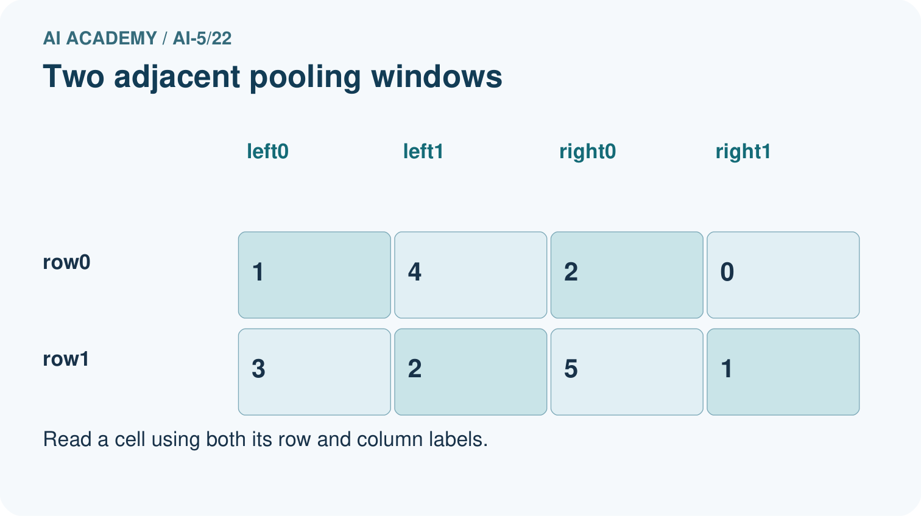
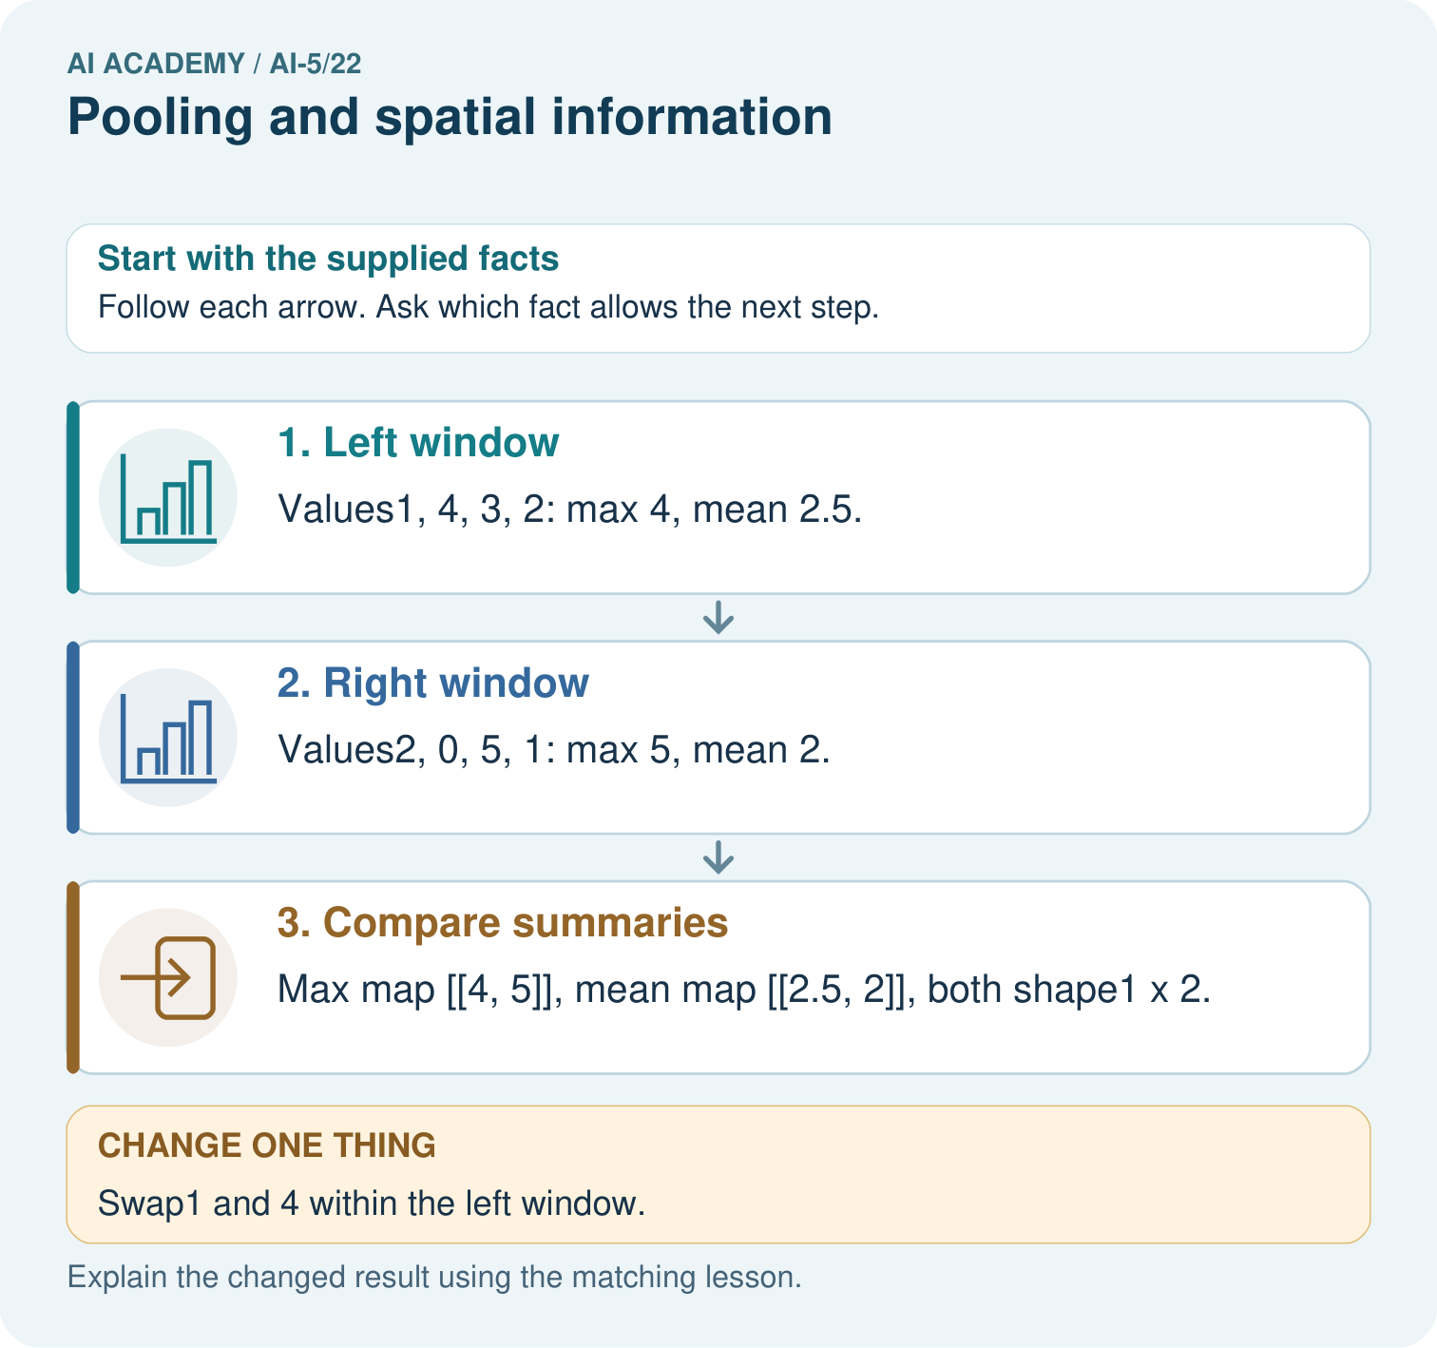
Can the max map reveal where the 4 originally appeared? Point to the relevant step in the picture, then write the changed result and the rule or evidence that supports it.

My picture-based explanation and changed-case prediction
________________________________________________________________
________________________________________________________________
________________________________________________________________
________________________________________________________________
________________________________________________________________
________________________________________________________________
Support used: alone / hint / worked example. This record is practice evidence.
Project connection: For your Image-pattern Network Investigation, save the input, procedure, observed result and limitation of this check. Label this worked example as practice; use a different, previously unreviewed case when checking independent understanding.

13. Project portfolio milestone
Project: Image-pattern Network Investigation
Current milestone: Evaluate and revise. Compare with your starting method, explain errors and record a justified revision.
For your Image-pattern Network Investigation, save the input, procedure, observed result and limitation of this check. Label this worked example as practice; use a different, previously unreviewed case when checking independent understanding.
Evidence to keep | My record
This week’s input and deciding step
Prediction and actual result (or labelled paper trace)
One change since the previous checkpoint and why
One error or limit and the next test

Explain what this week adds to your project. Reuse last week’s record rather than starting again.
________________________________________________________________
________________________________________________________________
________________________________________________________________
________________________________________________________________
________________________________________________________________

14. Supported practice and learning evidence
Use this supported practice once, in the browser or on paper. Keep the reserved independent assessment for a separate first attempt before teacher feedback.
Pool a small map and show the detail it cannot retain.

Practice 1: explain the deciding evidence
Which labelled step matches this detail? Max map [[4, 5]], mean map [[2.5, 2]], both shape1×2.
1. Left window
2. Compare summaries
3. Right window

My selected conclusion, deciding fact and explanation
________________________________________________________________
________________________________________________________________
________________________________________________________________
________________________________________________________________
________________________________________________________________
Hint if needed: Read the steps in the pictorial case. Match the supplied detail to the stage that performs or records it.
After your attempt, compare with the supported explanation: Compare summaries Max map [[4, 5]], mean map [[2.5, 2]], both shape1×2. Pooling compresses each local window into a summary. Maximum keeps its largest value; mean keeps its average. Neither summary records where each value appeared. Swapping values inside one window leaves both summaries unchanged here, so the pooled output cannot reconstruct the original arrangement. The chosen window, stride and boundary policy determine the output shape.

Practice 2: explain the deciding evidence
Changed-case practice: Swap1 and 4 within the left window. Which conclusion is supported by the supplied facts?
1. This one example guarantees correct results for every future input.
2. We can decide the result without examining the changed input or the procedure.
3. Both pooled maps remain unchanged.

My selected conclusion, deciding fact and explanation
________________________________________________________________
________________________________________________________________
________________________________________________________________
________________________________________________________________
________________________________________________________________
Hint if needed: Use the changed condition and the deciding step in the pictorial trace. The answer must say what follows from those facts.
After your attempt, compare with the supported explanation: Both pooled maps remain unchanged. Max and mean ignore the positions of values inside the same window.

Repair a missing building block
Review Convolution as a local operation (ai-5/21). Goal: Compute a local weighted sum at each valid image position. Short practice: Why is flipping the kernel an implementation change here? Point to the relevant step in the picture, then write the changed result and the rule or evidence that supports it.. Return to this week and explain what you changed.
Review Learned representations (ai-5/19). Goal: Trace an input through a hidden representation and a decision rule. Short practice: Why can no deterministic head using only the sum classify both correctly? Point to the relevant step in the picture, then write the changed result and the rule or evidence that supports it.. Return to this week and explain what you changed.
Review Regularisation and early stopping (ai-5/16). Goal: Separate a weight penalty from prediction error. Short practice: Why should the penalty value not be reported as validation error? Point to the relevant step in the picture, then write the changed result and the rule or evidence that supports it.. Return to this week and explain what you changed.

Predict, run and debug
The browser lab lets you edit the supported Python examples already included in this lesson. Predict first, run, inspect the actual output or error, change one input, then run again. Keep code, predictions, actual results and a reasoned revision together. On paper, label your result as a trace rather than an execution.

Keep your completed work
Use Download completed work in the hosted lesson to export your answers, reflections, practice feedback and code-run evidence. Open the HTML copy to read or print it. Drafts stay in this browser when storage is available; clear drafts on a shared device.

What I repaired, the evidence I kept and the next test
________________________________________________________________
________________________________________________________________
________________________________________________________________
________________________________________________________________
________________________________________________________________

