AI ACADEMY · WORKBOOK · ai-5/23

Training a small image model
Project: Image-pattern Network Investigation

01. Recall and choose your starting point
Try the recall before opening notes. Then use a different colour or a labelled second line to correct your explanation.

Pooling and spatial information
Without opening the old lesson, explain one key idea from Pooling and spatial information. Give an example and a mistake that the idea helps you avoid.

My remembered idea, example and correction
________________________________________________________________
________________________________________________________________
________________________________________________________________

Image tensors and channels
Without opening the old lesson, explain one key idea from Image tensors and channels. Give an example and a mistake that the idea helps you avoid.

My remembered idea, example and correction
________________________________________________________________
________________________________________________________________
________________________________________________________________

Initialisation and reproducibility
Without opening the old lesson, explain one key idea from Initialisation and reproducibility. Give an example and a mistake that the idea helps you avoid.

My remembered idea, example and correction
________________________________________________________________
________________________________________________________________
________________________________________________________________

02. Practise with fading help
Use W2: Check both updates for Training a small image model. Record the answer once; the lesson and workbook refer to the same attempt.
Given inputs | Procedure I chose | Middle steps | Result and check

The step I completed without help, and the hint I needed
________________________________________________________________
________________________________________________________________
________________________________________________________________

03. Individual reasoning check
Use the worked case for Training a small image model. Proposed explanation: “All parameters in a trained model must have been learned”. Decide whether this explanation is supported. Point to the step or supplied fact that decides; explain your repair if needed.

My explanation before partner discussion
________________________________________________________________
________________________________________________________________
________________________________________________________________
________________________________________________________________

04. Independent transfer case

Independent case: Choose a checkpoint independently
A separate model scores bd. Its training examples have d = 1 and -1 with signed targets 1 and -1. Start b = 0; gradient is 2(b - 1), rate 0.25 and budget two updates. Validation differences are 2 and -2 with targets 1 and -1. Calculate all three weights and their validation MSEs, then select by lowest validation MSE.

My independent explanation, trace and limits
________________________________________________________________
________________________________________________________________
________________________________________________________________
________________________________________________________________
________________________________________________________________
________________________________________________________________
________________________________________________________________
Attempt this case before feedback. Record any help. Earlier examples below are further practice; a case already practised with feedback cannot establish fresh transfer.

05. W1 Trace features and a prediction
For Train B, compute d, h1, h2 and the score at a = 0.45. Give the class prediction and squared error against its signed target.

My reasoning and evidence
________________________________________________________________
________________________________________________________________
________________________________________________________________
________________________________________________________________
________________________________________________________________
________________________________________________________________

06. W2 Check both updates
Starting at a = 0, use gradient 5a - 3 and rate 0.1 for two updates. Give each gradient, new weight and training MSE.

My reasoning and evidence
________________________________________________________________
________________________________________________________________
________________________________________________________________
________________________________________________________________
________________________________________________________________
________________________________________________________________

07. W3 Apply the selection rule
Select among the three saved lesson checkpoints using validation MSE, with earliest update breaking a tie. Is selecting by training accuracy the same declared procedure?

My reasoning and evidence
________________________________________________________________
________________________________________________________________
________________________________________________________________
________________________________________________________________
________________________________________________________________
________________________________________________________________

08. W4 Choose a checkpoint independently
A separate model scores bd. Its training examples have d = 1 and -1 with signed targets 1 and -1. Start b = 0; gradient is 2(b - 1), rate 0.25 and budget two updates. Validation differences are 2 and -2 with targets 1 and -1. Calculate all three weights and their validation MSEs, then select by lowest validation MSE.

My reasoning and evidence
________________________________________________________________
________________________________________________________________
________________________________________________________________
________________________________________________________________
________________________________________________________________
________________________________________________________________
________________________________________________________________
________________________________________________________________

09. W5 Audit a final evaluation
After inspecting the final cases, a team changes the decision threshold and reports the best result as an unseen test score. Explain the problem and list two things the original report should preserve.

My reasoning and evidence
________________________________________________________________
________________________________________________________________
________________________________________________________________
________________________________________________________________
________________________________________________________________
________________________________________________________________

10. Project checkpoint and reflection
Add a labelled training a small image model evidence sheet to Image-pattern Network Investigation. Show how you can trace a complete image model with fixed features and one trained weight. Use the supplied fictional case and keep its inputs, intermediate steps, calculation or prediction, and limitation. Connect this record to last week’s record; a matching answer without a trace is insufficient.

My project change, supporting evidence and remaining limit
________________________________________________________________
________________________________________________________________
________________________________________________________________
________________________________________________________________
________________________________________________________________
________________________________________________________________

11. Feedback, return check and learning record
Evidence | My record
Worked alone / hint / model
First step I repaired and why
New case checked later; date and result
What I can now explain without notes
One remaining question
Revisit this idea with your teacher after a delay. Familiarity is different from explaining and using it on a changed case.

12. Pictorial case practice: Training a small image model
Train one tiny image score with a fixed budget and a separately reserved check.
Toy brightness difference d=left−right; score=a×d. Training pair d=2, target 2; start a=0; squared loss; learning rate 1/16; two updates.
All inputs and outcomes in this worked example are invented classroom data; no real model run is claimed.
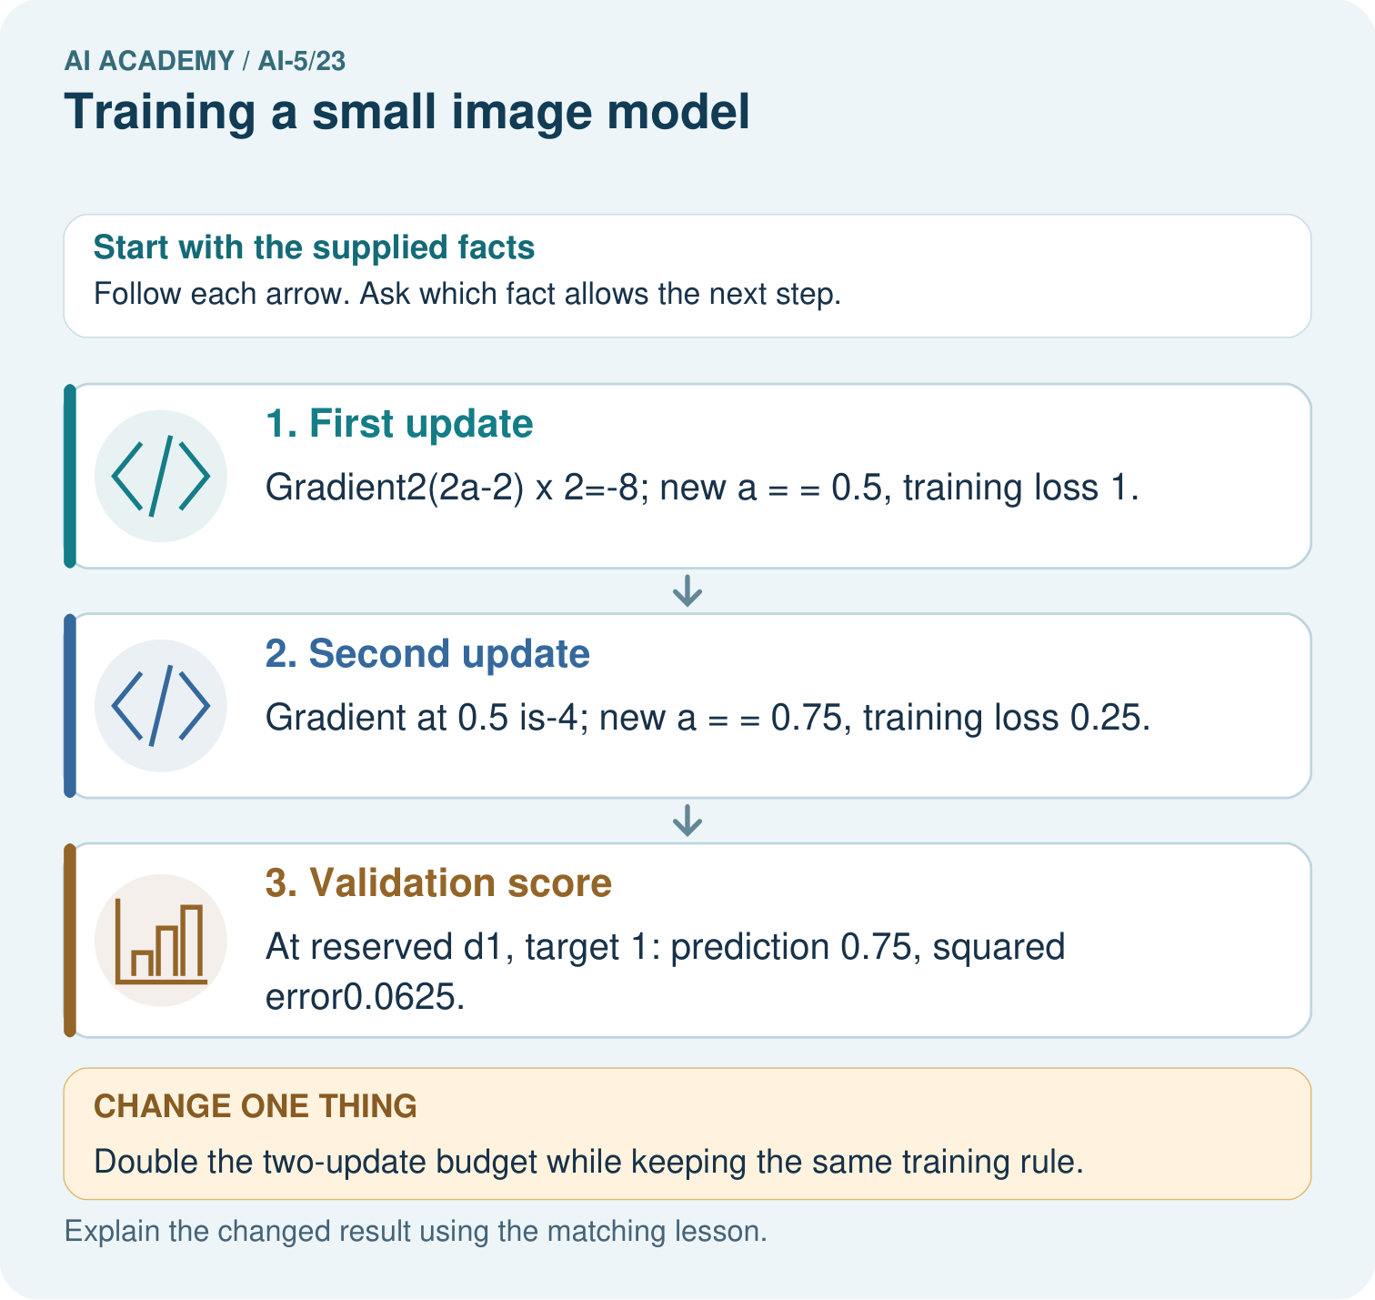
Does lower training loss alone establish that four updates generalise better? Point to the relevant step in the picture, then write the changed result and the rule or evidence that supports it.

My picture-based explanation and changed-case prediction
________________________________________________________________
________________________________________________________________
________________________________________________________________
________________________________________________________________
________________________________________________________________
________________________________________________________________
Support used: alone / hint / worked example. This record is practice evidence.
Project connection: For your Image-pattern Network Investigation, save the input, procedure, observed result and limitation of this check. Label this worked example as practice; use a different, previously unreviewed case when checking independent understanding.

13. Project portfolio milestone
Project: Image-pattern Network Investigation
Current milestone: Evaluate and revise. Compare with your starting method, explain errors and record a justified revision.
For your Image-pattern Network Investigation, save the input, procedure, observed result and limitation of this check. Label this worked example as practice; use a different, previously unreviewed case when checking independent understanding.
Evidence to keep | My record
This week’s input and deciding step
Prediction and actual result (or labelled paper trace)
One change since the previous checkpoint and why
One error or limit and the next test

Explain what this week adds to your project. Reuse last week’s record rather than starting again.
________________________________________________________________
________________________________________________________________
________________________________________________________________
________________________________________________________________
________________________________________________________________

14. Supported practice and learning evidence
Use this supported practice once, in the browser or on paper. Keep the reserved independent assessment for a separate first attempt before teacher feedback.
Train one tiny image score with a fixed budget and a separately reserved check.

Practice 1: explain the deciding evidence
Which labelled step matches this detail? At reserved d1, target 1: prediction 0.75, squared error0.0625.
1. Validation score
2. First update
3. Second update

My selected conclusion, deciding fact and explanation
________________________________________________________________
________________________________________________________________
________________________________________________________________
________________________________________________________________
________________________________________________________________
Hint if needed: Read the steps in the pictorial case. Match the supplied detail to the stage that performs or records it.
After your attempt, compare with the supported explanation: Validation score At reserved d1, target 1: prediction 0.75, squared error0.0625. The image feature is a brightness difference, and training adjusts one output weight multiplying it. Each gradient is computed using the current prediction before the next update. In this example, the rate halves the distance to the training optimum each time. More updates reduce this training loss, but choosing a budget still requires separate validation evidence.

Practice 2: explain the deciding evidence
Changed-case practice: Double the two-update budget while keeping the same training rule. Which conclusion is supported by the supplied facts?
1. We can decide the result without examining the changed input or the procedure.
2. This one example guarantees correct results for every future input.
3. Next a values 0.875 and 0.9375; training loss falls to 0.015625.

My selected conclusion, deciding fact and explanation
________________________________________________________________
________________________________________________________________
________________________________________________________________
________________________________________________________________
________________________________________________________________
Hint if needed: Use the changed condition and the deciding step in the pictorial trace. The answer must say what follows from those facts.
After your attempt, compare with the supported explanation: Next a values 0.875 and 0.9375; training loss falls to 0.015625. Each update halves the distance to the training optimum1 in this toy system.

Repair a missing building block
Review Pooling and spatial information (ai-5/22). Goal: Compute max and mean pooling under an explicit window rule. Short practice: Can the max map reveal where the 4 originally appeared? Point to the relevant step in the picture, then write the changed result and the rule or evidence that supports it.. Return to this week and explain what you changed.
Review Image tensors and channels (ai-5/20). Goal: Read a pixel using declared row column and channel axes. Short practice: Where is the bottom green pixel in the first batched image? Point to the relevant step in the picture, then write the changed result and the rule or evidence that supports it.. Return to this week and explain what you changed.
Review Initialisation and reproducibility (ai-5/17). Goal: Trace how starting values affect a fixed training budget. Short practice: Does the matching final loss mean the parameter values are equal? Point to the relevant step in the picture, then write the changed result and the rule or evidence that supports it.. Return to this week and explain what you changed.

Predict, run and debug
The browser lab lets you edit the supported Python examples already included in this lesson. Predict first, run, inspect the actual output or error, change one input, then run again. Keep code, predictions, actual results and a reasoned revision together. On paper, label your result as a trace rather than an execution.

Keep your completed work
Use Download completed work in the hosted lesson to export your answers, reflections, practice feedback and code-run evidence. Open the HTML copy to read or print it. Drafts stay in this browser when storage is available; clear drafts on a shared device.

What I repaired, the evidence I kept and the next test
________________________________________________________________
________________________________________________________________
________________________________________________________________
________________________________________________________________
________________________________________________________________

