AI ACADEMY · WORKBOOK · ai-5/30

Dataset shift in neural models
Project: Image-pattern Network Investigation

01. Recall and choose your starting point
Try the recall before opening notes. Then use a different colour or a labelled second line to correct your explanation.

Uncertainty and failure analysis
Without opening the old lesson, explain one key idea from Uncertainty and failure analysis. Give an example and a mistake that the idea helps you avoid.

My remembered idea, example and correction
________________________________________________________________
________________________________________________________________
________________________________________________________________

Similarity and normalisation
Without opening the old lesson, explain one key idea from Similarity and normalisation. Give an example and a mistake that the idea helps you avoid.

My remembered idea, example and correction
________________________________________________________________
________________________________________________________________
________________________________________________________________

Augmentation and leakage
Without opening the old lesson, explain one key idea from Augmentation and leakage. Give an example and a mistake that the idea helps you avoid.

My remembered idea, example and correction
________________________________________________________________
________________________________________________________________
________________________________________________________________

02. Practise with fading help
Use W2: Use the right denominator for Dataset shift in neural models. Record the answer once; the lesson and workbook refer to the same attempt.
Given inputs | Procedure I chose | Middle steps | Result and check

The step I completed without help, and the hint I needed
________________________________________________________________
________________________________________________________________
________________________________________________________________

03. Individual reasoning check
Use the worked case for Dataset shift in neural models. Proposed explanation: “Average the percentages regardless of group sizes”. Decide whether this explanation is supported. Point to the step or supplied fact that decides; explain your repair if needed.

My explanation before partner discussion
________________________________________________________________
________________________________________________________________
________________________________________________________________
________________________________________________________________

04. Independent transfer case

Independent case: Analyse a new mixture independently
A separate audit has development groups P: 60 cases, 48 correct and Q: 40 cases, 20 correct. New-use groups are P: 20 cases, 16 correct and Q: 80 cases, 40 correct. Compute each group rate, both overall accuracies, and the percentage-point change. Under the same group rates, what accuracy would equal-sized P and Q groups have?

My independent explanation, trace and limits
________________________________________________________________
________________________________________________________________
________________________________________________________________
________________________________________________________________
________________________________________________________________
________________________________________________________________
________________________________________________________________
Attempt this case before feedback. Record any help. Earlier examples below are further practice; a case already practised with feedback cannot establish fresh transfer.

05. W1 Audit the two cohorts
From the table, calculate clear and dim accuracy in each cohort and the clear/dim proportions. Which observed quantities change, and which remain the same?

My reasoning and evidence
________________________________________________________________
________________________________________________________________
________________________________________________________________
________________________________________________________________
________________________________________________________________
________________________________________________________________

06. W2 Use the right denominator
Calculate overall correct counts, accuracy and errors in both cohorts, plus the percentage-point drop. Explain why averaging 90 percent and 50 percent without weights gives the wrong overall result here.

My reasoning and evidence
________________________________________________________________
________________________________________________________________
________________________________________________________________
________________________________________________________________
________________________________________________________________
________________________________________________________________

07. W3 Separate an alert from an outcome
New-use monitoring shows more dim images but reference labels have not arrived. What can you report now, what can you not calculate, and what checks should precede blaming the neural network?

My reasoning and evidence
________________________________________________________________
________________________________________________________________
________________________________________________________________
________________________________________________________________
________________________________________________________________
________________________________________________________________

08. W4 Analyse a new mixture independently
A separate audit has development groups P: 60 cases, 48 correct and Q: 40 cases, 20 correct. New-use groups are P: 20 cases, 16 correct and Q: 80 cases, 40 correct. Compute each group rate, both overall accuracies, and the percentage-point change. Under the same group rates, what accuracy would equal-sized P and Q groups have?

My reasoning and evidence
________________________________________________________________
________________________________________________________________
________________________________________________________________
________________________________________________________________
________________________________________________________________
________________________________________________________________
________________________________________________________________
________________________________________________________________

09. W5 Protect the comparison
A team retrains using new-use errors, then evaluates on those same images and their brightened copies. Explain why the score is not independent evidence and propose a comparison that includes the original model.

My reasoning and evidence
________________________________________________________________
________________________________________________________________
________________________________________________________________
________________________________________________________________
________________________________________________________________
________________________________________________________________

10. Project checkpoint and reflection
Add a labelled dataset shift in neural models evidence sheet to Image-pattern Network Investigation. Show how you can explain how a changed input mix can change overall accuracy. Use the supplied fictional case and keep its inputs, intermediate steps, calculation or prediction, and limitation. Connect this record to last week’s record; a matching answer without a trace is insufficient.

My project change, supporting evidence and remaining limit
________________________________________________________________
________________________________________________________________
________________________________________________________________
________________________________________________________________
________________________________________________________________
________________________________________________________________

11. Feedback, return check and learning record
Evidence | My record
Worked alone / hint / model
First step I repaired and why
New case checked later; date and result
What I can now explain without notes
One remaining question
Revisit this idea with your teacher after a delay. Familiarity is different from explaining and using it on a changed case.

12. Pictorial case practice: Dataset shift in neural models
Separate within-setting performance from changing setting proportions.
Toy old-use mix: bright 40 cases32 correct; dim 10 cases5 correct. New-use mix: bright 10 cases8 correct; dim 40 cases20 correct.
All inputs and outcomes in this worked example are invented classroom data; no real model run is claimed.
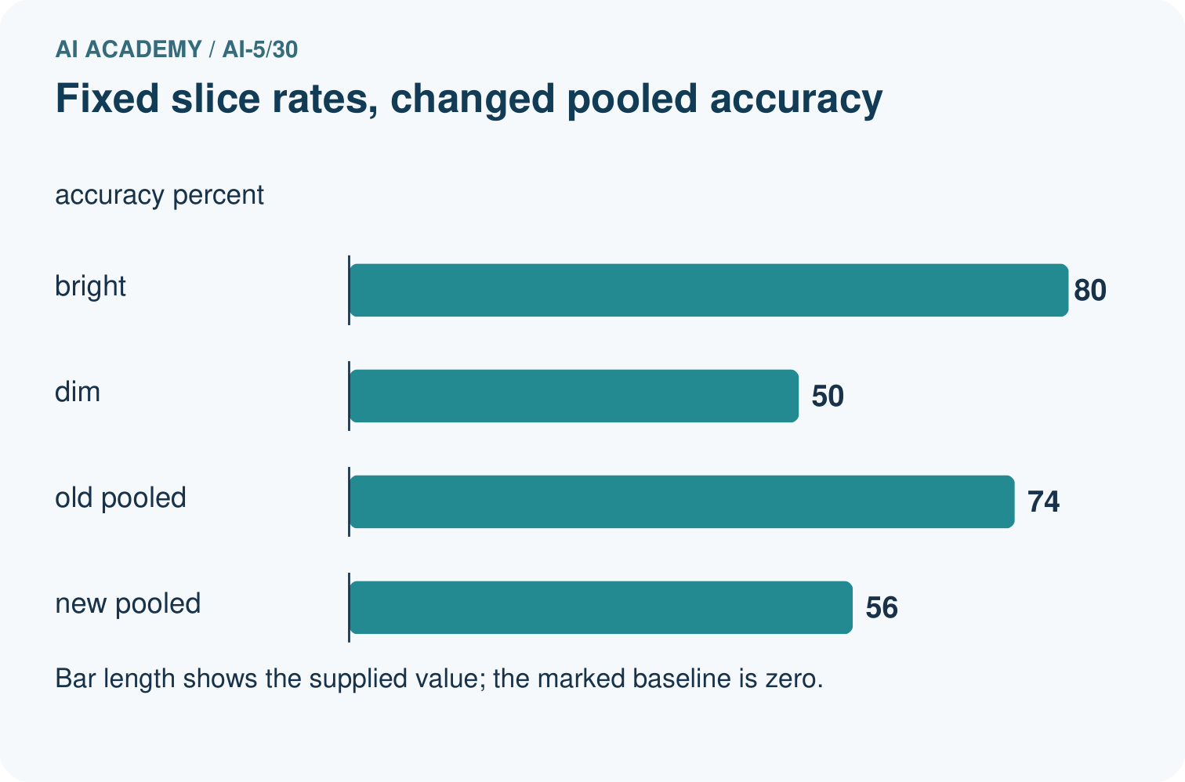
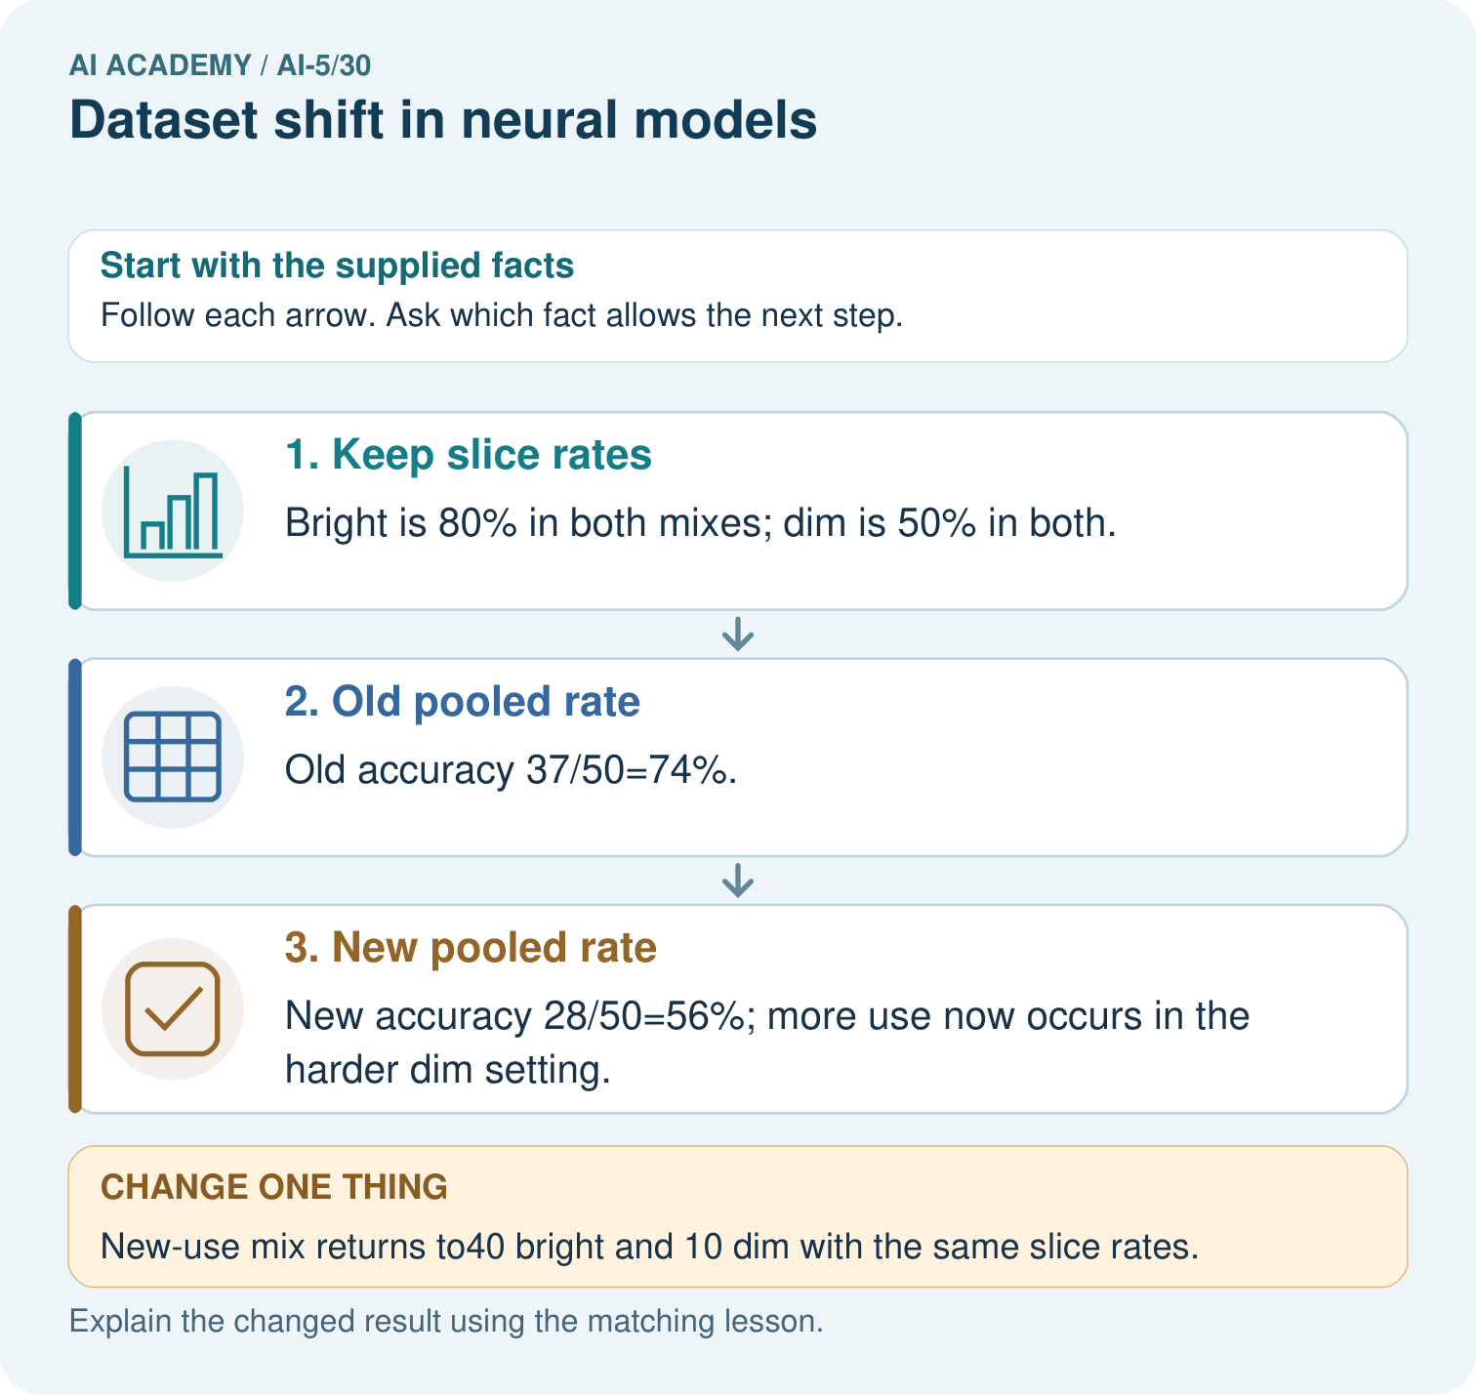
Did the supplied model’s dim-light accuracy deteriorate? Point to the relevant step in the picture, then write the changed result and the rule or evidence that supports it.

My picture-based explanation and changed-case prediction
________________________________________________________________
________________________________________________________________
________________________________________________________________
________________________________________________________________
________________________________________________________________
________________________________________________________________
Support used: alone / hint / worked example. This record is practice evidence.
Project connection: For your Image-pattern Network Investigation, save the input, procedure, observed result and limitation of this check. Label this worked example as practice; use a different, previously unreviewed case when checking independent understanding.

13. Project portfolio milestone
Project: Image-pattern Network Investigation
Current milestone: Prepare the demonstration. Gather reproducible instructions, evidence, access checks and remaining limitations.
For your Image-pattern Network Investigation, save the input, procedure, observed result and limitation of this check. Label this worked example as practice; use a different, previously unreviewed case when checking independent understanding.
Evidence to keep | My record
This week’s input and deciding step
Prediction and actual result (or labelled paper trace)
One change since the previous checkpoint and why
One error or limit and the next test

Explain what this week adds to your project. Reuse last week’s record rather than starting again.
________________________________________________________________
________________________________________________________________
________________________________________________________________
________________________________________________________________
________________________________________________________________

14. Supported practice and learning evidence
Use this supported practice once, in the browser or on paper. Keep the reserved independent assessment for a separate first attempt before teacher feedback.
Separate within-setting performance from changing setting proportions.

Practice 1: explain the deciding evidence
Which labelled step matches this detail? New accuracy 28/50=56%; more use now occurs in the harder dim setting.
1. New pooled rate
2. Keep slice rates
3. Old pooled rate

My selected conclusion, deciding fact and explanation
________________________________________________________________
________________________________________________________________
________________________________________________________________
________________________________________________________________
________________________________________________________________
Hint if needed: Read the steps in the pictorial case. Match the supplied detail to the stage that performs or records it.
After your attempt, compare with the supported explanation: New pooled rate New accuracy 28/50=56%; more use now occurs in the harder dim setting. A pooled rate depends on how often each condition appears as well as performance within that condition. Bright and dim accuracy stay fixed in this example. The new use contains more dim cases, so its pooled accuracy falls. Report both group counts and group rates before concluding that the network itself deteriorated.

Practice 2: explain the deciding evidence
Changed-case practice: New-use mix returns to40 bright and 10 dim with the same slice rates. Which conclusion is supported by the supplied facts?
1. This one example guarantees correct results for every future input.
2. Pooled accuracy returns to74%.
3. We can decide the result without examining the changed input or the procedure.

My selected conclusion, deciding fact and explanation
________________________________________________________________
________________________________________________________________
________________________________________________________________
________________________________________________________________
________________________________________________________________
Hint if needed: Use the changed condition and the deciding step in the pictorial trace. The answer must say what follows from those facts.
After your attempt, compare with the supported explanation: Pooled accuracy returns to74%. The mixture weights change, while each slice’s conditional performance stays fixed.

Repair a missing building block
Review Uncertainty and failure analysis (ai-5/29). Goal: Distinguish a predicted class, confidence score and observed correctness. Short practice: What is C’s positive-class probability and chosen-label confidence? Point to the relevant step in the picture, then write the changed result and the rule or evidence that supports it.. Return to this week and explain what you changed.
Review Similarity and normalisation (ai-5/27). Goal: Calculate vector length and normalise a nonzero vector. Short practice: Why do the original two metrics select different winners? Point to the relevant step in the picture, then write the changed result and the rule or evidence that supports it.. Return to this week and explain what you changed.
Review Augmentation and leakage (ai-5/24). Goal: Check whether a transformation preserves the task label. Short practice: How many independent source groups are in the final test? Point to the relevant step in the picture, then write the changed result and the rule or evidence that supports it.. Return to this week and explain what you changed.

Predict, run and debug
The browser lab lets you edit the supported Python examples already included in this lesson. Predict first, run, inspect the actual output or error, change one input, then run again. Keep code, predictions, actual results and a reasoned revision together. On paper, label your result as a trace rather than an execution.

Keep your completed work
Use Download completed work in the hosted lesson to export your answers, reflections, practice feedback and code-run evidence. Open the HTML copy to read or print it. Drafts stay in this browser when storage is available; clear drafts on a shared device.

What I repaired, the evidence I kept and the next test
________________________________________________________________
________________________________________________________________
________________________________________________________________
________________________________________________________________
________________________________________________________________

