AI ACADEMY · WORKBOOK · ai-5/34

Capstone controlled experiments
Project: Image-pattern Network Investigation

01. Recall and choose your starting point
Try the recall before opening notes. Then use a different colour or a labelled second line to correct your explanation.

Capstone hypothesis and baseline
Without opening the old lesson, explain one key idea from Capstone hypothesis and baseline. Give an example and a mistake that the idea helps you avoid.

My remembered idea, example and correction
________________________________________________________________
________________________________________________________________
________________________________________________________________

Efficiency and resource measurement
Without opening the old lesson, explain one key idea from Efficiency and resource measurement. Give an example and a mistake that the idea helps you avoid.

My remembered idea, example and correction
________________________________________________________________
________________________________________________________________
________________________________________________________________

Transfer learning
Without opening the old lesson, explain one key idea from Transfer learning. Give an example and a mistake that the idea helps you avoid.

My remembered idea, example and correction
________________________________________________________________
________________________________________________________________
________________________________________________________________

02. Practise with fading help
Use W2: Trace both runs for Capstone controlled experiments. Record the answer once; the lesson and workbook refer to the same attempt.
Given inputs | Procedure I chose | Middle steps | Result and check

The step I completed without help, and the hint I needed
________________________________________________________________
________________________________________________________________
________________________________________________________________

03. Individual reasoning check
Use the worked case for Capstone controlled experiments. Proposed explanation: “More runs mean more validation examples”. Decide whether this explanation is supported. Point to the step or supplied fact that decides; explain your repair if needed.

My explanation before partner discussion
________________________________________________________________
________________________________________________________________
________________________________________________________________
________________________________________________________________

04. Independent transfer case

Independent case: Run a new comparison independently
For training (1,3),(2,6) and validation (3,9),(4,12), start a = 1. Compare rates 0.1 and 0.2 for two updates. Gradient is 5*(a-3). Compute final weights and validation MSE, then select lower MSE; ties go to 0.1.

My independent explanation, trace and limits
________________________________________________________________
________________________________________________________________
________________________________________________________________
________________________________________________________________
________________________________________________________________
________________________________________________________________
________________________________________________________________
Attempt this case before feedback. Record any help. Earlier examples below are further practice; a case already practised with feedback cannot establish fresh transfer.

05. W1 Name the controls
List six settings held fixed and the single intended changed factor.

My reasoning and evidence
________________________________________________________________
________________________________________________________________
________________________________________________________________
________________________________________________________________
________________________________________________________________
________________________________________________________________

06. W2 Trace both runs
Compute both updates for rates 0.1 and 0.2 using gradient 5*(a-2).

My reasoning and evidence
________________________________________________________________
________________________________________________________________
________________________________________________________________
________________________________________________________________
________________________________________________________________
________________________________________________________________

07. W3 Select without extra evidence
Recompute validation MSE for the final weights and apply the written selection rule. How many distinct validation rows were used?

My reasoning and evidence
________________________________________________________________
________________________________________________________________
________________________________________________________________
________________________________________________________________
________________________________________________________________
________________________________________________________________

08. W4 Run a new comparison independently
For training (1,3),(2,6) and validation (3,9),(4,12), start a = 1. Compare rates 0.1 and 0.2 for two updates. Gradient is 5*(a-3). Compute final weights and validation MSE, then select lower MSE; ties go to 0.1.

My reasoning and evidence
________________________________________________________________
________________________________________________________________
________________________________________________________________
________________________________________________________________
________________________________________________________________
________________________________________________________________
________________________________________________________________
________________________________________________________________

09. W5 Audit a mixed comparison
Run A uses rate 0.1 for two updates; run B uses rate 0.2 for six updates and different training rows. Can the difference be attributed to rate alone? Propose a repair.

My reasoning and evidence
________________________________________________________________
________________________________________________________________
________________________________________________________________
________________________________________________________________
________________________________________________________________
________________________________________________________________

10. Project checkpoint and reflection
For Image-pattern Network Investigation, use this week’s independent task as a rehearsal for the final evidence pack: For training (1,3),(2,6) and validation (3,9),(4,12), start a = 1. Compare rates 0.1 and 0.2 for two updates. Gradient is 5*(a-3). Compute final weights and validation MSE, then select lower MSE; ties go to 0.1. Keep actual observations separate from expected results, preserve failures, compare a baseline and explain the limits.

My project change, supporting evidence and remaining limit
________________________________________________________________
________________________________________________________________
________________________________________________________________
________________________________________________________________
________________________________________________________________
________________________________________________________________

11. Feedback, return check and learning record
Evidence | My record
Worked alone / hint / model
First step I repaired and why
New case checked later; date and result
What I can now explain without notes
One remaining question
Revisit this idea with your teacher after a delay. Familiarity is different from explaining and using it on a changed case.

12. Pictorial case practice: Capstone controlled experiments
One controlled network change. The capstone compares two fixed networks on the same six labelled toy patterns. Only one feature connection is added.
A scores [1,1,0,1,0,1]; B scores [1,1,1,1,0,1]. Settings, labels and scoring remain fixed. Binary entries mean 1=correct and 0=incorrect.
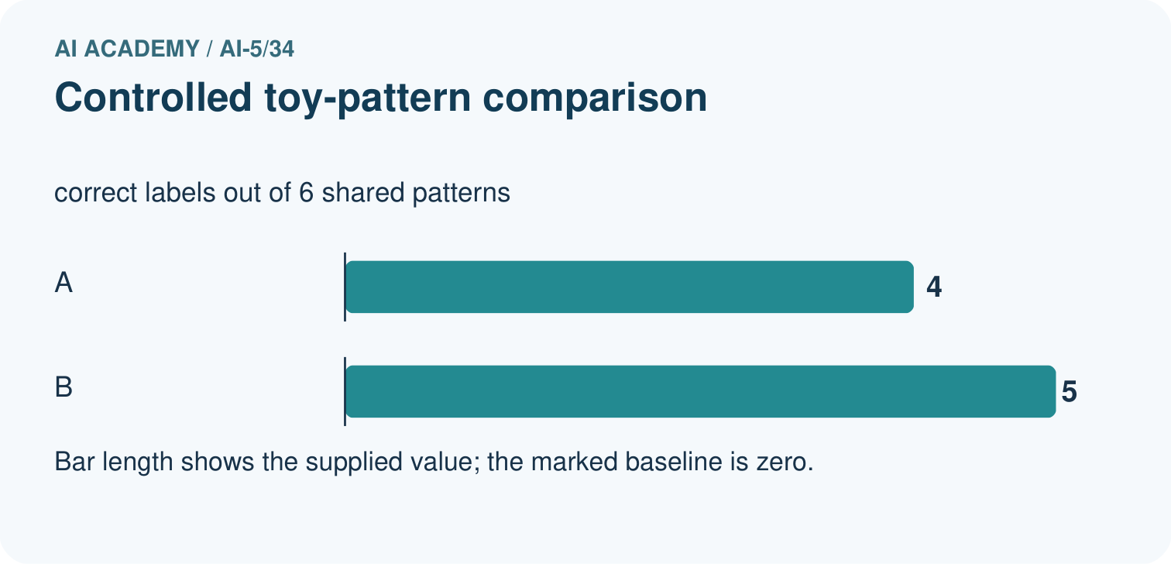
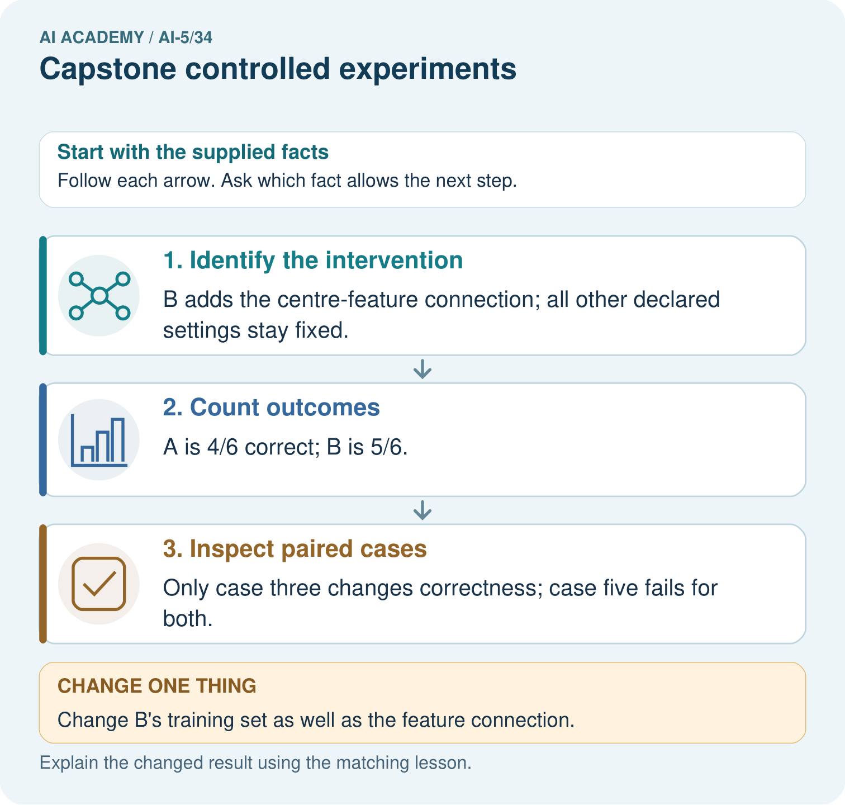
Compute the two correct counts and identify the changed case. Why would changing B’s training data weaken the conclusion about its added connection?

My picture-based explanation and changed-case prediction
________________________________________________________________
________________________________________________________________
________________________________________________________________
________________________________________________________________
________________________________________________________________
________________________________________________________________
Support used: alone / hint / worked example. This record is practice evidence.
Project connection: For the Image-pattern Network Investigation, save the labelled trace and the changed-case explanation beside the experiment record. State exactly what this example supports before linking it to the wider capstone claim.

13. Project portfolio milestone
Project: Image-pattern Network Investigation
Current milestone: Present and defend. Demonstrate the system, explain one failure and justify the next improvement with evidence.
For the Image-pattern Network Investigation, save the labelled trace and the changed-case explanation beside the experiment record. State exactly what this example supports before linking it to the wider capstone claim.
Evidence to keep | My record
This week’s input and deciding step
Prediction and actual result (or labelled paper trace)
One change since the previous checkpoint and why
One error or limit and the next test

Explain what this week adds to your project. Reuse last week’s record rather than starting again.
________________________________________________________________
________________________________________________________________
________________________________________________________________
________________________________________________________________
________________________________________________________________

14. Supported practice and learning evidence
Use this supported practice once, in the browser or on paper. Keep the reserved independent assessment for a separate first attempt before teacher feedback.
One controlled network change. The capstone compares two fixed networks on the same six labelled toy patterns. Only one feature connection is added.

Practice 1: explain the deciding evidence
Which labelled step matches this detail? Only case three changes correctness; case five fails for both.
1. Inspect paired cases
2. Identify the intervention
3. Count outcomes

My selected conclusion, deciding fact and explanation
________________________________________________________________
________________________________________________________________
________________________________________________________________
________________________________________________________________
________________________________________________________________
Hint if needed: Read the steps in the pictorial case. Match the supplied detail to the stage that performs or records it.
After your attempt, compare with the supported explanation: Inspect paired cases Only case three changes correctness; case five fails for both. Controlled experiments vary the specified component while retaining comparable cases. Pairing the outcomes by pattern shows where the score difference comes from instead of hiding it in an overall average.

Practice 2: explain the deciding evidence
Changed-case practice: Change B’s training set as well as the feature connection. Which conclusion is supported by the supplied facts?
1. This one example guarantees correct results for every future input.
2. We can decide the result without examining the changed input or the procedure.
3. The experiment no longer isolates the connection change.

My selected conclusion, deciding fact and explanation
________________________________________________________________
________________________________________________________________
________________________________________________________________
________________________________________________________________
________________________________________________________________
Hint if needed: Use the changed condition and the deciding step in the pictorial trace. The answer must say what follows from those facts.
After your attempt, compare with the supported explanation: The experiment no longer isolates the connection change. A training-data difference supplies an alternative explanation for the observed result.

Repair a missing building block
Review Capstone hypothesis and baseline (ai-5/33). Goal: Write a testable capstone hypothesis and a credible baseline. Short practice: Name the intended change, the baseline and the measured outcome. Why must both versions avoid training on the eight reserved labels?. Return to this week and explain what you changed.
Review Efficiency and resource measurement (ai-5/31). Goal: Calculate throughput and amortised time per example from repeated timings. Short practice: Why is 10ms/case not necessarily a single-request latency? Point to the relevant step in the picture, then write the changed result and the rule or evidence that supports it.. Return to this week and explain what you changed.
Review Transfer learning (ai-5/28). Goal: Trace a reused feature extractor and a newly fitted output head. Short practice: Which part was trained for the new task? Point to the relevant step in the picture, then write the changed result and the rule or evidence that supports it.. Return to this week and explain what you changed.

Keep your completed work
Use Download completed work in the hosted lesson to export your answers, reflections, practice feedback and code-run evidence. Open the HTML copy to read or print it. Drafts stay in this browser when storage is available; clear drafts on a shared device.

What I repaired, the evidence I kept and the next test
________________________________________________________________
________________________________________________________________
________________________________________________________________
________________________________________________________________
________________________________________________________________

