AI ACADEMY · WORKBOOK · ai-6/16

Timeouts retries and cancellation
Project: Grounded Learning Service

01. Recall and choose your starting point
Try the recall before opening notes. Then use a different colour or a labelled second line to correct your explanation.

Approval gates and idempotency
Without opening the old lesson, explain one key idea from Approval gates and idempotency. Give an example and a mistake that the idea helps you avoid.

My remembered idea, example and correction
________________________________________________________________
________________________________________________________________
________________________________________________________________

State machines for bounded agents
Without opening the old lesson, explain one key idea from State machines for bounded agents. Give an example and a mistake that the idea helps you avoid.

My remembered idea, example and correction
________________________________________________________________
________________________________________________________________
________________________________________________________________

Evaluation pipelines
Without opening the old lesson, explain one key idea from Evaluation pipelines. Give an example and a mistake that the idea helps you avoid.

My remembered idea, example and correction
________________________________________________________________
________________________________________________________________
________________________________________________________________

02. Practise with fading help
Use W2: Trace the worked case for Timeouts retries and cancellation. Record the answer once; the lesson and workbook refer to the same attempt.
Given inputs | Procedure I chose | Middle steps | Result and check

The step I completed without help, and the hint I needed
________________________________________________________________
________________________________________________________________
________________________________________________________________

03. Individual reasoning check
Use the worked case for Timeouts retries and cancellation. Proposed explanation: “The worked result establishes every future case”. Decide whether this explanation is supported. Point to the step or supplied fact that decides; explain your repair if needed.

My explanation before partner discussion
________________________________________________________________
________________________________________________________________
________________________________________________________________
________________________________________________________________

04. Independent transfer case

Independent case: Apply a new case independently
Two attempts, each up to 5 seconds, gap 2. Compute bound and decide whether authentication failure should retry.

My independent explanation, trace and limits
________________________________________________________________
________________________________________________________________
________________________________________________________________
________________________________________________________________
________________________________________________________________
________________________________________________________________
________________________________________________________________
Attempt this case before feedback. Record any help. Earlier examples below are further practice; a case already practised with feedback cannot establish fresh transfer.

05. W1 Explain the mechanism
Explain the weekly mechanism in your own words. Use the worked scenario to name its input, decision rule and output.

My reasoning and evidence
________________________________________________________________
________________________________________________________________
________________________________________________________________
________________________________________________________________
________________________________________________________________
________________________________________________________________

06. W2 Trace the worked case
Three attempts each time out after 4 seconds with gaps 1 and 2. A fourth is proposed. Show the intermediate steps and give the conclusion with its scope.

My reasoning and evidence
________________________________________________________________
________________________________________________________________
________________________________________________________________
________________________________________________________________
________________________________________________________________
________________________________________________________________
________________________________________________________________

07. W3 Audit the limit
A report omits this qualification: A timeout means the caller lacks a timely result, not necessarily that the remote operation did not occur. Explain how omitting it could change a reader's interpretation, and write an accurate replacement.

My reasoning and evidence
________________________________________________________________
________________________________________________________________
________________________________________________________________
________________________________________________________________
________________________________________________________________
________________________________________________________________

08. W4 Apply a new case independently
Two attempts, each up to 5 seconds, gap 2. Compute bound and decide whether authentication failure should retry.

My reasoning and evidence
________________________________________________________________
________________________________________________________________
________________________________________________________________
________________________________________________________________
________________________________________________________________
________________________________________________________________
________________________________________________________________
________________________________________________________________

09. W5 Design a revealing follow-up
For the worked scenario, propose one additional case that could reveal a failure, describe its expected outcome before running it, and explain what would need to remain fixed for a fair comparison. Do not reuse W4 as a new final test after receiving feedback.

My reasoning and evidence
________________________________________________________________
________________________________________________________________
________________________________________________________________
________________________________________________________________
________________________________________________________________
________________________________________________________________
________________________________________________________________

10. Project checkpoint and reflection
Add a labelled timeouts retries and cancellation evidence sheet to Grounded Learning Service. Show how you can explain the mechanism and terminology of timeouts retries and cancellation. Use the supplied fictional case and keep its inputs, intermediate steps, calculation or prediction, and limitation. Connect this record to last week’s record; a matching answer without a trace is insufficient.

My project change, supporting evidence and remaining limit
________________________________________________________________
________________________________________________________________
________________________________________________________________
________________________________________________________________
________________________________________________________________
________________________________________________________________

11. Feedback, return check and learning record
Evidence | My record
Worked alone / hint / model
First step I repaired and why
New case checked later; date and result
What I can now explain without notes
One remaining question
Revisit this idea with your teacher after a delay. Familiarity is different from explaining and using it on a changed case.

12. Pictorial case practice: Timeouts retries and cancellation
Retry within declared limits. A read-only lookup allows two attempts of at most one second each. Cancellation forbids further attempts.
First attempt times out at 1 second. Second succeeds in 0.4 seconds. Ignore overhead. No cancellation occurs.
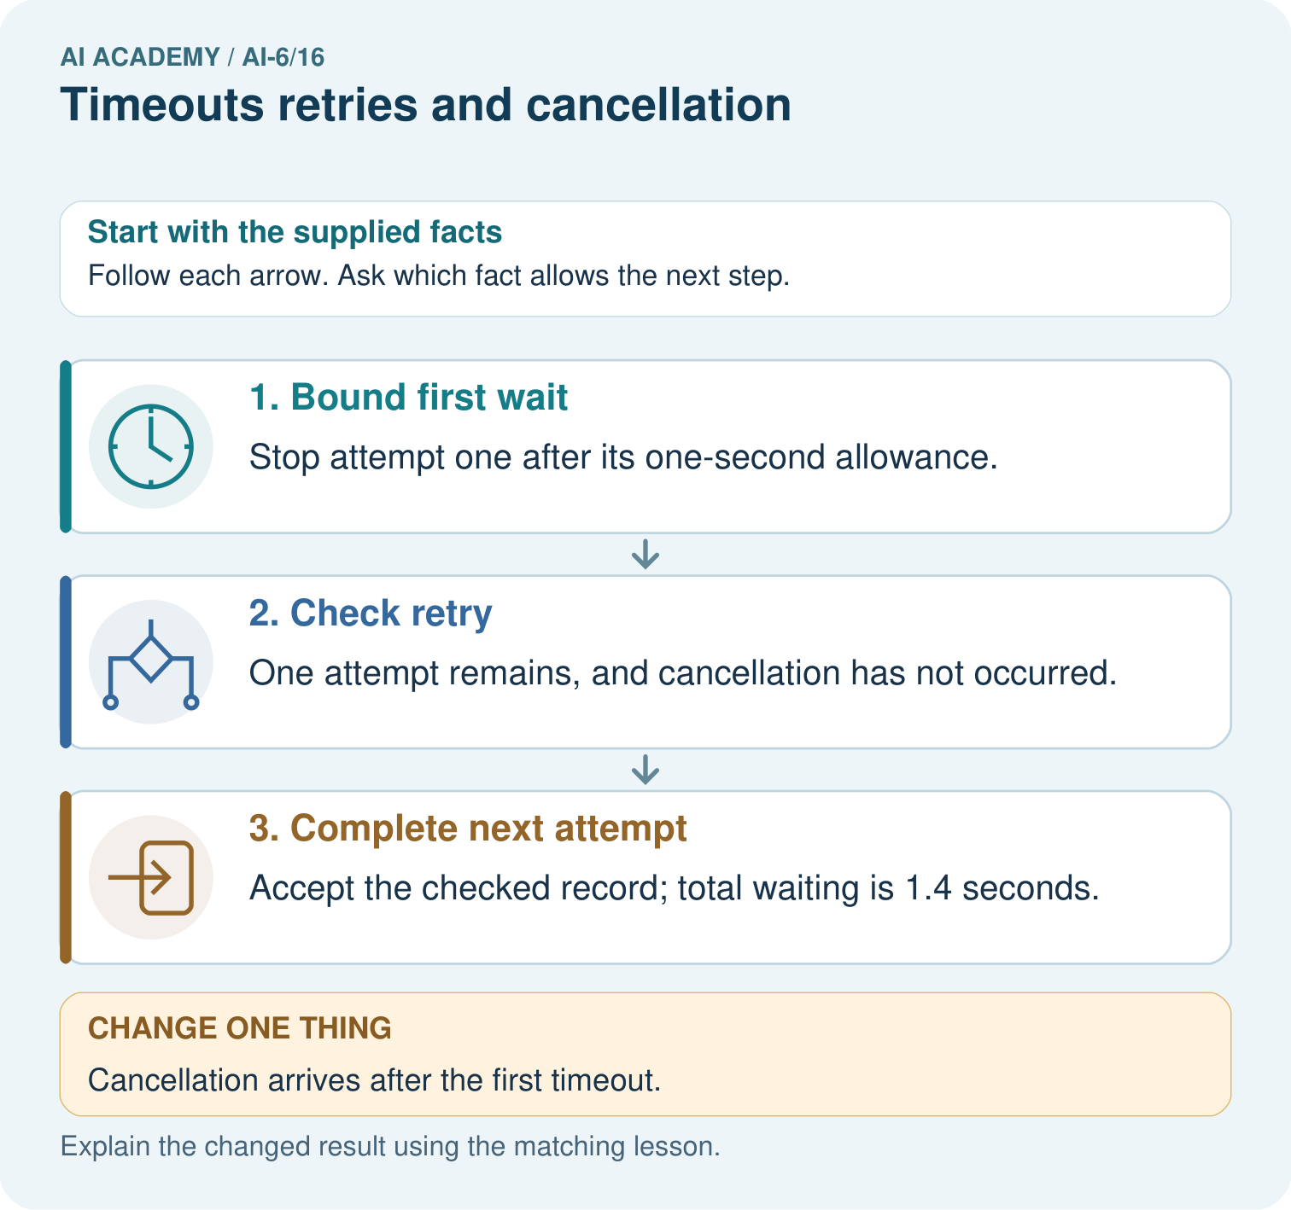
Calculate waiting time for a one-second timeout followed by a 0.4-second success. What changes if cancellation arrives after the first attempt but before the retry?

My picture-based explanation and changed-case prediction
________________________________________________________________
________________________________________________________________
________________________________________________________________
________________________________________________________________
________________________________________________________________
________________________________________________________________
Support used: alone / hint / worked example. This record is practice evidence.
Project connection: For the Grounded Learning Service, retain an annotated trace and the changed-case result. Name the contract or evidence that makes the deciding step valid, so another team can review it.

13. Project portfolio milestone
Project: Grounded Learning Service
Current milestone: Test changed cases. Keep normal, boundary and failure cases; compare expected and observed results.
For the Grounded Learning Service, retain an annotated trace and the changed-case result. Name the contract or evidence that makes the deciding step valid, so another team can review it.
Evidence to keep | My record
This week’s input and deciding step
Prediction and actual result (or labelled paper trace)
One change since the previous checkpoint and why
One error or limit and the next test

Explain what this week adds to your project. Reuse last week’s record rather than starting again.
________________________________________________________________
________________________________________________________________
________________________________________________________________
________________________________________________________________
________________________________________________________________

14. Supported practice and learning evidence
Use this supported practice once, in the browser or on paper. Keep the reserved independent assessment for a separate first attempt before teacher feedback.
Retry within declared limits. A read-only lookup allows two attempts of at most one second each. Cancellation forbids further attempts.

Practice 1: explain the deciding evidence
Which labelled step matches this detail? Accept the checked record; total waiting is 1.4 seconds.
1. Complete next attempt
2. Bound first wait
3. Check retry

My selected conclusion, deciding fact and explanation
________________________________________________________________
________________________________________________________________
________________________________________________________________
________________________________________________________________
________________________________________________________________
Hint if needed: Read the steps in the pictorial case. Match the supplied detail to the stage that performs or records it.
After your attempt, compare with the supported explanation: Complete next attempt Accept the checked record; total waiting is 1.4 seconds. A timeout bounds waiting; a retry tries again; cancellation withdraws the request. They are separate conditions on the next action.

Practice 2: explain the deciding evidence
Changed-case practice: Cancellation arrives after the first timeout. Which conclusion is supported by the supplied facts?
1. We can decide the result without examining the changed input or the procedure.
2. Do not start the second attempt.
3. This one example guarantees correct results for every future input.

My selected conclusion, deciding fact and explanation
________________________________________________________________
________________________________________________________________
________________________________________________________________
________________________________________________________________
________________________________________________________________
Hint if needed: Use the changed condition and the deciding step in the pictorial trace. The answer must say what follows from those facts.
After your attempt, compare with the supported explanation: Do not start the second attempt. Cancellation overrides the unused retry allowance.

Repair a missing building block
Review Approval gates and idempotency (ai-6/15). Goal: Explain the mechanism and terminology of approval gates and idempotency. Short practice: Trace the two deliveries of approved K9. How many reservations should occur, and why can a new K10 for desk 5 not borrow K9’s approval?. Return to this week and explain what you changed.
Review State machines for bounded agents (ai-6/13). Goal: Explain the mechanism and terminology of state machines for bounded agents. Short practice: Trace A and B through the state diagram. Name B’s forbidden transition and explain whether adding checking→querying permits that shortcut.. Return to this week and explain what you changed.
Review Evaluation pipelines (ai-6/10). Goal: Explain the mechanism and terminology of evaluation pipelines. Short practice: Calculate A’s and B’s correct rates on all four cases. Identify their shared failure and explain why removing that case after scoring changes the honesty of the comparison.. Return to this week and explain what you changed.

Predict, run and debug
The browser lab lets you edit the supported Python examples already included in this lesson. Predict first, run, inspect the actual output or error, change one input, then run again. Keep code, predictions, actual results and a reasoned revision together. On paper, label your result as a trace rather than an execution.

Keep your completed work
Use Download completed work in the hosted lesson to export your answers, reflections, practice feedback and code-run evidence. Open the HTML copy to read or print it. Drafts stay in this browser when storage is available; clear drafts on a shared device.

What I repaired, the evidence I kept and the next test
________________________________________________________________
________________________________________________________________
________________________________________________________________
________________________________________________________________
________________________________________________________________

