AI ACADEMY · WORKBOOK · ai-6/27

Human escalation workflows
Project: Grounded Learning Service

01. Recall and choose your starting point
Try the recall before opening notes. Then use a different colour or a labelled second line to correct your explanation.

Incident investigation
Without opening the old lesson, explain one key idea from Incident investigation. Give an example and a mistake that the idea helps you avoid.

My remembered idea, example and correction
________________________________________________________________
________________________________________________________________
________________________________________________________________

Release and rollback
Without opening the old lesson, explain one key idea from Release and rollback. Give an example and a mistake that the idea helps you avoid.

My remembered idea, example and correction
________________________________________________________________
________________________________________________________________
________________________________________________________________

Caching and stale information
Without opening the old lesson, explain one key idea from Caching and stale information. Give an example and a mistake that the idea helps you avoid.

My remembered idea, example and correction
________________________________________________________________
________________________________________________________________
________________________________________________________________

02. Practise with fading help
Use W2: Trace the worked case for Human escalation workflows. Record the answer once; the lesson and workbook refer to the same attempt.
Given inputs | Procedure I chose | Middle steps | Result and check

The step I completed without help, and the hint I needed
________________________________________________________________
________________________________________________________________
________________________________________________________________

03. Individual reasoning check
Use the worked case for Human escalation workflows. Proposed explanation: “The worked result establishes every future case”. Decide whether this explanation is supported. Point to the step or supplied fact that decides; explain your repair if needed.

My explanation before partner discussion
________________________________________________________________
________________________________________________________________
________________________________________________________________
________________________________________________________________

04. Independent transfer case

Independent case: Apply a new case independently
Reviewer deadline is16:00; no reply by16:00. Policy says remain pending, not auto-approve. Decide.

My independent explanation, trace and limits
________________________________________________________________
________________________________________________________________
________________________________________________________________
________________________________________________________________
________________________________________________________________
________________________________________________________________
________________________________________________________________
Attempt this case before feedback. Record any help. Earlier examples below are further practice; a case already practised with feedback cannot establish fresh transfer.

05. W1 Explain the mechanism
Explain the weekly mechanism in your own words. Use the worked scenario to name its input, decision rule and output.

My reasoning and evidence
________________________________________________________________
________________________________________________________________
________________________________________________________________
________________________________________________________________
________________________________________________________________
________________________________________________________________

06. W2 Trace the worked case
Conflict is detected, but no reviewer is assigned and the system silently books the first room. Show the intermediate steps and give the conclusion with its scope.

My reasoning and evidence
________________________________________________________________
________________________________________________________________
________________________________________________________________
________________________________________________________________
________________________________________________________________
________________________________________________________________
________________________________________________________________

07. W3 Audit the limit
A report omits this qualification: Escalation without a responsible actor and declared fallback cannot guarantee resolution. Explain how omitting it could change a reader's interpretation, and write an accurate replacement.

My reasoning and evidence
________________________________________________________________
________________________________________________________________
________________________________________________________________
________________________________________________________________
________________________________________________________________
________________________________________________________________

08. W4 Apply a new case independently
Reviewer deadline is16:00; no reply by16:00. Policy says remain pending, not auto-approve. Decide.

My reasoning and evidence
________________________________________________________________
________________________________________________________________
________________________________________________________________
________________________________________________________________
________________________________________________________________
________________________________________________________________
________________________________________________________________
________________________________________________________________

09. W5 Design a revealing follow-up
For the worked scenario, propose one additional case that could reveal a failure, describe its expected outcome before running it, and explain what would need to remain fixed for a fair comparison. Do not reuse W4 as a new final test after receiving feedback.

My reasoning and evidence
________________________________________________________________
________________________________________________________________
________________________________________________________________
________________________________________________________________
________________________________________________________________
________________________________________________________________
________________________________________________________________

10. Project checkpoint and reflection
Add a labelled human escalation workflows evidence sheet to Grounded Learning Service. Show how you can explain the mechanism and terminology of human escalation workflows. Use the supplied fictional case and keep its inputs, intermediate steps, calculation or prediction, and limitation. Connect this record to last week’s record; a matching answer without a trace is insufficient.

My project change, supporting evidence and remaining limit
________________________________________________________________
________________________________________________________________
________________________________________________________________
________________________________________________________________
________________________________________________________________
________________________________________________________________

11. Feedback, return check and learning record
Evidence | My record
Worked alone / hint / model
First step I repaired and why
New case checked later; date and result
What I can now explain without notes
One remaining question
Revisit this idea with your teacher after a delay. Familiarity is different from explaining and using it on a changed case.

12. Pictorial case practice: Human escalation workflows
A useful human handoff. A learner asks whether a damaged laboratory bottle is safe; the bot handles lesson notes only.
The contract excludes equipment certification. An assigned adult supervisor handles equipment concerns.
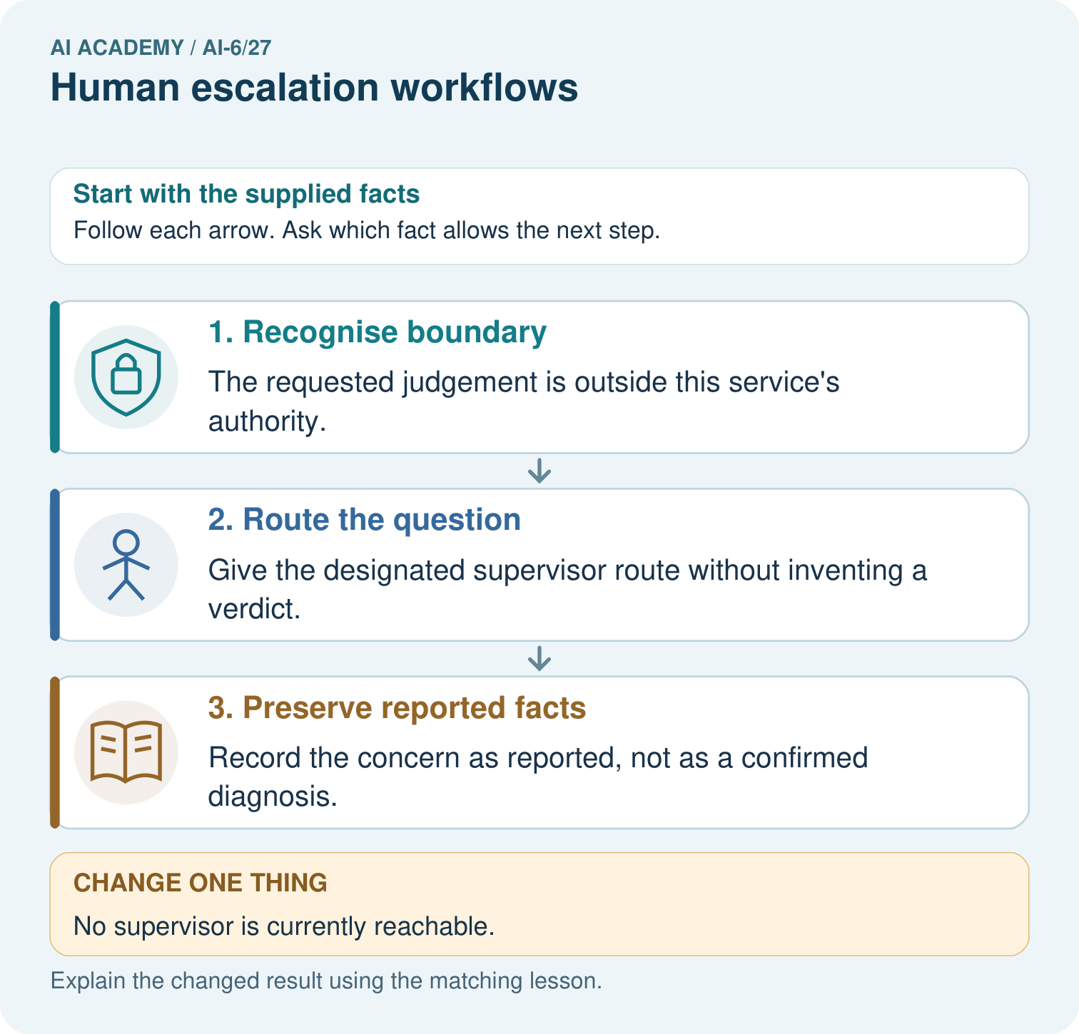
Identify the exact service boundary in the bottle question. What accurate information belongs in the supervisor handoff, and what remains unresolved if nobody is reachable?

My picture-based explanation and changed-case prediction
________________________________________________________________
________________________________________________________________
________________________________________________________________
________________________________________________________________
________________________________________________________________
________________________________________________________________
Support used: alone / hint / worked example. This record is practice evidence.
Project connection: For the Grounded Learning Service, retain an annotated trace and the changed-case result. Name the contract or evidence that makes the deciding step valid, so another team can review it.

13. Project portfolio milestone
Project: Grounded Learning Service
Current milestone: Prepare the demonstration. Gather reproducible instructions, evidence, access checks and remaining limitations.
For the Grounded Learning Service, retain an annotated trace and the changed-case result. Name the contract or evidence that makes the deciding step valid, so another team can review it.
Evidence to keep | My record
This week’s input and deciding step
Prediction and actual result (or labelled paper trace)
One change since the previous checkpoint and why
One error or limit and the next test

Explain what this week adds to your project. Reuse last week’s record rather than starting again.
________________________________________________________________
________________________________________________________________
________________________________________________________________
________________________________________________________________
________________________________________________________________

14. Supported practice and learning evidence
Use this supported practice once, in the browser or on paper. Keep the reserved independent assessment for a separate first attempt before teacher feedback.
A useful human handoff. A learner asks whether a damaged laboratory bottle is safe; the bot handles lesson notes only.

Practice 1: explain the deciding evidence
Which labelled step matches this detail? Record the concern as reported, not as a confirmed diagnosis.
1. Recognise boundary
2. Route the question
3. Preserve reported facts

My selected conclusion, deciding fact and explanation
________________________________________________________________
________________________________________________________________
________________________________________________________________
________________________________________________________________
________________________________________________________________
Hint if needed: Read the steps in the pictorial case. Match the supplied detail to the stage that performs or records it.
After your attempt, compare with the supported explanation: Preserve reported facts Record the concern as reported, not as a confirmed diagnosis. Escalation needs an appropriate person and accurate context. Model confidence cannot replace required authority or physical inspection.

Practice 2: explain the deciding evidence
Changed-case practice: No supervisor is currently reachable. Which conclusion is supported by the supplied facts?
1. State unresolved status and use the institution’s approved waiting procedure.
2. We can decide the result without examining the changed input or the procedure.
3. This one example guarantees correct results for every future input.

My selected conclusion, deciding fact and explanation
________________________________________________________________
________________________________________________________________
________________________________________________________________
________________________________________________________________
________________________________________________________________
Hint if needed: Use the changed condition and the deciding step in the pictorial trace. The answer must say what follows from those facts.
After your attempt, compare with the supported explanation: State unresolved status and use the institution’s approved waiting procedure. Lack of a human reply does not expand the bot’s authority.

Repair a missing building block
Review Incident investigation (ai-6/26). Goal: Explain the mechanism and terminology of incident investigation. Short practice: Order the three incident records and locate the old evidence version. How does the investigation change if the trace instead retrieves version 6 but drafts room C?. Return to this week and explain what you changed.
Review Release and rollback (ai-6/24). Goal: Explain the mechanism and terminology of release and rollback. Short practice: Compute A’s and B’s correctness percentages. Why is B still blocked, and does passing a fresh privacy check automatically satisfy every release gate?. Return to this week and explain what you changed.
Review Caching and stale information (ai-6/21). Goal: Explain the mechanism and terminology of caching and stale information. Short practice: Identify the version mismatch in the cached 09:00 answer. What should the first version-5 request return, and what permits a later version-5 cache hit?. Return to this week and explain what you changed.

Keep your completed work
Use Download completed work in the hosted lesson to export your answers, reflections, practice feedback and code-run evidence. Open the HTML copy to read or print it. Drafts stay in this browser when storage is available; clear drafts on a shared device.

What I repaired, the evidence I kept and the next test
________________________________________________________________
________________________________________________________________
________________________________________________________________
________________________________________________________________
________________________________________________________________

