AI ACADEMY · WORKBOOK · ai-6/32

Documentation and operational readiness
Project: Grounded Learning Service

01. Recall and choose your starting point
Try the recall before opening notes. Then use a different colour or a labelled second line to correct your explanation.

Red team exercises
Without opening the old lesson, explain one key idea from Red team exercises. Give an example and a mistake that the idea helps you avoid.

My remembered idea, example and correction
________________________________________________________________
________________________________________________________________
________________________________________________________________

Performance and cost experiments
Without opening the old lesson, explain one key idea from Performance and cost experiments. Give an example and a mistake that the idea helps you avoid.

My remembered idea, example and correction
________________________________________________________________
________________________________________________________________
________________________________________________________________

Incident investigation
Without opening the old lesson, explain one key idea from Incident investigation. Give an example and a mistake that the idea helps you avoid.

My remembered idea, example and correction
________________________________________________________________
________________________________________________________________
________________________________________________________________

02. Practise with fading help
Use W2: Trace the worked case for Documentation and operational readiness. Record the answer once; the lesson and workbook refer to the same attempt.
Given inputs | Procedure I chose | Middle steps | Result and check

The step I completed without help, and the hint I needed
________________________________________________________________
________________________________________________________________
________________________________________________________________

03. Individual reasoning check
Use the worked case for Documentation and operational readiness. Proposed explanation: “The worked result establishes every future case”. Decide whether this explanation is supported. Point to the step or supplied fact that decides; explain your repair if needed.

My explanation before partner discussion
________________________________________________________________
________________________________________________________________
________________________________________________________________
________________________________________________________________

04. Independent transfer case

Independent case: Apply a new case independently
Documentation includes all setup steps but no incident owner or compatible rollback. Identify readiness gaps.

My independent explanation, trace and limits
________________________________________________________________
________________________________________________________________
________________________________________________________________
________________________________________________________________
________________________________________________________________
________________________________________________________________
________________________________________________________________
Attempt this case before feedback. Record any help. Earlier examples below are further practice; a case already practised with feedback cannot establish fresh transfer.

05. W1 Explain the mechanism
Explain the weekly mechanism in your own words. Use the worked scenario to name its input, decision rule and output.

My reasoning and evidence
________________________________________________________________
________________________________________________________________
________________________________________________________________
________________________________________________________________
________________________________________________________________
________________________________________________________________

06. W2 Trace the worked case
Runbook says start server, but omits data version and recovery steps. Another operator cannot reproduce a result. Show the intermediate steps and give the conclusion with its scope.

My reasoning and evidence
________________________________________________________________
________________________________________________________________
________________________________________________________________
________________________________________________________________
________________________________________________________________
________________________________________________________________
________________________________________________________________

07. W3 Audit the limit
A report omits this qualification: Documentation readiness requires a tested replay and operational ownership, not merely complete-looking prose. Explain how omitting it could change a reader's interpretation, and write an accurate replacement.

My reasoning and evidence
________________________________________________________________
________________________________________________________________
________________________________________________________________
________________________________________________________________
________________________________________________________________
________________________________________________________________

08. W4 Apply a new case independently
Documentation includes all setup steps but no incident owner or compatible rollback. Identify readiness gaps.

My reasoning and evidence
________________________________________________________________
________________________________________________________________
________________________________________________________________
________________________________________________________________
________________________________________________________________
________________________________________________________________
________________________________________________________________
________________________________________________________________

09. W5 Design a revealing follow-up
For the worked scenario, propose one additional case that could reveal a failure, describe its expected outcome before running it, and explain what would need to remain fixed for a fair comparison. Do not reuse W4 as a new final test after receiving feedback.

My reasoning and evidence
________________________________________________________________
________________________________________________________________
________________________________________________________________
________________________________________________________________
________________________________________________________________
________________________________________________________________
________________________________________________________________

10. Project checkpoint and reflection
Add a labelled documentation and operational readiness evidence sheet to Grounded Learning Service. Show how you can explain the mechanism and terminology of documentation and operational readiness. Use the supplied fictional case and keep its inputs, intermediate steps, calculation or prediction, and limitation. Connect this record to last week’s record; a matching answer without a trace is insufficient.

My project change, supporting evidence and remaining limit
________________________________________________________________
________________________________________________________________
________________________________________________________________
________________________________________________________________
________________________________________________________________
________________________________________________________________

11. Feedback, return check and learning record
Evidence | My record
Worked alone / hint / model
First step I repaired and why
New case checked later; date and result
What I can now explain without notes
One remaining question
Revisit this idea with your teacher after a delay. Familiarity is different from explaining and using it on a changed case.

12. Pictorial case practice: Documentation and operational readiness
A runbook with an owner. Another teacher must handle SOURCE_UNAVAILABLE without inventing an answer.
The runbook names a maintainer and a read-only source-connection diagnostic. The code means no supported answer can be produced.
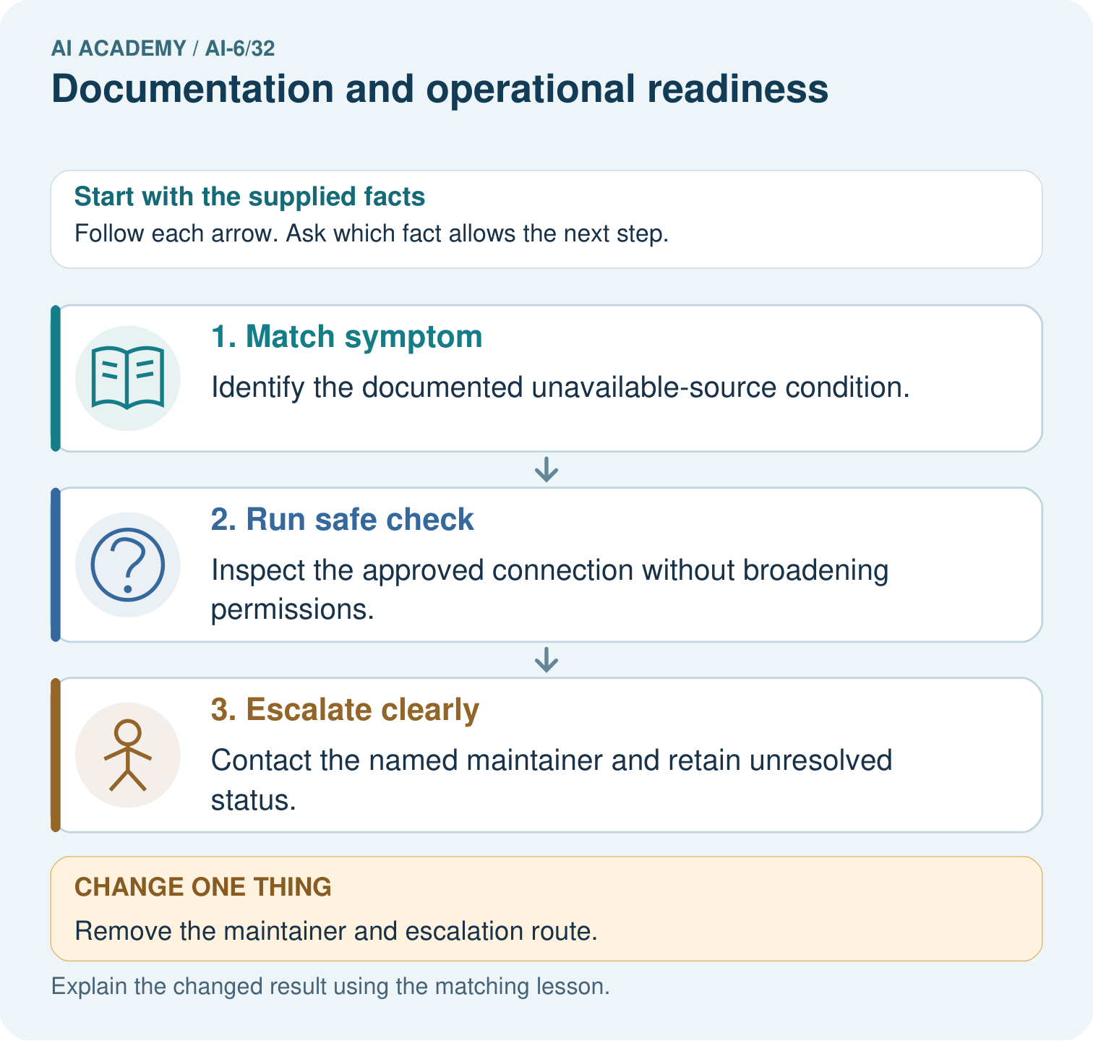
Match SOURCE_UNAVAILABLE to its safe check and escalation owner. What is lost when the maintainer route is removed, even if the diagnostic instructions stay readable?

My picture-based explanation and changed-case prediction
________________________________________________________________
________________________________________________________________
________________________________________________________________
________________________________________________________________
________________________________________________________________
________________________________________________________________
Support used: alone / hint / worked example. This record is practice evidence.
Project connection: For the Grounded Learning Service, retain an annotated trace and the changed-case result. Name the contract or evidence that makes the deciding step valid, so another team can review it.

13. Project portfolio milestone
Project: Grounded Learning Service
Current milestone: Present and defend. Demonstrate the system, explain one failure and justify the next improvement with evidence.
For the Grounded Learning Service, retain an annotated trace and the changed-case result. Name the contract or evidence that makes the deciding step valid, so another team can review it.
Evidence to keep | My record
This week’s input and deciding step
Prediction and actual result (or labelled paper trace)
One change since the previous checkpoint and why
One error or limit and the next test

Explain what this week adds to your project. Reuse last week’s record rather than starting again.
________________________________________________________________
________________________________________________________________
________________________________________________________________
________________________________________________________________
________________________________________________________________

14. Supported practice and learning evidence
Use this supported practice once, in the browser or on paper. Keep the reserved independent assessment for a separate first attempt before teacher feedback.
A runbook with an owner. Another teacher must handle SOURCE_UNAVAILABLE without inventing an answer.

Practice 1: explain the deciding evidence
Which labelled step matches this detail? Contact the named maintainer and retain unresolved status.
1. Match symptom
2. Escalate clearly
3. Run safe check

My selected conclusion, deciding fact and explanation
________________________________________________________________
________________________________________________________________
________________________________________________________________
________________________________________________________________
________________________________________________________________
Hint if needed: Read the steps in the pictorial case. Match the supplied detail to the stage that performs or records it.
After your attempt, compare with the supported explanation: Escalate clearly Contact the named maintainer and retain unresolved status. Operational documentation connects a symptom, bounded action, responsible person and recovery check. Component names alone do not tell an operator what to do.

Practice 2: explain the deciding evidence
Changed-case practice: Remove the maintainer and escalation route. Which conclusion is supported by the supplied facts?
1. The diagnostic remains, but responsibility for an unresolved fault becomes unclear.
2. We can decide the result without examining the changed input or the procedure.
3. This one example guarantees correct results for every future input.

My selected conclusion, deciding fact and explanation
________________________________________________________________
________________________________________________________________
________________________________________________________________
________________________________________________________________
________________________________________________________________
Hint if needed: Use the changed condition and the deciding step in the pictorial trace. The answer must say what follows from those facts.
After your attempt, compare with the supported explanation: The diagnostic remains, but responsibility for an unresolved fault becomes unclear. Readiness includes who acts when routine checks do not solve the problem.

Repair a missing building block
Review Red team exercises (ai-6/31). Goal: Explain the mechanism and terminology of red team exercises. Short practice: Distinguish the exhibit fact from the embedded edit instruction. Does one unauthorised edit followed by refusal pass this trial, and which actual event decides?. Return to this week and explain what you changed.
Review Performance and cost experiments (ai-6/29). Goal: Explain the mechanism and terminology of performance and cost experiments. Short practice: Calculate per-case seconds and cost units for A and B. Which meets a budget of at most 2 cost units per case, and what speed trade-off does that choice make?. Return to this week and explain what you changed.
Review Incident investigation (ai-6/26). Goal: Explain the mechanism and terminology of incident investigation. Short practice: Order the three incident records and locate the old evidence version. How does the investigation change if the trace instead retrieves version 6 but drafts room C?. Return to this week and explain what you changed.

Keep your completed work
Use Download completed work in the hosted lesson to export your answers, reflections, practice feedback and code-run evidence. Open the HTML copy to read or print it. Drafts stay in this browser when storage is available; clear drafts on a shared device.

What I repaired, the evidence I kept and the next test
________________________________________________________________
________________________________________________________________
________________________________________________________________
________________________________________________________________
________________________________________________________________

