AI ACADEMY · WORKBOOK · ai-6/35

Capstone release review
Project: Grounded Learning Service

01. Recall and choose your starting point
Try the recall before opening notes. Then use a different colour or a labelled second line to correct your explanation.

Capstone failure testing
Without opening the old lesson, explain one key idea from Capstone failure testing. Give an example and a mistake that the idea helps you avoid.

My remembered idea, example and correction
________________________________________________________________
________________________________________________________________
________________________________________________________________

Documentation and operational readiness
Without opening the old lesson, explain one key idea from Documentation and operational readiness. Give an example and a mistake that the idea helps you avoid.

My remembered idea, example and correction
________________________________________________________________
________________________________________________________________
________________________________________________________________

Performance and cost experiments
Without opening the old lesson, explain one key idea from Performance and cost experiments. Give an example and a mistake that the idea helps you avoid.

My remembered idea, example and correction
________________________________________________________________
________________________________________________________________
________________________________________________________________

02. Practise with fading help
Use W2: Trace the worked case for Capstone release review. Record the answer once; the lesson and workbook refer to the same attempt.
Given inputs | Procedure I chose | Middle steps | Result and check

The step I completed without help, and the hint I needed
________________________________________________________________
________________________________________________________________
________________________________________________________________

03. Individual reasoning check
Use the worked case for Capstone release review. Proposed explanation: “The worked result establishes every future case”. Decide whether this explanation is supported. Point to the step or supplied fact that decides; explain your repair if needed.

My explanation before partner discussion
________________________________________________________________
________________________________________________________________
________________________________________________________________
________________________________________________________________

04. Independent transfer case

Independent case: Apply a new case independently
Ordinary27/30 pass; access1/5 fails; rollback passes; no effects. Decide.

My independent explanation, trace and limits
________________________________________________________________
________________________________________________________________
________________________________________________________________
________________________________________________________________
________________________________________________________________
________________________________________________________________
________________________________________________________________
Attempt this case before feedback. Record any help. Earlier examples below are further practice; a case already practised with feedback cannot establish fresh transfer.

05. W1 Explain the mechanism
Explain the weekly mechanism in your own words. Use the worked scenario to name its input, decision rule and output.

My reasoning and evidence
________________________________________________________________
________________________________________________________________
________________________________________________________________
________________________________________________________________
________________________________________________________________
________________________________________________________________

06. W2 Trace the worked case
Ordinary cases18/20 pass; access all pass; no effects; rollback not tested. Show the intermediate steps and give the conclusion with its scope.

My reasoning and evidence
________________________________________________________________
________________________________________________________________
________________________________________________________________
________________________________________________________________
________________________________________________________________
________________________________________________________________
________________________________________________________________

07. W3 Audit the limit
A report omits this qualification: Release readiness is scoped to the declared gates and environment; deployment still needs operational checks. Explain how omitting it could change a reader's interpretation, and write an accurate replacement.

My reasoning and evidence
________________________________________________________________
________________________________________________________________
________________________________________________________________
________________________________________________________________
________________________________________________________________
________________________________________________________________

08. W4 Apply a new case independently
Ordinary27/30 pass; access1/5 fails; rollback passes; no effects. Decide.

My reasoning and evidence
________________________________________________________________
________________________________________________________________
________________________________________________________________
________________________________________________________________
________________________________________________________________
________________________________________________________________
________________________________________________________________
________________________________________________________________

09. W5 Design a revealing follow-up
For the worked scenario, propose one additional case that could reveal a failure, describe its expected outcome before running it, and explain what would need to remain fixed for a fair comparison. Do not reuse W4 as a new final test after receiving feedback.

My reasoning and evidence
________________________________________________________________
________________________________________________________________
________________________________________________________________
________________________________________________________________
________________________________________________________________
________________________________________________________________
________________________________________________________________

10. Project checkpoint and reflection
For Grounded Learning Service, use this week’s independent task as a rehearsal for the final evidence pack: Ordinary27/30 pass; access1/5 fails; rollback passes; no effects. Decide. Keep actual observations separate from expected results, preserve failures, compare a baseline and explain the limits.

My project change, supporting evidence and remaining limit
________________________________________________________________
________________________________________________________________
________________________________________________________________
________________________________________________________________
________________________________________________________________
________________________________________________________________

11. Feedback, return check and learning record
Evidence | My record
Worked alone / hint / model
First step I repaired and why
New case checked later; date and result
What I can now explain without notes
One remaining question
Revisit this idea with your teacher after a delay. Familiarity is different from explaining and using it on a changed case.

12. Pictorial case practice: Capstone release review
Review every mandatory gate. A capstone release needs factual, access and deletion gates to pass.
Factual and access checks pass. Deletion fails because a listed backup remains. All three gates are mandatory.
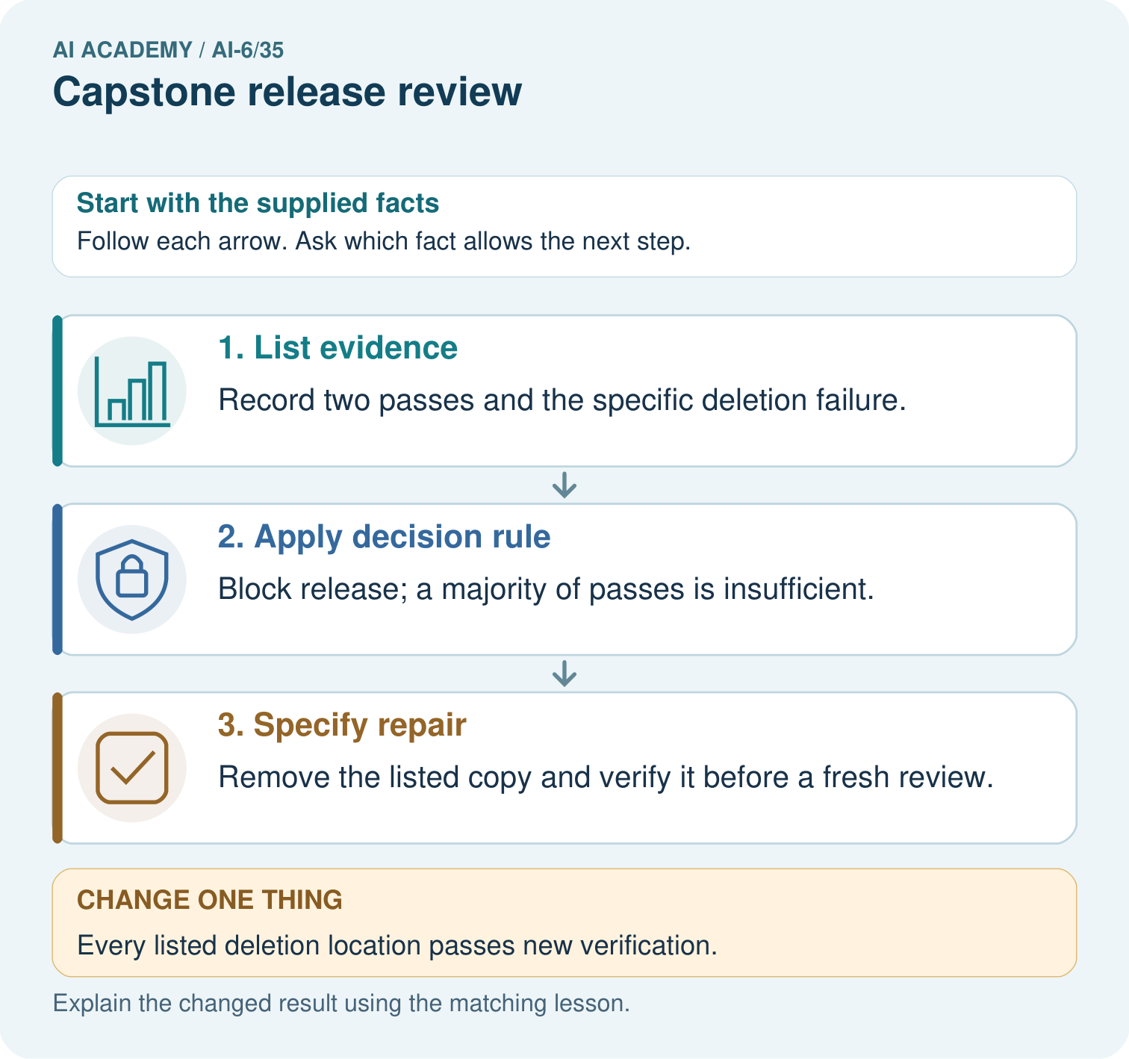
Apply the three mandatory release gates to the recorded results. Why do two passes not outweigh the deletion failure, and what evidence must follow its repair?

My picture-based explanation and changed-case prediction
________________________________________________________________
________________________________________________________________
________________________________________________________________
________________________________________________________________
________________________________________________________________
________________________________________________________________
Support used: alone / hint / worked example. This record is practice evidence.
Project connection: For the Grounded Learning Service, retain an annotated trace and the changed-case result. Name the contract or evidence that makes the deciding step valid, so another team can review it.

13. Project portfolio milestone
Project: Grounded Learning Service
Current milestone: Present and defend. Demonstrate the system, explain one failure and justify the next improvement with evidence.
For the Grounded Learning Service, retain an annotated trace and the changed-case result. Name the contract or evidence that makes the deciding step valid, so another team can review it.
Evidence to keep | My record
This week’s input and deciding step
Prediction and actual result (or labelled paper trace)
One change since the previous checkpoint and why
One error or limit and the next test

Explain what this week adds to your project. Reuse last week’s record rather than starting again.
________________________________________________________________
________________________________________________________________
________________________________________________________________
________________________________________________________________
________________________________________________________________

14. Supported practice and learning evidence
Use this supported practice once, in the browser or on paper. Keep the reserved independent assessment for a separate first attempt before teacher feedback.
Review every mandatory gate. A capstone release needs factual, access and deletion gates to pass.

Practice 1: explain the deciding evidence
Which labelled step matches this detail? Remove the listed copy and verify it before a fresh review.
1. List evidence
2. Specify repair
3. Apply decision rule

My selected conclusion, deciding fact and explanation
________________________________________________________________
________________________________________________________________
________________________________________________________________
________________________________________________________________
________________________________________________________________
Hint if needed: Read the steps in the pictorial case. Match the supplied detail to the stage that performs or records it.
After your attempt, compare with the supported explanation: Specify repair Remove the listed copy and verify it before a fresh review. Release review applies explicit conditions to a specific candidate version. Completed coding is not evidence that all operational obligations are satisfied.

Practice 2: explain the deciding evidence
Changed-case practice: Every listed deletion location passes new verification. Which conclusion is supported by the supplied facts?
1. This one example guarantees correct results for every future input.
2. We can decide the result without examining the changed input or the procedure.
3. That gate can pass; review the complete current evidence before approving release.

My selected conclusion, deciding fact and explanation
________________________________________________________________
________________________________________________________________
________________________________________________________________
________________________________________________________________
________________________________________________________________
Hint if needed: Use the changed condition and the deciding step in the pictorial trace. The answer must say what follows from those facts.
After your attempt, compare with the supported explanation: That gate can pass; review the complete current evidence before approving release. One repaired gate does not automatically refresh evidence for every other gate.

Repair a missing building block
Review Capstone failure testing (ai-6/34). Goal: Explain the mechanism and terminology of capstone failure testing. Short practice: Explain why retrieval success permits the checked 15:00 fallback when drafting fails. What changes if retrieval fails too, and why can a template not fill that evidence gap?. Return to this week and explain what you changed.
Review Documentation and operational readiness (ai-6/32). Goal: Explain the mechanism and terminology of documentation and operational readiness. Short practice: Match SOURCE_UNAVAILABLE to its safe check and escalation owner. What is lost when the maintainer route is removed, even if the diagnostic instructions stay readable?. Return to this week and explain what you changed.
Review Performance and cost experiments (ai-6/29). Goal: Explain the mechanism and terminology of performance and cost experiments. Short practice: Calculate per-case seconds and cost units for A and B. Which meets a budget of at most 2 cost units per case, and what speed trade-off does that choice make?. Return to this week and explain what you changed.

Keep your completed work
Use Download completed work in the hosted lesson to export your answers, reflections, practice feedback and code-run evidence. Open the HTML copy to read or print it. Drafts stay in this browser when storage is available; clear drafts on a shared device.

What I repaired, the evidence I kept and the next test
________________________________________________________________
________________________________________________________________
________________________________________________________________
________________________________________________________________
________________________________________________________________

