AI ACADEMY · WORKBOOK · ai-7/8

Baselines and fair comparisons
Project: Reproducible AI Research Study

01. Recall and choose your starting point
Try the recall before opening notes. Then use a different colour or a labelled second line to correct your explanation.

Hypotheses and measurable outcomes
Without opening the old lesson, explain one key idea from Hypotheses and measurable outcomes. Give an example and a mistake that the idea helps you avoid.

My remembered idea, example and correction
________________________________________________________________
________________________________________________________________
________________________________________________________________

Replication and reproduction
Without opening the old lesson, explain one key idea from Replication and reproduction. Give an example and a mistake that the idea helps you avoid.

My remembered idea, example and correction
________________________________________________________________
________________________________________________________________
________________________________________________________________

Reading a research claim
Without opening the old lesson, explain one key idea from Reading a research claim. Give an example and a mistake that the idea helps you avoid.

My remembered idea, example and correction
________________________________________________________________
________________________________________________________________
________________________________________________________________

02. Practise with fading help
Use W2: Trace the worked case for Baselines and fair comparisons. Record the answer once; the lesson and workbook refer to the same attempt.
Given inputs | Procedure I chose | Middle steps | Result and check

The step I completed without help, and the hint I needed
________________________________________________________________
________________________________________________________________
________________________________________________________________

03. Individual reasoning check
Use the worked case for Baselines and fair comparisons. Proposed explanation: “The worked result establishes every future case”. Decide whether this explanation is supported. Point to the step or supplied fact that decides; explain your repair if needed.

My explanation before partner discussion
________________________________________________________________
________________________________________________________________
________________________________________________________________
________________________________________________________________

04. Independent transfer case

Independent case: Apply a new case independently
Model uses12 seconds and baseline2 on each case. Task has a3-second budget. How should results be framed?

My independent explanation, trace and limits
________________________________________________________________
________________________________________________________________
________________________________________________________________
________________________________________________________________
________________________________________________________________
________________________________________________________________
________________________________________________________________
Attempt this case before feedback. Record any help. Earlier examples below are further practice; a case already practised with feedback cannot establish fresh transfer.

05. W1 Explain the mechanism
Explain the weekly mechanism in your own words. Use the worked scenario to name its input, decision rule and output.

My reasoning and evidence
________________________________________________________________
________________________________________________________________
________________________________________________________________
________________________________________________________________
________________________________________________________________
________________________________________________________________

06. W2 Trace the worked case
Assistant gets current register; baseline gets an obsolete one. Assistant scores higher. Show the intermediate steps and give the conclusion with its scope.

My reasoning and evidence
________________________________________________________________
________________________________________________________________
________________________________________________________________
________________________________________________________________
________________________________________________________________
________________________________________________________________
________________________________________________________________

07. W3 Audit the limit
A report omits this qualification: A baseline is credible relative to the task, not merely a procedure easy to outperform. Explain how omitting it could change a reader's interpretation, and write an accurate replacement.

My reasoning and evidence
________________________________________________________________
________________________________________________________________
________________________________________________________________
________________________________________________________________
________________________________________________________________
________________________________________________________________

08. W4 Apply a new case independently
Model uses12 seconds and baseline2 on each case. Task has a3-second budget. How should results be framed?

My reasoning and evidence
________________________________________________________________
________________________________________________________________
________________________________________________________________
________________________________________________________________
________________________________________________________________
________________________________________________________________
________________________________________________________________
________________________________________________________________

09. W5 Design a revealing follow-up
For the worked scenario, propose one additional case that could reveal a failure, describe its expected outcome before running it, and explain what would need to remain fixed for a fair comparison. Do not reuse W4 as a new final test after receiving feedback.

My reasoning and evidence
________________________________________________________________
________________________________________________________________
________________________________________________________________
________________________________________________________________
________________________________________________________________
________________________________________________________________
________________________________________________________________

10. Project checkpoint and reflection
Add a labelled baselines and fair comparisons evidence sheet to Reproducible AI Research Study. Show how you can explain the mechanism and terminology of baselines and fair comparisons. Use the supplied fictional case and keep its inputs, intermediate steps, calculation or prediction, and limitation. Connect this record to last week’s record; a matching answer without a trace is insufficient.

My project change, supporting evidence and remaining limit
________________________________________________________________
________________________________________________________________
________________________________________________________________
________________________________________________________________
________________________________________________________________
________________________________________________________________

11. Feedback, return check and learning record
Evidence | My record
Worked alone / hint / model
First step I repaired and why
New case checked later; date and result
What I can now explain without notes
One remaining question
Revisit this idea with your teacher after a delay. Familiarity is different from explaining and using it on a changed case.

12. Pictorial case practice: Baselines and fair comparisons
A baseline deserves a fair chance. Two classifiers answer the same eight fixed questions with the same allowed sources.
Simple rule A: 6/8 correct. New model B: 7/8 correct. No test case is used to tune either version.
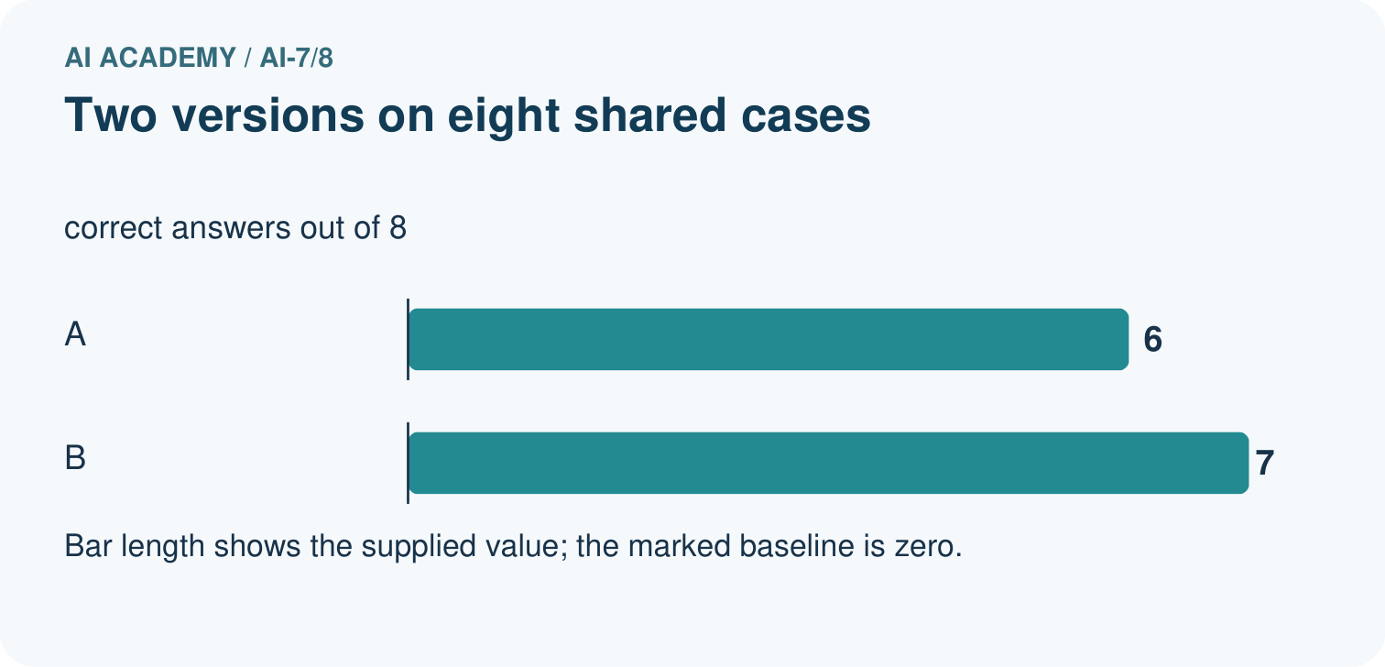
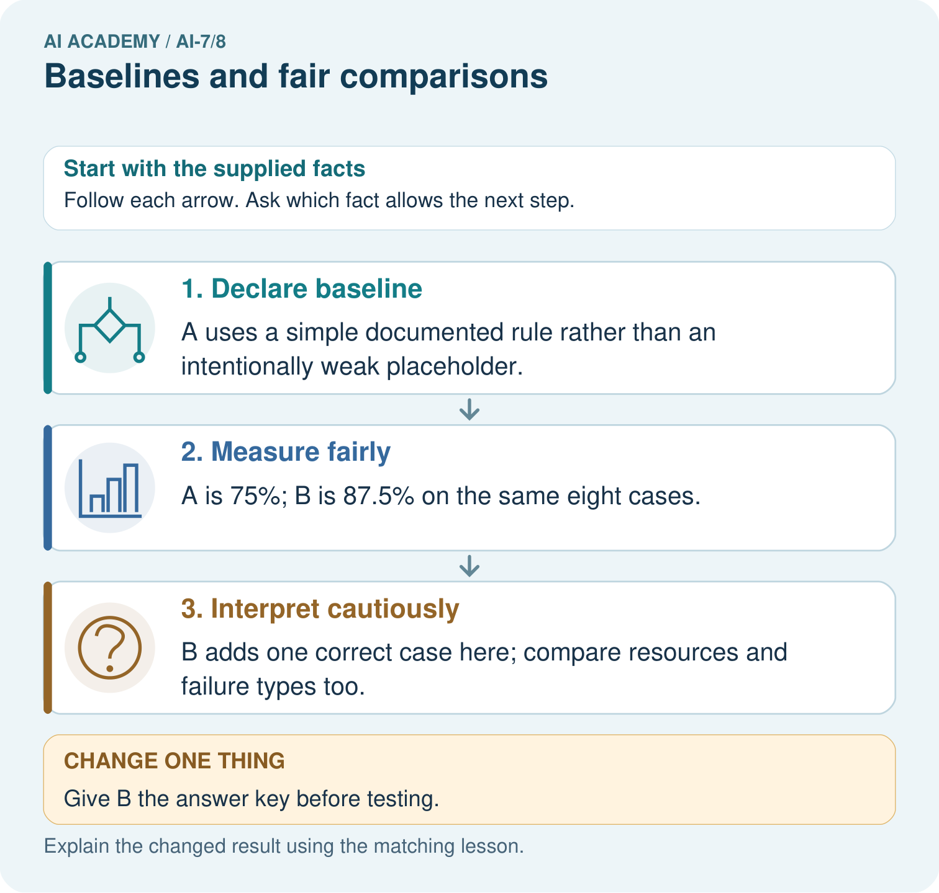
Calculate 6/8 and 7/8 correctness and name the one-case gain. Why is giving B the answer key incompatible with an unseen comparison to the simple baseline?

My picture-based explanation and changed-case prediction
________________________________________________________________
________________________________________________________________
________________________________________________________________
________________________________________________________________
________________________________________________________________
________________________________________________________________
Support used: alone / hint / worked example. This record is practice evidence.
Project connection: For the Reproducible AI Research Study, retain an annotated worked trace and the changed-case reasoning. Connect the claim to its records, units and assumptions so another investigator can challenge or reproduce it.

13. Project portfolio milestone
Project: Reproducible AI Research Study
Current milestone: Make a transparent first version. Keep a trace of how one input becomes an output; explain the rule or learned component.
For the Reproducible AI Research Study, retain an annotated worked trace and the changed-case reasoning. Connect the claim to its records, units and assumptions so another investigator can challenge or reproduce it.
Evidence to keep | My record
This week’s input and deciding step
Prediction and actual result (or labelled paper trace)
One change since the previous checkpoint and why
One error or limit and the next test

Explain what this week adds to your project. Reuse last week’s record rather than starting again.
________________________________________________________________
________________________________________________________________
________________________________________________________________
________________________________________________________________
________________________________________________________________

14. Supported practice and learning evidence
Use this supported practice once, in the browser or on paper. Keep the reserved independent assessment for a separate first attempt before teacher feedback.
A baseline deserves a fair chance. Two classifiers answer the same eight fixed questions with the same allowed sources.

Practice 1: explain the deciding evidence
Which labelled step matches this detail? B adds one correct case here; compare resources and failure types too.
1. Declare baseline
2. Interpret cautiously
3. Measure fairly

My selected conclusion, deciding fact and explanation
________________________________________________________________
________________________________________________________________
________________________________________________________________
________________________________________________________________
________________________________________________________________
Hint if needed: Read the steps in the pictorial case. Match the supplied detail to the stage that performs or records it.
After your attempt, compare with the supported explanation: Interpret cautiously B adds one correct case here; compare resources and failure types too. A baseline anchors the claim of improvement. Fair comparison keeps information access, cases and scoring aligned while allowing the declared method difference.

Practice 2: explain the deciding evidence
Changed-case practice: Give B the answer key before testing. Which conclusion is supported by the supplied facts?
1. We can decide the result without examining the changed input or the procedure.
2. The resulting comparison is invalid as unseen evaluation.
3. This one example guarantees correct results for every future input.

My selected conclusion, deciding fact and explanation
________________________________________________________________
________________________________________________________________
________________________________________________________________
________________________________________________________________
________________________________________________________________
Hint if needed: Use the changed condition and the deciding step in the pictorial trace. The answer must say what follows from those facts.
After your attempt, compare with the supported explanation: The resulting comparison is invalid as unseen evaluation. B would receive privileged information that A did not receive.

Repair a missing building block
Review Hypotheses and measurable outcomes (ai-7/7). Goal: Explain the mechanism and terminology of hypotheses and measurable outcomes. Short practice: Name the predicted outcome and how unsupported is scored. If B sounds friendlier but ties A’s unsupported count, does the recorded improvement hypothesis receive support?. Return to this week and explain what you changed.
Review Replication and reproduction (ai-7/5). Goal: Explain the mechanism and terminology of replication and reproduction. Short practice: Calculate the scores from the original and new four-record sets. Which activity reproduces saved analysis, which repeats the protocol, and why does a different rerun of the original data need investigation?. Return to this week and explain what you changed.
Review Reading a research claim (ai-7/2). Goal: Explain the mechanism and terminology of reading a research claim. Short practice: Calculate the baseline and new rates for 2/10 and 4/10. Explain both twice the rate and the percentage-point change, and say why neither measures every learner’s improvement.. Return to this week and explain what you changed.

Keep your completed work
Use Download completed work in the hosted lesson to export your answers, reflections, practice feedback and code-run evidence. Open the HTML copy to read or print it. Drafts stay in this browser when storage is available; clear drafts on a shared device.

What I repaired, the evidence I kept and the next test
________________________________________________________________
________________________________________________________________
________________________________________________________________
________________________________________________________________
________________________________________________________________

