AI ACADEMY · WORKBOOK · ai-7/10

Confounders and controls
Project: Reproducible AI Research Study

01. Recall and choose your starting point
Try the recall before opening notes. Then use a different colour or a labelled second line to correct your explanation.

Experimental units and independence
Without opening the old lesson, explain one key idea from Experimental units and independence. Give an example and a mistake that the idea helps you avoid.

My remembered idea, example and correction
________________________________________________________________
________________________________________________________________
________________________________________________________________

Hypotheses and measurable outcomes
Without opening the old lesson, explain one key idea from Hypotheses and measurable outcomes. Give an example and a mistake that the idea helps you avoid.

My remembered idea, example and correction
________________________________________________________________
________________________________________________________________
________________________________________________________________

Methods results and limitations
Without opening the old lesson, explain one key idea from Methods results and limitations. Give an example and a mistake that the idea helps you avoid.

My remembered idea, example and correction
________________________________________________________________
________________________________________________________________
________________________________________________________________

02. Practise with fading help
Use W2: Trace the worked case for Confounders and controls. Record the answer once; the lesson and workbook refer to the same attempt.
Given inputs | Procedure I chose | Middle steps | Result and check

The step I completed without help, and the hint I needed
________________________________________________________________
________________________________________________________________
________________________________________________________________

03. Individual reasoning check
Use the worked case for Confounders and controls. Proposed explanation: “The worked result establishes every future case”. Decide whether this explanation is supported. Point to the step or supplied fact that decides; explain your repair if needed.

My explanation before partner discussion
________________________________________________________________
________________________________________________________________
________________________________________________________________
________________________________________________________________

04. Independent transfer case

Independent case: Apply a new case independently
Every method A run is morning and B run afternoon; network speed varies by time. Propose a repair.

My independent explanation, trace and limits
________________________________________________________________
________________________________________________________________
________________________________________________________________
________________________________________________________________
________________________________________________________________
________________________________________________________________
________________________________________________________________
Attempt this case before feedback. Record any help. Earlier examples below are further practice; a case already practised with feedback cannot establish fresh transfer.

05. W1 Explain the mechanism
Explain the weekly mechanism in your own words. Use the worked scenario to name its input, decision rule and output.

My reasoning and evidence
________________________________________________________________
________________________________________________________________
________________________________________________________________
________________________________________________________________
________________________________________________________________
________________________________________________________________

06. W2 Trace the worked case
New method uses better corpus and different queries while old method uses the original set. Show the intermediate steps and give the conclusion with its scope.

My reasoning and evidence
________________________________________________________________
________________________________________________________________
________________________________________________________________
________________________________________________________________
________________________________________________________________
________________________________________________________________
________________________________________________________________

07. W3 Audit the limit
A report omits this qualification: Controls address specified alternatives, not every possible unknown confounder. Explain how omitting it could change a reader's interpretation, and write an accurate replacement.

My reasoning and evidence
________________________________________________________________
________________________________________________________________
________________________________________________________________
________________________________________________________________
________________________________________________________________
________________________________________________________________

08. W4 Apply a new case independently
Every method A run is morning and B run afternoon; network speed varies by time. Propose a repair.

My reasoning and evidence
________________________________________________________________
________________________________________________________________
________________________________________________________________
________________________________________________________________
________________________________________________________________
________________________________________________________________
________________________________________________________________
________________________________________________________________

09. W5 Design a revealing follow-up
For the worked scenario, propose one additional case that could reveal a failure, describe its expected outcome before running it, and explain what would need to remain fixed for a fair comparison. Do not reuse W4 as a new final test after receiving feedback.

My reasoning and evidence
________________________________________________________________
________________________________________________________________
________________________________________________________________
________________________________________________________________
________________________________________________________________
________________________________________________________________
________________________________________________________________

10. Project checkpoint and reflection
Add a labelled confounders and controls evidence sheet to Reproducible AI Research Study. Show how you can explain the mechanism and terminology of confounders and controls. Use the supplied fictional case and keep its inputs, intermediate steps, calculation or prediction, and limitation. Connect this record to last week’s record; a matching answer without a trace is insufficient.

My project change, supporting evidence and remaining limit
________________________________________________________________
________________________________________________________________
________________________________________________________________
________________________________________________________________
________________________________________________________________
________________________________________________________________

11. Feedback, return check and learning record
Evidence | My record
Worked alone / hint / model
First step I repaired and why
New case checked later; date and result
What I can now explain without notes
One remaining question
Revisit this idea with your teacher after a delay. Familiarity is different from explaining and using it on a changed case.

12. Pictorial case practice: Confounders and controls
Separate background from class. Training data show every healthy leaf on white paper and every spotted leaf on blue paper.
Goal is leaf condition, not paper colour. A proposed check uses both paper colours for each condition.
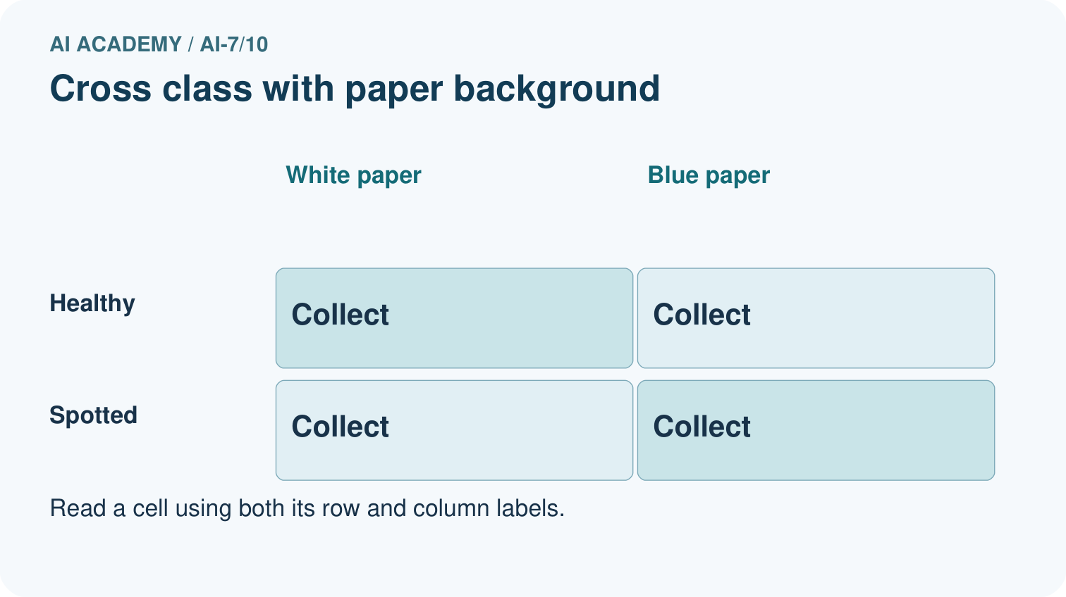
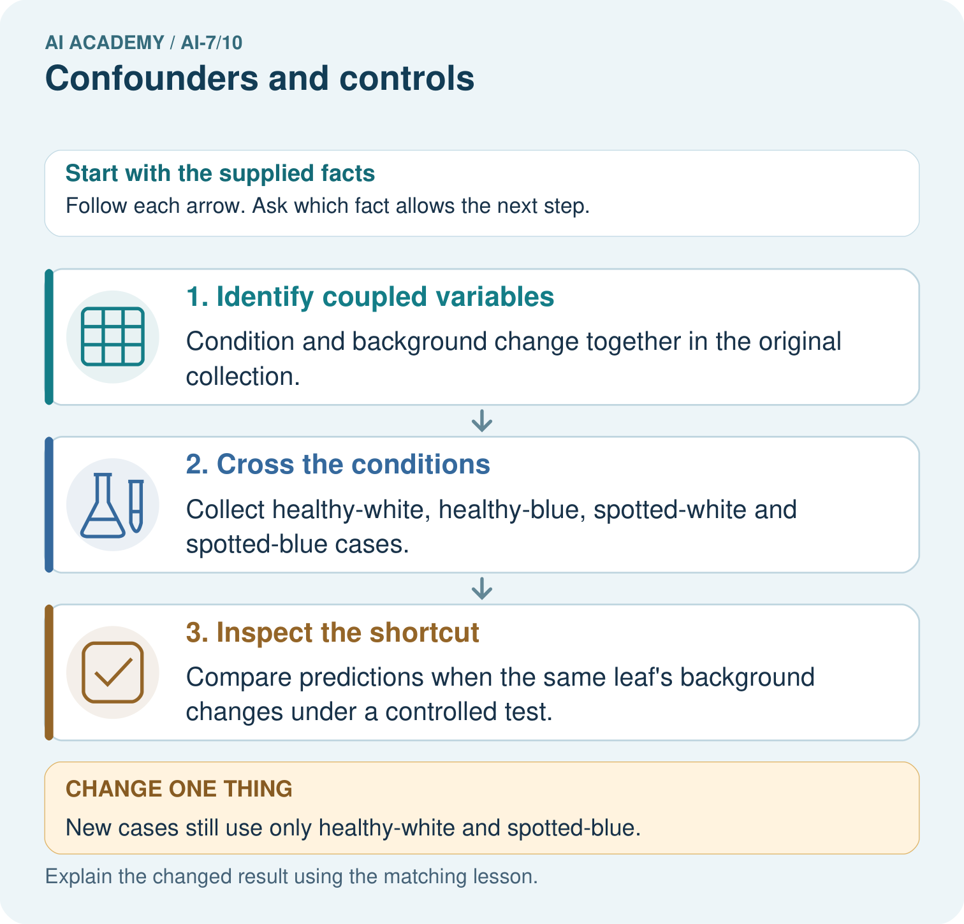
Draw the four condition/background combinations. Which variables were coupled before, and why would collecting only healthy-white and spotted-blue again leave the confounding unresolved?

My picture-based explanation and changed-case prediction
________________________________________________________________
________________________________________________________________
________________________________________________________________
________________________________________________________________
________________________________________________________________
________________________________________________________________
Support used: alone / hint / worked example. This record is practice evidence.
Project connection: For the Reproducible AI Research Study, retain an annotated worked trace and the changed-case reasoning. Connect the claim to its records, units and assumptions so another investigator can challenge or reproduce it.

13. Project portfolio milestone
Project: Reproducible AI Research Study
Current milestone: Make a transparent first version. Keep a trace of how one input becomes an output; explain the rule or learned component.
For the Reproducible AI Research Study, retain an annotated worked trace and the changed-case reasoning. Connect the claim to its records, units and assumptions so another investigator can challenge or reproduce it.
Evidence to keep | My record
This week’s input and deciding step
Prediction and actual result (or labelled paper trace)
One change since the previous checkpoint and why
One error or limit and the next test

Explain what this week adds to your project. Reuse last week’s record rather than starting again.
________________________________________________________________
________________________________________________________________
________________________________________________________________
________________________________________________________________
________________________________________________________________

14. Supported practice and learning evidence
Use this supported practice once, in the browser or on paper. Keep the reserved independent assessment for a separate first attempt before teacher feedback.
Separate background from class. Training data show every healthy leaf on white paper and every spotted leaf on blue paper.

Practice 1: explain the deciding evidence
Which labelled step matches this detail? Compare predictions when the same leaf’s background changes under a controlled test.
1. Identify coupled variables
2. Inspect the shortcut
3. Cross the conditions

My selected conclusion, deciding fact and explanation
________________________________________________________________
________________________________________________________________
________________________________________________________________
________________________________________________________________
________________________________________________________________
Hint if needed: Read the steps in the pictorial case. Match the supplied detail to the stage that performs or records it.
After your attempt, compare with the supported explanation: Inspect the shortcut Compare predictions when the same leaf’s background changes under a controlled test. A confounder can provide an alternative explanation for a result. Crossing conditions makes the intended feature and the nuisance feature less entangled.

Practice 2: explain the deciding evidence
Changed-case practice: New cases still use only healthy-white and spotted-blue. Which conclusion is supported by the supplied facts?
1. We can decide the result without examining the changed input or the procedure.
2. The collection does not resolve the background confounding.
3. This one example guarantees correct results for every future input.

My selected conclusion, deciding fact and explanation
________________________________________________________________
________________________________________________________________
________________________________________________________________
________________________________________________________________
________________________________________________________________
Hint if needed: Use the changed condition and the deciding step in the pictorial trace. The answer must say what follows from those facts.
After your attempt, compare with the supported explanation: The collection does not resolve the background confounding. The same two variables remain coupled instead of being varied separately.

Repair a missing building block
Review Experimental units and independence (ai-7/9). Goal: Explain the mechanism and terminology of experimental units and independence. Short practice: Count independent plants and photo views. Construct the stated group-correct split, then explain why placing a P1 view in evaluation creates leakage for the new-plant goal.. Return to this week and explain what you changed.
Review Hypotheses and measurable outcomes (ai-7/7). Goal: Explain the mechanism and terminology of hypotheses and measurable outcomes. Short practice: Name the predicted outcome and how unsupported is scored. If B sounds friendlier but ties A’s unsupported count, does the recorded improvement hypothesis receive support?. Return to this week and explain what you changed.
Review Methods results and limitations (ai-7/4). Goal: Explain the mechanism and terminology of methods results and limitations. Short practice: Place the five-photo procedure, 3/5 versus 4/5 finding and missing outdoor evidence in their proper categories. Why cannot the result establish that B is best for outdoor farming?. Return to this week and explain what you changed.

Keep your completed work
Use Download completed work in the hosted lesson to export your answers, reflections, practice feedback and code-run evidence. Open the HTML copy to read or print it. Drafts stay in this browser when storage is available; clear drafts on a shared device.

What I repaired, the evidence I kept and the next test
________________________________________________________________
________________________________________________________________
________________________________________________________________
________________________________________________________________
________________________________________________________________

