AI ACADEMY · WORKBOOK · ai-7/12

Uncertainty intervals
Project: Reproducible AI Research Study

01. Recall and choose your starting point
Try the recall before opening notes. Then use a different colour or a labelled second line to correct your explanation.

Sampling variability
Without opening the old lesson, explain one key idea from Sampling variability. Give an example and a mistake that the idea helps you avoid.

My remembered idea, example and correction
________________________________________________________________
________________________________________________________________
________________________________________________________________

Experimental units and independence
Without opening the old lesson, explain one key idea from Experimental units and independence. Give an example and a mistake that the idea helps you avoid.

My remembered idea, example and correction
________________________________________________________________
________________________________________________________________
________________________________________________________________

A literature comparison matrix
Without opening the old lesson, explain one key idea from A literature comparison matrix. Give an example and a mistake that the idea helps you avoid.

My remembered idea, example and correction
________________________________________________________________
________________________________________________________________
________________________________________________________________

02. Practise with fading help
Use W2: Trace the worked case for Uncertainty intervals. Record the answer once; the lesson and workbook refer to the same attempt.
Given inputs | Procedure I chose | Middle steps | Result and check

The step I completed without help, and the hint I needed
________________________________________________________________
________________________________________________________________
________________________________________________________________

03. Individual reasoning check
Use the worked case for Uncertainty intervals. Proposed explanation: “The worked result establishes every future case”. Decide whether this explanation is supported. Point to the step or supplied fact that decides; explain your repair if needed.

My explanation before partner discussion
________________________________________________________________
________________________________________________________________
________________________________________________________________
________________________________________________________________

04. Independent transfer case

Independent case: Apply a new case independently
Mean20, n25, known sigma5 and critical1.96. Compute interval and name one assumption.

My independent explanation, trace and limits
________________________________________________________________
________________________________________________________________
________________________________________________________________
________________________________________________________________
________________________________________________________________
________________________________________________________________
________________________________________________________________
Attempt this case before feedback. Record any help. Earlier examples below are further practice; a case already practised with feedback cannot establish fresh transfer.

05. W1 Explain the mechanism
Explain the weekly mechanism in your own words. Use the worked scenario to name its input, decision rule and output.

My reasoning and evidence
________________________________________________________________
________________________________________________________________
________________________________________________________________
________________________________________________________________
________________________________________________________________
________________________________________________________________

06. W2 Trace the worked case
Observed mean10, n16, sigma2. Compute standard error, margin and interval. Show the intermediate steps and give the conclusion with its scope.

My reasoning and evidence
________________________________________________________________
________________________________________________________________
________________________________________________________________
________________________________________________________________
________________________________________________________________
________________________________________________________________
________________________________________________________________

07. W3 Audit the limit
A report omits this qualification: A narrow interval can be precisely biased; sampling independence and representativeness must be justified. Explain how omitting it could change a reader's interpretation, and write an accurate replacement.

My reasoning and evidence
________________________________________________________________
________________________________________________________________
________________________________________________________________
________________________________________________________________
________________________________________________________________
________________________________________________________________

08. W4 Apply a new case independently
Mean20, n25, known sigma5 and critical1.96. Compute interval and name one assumption.

My reasoning and evidence
________________________________________________________________
________________________________________________________________
________________________________________________________________
________________________________________________________________
________________________________________________________________
________________________________________________________________
________________________________________________________________
________________________________________________________________

09. W5 Design a revealing follow-up
For the worked scenario, propose one additional case that could reveal a failure, describe its expected outcome before running it, and explain what would need to remain fixed for a fair comparison. Do not reuse W4 as a new final test after receiving feedback.

My reasoning and evidence
________________________________________________________________
________________________________________________________________
________________________________________________________________
________________________________________________________________
________________________________________________________________
________________________________________________________________
________________________________________________________________

10. Project checkpoint and reflection
Add a labelled uncertainty intervals evidence sheet to Reproducible AI Research Study. Show how you can explain the mechanism and terminology of uncertainty intervals. Use the supplied fictional case and keep its inputs, intermediate steps, calculation or prediction, and limitation. Connect this record to last week’s record; a matching answer without a trace is insufficient.

My project change, supporting evidence and remaining limit
________________________________________________________________
________________________________________________________________
________________________________________________________________
________________________________________________________________
________________________________________________________________
________________________________________________________________

11. Feedback, return check and learning record
Evidence | My record
Worked alone / hint / model
First step I repaired and why
New case checked later; date and result
What I can now explain without notes
One remaining question
Revisit this idea with your teacher after a delay. Familiarity is different from explaining and using it on a changed case.

12. Pictorial case practice: Uncertainty intervals
Read a supplied uncertainty interval. A fictional study supplies an interval for a mean time difference under its stated sampling model.
Estimated difference B−A is -0.8 seconds; supplied 95% confidence interval is [-1.4,-0.2] seconds. Assume the study’s interval method is appropriate.
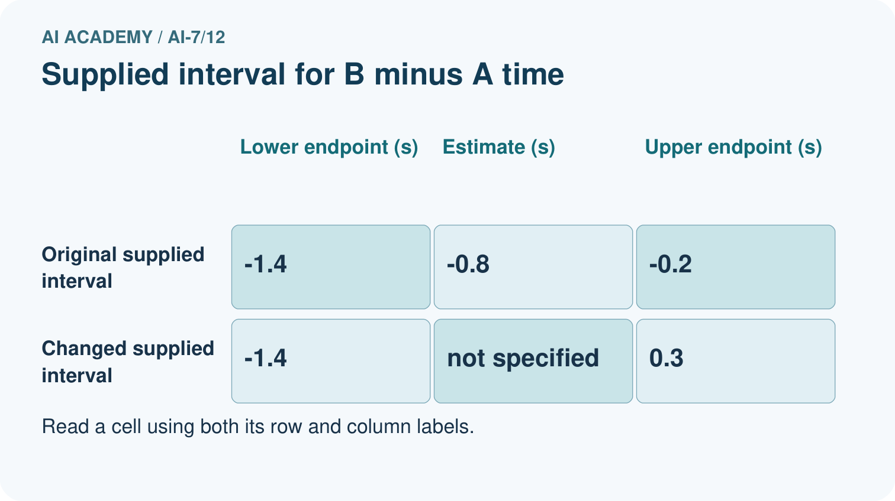
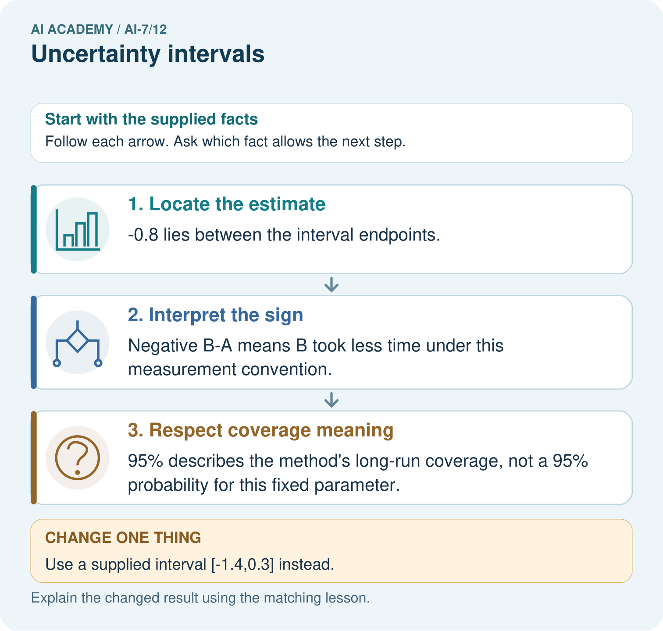
Locate -0.8 and zero relative to the supplied interval [-1.4,-0.2]. Interpret the sign and confidence-method meaning, then describe what changes with interval [-1.4,0.3].

My picture-based explanation and changed-case prediction
________________________________________________________________
________________________________________________________________
________________________________________________________________
________________________________________________________________
________________________________________________________________
________________________________________________________________
Support used: alone / hint / worked example. This record is practice evidence.
Project connection: For the Reproducible AI Research Study, retain an annotated worked trace and the changed-case reasoning. Connect the claim to its records, units and assumptions so another investigator can challenge or reproduce it.

13. Project portfolio milestone
Project: Reproducible AI Research Study
Current milestone: Make a transparent first version. Keep a trace of how one input becomes an output; explain the rule or learned component.
For the Reproducible AI Research Study, retain an annotated worked trace and the changed-case reasoning. Connect the claim to its records, units and assumptions so another investigator can challenge or reproduce it.
Evidence to keep | My record
This week’s input and deciding step
Prediction and actual result (or labelled paper trace)
One change since the previous checkpoint and why
One error or limit and the next test

Explain what this week adds to your project. Reuse last week’s record rather than starting again.
________________________________________________________________
________________________________________________________________
________________________________________________________________
________________________________________________________________
________________________________________________________________

14. Supported practice and learning evidence
Use this supported practice once, in the browser or on paper. Keep the reserved independent assessment for a separate first attempt before teacher feedback.
Read a supplied uncertainty interval. A fictional study supplies an interval for a mean time difference under its stated sampling model.

Practice 1: explain the deciding evidence
Which labelled step matches this detail? 95% describes the method’s long-run coverage, not a 95% probability for this fixed parameter.
1. Interpret the sign
2. Locate the estimate
3. Respect coverage meaning

My selected conclusion, deciding fact and explanation
________________________________________________________________
________________________________________________________________
________________________________________________________________
________________________________________________________________
________________________________________________________________
Hint if needed: Read the steps in the pictorial case. Match the supplied detail to the stage that performs or records it.
After your attempt, compare with the supported explanation: Respect coverage meaning 95% describes the method’s long-run coverage, not a 95% probability for this fixed parameter. An uncertainty interval conveys precision under assumptions. Its endpoints, units, comparison direction and method all matter; the interval is supplied here, not calculated from unavailable raw data.

Practice 2: explain the deciding evidence
Changed-case practice: Use a supplied interval [-1.4,0.3] instead. Which conclusion is supported by the supplied facts?
1. This one example guarantees correct results for every future input.
2. We can decide the result without examining the changed input or the procedure.
3. It includes zero and positive differences, so both no difference and slower B remain compatible with that interval.

My selected conclusion, deciding fact and explanation
________________________________________________________________
________________________________________________________________
________________________________________________________________
________________________________________________________________
________________________________________________________________
Hint if needed: Use the changed condition and the deciding step in the pictorial trace. The answer must say what follows from those facts.
After your attempt, compare with the supported explanation: It includes zero and positive differences, so both no difference and slower B remain compatible with that interval. The new upper endpoint crosses zero.

Repair a missing building block
Review Sampling variability (ai-7/11). Goal: Explain the mechanism and terminology of sampling variability. Short practice: Calculate the two four-case rates and their difference. Explain how changed included cases can affect a fixed model, and why identical deterministic records should not differ on a rerun.. Return to this week and explain what you changed.
Review Experimental units and independence (ai-7/9). Goal: Explain the mechanism and terminology of experimental units and independence. Short practice: Count independent plants and photo views. Construct the stated group-correct split, then explain why placing a P1 view in evaluation creates leakage for the new-plant goal.. Return to this week and explain what you changed.
Review A literature comparison matrix (ai-7/6). Goal: Explain the mechanism and terminology of a literature comparison matrix. Short practice: Explain why 8/10 indoors and 16/20 outdoors share a rate but not a controlled comparison. Which condition column must the literature matrix preserve?. Return to this week and explain what you changed.

Predict, run and debug
The browser lab lets you edit the supported Python examples already included in this lesson. Predict first, run, inspect the actual output or error, change one input, then run again. Keep code, predictions, actual results and a reasoned revision together. On paper, label your result as a trace rather than an execution.

Keep your completed work
Use Download completed work in the hosted lesson to export your answers, reflections, practice feedback and code-run evidence. Open the HTML copy to read or print it. Drafts stay in this browser when storage is available; clear drafts on a shared device.

What I repaired, the evidence I kept and the next test
________________________________________________________________
________________________________________________________________
________________________________________________________________
________________________________________________________________
________________________________________________________________

