AI ACADEMY · WORKBOOK · ai-7/13

Effect size and practical importance
Project: Reproducible AI Research Study

01. Recall and choose your starting point
Try the recall before opening notes. Then use a different colour or a labelled second line to correct your explanation.

Uncertainty intervals
Without opening the old lesson, explain one key idea from Uncertainty intervals. Give an example and a mistake that the idea helps you avoid.

My remembered idea, example and correction
________________________________________________________________
________________________________________________________________
________________________________________________________________

Confounders and controls
Without opening the old lesson, explain one key idea from Confounders and controls. Give an example and a mistake that the idea helps you avoid.

My remembered idea, example and correction
________________________________________________________________
________________________________________________________________
________________________________________________________________

Hypotheses and measurable outcomes
Without opening the old lesson, explain one key idea from Hypotheses and measurable outcomes. Give an example and a mistake that the idea helps you avoid.

My remembered idea, example and correction
________________________________________________________________
________________________________________________________________
________________________________________________________________

02. Practise with fading help
Use W2: Trace the worked case for Effect size and practical importance. Record the answer once; the lesson and workbook refer to the same attempt.
Given inputs | Procedure I chose | Middle steps | Result and check

The step I completed without help, and the hint I needed
________________________________________________________________
________________________________________________________________
________________________________________________________________

03. Individual reasoning check
Use the worked case for Effect size and practical importance. Proposed explanation: “The worked result establishes every future case”. Decide whether this explanation is supported. Point to the step or supplied fact that decides; explain your repair if needed.

My explanation before partner discussion
________________________________________________________________
________________________________________________________________
________________________________________________________________
________________________________________________________________

04. Independent transfer case

Independent case: Apply a new case independently
Baseline6, 8, 10; candidate5, 7, 9. Useful mean gain at least1.5. Decide.

My independent explanation, trace and limits
________________________________________________________________
________________________________________________________________
________________________________________________________________
________________________________________________________________
________________________________________________________________
________________________________________________________________
________________________________________________________________
Attempt this case before feedback. Record any help. Earlier examples below are further practice; a case already practised with feedback cannot establish fresh transfer.

05. W1 Explain the mechanism
Explain the weekly mechanism in your own words. Use the worked scenario to name its input, decision rule and output.

My reasoning and evidence
________________________________________________________________
________________________________________________________________
________________________________________________________________
________________________________________________________________
________________________________________________________________
________________________________________________________________

06. W2 Trace the worked case
Baseline times10, 12, 8; candidate8, 9, 7 seconds. Useful gain threshold2 seconds. Show the intermediate steps and give the conclusion with its scope.

My reasoning and evidence
________________________________________________________________
________________________________________________________________
________________________________________________________________
________________________________________________________________
________________________________________________________________
________________________________________________________________
________________________________________________________________

07. W3 Audit the limit
A report omits this qualification: A meaningful sample effect may remain statistically uncertain; statistical significance can also concern a practically tiny effect. Explain how omitting it could change a reader's interpretation, and write an accurate replacement.

My reasoning and evidence
________________________________________________________________
________________________________________________________________
________________________________________________________________
________________________________________________________________
________________________________________________________________
________________________________________________________________

08. W4 Apply a new case independently
Baseline6, 8, 10; candidate5, 7, 9. Useful mean gain at least1.5. Decide.

My reasoning and evidence
________________________________________________________________
________________________________________________________________
________________________________________________________________
________________________________________________________________
________________________________________________________________
________________________________________________________________
________________________________________________________________
________________________________________________________________

09. W5 Design a revealing follow-up
For the worked scenario, propose one additional case that could reveal a failure, describe its expected outcome before running it, and explain what would need to remain fixed for a fair comparison. Do not reuse W4 as a new final test after receiving feedback.

My reasoning and evidence
________________________________________________________________
________________________________________________________________
________________________________________________________________
________________________________________________________________
________________________________________________________________
________________________________________________________________
________________________________________________________________

10. Project checkpoint and reflection
Add a labelled effect size and practical importance evidence sheet to Reproducible AI Research Study. Show how you can explain the mechanism and terminology of effect size and practical importance. Use the supplied fictional case and keep its inputs, intermediate steps, calculation or prediction, and limitation. Connect this record to last week’s record; a matching answer without a trace is insufficient.

My project change, supporting evidence and remaining limit
________________________________________________________________
________________________________________________________________
________________________________________________________________
________________________________________________________________
________________________________________________________________
________________________________________________________________

11. Feedback, return check and learning record
Evidence | My record
Worked alone / hint / model
First step I repaired and why
New case checked later; date and result
What I can now explain without notes
One remaining question
Revisit this idea with your teacher after a delay. Familiarity is different from explaining and using it on a changed case.

12. Pictorial case practice: Effect size and practical importance
An improvement with a practical threshold. A team compares error rates against a predeclared practical threshold.
A makes 20 errors in 1000 tasks; B makes 15. Practical improvement requires at least 10 fewer errors per 1000.
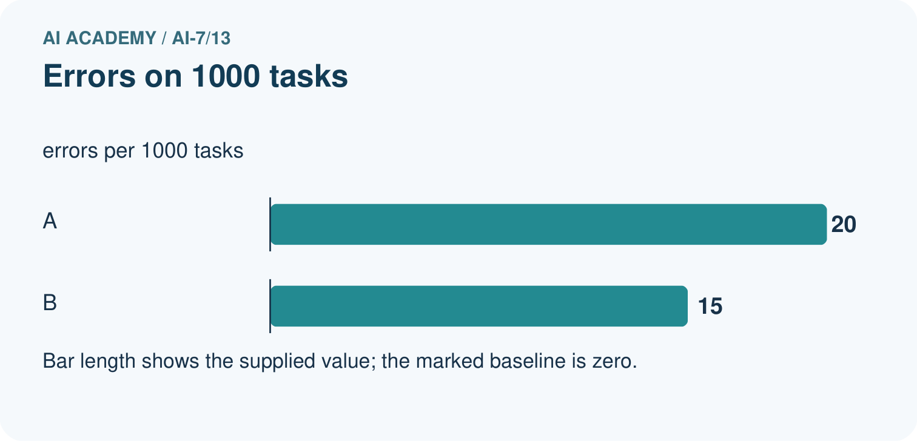
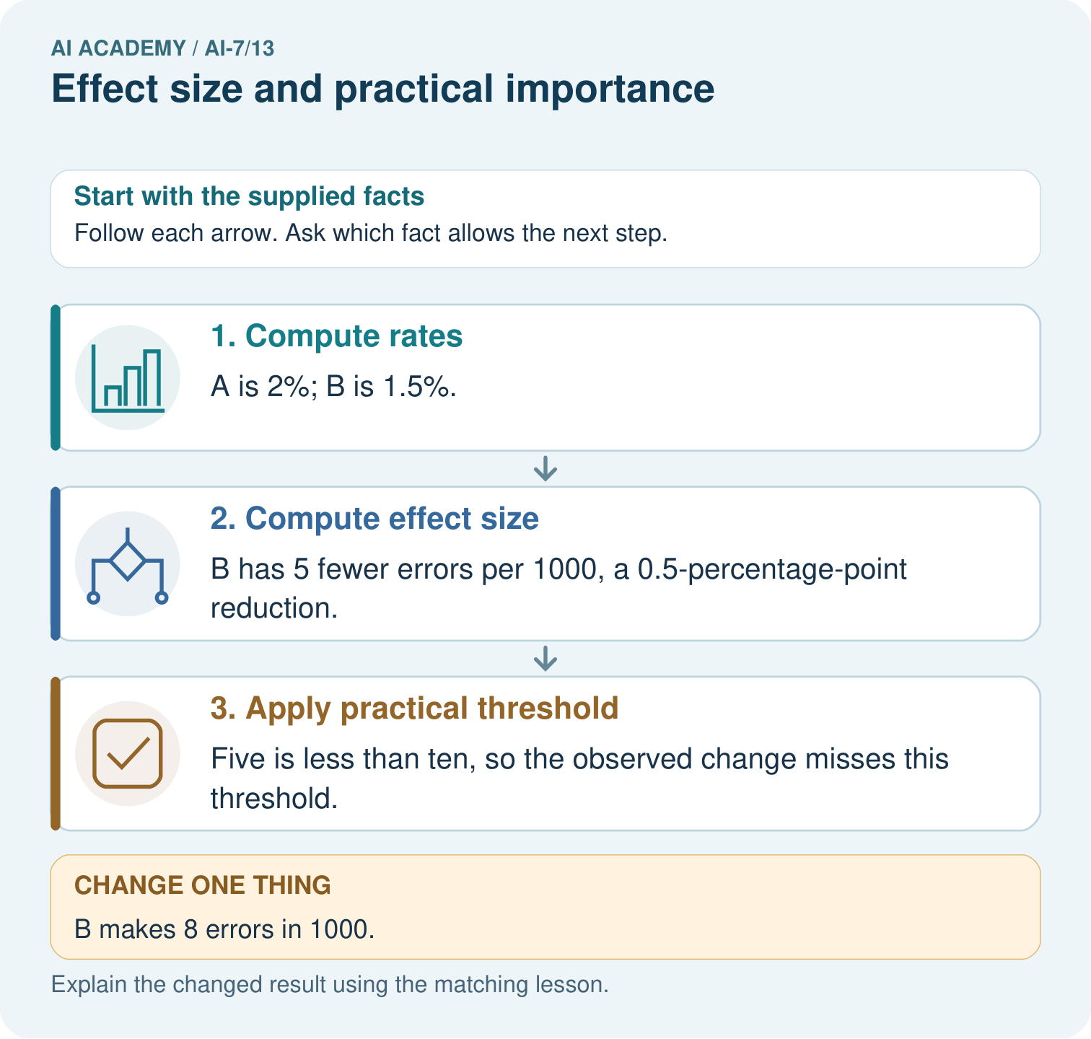
Calculate the absolute error-rate reduction from 20/1000 to 15/1000. Does it meet the ten-fewer-errors threshold, and what changes when B has eight errors?

My picture-based explanation and changed-case prediction
________________________________________________________________
________________________________________________________________
________________________________________________________________
________________________________________________________________
________________________________________________________________
________________________________________________________________
Support used: alone / hint / worked example. This record is practice evidence.
Project connection: For the Reproducible AI Research Study, retain an annotated worked trace and the changed-case reasoning. Connect the claim to its records, units and assumptions so another investigator can challenge or reproduce it.

13. Project portfolio milestone
Project: Reproducible AI Research Study
Current milestone: Test changed cases. Keep normal, boundary and failure cases; compare expected and observed results.
For the Reproducible AI Research Study, retain an annotated worked trace and the changed-case reasoning. Connect the claim to its records, units and assumptions so another investigator can challenge or reproduce it.
Evidence to keep | My record
This week’s input and deciding step
Prediction and actual result (or labelled paper trace)
One change since the previous checkpoint and why
One error or limit and the next test

Explain what this week adds to your project. Reuse last week’s record rather than starting again.
________________________________________________________________
________________________________________________________________
________________________________________________________________
________________________________________________________________
________________________________________________________________

14. Supported practice and learning evidence
Use this supported practice once, in the browser or on paper. Keep the reserved independent assessment for a separate first attempt before teacher feedback.
An improvement with a practical threshold. A team compares error rates against a predeclared practical threshold.

Practice 1: explain the deciding evidence
Which labelled step matches this detail? Five is less than ten, so the observed change misses this threshold.
1. Apply practical threshold
2. Compute rates
3. Compute effect size

My selected conclusion, deciding fact and explanation
________________________________________________________________
________________________________________________________________
________________________________________________________________
________________________________________________________________
________________________________________________________________
Hint if needed: Read the steps in the pictorial case. Match the supplied detail to the stage that performs or records it.
After your attempt, compare with the supported explanation: Apply practical threshold Five is less than ten, so the observed change misses this threshold. Effect size describes how much the outcome changes. Practical importance depends on the real decision criterion; relative changes can sound large while absolute changes remain small.

Practice 2: explain the deciding evidence
Changed-case practice: B makes 8 errors in 1000. Which conclusion is supported by the supplied facts?
1. The reduction becomes 12 per 1000 and meets the stated practical threshold.
2. This one example guarantees correct results for every future input.
3. We can decide the result without examining the changed input or the procedure.

My selected conclusion, deciding fact and explanation
________________________________________________________________
________________________________________________________________
________________________________________________________________
________________________________________________________________
________________________________________________________________
Hint if needed: Use the changed condition and the deciding step in the pictorial trace. The answer must say what follows from those facts.
After your attempt, compare with the supported explanation: The reduction becomes 12 per 1000 and meets the stated practical threshold. Twenty minus eight exceeds the required ten fewer errors.

Repair a missing building block
Review Uncertainty intervals (ai-7/12). Goal: Explain the mechanism and terminology of uncertainty intervals. Short practice: Locate -0.8 and zero relative to the supplied interval [-1.4,-0.2]. Interpret the sign and confidence-method meaning, then describe what changes with interval [-1.4,0.3].. Return to this week and explain what you changed.
Review Confounders and controls (ai-7/10). Goal: Explain the mechanism and terminology of confounders and controls. Short practice: Draw the four condition/background combinations. Which variables were coupled before, and why would collecting only healthy-white and spotted-blue again leave the confounding unresolved?. Return to this week and explain what you changed.
Review Hypotheses and measurable outcomes (ai-7/7). Goal: Explain the mechanism and terminology of hypotheses and measurable outcomes. Short practice: Name the predicted outcome and how unsupported is scored. If B sounds friendlier but ties A’s unsupported count, does the recorded improvement hypothesis receive support?. Return to this week and explain what you changed.

Predict, run and debug
The browser lab lets you edit the supported Python examples already included in this lesson. Predict first, run, inspect the actual output or error, change one input, then run again. Keep code, predictions, actual results and a reasoned revision together. On paper, label your result as a trace rather than an execution.

Keep your completed work
Use Download completed work in the hosted lesson to export your answers, reflections, practice feedback and code-run evidence. Open the HTML copy to read or print it. Drafts stay in this browser when storage is available; clear drafts on a shared device.

What I repaired, the evidence I kept and the next test
________________________________________________________________
________________________________________________________________
________________________________________________________________
________________________________________________________________
________________________________________________________________

