AI ACADEMY · WORKBOOK · ai-7/23

Power and resource tradeoffs
Project: Reproducible AI Research Study

01. Recall and choose your starting point
Try the recall before opening notes. Then use a different colour or a labelled second line to correct your explanation.

Pilot experiments
Without opening the old lesson, explain one key idea from Pilot experiments. Give an example and a mistake that the idea helps you avoid.

My remembered idea, example and correction
________________________________________________________________
________________________________________________________________
________________________________________________________________

Privacy and data governance
Without opening the old lesson, explain one key idea from Privacy and data governance. Give an example and a mistake that the idea helps you avoid.

My remembered idea, example and correction
________________________________________________________________
________________________________________________________________
________________________________________________________________

Sensitivity analysis
Without opening the old lesson, explain one key idea from Sensitivity analysis. Give an example and a mistake that the idea helps you avoid.

My remembered idea, example and correction
________________________________________________________________
________________________________________________________________
________________________________________________________________

02. Practise with fading help
Use W2: Trace the worked case for Power and resource tradeoffs. Record the answer once; the lesson and workbook refer to the same attempt.
Given inputs | Procedure I chose | Middle steps | Result and check

The step I completed without help, and the hint I needed
________________________________________________________________
________________________________________________________________
________________________________________________________________

03. Individual reasoning check
Use the worked case for Power and resource tradeoffs. Proposed explanation: “The worked result establishes every future case”. Decide whether this explanation is supported. Point to the step or supplied fact that decides; explain your repair if needed.

My explanation before partner discussion
________________________________________________________________
________________________________________________________________
________________________________________________________________
________________________________________________________________

04. Independent transfer case

Independent case: Apply a new case independently
One hundred alternative trials detect70 at n30 and85 at n60; unit cost2. Compare.

My independent explanation, trace and limits
________________________________________________________________
________________________________________________________________
________________________________________________________________
________________________________________________________________
________________________________________________________________
________________________________________________________________
________________________________________________________________
Attempt this case before feedback. Record any help. Earlier examples below are further practice; a case already practised with feedback cannot establish fresh transfer.

05. W1 Explain the mechanism
Explain the weekly mechanism in your own words. Use the worked scenario to name its input, decision rule and output.

My reasoning and evidence
________________________________________________________________
________________________________________________________________
________________________________________________________________
________________________________________________________________
________________________________________________________________
________________________________________________________________

06. W2 Trace the worked case
For a fixed alternative100 simulations detect62 times at n20 and83 at n40. Per-unit cost3 credits. Show the intermediate steps and give the conclusion with its scope.

My reasoning and evidence
________________________________________________________________
________________________________________________________________
________________________________________________________________
________________________________________________________________
________________________________________________________________
________________________________________________________________
________________________________________________________________

07. W3 Audit the limit
A report omits this qualification: Power estimates do not repair biased sampling or establish the probability a particular hypothesis is true. Explain how omitting it could change a reader's interpretation, and write an accurate replacement.

My reasoning and evidence
________________________________________________________________
________________________________________________________________
________________________________________________________________
________________________________________________________________
________________________________________________________________
________________________________________________________________

08. W4 Apply a new case independently
One hundred alternative trials detect70 at n30 and85 at n60; unit cost2. Compare.

My reasoning and evidence
________________________________________________________________
________________________________________________________________
________________________________________________________________
________________________________________________________________
________________________________________________________________
________________________________________________________________
________________________________________________________________
________________________________________________________________

09. W5 Design a revealing follow-up
For the worked scenario, propose one additional case that could reveal a failure, describe its expected outcome before running it, and explain what would need to remain fixed for a fair comparison. Do not reuse W4 as a new final test after receiving feedback.

My reasoning and evidence
________________________________________________________________
________________________________________________________________
________________________________________________________________
________________________________________________________________
________________________________________________________________
________________________________________________________________
________________________________________________________________

10. Project checkpoint and reflection
Add a labelled power and resource tradeoffs evidence sheet to Reproducible AI Research Study. Show how you can explain the mechanism and terminology of power and resource tradeoffs. Use the supplied fictional case and keep its inputs, intermediate steps, calculation or prediction, and limitation. Connect this record to last week’s record; a matching answer without a trace is insufficient.

My project change, supporting evidence and remaining limit
________________________________________________________________
________________________________________________________________
________________________________________________________________
________________________________________________________________
________________________________________________________________
________________________________________________________________

11. Feedback, return check and learning record
Evidence | My record
Worked alone / hint / model
First step I repaired and why
New case checked later; date and result
What I can now explain without notes
One remaining question
Revisit this idea with your teacher after a delay. Familiarity is different from explaining and using it on a changed case.

12. Pictorial case practice: Power and resource tradeoffs
A simulated detection-and-resource trade-off. A fictional simulation repeats a study under the same assumed alternative effect, using two independent-unit sample sizes.
There are 100 simulation trials per design. At n=20, 60 detect the specified effect; at n=40, 80 detect it. Each independent unit costs 2 resource units. Same test and effect assumptions are used.
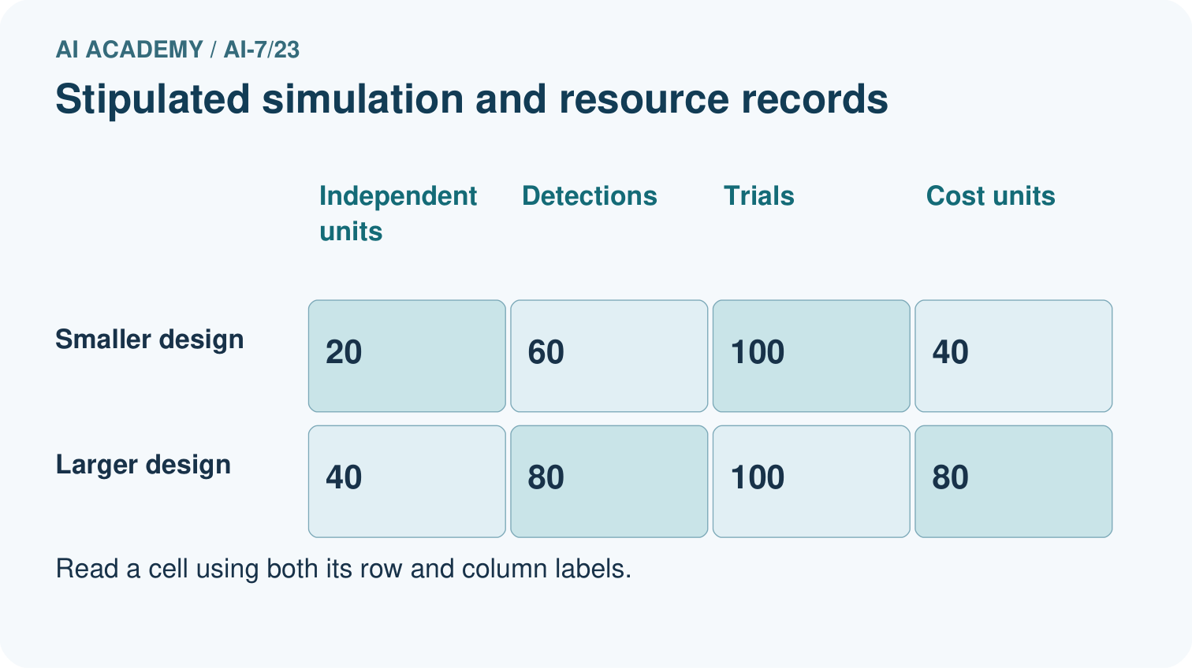
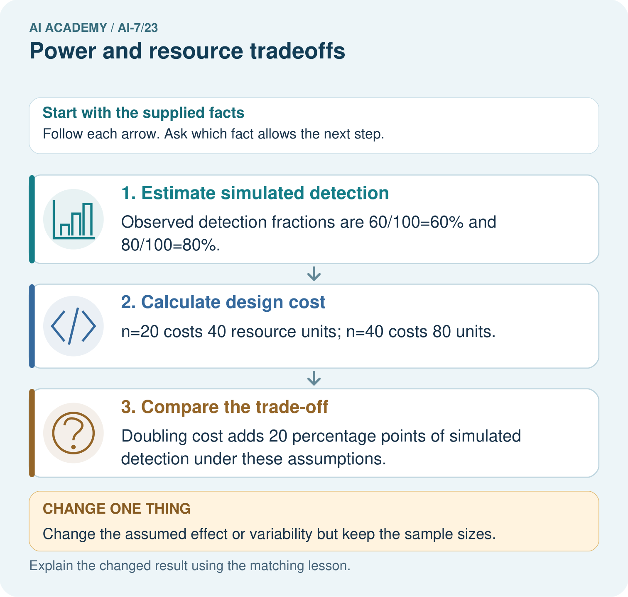
Calculate both simulated detection fractions and resource costs. What additional detection is observed for the extra forty units, and does that establish power for an actual classroom study?

My picture-based explanation and changed-case prediction
________________________________________________________________
________________________________________________________________
________________________________________________________________
________________________________________________________________
________________________________________________________________
________________________________________________________________
Support used: alone / hint / worked example. This record is practice evidence.
Project connection: For the Reproducible AI Research Study, retain an annotated worked trace and the changed-case reasoning. Connect the claim to its records, units and assumptions so another investigator can challenge or reproduce it.

13. Project portfolio milestone
Project: Reproducible AI Research Study
Current milestone: Evaluate and revise. Compare with your starting method, explain errors and record a justified revision.
For the Reproducible AI Research Study, retain an annotated worked trace and the changed-case reasoning. Connect the claim to its records, units and assumptions so another investigator can challenge or reproduce it.
Evidence to keep | My record
This week’s input and deciding step
Prediction and actual result (or labelled paper trace)
One change since the previous checkpoint and why
One error or limit and the next test

Explain what this week adds to your project. Reuse last week’s record rather than starting again.
________________________________________________________________
________________________________________________________________
________________________________________________________________
________________________________________________________________
________________________________________________________________

14. Supported practice and learning evidence
Use this supported practice once, in the browser or on paper. Keep the reserved independent assessment for a separate first attempt before teacher feedback.
A simulated detection-and-resource trade-off. A fictional simulation repeats a study under the same assumed alternative effect, using two independent-unit sample sizes.

Practice 1: explain the deciding evidence
Which labelled step matches this detail? Doubling cost adds 20 percentage points of simulated detection under these assumptions.
1. Compare the trade-off
2. Estimate simulated detection
3. Calculate design cost

My selected conclusion, deciding fact and explanation
________________________________________________________________
________________________________________________________________
________________________________________________________________
________________________________________________________________
________________________________________________________________
Hint if needed: Read the steps in the pictorial case. Match the supplied detail to the stage that performs or records it.
After your attempt, compare with the supported explanation: Compare the trade-off Doubling cost adds 20 percentage points of simulated detection under these assumptions. Power is the probability of detecting a specified effect under a specified model and decision rule. Repeated simulation can estimate it; the estimate depends on effect size, variability, design and test assumptions, not sample size alone.

Practice 2: explain the deciding evidence
Changed-case practice: Change the assumed effect or variability but keep the sample sizes. Which conclusion is supported by the supplied facts?
1. This one example guarantees correct results for every future input.
2. We can decide the result without examining the changed input or the procedure.
3. The detection fractions need new simulation; the resource costs stay 40 and 80.

My selected conclusion, deciding fact and explanation
________________________________________________________________
________________________________________________________________
________________________________________________________________
________________________________________________________________
________________________________________________________________
Hint if needed: Use the changed condition and the deciding step in the pictorial trace. The answer must say what follows from those facts.
After your attempt, compare with the supported explanation: The detection fractions need new simulation; the resource costs stay 40 and 80. Power depends on the data-generating assumptions, while this stated unit-cost calculation does not.

Repair a missing building block
Review Pilot experiments (ai-7/22). Goal: Explain the mechanism and terminology of pilot experiments. Short practice: Calculate reviewer agreement on the four pilot answers. What can the disagreement improve, and why are those revised practice answers not untouched final evidence?. Return to this week and explain what you changed.
Review Privacy and data governance (ai-7/20). Goal: Explain the mechanism and terminology of privacy and data governance. Short practice: Point to the analysis table and the restricted identity key. Why are the codes pseudonymous rather than guaranteed anonymous, and what changes if the key is published?. Return to this week and explain what you changed.
Review Sensitivity analysis (ai-7/17). Goal: Explain the mechanism and terminology of sensitivity analysis. Short practice: Classify 0.4, 0.6 and 0.8 at cutoffs 0.5, 0.7 and exactly 0.6. Which equality rule decides the boundary, and can these unlabelled scores identify the best cutoff?. Return to this week and explain what you changed.

Keep your completed work
Use Download completed work in the hosted lesson to export your answers, reflections, practice feedback and code-run evidence. Open the HTML copy to read or print it. Drafts stay in this browser when storage is available; clear drafts on a shared device.

What I repaired, the evidence I kept and the next test
________________________________________________________________
________________________________________________________________
________________________________________________________________
________________________________________________________________
________________________________________________________________

