AI ACADEMY · WORKBOOK · ai-7/29

Figures that preserve evidence
Project: Reproducible AI Research Study

01. Recall and choose your starting point
Try the recall before opening notes. Then use a different colour or a labelled second line to correct your explanation.

Negative results and claim revision
Without opening the old lesson, explain one key idea from Negative results and claim revision. Give an example and a mistake that the idea helps you avoid.

My remembered idea, example and correction
________________________________________________________________
________________________________________________________________
________________________________________________________________

Inspecting failures and anomalies
Without opening the old lesson, explain one key idea from Inspecting failures and anomalies. Give an example and a mistake that the idea helps you avoid.

My remembered idea, example and correction
________________________________________________________________
________________________________________________________________
________________________________________________________________

Power and resource tradeoffs
Without opening the old lesson, explain one key idea from Power and resource tradeoffs. Give an example and a mistake that the idea helps you avoid.

My remembered idea, example and correction
________________________________________________________________
________________________________________________________________
________________________________________________________________

02. Practise with fading help
Use W2: Trace the worked case for Figures that preserve evidence. Record the answer once; the lesson and workbook refer to the same attempt.
Given inputs | Procedure I chose | Middle steps | Result and check

The step I completed without help, and the hint I needed
________________________________________________________________
________________________________________________________________
________________________________________________________________

03. Individual reasoning check
Use the worked case for Figures that preserve evidence. Proposed explanation: “The worked result establishes every future case”. Decide whether this explanation is supported. Point to the step or supplied fact that decides; explain your repair if needed.

My explanation before partner discussion
________________________________________________________________
________________________________________________________________
________________________________________________________________
________________________________________________________________

04. Independent transfer case

Independent case: Apply a new case independently
CountsA8/10, B9/15 are plotted as8 versus9 without denominators. Correct.

My independent explanation, trace and limits
________________________________________________________________
________________________________________________________________
________________________________________________________________
________________________________________________________________
________________________________________________________________
________________________________________________________________
________________________________________________________________
Attempt this case before feedback. Record any help. Earlier examples below are further practice; a case already practised with feedback cannot establish fresh transfer.

05. W1 Explain the mechanism
Explain the weekly mechanism in your own words. Use the worked scenario to name its input, decision rule and output.

My reasoning and evidence
________________________________________________________________
________________________________________________________________
________________________________________________________________
________________________________________________________________
________________________________________________________________
________________________________________________________________

06. W2 Trace the worked case
RatesA80%, B82% are plotted on bars starting79%, making B look several times larger. Show the intermediate steps and give the conclusion with its scope.

My reasoning and evidence
________________________________________________________________
________________________________________________________________
________________________________________________________________
________________________________________________________________
________________________________________________________________
________________________________________________________________
________________________________________________________________

07. W3 Audit the limit
A report omits this qualification: Visual choices must reflect the intended metric and cannot imply causal certainty from association. Explain how omitting it could change a reader's interpretation, and write an accurate replacement.

My reasoning and evidence
________________________________________________________________
________________________________________________________________
________________________________________________________________
________________________________________________________________
________________________________________________________________
________________________________________________________________

08. W4 Apply a new case independently
CountsA8/10, B9/15 are plotted as8 versus9 without denominators. Correct.

My reasoning and evidence
________________________________________________________________
________________________________________________________________
________________________________________________________________
________________________________________________________________
________________________________________________________________
________________________________________________________________
________________________________________________________________
________________________________________________________________

09. W5 Design a revealing follow-up
For the worked scenario, propose one additional case that could reveal a failure, describe its expected outcome before running it, and explain what would need to remain fixed for a fair comparison. Do not reuse W4 as a new final test after receiving feedback.

My reasoning and evidence
________________________________________________________________
________________________________________________________________
________________________________________________________________
________________________________________________________________
________________________________________________________________
________________________________________________________________
________________________________________________________________

10. Project checkpoint and reflection
Add a labelled figures that preserve evidence evidence sheet to Reproducible AI Research Study. Show how you can explain the mechanism and terminology of figures that preserve evidence. Use the supplied fictional case and keep its inputs, intermediate steps, calculation or prediction, and limitation. Connect this record to last week’s record; a matching answer without a trace is insufficient.

My project change, supporting evidence and remaining limit
________________________________________________________________
________________________________________________________________
________________________________________________________________
________________________________________________________________
________________________________________________________________
________________________________________________________________

11. Feedback, return check and learning record
Evidence | My record
Worked alone / hint / model
First step I repaired and why
New case checked later; date and result
What I can now explain without notes
One remaining question
Revisit this idea with your teacher after a delay. Familiarity is different from explaining and using it on a changed case.

12. Pictorial case practice: Figures that preserve evidence
Draw bars that preserve the comparison. A report plots correct counts for two versions on the same ten cases.
A has 6/10 correct; B has 8/10. The count axis should start at zero and identify the ten-case denominator.
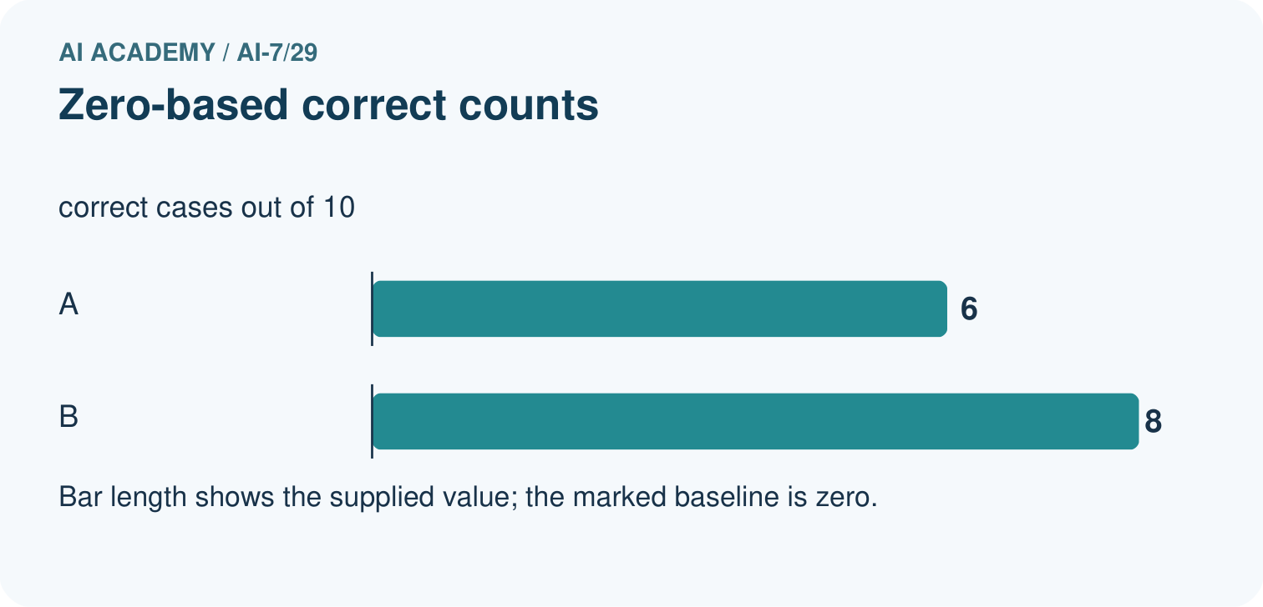
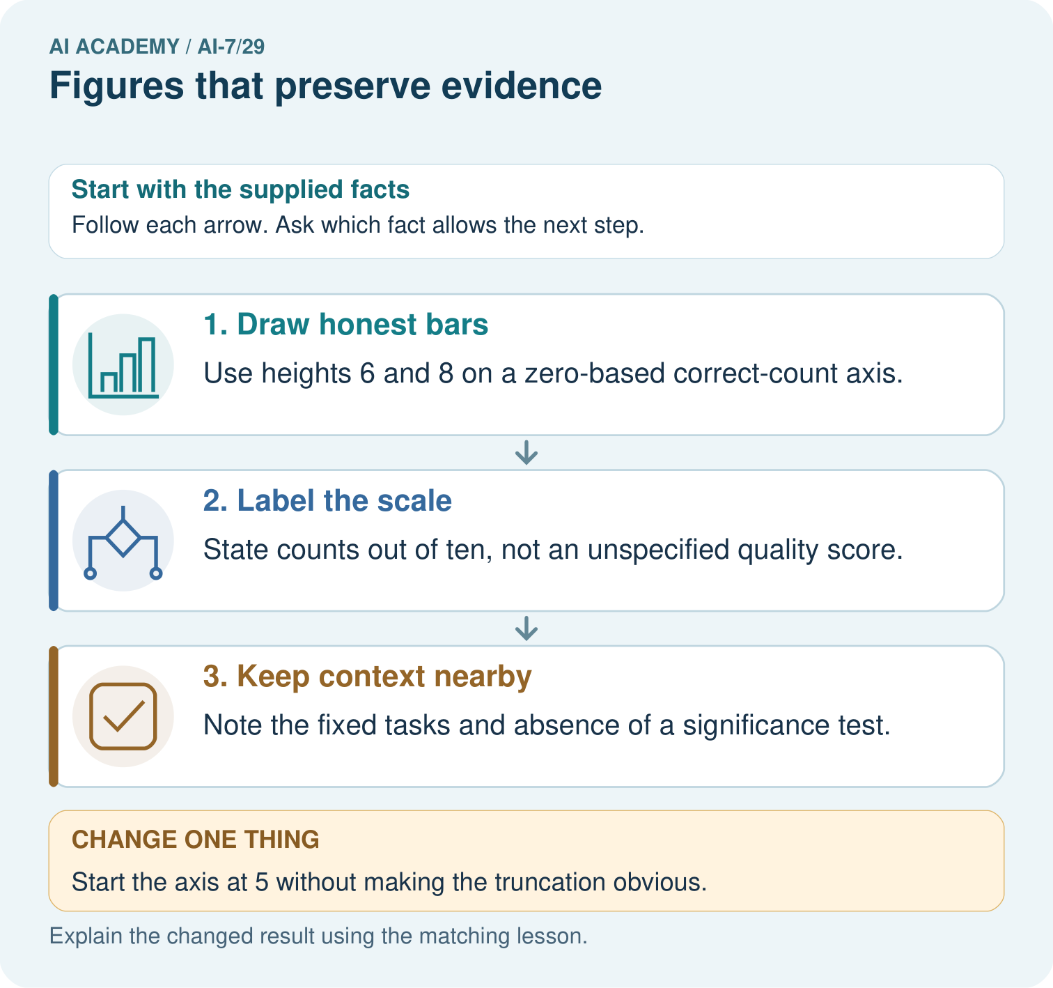
Draw count bars for 6/10 and 8/10 using the stated axis. Why must the denominator and fixed task context remain visible, and what distortion arises from an undisclosed axis start at five?

My picture-based explanation and changed-case prediction
________________________________________________________________
________________________________________________________________
________________________________________________________________
________________________________________________________________
________________________________________________________________
________________________________________________________________
Support used: alone / hint / worked example. This record is practice evidence.
Project connection: For the Reproducible AI Research Study, retain an annotated worked trace and the changed-case reasoning. Connect the claim to its records, units and assumptions so another investigator can challenge or reproduce it.

13. Project portfolio milestone
Project: Reproducible AI Research Study
Current milestone: Prepare the demonstration. Gather reproducible instructions, evidence, access checks and remaining limitations.
For the Reproducible AI Research Study, retain an annotated worked trace and the changed-case reasoning. Connect the claim to its records, units and assumptions so another investigator can challenge or reproduce it.
Evidence to keep | My record
This week’s input and deciding step
Prediction and actual result (or labelled paper trace)
One change since the previous checkpoint and why
One error or limit and the next test

Explain what this week adds to your project. Reuse last week’s record rather than starting again.
________________________________________________________________
________________________________________________________________
________________________________________________________________
________________________________________________________________
________________________________________________________________

14. Supported practice and learning evidence
Use this supported practice once, in the browser or on paper. Keep the reserved independent assessment for a separate first attempt before teacher feedback.
Draw bars that preserve the comparison. A report plots correct counts for two versions on the same ten cases.

Practice 1: explain the deciding evidence
Which labelled step matches this detail? Note the fixed tasks and absence of a significance test.
1. Draw honest bars
2. Label the scale
3. Keep context nearby

My selected conclusion, deciding fact and explanation
________________________________________________________________
________________________________________________________________
________________________________________________________________
________________________________________________________________
________________________________________________________________
Hint if needed: Read the steps in the pictorial case. Match the supplied detail to the stage that performs or records it.
After your attempt, compare with the supported explanation: Keep context nearby Note the fixed tasks and absence of a significance test. Figures make evidence easier to inspect when labels and scales preserve meaning. A dramatic-looking visual cannot supply missing uncertainty or representativeness.

Practice 2: explain the deciding evidence
Changed-case practice: Start the axis at 5 without making the truncation obvious. Which conclusion is supported by the supplied facts?
1. This one example guarantees correct results for every future input.
2. The bars exaggerate the visual contrast and require correction or clear disclosure.
3. We can decide the result without examining the changed input or the procedure.

My selected conclusion, deciding fact and explanation
________________________________________________________________
________________________________________________________________
________________________________________________________________
________________________________________________________________
________________________________________________________________
Hint if needed: Use the changed condition and the deciding step in the pictorial trace. The answer must say what follows from those facts.
After your attempt, compare with the supported explanation: The bars exaggerate the visual contrast and require correction or clear disclosure. Visible heights no longer correspond to the full count scale.

Repair a missing building block
Review Negative results and claim revision (ai-7/28). Goal: Explain the mechanism and terminology of negative results and claim revision. Short practice: Does a 6/8 tie support the prediction that B scores higher? Explain why one newly selected favourable demonstration does not replace the original result or prove equivalence.. Return to this week and explain what you changed.
Review Inspecting failures and anomalies (ai-7/26). Goal: Explain the mechanism and terminology of inspecting failures and anomalies. Short practice: Calculate mean and median for 2,2,2,10. What does the timeout log establish, and why is deleting that inconvenient record incompatible with the stated plan?. Return to this week and explain what you changed.
Review Power and resource tradeoffs (ai-7/23). Goal: Explain the mechanism and terminology of power and resource tradeoffs. Short practice: Calculate both simulated detection fractions and resource costs. What additional detection is observed for the extra forty units, and does that establish power for an actual classroom study?. Return to this week and explain what you changed.

Keep your completed work
Use Download completed work in the hosted lesson to export your answers, reflections, practice feedback and code-run evidence. Open the HTML copy to read or print it. Drafts stay in this browser when storage is available; clear drafts on a shared device.

What I repaired, the evidence I kept and the next test
________________________________________________________________
________________________________________________________________
________________________________________________________________
________________________________________________________________
________________________________________________________________

