AI ACADEMY · WORKBOOK · ai-7/30

Writing the methods section
Project: Reproducible AI Research Study

01. Recall and choose your starting point
Try the recall before opening notes. Then use a different colour or a labelled second line to correct your explanation.

Figures that preserve evidence
Without opening the old lesson, explain one key idea from Figures that preserve evidence. Give an example and a mistake that the idea helps you avoid.

My remembered idea, example and correction
________________________________________________________________
________________________________________________________________
________________________________________________________________

Robustness across conditions
Without opening the old lesson, explain one key idea from Robustness across conditions. Give an example and a mistake that the idea helps you avoid.

My remembered idea, example and correction
________________________________________________________________
________________________________________________________________
________________________________________________________________

Reproducible environment and records
Without opening the old lesson, explain one key idea from Reproducible environment and records. Give an example and a mistake that the idea helps you avoid.

My remembered idea, example and correction
________________________________________________________________
________________________________________________________________
________________________________________________________________

02. Practise with fading help
Use W2: Trace the worked case for Writing the methods section. Record the answer once; the lesson and workbook refer to the same attempt.
Given inputs | Procedure I chose | Middle steps | Result and check

The step I completed without help, and the hint I needed
________________________________________________________________
________________________________________________________________
________________________________________________________________

03. Individual reasoning check
Use the worked case for Writing the methods section. Proposed explanation: “The worked result establishes every future case”. Decide whether this explanation is supported. Point to the step or supplied fact that decides; explain your repair if needed.

My explanation before partner discussion
________________________________________________________________
________________________________________________________________
________________________________________________________________
________________________________________________________________

04. Independent transfer case

Independent case: Apply a new case independently
Methods names a dataset and metric, but not whether near-duplicate sources cross the split. What detail matters?

My independent explanation, trace and limits
________________________________________________________________
________________________________________________________________
________________________________________________________________
________________________________________________________________
________________________________________________________________
________________________________________________________________
________________________________________________________________
Attempt this case before feedback. Record any help. Earlier examples below are further practice; a case already practised with feedback cannot establish fresh transfer.

05. W1 Explain the mechanism
Explain the weekly mechanism in your own words. Use the worked scenario to name its input, decision rule and output.

My reasoning and evidence
________________________________________________________________
________________________________________________________________
________________________________________________________________
________________________________________________________________
________________________________________________________________
________________________________________________________________

06. W2 Trace the worked case
Methods says used AI on data and got good scores; code and split are absent. Show the intermediate steps and give the conclusion with its scope.

My reasoning and evidence
________________________________________________________________
________________________________________________________________
________________________________________________________________
________________________________________________________________
________________________________________________________________
________________________________________________________________
________________________________________________________________

07. W3 Audit the limit
A report omits this qualification: A detailed methods section can reveal limitations; it does not guarantee a correct design. Explain how omitting it could change a reader's interpretation, and write an accurate replacement.

My reasoning and evidence
________________________________________________________________
________________________________________________________________
________________________________________________________________
________________________________________________________________
________________________________________________________________
________________________________________________________________

08. W4 Apply a new case independently
Methods names a dataset and metric, but not whether near-duplicate sources cross the split. What detail matters?

My reasoning and evidence
________________________________________________________________
________________________________________________________________
________________________________________________________________
________________________________________________________________
________________________________________________________________
________________________________________________________________
________________________________________________________________
________________________________________________________________

09. W5 Design a revealing follow-up
For the worked scenario, propose one additional case that could reveal a failure, describe its expected outcome before running it, and explain what would need to remain fixed for a fair comparison. Do not reuse W4 as a new final test after receiving feedback.

My reasoning and evidence
________________________________________________________________
________________________________________________________________
________________________________________________________________
________________________________________________________________
________________________________________________________________
________________________________________________________________
________________________________________________________________

10. Project checkpoint and reflection
Add a labelled writing the methods section evidence sheet to Reproducible AI Research Study. Show how you can explain the mechanism and terminology of writing the methods section. Use the supplied fictional case and keep its inputs, intermediate steps, calculation or prediction, and limitation. Connect this record to last week’s record; a matching answer without a trace is insufficient.

My project change, supporting evidence and remaining limit
________________________________________________________________
________________________________________________________________
________________________________________________________________
________________________________________________________________
________________________________________________________________
________________________________________________________________

11. Feedback, return check and learning record
Evidence | My record
Worked alone / hint / model
First step I repaired and why
New case checked later; date and result
What I can now explain without notes
One remaining question
Revisit this idea with your teacher after a delay. Familiarity is different from explaining and using it on a changed case.

12. Pictorial case practice: Writing the methods section
Methods that another team can repeat. A paper describes a toy string-classification experiment using a stated length rule.
Inputs: "oak", "pine", "willow". Rule: length at least 4→long, otherwise short. No whitespace trimming occurs.
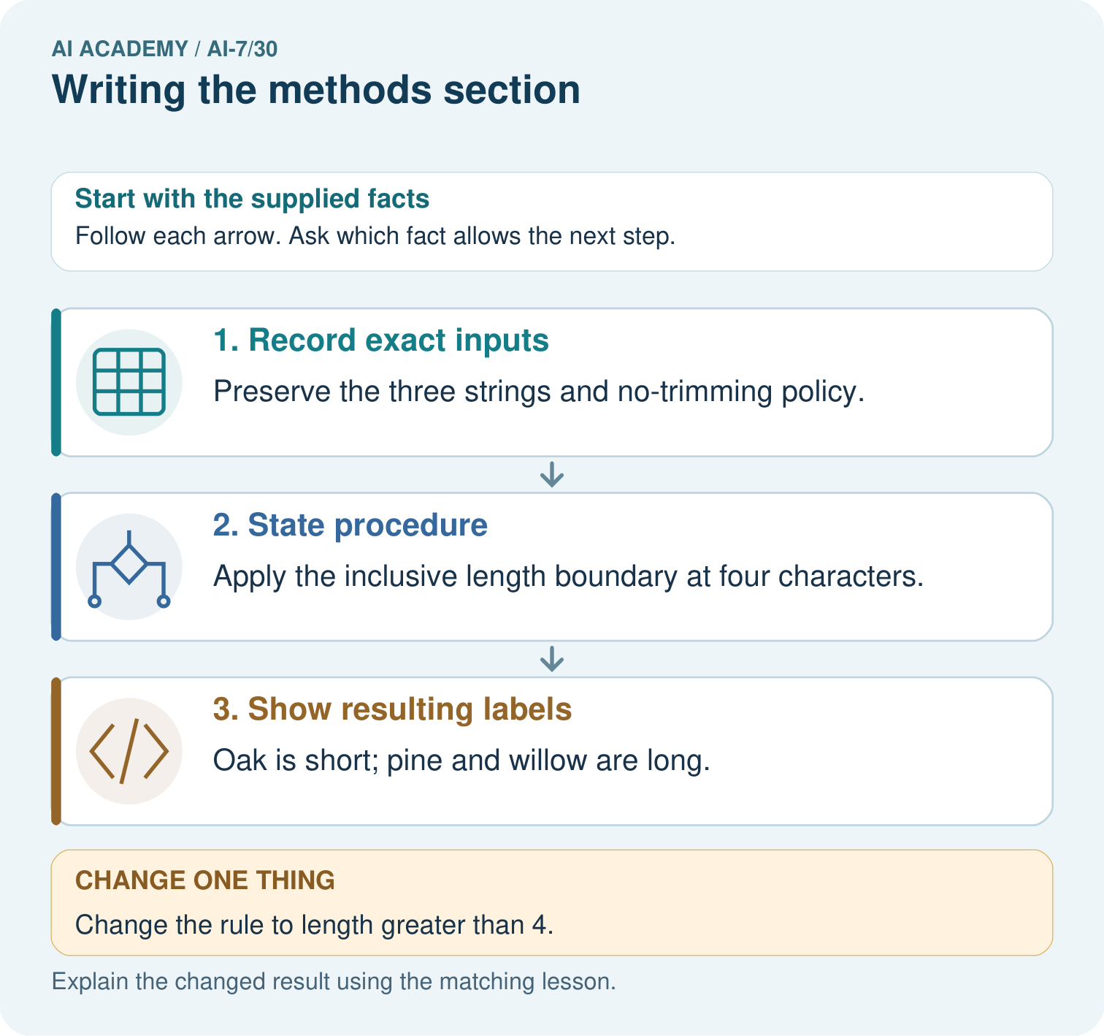
Apply the inclusive four-character rule to oak, pine and willow. Which label changes under greater-than-four, and what method detail allows another team to reproduce the distinction?

My picture-based explanation and changed-case prediction
________________________________________________________________
________________________________________________________________
________________________________________________________________
________________________________________________________________
________________________________________________________________
________________________________________________________________
Support used: alone / hint / worked example. This record is practice evidence.
Project connection: For the Reproducible AI Research Study, retain an annotated worked trace and the changed-case reasoning. Connect the claim to its records, units and assumptions so another investigator can challenge or reproduce it.

13. Project portfolio milestone
Project: Reproducible AI Research Study
Current milestone: Prepare the demonstration. Gather reproducible instructions, evidence, access checks and remaining limitations.
For the Reproducible AI Research Study, retain an annotated worked trace and the changed-case reasoning. Connect the claim to its records, units and assumptions so another investigator can challenge or reproduce it.
Evidence to keep | My record
This week’s input and deciding step
Prediction and actual result (or labelled paper trace)
One change since the previous checkpoint and why
One error or limit and the next test

Explain what this week adds to your project. Reuse last week’s record rather than starting again.
________________________________________________________________
________________________________________________________________
________________________________________________________________
________________________________________________________________
________________________________________________________________

14. Supported practice and learning evidence
Use this supported practice once, in the browser or on paper. Keep the reserved independent assessment for a separate first attempt before teacher feedback.
Methods that another team can repeat. A paper describes a toy string-classification experiment using a stated length rule.

Practice 1: explain the deciding evidence
Which labelled step matches this detail? Oak is short; pine and willow are long.
1. State procedure
2. Record exact inputs
3. Show resulting labels

My selected conclusion, deciding fact and explanation
________________________________________________________________
________________________________________________________________
________________________________________________________________
________________________________________________________________
________________________________________________________________
Hint if needed: Read the steps in the pictorial case. Match the supplied detail to the stage that performs or records it.
After your attempt, compare with the supported explanation: Show resulting labels Oak is short; pine and willow are long. A methods section specifies inputs, processing, boundaries, versions and scoring. Precise procedures allow a reader to repeat the computation instead of inferring it from the final labels.

Practice 2: explain the deciding evidence
Changed-case practice: Change the rule to length greater than 4. Which conclusion is supported by the supplied facts?
1. We can decide the result without examining the changed input or the procedure.
2. Pine becomes short; willow stays long and oak stays short.
3. This one example guarantees correct results for every future input.

My selected conclusion, deciding fact and explanation
________________________________________________________________
________________________________________________________________
________________________________________________________________
________________________________________________________________
________________________________________________________________
Hint if needed: Use the changed condition and the deciding step in the pictorial trace. The answer must say what follows from those facts.
After your attempt, compare with the supported explanation: Pine becomes short; willow stays long and oak stays short. The equality case distinguishes the two procedures.

Repair a missing building block
Review Figures that preserve evidence (ai-7/29). Goal: Explain the mechanism and terminology of figures that preserve evidence. Short practice: Draw count bars for 6/10 and 8/10 using the stated axis. Why must the denominator and fixed task context remain visible, and what distortion arises from an undisclosed axis start at five?. Return to this week and explain what you changed.
Review Robustness across conditions (ai-7/27). Goal: Explain the mechanism and terminology of robustness across conditions. Short practice: Calculate indoor, outdoor and combined rates. Which relevant weakness disappears from view when only the combined rate is reported?. Return to this week and explain what you changed.
Review Reproducible environment and records (ai-7/24). Goal: Explain the mechanism and terminology of reproducible environment and records. Short practice: Trace the recorded mean for 2,4,6 and its changed result for 2,4,9. Which artefacts must accompany the output so another team can identify the exact run?. Return to this week and explain what you changed.

Keep your completed work
Use Download completed work in the hosted lesson to export your answers, reflections, practice feedback and code-run evidence. Open the HTML copy to read or print it. Drafts stay in this browser when storage is available; clear drafts on a shared device.

What I repaired, the evidence I kept and the next test
________________________________________________________________
________________________________________________________________
________________________________________________________________
________________________________________________________________
________________________________________________________________

