AI ACADEMY · WORKBOOK · ai-7/31

Writing results and limitations
Project: Reproducible AI Research Study

01. Recall and choose your starting point
Try the recall before opening notes. Then use a different colour or a labelled second line to correct your explanation.

Writing the methods section
Without opening the old lesson, explain one key idea from Writing the methods section. Give an example and a mistake that the idea helps you avoid.

My remembered idea, example and correction
________________________________________________________________
________________________________________________________________
________________________________________________________________

Negative results and claim revision
Without opening the old lesson, explain one key idea from Negative results and claim revision. Give an example and a mistake that the idea helps you avoid.

My remembered idea, example and correction
________________________________________________________________
________________________________________________________________
________________________________________________________________

Running the primary experiment
Without opening the old lesson, explain one key idea from Running the primary experiment. Give an example and a mistake that the idea helps you avoid.

My remembered idea, example and correction
________________________________________________________________
________________________________________________________________
________________________________________________________________

02. Practise with fading help
Use W2: Trace the worked case for Writing results and limitations. Record the answer once; the lesson and workbook refer to the same attempt.
Given inputs | Procedure I chose | Middle steps | Result and check

The step I completed without help, and the hint I needed
________________________________________________________________
________________________________________________________________
________________________________________________________________

03. Individual reasoning check
Use the worked case for Writing results and limitations. Proposed explanation: “The worked result establishes every future case”. Decide whether this explanation is supported. Point to the step or supplied fact that decides; explain your repair if needed.

My explanation before partner discussion
________________________________________________________________
________________________________________________________________
________________________________________________________________
________________________________________________________________

04. Independent transfer case

Independent case: Apply a new case independently
Candidate10/15, baseline9/15; no timings measured. Write result and two limits.

My independent explanation, trace and limits
________________________________________________________________
________________________________________________________________
________________________________________________________________
________________________________________________________________
________________________________________________________________
________________________________________________________________
________________________________________________________________
Attempt this case before feedback. Record any help. Earlier examples below are further practice; a case already practised with feedback cannot establish fresh transfer.

05. W1 Explain the mechanism
Explain the weekly mechanism in your own words. Use the worked scenario to name its input, decision rule and output.

My reasoning and evidence
________________________________________________________________
________________________________________________________________
________________________________________________________________
________________________________________________________________
________________________________________________________________
________________________________________________________________

06. W2 Trace the worked case
B passes9/12, A8/12; three B failures all concern conflicting sources. No user study occurred. Show the intermediate steps and give the conclusion with its scope.

My reasoning and evidence
________________________________________________________________
________________________________________________________________
________________________________________________________________
________________________________________________________________
________________________________________________________________
________________________________________________________________
________________________________________________________________

07. W3 Audit the limit
A report omits this qualification: A limitation should directly bound the corresponding claim rather than contradict an oversized headline. Explain how omitting it could change a reader's interpretation, and write an accurate replacement.

My reasoning and evidence
________________________________________________________________
________________________________________________________________
________________________________________________________________
________________________________________________________________
________________________________________________________________
________________________________________________________________

08. W4 Apply a new case independently
Candidate10/15, baseline9/15; no timings measured. Write result and two limits.

My reasoning and evidence
________________________________________________________________
________________________________________________________________
________________________________________________________________
________________________________________________________________
________________________________________________________________
________________________________________________________________
________________________________________________________________
________________________________________________________________

09. W5 Design a revealing follow-up
For the worked scenario, propose one additional case that could reveal a failure, describe its expected outcome before running it, and explain what would need to remain fixed for a fair comparison. Do not reuse W4 as a new final test after receiving feedback.

My reasoning and evidence
________________________________________________________________
________________________________________________________________
________________________________________________________________
________________________________________________________________
________________________________________________________________
________________________________________________________________
________________________________________________________________

10. Project checkpoint and reflection
Add a labelled writing results and limitations evidence sheet to Reproducible AI Research Study. Show how you can explain the mechanism and terminology of writing results and limitations. Use the supplied fictional case and keep its inputs, intermediate steps, calculation or prediction, and limitation. Connect this record to last week’s record; a matching answer without a trace is insufficient.

My project change, supporting evidence and remaining limit
________________________________________________________________
________________________________________________________________
________________________________________________________________
________________________________________________________________
________________________________________________________________
________________________________________________________________

11. Feedback, return check and learning record
Evidence | My record
Worked alone / hint / model
First step I repaired and why
New case checked later; date and result
What I can now explain without notes
One remaining question
Revisit this idea with your teacher after a delay. Familiarity is different from explaining and using it on a changed case.

12. Pictorial case practice: Writing results and limitations
Write results without enlarging them. A fictional study evaluates answer support on twelve fixed questions from one approved collection.
A supports 9/12 answers; B supports 10/12. No user learning outcomes are recorded.
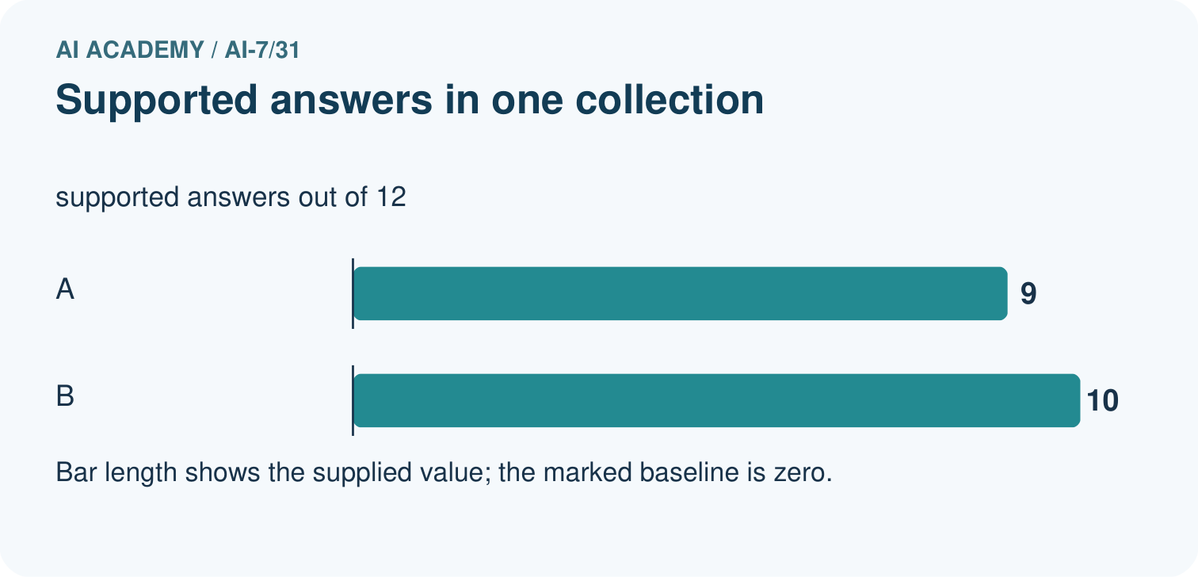
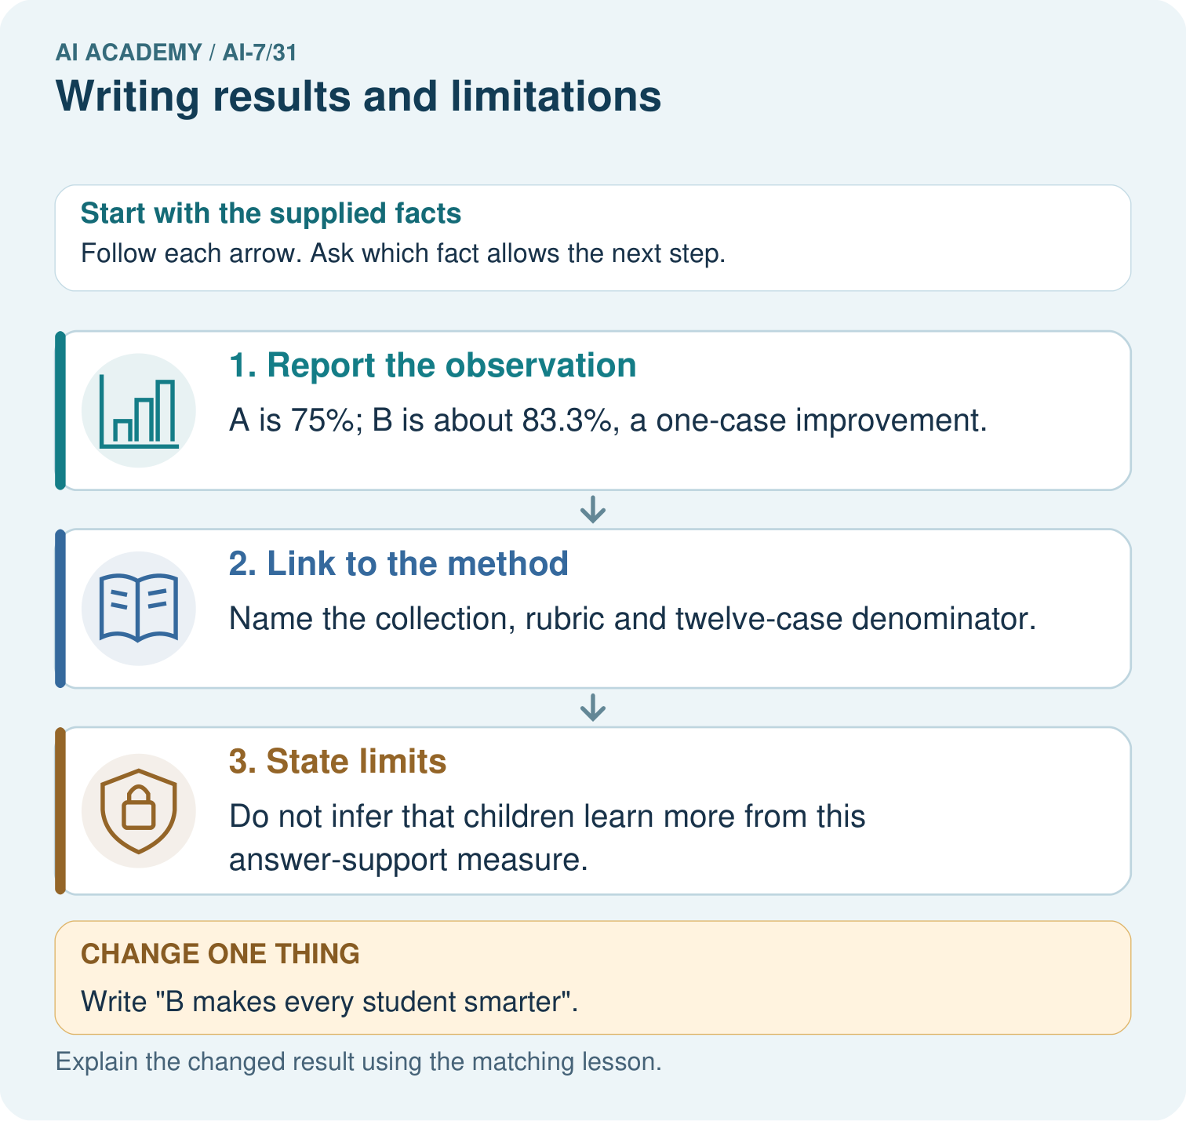
Compute the supported-answer rates for 9/12 and 10/12. What actual outcome was measured, and why is a claim that every student becomes smarter outside this evidence?

My picture-based explanation and changed-case prediction
________________________________________________________________
________________________________________________________________
________________________________________________________________
________________________________________________________________
________________________________________________________________
________________________________________________________________
Support used: alone / hint / worked example. This record is practice evidence.
Project connection: For the Reproducible AI Research Study, retain an annotated worked trace and the changed-case reasoning. Connect the claim to its records, units and assumptions so another investigator can challenge or reproduce it.

13. Project portfolio milestone
Project: Reproducible AI Research Study
Current milestone: Present and defend. Demonstrate the system, explain one failure and justify the next improvement with evidence.
For the Reproducible AI Research Study, retain an annotated worked trace and the changed-case reasoning. Connect the claim to its records, units and assumptions so another investigator can challenge or reproduce it.
Evidence to keep | My record
This week’s input and deciding step
Prediction and actual result (or labelled paper trace)
One change since the previous checkpoint and why
One error or limit and the next test

Explain what this week adds to your project. Reuse last week’s record rather than starting again.
________________________________________________________________
________________________________________________________________
________________________________________________________________
________________________________________________________________
________________________________________________________________

14. Supported practice and learning evidence
Use this supported practice once, in the browser or on paper. Keep the reserved independent assessment for a separate first attempt before teacher feedback.
Write results without enlarging them. A fictional study evaluates answer support on twelve fixed questions from one approved collection.

Practice 1: explain the deciding evidence
Which labelled step matches this detail? Do not infer that children learn more from this answer-support measure.
1. Report the observation
2. Link to the method
3. State limits

My selected conclusion, deciding fact and explanation
________________________________________________________________
________________________________________________________________
________________________________________________________________
________________________________________________________________
________________________________________________________________
Hint if needed: Read the steps in the pictorial case. Match the supplied detail to the stage that performs or records it.
After your attempt, compare with the supported explanation: State limits Do not infer that children learn more from this answer-support measure. Results describe what was measured; limitations prevent substitution of a different outcome or population. A small descriptive improvement needs its scope attached.

Practice 2: explain the deciding evidence
Changed-case practice: Write "B makes every student smarter". Which conclusion is supported by the supplied facts?
1. We can decide the result without examining the changed input or the procedure.
2. This one example guarantees correct results for every future input.
3. Remove that sentence as unsupported by the study.

My selected conclusion, deciding fact and explanation
________________________________________________________________
________________________________________________________________
________________________________________________________________
________________________________________________________________
________________________________________________________________
Hint if needed: Use the changed condition and the deciding step in the pictorial trace. The answer must say what follows from those facts.
After your attempt, compare with the supported explanation: Remove that sentence as unsupported by the study. The measured unit was answers, not student understanding or intelligence.

Repair a missing building block
Review Writing the methods section (ai-7/30). Goal: Explain the mechanism and terminology of writing the methods section. Short practice: Apply the inclusive four-character rule to oak, pine and willow. Which label changes under greater-than-four, and what method detail allows another team to reproduce the distinction?. Return to this week and explain what you changed.
Review Negative results and claim revision (ai-7/28). Goal: Explain the mechanism and terminology of negative results and claim revision. Short practice: Does a 6/8 tie support the prediction that B scores higher? Explain why one newly selected favourable demonstration does not replace the original result or prove equivalence.. Return to this week and explain what you changed.
Review Running the primary experiment (ai-7/25). Goal: Explain the mechanism and terminology of running the primary experiment. Short practice: Compute A’s and B’s six-case counts and identify the cases that favour each. How must a B revision tuned on case four be labelled when evaluated again on the same set?. Return to this week and explain what you changed.

Keep your completed work
Use Download completed work in the hosted lesson to export your answers, reflections, practice feedback and code-run evidence. Open the HTML copy to read or print it. Drafts stay in this browser when storage is available; clear drafts on a shared device.

What I repaired, the evidence I kept and the next test
________________________________________________________________
________________________________________________________________
________________________________________________________________
________________________________________________________________
________________________________________________________________

