AI ACADEMY · WORKBOOK · ai-7/34

Final project manuscript
Project: Reproducible AI Research Study

01. Recall and choose your starting point
Try the recall before opening notes. Then use a different colour or a labelled second line to correct your explanation.

Independent reproduction check
Without opening the old lesson, explain one key idea from Independent reproduction check. Give an example and a mistake that the idea helps you avoid.

My remembered idea, example and correction
________________________________________________________________
________________________________________________________________
________________________________________________________________

Writing results and limitations
Without opening the old lesson, explain one key idea from Writing results and limitations. Give an example and a mistake that the idea helps you avoid.

My remembered idea, example and correction
________________________________________________________________
________________________________________________________________
________________________________________________________________

Negative results and claim revision
Without opening the old lesson, explain one key idea from Negative results and claim revision. Give an example and a mistake that the idea helps you avoid.

My remembered idea, example and correction
________________________________________________________________
________________________________________________________________
________________________________________________________________

02. Practise with fading help
Use W2: Trace the worked case for Final project manuscript. Record the answer once; the lesson and workbook refer to the same attempt.
Given inputs | Procedure I chose | Middle steps | Result and check

The step I completed without help, and the hint I needed
________________________________________________________________
________________________________________________________________
________________________________________________________________

03. Individual reasoning check
Use the worked case for Final project manuscript. Proposed explanation: “The worked result establishes every future case”. Decide whether this explanation is supported. Point to the step or supplied fact that decides; explain your repair if needed.

My explanation before partner discussion
________________________________________________________________
________________________________________________________________
________________________________________________________________
________________________________________________________________

04. Independent transfer case

Independent case: Apply a new case independently
Manuscript says12 evaluated cases, raw record has10 completed and2 missing with8 passes. Correct the summary.

My independent explanation, trace and limits
________________________________________________________________
________________________________________________________________
________________________________________________________________
________________________________________________________________
________________________________________________________________
________________________________________________________________
________________________________________________________________
Attempt this case before feedback. Record any help. Earlier examples below are further practice; a case already practised with feedback cannot establish fresh transfer.

05. W1 Explain the mechanism
Explain the weekly mechanism in your own words. Use the worked scenario to name its input, decision rule and output.

My reasoning and evidence
________________________________________________________________
________________________________________________________________
________________________________________________________________
________________________________________________________________
________________________________________________________________
________________________________________________________________

06. W2 Trace the worked case
Abstract says100% success; results table shows18/20, and two failures are omitted from the figure. Show the intermediate steps and give the conclusion with its scope.

My reasoning and evidence
________________________________________________________________
________________________________________________________________
________________________________________________________________
________________________________________________________________
________________________________________________________________
________________________________________________________________
________________________________________________________________

07. W3 Audit the limit
A report omits this qualification: A manuscript is ready only when its claims and artifacts align; formatting alone cannot certify evidence. Explain how omitting it could change a reader's interpretation, and write an accurate replacement.

My reasoning and evidence
________________________________________________________________
________________________________________________________________
________________________________________________________________
________________________________________________________________
________________________________________________________________
________________________________________________________________

08. W4 Apply a new case independently
Manuscript says12 evaluated cases, raw record has10 completed and2 missing with8 passes. Correct the summary.

My reasoning and evidence
________________________________________________________________
________________________________________________________________
________________________________________________________________
________________________________________________________________
________________________________________________________________
________________________________________________________________
________________________________________________________________
________________________________________________________________

09. W5 Design a revealing follow-up
For the worked scenario, propose one additional case that could reveal a failure, describe its expected outcome before running it, and explain what would need to remain fixed for a fair comparison. Do not reuse W4 as a new final test after receiving feedback.

My reasoning and evidence
________________________________________________________________
________________________________________________________________
________________________________________________________________
________________________________________________________________
________________________________________________________________
________________________________________________________________
________________________________________________________________

10. Project checkpoint and reflection
For Reproducible AI Research Study, use this week’s independent task as a rehearsal for the final evidence pack: Manuscript says12 evaluated cases, raw record has10 completed and2 missing with8 passes. Correct the summary. Keep actual observations separate from expected results, preserve failures, compare a baseline and explain the limits.

My project change, supporting evidence and remaining limit
________________________________________________________________
________________________________________________________________
________________________________________________________________
________________________________________________________________
________________________________________________________________
________________________________________________________________

11. Feedback, return check and learning record
Evidence | My record
Worked alone / hint / model
First step I repaired and why
New case checked later; date and result
What I can now explain without notes
One remaining question
Revisit this idea with your teacher after a delay. Familiarity is different from explaining and using it on a changed case.

12. Pictorial case practice: Final project manuscript
Build a manuscript from claim to record. A capstone manuscript compares two frozen pattern classifiers on ten reserved cases.
A is correct on 7/10; B on 8/10. All cases are indoor, from five plants with two views each.
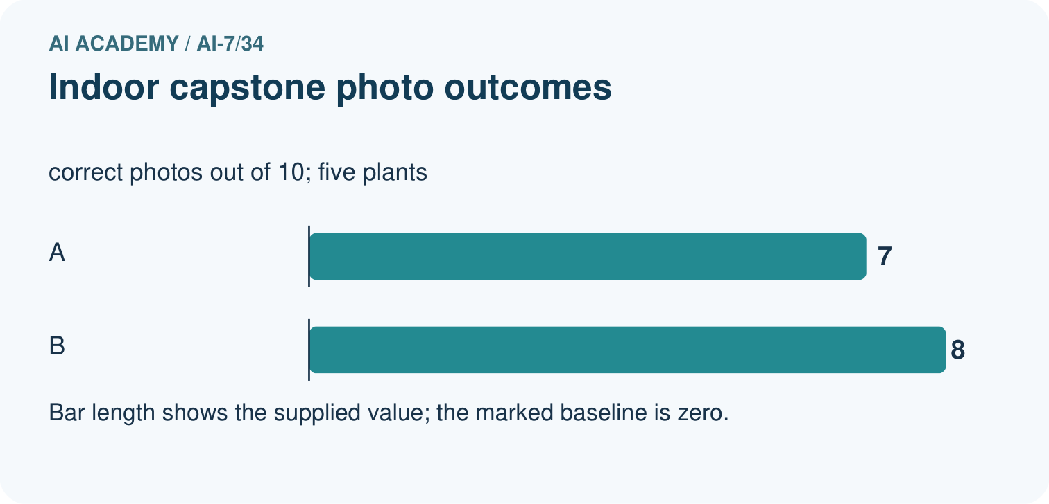
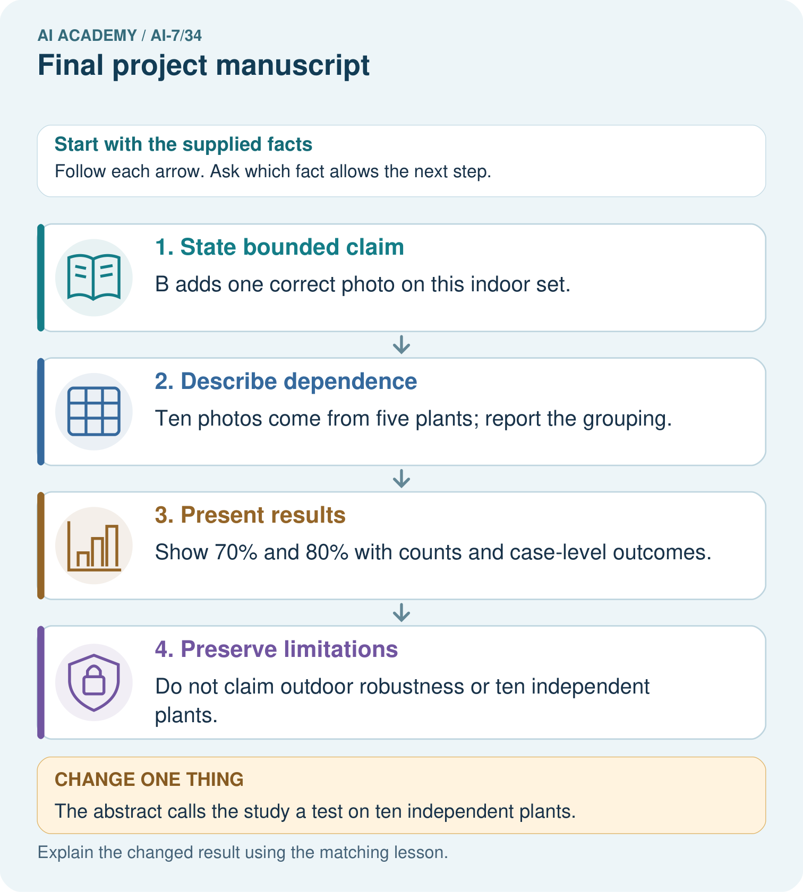
Connect the manuscript’s 7/10 and 8/10 scores to the five-plant grouping. Which abstract claim must be corrected if it says ten independent plants?

My picture-based explanation and changed-case prediction
________________________________________________________________
________________________________________________________________
________________________________________________________________
________________________________________________________________
________________________________________________________________
________________________________________________________________
Support used: alone / hint / worked example. This record is practice evidence.
Project connection: For the Reproducible AI Research Study, retain an annotated worked trace and the changed-case reasoning. Connect the claim to its records, units and assumptions so another investigator can challenge or reproduce it.

13. Project portfolio milestone
Project: Reproducible AI Research Study
Current milestone: Present and defend. Demonstrate the system, explain one failure and justify the next improvement with evidence.
For the Reproducible AI Research Study, retain an annotated worked trace and the changed-case reasoning. Connect the claim to its records, units and assumptions so another investigator can challenge or reproduce it.
Evidence to keep | My record
This week’s input and deciding step
Prediction and actual result (or labelled paper trace)
One change since the previous checkpoint and why
One error or limit and the next test

Explain what this week adds to your project. Reuse last week’s record rather than starting again.
________________________________________________________________
________________________________________________________________
________________________________________________________________
________________________________________________________________
________________________________________________________________

14. Supported practice and learning evidence
Use this supported practice once, in the browser or on paper. Keep the reserved independent assessment for a separate first attempt before teacher feedback.
Build a manuscript from claim to record. A capstone manuscript compares two frozen pattern classifiers on ten reserved cases.

Practice 1: explain the deciding evidence
Which labelled step matches this detail? Do not claim outdoor robustness or ten independent plants.
1. Present results
2. Describe dependence
3. State bounded claim
4. Preserve limitations

My selected conclusion, deciding fact and explanation
________________________________________________________________
________________________________________________________________
________________________________________________________________
________________________________________________________________
________________________________________________________________
Hint if needed: Read the steps in the pictorial case. Match the supplied detail to the stage that performs or records it.
After your attempt, compare with the supported explanation: Preserve limitations Do not claim outdoor robustness or ten independent plants. A final manuscript aligns question, procedure, evidence and scope. Every figure and conclusion should point back to the records that support it.

Practice 2: explain the deciding evidence
Changed-case practice: The abstract calls the study a test on ten independent plants. Which conclusion is supported by the supplied facts?
1. We can decide the result without examining the changed input or the procedure.
2. Correct it to five plants with two views each.
3. This one example guarantees correct results for every future input.

My selected conclusion, deciding fact and explanation
________________________________________________________________
________________________________________________________________
________________________________________________________________
________________________________________________________________
________________________________________________________________
Hint if needed: Use the changed condition and the deciding step in the pictorial trace. The answer must say what follows from those facts.
After your attempt, compare with the supported explanation: Correct it to five plants with two views each. The source-object count, not the photo count, defines the independent plants.

Repair a missing building block
Review Independent reproduction check (ai-7/33). Goal: Explain the mechanism and terminology of independent reproduction check. Short practice: Locate the Q3 scoring disagreement between 5/6 and 4/6. What should the teams inspect before choosing a score, and what limitation follows if the saved Q3 file is missing?. Return to this week and explain what you changed.
Review Writing results and limitations (ai-7/31). Goal: Explain the mechanism and terminology of writing results and limitations. Short practice: Compute the supported-answer rates for 9/12 and 10/12. What actual outcome was measured, and why is a claim that every student becomes smarter outside this evidence?. Return to this week and explain what you changed.
Review Negative results and claim revision (ai-7/28). Goal: Explain the mechanism and terminology of negative results and claim revision. Short practice: Does a 6/8 tie support the prediction that B scores higher? Explain why one newly selected favourable demonstration does not replace the original result or prove equivalence.. Return to this week and explain what you changed.

Keep your completed work
Use Download completed work in the hosted lesson to export your answers, reflections, practice feedback and code-run evidence. Open the HTML copy to read or print it. Drafts stay in this browser when storage is available; clear drafts on a shared device.

What I repaired, the evidence I kept and the next test
________________________________________________________________
________________________________________________________________
________________________________________________________________
________________________________________________________________
________________________________________________________________

