AI ACADEMY · WORKBOOK · python-bridge/2

Values variables and types
Project: Python readiness portfolio

01. Recall and choose your starting point
Try the recall before opening notes. Then use a different colour or a labelled second line to correct your explanation.

From a paper algorithm to Python
Without opening the old lesson, explain one key idea from From a paper algorithm to Python. Give an example and a mistake that the idea helps you avoid.

My remembered idea, example and correction
________________________________________________________________
________________________________________________________________
________________________________________________________________

02. Practise with fading help
Use W2: Trace a saved value for Values variables and types. Record the answer once; the lesson and workbook refer to the same attempt.
Given inputs | Procedure I chose | Middle steps | Result and check

The step I completed without help, and the hint I needed
________________________________________________________________
________________________________________________________________
________________________________________________________________

03. Individual reasoning check
Use the worked case for Values variables and types. Proposed explanation: “Digits always mean a number”. Decide whether this explanation is supported. Point to the step or supplied fact that decides; explain your repair if needed.

My explanation before partner discussion
________________________________________________________________
________________________________________________________________
________________________________________________________________
________________________________________________________________

04. Independent transfer case

Independent case: Trace values, types and reassignment
Predict both output lines and explain why estimate stays unchanged when count is reassigned. Repeat the trace with initial count=0. Explain why note is text even though its printed characters look like a number.
count = 4
note = "4"
estimate = count / 2
fits = count <= 5
count = count + 3
print(count, note, estimate, fits)
print(type(count).__name__, type(note).__name__, type(estimate).__name__, type(fits).__name__)

My independent explanation, trace and limits
________________________________________________________________
________________________________________________________________
________________________________________________________________
________________________________________________________________
________________________________________________________________
________________________________________________________________
________________________________________________________________
Attempt this case before feedback. Record any help. Earlier examples below are further practice; a case already practised with feedback cannot establish fresh transfer.

05. W1 Identify the value and its type
Classify 12, 1.5, "12", False and "False". Explain why the last two are different.

My reasoning and evidence
________________________________________________________________
________________________________________________________________
________________________________________________________________
________________________________________________________________
________________________________________________________________
________________________________________________________________

06. W2 Trace a saved value
Trace the five-line count and saved program. Record both printed outputs, then predict the result of assigning saved = count after the change. Check with a run or label a paper trace.

My reasoning and evidence
________________________________________________________________
________________________________________________________________
________________________________________________________________
________________________________________________________________
________________________________________________________________
________________________________________________________________

07. W3 Diagnose the operation
Predict 6 + 3, "6" + "3" and "6" * 3. Explain what happens for "6" + 3. Which expression counts six groups of three?

My reasoning and evidence
________________________________________________________________
________________________________________________________________
________________________________________________________________
________________________________________________________________
________________________________________________________________
________________________________________________________________

08. W4 Trace a new pair of names independently
A fresh script runs seats = 12; booked = seats; seats = seats - 5; print(seats); print(booked), with each statement on a separate line. Predict both outputs. Then add booked = seats + 1 and print(booked). Explain the evaluation order and choose a type for a seat label "07".

My reasoning and evidence
________________________________________________________________
________________________________________________________________
________________________________________________________________
________________________________________________________________
________________________________________________________________
________________________________________________________________
________________________________________________________________

09. W5 Separate type from validity
Give a suitable type for a counter count, a length of 2.5 metres, a shelf ID with a leading zero, and a yes-or-no availability flag. Give a count value with the right type that should still be rejected.

My reasoning and evidence
________________________________________________________________
________________________________________________________________
________________________________________________________________
________________________________________________________________
________________________________________________________________
________________________________________________________________

10. Project checkpoint and reflection
Add a labelled values variables and types evidence sheet to Python readiness portfolio. Show how you can distinguish integer, floating-point, text and boolean values. Use the supplied fictional case and keep its inputs, intermediate steps, calculation or prediction, and limitation. Connect this record to last week’s record; a matching answer without a trace is insufficient.

My project change, supporting evidence and remaining limit
________________________________________________________________
________________________________________________________________
________________________________________________________________
________________________________________________________________
________________________________________________________________
________________________________________________________________

11. Feedback, return check and learning record
Evidence | My record
Worked alone / hint / model
First step I repaired and why
New case checked later; date and result
What I can now explain without notes
One remaining question
Revisit this idea with your teacher after a delay. Familiarity is different from explaining and using it on a changed case.

12. Pictorial case practice: Values variables and types
A number and its printed-looking text. A program stores a numeric badge count and a string that looks like that count.
Python 3: count=8; tag="8"; print(count+2); print(tag+"2").
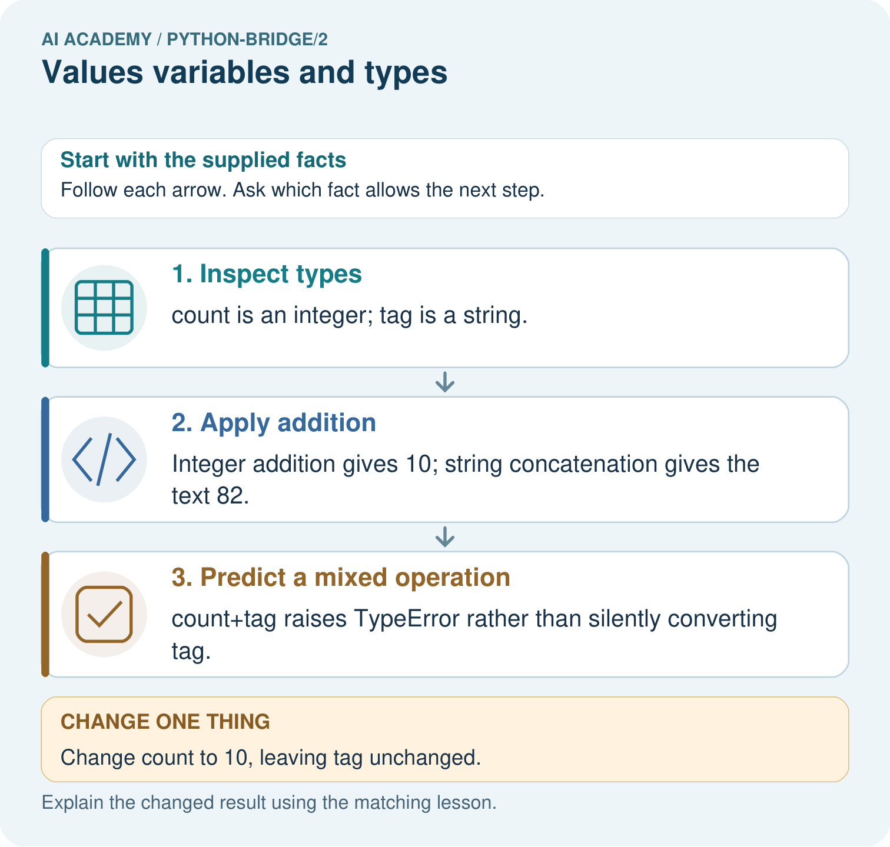
Predict both print outputs and explain why they differ. Does count+tag work, and what happens to each valid output after count becomes ten?

My picture-based explanation and changed-case prediction
________________________________________________________________
________________________________________________________________
________________________________________________________________
________________________________________________________________
________________________________________________________________
________________________________________________________________
Support used: alone / hint / worked example. This record is practice evidence.
Project connection: For Python readiness before the Responsible Plant Classifier, retain a trace of the values, the predicted outputs and the changed-case explanation. Use actual Python 3 results to check the prediction after reasoning first.

13. Project portfolio milestone
Project: Python readiness portfolio
Current milestone: Python readiness portfolio. Keep runnable code, predictions, actual outputs, one repaired error and an explanation of a function on changed inputs.
For Python readiness before the Responsible Plant Classifier, retain a trace of the values, the predicted outputs and the changed-case explanation. Use actual Python 3 results to check the prediction after reasoning first.
Evidence to keep | My record
This week’s input and deciding step
Prediction and actual result (or labelled paper trace)
One change since the previous checkpoint and why
One error or limit and the next test

Explain what this week adds to your project. Reuse last week’s record rather than starting again.
________________________________________________________________
________________________________________________________________
________________________________________________________________
________________________________________________________________
________________________________________________________________

14. Supported practice and learning evidence
Use this supported practice once, in the browser or on paper. Keep the reserved independent assessment for a separate first attempt before teacher feedback.
A number and its printed-looking text. A program stores a numeric badge count and a string that looks like that count.

Practice 1: explain the deciding evidence
Which labelled step matches this detail? count+tag raises TypeError rather than silently converting tag.
1. Predict a mixed operation
2. Inspect types
3. Apply addition

My selected conclusion, deciding fact and explanation
________________________________________________________________
________________________________________________________________
________________________________________________________________
________________________________________________________________
________________________________________________________________
Hint if needed: Read the steps in the pictorial case. Match the supplied detail to the stage that performs or records it.
After your attempt, compare with the supported explanation: Predict a mixed operation count+tag raises TypeError rather than silently converting tag. Values carry types, not merely appearances. The plus operator performs numeric addition for these integers and concatenation for these strings; the mixed operation is invalid here.

Practice 2: explain the deciding evidence
Changed-case practice: Change count to 10, leaving tag unchanged. Which conclusion is supported by the supplied facts?
1. This one example guarantees correct results for every future input.
2. We can decide the result without examining the changed input or the procedure.
3. The two valid outputs become 12 and 82.

My selected conclusion, deciding fact and explanation
________________________________________________________________
________________________________________________________________
________________________________________________________________
________________________________________________________________
________________________________________________________________
Hint if needed: Use the changed condition and the deciding step in the pictorial trace. The answer must say what follows from those facts.
After your attempt, compare with the supported explanation: The two valid outputs become 12 and 82. Only the integer variable changes; the string still contains the character 8.

Repair a missing building block
Review From a paper algorithm to Python (python-bridge/1). Goal: Translate a short paper calculation into a Python script. Short practice: Match each paper quantity to its Python name. Why does the spare count get added once, and what prints when spare is five?. Return to this week and explain what you changed.

Predict, run and debug
The browser lab lets you edit the supported Python examples already included in this lesson. Predict first, run, inspect the actual output or error, change one input, then run again. Keep code, predictions, actual results and a reasoned revision together. On paper, label your result as a trace rather than an execution.

Keep your completed work
Use Download completed work in the hosted lesson to export your answers, reflections, practice feedback and code-run evidence. Open the HTML copy to read or print it. Drafts stay in this browser when storage is available; clear drafts on a shared device.

What I repaired, the evidence I kept and the next test
________________________________________________________________
________________________________________________________________
________________________________________________________________
________________________________________________________________
________________________________________________________________

