AI ACADEMY · WORKBOOK · python-bridge/3

Expressions and operator order
Project: Python readiness portfolio

01. Recall and choose your starting point
Try the recall before opening notes. Then use a different colour or a labelled second line to correct your explanation.

Values variables and types
Without opening the old lesson, explain one key idea from Values variables and types. Give an example and a mistake that the idea helps you avoid.

My remembered idea, example and correction
________________________________________________________________
________________________________________________________________
________________________________________________________________

02. Practise with fading help
Use W2: Predict then test expressions for Expressions and operator order. Record the answer once; the lesson and workbook refer to the same attempt.
Given inputs | Procedure I chose | Middle steps | Result and check

The step I completed without help, and the hint I needed
________________________________________________________________
________________________________________________________________
________________________________________________________________

03. Individual reasoning check
Use the worked case for Expressions and operator order. Proposed explanation: “All operations are read left to right regardless of precedence”. Decide whether this explanation is supported. Point to the step or supplied fact that decides; explain your repair if needed.

My explanation before partner discussion
________________________________________________________________
________________________________________________________________
________________________________________________________________
________________________________________________________________

04. Independent transfer case

Independent case: Group an expression deliberately
Predict each line. Explain which calculation groups addition before division. What would (17+5)%5 return, and how do /, // and % differ for the supplied positive integers?
print((17 + 5) // 5)
print(17 + 5 // 5)
print(17 / 5, 17 // 5, 17 % 5)

My independent explanation, trace and limits
________________________________________________________________
________________________________________________________________
________________________________________________________________
________________________________________________________________
________________________________________________________________
________________________________________________________________
________________________________________________________________
Attempt this case before feedback. Record any help. Earlier examples below are further practice; a case already practised with feedback cannot establish fresh transfer.

05. W1 State the intended grouping
Write an expression for three packs of eight counters plus two loose counters. Explain why adding two within the parentheses for every pack describes a different situation.

My reasoning and evidence
________________________________________________________________
________________________________________________________________
________________________________________________________________
________________________________________________________________
________________________________________________________________
________________________________________________________________

06. W2 Predict then test expressions
Predict 16 - 5 - 3, 16 - (5 - 3), and 18 / 3 * 2. Write the grouping, run each line and record actual results separately.

My reasoning and evidence
________________________________________________________________
________________________________________________________________
________________________________________________________________
________________________________________________________________
________________________________________________________________
________________________________________________________________

07. W3 Explain whole groups
For 17 counters in groups of 5, explain /, // and %. Show a multiplication-and-addition check for the complete groups and remainder.

My reasoning and evidence
________________________________________________________________
________________________________________________________________
________________________________________________________________
________________________________________________________________
________________________________________________________________
________________________________________________________________

08. W4 Translate a new situation independently
Four trays hold six tiles each and five tiles are loose. Write and evaluate the total expression. Then pack the total into complete groups of four and find the remainder. Explain why 4 * (6 + 5) is wrong for this story.

My reasoning and evidence
________________________________________________________________
________________________________________________________________
________________________________________________________________
________________________________________________________________
________________________________________________________________
________________________________________________________________
________________________________________________________________

09. W5 Check a limit
Explain why a group size of zero must be excluded. State the assumptions that let complete groups and a remainder describe the packing task.

My reasoning and evidence
________________________________________________________________
________________________________________________________________
________________________________________________________________
________________________________________________________________
________________________________________________________________
________________________________________________________________

10. Project checkpoint and reflection
Add a labelled expressions and operator order evidence sheet to Python readiness portfolio. Show how you can evaluate numeric expressions using python’s grouping rules. Use the supplied fictional case and keep its inputs, intermediate steps, calculation or prediction, and limitation. Connect this record to last week’s record; a matching answer without a trace is insufficient.

My project change, supporting evidence and remaining limit
________________________________________________________________
________________________________________________________________
________________________________________________________________
________________________________________________________________
________________________________________________________________
________________________________________________________________

11. Feedback, return check and learning record
Evidence | My record
Worked alone / hint / model
First step I repaired and why
New case checked later; date and result
What I can now explain without notes
One remaining question
Revisit this idea with your teacher after a delay. Familiarity is different from explaining and using it on a changed case.

12. Pictorial case practice: Expressions and operator order
Parentheses change an expression. A toy shelf calculator compares adding a fixed cost after multiplication with multiplying an entire group.
Python 3: print(3+2*5); print((3+2)*5). Inputs are dimensionless for this arithmetic exercise.
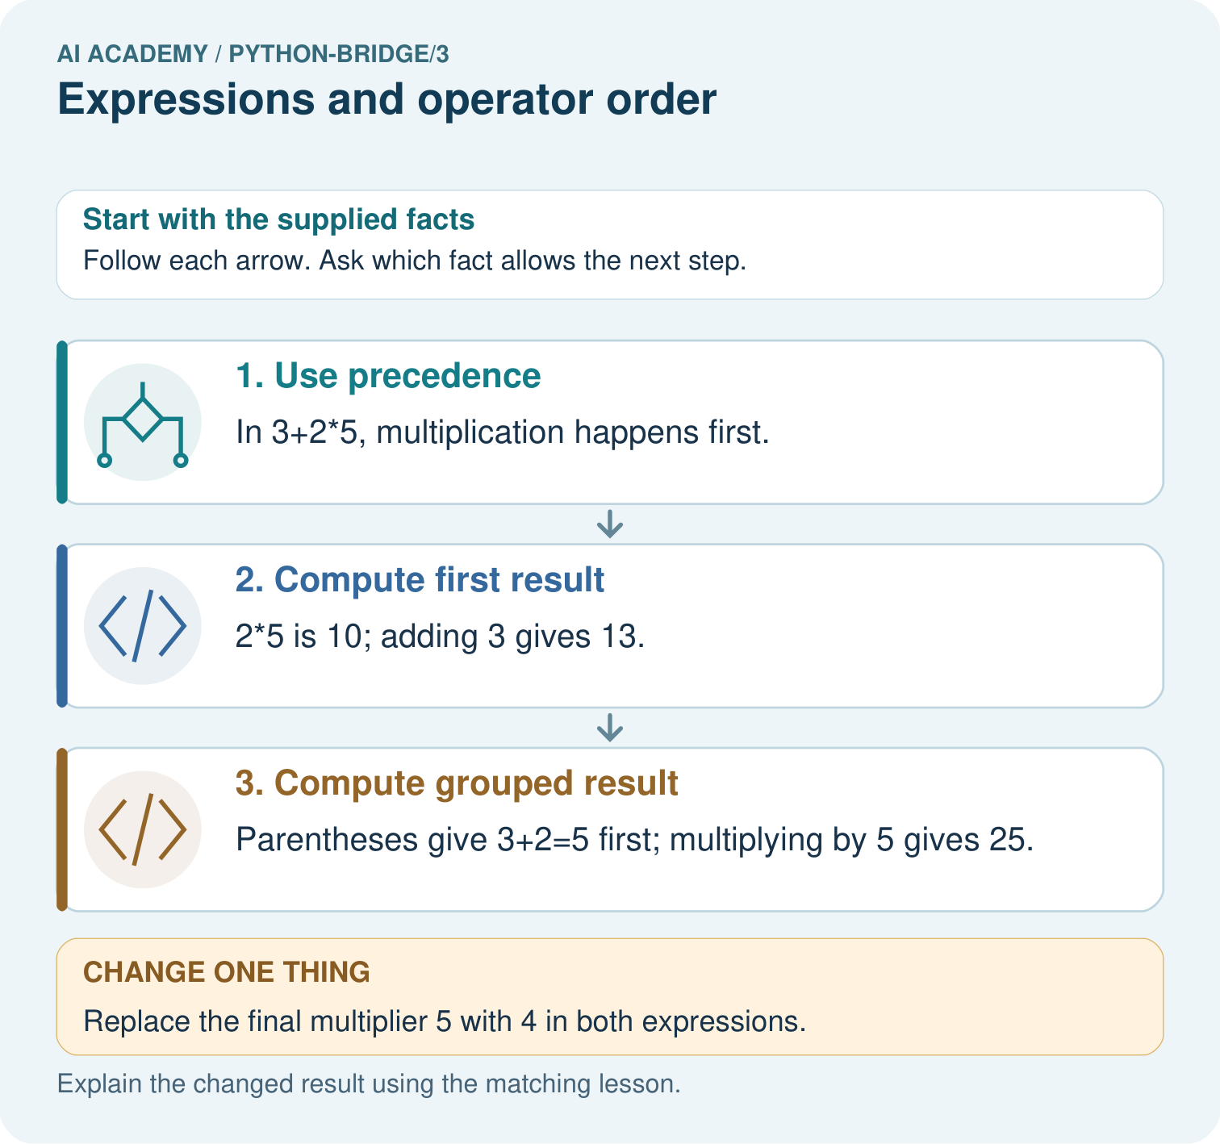
Trace the operation order in both expressions. Identify which picture step changes with parentheses and predict both results when the multiplier becomes four.

My picture-based explanation and changed-case prediction
________________________________________________________________
________________________________________________________________
________________________________________________________________
________________________________________________________________
________________________________________________________________
________________________________________________________________
Support used: alone / hint / worked example. This record is practice evidence.
Project connection: For Python readiness before the Responsible Plant Classifier, retain a trace of the values, the predicted outputs and the changed-case explanation. Use actual Python 3 results to check the prediction after reasoning first.

13. Project portfolio milestone
Project: Python readiness portfolio
Current milestone: Python readiness portfolio. Keep runnable code, predictions, actual outputs, one repaired error and an explanation of a function on changed inputs.
For Python readiness before the Responsible Plant Classifier, retain a trace of the values, the predicted outputs and the changed-case explanation. Use actual Python 3 results to check the prediction after reasoning first.
Evidence to keep | My record
This week’s input and deciding step
Prediction and actual result (or labelled paper trace)
One change since the previous checkpoint and why
One error or limit and the next test

Explain what this week adds to your project. Reuse last week’s record rather than starting again.
________________________________________________________________
________________________________________________________________
________________________________________________________________
________________________________________________________________
________________________________________________________________

14. Supported practice and learning evidence
Use this supported practice once, in the browser or on paper. Keep the reserved independent assessment for a separate first attempt before teacher feedback.
Parentheses change an expression. A toy shelf calculator compares adding a fixed cost after multiplication with multiplying an entire group.

Practice 1: explain the deciding evidence
Which labelled step matches this detail? Parentheses give 3+2=5 first; multiplying by 5 gives 25.
1. Compute grouped result
2. Use precedence
3. Compute first result

My selected conclusion, deciding fact and explanation
________________________________________________________________
________________________________________________________________
________________________________________________________________
________________________________________________________________
________________________________________________________________
Hint if needed: Read the steps in the pictorial case. Match the supplied detail to the stage that performs or records it.
After your attempt, compare with the supported explanation: Compute grouped result Parentheses give 3+2=5 first; multiplying by 5 gives 25. Parentheses explicitly group an operation. Without them, Python multiplication takes priority over addition; the same numerals can therefore describe different procedures.

Practice 2: explain the deciding evidence
Changed-case practice: Replace the final multiplier 5 with 4 in both expressions. Which conclusion is supported by the supplied facts?
1. We can decide the result without examining the changed input or the procedure.
2. This one example guarantees correct results for every future input.
3. The first result is 11; the grouped result is 20.

My selected conclusion, deciding fact and explanation
________________________________________________________________
________________________________________________________________
________________________________________________________________
________________________________________________________________
________________________________________________________________
Hint if needed: Use the changed condition and the deciding step in the pictorial trace. The answer must say what follows from those facts.
After your attempt, compare with the supported explanation: The first result is 11; the grouped result is 20. 3+2*4=3+8; (3+2)*4=5*4.

Repair a missing building block
Review Values variables and types (python-bridge/2). Goal: Distinguish integer, floating-point, text and Boolean values. Short practice: Predict both print outputs and explain why they differ. Does count+tag work, and what happens to each valid output after count becomes ten?. Return to this week and explain what you changed.

Predict, run and debug
The browser lab lets you edit the supported Python examples already included in this lesson. Predict first, run, inspect the actual output or error, change one input, then run again. Keep code, predictions, actual results and a reasoned revision together. On paper, label your result as a trace rather than an execution.

Keep your completed work
Use Download completed work in the hosted lesson to export your answers, reflections, practice feedback and code-run evidence. Open the HTML copy to read or print it. Drafts stay in this browser when storage is available; clear drafts on a shared device.

What I repaired, the evidence I kept and the next test
________________________________________________________________
________________________________________________________________
________________________________________________________________
________________________________________________________________
________________________________________________________________

