AI ACADEMY · WORKBOOK · python-bridge/4

Boolean conditions
Project: Python readiness portfolio

01. Recall and choose your starting point
Try the recall before opening notes. Then use a different colour or a labelled second line to correct your explanation.

Expressions and operator order
Without opening the old lesson, explain one key idea from Expressions and operator order. Give an example and a mistake that the idea helps you avoid.

My remembered idea, example and correction
________________________________________________________________
________________________________________________________________
________________________________________________________________

From a paper algorithm to Python
Without opening the old lesson, explain one key idea from From a paper algorithm to Python. Give an example and a mistake that the idea helps you avoid.

My remembered idea, example and correction
________________________________________________________________
________________________________________________________________
________________________________________________________________

02. Practise with fading help
Use W2: Trace separate checks for Boolean conditions. Record the answer once; the lesson and workbook refer to the same attempt.
Given inputs | Procedure I chose | Middle steps | Result and check

The step I completed without help, and the hint I needed
________________________________________________________________
________________________________________________________________
________________________________________________________________

03. Individual reasoning check
Use the worked case for Boolean conditions. Proposed explanation: “At most excludes the boundary”. Decide whether this explanation is supported. Point to the step or supplied fact that decides; explain your repair if needed.

My explanation before partner discussion
________________________________________________________________
________________________________________________________________
________________________________________________________________
________________________________________________________________

04. Independent transfer case

Independent case: Combine requirements without replacing AND
Predict all four booleans. Eligibility requires science AND at most100 pages AND availability. Repeat with genre="history" and all other values unchanged. Which OR result could wrongly suggest the genre requirement passed?
pages = 90
genre = "science"
available = False
print(genre == "science" and pages <= 100)
print((genre == "science" and pages <= 100) and available)
print(not available)
print(genre == "science" or pages <= 100)

My independent explanation, trace and limits
________________________________________________________________
________________________________________________________________
________________________________________________________________
________________________________________________________________
________________________________________________________________
________________________________________________________________
________________________________________________________________
Attempt this case before feedback. Record any help. Earlier examples below are further practice; a case already practised with feedback cannot establish fresh transfer.

05. W1 Translate the requirement
Write a condition for an activity taking at most 12 minutes and being quiet. Explain why exactly 12 minutes is included.

My reasoning and evidence
________________________________________________________________
________________________________________________________________
________________________________________________________________
________________________________________________________________
________________________________________________________________
________________________________________________________________

06. W2 Trace separate checks
For (minutes, quiet) cases (11, True), (12, False), and (13, True), write the time comparison and final suitability values before running the program.

My reasoning and evidence
________________________________________________________________
________________________________________________________________
________________________________________________________________
________________________________________________________________
________________________________________________________________
________________________________________________________________

07. W3 Distinguish alternatives
Complete all four Boolean combinations for pencil or crayon. Explain the both-available case and the effect of not pencil.

My reasoning and evidence
________________________________________________________________
________________________________________________________________
________________________________________________________________
________________________________________________________________
________________________________________________________________
________________________________________________________________

08. W4 Write a new rule independently
A fictional puzzle qualifies when its duration is at least 5 and at most 9 minutes and its available flag is True. Write the condition. Predict results for (5, True), (9, True), (10, True), and (7, False). Choose a case that detects replacing and with or between the range check and available.

My reasoning and evidence
________________________________________________________________
________________________________________________________________
________________________________________________________________
________________________________________________________________
________________________________________________________________
________________________________________________________________
________________________________________________________________

09. W5 Separate a check from a guarantee
Explain why a True suitability result does not prove that the supplied duration is accurate or that a child has permission to start the activity.

My reasoning and evidence
________________________________________________________________
________________________________________________________________
________________________________________________________________
________________________________________________________________
________________________________________________________________
________________________________________________________________

10. Project checkpoint and reflection
Add a labelled boolean conditions evidence sheet to Python readiness portfolio. Show how you can translate stated requirements into comparisons. Use the supplied fictional case and keep its inputs, intermediate steps, calculation or prediction, and limitation. Connect this record to last week’s record; a matching answer without a trace is insufficient.

My project change, supporting evidence and remaining limit
________________________________________________________________
________________________________________________________________
________________________________________________________________
________________________________________________________________
________________________________________________________________
________________________________________________________________

11. Feedback, return check and learning record
Evidence | My record
Worked alone / hint / model
First step I repaired and why
New case checked later; date and result
What I can now explain without notes
One remaining question
Revisit this idea with your teacher after a delay. Familiarity is different from explaining and using it on a changed case.

12. Pictorial case practice: Boolean conditions
Two conditions for entry. A toy club accepts integer ages from 12 through 15 inclusive.
Python 3: age=15; allowed=(age>=12) and (age<=15); print(allowed). No type validation is implemented here.
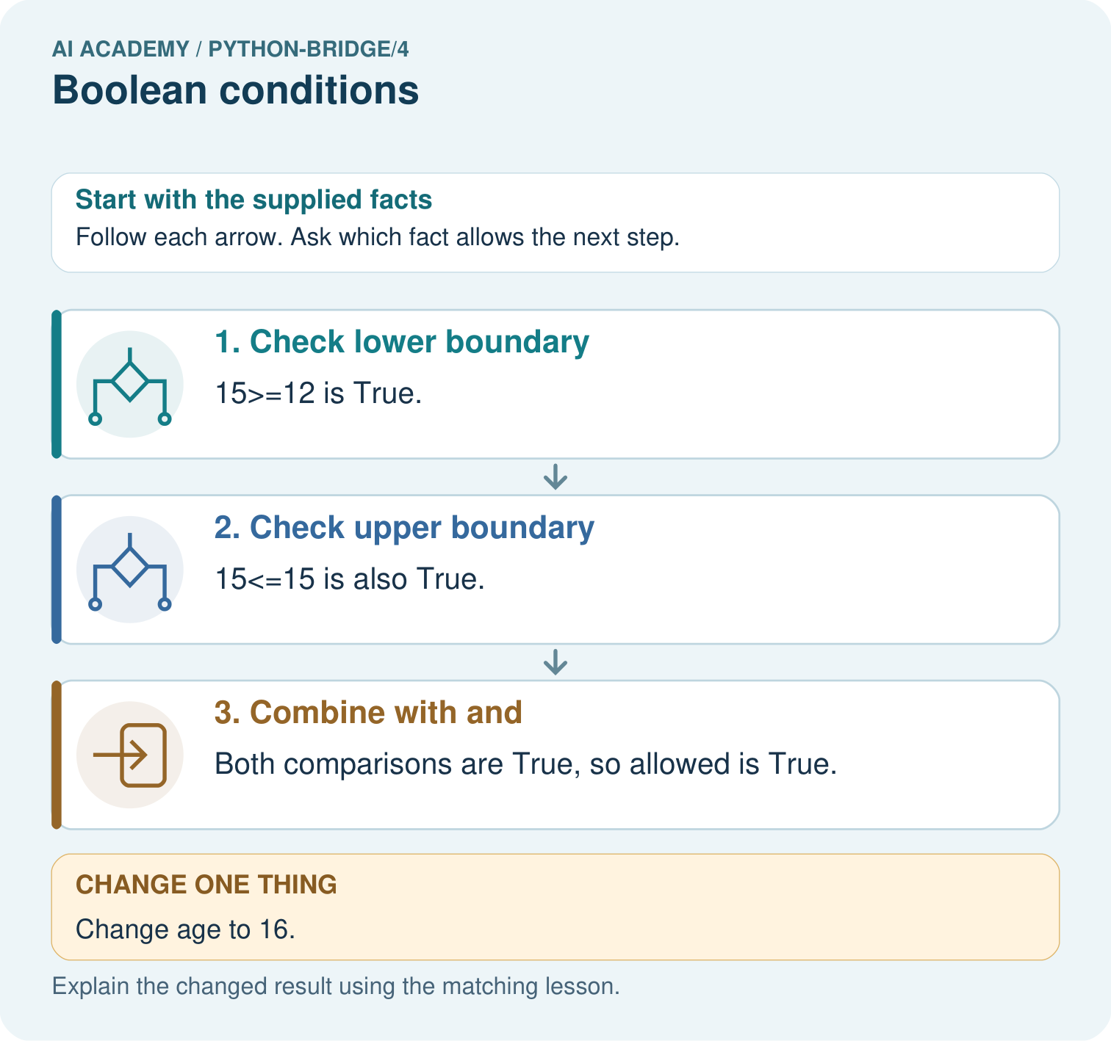
Give both comparison results for ages 11, 15 and 16. Which comparison rejects each outside value, and why does and matter?

My picture-based explanation and changed-case prediction
________________________________________________________________
________________________________________________________________
________________________________________________________________
________________________________________________________________
________________________________________________________________
________________________________________________________________
Support used: alone / hint / worked example. This record is practice evidence.
Project connection: For Python readiness before the Responsible Plant Classifier, retain a trace of the values, the predicted outputs and the changed-case explanation. Use actual Python 3 results to check the prediction after reasoning first.

13. Project portfolio milestone
Project: Python readiness portfolio
Current milestone: Python readiness portfolio. Keep runnable code, predictions, actual outputs, one repaired error and an explanation of a function on changed inputs.
For Python readiness before the Responsible Plant Classifier, retain a trace of the values, the predicted outputs and the changed-case explanation. Use actual Python 3 results to check the prediction after reasoning first.
Evidence to keep | My record
This week’s input and deciding step
Prediction and actual result (or labelled paper trace)
One change since the previous checkpoint and why
One error or limit and the next test

Explain what this week adds to your project. Reuse last week’s record rather than starting again.
________________________________________________________________
________________________________________________________________
________________________________________________________________
________________________________________________________________
________________________________________________________________

14. Supported practice and learning evidence
Use this supported practice once, in the browser or on paper. Keep the reserved independent assessment for a separate first attempt before teacher feedback.
Two conditions for entry. A toy club accepts integer ages from 12 through 15 inclusive.

Practice 1: explain the deciding evidence
Which labelled step matches this detail? Both comparisons are True, so allowed is True.
1. Check lower boundary
2. Check upper boundary
3. Combine with and

My selected conclusion, deciding fact and explanation
________________________________________________________________
________________________________________________________________
________________________________________________________________
________________________________________________________________
________________________________________________________________
Hint if needed: Read the steps in the pictorial case. Match the supplied detail to the stage that performs or records it.
After your attempt, compare with the supported explanation: Combine with and Both comparisons are True, so allowed is True. A Boolean condition represents a yes-or-no result. And requires both conditions; checking only one boundary would accept values outside the intended interval.

Practice 2: explain the deciding evidence
Changed-case practice: Change age to 16. Which conclusion is supported by the supplied facts?
1. This one example guarantees correct results for every future input.
2. We can decide the result without examining the changed input or the procedure.
3. The result becomes False.

My selected conclusion, deciding fact and explanation
________________________________________________________________
________________________________________________________________
________________________________________________________________
________________________________________________________________
________________________________________________________________
Hint if needed: Use the changed condition and the deciding step in the pictorial trace. The answer must say what follows from those facts.
After your attempt, compare with the supported explanation: The result becomes False. The lower condition remains True, but the upper condition fails.

Repair a missing building block
Review Expressions and operator order (python-bridge/3). Goal: Evaluate numeric expressions using Python’s grouping rules. Short practice: Trace the operation order in both expressions. Identify which picture step changes with parentheses and predict both results when the multiplier becomes four.. Return to this week and explain what you changed.
Review From a paper algorithm to Python (python-bridge/1). Goal: Translate a short paper calculation into a Python script. Short practice: Match each paper quantity to its Python name. Why does the spare count get added once, and what prints when spare is five?. Return to this week and explain what you changed.

Predict, run and debug
The browser lab lets you edit the supported Python examples already included in this lesson. Predict first, run, inspect the actual output or error, change one input, then run again. Keep code, predictions, actual results and a reasoned revision together. On paper, label your result as a trace rather than an execution.

Keep your completed work
Use Download completed work in the hosted lesson to export your answers, reflections, practice feedback and code-run evidence. Open the HTML copy to read or print it. Drafts stay in this browser when storage is available; clear drafts on a shared device.

What I repaired, the evidence I kept and the next test
________________________________________________________________
________________________________________________________________
________________________________________________________________
________________________________________________________________
________________________________________________________________

