AI ACADEMY · WORKBOOK · python-bridge/11

Reading structured data
Project: Python readiness portfolio

01. Recall and choose your starting point
Try the recall before opening notes. Then use a different colour or a labelled second line to correct your explanation.

Dictionaries and records
Without opening the old lesson, explain one key idea from Dictionaries and records. Give an example and a mistake that the idea helps you avoid.

My remembered idea, example and correction
________________________________________________________________
________________________________________________________________
________________________________________________________________

Functions and arguments
Without opening the old lesson, explain one key idea from Functions and arguments. Give an example and a mistake that the idea helps you avoid.

My remembered idea, example and correction
________________________________________________________________
________________________________________________________________
________________________________________________________________

Branching and boundary tests
Without opening the old lesson, explain one key idea from Branching and boundary tests. Give an example and a mistake that the idea helps you avoid.

My remembered idea, example and correction
________________________________________________________________
________________________________________________________________
________________________________________________________________

02. Practise with fading help
Use W2: Trace all updates for Reading structured data. Record the answer once; the lesson and workbook refer to the same attempt.
Given inputs | Procedure I chose | Middle steps | Result and check

The step I completed without help, and the hint I needed
________________________________________________________________
________________________________________________________________
________________________________________________________________

03. Individual reasoning check
Use the worked case for Reading structured data. Proposed explanation: “A successful run proves the conclusion”. Decide whether this explanation is supported. Point to the step or supplied fact that decides; explain your repair if needed.

My explanation before partner discussion
________________________________________________________________
________________________________________________________________
________________________________________________________________
________________________________________________________________

04. Independent transfer case

Independent case: Preserve records and report measured coverage
Trace the named fields and missing-value policy. Predict the output, state the observed total and mean denominator, and report coverage. What changes if all three rows are empty records?
rows = [{"score": 2}, {"score": 6}, {}]
values = []
for row in rows:
value = row.get("score")
if value is not None:
values.append(value)
observed_total = sum(values)
if len(values) > 0:
mean = observed_total / len(values)
else:
mean = None
print(observed_total, len(values), len(rows), mean)

My independent explanation, trace and limits
________________________________________________________________
________________________________________________________________
________________________________________________________________
________________________________________________________________
________________________________________________________________
________________________________________________________________
________________________________________________________________
Attempt this case before feedback. Record any help. Earlier examples below are further practice; a case already practised with feedback cannot establish fresh transfer.

05. W1 Read a row
In the worked dataset, state the number of records and the spare spaces in the second record.

My reasoning and evidence
________________________________________________________________
________________________________________________________________
________________________________________________________________
________________________________________________________________
________________________________________________________________
________________________________________________________________

06. W2 Trace all updates
For spare contributions 2, 4 and 1, trace total starting at 0.

My reasoning and evidence
________________________________________________________________
________________________________________________________________
________________________________________________________________
________________________________________________________________
________________________________________________________________
________________________________________________________________

07. W3 Repair initialization
A loop resets total to 0 on each pass over contributions 2, 4, 1. What final total appears and how should it be fixed?

My reasoning and evidence
________________________________________________________________
________________________________________________________________
________________________________________________________________
________________________________________________________________
________________________________________________________________
________________________________________________________________

08. W4 Process new records independently
Write a loop for records (capacity 9, used 2), (capacity 5, used 1), and (capacity 4, used 4). Predict the total. Reverse the order and test an empty list.

My reasoning and evidence
________________________________________________________________
________________________________________________________________
________________________________________________________________
________________________________________________________________
________________________________________________________________
________________________________________________________________
________________________________________________________________
________________________________________________________________

09. W5 Interpret an empty result
An empty dataset produces total 0. Can you conclude that every cupboard is full?

My reasoning and evidence
________________________________________________________________
________________________________________________________________
________________________________________________________________
________________________________________________________________
________________________________________________________________
________________________________________________________________

10. Project checkpoint and reflection
Add a labelled reading structured data evidence sheet to Python readiness portfolio. Show how you can process a list of records consistently. Use the supplied fictional case and keep its inputs, intermediate steps, calculation or prediction, and limitation. Connect this record to last week’s record; a matching answer without a trace is insufficient.

My project change, supporting evidence and remaining limit
________________________________________________________________
________________________________________________________________
________________________________________________________________
________________________________________________________________
________________________________________________________________
________________________________________________________________

11. Feedback, return check and learning record
Evidence | My record
Worked alone / hint / model
First step I repaired and why
New case checked later; date and result
What I can now explain without notes
One remaining question
Revisit this idea with your teacher after a delay. Familiarity is different from explaining and using it on a changed case.

12. Pictorial case practice: Reading structured data
Read rows with a missing-field policy. A toy table is represented as a list of dictionaries; count only rows with a recorded count.
Python 3 records: [{"count":2},{"count":0},{}]. Policy: include existing numeric counts, including zero; skip an absent field.
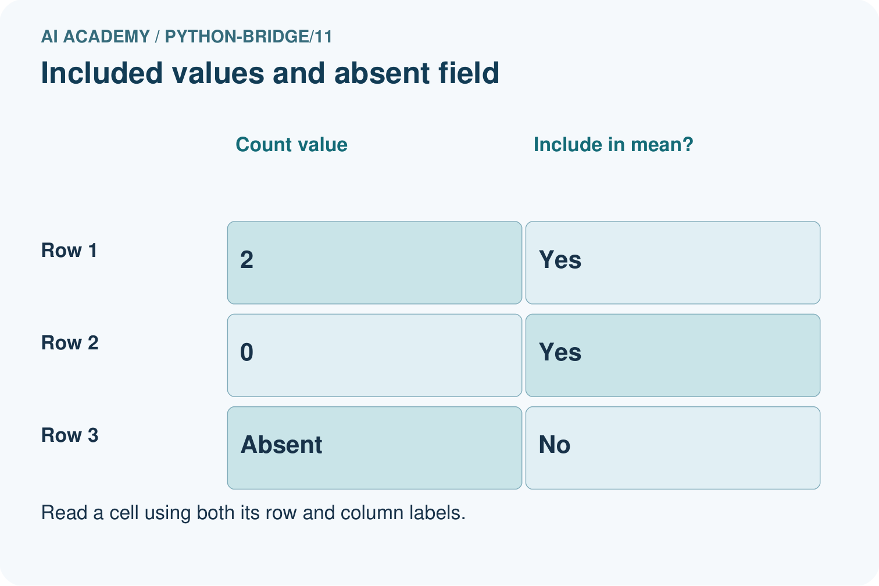
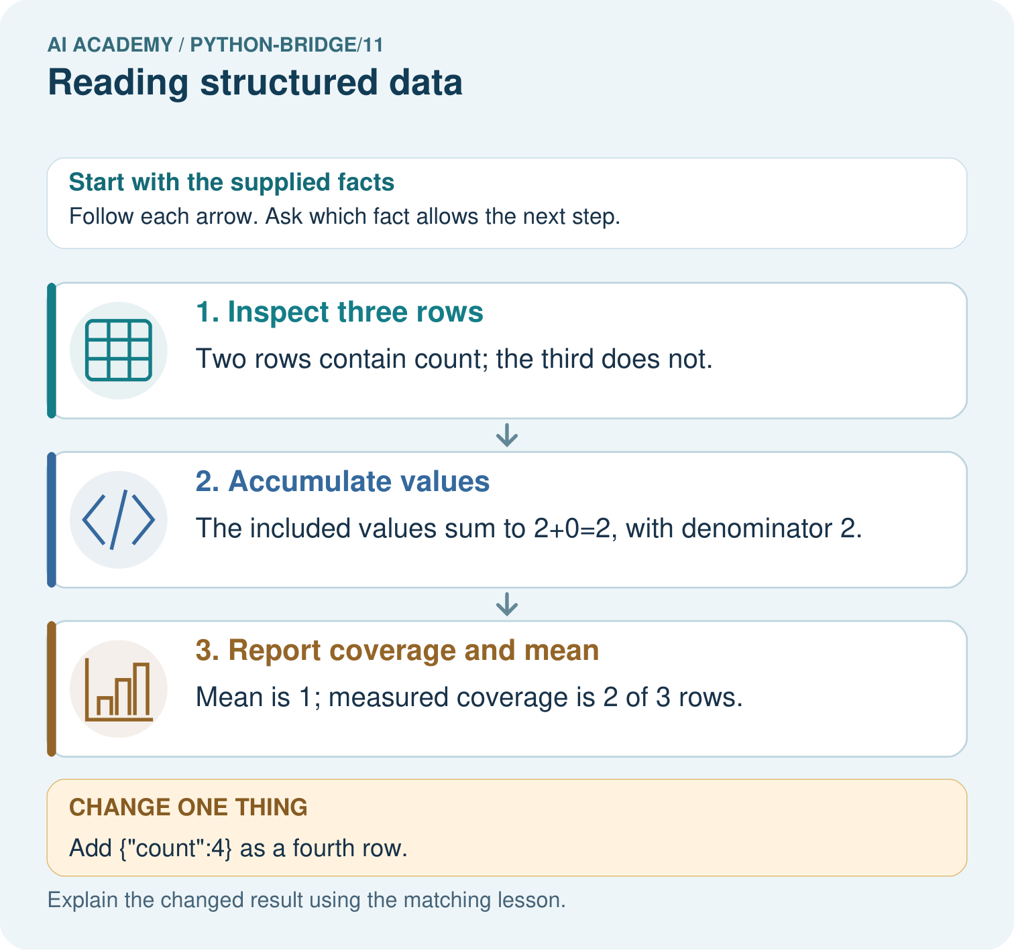
Circle the included rows, calculate the sum and mean, and state coverage. Repeat after adding the fourth row with count four.

My picture-based explanation and changed-case prediction
________________________________________________________________
________________________________________________________________
________________________________________________________________
________________________________________________________________
________________________________________________________________
________________________________________________________________
Support used: alone / hint / worked example. This record is practice evidence.
Project connection: For Python readiness before the Responsible Plant Classifier, retain a trace of the values, the predicted outputs and the changed-case explanation. Use actual Python 3 results to check the prediction after reasoning first.

13. Project portfolio milestone
Project: Python readiness portfolio
Current milestone: Python readiness portfolio. Keep runnable code, predictions, actual outputs, one repaired error and an explanation of a function on changed inputs.
For Python readiness before the Responsible Plant Classifier, retain a trace of the values, the predicted outputs and the changed-case explanation. Use actual Python 3 results to check the prediction after reasoning first.
Evidence to keep | My record
This week’s input and deciding step
Prediction and actual result (or labelled paper trace)
One change since the previous checkpoint and why
One error or limit and the next test

Explain what this week adds to your project. Reuse last week’s record rather than starting again.
________________________________________________________________
________________________________________________________________
________________________________________________________________
________________________________________________________________
________________________________________________________________

14. Supported practice and learning evidence
Use this supported practice once, in the browser or on paper. Keep the reserved independent assessment for a separate first attempt before teacher feedback.
Read rows with a missing-field policy. A toy table is represented as a list of dictionaries; count only rows with a recorded count.

Practice 1: explain the deciding evidence
Which labelled step matches this detail? Mean is 1; measured coverage is 2 of 3 rows.
1. Inspect three rows
2. Report coverage and mean
3. Accumulate values

My selected conclusion, deciding fact and explanation
________________________________________________________________
________________________________________________________________
________________________________________________________________
________________________________________________________________
________________________________________________________________
Hint if needed: Read the steps in the pictorial case. Match the supplied detail to the stage that performs or records it.
After your attempt, compare with the supported explanation: Report coverage and mean Mean is 1; measured coverage is 2 of 3 rows. Structured data need a row policy before aggregation. Treating missing as zero changes the statistic and can conceal incomplete coverage; real zero remains an observation.

Practice 2: explain the deciding evidence
Changed-case practice: Add {"count":4} as a fourth row. Which conclusion is supported by the supplied facts?
1. We can decide the result without examining the changed input or the procedure.
2. This one example guarantees correct results for every future input.
3. Sum becomes 6, denominator 3, mean 2; coverage is 3 of 4.

My selected conclusion, deciding fact and explanation
________________________________________________________________
________________________________________________________________
________________________________________________________________
________________________________________________________________
________________________________________________________________
Hint if needed: Use the changed condition and the deciding step in the pictorial trace. The answer must say what follows from those facts.
After your attempt, compare with the supported explanation: Sum becomes 6, denominator 3, mean 2; coverage is 3 of 4. Only the added recorded value contributes; the existing absent field remains skipped.

Repair a missing building block
Review Dictionaries and records (python-bridge/10). Goal: Read and update named dictionary fields. Short practice: Predict all three original outputs. Explain the difference between count=0 and missing price, then predict the lookup after price=0 is added.. Return to this week and explain what you changed.
Review Functions and arguments (python-bridge/8). Goal: Distinguish a function definition from a function call. Short practice: Match every argument to a parameter for the two calls. Why do outputs differ, and what prints when both calls are removed?. Return to this week and explain what you changed.
Review Branching and boundary tests (python-bridge/5). Goal: Trace the selected branch in an if elif else chain. Short practice: Trace -2, 4 and 5 through the branches. Explain why the negative check comes first and what label -2 gets if it is removed.. Return to this week and explain what you changed.

Predict, run and debug
The browser lab lets you edit the supported Python examples already included in this lesson. Predict first, run, inspect the actual output or error, change one input, then run again. Keep code, predictions, actual results and a reasoned revision together. On paper, label your result as a trace rather than an execution.

Keep your completed work
Use Download completed work in the hosted lesson to export your answers, reflections, practice feedback and code-run evidence. Open the HTML copy to read or print it. Drafts stay in this browser when storage is available; clear drafts on a shared device.

What I repaired, the evidence I kept and the next test
________________________________________________________________
________________________________________________________________
________________________________________________________________
________________________________________________________________
________________________________________________________________

