AI ACADEMY · STUDENT · ai-1/11

Repeating Efficiently
Project: Helpful Classroom Sorter

Before you start
Week 10: a condition can decide whether an action runs.

01. Your mission

Your learning target
I can trace a loop by testing its condition before every repetition.
I can distinguish the number of repetitions from the final value and include zero repetitions.
I can explain why an update reaches a stopping condition or why a faulty loop keeps repeating.

Remember before reading
Close your notes first. A rough first answer helps us choose the right starting point; it is not a score for your ability.
Without opening the old lesson, explain one key idea from If/Then Decisions. Give an example and a mistake that the idea helps you avoid.
Without opening the old lesson, explain one key idea from Features: Useful Clues. Give an example and a mistake that the idea helps you avoid.
Without opening the old lesson, explain one key idea from Pictures Become Numbers. Give an example and a mistake that the idea helps you avoid.
After trying, check the relevant lesson or ask your teacher. Change the part of your explanation that the evidence shows was wrong.
A loop repeats a useful step until a stopping condition is met.
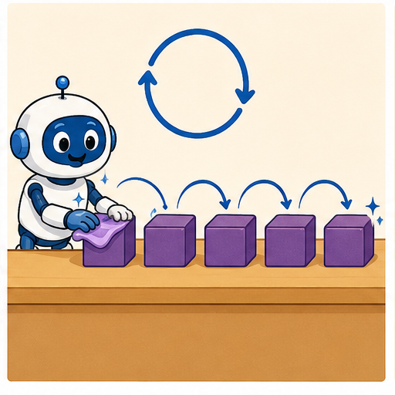
LEARNING TARGET A robot stamps the next unstamped card until it has stamped five cards. Only three cards are available. Write a stopping rule that handles both limits and trace the number stamped.
Learner name:

Readiness for the connected explanation
Score is 4. If score is below 5, add 3; otherwise subtract 2. Report and stop. Does reaching 7 cause another test? Explain.

This week’s end goal
By the end, I can check a loop condition before each update and count iterations.

02. Notice the evidence
PICTURE STORY

Look Closely Before You Explain
Pictures give clues; evidence tells us what the clues mean.

MYSTERY Instead of writing draw-side and turn four times, a square algorithm can repeat those steps four times.

What do you notice?
Name three visible details without explaining them yet.
Circle the detail most connected to the system's decision.
Name one detail that may be decoration or distraction.
Make a first prediction and state the clue that supports it.
My observations, prediction, and evidence:
GOOD THINKING A prediction can change when stronger evidence appears.

A closer explanation
A paper counter starts at 1. While the counter is below 7, add 2 to it. When the test is false, report the counter and stop. The word while means test first, run the body only if true, then return to the test using the updated value. The body here is just add 2.
The counter follows 1, 3, 5, 7. At 1, 3 and 5 the condition is true, so each test is followed by one addition. At 7 the condition is false. No addition follows that final test. The loop has three iterations and reports 7.
Compare the Week 10 instruction if counter is below 7, add 2, then report. From 1 that single decision reports 3. A while loop explicitly returns to its test; an if decision does not. Draw a pointer to the instruction being executed instead of deciding for yourself when to repeat.

03. See how it works
VISUAL MECHANISM

Input → Process → Output
Follow the information instead of imagining magic inside the machine.
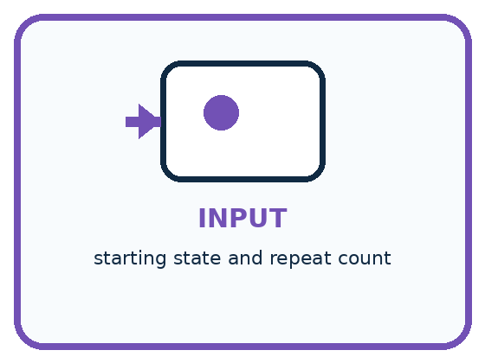
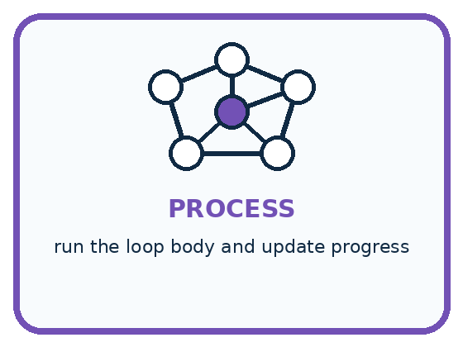
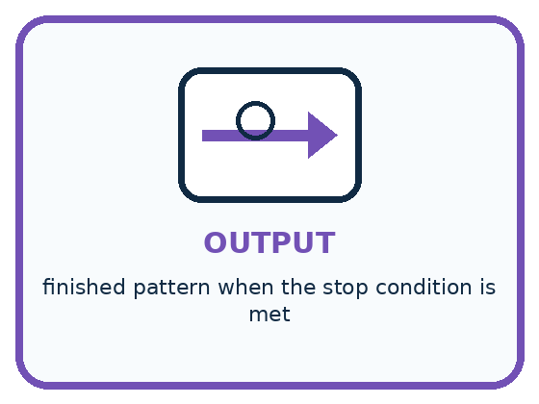
INPUT starting state and repeat count
PROCESS run the loop body and update progress
OUTPUT finished pattern when the stop condition is met
CORE IDEA A loop repeats a useful step until a stopping condition is met.
UNDER THE HOOD A loop requires an initialization, body, update, and termination condition. Repetition is safe only when each iteration moves state toward stopping; otherwise the loop may run forever or the wrong number of times.
Draw a fresh example with all three stages:

A closer explanation

A complete loop trace
Counter before test | Is counter below 7 | Next action
1 | True | Add 2 to reach 3
3 | True | Add 2 to reach 5
5 | True | Add 2 to reach 7
7 | False | Report 7 and stop
Read the rows from top to bottom as one run. Each true test performs one addition and returns to the test. The final false test performs no addition.
The trace has four tests but only three iterations. The false test is evidence that this run stops. A list ending at 5 would be incomplete, while a list continuing to 9 would include an addition the loop did not authorise.
Write the current value, the test result and the action on every row. Repeated values can matter: if the body does not change the state used by the test, the same true test may occur again. Do not erase these rows simply because they look unhelpful.

Connect the picture and the explanation
Point to the input, the deciding step and the result in this week’s visual. Explain the same step in ordinary words. A picture helps when you can say what each part represents.

04. Compare the cases
PICTURE GALLERY

Four Cases, Four Clues
Use the visual cue, then read the evidence carefully.
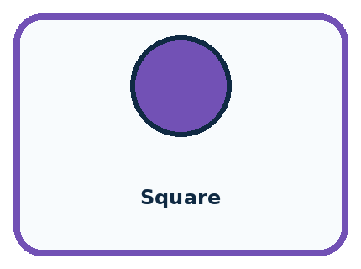
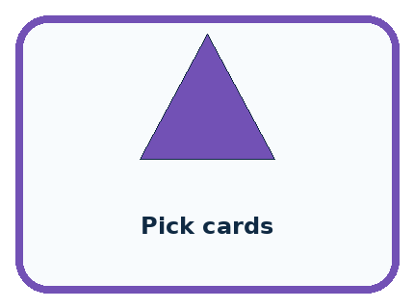

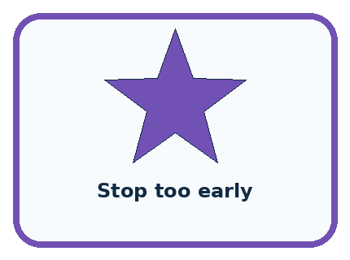
CASE 1 — Square Clue: repeat move and turn 4 times. Meaning: counted loop.
CASE 2 — Pick cards Clue: repeat until pile empty. Meaning: condition loop.
CASE 3 — No counter update Clue: condition never changes. Meaning: infinite loop risk.
CASE 4 — Stop too early Clue: one item remains. Meaning: off-by-one error.
BOUNDARY Repeat forever is not an efficient algorithm unless endless operation is truly the goal and can be stopped safely.
Which two pictures are easiest to confuse? What evidence separates them?

Change one thing in the pictured case
Change: Start at 10 instead of 2.
Prediction: The loop runs zero times and reports 10.
Reason: Its first condition is already false, so no addition happens.

05. Words that unlock the idea
VOCABULARY

Words You Can See and Use
The badge is a memory cue; the definition does the real thinking work.
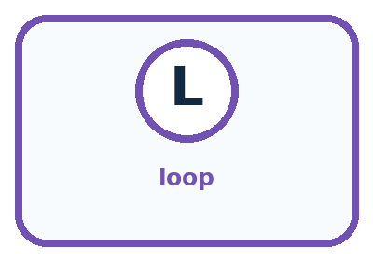
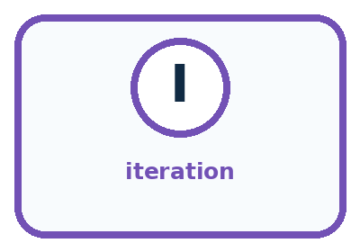
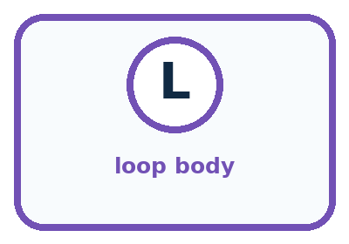
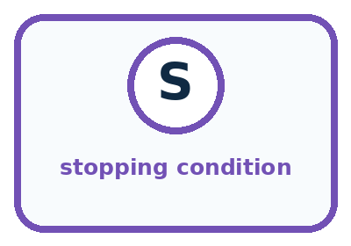
Word | Meaning | My example
loop | control structure that repeats steps
iteration | one pass through the loop
loop body | steps repeated each time
stopping condition | rule that ends repetition

Misconception detective
CLAIM TO REPAIR A loop is just copying the same words many times.
Use one vocabulary word and one piece of evidence to repair it:
WORD POWER A strong definition helps you decide something in a new case.

Words used in the closer explanation
Word | Meaning
Body | The instructions performed on each iteration
Progress | A change that brings the state closer to a stopping condition

06. Follow a worked example
WORKED EXAMPLE

Watch the Reasoning, Not Just the Answer
Every step connects a claim to observable evidence.

CASE Instead of writing draw-side and turn four times, a square algorithm can repeat those steps four times.
STEP 1 — OBSERVE starting state and repeat count
STEP 2 — TRACE run the loop body and update progress
STEP 3 — CONCLUDE finished pattern when the stop condition is met
MODEL REASONING Place only the repeated steps inside the loop, initialize the counter, update it once per pass, and stop after the required count. Trace each iteration to catch one-too-many or one-too-few errors.
DO NOT OVERCLAIM Repeat forever is not an efficient algorithm unless endless operation is truly the goal and can be stopped safely.
What new evidence could change this answer?

A closer explanation
Starting counter | Values at successive tests | Iterations and reported value
5 | 5 true then 7 false | 1 iteration and report 7
6 | 6 true then 8 false | 1 iteration and report 8
7 | 7 false | 0 iterations and report 7
8 | 8 false | 0 iterations and report 8
While tests before the body. If the first test is false, the body runs zero times. Do not add 2 once just because a loop is present. Starting at 7 or 8 is a useful test of this rule.
A loop that stops when the counter is no longer below 7 does not promise to finish at exactly 7. Starting at 6 produces 8. Passing the boundary is allowed by these instructions. Always report the actual final state instead of replacing it with the threshold.

Learn from the worked case
Cover the result before checking it. Say what is given, choose the procedure, and follow one step at a time. Then uncover the result and explain your first mismatch. Ask why a step is allowed, not only what number it produces.

A pictorial worked case: Repeating Efficiently
A fictional paper counter advances through a display until its condition becomes false.

The facts we will use
Start at 2. While the current counter is below 10, add 3.
Test before each addition; report when the condition is false.
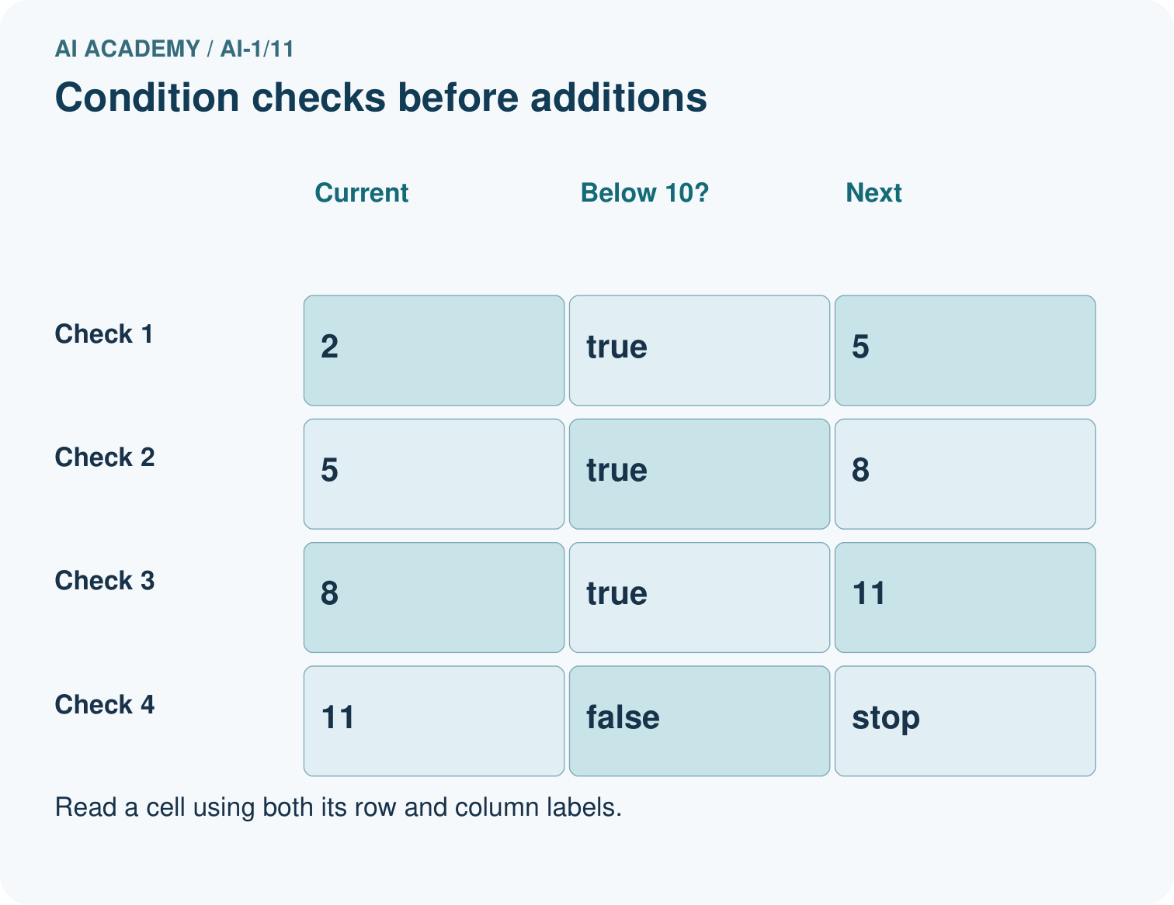
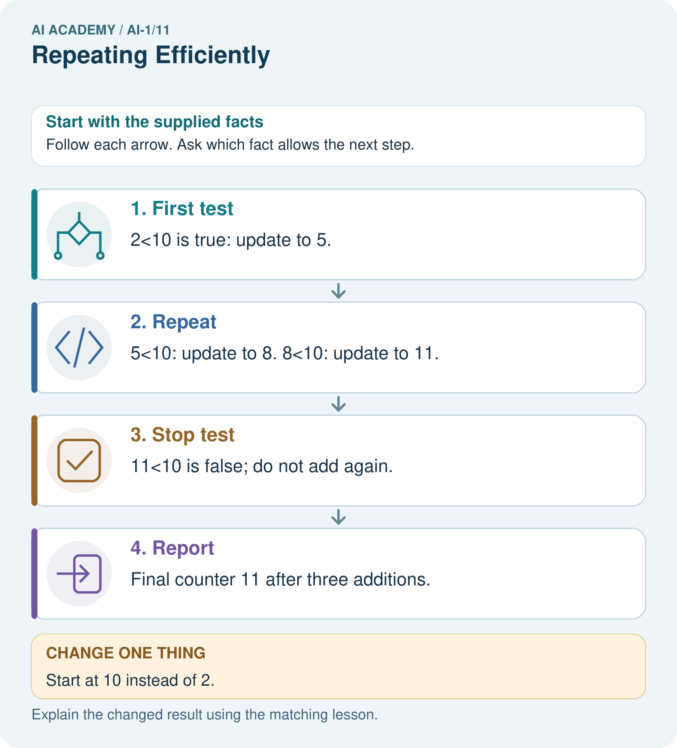

Read the picture one step at a time
Step | What happens and why
1. First test | 2<10 is true: update to 5.
2. Repeat | 5<10: update to 8. 8<10: update to 11.
3. Stop test | 11<10 is false; do not add again.
4. Report | Final counter 11 after three additions.
Match each pictured step to the supplied facts. This is a worked teaching case, not an independent assessment.

Why this result follows
The condition checks whether to do the next update; it does not constrain every resulting value to stay below 10. The final 11 is therefore allowed by this procedure. Record both the condition and counter to distinguish a correct stop from an assumed endpoint.

What this example does not establish
This loop stops because positive increments eventually cross the limit. Other updates can fail to make progress.

07. Find and repair a mistake
COMPARE

Same Result, Different Reason
A comparison helps reveal the true concept boundary.
Case | Evidence | What it shows
Square | repeat move and turn 4 times | counted loop
Pick cards | repeat until pile empty | condition loop
No counter update | condition never changes | infinite loop risk
Stop too early | one item remains | off-by-one error

Repair two tempting claims
CLAIM A A loop is just copying the same words many times.
Repair:
CLAIM B The stopping condition will become true by itself.
Repair:
STRONG ANSWER FRAME I claim ______ because the evidence shows ______. The process is ______. One limit is ______.

A closer explanation
A different mistake says while counter is not equal to 7, add 2. From 6 the values are 6, 8, 10 and then larger even numbers. None is 7, so this equality test never becomes false. A growing number does not guarantee termination: the update must be able to reach a state that makes this particular test false.
Our paper examples use known whole numbers without a maximum size. For this lesson, an unreadable starting counter means pause and request the value. It does not mean start at zero. Later programs will need explicit rules for unavailable inputs and resource limits.

A tester runs the below 7 loop only from starting counter 1. Choose one additional start that checks zero repetitions and one that checks passing the boundary without landing on it. Give the expected reported values
________________________________________________________________
________________________________________________________________
________________________________________________________________
________________________________________________________________

08. Practise together
GUIDED PRACTICE

Try It, Check It, Explain It
Use support now so you can succeed independently later.

Explain how the picture story demonstrates this idea: A loop repeats a useful step until a stopping condition is met.
Use a fresh example to explain loop.
Trace a new input → process → output example.
Find and repair the error in: The stopping condition will become true by itself.
Invent one edge case and name the safe response.
PARTNER CHECK Point to the evidence. Do not accept an answer that only repeats the vocabulary word.

A closer explanation
For our known whole-number counters below 7, adding 2 makes the counter larger each time. After enough additions it is at least 7, so the test becomes false. This explains why this loop stops for these inputs; one successful trace alone would not establish that for every possible procedure.
Now change the body to add 0. Starting at 1 gives the same value 1 at every test. Below 7 remains true, and the loop never reaches its reporting instruction. A classroom trace should be stopped by the teacher after the repeated state is established. That intervention is not a successful program result.

Compare the original add 2 loop from starting counter 3 with the faulty add 0 version. Record enough test rows to justify each conclusion. Explain the difference between the final reported value and a value merely seen during a non stopping run
________________________________________________________________
________________________________________________________________
________________________________________________________________
________________________________________________________________
________________________________________________________________
________________________________________________________________

Practise with less help: Check the first test
Use workbook W2 for the connected example “Loops and stopping rules”. First fill the input and rule boxes. Try the middle steps before asking for a hint. After a hint, try the next step yourself.
Plan | Do | Check
What is given? Which rule or procedure applies? | Record each intermediate step. | Does the result follow? What remains unknown?
Explain your trace to a partner. Your partner points to one step to check. Swap roles on the next case. Each person writes their own explanation.

Check your reasoning
Use the worked case for Loops and stopping rules. Proposed explanation: “Every loop runs at least once”. Decide whether this explanation is supported. Point to the step or supplied fact that decides; explain your repair if needed.
Answer on your own before discussion. If you are unsure, say which step you need help with.

Explain the picture
Trace a fresh start of 9. How many additions occur, and must the report equal 10?

My explanation using a pictured step and the given facts
________________________________________________________________
________________________________________________________________
________________________________________________________________
________________________________________________________________
This is supported practice. Keep the separately named independent case for an attempt before feedback.

09. Run the investigation
EXPLORER LAB

Loop Card Drawing
Predict first, test honestly, and explain what the evidence means.
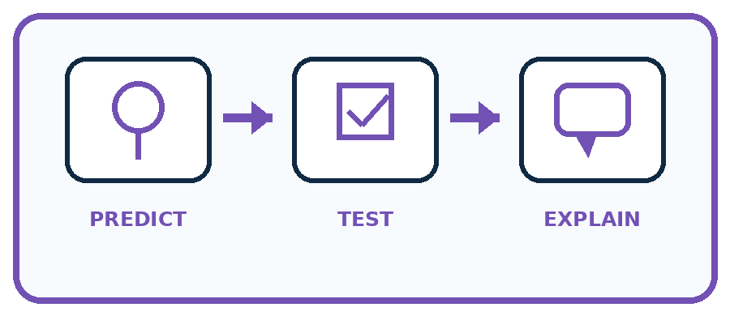
State your prediction before the result is known.
Complete the task: Compress a repeated drawing algorithm using a loop card.
Keep a normal case and an edge case clearly separated.
Record what happened—even when it does not match your prediction.
Explain the result, one limitation, and the next useful test.
Case | Prediction | Observed result | What it means
Normal
Edge
INDEPENDENCE After support is removed, repeat the proof with a fresh case.

Plan → try → check
Before trying: what do I expect, and why? While trying: which step could first go wrong? Afterwards: what did I actually observe, and what should change? Keep “not run” if you only traced the procedure.

10. Build your understanding
PRACTICE LADDER

Climb from Recall to Defense
Each step asks for a stronger kind of understanding.
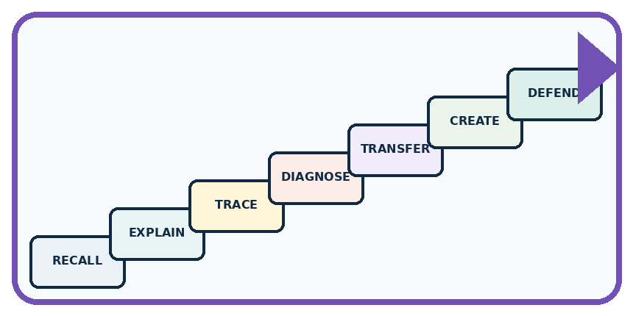
RECALL Define loop.
EXPLAIN A loop repeats a useful step until a stopping condition is met.
TRACE Show the input, process, and output.
DIAGNOSE Repair: A loop is just copying the same words many times.
TRANSFER Apply the idea to a new home or classroom case.
CREATE Design one revealing test.
DEFEND Give a claim, evidence, mechanism, limit, and safe action.
RETRY RULE A coached answer becomes mastery only after you solve a different case independently.

11. Connect your project
PROJECT

Helpful Classroom Sorter
Build one coherent system across the year, one evidence-based decision at a time.
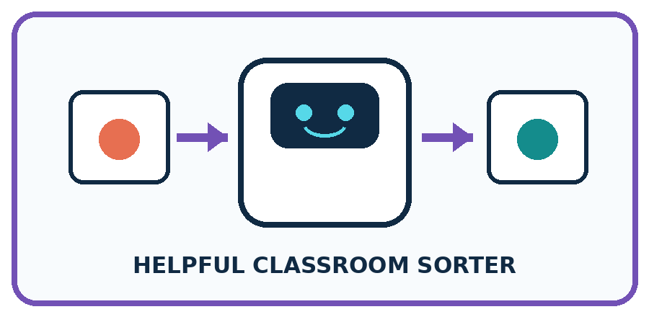
THIS WEEK'S CHECKPOINT Use a loop to process each item card in the test pile, with an explicit stop when no cards remain.
What real classroom need does this serve?
What information is necessary—and what should stay private?
What happens inside the process?
What normal and edge cases will you test?
When should it say not sure or ask a person?

RESPONSIBLE DESIGN Repeat forever is not an efficient algorithm unless endless operation is truly the goal and can be stopped safely.
My project decision:

Evidence for your project
Give any repeated sorter step an explicit stopping condition and trace a zero-iteration example.

12. Show what you know
MASTERY

Fresh-Case Independent Proof
Complete this after teaching and guided practice have ended.
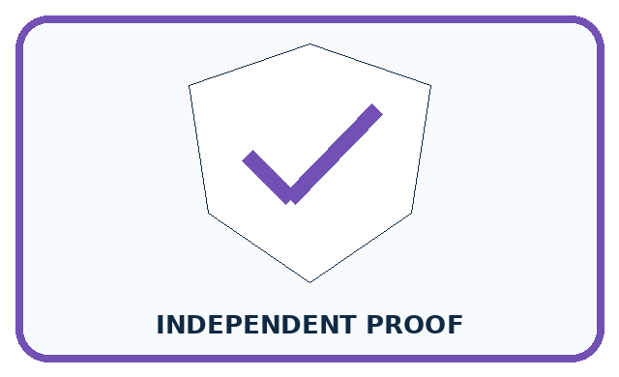
REQUIRED PROOF Compress a repeated drawing into a loop, predict the iteration count, and explain what makes it stop.
□ Name or draw the fresh case.
□ Trace input, process, and output.
□ State the conclusion and strongest evidence.
□ Name one limit, failure, missing clue, or fairness/privacy concern.
□ Explain one safe next action or improvement.
Independent evidence:
SELF-CHECK Place only the repeated steps inside the loop, initialize the counter, update it once per pass, and stop after the required count. Trace each iteration to catch one-too-many or one-too-few errors.
My level: □ Not yet □ With one hint □ Independently □ I can teach it
NEXT BRIDGE Carry today's evidence habit into: Debug the Cause.

13. Study a complete case

Week 11 Worked case
Use the supplied details to practise the weekly concept before attempting the independent question. This case extends the illustrated lesson.

The situation
Repeat take the next unstamped card and stamp it four times.

The question
How many cards are stamped? What assumption matters?

Worked explanation
Four, provided four unstamped cards exist and each repeat takes the next one. A limit or end-of-stack check prevents continuing indefinitely.

Explain it in your own words
Which detail supports the answer, and why does it matter?

Write or draw your reasoning and evidence.
________________________________________________________________
________________________________________________________________
________________________________________________________________
________________________________________________________________
________________________________________________________________

Trace the supplied case visually

Repeat with a clear stopping point
Evidence or stage | Value or result
Before | 0 stamped
Repeat 1 | 1 stamped
Repeat 2 | 2 stamped
Repeat 3 | 3 stamped
Repeat 4 | 4 stamped, stop
Repeat take the next unstamped card and stamp it four times.
How many cards are stamped? What assumption matters?
Four, provided four unstamped cards exist and each repeat takes the next one. A limit or end-of-stack check prevents continuing indefinitely.

14. Try a new case independently

Independent case: Transfer to a countdown
A paper countdown starts at 7. While remaining is above 1, subtract 2. When false, report and stop. Trace the run and count iterations. Repeat from 6 and from 1. Explain why the final value need not equal 1. What happens from 7 if subtract 2 is replaced by subtract 0?

My independent explanation, trace and limits
________________________________________________________________
________________________________________________________________
________________________________________________________________
________________________________________________________________
________________________________________________________________
________________________________________________________________
________________________________________________________________
Attempt this case before feedback. Record any help. Earlier examples below are further practice; a case already practised with feedback cannot establish fresh transfer.

Week 11 Independent application
Close the worked explanation. Apply the idea to this different question without copying.
Repeat clap then tap three times. Write the complete sequence. How many actions occur? What would happen if the stopping instruction were missing?
My answer, with a trace, calculation or supporting evidence

Write or draw your reasoning and evidence.
________________________________________________________________
________________________________________________________________
________________________________________________________________
________________________________________________________________
________________________________________________________________

Create and test
Change one relevant detail. Predict the result before testing. Include a boundary or missing-information case when it helps reveal a limit.
My changed input and expected result

Write or draw your reasoning and evidence.
________________________________________________________________
________________________________________________________________
________________________________________________________________
________________________________________________________________
________________________________________________________________

Connect to your project
Use a loop to process each item card in the test pile, with an explicit stop when no cards remain.
The evidence I will keep

Write or draw your reasoning and evidence.
________________________________________________________________
________________________________________________________________
________________________________________________________________
________________________________________________________________
________________________________________________________________
Your teacher has the independent answer and scoring criteria. Complete the matching workbook week to keep your practice evidence together.

Transfer practice from the original programme
A robot stamps the next unstamped card until it has stamped five cards. Only three cards are available. Write a stopping rule that handles both limits and trace the number stamped.

Explain the mechanism, evidence and one limit.
________________________________________________________________
________________________________________________________________
________________________________________________________________
________________________________________________________________
________________________________________________________________
________________________________________________________________
________________________________________________________________

Use feedback to improve
Attempt the independent case before hints. Record whether you worked alone, used a hint or followed a model. After feedback, fix the first unsupported step and explain why it changed. A later check uses a changed case, not a copied answer.

