AI ACADEMY · STUDENT · ai-1/12

Debug the Cause
Project: Helpful Classroom Sorter

Before you start
Weeks 9–11: trace state, conditions and repetition.

01. Your mission

Your learning target
I can compare expected and observed traces to locate the first difference.
I can choose a test that distinguishes competing explanations of a fault.
I can repair a stated instruction and rerun both the failing case and earlier passing cases.

Remember before reading
Close your notes first. A rough first answer helps us choose the right starting point; it is not a score for your ability.
Without opening the old lesson, explain one key idea from Repeating Efficiently. Give an example and a mistake that the idea helps you avoid.
Without opening the old lesson, explain one key idea from Algorithms as Recipes. Give an example and a mistake that the idea helps you avoid.
Without opening the old lesson, explain one key idea from Sound Becomes a Signal. Give an example and a mistake that the idea helps you avoid.
After trying, check the relevant lesson or ask your teacher. Change the part of your explanation that the evidence shows was wrong.
Debugging finds the broken assumption or step before changing the solution.
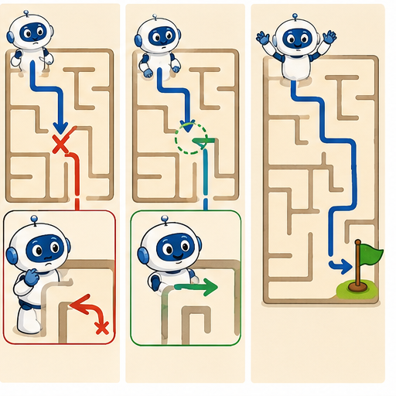
LEARNING TARGET Starting at square 0, the target is square 3. Program: repeat twice {MOVE 1}; STOP. A teammate changes the target to 2 and calls the bug fixed. Repair the program and give two tests.
Learner name:

Readiness for the connected explanation
Start at 3. While counter is below 7, add 2. List the values at every test and state when the body stops running.

This week’s end goal
By the end, I can choose a test that separates two possible causes of an error.

02. Notice the evidence
PICTURE STORY

Look Closely Before You Explain
Pictures give clues; evidence tells us what the clues mean.

MYSTERY A paper robot hits a wall because one turn instruction assumes it faces north when it actually faces east.

What do you notice?
Name three visible details without explaining them yet.
Circle the detail most connected to the system's decision.
Name one detail that may be decoration or distraction.
Make a first prediction and state the clue that supports it.
My observations, prediction, and evidence:
GOOD THINKING A prediction can change when stronger evidence appears.

A closer explanation
A paper points machine must add 3 to its starting score, double the updated score, then subtract 2 and report. From 4 the expected values are 4, 7, 14 and 12. These instructions are the specification. Calculate the expected result from them before looking at the machine output.
An observed run instead records 4, 7, 11 and 9. The final result is wrong, but changing the report from 9 to 12 would only hide this particular failure. Compare the intermediate values to find where the behaviour first stopped matching the instructions.
The first difference is after the doubling instruction: expected 14, observed 11. The final subtraction is consistent with the observed 11, since 11 minus 2 is 9. That later difference can be a consequence of the earlier fault rather than a second faulty subtraction. A trace narrows the investigation; it does not automatically reveal every cause.

03. See how it works
VISUAL MECHANISM

Input → Process → Output
Follow the information instead of imagining magic inside the machine.
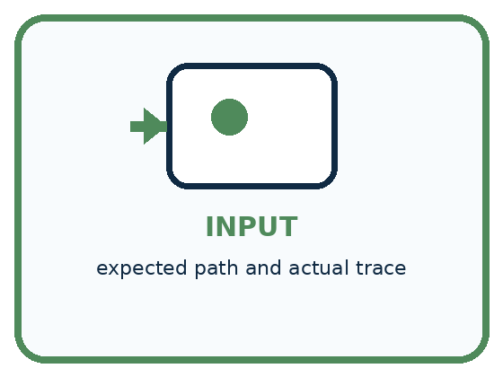
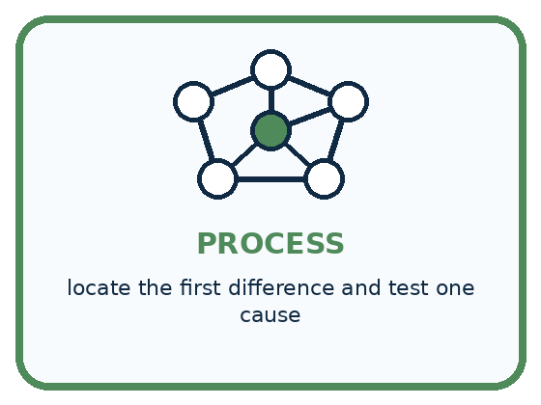
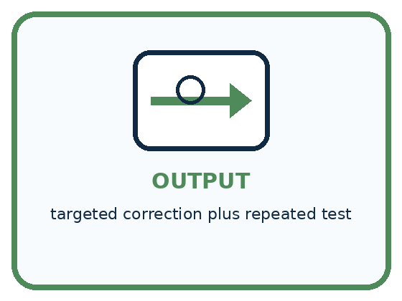
INPUT expected path and actual trace
PROCESS locate the first difference and test one cause
OUTPUT targeted correction plus repeated test
CORE IDEA Debugging finds the broken assumption or step before changing the solution.
UNDER THE HOOD Debugging is causal diagnosis. The first observable divergence narrows the faulty assumption, data, state, condition, or step. Changing multiple things at once destroys evidence about which change repaired the behavior.
Draw a fresh example with all three stages:

A closer explanation

Locate the first mismatch
Recorded checkpoint | Compare the values | What the evidence tells us
Start | Expected 4 observed 4 | Values agree
After add 3 | Expected 7 observed 7 | Values agree
After double | Expected 14 observed 11 | First difference
After subtract 2 | Expected 12 observed 9 | Difference continues
Each row compares the same checkpoint in two traces. Arrows lead from the checkpoint to its comparison and interpretation; they do not represent arithmetic between columns.
Record the input, the exact instruction version, expected values, observed values and first mismatch. This makes the failure reproducible: someone else can follow the same procedure with the same starting value and check your observation.
Do not rewrite the expected column to match the observed result. If the specification itself seems ambiguous, clarify it first and record that change openly. A test can judge an implementation only against a stated expectation.

Connect the picture and the explanation
Point to the input, the deciding step and the result in this week’s visual. Explain the same step in ordinary words. A picture helps when you can say what each part represents.

04. Compare the cases
PICTURE GALLERY

Four Cases, Four Clues
Use the visual cue, then read the evidence carefully.
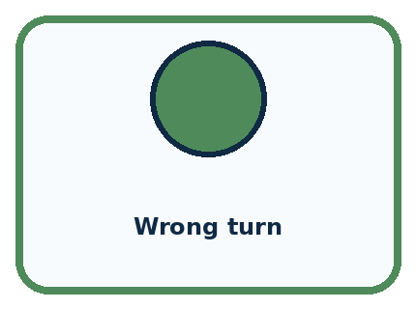
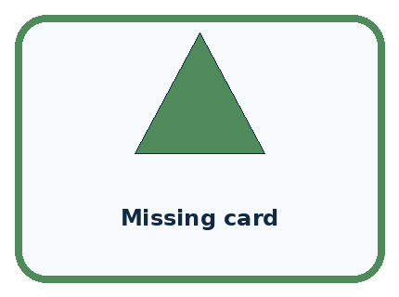
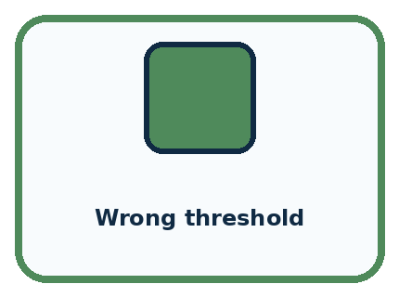
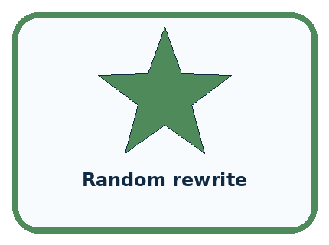
CASE 1 — Wrong turn Clue: first divergence at step 4. Meaning: inspect orientation assumption.
CASE 2 — Missing card Clue: input absent before step 1. Meaning: data/setup cause.
CASE 3 — Wrong threshold Clue: branch changes at 10. Meaning: condition cause.
CASE 4 — Random rewrite Clue: many steps changed. Meaning: weak debugging evidence.
BOUNDARY A successful new run does not prove the diagnosis if several things changed together.
Which two pictures are easiest to confuse? What evidence separates them?

Change one thing in the pictured case
Change: Use input 6 again instead of 2.
Prediction: Both hypotheses predict 12; the test remains inconclusive.
Reason: A revealing test requires different predicted outputs, not merely another recorded run.

05. Words that unlock the idea
VOCABULARY

Words You Can See and Use
The badge is a memory cue; the definition does the real thinking work.
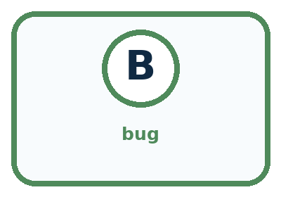
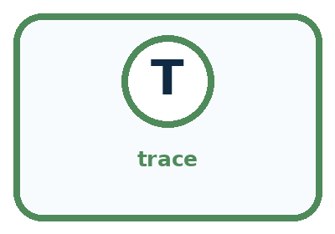
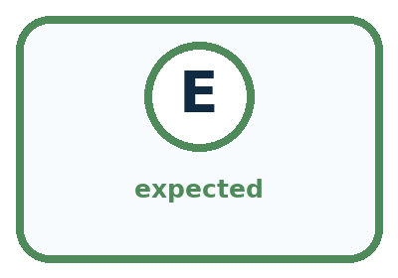
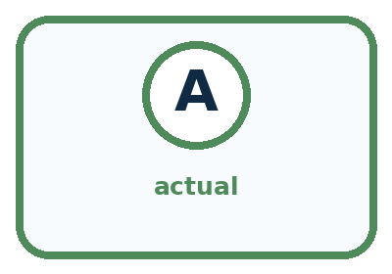
Word | Meaning | My example
bug | cause of incorrect or unexpected behavior
trace | record of steps and changing state
expected | result predicted before the test
actual | result observed during the test

Misconception detective
CLAIM TO REPAIR Debugging means rewriting everything that looks suspicious.
Use one vocabulary word and one piece of evidence to repair it:
WORD POWER A strong definition helps you decide something in a new case.

Words used in the closer explanation
Word | Meaning
Specification | A statement of what a system is required to do
Expected result | The result worked out from the specification before running a test
Observed result | The result actually recorded during a test
First divergence | The earliest step where observed behaviour differs from expected behaviour
Regression test | A repeated check that previously correct behaviour still works after a change

06. Follow a worked example
WORKED EXAMPLE

Watch the Reasoning, Not Just the Answer
Every step connects a claim to observable evidence.

CASE A paper robot hits a wall because one turn instruction assumes it faces north when it actually faces east.
STEP 1 — OBSERVE expected path and actual trace
STEP 2 — TRACE locate the first difference and test one cause
STEP 3 — CONCLUDE targeted correction plus repeated test
MODEL REASONING Trace expected and actual positions step by step. The first mismatch reveals the earliest plausible cause. Change that instruction or assumption only, then rerun the identical maze to show whether the cause was correct.
DO NOT OVERCLAIM A successful new run does not prove the diagnosis if several things changed together.
What new evidence could change this answer?

A closer explanation
For the faulty doubling step, two explanations fit the observed change from 7 to 11. Perhaps the step adds 4. Perhaps it adds the original starting score, which was 4. Repeating the same start 4 cannot separate those explanations because they make the same prediction.
Start score | Expected final result | If step adds 4 or original start
4 | 12 | 9 under either explanation
2 | 8 | 7 if add 4 or 5 if add original 2
5 | 14 | 10 if add 4 or 11 if add original 5
Starting at 2 produces 5 after the first addition. The intended double gives 10 and then reports 8. Adding 4 would give 9 and report 7. Adding the original 2 would give 7 and report 5. The different predictions make this a revealing test.
If the observed final result is 7, it supports add 4 over add original among these two explanations. Other faults could still give 7, so inspect the actual instruction or more checkpoints before claiming a unique cause.

Learn from the worked case
Cover the result before checking it. Say what is given, choose the procedure, and follow one step at a time. Then uncover the result and explain your first mismatch. Ask why a step is allowed, not only what number it produces.

A pictorial worked case: Debug the Cause
A fictional paper calculator should double the current value, but a copied instruction behaves strangely.

The facts we will use
After input 6, the faulty step reports 12. Hypothesis A: add 6. Hypothesis B: double.
Both hypotheses fit this first observation. A new input may be chosen.
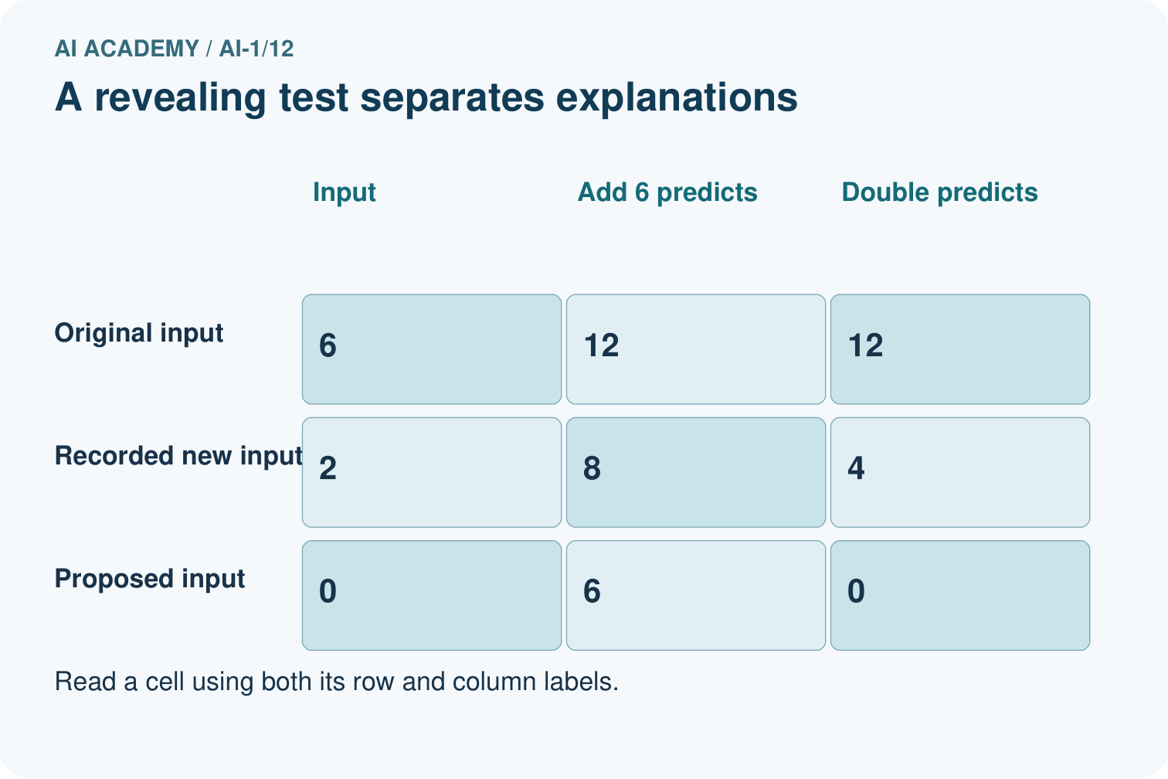
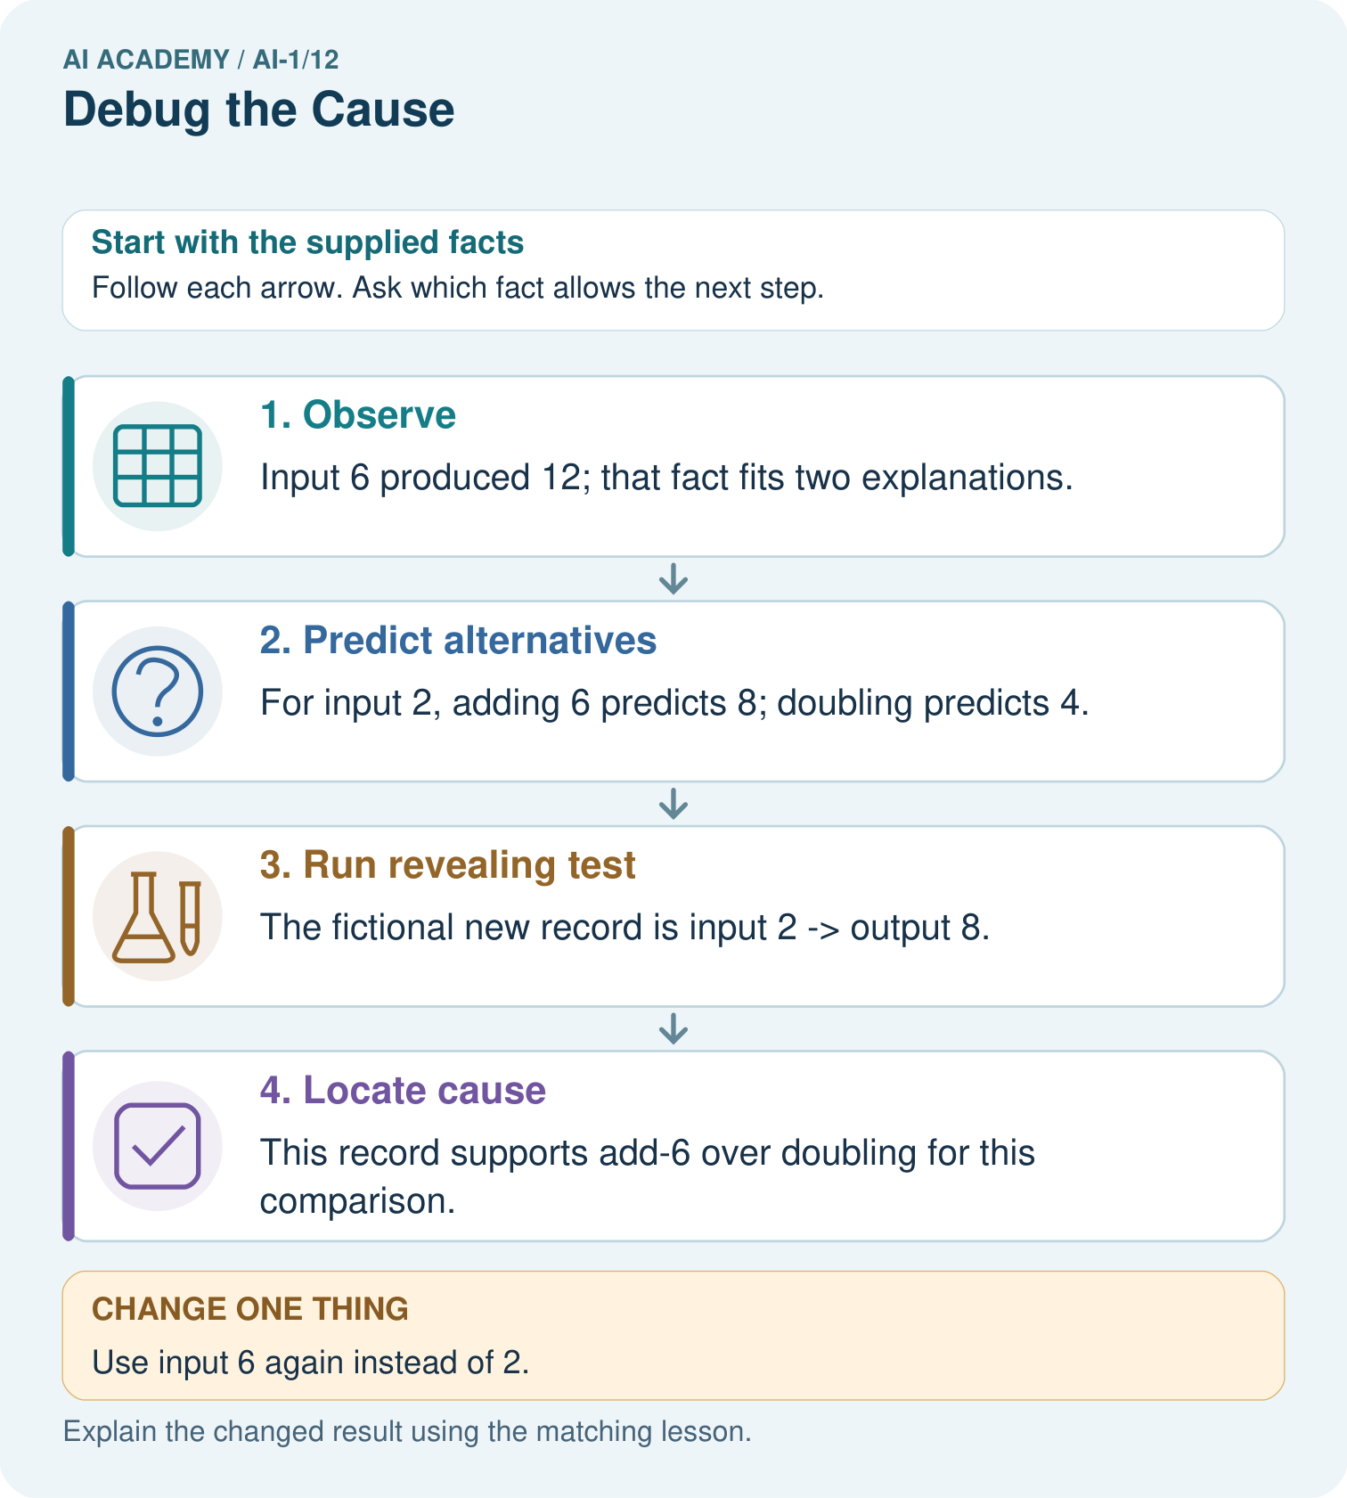

Read the picture one step at a time
Step | What happens and why
1. Observe | Input 6 produced 12; that fact fits two explanations.
2. Predict alternatives | For input 2, adding 6 predicts 8; doubling predicts 4.
3. Run revealing test | The fictional new record is input 2 → output 8.
4. Locate cause | This record supports add-6 over doubling for this comparison.
Match each pictured step to the supplied facts. This is a worked teaching case, not an independent assessment.

Why this result follows
Repeating input 6 would not separate the two hypotheses because both again predict 12. Input 2 makes their predictions different before the test is run. The second record supports investigating an added constant, but inspecting the instruction is still needed to confirm the implementation.

What this example does not establish
Two toy hypotheses do not exhaust every possible bug; a matching output alone cannot identify arbitrary hidden code.

07. Find and repair a mistake
COMPARE

Same Result, Different Reason
A comparison helps reveal the true concept boundary.
Case | Evidence | What it shows
Wrong turn | first divergence at step 4 | inspect orientation assumption
Missing card | input absent before step 1 | data/setup cause
Wrong threshold | branch changes at 10 | condition cause
Random rewrite | many steps changed | weak debugging evidence

Repair two tempting claims
CLAIM A Debugging means rewriting everything that looks suspicious.
Repair:
CLAIM B The last visible error must be the original cause.
Repair:
STRONG ANSWER FRAME I claim ______ because the evidence shows ______. The process is ______. One limit is ______.

A closer explanation
For an arithmetic step, choose inputs that produce different predictions under plausible faults. For a condition, test its equality case as well as values on each side. For a loop, include a false first test and a run that crosses its stopping boundary. A test list is stronger when you can explain what each case checks.
A useful bug report names the version and input, says what should happen, records what did happen, and identifies the first known difference. Include the repair and retest evidence once available. Passing a finite collection of tests increases confidence in those behaviours; it does not prove every possible input correct.

A repaired below 7 loop is checked only from start 1. Name a regression test that would reveal an accidental change from below 7 to at most 7, give both expected outcomes with add 2, and explain why the test is revealing
________________________________________________________________
________________________________________________________________
________________________________________________________________
________________________________________________________________

08. Practise together
GUIDED PRACTICE

Try It, Check It, Explain It
Use support now so you can succeed independently later.

Explain how the picture story demonstrates this idea: Debugging finds the broken assumption or step before changing the solution.
Use a fresh example to explain bug.
Trace a new input → process → output example.
Find and repair the error in: The last visible error must be the original cause.
Invent one edge case and name the safe response.
PARTNER CHECK Point to the evidence. Do not accept an answer that only repeats the vocabulary word.

A closer explanation
Suppose inspection confirms that the second instruction says add 4. Replace that instruction with double the current score. Keep the original failing test, then rerun other inputs. From starts 4, 2 and 5, the corrected final results should be 12, 8 and 14.

A copied machine reports 9 from start 4 and 7 from start 2. Which of the two proposed explanations is consistent with both results? State what to inspect, the repair if confirmed, and the expected results to record after the repair
________________________________________________________________
________________________________________________________________
________________________________________________________________
________________________________________________________________
________________________________________________________________
________________________________________________________________
Change the suspected instruction while keeping the test inputs fixed. If you change several instructions and inputs together, it is harder to tell which change mattered. Rerun previously passing cases as regression tests, because a repair can accidentally break other behaviour.

Practise with less help: Choose between two explanations
Use workbook W2 for the connected example “Debugging with revealing tests”. First fill the input and rule boxes. Try the middle steps before asking for a hint. After a hint, try the next step yourself.
Plan | Do | Check
What is given? Which rule or procedure applies? | Record each intermediate step. | Does the result follow? What remains unknown?
Explain your trace to a partner. Your partner points to one step to check. Swap roles on the next case. Each person writes their own explanation.

Check your reasoning
Use the worked case for Debugging with revealing tests. Proposed explanation: “The last wrong number locates the fault”. Decide whether this explanation is supported. Point to the step or supplied fact that decides; explain your repair if needed.
Answer on your own before discussion. If you are unsure, say which step you need help with.

Explain the picture
Propose input 0 and give both predicted outputs without inventing an observed result.

My explanation using a pictured step and the given facts
________________________________________________________________
________________________________________________________________
________________________________________________________________
________________________________________________________________
This is supported practice. Keep the separately named independent case for an attempt before feedback.

09. Run the investigation
EXPLORER LAB

Maze Cause Detective
Predict first, test honestly, and explain what the evidence means.
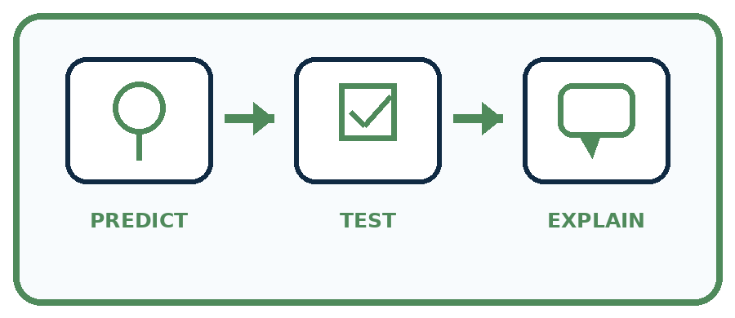
State your prediction before the result is known.
Complete the task: Repair a maze algorithm and explain the exact failure.
Keep a normal case and an edge case clearly separated.
Record what happened—even when it does not match your prediction.
Explain the result, one limitation, and the next useful test.
Case | Prediction | Observed result | What it means
Normal
Edge
INDEPENDENCE After support is removed, repeat the proof with a fresh case.

Plan → try → check
Before trying: what do I expect, and why? While trying: which step could first go wrong? Afterwards: what did I actually observe, and what should change? Keep “not run” if you only traced the procedure.

10. Build your understanding
PRACTICE LADDER

Climb from Recall to Defense
Each step asks for a stronger kind of understanding.
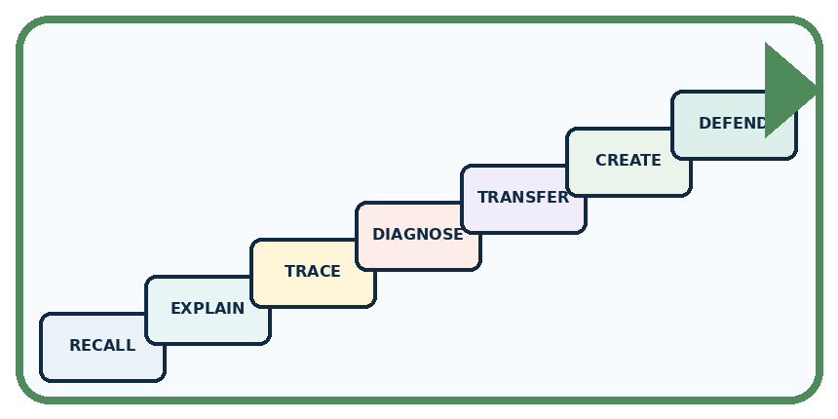
RECALL Define bug.
EXPLAIN Debugging finds the broken assumption or step before changing the solution.
TRACE Show the input, process, and output.
DIAGNOSE Repair: Debugging means rewriting everything that looks suspicious.
TRANSFER Apply the idea to a new home or classroom case.
CREATE Design one revealing test.
DEFEND Give a claim, evidence, mechanism, limit, and safe action.
RETRY RULE A coached answer becomes mastery only after you solve a different case independently.

11. Connect your project
PROJECT

Helpful Classroom Sorter
Build one coherent system across the year, one evidence-based decision at a time.
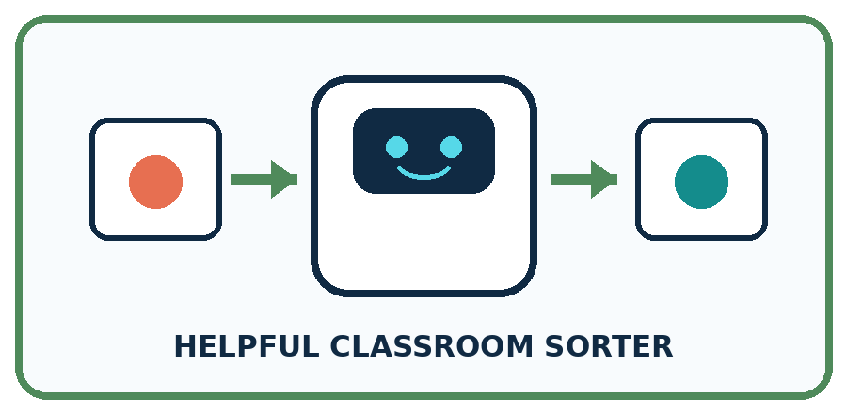
THIS WEEK'S CHECKPOINT When the sorter fails, log the first wrong stage and change only the responsible rule, input, or label.
What real classroom need does this serve?
What information is necessary—and what should stay private?
What happens inside the process?
What normal and edge cases will you test?
When should it say not sure or ask a person?

RESPONSIBLE DESIGN A successful new run does not prove the diagnosis if several things changed together.
My project decision:

Evidence for your project
When the sorter fails, write competing explanations and predicted traces before changing code or instructions.

12. Show what you know
MASTERY

Fresh-Case Independent Proof
Complete this after teaching and guided practice have ended.
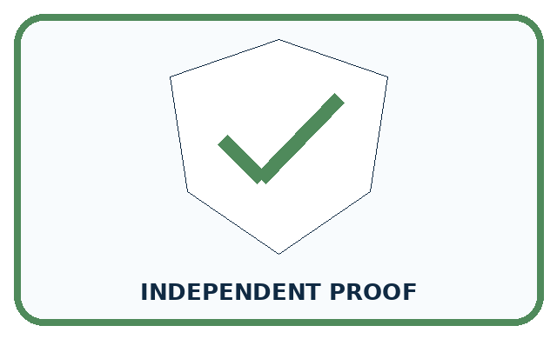
REQUIRED PROOF Repair a maze algorithm and name the first divergence, the tested cause, the one change, and the retest result.
□ Name or draw the fresh case.
□ Trace input, process, and output.
□ State the conclusion and strongest evidence.
□ Name one limit, failure, missing clue, or fairness/privacy concern.
□ Explain one safe next action or improvement.
Independent evidence:
SELF-CHECK Trace expected and actual positions step by step. The first mismatch reveals the earliest plausible cause. Change that instruction or assumption only, then rerun the identical maze to show whether the cause was correct.
My level: □ Not yet □ With one hint □ Independently □ I can teach it
NEXT BRIDGE Carry today's evidence habit into: Learning from Examples.

13. Study a complete case

Week 12 Worked case
Use the supplied details to practise the weekly concept before attempting the independent question. This case extends the illustrated lesson.

The situation
A robot should go from square one to square three. Its program is MOVE ONE, STOP.

The question
Find the cause and repair one thing.

Worked explanation
It stops at square two because one move is missing. Add MOVE ONE before STOP and retest from the same start.

Explain it in your own words
Which detail supports the answer, and why does it matter?

Write or draw your reasoning and evidence.
________________________________________________________________
________________________________________________________________
________________________________________________________________
________________________________________________________________
________________________________________________________________

Trace the supplied case visually

Repair the earliest missing action
Evidence or stage | Value or result
Intended destination | Square three
Broken program | MOVE, STOP → square two
Repaired program | MOVE, MOVE, STOP → square three
A robot should go from square one to square three. Its program is MOVE ONE, STOP.
Find the cause and repair one thing.
It stops at square two because one move is missing. Add MOVE ONE before STOP and retest from the same start.

14. Try a new case independently

Independent case: Debug a new ticket rule
A paper ticket rule must add 1 to the input count. If the updated count is at least 5, report Group; otherwise report Single. A copied version says above 5. Choose the smallest three consecutive nonnegative starting counts that test just below, exactly at and just above the comparison boundary. Predict both versions, identify the revealing start and state the repair and retests.

My independent explanation, trace and limits
________________________________________________________________
________________________________________________________________
________________________________________________________________
________________________________________________________________
________________________________________________________________
________________________________________________________________
________________________________________________________________
Attempt this case before feedback. Record any help. Earlier examples below are further practice; a case already practised with feedback cannot establish fresh transfer.

Week 12 Independent application
Close the worked explanation. Apply the idea to this different question without copying.
A sorting rule says blue goes left. A blue card goes right. The reader correctly reports blue, but the direction rule says blue goes right. Which part should you fix first?
My answer, with a trace, calculation or supporting evidence

Write or draw your reasoning and evidence.
________________________________________________________________
________________________________________________________________
________________________________________________________________
________________________________________________________________
________________________________________________________________

Create and test
Change one relevant detail. Predict the result before testing. Include a boundary or missing-information case when it helps reveal a limit.
My changed input and expected result

Write or draw your reasoning and evidence.
________________________________________________________________
________________________________________________________________
________________________________________________________________
________________________________________________________________
________________________________________________________________

Connect to your project
When the sorter fails, log the first wrong stage and change only the responsible rule, input, or label.
The evidence I will keep

Write or draw your reasoning and evidence.
________________________________________________________________
________________________________________________________________
________________________________________________________________
________________________________________________________________
________________________________________________________________
Your teacher has the independent answer and scoring criteria. Complete the matching workbook week to keep your practice evidence together.

Transfer practice from the original programme
The requirement is to move exactly three squares forward from any valid starting square, then stop. Starting at square 0, repeat twice {MOVE 1}; STOP ends at 2. A teammate reduces the required distance to two squares. Repair the program without changing the requirement; test starts 0 and 2.

Explain the mechanism, evidence and one limit.
________________________________________________________________
________________________________________________________________
________________________________________________________________
________________________________________________________________
________________________________________________________________
________________________________________________________________
________________________________________________________________

Use feedback to improve
Attempt the independent case before hints. Record whether you worked alone, used a hint or followed a model. After feedback, fix the first unsupported step and explain why it changed. A later check uses a changed case, not a copied answer.

