AI ACADEMY · STUDENT · ai-1/13

Learning from Examples
Project: Helpful Classroom Sorter

Before you start
Weeks 7–8: labels and features have different roles.

01. Your mission

Your learning target
I can fit a threshold by tracing predictions and counting disagreements for every candidate.
I can apply an explicit tie rule while recording what the fitting examples leave unresolved.
I can use a selected rule on a new input and explain why fit alone does not establish future correctness.

Remember before reading
Close your notes first. A rough first answer helps us choose the right starting point; it is not a score for your ability.
Without opening the old lesson, explain one key idea from Debug the Cause. Give an example and a mistake that the idea helps you avoid.
Without opening the old lesson, explain one key idea from If/Then Decisions. Give an example and a mistake that the idea helps you avoid.
Without opening the old lesson, explain one key idea from Categories and Labels. Give an example and a mistake that the idea helps you avoid.
After trying, check the relevant lesson or ask your teacher. Change the part of your explanation that the evidence shows was wrong.
Training examples influence how a model handles later inputs.
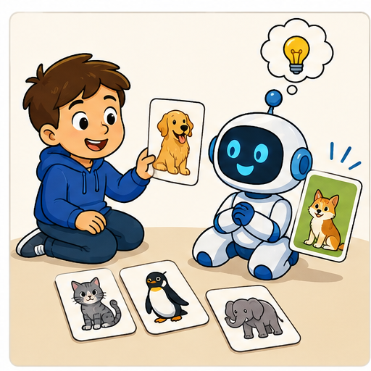
LEARNING TARGET Training cards show lengths 2,3 labelled S and 7,8 labelled L. Two proposed rules are 'L at 5 or above' and 'L at 7 or above'. Both fit training. Choose one new labelled card length that would distinguish them and explain what remains unknown.
Learner name:

Readiness for the connected explanation
A rule predicts tall when height is at least 5 cm. What does it predict at 4, 5 and 6 cm? Why is 5 a useful boundary test?

This week’s end goal
By the end, I can compare candidate models, resolve a tie explicitly and separate fit from prediction.

02. Notice the evidence
PICTURE STORY

Look Closely Before You Explain
Pictures give clues; evidence tells us what the clues mean.

MYSTERY A learner shown mostly striped triangles may wrongly treat stripes as the important clue for the triangle label.

What do you notice?
Name three visible details without explaining them yet.
Circle the detail most connected to the system's decision.
Name one detail that may be decoration or distraction.
Make a first prediction and state the clue that supports it.
My observations, prediction, and evidence:
GOOD THINKING A prediction can change when stronger evidence appears.

A closer explanation
Four imaginary paper towers have heights 2, 4, 6 and 8 centimetres. Their supplied labels are short, short, tall and tall. These labels belong to this classroom task; they are not a universal definition of tall. We will fit a rule using height as its only input.
Every candidate predicts tall when height is at least its threshold and short otherwise. Compare thresholds 3, 5, 6 and 7 centimetres. The fitting procedure chooses the fewest disagreements with the four labels. If candidates tie, choose the smaller threshold. Write these choices before comparing results.
For each candidate, start its count at zero. For each example, predict with that candidate, compare with the supplied label, and add one only for a disagreement. After all four examples, record the count. Then move to the next candidate with a fresh count. This uses the conditions and repetition you have already traced.

03. See how it works
VISUAL MECHANISM

Input → Process → Output
Follow the information instead of imagining magic inside the machine.
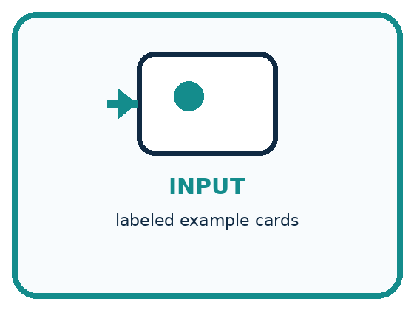
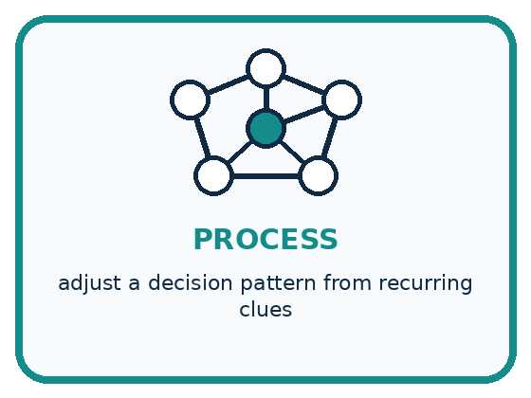
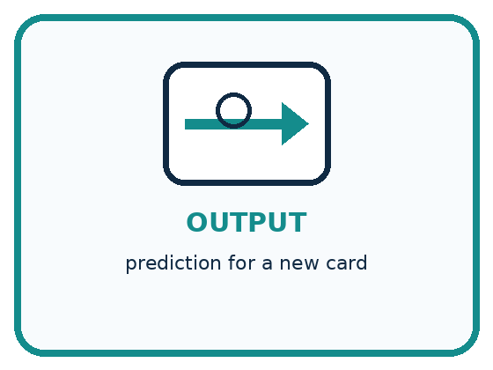
INPUT labeled example cards
PROCESS adjust a decision pattern from recurring clues
OUTPUT prediction for a new card
CORE IDEA Training examples influence how a model handles later inputs.
UNDER THE HOOD Supervised learning uses labeled examples to fit a mapping from represented inputs to outputs. The model does not store a human rule automatically; its fitted behavior reflects correlations, coverage, labels, and optimization choices.
Draw a fresh example with all three stages:

A closer explanation

Disagreements on the four fitting examples
Candidate | Disagreements
Threshold 3 | 1 of 4
Threshold 5 | 0 of 4
Threshold 6 | 0 of 4
Threshold 7 | 1 of 4
All candidates use the same four examples and the same zero to four scale. Thresholds 5 and 6 have zero-length bars. They tie; our stated smaller-threshold rule selects 5.
Threshold 3 incorrectly calls the height 4 tower tall. Threshold 7 incorrectly calls the height 6 tower short. Thresholds 5 and 6 agree with all four supplied labels. Check each disagreement against the individual example instead of trusting a total without its trace.
The bar chart compares disagreement counts, so a shorter bar is better on this fitting set. Zero is a measured count here, not missing data. This chart says nothing yet about the error count on new towers.

Connect the picture and the explanation
Point to the input, the deciding step and the result in this week’s visual. Explain the same step in ordinary words. A picture helps when you can say what each part represents.

04. Compare the cases
PICTURE GALLERY

Four Cases, Four Clues
Use the visual cue, then read the evidence carefully.
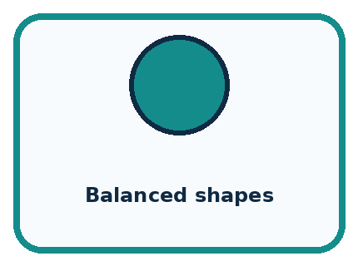
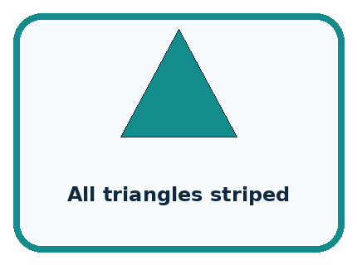
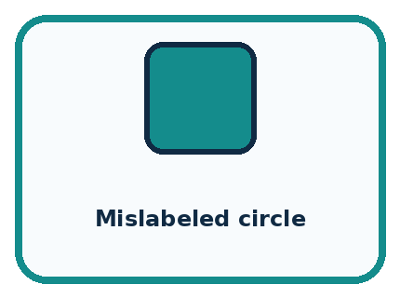
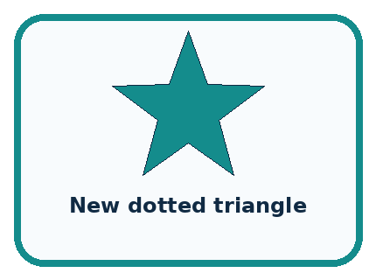
CASE 1 — Balanced shapes Clue: colors vary within each shape. Meaning: shape clue becomes clearer.
CASE 2 — All triangles striped Clue: stripe and triangle always co-occur. Meaning: confounded clue.
CASE 3 — Mislabeled circle Clue: target is incorrect. Meaning: label noise.
CASE 4 — New dotted triangle Clue: unseen combination. Meaning: tests learned behavior.
BOUNDARY Learning from examples is not the same as memorizing every example or understanding the concept like a person.
Which two pictures are easiest to confuse? What evidence separates them?

Change one thing in the pictured case
Change: Reverse the tie policy to prefer the larger boundary.
Prediction: Boundary 7 is selected and predicts short at 6.
Reason: The training fit is unchanged; only the explicit choice between tied candidates changes.

05. Words that unlock the idea
VOCABULARY

Words You Can See and Use
The badge is a memory cue; the definition does the real thinking work.
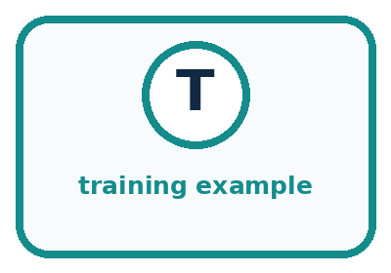
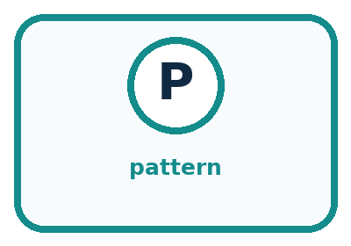
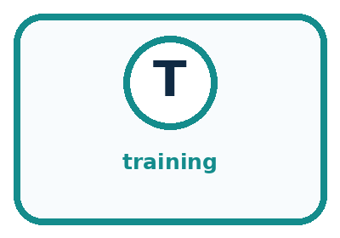
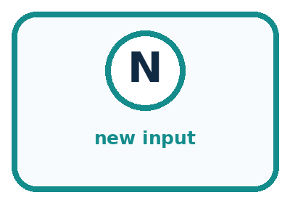
Word | Meaning | My example
training example | input paired with a target label
pattern | recurring relationship across examples
training | fitting behavior from examples
new input | case not used in fitting

Misconception detective
CLAIM TO REPAIR The model discovers the one true rule hidden in nature.
Use one vocabulary word and one piece of evidence to repair it:
WORD POWER A strong definition helps you decide something in a new case.

Words used in the closer explanation
Word | Meaning
Candidate model | One possible rule being compared during fitting
Fitting set | The examples used to choose or adjust a model
Disagreement count | The number of predictions that differ from their comparison labels
Tie rule | An explicit method for choosing between equally scoring candidates
Generalisation | How well a fitted model works on new cases beyond its fitting examples

06. Follow a worked example
WORKED EXAMPLE

Watch the Reasoning, Not Just the Answer
Every step connects a claim to observable evidence.

CASE A learner shown mostly striped triangles may wrongly treat stripes as the important clue for the triangle label.
STEP 1 — OBSERVE labeled example cards
STEP 2 — TRACE adjust a decision pattern from recurring clues
STEP 3 — CONCLUDE prediction for a new card
MODEL REASONING Early examples may support several rules. New examples eliminate some possibilities and may change the decision boundary. Record each revision as evidence that training data shapes later behavior.
DO NOT OVERCLAIM Learning from examples is not the same as memorizing every example or understanding the concept like a person.
What new evidence could change this answer?

A closer explanation
Height and supplied label | Prediction under threshold 5 | Prediction under threshold 6
2 cm short | Short | Short
4 cm short | Short | Short
6 cm tall | Tall | Tall
8 cm tall | Tall | Tall
5 cm label not yet supplied | Tall | Short
The first four rows are fitting examples. The final row asks what the two tied candidates predict at a height missing from that set. Our tie rule selects 5, so the selected model predicts tall at 5. The fitting examples alone do not tell us whether that new prediction matches the task label.
A tie rule makes the selection reproducible. It does not prove that the chosen threshold is the true boundary. Record that 6 tied with 5 and that they disagree at height 5. Hiding the tie would hide a real limitation of the available evidence.

Learn from the worked case
Cover the result before checking it. Say what is given, choose the procedure, and follow one step at a time. Then uncover the result and explain your first mismatch. Ask why a step is allowed, not only what number it produces.

A pictorial worked case: Learning from Examples
A fictional classifier learns whether measured sticks are short or long.

The facts we will use
Training lengths 2,4,8,10 cm have labels short,short,long,long.
Candidate boundaries: long at least 5 or at least 7. Lowest errors wins; tie chooses smaller boundary.
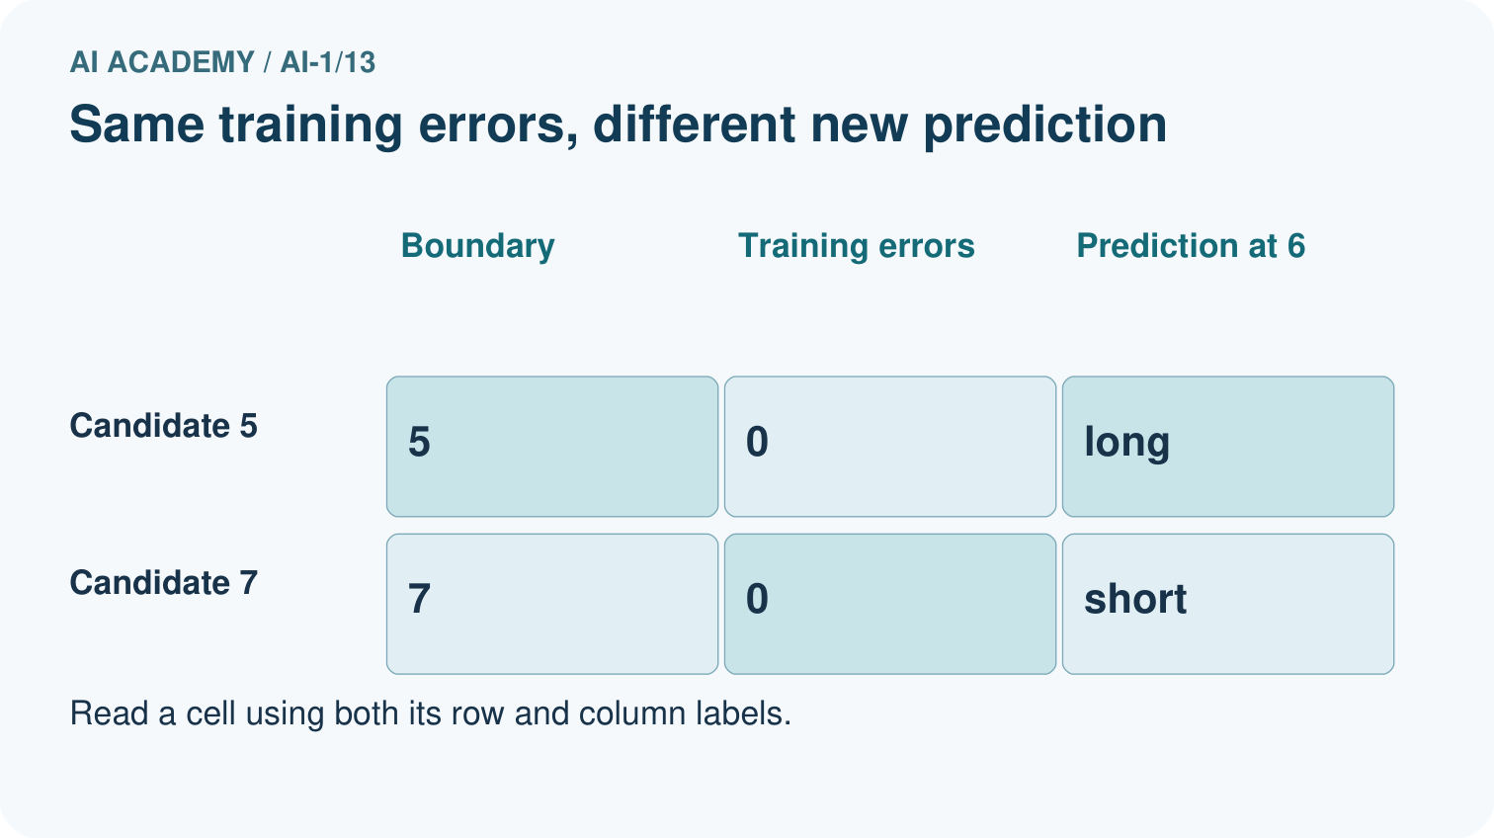
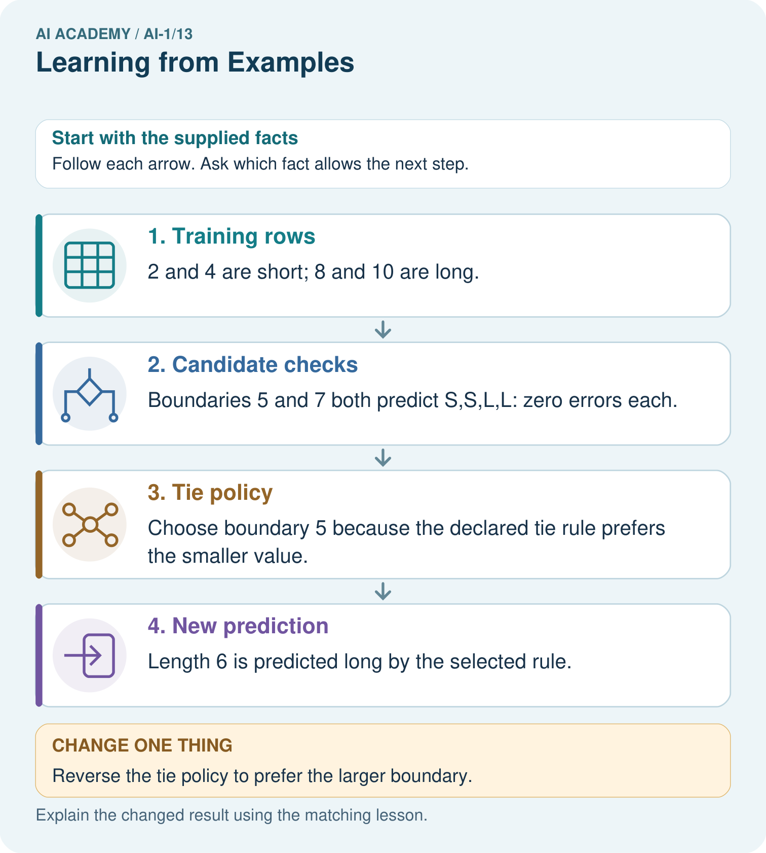

Read the picture one step at a time
Step | What happens and why
1. Training rows | 2 and 4 are short; 8 and 10 are long.
2. Candidate checks | Boundaries 5 and 7 both predict S,S,L,L: zero errors each.
3. Tie policy | Choose boundary 5 because the declared tie rule prefers the smaller value.
4. New prediction | Length 6 is predicted long by the selected rule.
Match each pictured step to the supplied facts. This is a worked teaching case, not an independent assessment.

Why this result follows
There is no training stick between 4 and 8 to distinguish these candidates. The tie policy chooses one consistently; it is not additional evidence that its prediction at 6 is true. Label-free prediction applies the selected boundary, while evaluation would require an appropriate new reference label.

What this example does not establish
Zero training errors for both rules cannot determine the correct label of every unobserved stick.

07. Find and repair a mistake
COMPARE

Same Result, Different Reason
A comparison helps reveal the true concept boundary.
Case | Evidence | What it shows
Balanced shapes | colors vary within each shape | shape clue becomes clearer
All triangles striped | stripe and triangle always co-occur | confounded clue
Mislabeled circle | target is incorrect | label noise
New dotted triangle | unseen combination | tests learned behavior

Repair two tempting claims
CLAIM A The model discovers the one true rule hidden in nature.
Repair:
CLAIM B One example is enough to learn a reliable category.
Repair:
STRONG ANSWER FRAME I claim ______ because the evidence shows ______. The process is ______. One limit is ______.

A closer explanation
The best candidate means best among the candidates compared, using this counting rule and these recorded labels. A different candidate family, feature or label policy might give a different result. People chose those ingredients; fitting does not remove those choices.
If two records with identical input height have different labels, any deterministic rule using only that height gives them the same prediction. It must disagree with at least one label. Investigate the records and task definition instead of silently changing a label to make the model look perfect.

The selected threshold has zero disagreements on four fitting examples. A learner claims it will label every future tower correctly. Write a more accurate claim and name evidence that is still needed
________________________________________________________________
________________________________________________________________
________________________________________________________________
________________________________________________________________

08. Practise together
GUIDED PRACTICE

Try It, Check It, Explain It
Use support now so you can succeed independently later.

Explain how the picture story demonstrates this idea: Training examples influence how a model handles later inputs.
Use a fresh example to explain training example.
Trace a new input → process → output example.
Find and repair the error in: One example is enough to learn a reliable category.
Invent one edge case and name the safe response.
PARTNER CHECK Point to the evidence. Do not accept an answer that only repeats the vocabulary word.

A closer explanation
Suppose the task designer supplies an additional fitting example: height 5 centimetres, label short. Compare thresholds 5 and 6 again using all five fitting examples. Do not discard the original four when adding the new example.

List the prediction at the added height 5 under each candidate and update both total disagreement counts. Select between 5 and 6 under the fitting procedure. Explain why the added example is now fitting evidence rather than an independent final test
________________________________________________________________
________________________________________________________________
________________________________________________________________
________________________________________________________________
________________________________________________________________
________________________________________________________________
A label that helps choose the threshold participates in fitting. This is allowed, but it changes what the example can establish. We must use separate evidence to evaluate the selected model beyond the examples that shaped it. Week 15 will develop that separation in detail.

Practise with less help: Explain a tied fit
Use workbook W2 for the connected example “Fitting a pattern from examples”. First fill the input and rule boxes. Try the middle steps before asking for a hint. After a hint, try the next step yourself.
Plan | Do | Check
What is given? Which rule or procedure applies? | Record each intermediate step. | Does the result follow? What remains unknown?
Explain your trace to a partner. Your partner points to one step to check. Swap roles on the next case. Each person writes their own explanation.

Check your reasoning
Use the worked case for Fitting a pattern from examples. Proposed explanation: “The lowest error count is added across candidates”. Decide whether this explanation is supported. Point to the step or supplied fact that decides; explain your repair if needed.
Answer on your own before discussion. If you are unsure, say which step you need help with.

Explain the picture
Which new measured length would reveal disagreement between the candidates?

My explanation using a pictured step and the given facts
________________________________________________________________
________________________________________________________________
________________________________________________________________
________________________________________________________________
This is supported practice. Keep the separately named independent case for an attempt before feedback.

09. Run the investigation
EXPLORER LAB

Human Shape Model
Predict first, test honestly, and explain what the evidence means.
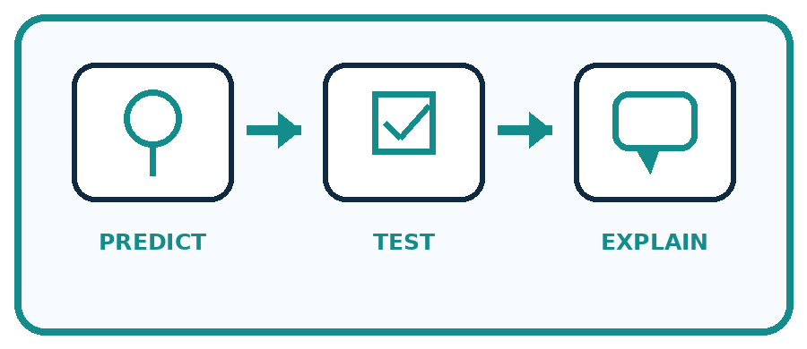
State your prediction before the result is known.
Complete the task: Act as a model trained on shape cards; record rule changes.
Keep a normal case and an edge case clearly separated.
Record what happened—even when it does not match your prediction.
Explain the result, one limitation, and the next useful test.
Case | Prediction | Observed result | What it means
Normal
Edge
INDEPENDENCE After support is removed, repeat the proof with a fresh case.

Plan → try → check
Before trying: what do I expect, and why? While trying: which step could first go wrong? Afterwards: what did I actually observe, and what should change? Keep “not run” if you only traced the procedure.

10. Build your understanding
PRACTICE LADDER

Climb from Recall to Defense
Each step asks for a stronger kind of understanding.
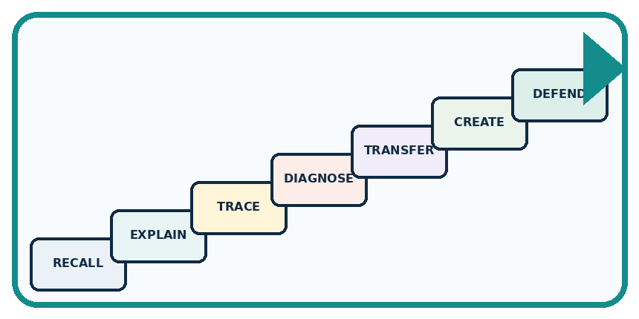
RECALL Define training example.
EXPLAIN Training examples influence how a model handles later inputs.
TRACE Show the input, process, and output.
DIAGNOSE Repair: The model discovers the one true rule hidden in nature.
TRANSFER Apply the idea to a new home or classroom case.
CREATE Design one revealing test.
DEFEND Give a claim, evidence, mechanism, limit, and safe action.
RETRY RULE A coached answer becomes mastery only after you solve a different case independently.

11. Connect your project
PROJECT

Helpful Classroom Sorter
Build one coherent system across the year, one evidence-based decision at a time.
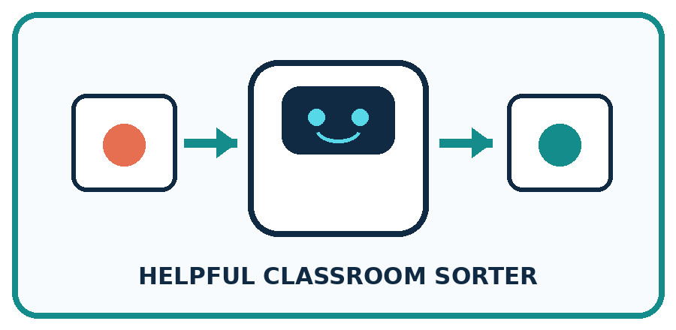
THIS WEEK'S CHECKPOINT Create the first small labeled example set for the sorter and explain which visual differences it covers.
What real classroom need does this serve?
What information is necessary—and what should stay private?
What happens inside the process?
What normal and edge cases will you test?
When should it say not sure or ask a person?

RESPONSIBLE DESIGN Learning from examples is not the same as memorizing every example or understanding the concept like a person.
My project decision:

Evidence for your project
Save candidate definitions, training errors and tie policy with any sorter model version.

12. Show what you know
MASTERY

Fresh-Case Independent Proof
Complete this after teaching and guided practice have ended.
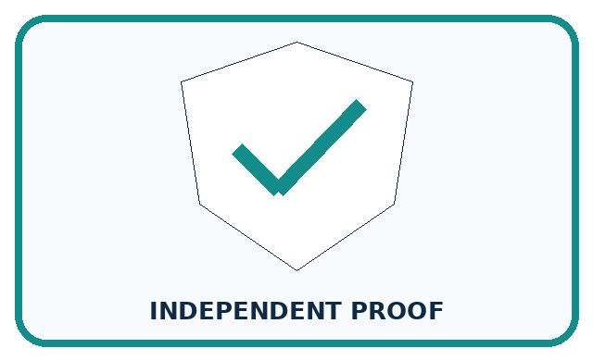
REQUIRED PROOF Train on shape cards, record how added examples change the inferred rule, and predict a new card.
□ Name or draw the fresh case.
□ Trace input, process, and output.
□ State the conclusion and strongest evidence.
□ Name one limit, failure, missing clue, or fairness/privacy concern.
□ Explain one safe next action or improvement.
Independent evidence:
SELF-CHECK Early examples may support several rules. New examples eliminate some possibilities and may change the decision boundary. Record each revision as evidence that training data shapes later behavior.
My level: □ Not yet □ With one hint □ Independently □ I can teach it
NEXT BRIDGE Carry today's evidence habit into: Build a Human Classifier.

13. Study a complete case

Week 13 Worked case
Use the supplied details to practise the weekly concept before attempting the independent question. This case extends the illustrated lesson.

The situation
Training examples label smooth leaves S and toothed leaves T. A new leaf is toothed.

The question
Predict and state the evidence limit.

Worked explanation
Predict T from the demonstrated edge pattern. One success does not establish broad reliability; use fresh labelled tests including ambiguous cases.

Explain it in your own words
Which detail supports the answer, and why does it matter?

Write or draw your reasoning and evidence.
________________________________________________________________
________________________________________________________________
________________________________________________________________
________________________________________________________________
________________________________________________________________

Trace the supplied case visually

Examples suggest a pattern to test
Evidence or stage | Value or result
Smooth leaves | Training label S
Toothed leaves | Training label T
New toothed leaf | Predict T
Fresh labelled cases | Check the prediction rule
Training examples label smooth leaves S and toothed leaves T. A new leaf is toothed.
Predict and state the evidence limit.
Predict T from the demonstrated edge pattern. One success does not establish broad reliability; use fresh labelled tests including ambiguous cases.

14. Try a new case independently

Independent case: Fit a new distance task
Imaginary map markers have distances 1, 3, 5 and 7 units, with supplied labels near, far, far and far. Compare candidates that predict far when distance is at least 2, 4 or 6 units. List every prediction and error count, select the lowest-error candidate, then predict at distance 2 before any comparison label is supplied. Limit your conclusion.

My independent explanation, trace and limits
________________________________________________________________
________________________________________________________________
________________________________________________________________
________________________________________________________________
________________________________________________________________
________________________________________________________________
________________________________________________________________
Attempt this case before feedback. Record any help. Earlier examples below are further practice; a case already practised with feedback cannot establish fresh transfer.

Week 13 Independent application
Close the worked explanation. Apply the idea to this different question without copying.
A learner sees three red apples and no green apples, then calls a green apple not an apple. What missing evidence could help? How would you check improvement?
My answer, with a trace, calculation or supporting evidence

Write or draw your reasoning and evidence.
________________________________________________________________
________________________________________________________________
________________________________________________________________
________________________________________________________________
________________________________________________________________

Create and test
Change one relevant detail. Predict the result before testing. Include a boundary or missing-information case when it helps reveal a limit.
My changed input and expected result

Write or draw your reasoning and evidence.
________________________________________________________________
________________________________________________________________
________________________________________________________________
________________________________________________________________
________________________________________________________________

Connect to your project
Create the first small labeled example set for the sorter and explain which visual differences it covers.
The evidence I will keep

Write or draw your reasoning and evidence.
________________________________________________________________
________________________________________________________________
________________________________________________________________
________________________________________________________________
________________________________________________________________
Your teacher has the independent answer and scoring criteria. Complete the matching workbook week to keep your practice evidence together.

Transfer practice from the original programme
Training cards show lengths 2,3 labelled S and 7,8 labelled L. Two proposed rules are 'L at 5 or above' and 'L at 7 or above'. Both fit training. Choose one new labelled card length that would distinguish them and explain what remains unknown.

Explain the mechanism, evidence and one limit.
________________________________________________________________
________________________________________________________________
________________________________________________________________
________________________________________________________________
________________________________________________________________
________________________________________________________________
________________________________________________________________

Use feedback to improve
Attempt the independent case before hints. Record whether you worked alone, used a hint or followed a model. After feedback, fix the first unsupported step and explain why it changed. A later check uses a changed case, not a copied answer.

