AI ACADEMY · STUDENT · ai-1/29

Find a Real Problem
Project: Helpful Classroom Sorter

Before you start
Week 23: evaluate success using recorded cases.

01. Your mission

Your learning target
I can describe a specific user difficulty using supplied evidence without inventing its cause.
I can define a useful outcome and a way to observe it before choosing a solution.
I can choose a small project with clear boundaries, permitted information and a simple alternative.

Remember before reading
Close your notes first. A rough first answer helps us choose the right starting point; it is not a score for your ability.
Without opening the old lesson, explain one key idea from Humans Set Boundaries. Give an example and a mistake that the idea helps you avoid.
Without opening the old lesson, explain one key idea from Prompts Are Design Instructions. Give an example and a mistake that the idea helps you avoid.
Without opening the old lesson, explain one key idea from Fair for Whom?. Give an example and a mistake that the idea helps you avoid.
After trying, check the relevant lesson or ask your teacher. Change the part of your explanation that the evidence shows was wrong.
A strong project begins with a specific user and observable need.
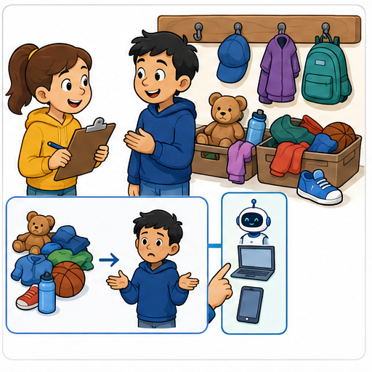
LEARNING TARGET Students spend three minutes finding returned books. Compare shelf labels with an AI locator. Define one fair success test before choosing a solution.
Learner name:

Readiness for the connected explanation
A teacher permits a paper prototype using fictional activity requests. Does this permit collecting real pupils’ names and publishing their choices? Explain.

This week’s end goal
By the end, I can turn a recorded problem into a bounded, measurable project goal.

02. Notice the evidence
PICTURE STORY

Look Closely Before You Explain
Pictures give clues; evidence tells us what the clues mean.

MYSTERY 'Students need AI' is not a problem statement; 'students spend five minutes finding misplaced supplies after art' is observable and testable.

What do you notice?
Name three visible details without explaining them yet.
Circle the detail most connected to the system's decision.
Name one detail that may be decoration or distraction.
Make a first prediction and state the clue that supports it.
My observations, prediction, and evidence:
GOOD THINKING A prediction can change when stronger evidence appears.

A closer explanation
For the final project sequence, we will develop a small activity recommender on paper. Its users are fictional pupils choosing a classroom activity that fits their available time and room conditions. We will decide what the recommender must do, build a traceable process, test it and explain its limits. A recommendation is a suggestion; the pupil can decline it.
Start before the solution. Our supplied observation log describes ten fictional requests made using an activity catalogue. Six first choices fit the request’s time and room conditions. Four did not and needed another choice. These invented classroom records give us a problem to investigate. They are not observations of your classmates and do not show how often this happens in other classes.
A useful problem statement is: “In the supplied ten-request exercise, four first choices did not fit the stated time or room conditions, so those users had to choose again.” “We need AI” names a possible technology but says neither who needs help nor what should improve. The log also does not establish whether unclear wording, missing information or another cause produced the mismatches.

03. See how it works
VISUAL MECHANISM

Input → Process → Output
Follow the information instead of imagining magic inside the machine.
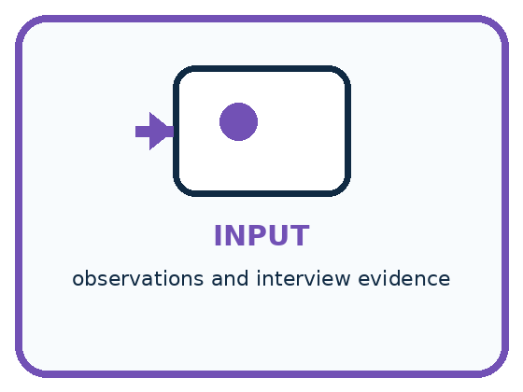
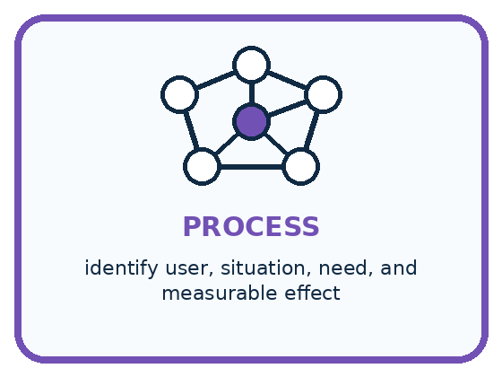
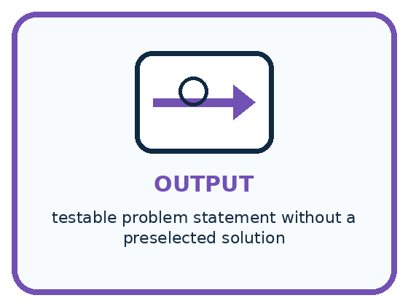
INPUT observations and interview evidence
PROCESS identify user, situation, need, and measurable effect
OUTPUT testable problem statement without a preselected solution
CORE IDEA A strong project begins with a specific user and observable need.
UNDER THE HOOD Problem framing separates evidence about a user's need from assumptions about a solution. A strong statement identifies who, when, what observable difficulty occurs, and how improvement could be measured.
Draw a fresh example with all three stages:

A closer explanation

From an observed difficulty to a testable goal
Evidence or decision | What it supports | What remains to check
4 of 10 choices mismatch | Some re-selection occurred | Cause is not established
Need a compatible choice | Check time and conditions | User can still decline
Paper suggestion process | Small permitted prototype | Benefit needs a comparison
Measure fit and coverage | Observe useful outcomes | Do not hide no-result cases
The goal describes a useful result. Building a tool is an activity, not evidence that users benefited.
Our target outcome is a compatible suggestion when the catalogue contains one, and a clear no-match message when none fits. Compatibility means respecting the stated conditions; it does not mean that every pupil will enjoy the activity. We can check time and room conditions from a request and catalogue. Enjoyment would need different evidence.
Count compatible suggestions, incompatible suggestions and no-match messages separately. Otherwise a system could avoid every wrong suggestion by refusing to suggest anything. If a valid option existed, that refusal would still fail to provide the intended help. Record the total number of requests so a count has a clear denominator.

Connect the picture and the explanation
Point to the input, the deciding step and the result in this week’s visual. Explain the same step in ordinary words. A picture helps when you can say what each part represents.

04. Compare the cases
PICTURE GALLERY

Four Cases, Four Clues
Use the visual cue, then read the evidence carefully.
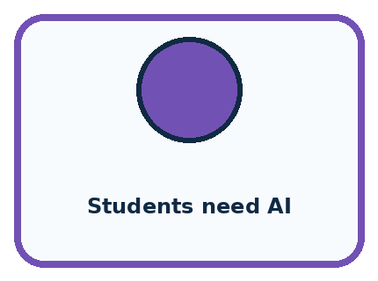
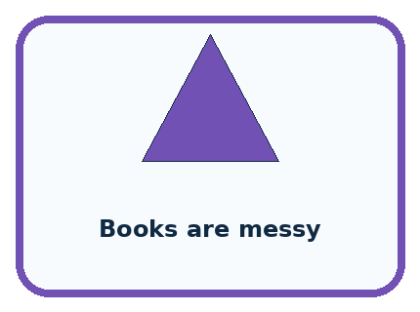

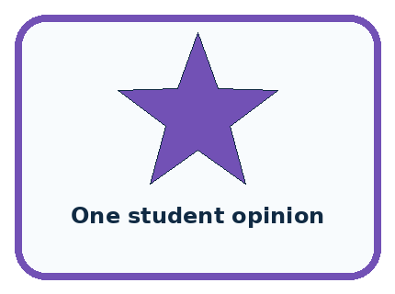
CASE 1 — Students need AI Clue: technology-first claim. Meaning: weak framing.
CASE 2 — Books are messy Clue: vague judgment. Meaning: needs observation.
CASE 3 — Librarian re-sorts 20 books daily Clue: specific burden. Meaning: testable need.
CASE 4 — One student opinion Clue: useful but limited. Meaning: seek more evidence.
BOUNDARY Do not collect personal stories unrelated to the design question.
Which two pictures are easiest to confuse? What evidence separates them?

Change one thing in the pictured case
Change: The approved list contains no tray with every requested tool.
Prediction: The finder should report no suitable tray rather than guess.
Reason: Success includes honestly identifying unsatisfied requirements.

05. Words that unlock the idea
VOCABULARY

Words You Can See and Use
The badge is a memory cue; the definition does the real thinking work.
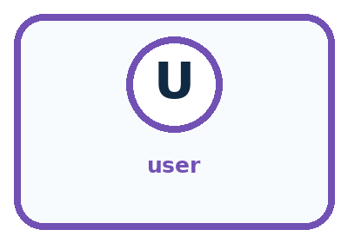
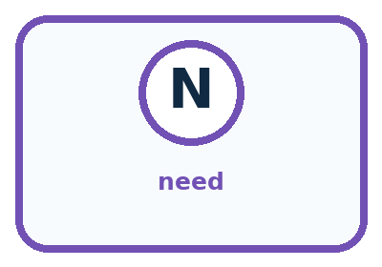
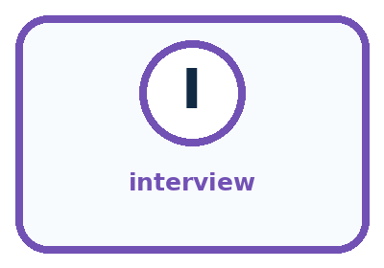
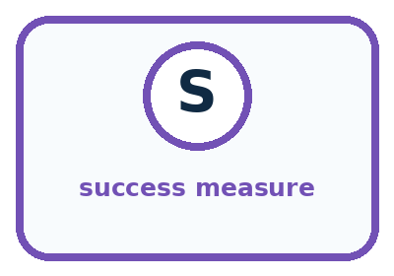
Word | Meaning | My example
user | person affected by the problem or solution
need | observable difficulty or goal
interview | structured questions used to learn from a person
success measure | evidence showing whether the need improved

Misconception detective
CLAIM TO REPAIR A popular technology is proof of a real problem.
Use one vocabulary word and one piece of evidence to repair it:
WORD POWER A strong definition helps you decide something in a new case.

Words used in the closer explanation
Word | Meaning
User need | Something a person needs to accomplish in a particular situation
Problem statement | A specific description of who faces a difficulty and what that difficulty is
Outcome | The result experienced by the user
Constraint | A condition that a proposed solution must respect

06. Follow a worked example
WORKED EXAMPLE

Watch the Reasoning, Not Just the Answer
Every step connects a claim to observable evidence.

CASE 'Students need AI' is not a problem statement; 'students spend five minutes finding misplaced supplies after art' is observable and testable.
STEP 1 — OBSERVE observations and interview evidence
STEP 2 — TRACE identify user, situation, need, and measurable effect
STEP 3 — CONCLUDE testable problem statement without a preselected solution
MODEL REASONING A strong statement names the user, context, observable difficulty, and desired improvement without requiring AI. Protect privacy, avoid leading questions, and distinguish what the user said from your inference.
DO NOT OVERCLAIM Do not collect personal stories unrelated to the design question.
What new evidence could change this answer?

A closer explanation
Project choice | Boundary for this sequence | Reason
Users and setting | Fictional classroom activity requests | A clear situation to test
Information | Available minutes and quiet-room requirement | Relevant to compatibility
Action | Suggest an activity or report no match | The user retains the choice
Outside the project | Names, profiles, purchases and public posting | Not needed for this paper task
The teacher permits a paper prototype using fictional requests and an approved catalogue. We do not need names, home details or a history of a pupil’s choices. A request can say “10 minutes, quiet room required” without identifying anyone. Use only the request information needed to test the intended outcome.
A clear catalogue or a short checklist may solve this problem. We will compare a proposed recommender with a simple starting method instead of assuming a more complicated system is better. This project can use explicit rules; it does not have to fit a machine-learning model. The choice should follow the problem, available evidence and limits of the task.

Learn from the worked case
Cover the result before checking it. Say what is given, choose the procedure, and follow one step at a time. Then uncover the result and explain your first mismatch. Ask why a step is allowed, not only what number it produces.

A pictorial worked case: Find a Real Problem
A fictional class loses time finding the correct craft tray.

The facts we will use
In eight recorded requests, three selected trays lack a required tool; five match.
The teacher permits a paper finder using fictional requests and an approved tray list, with no pupil names.
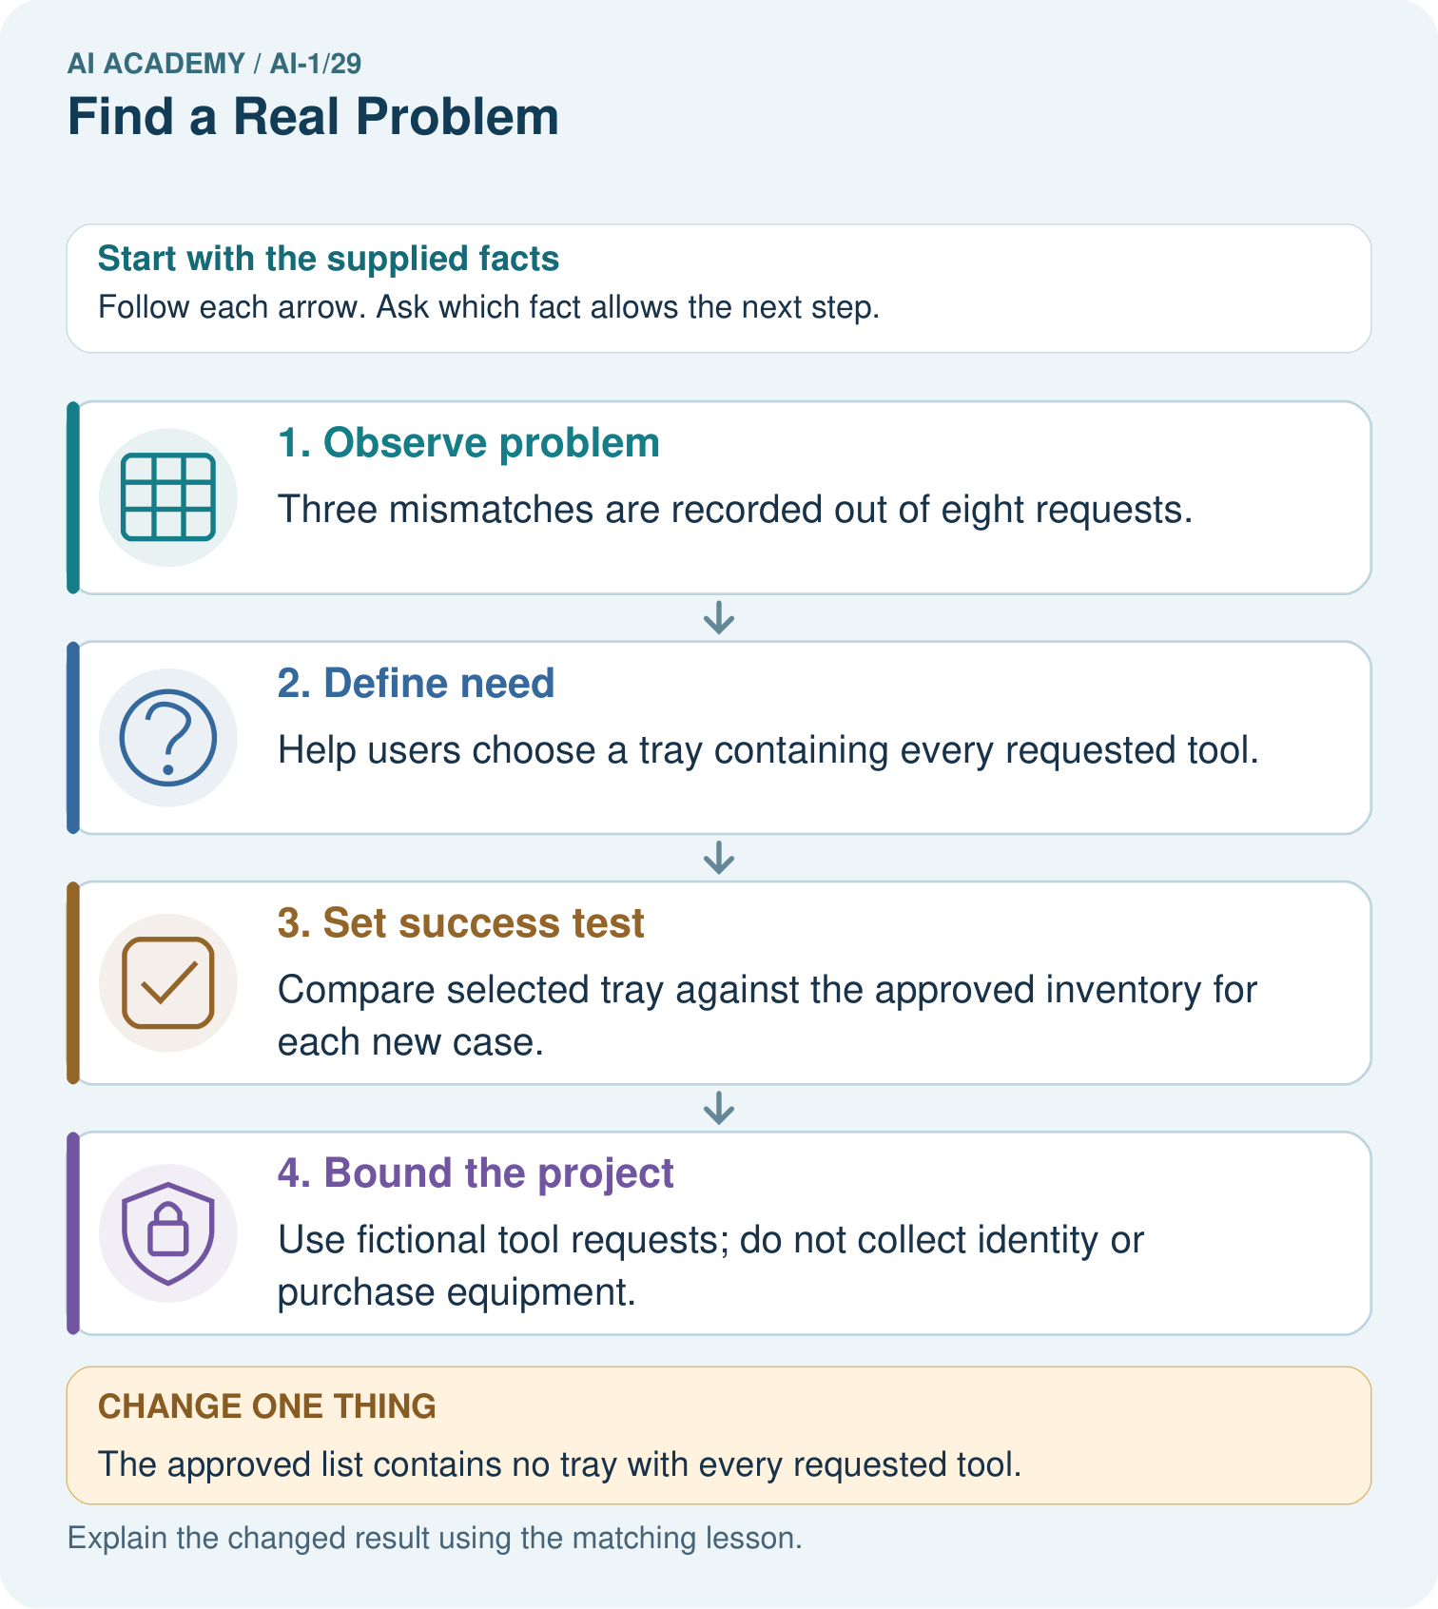

Read the picture one step at a time
Step | What happens and why
1. Observe problem | Three mismatches are recorded out of eight requests.
2. Define need | Help users choose a tray containing every requested tool.
3. Set success test | Compare selected tray against the approved inventory for each new case.
4. Bound the project | Use fictional tool requests; do not collect identity or purchase equipment.
Match each pictured step to the supplied facts. This is a worked teaching case, not an independent assessment.

Why this result follows
The mismatch record describes a concrete need. A measurable goal checks whether the chosen tray satisfies the request; calling the system smart would not tell us how to evaluate it. Start with a transparent paper baseline, and keep unsatisfied requests visible instead of selecting a near match without warning.

What this example does not establish
Eight requests do not show the problem’s frequency across the entire school or prove AI is necessary.

07. Find and repair a mistake
COMPARE

Same Result, Different Reason
A comparison helps reveal the true concept boundary.
Case | Evidence | What it shows
Students need AI | technology-first claim | weak framing
Books are messy | vague judgment | needs observation
Librarian re-sorts 20 books daily | specific burden | testable need
One student opinion | useful but limited | seek more evidence

Repair two tempting claims
CLAIM A A popular technology is proof of a real problem.
Repair:
CLAIM B The first interview represents every user.
Repair:
STRONG ANSWER FRAME I claim ______ because the evidence shows ______. The process is ______. One limit is ______.

A closer explanation
Before building, say what would count against your idea. If a clear catalogue already produces compatible choices for all supplied cases, adding a recommender might offer little benefit on those cases. If the recommender hides valid options or produces unexplained no-match messages, revise it or keep the simpler method. A project can succeed as an investigation even when the evidence favours a simpler solution.
Keep the ten-request observation log separate from later evaluation records. It motivates the problem; it is not a fair test result for a tool that has not been built. Later weeks will introduce explicit requirements and test cases, including a reserved final set. Label plans as plans and measured results as results.

A proposed system always says “Ask the teacher”. It never suggests an incompatible activity. Has this alone demonstrated the intended benefit? Explain which additional result you would need to check
________________________________________________________________
________________________________________________________________
________________________________________________________________
________________________________________________________________

08. Practise together
GUIDED PRACTICE

Try It, Check It, Explain It
Use support now so you can succeed independently later.

Explain how the picture story demonstrates this idea: A strong project begins with a specific user and observable need.
Use a fresh example to explain user.
Trace a new input → process → output example.
Find and repair the error in: The first interview represents every user.
Invent one edge case and name the safe response.
PARTNER CHECK Point to the evidence. Do not accept an answer that only repeats the vocabulary word.

A closer explanation
Suppose a team writes “All pupils hate the catalogue because it is too long.” The supplied log says nothing about every pupil’s feelings or the cause of the mismatches. A more careful note is “Four of ten first choices were incompatible; the cause is not yet known.” A hypothesis such as “the time information may be hard to find” is something to investigate, not an established finding.

Write a short project brief for the activity problem. Include the users and setting, the supplied evidence, the desired outcome, information needed, one boundary and a simple alternative. Name one claim the ten-request log does not establish
________________________________________________________________
________________________________________________________________
________________________________________________________________
________________________________________________________________
________________________________________________________________
________________________________________________________________
________________________________________________________________
If we later investigate the cause, we could inspect where compatibility information appears in the catalogue or have a teacher organise a permitted comparison of clearer formats. Do not quietly collect real pupils’ data just because it might help. For this sequence, the supplied fictional records are enough to build and test a paper process.

Practise with less help: Identify claims beyond the evidence
Use workbook W2 for the connected example “A problem worth solving”. First fill the input and rule boxes. Try the middle steps before asking for a hint. After a hint, try the next step yourself.
Plan | Do | Check
What is given? Which rule or procedure applies? | Record each intermediate step. | Does the result follow? What remains unknown?
Explain your trace to a partner. Your partner points to one step to check. Swap roles on the next case. Each person writes their own explanation.

Check your reasoning
Use the worked case for A problem worth solving. Proposed explanation: “Using AI is itself the outcome”. Decide whether this explanation is supported. Point to the step or supplied fact that decides; explain your repair if needed.
Answer on your own before discussion. If you are unsure, say which step you need help with.

Explain the picture
Write a one-sentence project goal and say what evidence would count as a failure.

My explanation using a pictured step and the given facts
________________________________________________________________
________________________________________________________________
________________________________________________________________
________________________________________________________________
This is supported practice. Keep the separately named independent case for an attempt before feedback.

09. Run the investigation
EXPLORER LAB

Need-Finding Interview
Predict first, test honestly, and explain what the evidence means.
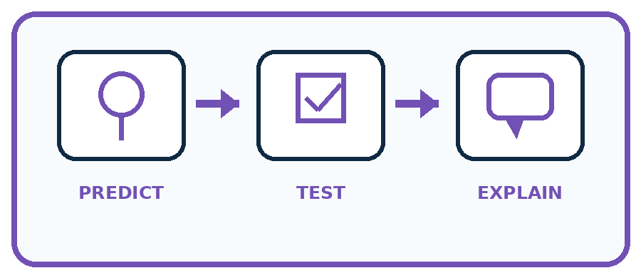
State your prediction before the result is known.
Complete the task: Interview a classmate and write one testable need statement.
Keep a normal case and an edge case clearly separated.
Record what happened—even when it does not match your prediction.
Explain the result, one limitation, and the next useful test.
Case | Prediction | Observed result | What it means
Normal
Edge
INDEPENDENCE After support is removed, repeat the proof with a fresh case.

Plan → try → check
Before trying: what do I expect, and why? While trying: which step could first go wrong? Afterwards: what did I actually observe, and what should change? Keep “not run” if you only traced the procedure.

10. Build your understanding
PRACTICE LADDER

Climb from Recall to Defense
Each step asks for a stronger kind of understanding.
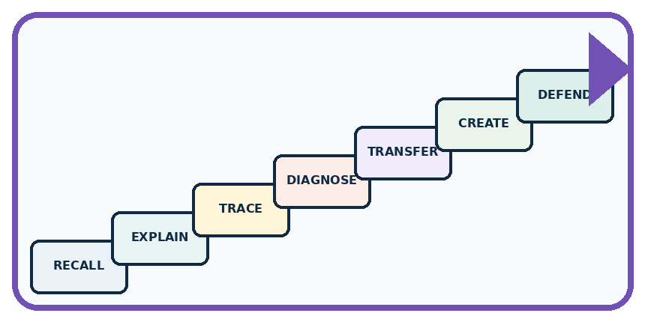
RECALL Define user.
EXPLAIN A strong project begins with a specific user and observable need.
TRACE Show the input, process, and output.
DIAGNOSE Repair: A popular technology is proof of a real problem.
TRANSFER Apply the idea to a new home or classroom case.
CREATE Design one revealing test.
DEFEND Give a claim, evidence, mechanism, limit, and safe action.
RETRY RULE A coached answer becomes mastery only after you solve a different case independently.

11. Connect your project
PROJECT

Helpful Classroom Sorter
Build one coherent system across the year, one evidence-based decision at a time.
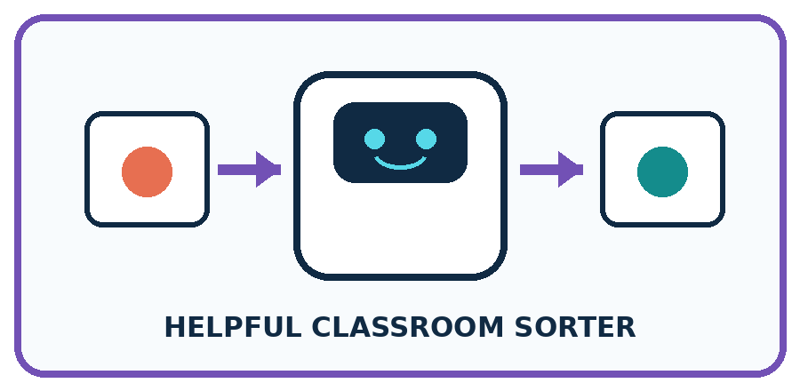
THIS WEEK'S CHECKPOINT Choose the Classroom Sorter's real user and measurable need; keep an AI-free solution option open.
What real classroom need does this serve?
What information is necessary—and what should stay private?
What happens inside the process?
What normal and edge cases will you test?
When should it say not sure or ask a person?

RESPONSIBLE DESIGN Do not collect personal stories unrelated to the design question.
My project decision:

Evidence for your project
For the Helpful Classroom Sorter, retain the problem record, permitted scope, baseline and observable acceptance criteria.

12. Show what you know
MASTERY

Fresh-Case Independent Proof
Complete this after teaching and guided practice have ended.
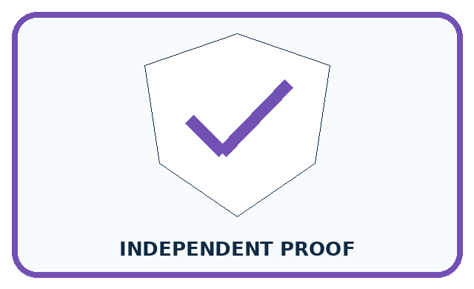
REQUIRED PROOF Interview a classmate and write one testable user-need statement supported by an observation or quote.
□ Name or draw the fresh case.
□ Trace input, process, and output.
□ State the conclusion and strongest evidence.
□ Name one limit, failure, missing clue, or fairness/privacy concern.
□ Explain one safe next action or improvement.
Independent evidence:
SELF-CHECK A strong statement names the user, context, observable difficulty, and desired improvement without requiring AI. Protect privacy, avoid leading questions, and distinguish what the user said from your inference.
My level: □ Not yet □ With one hint □ Independently □ I can teach it
NEXT BRIDGE Carry today's evidence habit into: Choose Inputs and Outputs.

13. Study a complete case

Week 29 Worked case
Use the supplied details to practise the weekly concept before attempting the independent question. This case extends the illustrated lesson.

The situation
Shared markers are often lost because tray labels are unclear.

The question
State the need before selecting AI.

Worked explanation
Students need to return markers correctly and quickly. Test clearer labels before proposing a model.

Explain it in your own words
Which detail supports the answer, and why does it matter?

Write or draw your reasoning and evidence.
________________________________________________________________
________________________________________________________________
________________________________________________________________
________________________________________________________________
________________________________________________________________

Trace the supplied case visually

Solve the need before selecting technology
Evidence or stage | Value or result
Problem | Markers returned to wrong trays
Possible cause | Unclear tray labels
Simple trial | Clearer labels
Evidence | Measure correct and quick returns
Shared markers are often lost because tray labels are unclear.
State the need before selecting AI.
Students need to return markers correctly and quickly. Test clearer labels before proposing a model.

14. Try a new case independently

Independent case: Frame a different problem independently
In a fictional equipment cupboard exercise, eight teams choose a box from a list. Three boxes do not contain the items required by the corresponding request; five do. The teacher permits a paper box-finder using fictional item requests and an inventory. Write a brief naming the user difficulty, evidence, desired outcome, necessary information, an excluded action and a simple alternative. Identify one cause or benefit that these counts do not establish.

My independent explanation, trace and limits
________________________________________________________________
________________________________________________________________
________________________________________________________________
________________________________________________________________
________________________________________________________________
________________________________________________________________
________________________________________________________________
Attempt this case before feedback. Record any help. Earlier examples below are further practice; a case already practised with feedback cannot establish fresh transfer.

Week 29 Independent application
Close the worked explanation. Apply the idea to this different question without copying.
Learners often cannot find borrowed classroom books. Define the problem before choosing an AI tool. Suggest one simple solution to compare with AI.
My answer, with a trace, calculation or supporting evidence

Write or draw your reasoning and evidence.
________________________________________________________________
________________________________________________________________
________________________________________________________________
________________________________________________________________
________________________________________________________________

Create and test
Change one relevant detail. Predict the result before testing. Include a boundary or missing-information case when it helps reveal a limit.
My changed input and expected result

Write or draw your reasoning and evidence.
________________________________________________________________
________________________________________________________________
________________________________________________________________
________________________________________________________________
________________________________________________________________

Connect to your project
Choose the Classroom Sorter's real user and measurable need; keep an AI-free solution option open.
The evidence I will keep

Write or draw your reasoning and evidence.
________________________________________________________________
________________________________________________________________
________________________________________________________________
________________________________________________________________
________________________________________________________________
Your teacher has the independent answer and scoring criteria. Complete the matching workbook week to keep your practice evidence together.

Transfer practice from the original programme
Students spend three minutes finding returned books. Compare shelf labels with an AI locator. Define one fair success test before choosing a solution.

Explain the mechanism, evidence and one limit.
________________________________________________________________
________________________________________________________________
________________________________________________________________
________________________________________________________________
________________________________________________________________
________________________________________________________________
________________________________________________________________

Use feedback to improve
Attempt the independent case before hints. Record whether you worked alone, used a hint or followed a model. After feedback, fix the first unsupported step and explain why it changed. A later check uses a changed case, not a copied answer.

