AI ACADEMY · STUDENT · ai-1/35

Improve One Cause
Project: Helpful Classroom Sorter

Before you start
Week 33: retain failures and conditions in the test record.

01. Your mission

Your learning target
I can repair a located defect without changing the agreed requirements.
I can check the repaired case and earlier successful behaviour.
I can preserve versioned evidence and fix a candidate before final evaluation.

Remember before reading
Close your notes first. A rough first answer helps us choose the right starting point; it is not a score for your ability.
Without opening the old lesson, explain one key idea from Test Edge Cases and Fairness. Give an example and a mistake that the idea helps you avoid.
Without opening the old lesson, explain one key idea from Build a Paper Prototype. Give an example and a mistake that the idea helps you avoid.
Without opening the old lesson, explain one key idea from Find a Real Problem. Give an example and a mistake that the idea helps you avoid.
After trying, check the relevant lesson or ask your teacher. Change the part of your explanation that the evidence shows was wrong.
An improvement should target evidence from a failure, not random change.
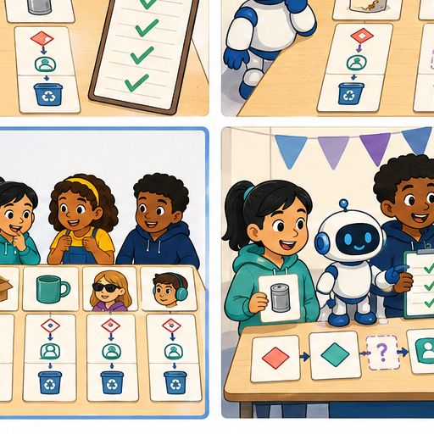
LEARNING TARGET Version A makes four errors. Version B makes one after lighting, labels and rules all change. What can you conclude, and how would you isolate the effect of lighting?
Learner name:

Readiness for the connected explanation
The faulty S comparison rejects an activity that takes exactly the available time. Which requirement does this break?

This week’s end goal
By the end, I can repair one identified cause and rerun cases that previously passed.

02. Notice the evidence
PICTURE STORY

Look Closely Before You Explain
Pictures give clues; evidence tells us what the clues mean.

MYSTERY The sorter misclassifies worn labels, so the team changes the text-reading rule or adds a safe visual clue while keeping other parts fixed.

What do you notice?
Name three visible details without explaining them yet.
Circle the detail most connected to the system's decision.
Name one detail that may be decoration or distraction.
Make a first prediction and state the clue that supports it.
My observations, prediction, and evidence:
GOOD THINKING A prediction can change when stronger evidence appears.

A closer explanation
Finding a failure is useful only if you can explain and check the repair. This week you will locate an incorrect comparison, change it in a labelled version, and test both the revealing case and behaviour that worked before. A repair can solve one problem while introducing another, so one newly passing example is not enough.
Keep catalogue B version 1 in order: B1 Bookmark drawing, 10 minutes, quiet Yes; B2 Story circle, 8 minutes, quiet No; B3 Pattern puzzle, 12 minutes, quiet Yes; B4 Tower challenge, 15 minutes, quiet No. These fictional values assume materials are available. Inputs are whole minutes from 0 to 30 inclusive and Quiet required Yes or No. No allows either quiet or nonquiet activities.
A candidate fits when its duration is no more than the available minutes AND either quiet is not required or the activity is quiet. Return the first fit with a correct reason. Valid input with no fit gives no match after all rows fail. Invalid or missing input needs clarification before search. Each new run starts with validation and a cleared output, then the first row if valid. Suggestions do not book or publish anything. These written rules are not a model fitted from examples.

03. See how it works
VISUAL MECHANISM

Input → Process → Output
Follow the information instead of imagining magic inside the machine.
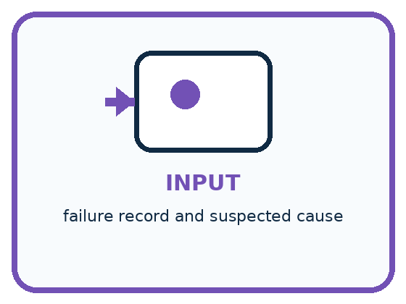
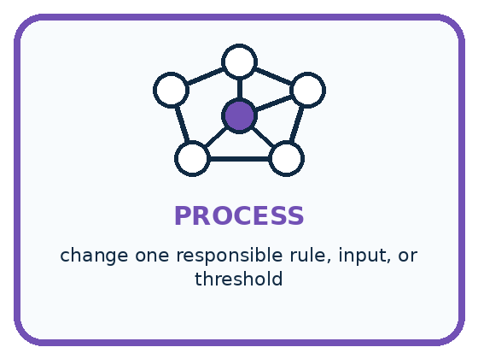
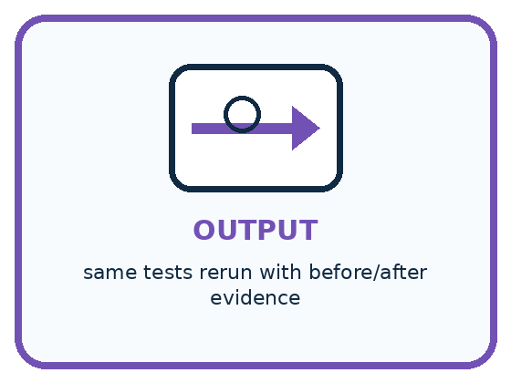
INPUT failure record and suspected cause
PROCESS change one responsible rule, input, or threshold
OUTPUT same tests rerun with before/after evidence
CORE IDEA An improvement should target evidence from a failure, not random change.
UNDER THE HOOD Controlled iteration links an intervention to an observed outcome. Holding test cases and unrelated components constant strengthens causal inference. Improvement claims must include regressions and tradeoffs, not only repaired cases.
Draw a fresh example with all three stages:

A closer explanation

A repair with evidence
Locate | Change | Check
Keep the failing trace | Save a new version | Rerun the revealing case
Name the broken requirement | Correct the faulty step | Rerun earlier passing cases
Keep input and catalogue labels | Record what changed | Keep every result and limit
A passing repair test checks the reported defect. Regression tests examine previously correct behaviour.
S version 0 follows the P1 process except that its time check uses strictly less than. On 10 Yes with catalogue B version 1, it reports no match. The expected result is B1 because 10 fits exactly and B1 is quiet. Compare the saved instruction with the trace: the cause is the exclusion of equality, not a need to change the catalogue or expected answer.
Create S version 1 by replacing only the time comparison with no more than. Keep validation, the quiet condition, catalogue order, advancement and stopping rules. Write a change record naming S0, S1, the failing 10 Yes case, the comparison changed and why equality belongs in the rule. Retain the old version and failed trace; do not overwrite them with the new result.

Connect the picture and the explanation
Point to the input, the deciding step and the result in this week’s visual. Explain the same step in ordinary words. A picture helps when you can say what each part represents.

04. Compare the cases
PICTURE GALLERY

Four Cases, Four Clues
Use the visual cue, then read the evidence carefully.
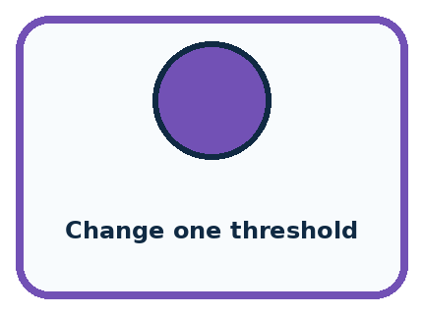
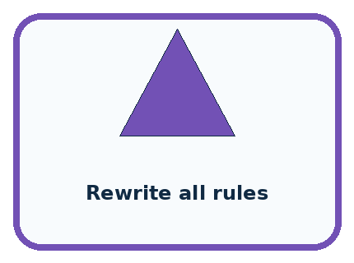
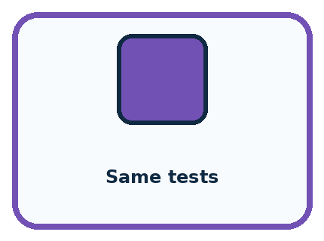
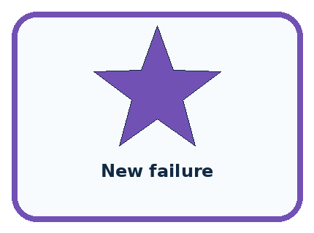
CASE 1 — Change one threshold Clue: targeted intervention. Meaning: interpretable.
CASE 2 — Rewrite all rules Clue: many causes changed. Meaning: weak evidence.
CASE 3 — Same tests Clue: before/after comparable. Meaning: stronger evidence.
CASE 4 — New failure Clue: old case now breaks. Meaning: regression.
BOUNDARY A higher pass count can hide a serious new failure; review every changed outcome.
Which two pictures are easiest to confuse? What evidence separates them?

Change one thing in the pictured case
Change: Use U2, which changes < to ≤ and keeps the quiet check.
Prediction: At 8 return A; at 6 return none.
Reason: Equality is repaired while B remains ineligible because it is noisy.

05. Words that unlock the idea
VOCABULARY

Words You Can See and Use
The badge is a memory cue; the definition does the real thinking work.
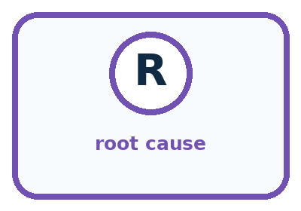
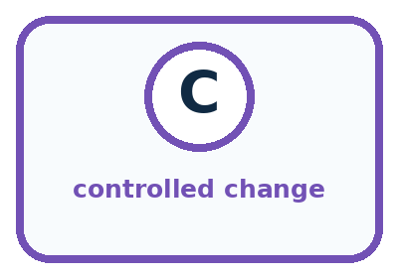
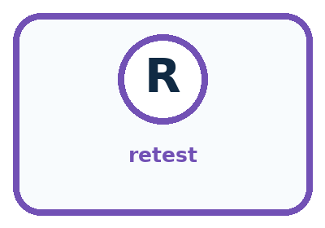
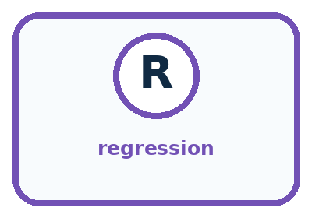
Word | Meaning | My example
root cause | earliest responsible reason for a failure
controlled change | one targeted modification while other factors stay fixed
retest | repeat the same case after a change
regression | previously working behavior that becomes worse

Misconception detective
CLAIM TO REPAIR Any change after a failure counts as improvement.
Use one vocabulary word and one piece of evidence to repair it:
WORD POWER A strong definition helps you decide something in a new case.

Words used in the closer explanation
Word | Meaning
Defect | A fault in the instructions or implementation that can cause incorrect behaviour
Repair | A change intended to correct a located defect
Change record | A note of what changed, why, and which versions and tests support it
Fixed candidate | A saved version kept unchanged while a specified evaluation is run

06. Follow a worked example
WORKED EXAMPLE

Watch the Reasoning, Not Just the Answer
Every step connects a claim to observable evidence.

CASE The sorter misclassifies worn labels, so the team changes the text-reading rule or adds a safe visual clue while keeping other parts fixed.
STEP 1 — OBSERVE failure record and suspected cause
STEP 2 — TRACE change one responsible rule, input, or threshold
STEP 3 — CONCLUDE same tests rerun with before/after evidence
MODEL REASONING Name the evidence, suspected cause, single change, and predicted effect before editing. Rerun the full fixed suite, compare case by case, and keep the change only if benefits outweigh new failures.
DO NOT OVERCLAIM A higher pass count can hide a serious new failure; review every changed outcome.
What new evidence could change this answer?

A closer explanation
Consider a different proposed repair, T version 1. It accepts equal times but accidentally removes the quiet check. It fixes 10 Yes, yet now returns B2 for 9 Yes. That second request correctly returned no match under S0 because B2 is not quiet. Previously correct behaviour has become wrong: this is a regression.
Case with catalogue B version 1 | Required result | Outputs from the stated instructions
10 Yes; equality repair | B1 with a valid reason | S0 no match; T1 B1; S1 B1
9 Yes; quiet regression check | No match with a valid reason | S0 no match; T1 B2; S1 no match
8 No; another equality case | B2 with a valid reason | S0 no match; T1 B2; S1 B2
6 No; exhaustion check | No match with a valid reason | S0 no match; T1 no match; S1 no match
These outputs are worked predictions from the described versions. Your own test record must contain the actual runs and their reasons. T1 should not replace the candidate merely because it passes the first row. For S1, check the revealing equality cases and rerun all four routine cases from Week 33, then validation and the labelled catalogue variations from Week 34. A full pass still needs both the required output and a correct explanation.

Learn from the worked case
Cover the result before checking it. Say what is given, choose the procedure, and follow one step at a time. Then uncover the result and explain your first mismatch. Ask why a step is allowed, not only what number it produces.

A pictorial worked case: Improve One Cause
A fictional quiet-activity chooser has a boundary bug and a proposed repair.

The facts we will use
A: quiet Yes, 8 minutes; B: quiet No, 5 minutes. Request quiet required Yes.
U0 accepts only duration<available time. U1 fixes ≤ but accidentally removes the quiet requirement.
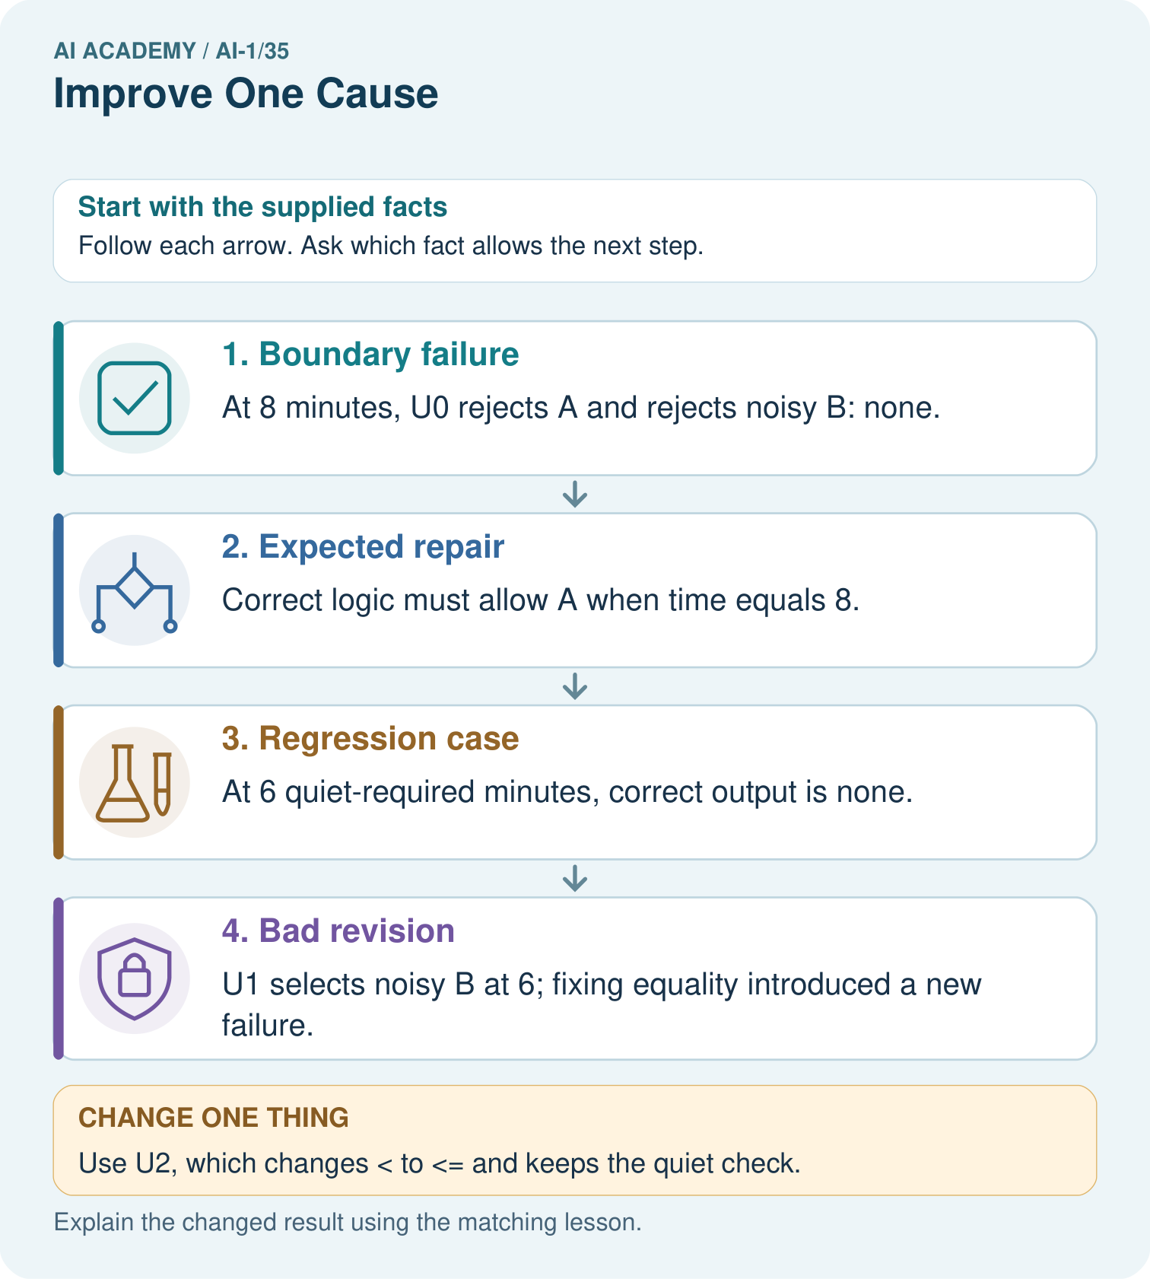

Read the picture one step at a time
Step | What happens and why
1. Boundary failure | At 8 minutes, U0 rejects A and rejects noisy B: none.
2. Expected repair | Correct logic must allow A when time equals 8.
3. Regression case | At 6 quiet-required minutes, correct output is none.
4. Bad revision | U1 selects noisy B at 6; fixing equality introduced a new failure.
Match each pictured step to the supplied facts. This is a worked teaching case, not an independent assessment.

Why this result follows
A repair must preserve the full contract, not just make one failing example pass. The quiet condition and duration comparison are separate requirements. Changing only the inequality targets the recorded cause; removing the quiet check changes another behavior. Save previously passing cases to reveal such regressions.

What this example does not establish
Two examples establish only these outcomes; further cases are needed before generalising the repair.

07. Find and repair a mistake
COMPARE

Same Result, Different Reason
A comparison helps reveal the true concept boundary.
Case | Evidence | What it shows
Change one threshold | targeted intervention | interpretable
Rewrite all rules | many causes changed | weak evidence
Same tests | before/after comparable | stronger evidence
New failure | old case now breaks | regression

Repair two tempting claims
CLAIM A Any change after a failure counts as improvement.
Repair:
CLAIM B Retest only the failed case to save time.
Repair:
STRONG ANSWER FRAME I claim ______ because the evidence shows ______. The process is ______. One limit is ______.

A closer explanation
If your own P1 already passes the development set, do not introduce a defect just to claim an improvement. Use the supplied S example to practise repair, and report that no change was needed in your saved version for the tested cases. If your version fails, retain the evidence, locate the cause and label the next repair. A new label alone does not prove a better version.
Save a candidate with its complete instructions, required catalogue data, input rules, change history and development results. State unresolved failures and limitations. Keep this version unchanged during the final evaluation. Do not inspect reserved final cases to decide which repair to make. If you revise after seeing final results, retain those results as belonging to the old version and treat the seen cases as development evidence; they are no longer an unseen evaluation for the revision.

A team fixes 10 Yes, checks only that case and deletes S0’s failed trace. Explain two weaknesses in its evidence and give a better next action. Why should the candidate be fixed before reserved final cases are revealed?
________________________________________________________________
________________________________________________________________
________________________________________________________________
________________________________________________________________

08. Practise together
GUIDED PRACTICE

Try It, Check It, Explain It
Use support now so you can succeed independently later.

Explain how the picture story demonstrates this idea: An improvement should target evidence from a failure, not random change.
Use a fresh example to explain root cause.
Trace a new input → process → output example.
Find and repair the error in: Retest only the failed case to save time.
Invent one edge case and name the safe response.
PARTNER CHECK Point to the evidence. Do not accept an answer that only repeats the vocabulary word.

A closer explanation
Write expectations before running S1. Use B version 1 for 11 Yes, 9 No, 6 No and 9 Yes; include the revealing 10 Yes and 8 No. Add 0 Yes, 30 Yes, 31 Yes, blank minutes with Yes, 10.5 Yes and 10 Maybe to check valid endpoints and invalid fields. Keep cases and results separated by version, and compare with the manual baseline under the same conditions.
Retain the catalogue variation tests: B version 2 changes only B1 time to 20, giving B3 for 12 Yes. B version 3 has times 20, 18, 17 and 15 for B1 to B4, with the original quiet labels and order; it gives B4 for 15 No and no match for 15 Yes. These cases check later successful paths and the quiet condition under changed data. Label each test with the catalogue it actually uses.

Explain why T1’s result on 9 Yes is a regression but S0’s result on 8 No is an existing defect. State the required result in each case and the instruction that explains the mistake. If S1 passes both, what further evidence should you keep before making a broader claim?
________________________________________________________________
________________________________________________________________
________________________________________________________________
________________________________________________________________
________________________________________________________________
________________________________________________________________
________________________________________________________________

Practise with less help: Check the repair and earlier behaviour
Use workbook W2 for the connected example “Improving and checking regressions”. First fill the input and rule boxes. Try the middle steps before asking for a hint. After a hint, try the next step yourself.
Plan | Do | Check
What is given? Which rule or procedure applies? | Record each intermediate step. | Does the result follow? What remains unknown?
Explain your trace to a partner. Your partner points to one step to check. Swap roles on the next case. Each person writes their own explanation.

Check your reasoning
Use the worked case for Improving and checking regressions. Proposed explanation: “One repaired example proves improvement everywhere”. Decide whether this explanation is supported. Point to the step or supplied fact that decides; explain your repair if needed.
Answer on your own before discussion. If you are unsure, say which step you need help with.

Explain the picture
Explain why “our repaired version now picks something” is not enough to show success at 6.

My explanation using a pictured step and the given facts
________________________________________________________________
________________________________________________________________
________________________________________________________________
________________________________________________________________
This is supported practice. Keep the separately named independent case for an attempt before feedback.

09. Run the investigation
EXPLORER LAB

One-Cause Improvement Cycle
Predict first, test honestly, and explain what the evidence means.
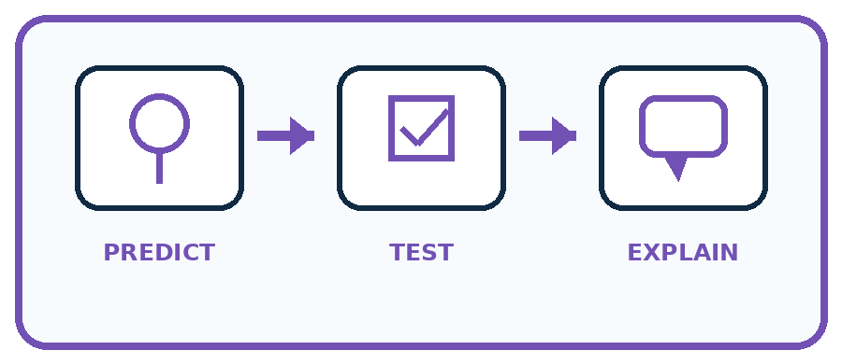
State your prediction before the result is known.
Complete the task: Revise one rule or input and rerun the same tests.
Keep a normal case and an edge case clearly separated.
Record what happened—even when it does not match your prediction.
Explain the result, one limitation, and the next useful test.
Case | Prediction | Observed result | What it means
Normal
Edge
INDEPENDENCE After support is removed, repeat the proof with a fresh case.

Plan → try → check
Before trying: what do I expect, and why? While trying: which step could first go wrong? Afterwards: what did I actually observe, and what should change? Keep “not run” if you only traced the procedure.

10. Build your understanding
PRACTICE LADDER

Climb from Recall to Defense
Each step asks for a stronger kind of understanding.
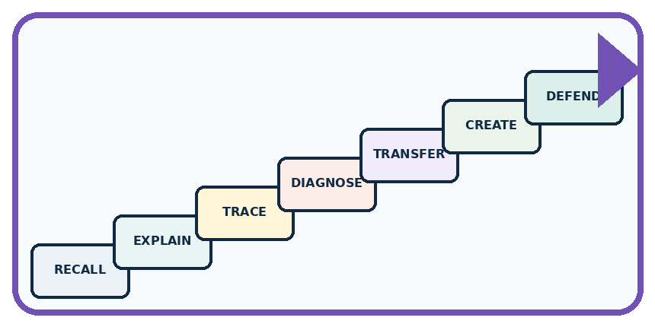
RECALL Define root cause.
EXPLAIN An improvement should target evidence from a failure, not random change.
TRACE Show the input, process, and output.
DIAGNOSE Repair: Any change after a failure counts as improvement.
TRANSFER Apply the idea to a new home or classroom case.
CREATE Design one revealing test.
DEFEND Give a claim, evidence, mechanism, limit, and safe action.
RETRY RULE A coached answer becomes mastery only after you solve a different case independently.

11. Connect your project
PROJECT

Helpful Classroom Sorter
Build one coherent system across the year, one evidence-based decision at a time.
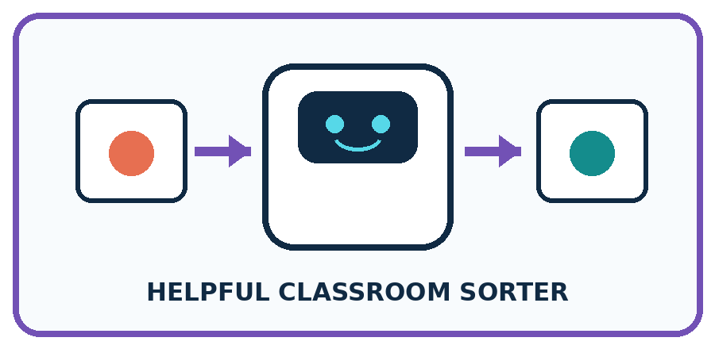
THIS WEEK'S CHECKPOINT Create sorter version 2 with one evidence-linked change and a before/after test table.
What real classroom need does this serve?
What information is necessary—and what should stay private?
What happens inside the process?
What normal and edge cases will you test?
When should it say not sure or ask a person?

RESPONSIBLE DESIGN A higher pass count can hide a serious new failure; review every changed outcome.
My project decision:

Evidence for your project
Maintain sorter regression tests and compare complete version traces, retaining new failures rather than hiding them.

12. Show what you know
MASTERY

Fresh-Case Independent Proof
Complete this after teaching and guided practice have ended.
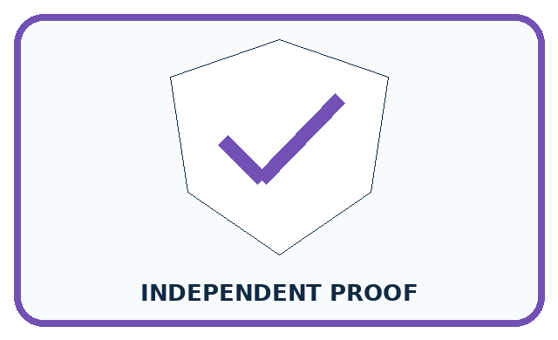
REQUIRED PROOF Revise one rule or input based on a failure and rerun the identical tests, reporting gains and regressions.
□ Name or draw the fresh case.
□ Trace input, process, and output.
□ State the conclusion and strongest evidence.
□ Name one limit, failure, missing clue, or fairness/privacy concern.
□ Explain one safe next action or improvement.
Independent evidence:
SELF-CHECK Name the evidence, suspected cause, single change, and predicted effect before editing. Rerun the full fixed suite, compare case by case, and keep the change only if benefits outweigh new failures.
My level: □ Not yet □ With one hint □ Independently □ I can teach it
NEXT BRIDGE Carry today's evidence habit into: Expo and Defense.

13. Study a complete case

Week 35 Worked case
Use the supplied details to practise the weekly concept before attempting the independent question. This case extends the illustrated lesson.

The situation
The team changes lighting, labels and rules together; errors fall from four to one.

The question
Can it identify the cause of improvement?

Worked explanation
No. Several factors changed. Compare one planned change at a time with controlled conditions.

Explain it in your own words
Which detail supports the answer, and why does it matter?

Write or draw your reasoning and evidence.
________________________________________________________________
________________________________________________________________
________________________________________________________________
________________________________________________________________
________________________________________________________________

Trace the supplied case visually

A fair comparison changes one cause
Evidence or stage | Value or result
Before | Four errors under recorded conditions
Confounded revision | Lighting, labels and rules all changed
Controlled revision | Change one planned factor and retest
The team changes lighting, labels and rules together; errors fall from four to one.
Can it identify the cause of improvement?
No. Several factors changed. Compare one planned change at a time with controlled conditions.

14. Try a new case independently

Independent case: Audit a different proposed repair
Equipment catalogue E lists E1 first with capacity 4 and E2 second with capacity 8. Valid whole group sizes are 1 to 10. Choose the first capacity at least the group size, or no match; invalid input needs clarification. Old U0 uses strictly greater capacity and stops at the first fit. Proposed U1 includes equality but keeps searching and returns the last fit. Independently compare U0, U1 and the requirement for groups 8 and 3. Identify the repair and regression, propose U2 and give one validation check. No booking occurs.

My independent explanation, trace and limits
________________________________________________________________
________________________________________________________________
________________________________________________________________
________________________________________________________________
________________________________________________________________
________________________________________________________________
________________________________________________________________
Attempt this case before feedback. Record any help. Earlier examples below are further practice; a case already practised with feedback cannot establish fresh transfer.

Week 35 Independent application
Close the worked explanation. Apply the idea to this different question without copying.
Dim photos fail. You change the lighting and all decision rules together; performance improves. Can you tell which change helped? Design a clearer comparison.
My answer, with a trace, calculation or supporting evidence

Write or draw your reasoning and evidence.
________________________________________________________________
________________________________________________________________
________________________________________________________________
________________________________________________________________
________________________________________________________________

Create and test
Change one relevant detail. Predict the result before testing. Include a boundary or missing-information case when it helps reveal a limit.
My changed input and expected result

Write or draw your reasoning and evidence.
________________________________________________________________
________________________________________________________________
________________________________________________________________
________________________________________________________________
________________________________________________________________

Connect to your project
Create sorter version 2 with one evidence-linked change and a before/after test table.
The evidence I will keep

Write or draw your reasoning and evidence.
________________________________________________________________
________________________________________________________________
________________________________________________________________
________________________________________________________________
________________________________________________________________
Your teacher has the independent answer and scoring criteria. Complete the matching workbook week to keep your practice evidence together.

Transfer practice from the original programme
Version A makes four errors. Version B makes one after lighting, labels and rules all change. What can you conclude, and how would you isolate the effect of lighting?

Explain the mechanism, evidence and one limit.
________________________________________________________________
________________________________________________________________
________________________________________________________________
________________________________________________________________
________________________________________________________________
________________________________________________________________
________________________________________________________________

Use feedback to improve
Attempt the independent case before hints. Record whether you worked alone, used a hint or followed a model. After feedback, fix the first unsupported step and explain why it changed. A later check uses a changed case, not a copied answer.

