AI ACADEMY · STUDENT · ai-2/3

Branching Logic
Project: Transparent Book Recommender

Before you start
AI-1 Week 10: distinguish strict and inclusive conditions.

01. Your mission

Your learning target
I can trace the selected branch in an if elif else chain.
I can use indentation to identify which statements belong to a branch.
I can test values at and around a decision boundary.

Remember before reading
Close your notes first. A rough first answer helps us choose the right starting point; it is not a score for your ability.
Without opening the old lesson, explain one key idea from Decompose a Goal. Give an example and a mistake that the idea helps you avoid.
After trying, check the relevant lesson or ask your teacher. Change the part of your explanation that the evidence shows was wrong.
Week 3: Branching Logic
Ordered conditions determine which path a system takes.
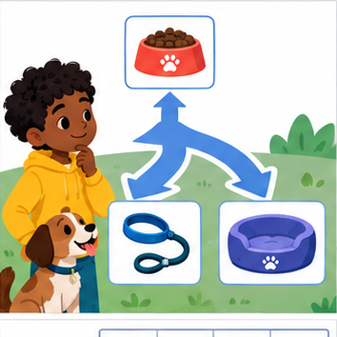
THINKER MISSION
Build and trace a three-branch pet-care algorithm.
Thinker name and date:

Write or draw your reasoning and evidence.
________________________________________________________________
________________________________________________________________
________________________________________________________________
________________________________________________________________
________________________________________________________________

Readiness for the connected explanation
Does minutes <= 12 accept exactly 12? How does < differ?

This week’s end goal
By the end, I can order branches so each input receives exactly its intended category.

02. Notice the evidence
PICTURE STORY
Notice → Predict → Explain
Begin with visible evidence. Do not explain more than the picture and information support.
MYSTERY
The learners must use branching logic to solve a problem. What information do they have? What decision or calculation do they make? What would count as evidence that it worked?
Three observations (what you can point to):

Write or draw your reasoning and evidence.
________________________________________________________________
________________________________________________________________
________________________________________________________________
________________________________________________________________
________________________________________________________________
My prediction and the clue supporting it:

Write or draw your reasoning and evidence.
________________________________________________________________
________________________________________________________________
________________________________________________________________
________________________________________________________________
________________________________________________________________

A closer explanation
A fictional activity sorter labels a supplied integer duration. Negative values are Invalid; values from zero through 12 are Short; larger values are Long. The labels describe duration only. Write this requirement before the program so that a test has an expected answer independent of the code.
An if statement selects a block when its condition is true. An elif is considered only if earlier conditions in the same chain were false. An else handles the remaining cases. Colons end the condition lines. Use four spaces for the indented statements and keep related branches aligned.

03. See how it works
VISUAL MECHANISM
Input → Process → Output
Trace the information. At each stage, ask what changed and how you could test it.
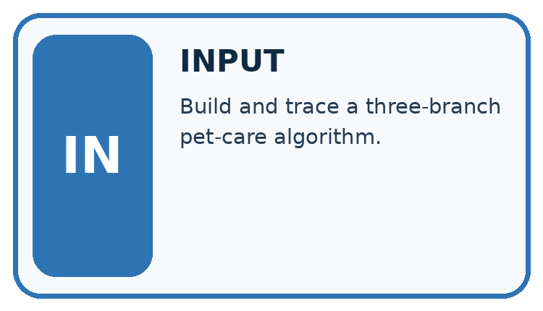
↓
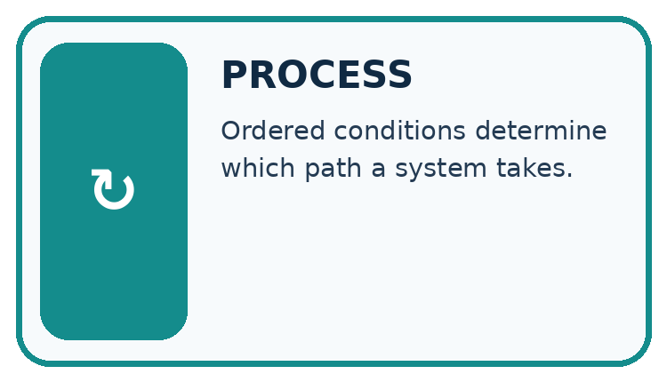
↓
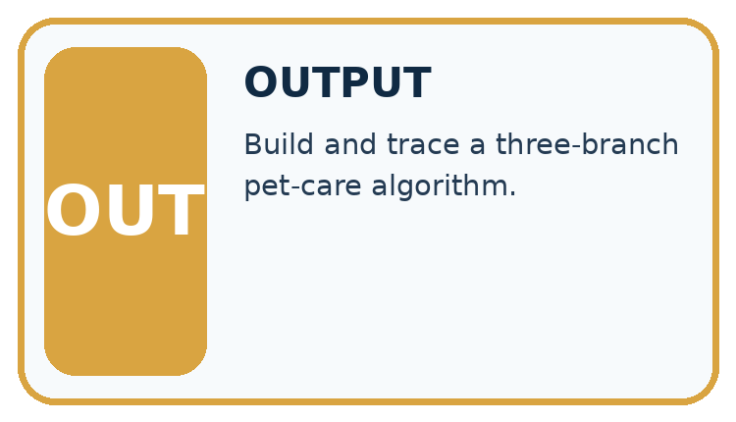
Which stage could fail even when the other two are correct? Explain:

Write or draw your reasoning and evidence.
________________________________________________________________
________________________________________________________________
________________________________________________________________
________________________________________________________________
________________________________________________________________

A closer explanation

One chain chooses one label
Input | Checks in order | Selected label
-1 | Below zero is True | Invalid
12 | Below zero False; <= 12 True | Short
13 | Both checks False | Long
Later branches in this chain are skipped after a condition succeeds.
minutes = 12
if minutes < 0:
label = "Invalid"
elif minutes <= 12:
label = "Short"
else:
label = "Long"
print(label)
The output is Short. For 12, the first condition is false and the second is true. The else block is skipped. print(label) is not indented, so it runs after the selected branch. Each path assigns label before this line reads it. Change only minutes and save before each fresh run.

Connect the picture and the explanation
Point to the input, the deciding step and the result in this week’s visual. Explain the same step in ordinary words. A picture helps when you can say what each part represents.

04. Compare the cases
CASE GALLERY
Four Tests, Four Kinds of Evidence
A system is not understood until it survives more than one comfortable example.


NORMAL CASE: predict and name evidence. BOUNDARY CASE: predict and name evidence.


MISSING INFORMATION: predict and name evidence. TRANSFER CASE: predict and name evidence.
Which case is most likely to reveal a hidden assumption? Why?

Write or draw your reasoning and evidence.
________________________________________________________________
________________________________________________________________
________________________________________________________________
________________________________________________________________
________________________________________________________________

Change one thing in the pictured case
Change: Move minutes<=10 to the first branch.
Prediction: −1 and 0 wrongly receive Short.
Reason: Both satisfy the earlier comparison before their intended checks are reached.

05. Words that unlock the idea
VOCABULARY LAB
Words You Can Use to Reason
A definition matters when you can recognize the idea, use it, and contrast it with a near-miss.
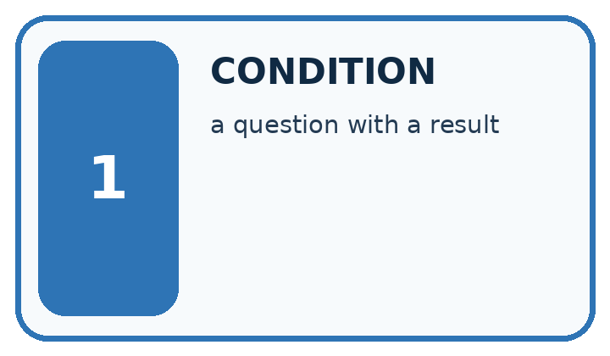
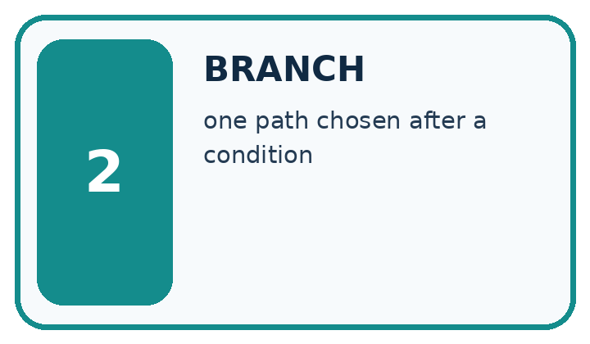
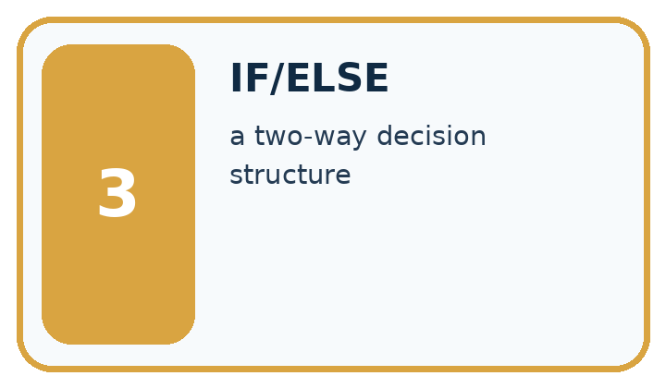
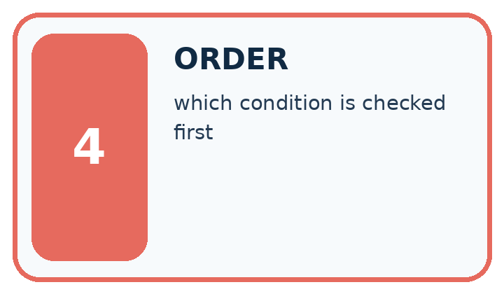
Word | My own example | Not this / boundary
condition | A statement evaluated as true or false to help select an action.
branch | One path taken when a condition selects among alternatives.
if/else | A programming structure that chooses a path according to whether a condition is true or false.
order | The sequence in which steps are performed or items are read.

Words used in the closer explanation
Word | Meaning
Indentation | Leading spaces that identify a Python code block
Boundary | A value where a classification may change
Regression check | A previous test rerun after an edit to detect a new failure

06. Follow a worked example
WORKED EVIDENCE
Reason Step by Step
Predict first. Then check each step. A correct answer without visible reasoning is incomplete evidence.
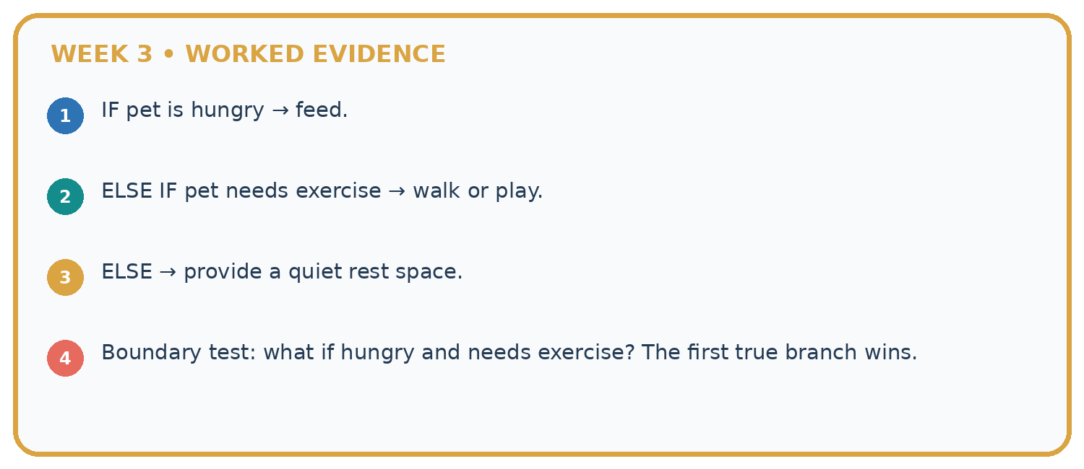
1. IF pet is hungry → feed.
2. ELSE IF pet needs exercise → walk or play.
3. ELSE → provide a quiet rest space.
4. Boundary test: what if hungry and needs exercise? The first true branch wins.
Recalculate, retrace, or restate the reasoning in your own representation:

Write or draw your reasoning and evidence.
________________________________________________________________
________________________________________________________________
________________________________________________________________
________________________________________________________________
________________________________________________________________
CHECK Did the evidence answer the exact question? Did the total, path, or source record stay consistent?

A closer explanation
Input minutes | Expected label | Reason for this test
-1 | Invalid | Negative input rejection
0 | Short | Lowest valid duration
11 | Short | Just below the upper boundary
12 | Short | Exact upper boundary
13 | Long | Just above the boundary
These tests exercise every branch and the equality case. A change from <= 12 to < 12 is exposed by 12; testing 11 alone misses it. Branch coverage means every branch was exercised, but it does not prove every condition is correct.

Suppose the program uses < 12 instead of <= 12. What is printed for 12, why does that violate the written rule, and which earlier test should still pass after repair?
________________________________________________________________
________________________________________________________________
________________________________________________________________
________________________________________________________________
________________________________________________________________

Learn from the worked case
Cover the result before checking it. Say what is given, choose the procedure, and follow one step at a time. Then uncover the result and explain your first mismatch. Ask why a step is allowed, not only what number it produces.

A pictorial worked case: Branching Logic
A fictional reading-time labeler uses one Python if/elif/else chain.

The facts we will use
Whole minutes below 0: Invalid; 0: Empty; 1–10: Short; above 10: Long.
Order checks as minutes<0, minutes==0, minutes<=10, otherwise. Print the assigned label once.
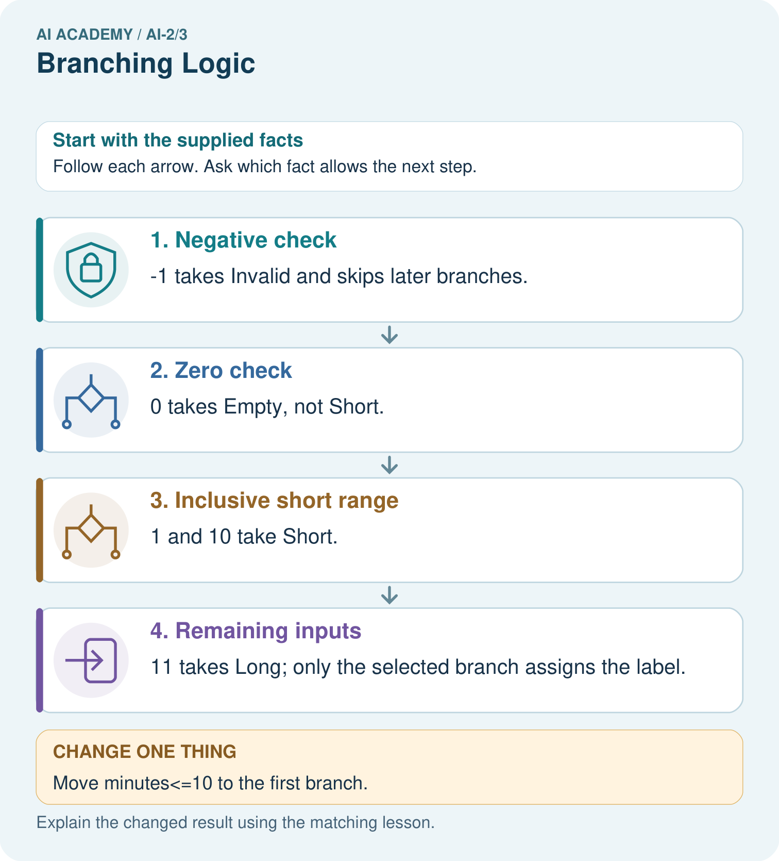

Read the picture one step at a time
Step | What happens and why
1. Negative check | −1 takes Invalid and skips later branches.
2. Zero check | 0 takes Empty, not Short.
3. Inclusive short range | 1 and 10 take Short.
4. Remaining inputs | 11 takes Long; only the selected branch assigns the label.
Match each pictured step to the supplied facts. This is a worked teaching case, not an independent assessment.

Why this result follows
The third comparison alone would include negative values and zero, but earlier branches already handle them. An elif chain selects its first true branch. Multiple independent if statements would have different behavior and could overwrite an earlier label. Boundary traces show why order belongs to the specification.

What this example does not establish
The example assumes whole numeric minutes; strings, missing values and fractional values need a separate declared input contract.

07. Find and repair a mistake
ERROR DETECTIVE
Compare → Diagnose → Repair
Do not patch the answer. Find the earliest unsupported assumption, wrong step, or weak evidence.
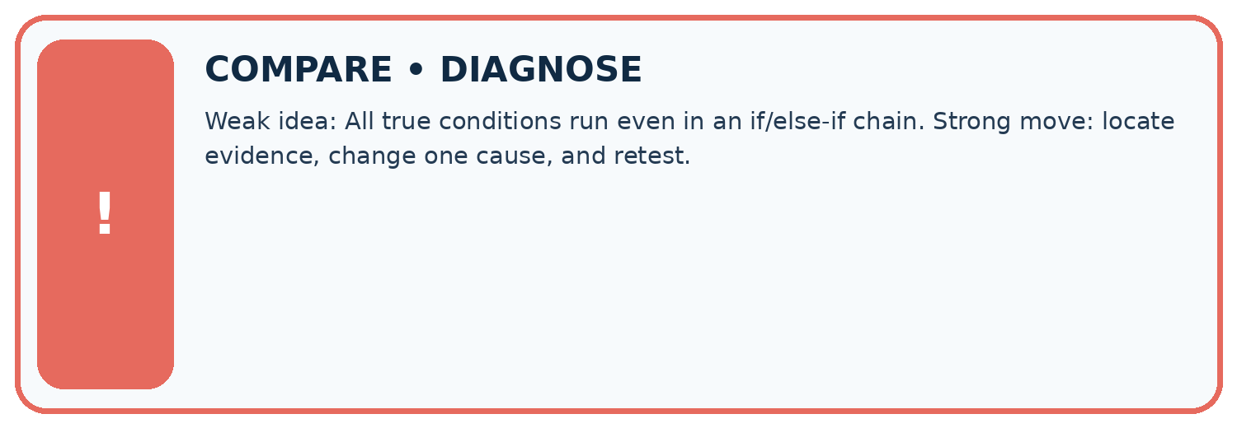
Evidence record | Expected | Actual | Likely cause / next test
normal case | works
boundary case | stated rule
missing input | safe response
fresh transfer | generalizes
Repair one cause. Why is this repair better than changing several things?

Write or draw your reasoning and evidence.
________________________________________________________________
________________________________________________________________
________________________________________________________________
________________________________________________________________
________________________________________________________________

A closer explanation
For each run, record input, expected label, conditions actually checked and observed label. Mark skipped conditions as skipped rather than pretending the program evaluated them. After a repair, rerun earlier cases as well as the failing one. Week 6 will repeat a block and track changes across iterations.

A learner tests -1, 2 and 20 and concludes the sorter is completely correct because all three branches ran. Explain what important case is missing and why branch coverage alone is insufficient.
________________________________________________________________
________________________________________________________________
________________________________________________________________
________________________________________________________________
________________________________________________________________

08. Practise together
LOGIC STUDIO
Trace Before You Run
Block code, pseudocode, tables, and diagrams are different ways to expose the same reasoning.

SET evidence_record
PREDICT expected_result
RUN one normal case and one boundary case
COMPARE actual_result with expected_result
IF different: locate first cause; change one factor; RETEST
EXPLAIN result, limitation, and next safe step
Trace one input. Which line changes the state or chooses a path?

Write or draw your reasoning and evidence.
________________________________________________________________
________________________________________________________________
________________________________________________________________
________________________________________________________________
________________________________________________________________

A closer explanation
minutes = -1
if minutes < 0:
label = "Invalid"
if minutes <= 12:
label = "Short"
else:
label = "Long"
print(label)
This faulty version prints Short. The second if starts a separate decision and overwrites Invalid. Its else belongs to that second if. Restoring elif makes the second test depend on the first test failing. Moving print inside one branch can also hide output on other paths; indentation affects behavior, not just appearance.
The script rejects negative integers, but it does not validate arbitrary types or check a measured duration. A supplied text value can raise an error during comparison. Keep the stated integer input contract and report the limitation honestly.

Practise with less help: Trace the tested path
Use workbook W2 for the connected example “Branching and boundary tests”. First fill the input and rule boxes. Try the middle steps before asking for a hint. After a hint, try the next step yourself.
Plan | Do | Check
What is given? Which rule or procedure applies? | Record each intermediate step. | Does the result follow? What remains unknown?
Explain your trace to a partner. Your partner points to one step to check. Swap roles on the next case. Each person writes their own explanation.

Check your reasoning
Use the worked case for Branching and boundary tests. Proposed explanation: “Every condition in the chain always runs”. Decide whether this explanation is supported. Point to the step or supplied fact that decides; explain your repair if needed.
Answer on your own before discussion. If you are unsure, say which step you need help with.

Explain the picture
Give expected labels for −1,0,10,11 and identify the equality boundary for Short.

My explanation using a pictured step and the given facts
________________________________________________________________
________________________________________________________________
________________________________________________________________
________________________________________________________________
This is supported practice. Keep the separately named independent case for an attempt before feedback.

09. Run the investigation
EVIDENCE LAB
Predict → Test → Record → Explain
Keep expected and actual results separate. Surprises are useful data when recorded honestly.
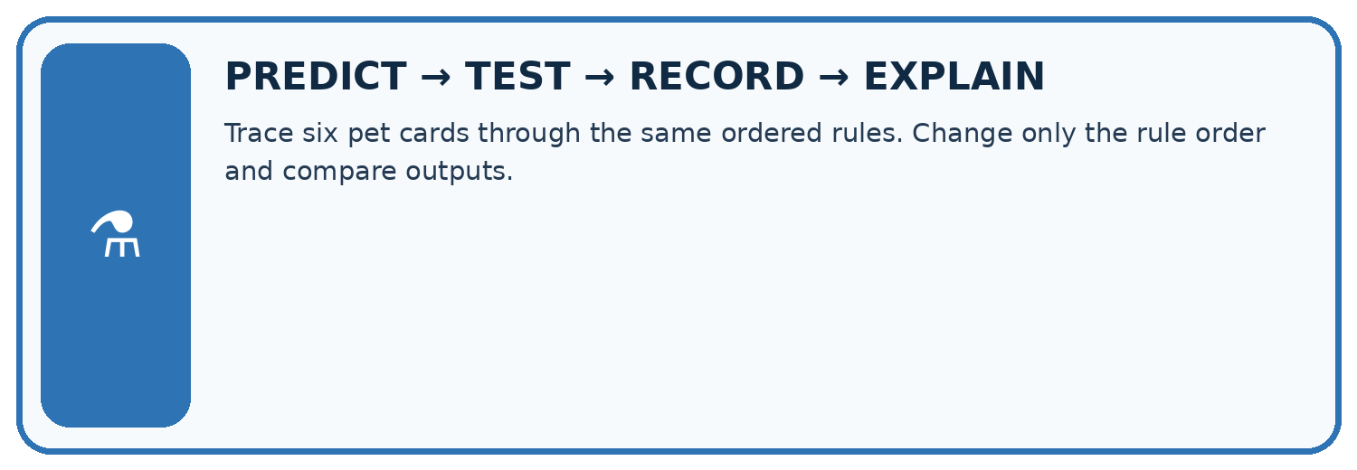
Trace six pet cards through the same ordered rules. Change only the rule order and compare outputs.
Test / input | Prediction | Actual | Evidence / calculation | Change or keep?
normal
boundary
missing
fresh transfer
What did the hardest test teach you that the normal test did not?

Write or draw your reasoning and evidence.
________________________________________________________________
________________________________________________________________
________________________________________________________________
________________________________________________________________
________________________________________________________________

Plan → try → check
Before trying: what do I expect, and why? While trying: which step could first go wrong? Afterwards: what did I actually observe, and what should change? Keep “not run” if you only traced the procedure.

10. Build your understanding
MASTERY
From Knowing the Word to Owning the Idea
Move upward only when you can produce evidence without copying the worked example.

1 • NAME: Define the concept without repeating the textbook.
2 • TRACE: Show the information, state, branch, calculation, or evidence path.
3 • APPLY: Solve a different example independently.
4 • CHALLENGE: Find a boundary case, counterexample, or unfair outcome.
5 • EXPLAIN LIMITS: Say when the result should not be trusted or used alone.
My strongest evidence of independent understanding:

Write or draw your reasoning and evidence.
________________________________________________________________
________________________________________________________________
________________________________________________________________
________________________________________________________________
________________________________________________________________

11. Connect your project
CUMULATIVE PROJECT
Transparent Book Recommender
Every week adds one inspectable piece. The system must show how it reached a result.
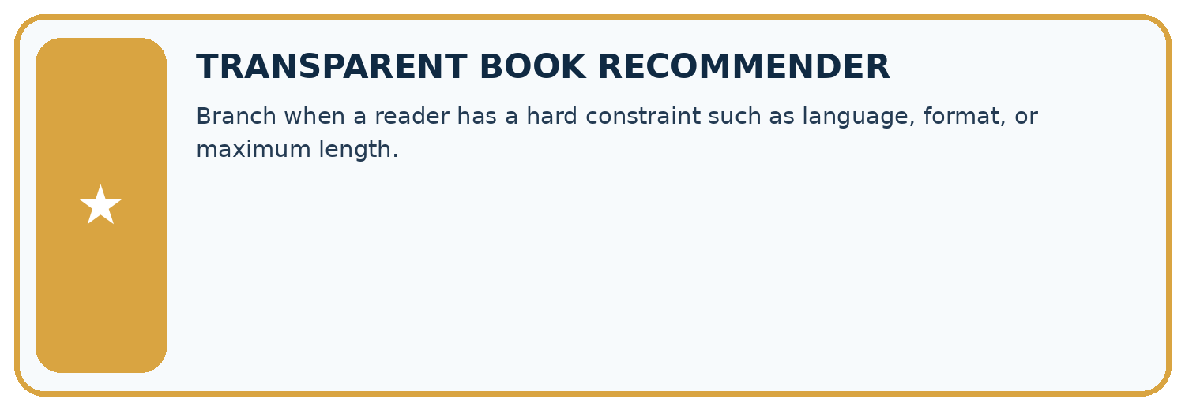
THIS WEEK’S CHECKPOINT Branch when a reader has a hard constraint such as language, format, or maximum length.
SYSTEM MAP Reader need → allowed inputs → transparent rule or score → ranked candidates → explanation → test record → human decision
What will you add, change, or verify in the project this week?

Write or draw your reasoning and evidence.
________________________________________________________________
________________________________________________________________
________________________________________________________________
________________________________________________________________
________________________________________________________________
What should remain under human control?

Write or draw your reasoning and evidence.
________________________________________________________________
________________________________________________________________
________________________________________________________________
________________________________________________________________
________________________________________________________________
RESPONSIBLE DESIGN Collect only necessary information. Show uncertainty and limits. Never confuse a ranking with a fact about a person.

Evidence for your project
Validate recommender requests before ranking items, retaining explicit labels for missing or invalid cases.

12. Show what you know
INDEPENDENT MASTERY PROOF
Explain • Transfer • Test • Defend
Complete this page without copying the worked example. Your reasoning matters more than decoration.
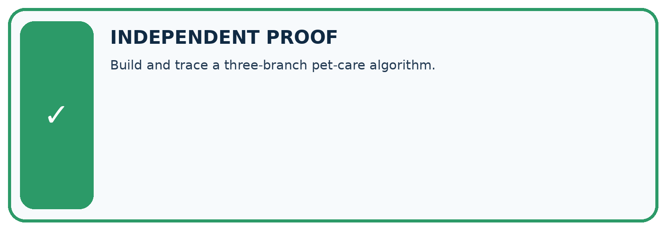
CHALLENGE Build and trace a three-branch pet-care algorithm.
1. My fresh example, trace, calculation, or design:

Write or draw your reasoning and evidence.
________________________________________________________________
________________________________________________________________
________________________________________________________________
________________________________________________________________
________________________________________________________________
2. My evidence that it works (include a boundary or missing-data case):

Write or draw your reasoning and evidence.
________________________________________________________________
________________________________________________________________
________________________________________________________________
________________________________________________________________
________________________________________________________________
3. One limitation, fairness concern, or situation needing human review:

Write or draw your reasoning and evidence.
________________________________________________________________
________________________________________________________________
________________________________________________________________
________________________________________________________________
________________________________________________________________
SELF-CHECK □ I explained the mechanism □ I used evidence □ I tested a fresh case □ I named a limitation □ I can answer ‘why?’

13. Study a complete case

Week 3 Worked case
Use the supplied details to practise the weekly concept before attempting the independent question. This case extends the illustrated lesson.

The situation
If pages<100 choose Short; otherwise if pages<=200 choose Medium; otherwise Long.

The question
Classify 99,100,200,201 pages.

Worked explanation
Short, Medium, Medium, Long. Strict and inclusive boundaries and branch order matter.

Explain it in your own words
Which detail supports the answer, and why does it matter?

Write or draw your reasoning and evidence.
________________________________________________________________
________________________________________________________________
________________________________________________________________
________________________________________________________________
________________________________________________________________

Trace the supplied case visually

Test strict and inclusive page boundaries
Evidence or stage | Value or result
99 pages | Less than 100 → Short
100 pages | 100 to 200 inclusive → Medium
200 pages | 100 to 200 inclusive → Medium
201 pages | Greater than 200 → Long
If pages<100 choose Short; otherwise if pages<=200 choose Medium; otherwise Long.
Classify 99,100,200,201 pages.
Short, Medium, Medium, Long. Strict and inclusive boundaries and branch order matter.

14. Try a new case independently

Independent case: Build a new sorter independently
Use an integer tiles count. Label a negative value Invalid, zero Empty, 1 through 6 Small and values above 6 Large. Write an ordered if elif else script and predict -1, 0, 1, 6 and 7. Include one print after the chain.

My independent explanation, trace and limits
________________________________________________________________
________________________________________________________________
________________________________________________________________
________________________________________________________________
________________________________________________________________
________________________________________________________________
________________________________________________________________
Attempt this case before feedback. Record any help. Earlier examples below are further practice; a case already practised with feedback cannot establish fresh transfer.

Week 3 Independent application
Close the worked explanation. Apply the idea to this different question without copying.
If pages are at most 80, choose short; otherwise choose long. Classify books with 79, 80 and 81 pages and explain the boundary.
My answer, with a trace, calculation or supporting evidence

Write or draw your reasoning and evidence.
________________________________________________________________
________________________________________________________________
________________________________________________________________
________________________________________________________________
________________________________________________________________

Create and test
Change one relevant detail. Predict the result before testing. Include a boundary or missing-information case when it helps reveal a limit.
My changed input and expected result

Write or draw your reasoning and evidence.
________________________________________________________________
________________________________________________________________
________________________________________________________________
________________________________________________________________
________________________________________________________________

Connect to your project
Branch when a reader has a hard constraint such as language, format, or maximum length.
The evidence I will keep

Write or draw your reasoning and evidence.
________________________________________________________________
________________________________________________________________
________________________________________________________________
________________________________________________________________
________________________________________________________________
Your teacher has the independent answer and scoring criteria. Complete the matching workbook week to keep your practice evidence together.

Transfer practice from the original programme
Classify lengths with if pages<80 then Short; else if pages<=160 then Medium; else Long. Trace 79,80,160,161. What happens if the <=160 branch is placed first?

Explain the mechanism, evidence and one limit.
________________________________________________________________
________________________________________________________________
________________________________________________________________
________________________________________________________________
________________________________________________________________
________________________________________________________________
________________________________________________________________

Use feedback to improve
Attempt the independent case before hints. Record whether you worked alone, used a hint or followed a model. After feedback, fix the first unsupported step and explain why it changed. A later check uses a changed case, not a copied answer.

