AI ACADEMY · STUDENT · ai-2/7

Rows Columns and Data Types
Project: Transparent Book Recommender

Before you start
Week 2: stages need agreed input formats.

01. Your mission

Your learning target
I can specify a table schema.
I can check types and units as well as names.
I can distinguish structural validity from truth.

Remember before reading
Close your notes first. A rough first answer helps us choose the right starting point; it is not a score for your ability.
Without opening the old lesson, explain one key idea from Debugging Strategies. Give an example and a mistake that the idea helps you avoid.
Without opening the old lesson, explain one key idea from Trace Tables. Give an example and a mistake that the idea helps you avoid.
Without opening the old lesson, explain one key idea from Precision in Algorithms. Give an example and a mistake that the idea helps you avoid.
After trying, check the relevant lesson or ask your teacher. Change the part of your explanation that the evidence shows was wrong.
Week 7: Rows, Columns, and Data Types
Structured tables preserve meaning through named fields and consistent types.
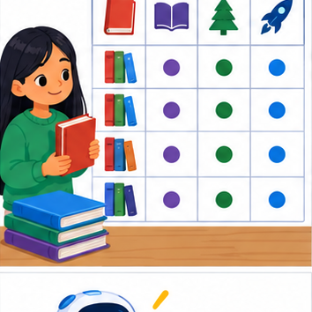
THINKER MISSION
Repair a mixed-up class-pet dataset.
Thinker name and date:

Write or draw your reasoning and evidence.
________________________________________________________________
________________________________________________________________
________________________________________________________________
________________________________________________________________
________________________________________________________________

Readiness for the connected explanation
What does row["used"] mean?

This week’s end goal
By the end, I can read a table schema and distinguish a numeric value from its text representation.

02. Notice the evidence
PICTURE STORY
Notice → Predict → Explain
Begin with visible evidence. Do not explain more than the picture and information support.
MYSTERY
The learners must use rows, columns, and data types to solve a problem. What information do they have? What decision or calculation do they make? What would count as evidence that it worked?
Three observations (what you can point to):

Write or draw your reasoning and evidence.
________________________________________________________________
________________________________________________________________
________________________________________________________________
________________________________________________________________
________________________________________________________________
My prediction and the clue supporting it:

Write or draw your reasoning and evidence.
________________________________________________________________
________________________________________________________________
________________________________________________________________
________________________________________________________________
________________________________________________________________

A closer explanation
A fictional classroom logs the duration of each activity. Before comparing durations, define a schema: activity is nonempty text, minutes is an integer from 0 through 60, and each row describes one activity session. These decisions make data interpretable.

03. See how it works
VISUAL MECHANISM
Input → Process → Output
Trace the information. At each stage, ask what changed and how you could test it.
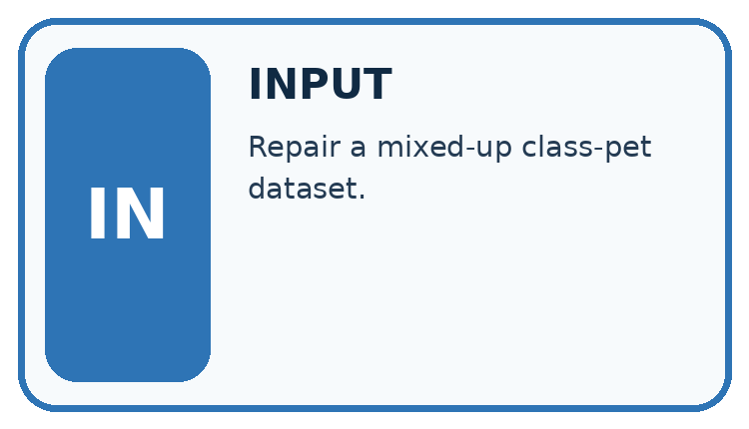
↓
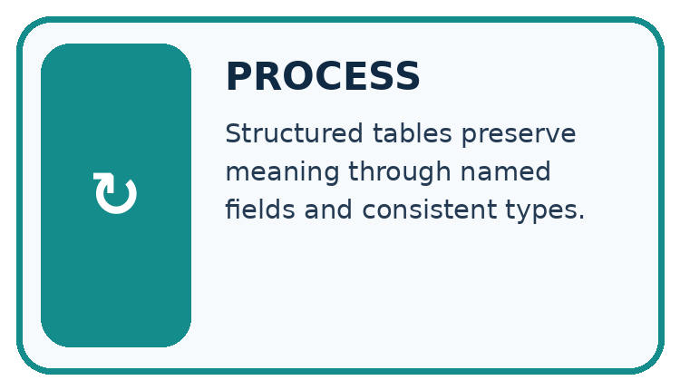
↓
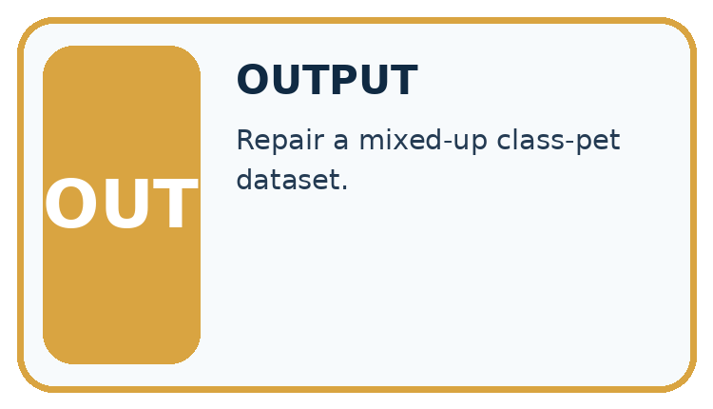
Which stage could fail even when the other two are correct? Explain:

Write or draw your reasoning and evidence.
________________________________________________________________
________________________________________________________________
________________________________________________________________
________________________________________________________________
________________________________________________________________

A closer explanation
rows = [{"activity": "Reading", "minutes": 12},
{"activity": "Sorting", "minutes": 0}]
for row in rows:
valid = (type(row["activity"]) is str
and len(row["activity"]) > 0
and type(row["minutes"]) is int
and 0 <= row["minutes"] <= 60)
print(valid)

Follow the evidence
Step or case | Evidence | Meaning
activity | Nonempty text | Names the session activity
minutes | Integer 0 through 60 | Duration in minutes
Read each row from left to right and connect the evidence to the stated rule.
The worked script prints True twice. type(value) is int checks the exact type here and avoids accepting a Boolean as a count. The chained comparison checks both boundaries. The example assumes both keys exist; next week handles missing fields. A zero duration is allowed by this written schema.

Check a row in separate steps
A schema is a checklist for what a row must contain. First ask whether the activity name is text and is not empty. Next ask whether minutes is an integer. Then ask whether that integer lies between 0 and 60, including both ends. Keep these checks separate when explaining a rejection. The number 12 and the text "12" look similar on a page, but only the number meets this lesson’s minutes rule.

Connect the picture and the explanation
Point to the input, the deciding step and the result in this week’s visual. Explain the same step in ordinary words. A picture helps when you can say what each part represents.

04. Compare the cases
CASE GALLERY
Four Tests, Four Kinds of Evidence
A system is not understood until it survives more than one comfortable example.


NORMAL CASE: predict and name evidence. BOUNDARY CASE: predict and name evidence.


MISSING INFORMATION: predict and name evidence. TRANSFER CASE: predict and name evidence.
Which case is most likely to reveal a hidden assumption? Why?

Write or draw your reasoning and evidence.
________________________________________________________________
________________________________________________________________
________________________________________________________________
________________________________________________________________
________________________________________________________________

Change one thing in the pictured case
Change: Change B’s pages from "90" to integer 90 using an approved repair.
Prediction: B now satisfies the declared schema.
Reason: Its id is nonempty and illustrated is Boolean; the page-type defect is removed.

05. Words that unlock the idea
VOCABULARY LAB
Words You Can Use to Reason
A definition matters when you can recognize the idea, use it, and contrast it with a near-miss.
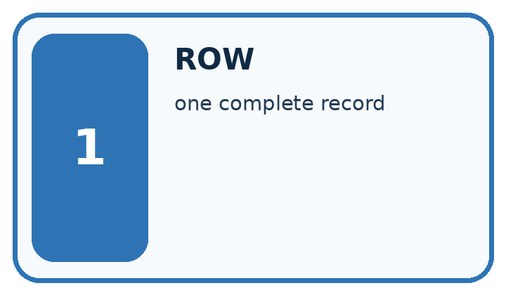
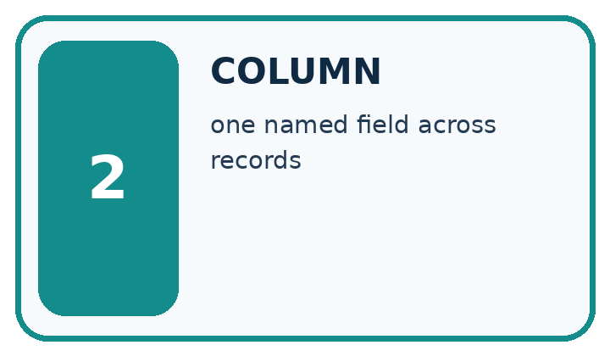
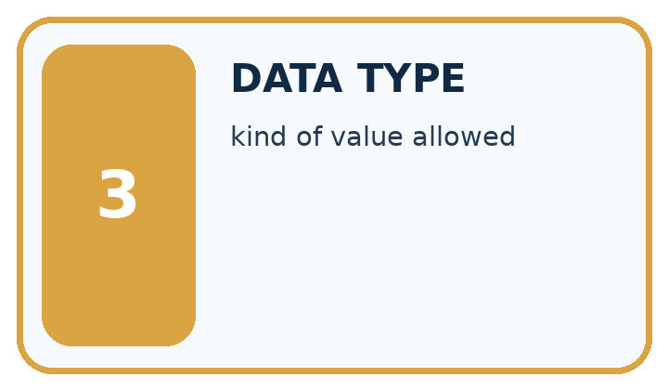
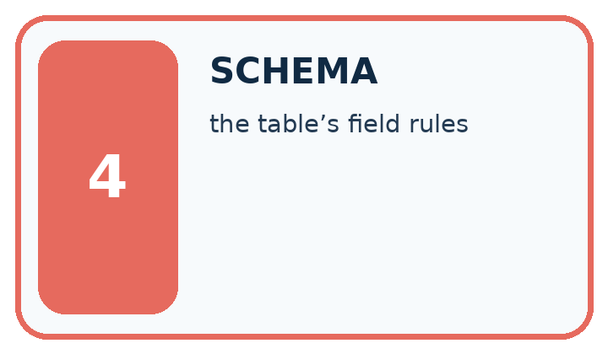
Word | My own example | Not this / boundary
row | One record or example in a table.
column | A table field containing the same kind of information across rows.
data type | A category of values, such as number, text or Boolean, with defined operations.
schema | A specification of required fields, types and structural rules for data.

Words used in the closer explanation
Word | Meaning
Type | A category such as integer or text
Unit | The quantity scale attached to a number
Constraint | A rule a valid record must satisfy

06. Follow a worked example
WORKED EVIDENCE
Reason Step by Step
Predict first. Then check each step. A correct answer without visible reasoning is incomplete evidence.
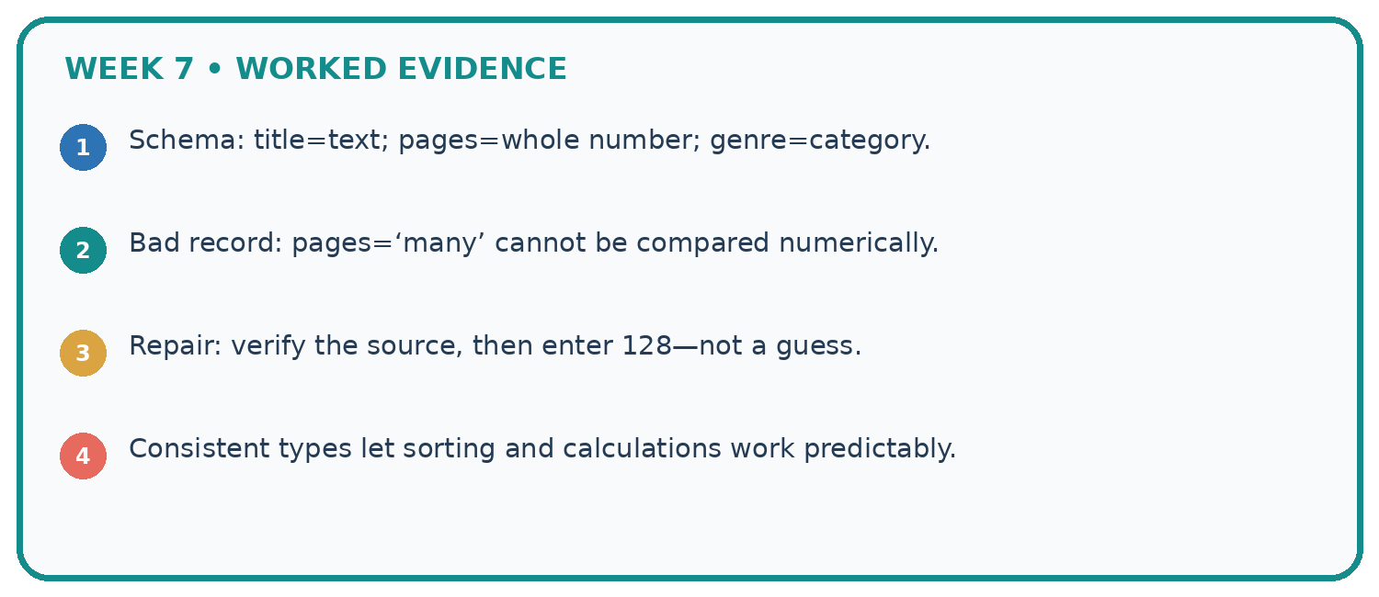
1. Schema: title=text; pages=whole number; genre=category.
2. Bad record: pages=‘many’ cannot be compared numerically.
3. Repair: verify the source, then enter 128—not a guess.
4. Consistent types let sorting and calculations work predictably.
Recalculate, retrace, or restate the reasoning in your own representation:

Write or draw your reasoning and evidence.
________________________________________________________________
________________________________________________________________
________________________________________________________________
________________________________________________________________
________________________________________________________________
CHECK Did the evidence answer the exact question? Did the total, path, or source record stay consistent?

A closer explanation

Would minutes of 61, "12" and 12 each pass? Explain the type distinction.
________________________________________________________________
________________________________________________________________
________________________________________________________________
________________________________________________________________
________________________________________________________________
________________________________________________________________

Learn from the worked case
Cover the result before checking it. Say what is given, choose the procedure, and follow one step at a time. Then uncover the result and explain your first mismatch. Ask why a step is allowed, not only what number it produces.

A pictorial worked case: Rows Columns and Data Types
A fictional approved book catalogue has three fields per row.

The facts we will use
Schema: id is nonempty text; pages is an integer 1–300; illustrated is Boolean True or False.
Rows A={id:"B7",pages:90,illustrated:True}; B={id:"B8",pages:"90",illustrated:False}; C={id:"",pages:80,illustrated:True}.
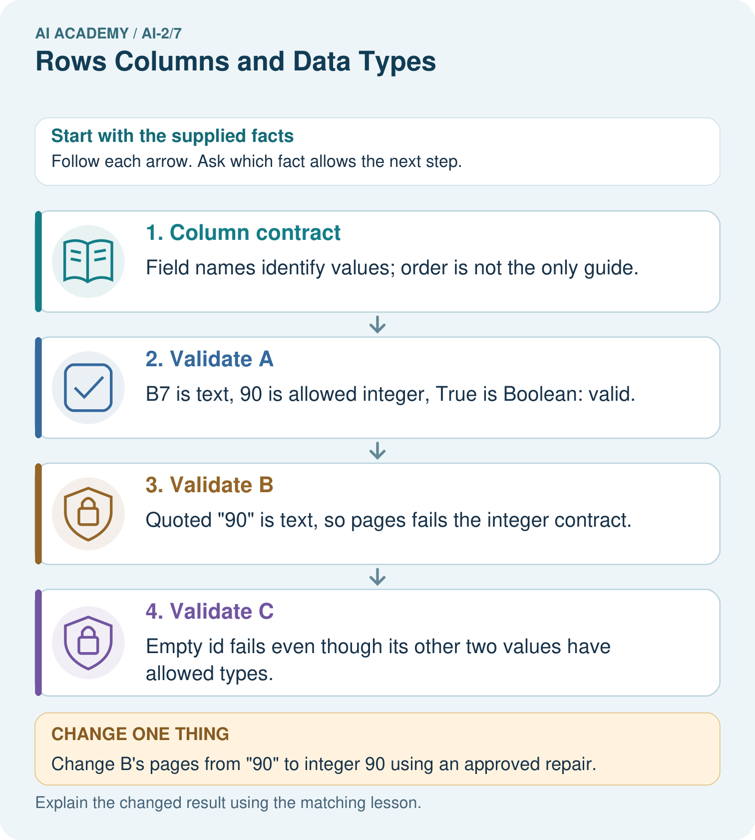

Read the picture one step at a time
Step | What happens and why
1. Column contract | Field names identify values; order is not the only guide.
2. Validate A | B7 is text, 90 is allowed integer, True is Boolean: valid.
3. Validate B | Quoted "90" is text, so pages fails the integer contract.
4. Validate C | Empty id fails even though its other two values have allowed types.
Match each pictured step to the supplied facts. This is a worked teaching case, not an independent assessment.

Why this result follows
A schema makes row meanings and expected types explicit. The string "90" looks like a number when printed but does not meet this strict integer schema. A repair can be authorised later, but must not be assumed silently. Missing or empty identifiers also prevent tracing an item back to its source.

What this example does not establish
Schema validity does not confirm that the book really has 90 pages or that its metadata is accurate.

07. Find and repair a mistake
ERROR DETECTIVE
Compare → Diagnose → Repair
Do not patch the answer. Find the earliest unsupported assumption, wrong step, or weak evidence.
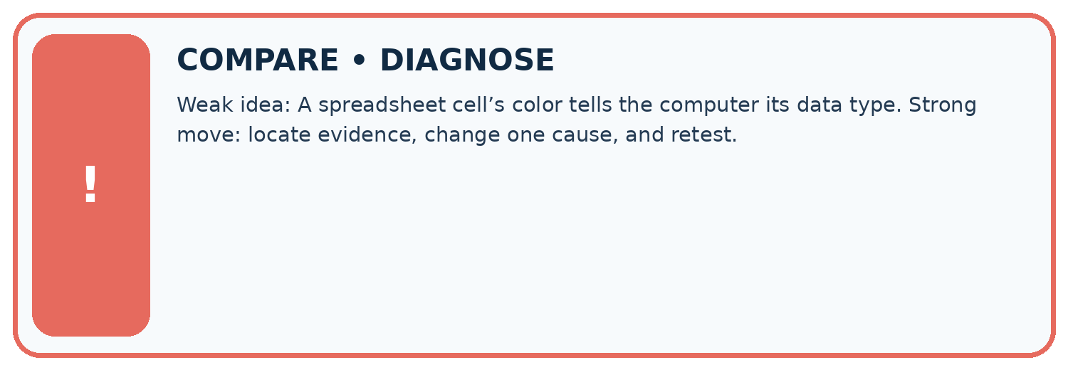
Evidence record | Expected | Actual | Likely cause / next test
normal case | works
boundary case | stated rule
missing input | safe response
fresh transfer | generalizes
Repair one cause. Why is this repair better than changing several things?

Write or draw your reasoning and evidence.
________________________________________________________________
________________________________________________________________
________________________________________________________________
________________________________________________________________
________________________________________________________________

A closer explanation
A row can satisfy every schema rule and still be a wrong observation. Schema validation checks our stated structure and constraints, not whether someone measured honestly or selected a representative sample.

A row says Reading, 12 and passes. Does that establish the session really lasted 12 minutes?
________________________________________________________________
________________________________________________________________
________________________________________________________________
________________________________________________________________
________________________________________________________________
________________________________________________________________

08. Practise together
LOGIC STUDIO
Trace Before You Run
Block code, pseudocode, tables, and diagrams are different ways to expose the same reasoning.

SET evidence_record
PREDICT expected_result
RUN one normal case and one boundary case
COMPARE actual_result with expected_result
IF different: locate first cause; change one factor; RETEST
EXPLAIN result, limitation, and next safe step
Trace one input. Which line changes the state or chooses a path?

Write or draw your reasoning and evidence.
________________________________________________________________
________________________________________________________________
________________________________________________________________
________________________________________________________________
________________________________________________________________

A closer explanation
If one row records 120 seconds in the minutes field, a simple numeric total becomes misleading. Correct the source or explicitly convert and document it; renaming a column alone does not convert values.

Practise with less help: Classify records
Use workbook W2 for the connected example “Rows columns and schemas”. First fill the input and rule boxes. Try the middle steps before asking for a hint. After a hint, try the next step yourself.
Plan | Do | Check
What is given? Which rule or procedure applies? | Record each intermediate step. | Does the result follow? What remains unknown?
Explain your trace to a partner. Your partner points to one step to check. Swap roles on the next case. Each person writes their own explanation.

Check your reasoning
Use the worked case for Rows columns and schemas. Proposed explanation: “A successful run proves the conclusion”. Decide whether this explanation is supported. Point to the step or supplied fact that decides; explain your repair if needed.
Answer on your own before discussion. If you are unsure, say which step you need help with.

Explain the picture
Which two rows originally fail, and do they fail for the same reason?

My explanation using a pictured step and the given facts
________________________________________________________________
________________________________________________________________
________________________________________________________________
________________________________________________________________
This is supported practice. Keep the separately named independent case for an attempt before feedback.

09. Run the investigation
EVIDENCE LAB
Predict → Test → Record → Explain
Keep expected and actual results separate. Surprises are useful data when recorded honestly.
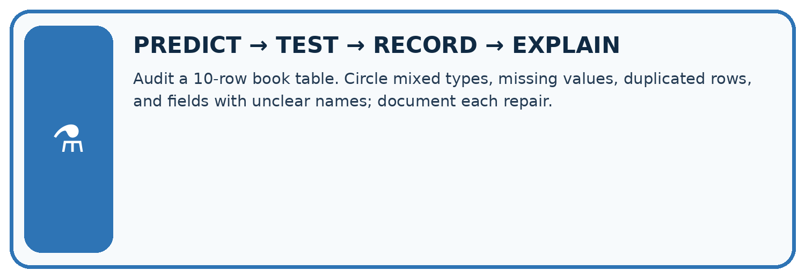
Audit a 10-row book table. Circle mixed types, missing values, duplicated rows, and fields with unclear names; document each repair.
Test / input | Prediction | Actual | Evidence / calculation | Change or keep?
normal
boundary
missing
fresh transfer
What did the hardest test teach you that the normal test did not?

Write or draw your reasoning and evidence.
________________________________________________________________
________________________________________________________________
________________________________________________________________
________________________________________________________________
________________________________________________________________

Plan → try → check
Before trying: what do I expect, and why? While trying: which step could first go wrong? Afterwards: what did I actually observe, and what should change? Keep “not run” if you only traced the procedure.

10. Build your understanding
MASTERY
From Knowing the Word to Owning the Idea
Move upward only when you can produce evidence without copying the worked example.

1 • NAME: Define the concept without repeating the textbook.
2 • TRACE: Show the information, state, branch, calculation, or evidence path.
3 • APPLY: Solve a different example independently.
4 • CHALLENGE: Find a boundary case, counterexample, or unfair outcome.
5 • EXPLAIN LIMITS: Say when the result should not be trusted or used alone.
My strongest evidence of independent understanding:

Write or draw your reasoning and evidence.
________________________________________________________________
________________________________________________________________
________________________________________________________________
________________________________________________________________
________________________________________________________________

11. Connect your project
CUMULATIVE PROJECT
Transparent Book Recommender
Every week adds one inspectable piece. The system must show how it reached a result.
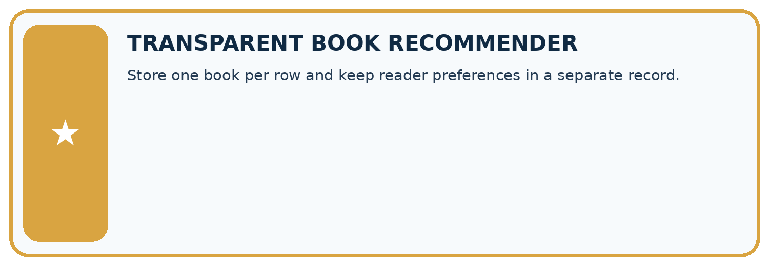
THIS WEEK’S CHECKPOINT Store one book per row and keep reader preferences in a separate record.
SYSTEM MAP Reader need → allowed inputs → transparent rule or score → ranked candidates → explanation → test record → human decision
What will you add, change, or verify in the project this week?

Write or draw your reasoning and evidence.
________________________________________________________________
________________________________________________________________
________________________________________________________________
________________________________________________________________
________________________________________________________________
What should remain under human control?

Write or draw your reasoning and evidence.
________________________________________________________________
________________________________________________________________
________________________________________________________________
________________________________________________________________
________________________________________________________________
RESPONSIBLE DESIGN Collect only necessary information. Show uncertainty and limits. Never confuse a ranking with a fact about a person.

Evidence for your project
Publish the recommender’s row schema and validation results before ranking books, preserving repair provenance.

12. Show what you know
INDEPENDENT MASTERY PROOF
Explain • Transfer • Test • Defend
Complete this page without copying the worked example. Your reasoning matters more than decoration.
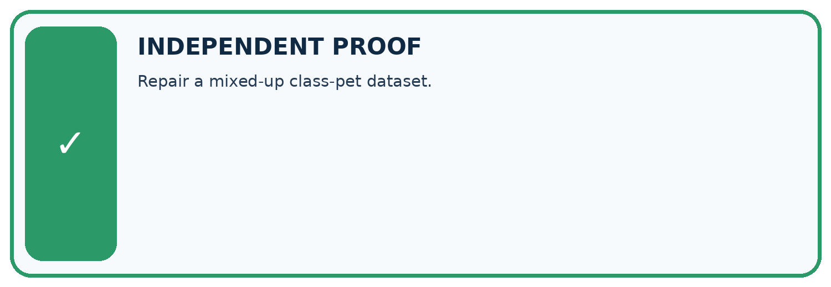
CHALLENGE Repair a mixed-up class-pet dataset.
1. My fresh example, trace, calculation, or design:

Write or draw your reasoning and evidence.
________________________________________________________________
________________________________________________________________
________________________________________________________________
________________________________________________________________
________________________________________________________________
2. My evidence that it works (include a boundary or missing-data case):

Write or draw your reasoning and evidence.
________________________________________________________________
________________________________________________________________
________________________________________________________________
________________________________________________________________
________________________________________________________________
3. One limitation, fairness concern, or situation needing human review:

Write or draw your reasoning and evidence.
________________________________________________________________
________________________________________________________________
________________________________________________________________
________________________________________________________________
________________________________________________________________
SELF-CHECK □ I explained the mechanism □ I used evidence □ I tested a fresh case □ I named a limitation □ I can answer ‘why?’

13. Study a complete case

Week 7 Worked case
Use the supplied details to practise the weekly concept before attempting the independent question. This case extends the illustrated lesson.

The situation
Fields are Title, Pages and Borrowed; a row contains River, ninety and yes.

The question
Assign intended types and a repair.

Worked explanation
Text, numeric and Boolean. Confirm ninety means 90, then convert and record the change; use a consistent Boolean representation.

Explain it in your own words
Which detail supports the answer, and why does it matter?

Write or draw your reasoning and evidence.
________________________________________________________________
________________________________________________________________
________________________________________________________________
________________________________________________________________
________________________________________________________________

Trace the supplied case visually

A field has a meaning and a type
Evidence or stage | Value or result
Title | Text → River
Pages | Number → 90 after checking source
Borrowed | Boolean → true or false
Fields are Title, Pages and Borrowed; a row contains River, ninety and yes.
Assign intended types and a repair.
Text, numeric and Boolean. Confirm ninety means 90, then convert and record the change; use a consistent Boolean representation.

14. Try a new case independently

Independent case: Design a schema independently
For a fictional shelf audit, define label and book_count fields. Require a nonempty text label and an integer count from 0 to 40. Give two valid and two invalid records with reasons.

My independent explanation, trace and limits
________________________________________________________________
________________________________________________________________
________________________________________________________________
________________________________________________________________
________________________________________________________________
________________________________________________________________
________________________________________________________________
Attempt this case before feedback. Record any help. Earlier examples below are further practice; a case already practised with feedback cannot establish fresh transfer.

Week 7 Independent application
Close the worked explanation. Apply the idea to this different question without copying.
A table row is book_id B7, pages 84, available true. Name the type of each field and explain why pages stored as eighty-four complicates calculation.
My answer, with a trace, calculation or supporting evidence

Write or draw your reasoning and evidence.
________________________________________________________________
________________________________________________________________
________________________________________________________________
________________________________________________________________
________________________________________________________________

Create and test
Change one relevant detail. Predict the result before testing. Include a boundary or missing-information case when it helps reveal a limit.
My changed input and expected result

Write or draw your reasoning and evidence.
________________________________________________________________
________________________________________________________________
________________________________________________________________
________________________________________________________________
________________________________________________________________

Connect to your project
Store one book per row and keep reader preferences in a separate record.
The evidence I will keep

Write or draw your reasoning and evidence.
________________________________________________________________
________________________________________________________________
________________________________________________________________
________________________________________________________________
________________________________________________________________
Your teacher has the independent answer and scoring criteria. Complete the matching workbook week to keep your practice evidence together.

Transfer practice from the original programme
A row contains title='Sky', pages='120', available='false'. Explain why treating nonempty text as true can misread availability. Propose explicit conversions and a rejected-input case.

Explain the mechanism, evidence and one limit.
________________________________________________________________
________________________________________________________________
________________________________________________________________
________________________________________________________________
________________________________________________________________
________________________________________________________________
________________________________________________________________

Use feedback to improve
Attempt the independent case before hints. Record whether you worked alone, used a hint or followed a model. After feedback, fix the first unsupported step and explain why it changed. A later check uses a changed case, not a copied answer.

