AI ACADEMY · STUDENT · ai-2/9

Features and Distractors
Project: Transparent Book Recommender

Before you start
Week 8: know the target before judging a feature.

01. Your mission

Your learning target
I can choose recorded properties that preserve distinctions needed for a stated task.
I can show why identical feature records can hide examples with different target labels.
I can reject an answer copied into the inputs and test a proposed feature with a new case.

Remember before reading
Close your notes first. A rough first answer helps us choose the right starting point; it is not a score for your ability.
Without opening the old lesson, explain one key idea from Operational Labels. Give an example and a mistake that the idea helps you avoid.
Without opening the old lesson, explain one key idea from Debugging Strategies. Give an example and a mistake that the idea helps you avoid.
Without opening the old lesson, explain one key idea from Branching Logic. Give an example and a mistake that the idea helps you avoid.
After trying, check the relevant lesson or ask your teacher. Change the part of your explanation that the evidence shows was wrong.
Week 9: Features and Distractors
A feature should help the task and be available at decision time.
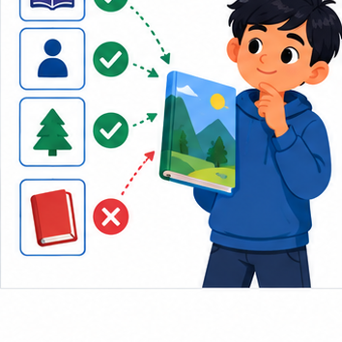
THINKER MISSION
Rank book features; reject cover color as a shortcut.
Thinker name and date:

Write or draw your reasoning and evidence.
________________________________________________________________
________________________________________________________________
________________________________________________________________
________________________________________________________________
________________________________________________________________

Readiness for the connected explanation
Two annotators agree that a calendar card is ready. What must you still check before treating that label as correct?

This week’s end goal
By the end, I can test a distracting feature with controlled changes rather than confounding clues.

02. Notice the evidence
PICTURE STORY
Notice → Predict → Explain
Begin with visible evidence. Do not explain more than the picture and information support.
MYSTERY
The learners must use features and distractors to solve a problem. What information do they have? What decision or calculation do they make? What would count as evidence that it worked?
Three observations (what you can point to):

Write or draw your reasoning and evidence.
________________________________________________________________
________________________________________________________________
________________________________________________________________
________________________________________________________________
________________________________________________________________
My prediction and the clue supporting it:

Write or draw your reasoning and evidence.
________________________________________________________________
________________________________________________________________
________________________________________________________________
________________________________________________________________
________________________________________________________________

A closer explanation
Imagine a paper sorting task for a model delivery station. Each rectangular card has a length, width, colour and card number. The station labels a card fits if its length is at most 12 centimetres and its width is at most 8 centimetres. Both limits include equality. Cards stay flat in the marked orientation; turning, bending and thickness are outside this paper task. All measurements in the first examples are known positive whole numbers.
A feature is a recorded input property, such as width in centimetres. The target label is the answer we want to produce: fits or too large under this guide. Decide what the answer means before choosing the inputs. A card number can help us find a record, but knowing its number does not tell us its dimensions.
This guide already gives us a direct rule, so we do not need to train a model to solve it. We use the task to investigate the information that either a rule or a learned model would need. Later, when relationships are learned from examples, the same question remains: did we supply the distinctions the task requires?

03. See how it works
VISUAL MECHANISM
Input → Process → Output
Trace the information. At each stage, ask what changed and how you could test it.
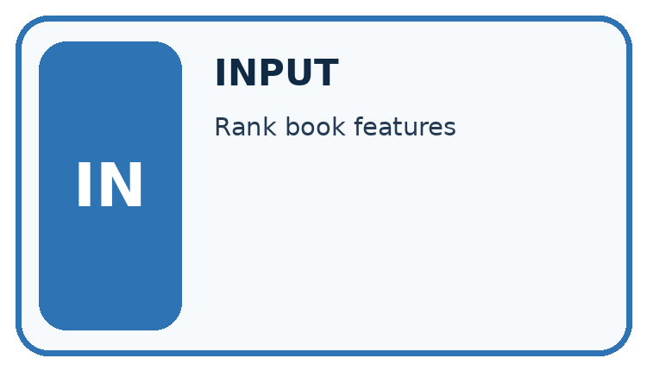
↓
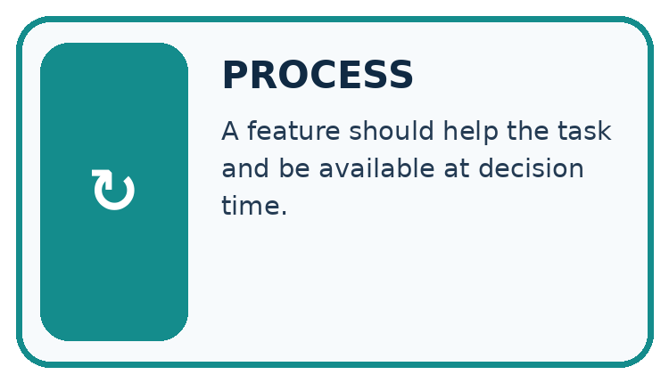
↓
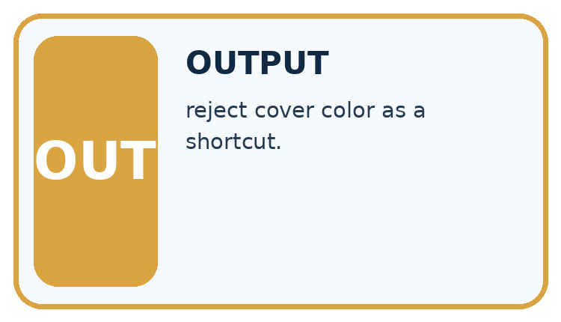
Which stage could fail even when the other two are correct? Explain:

Write or draw your reasoning and evidence.
________________________________________________________________
________________________________________________________________
________________________________________________________________
________________________________________________________________
________________________________________________________________

A closer explanation
Card A is 10 centimetres long and 7 centimetres wide. Card B is 10 centimetres long and 9 centimetres wide. A fits; B is too large because its width exceeds 8. Compare two ways of recording these cards.

The same cards under two feature choices
Original card | Choose the inputs | Resulting feature record
A is 10 by 7 cm and fits | Keep length only | 10 cm
B is 10 by 9 cm and is too large | Keep length only | 10 cm
A is 10 by 7 cm and fits | Keep length and width | 10 cm and 7 cm
B is 10 by 9 cm and is too large | Keep length and width | 10 cm and 9 cm
Length alone makes A and B look identical to the system. Retaining width preserves the difference needed by this task. The letters identify the examples here; they are not additional inputs.
A system receiving only the length cannot use the hidden width to tell these two cards apart. The same input, 10, is paired with two different correct answers. It may guess, return an uncertainty, or use a usual answer, but length alone cannot guarantee the right label for both. A more complicated model cannot reconstruct this missing distinction with certainty from that input alone.
A feature record needs a consistent order and units. Here we write length in centimetres first, then width in centimetres. The record 10, 7 means something different if someone silently switches the order or records millimetres. Write the definitions alongside the data.

Connect the picture and the explanation
Point to the input, the deciding step and the result in this week’s visual. Explain the same step in ordinary words. A picture helps when you can say what each part represents.

04. Compare the cases
CASE GALLERY
Four Tests, Four Kinds of Evidence
A system is not understood until it survives more than one comfortable example.


NORMAL CASE: predict and name evidence. BOUNDARY CASE: predict and name evidence.


MISSING INFORMATION: predict and name evidence. TRANSFER CASE: predict and name evidence.
Which case is most likely to reveal a hidden assumption? Why?

Write or draw your reasoning and evidence.
________________________________________________________________
________________________________________________________________
________________________________________________________________
________________________________________________________________
________________________________________________________________

Change one thing in the pictured case
Change: The first controlled pair yields mystery for triangle and science for circle.
Prediction: That pair is evidence of unwanted logo sensitivity.
Reason: The subject description stayed mystery; only the irrelevant logo changed.

05. Words that unlock the idea
VOCABULARY LAB
Words You Can Use to Reason
A definition matters when you can recognize the idea, use it, and contrast it with a near-miss.
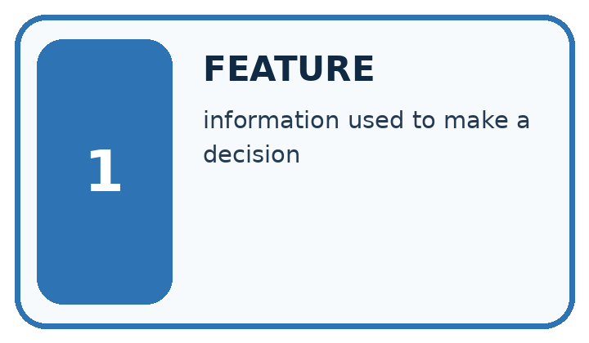
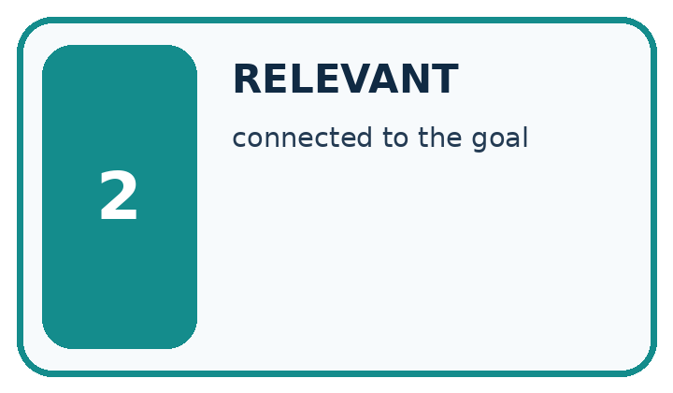
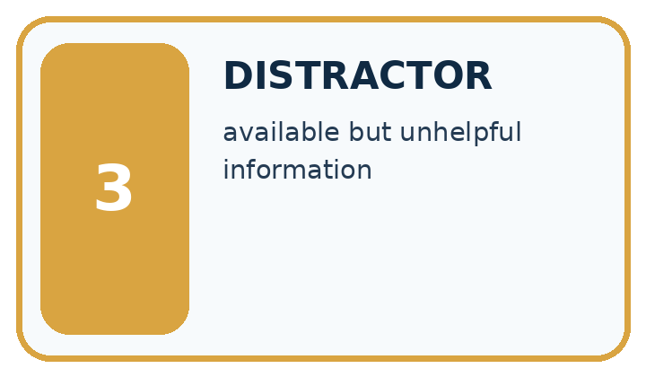
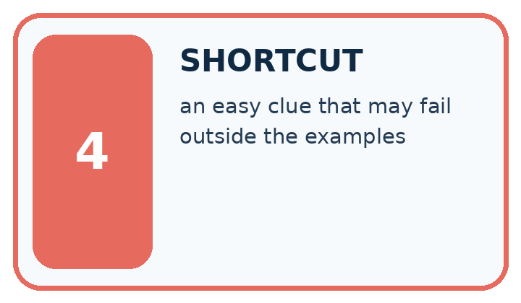
Word | My own example | Not this / boundary
feature | An input attribute or representation used by a model or decision rule.
relevant | Useful to the particular question, target or decision being considered.
distractor | A detail that draws attention but does not help answer the current question.
shortcut | A convenient but unreliable cue used instead of the relationship the task requires.

Words used in the closer explanation
Word | Meaning
Target label | The answer a supervised learning task asks a model to predict
Feature record | The selected input values for one example, in a defined order
Relevant feature | An input property that helps make distinctions needed for the stated task
Leakage | Information used during development that would not legitimately be available when making the intended prediction

06. Follow a worked example
WORKED EVIDENCE
Reason Step by Step
Predict first. Then check each step. A correct answer without visible reasoning is incomplete evidence.
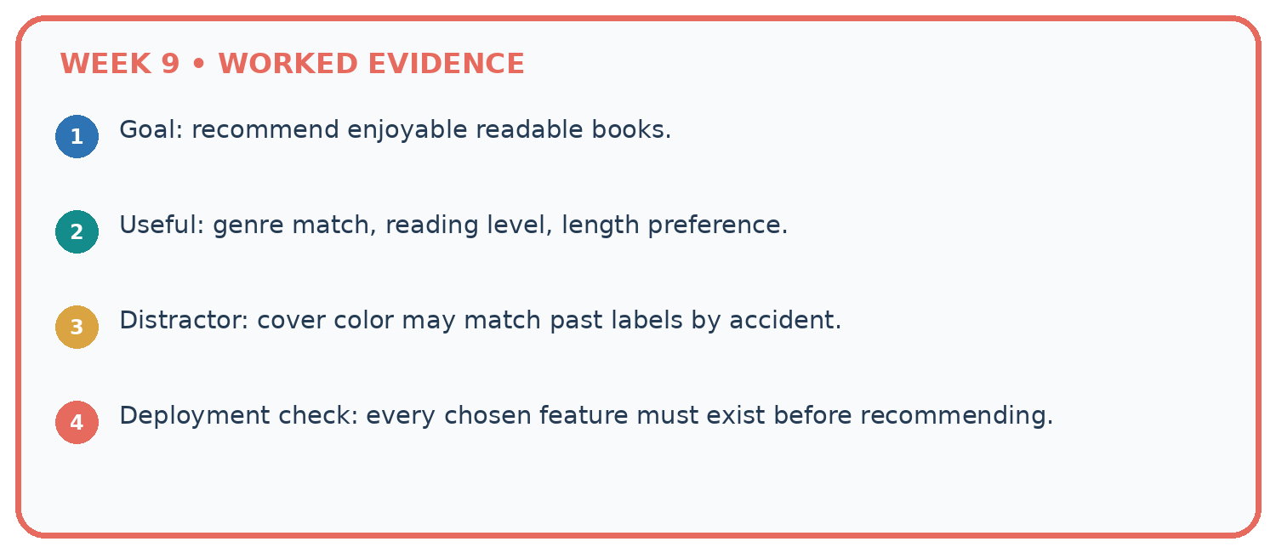
1. Goal: recommend enjoyable readable books.
2. Useful: genre match, reading level, length preference.
3. Distractor: cover color may match past labels by accident.
4. Deployment check: every chosen feature must exist before recommending.
Recalculate, retrace, or restate the reasoning in your own representation:

Write or draw your reasoning and evidence.
________________________________________________________________
________________________________________________________________
________________________________________________________________
________________________________________________________________
________________________________________________________________
CHECK Did the evidence answer the exact question? Did the total, path, or source record stay consistent?

A closer explanation
Card measurements and colour | Label under the guide | What the comparison shows
10 by 7 cm and blue | Fits | Compare with the next card
10 by 9 cm and blue | Too large | Same length and colour but width changes the label
13 by 7 cm and blue | Too large | Same width and colour as the first card but length changes the label
10 by 7 cm and red | Fits | Changing only colour does not change this guide
The first two cards show why width matters. The first and third show why length matters. The first and fourth show that colour has no part in this particular rule. That is a statement about our task, not a claim that colour is useless for every task. For sorting red and blue cards, colour would be essential.
Suppose every fitting card in a small practice set is blue and every oversized card is red. Colour would appear to predict the labels perfectly in that set. A red 10 by 7 card and a blue 13 by 7 card expose the shortcut. Check a proposed feature on deliberately different cases before trusting the practice score.

Learn from the worked case
Cover the result before checking it. Say what is given, choose the procedure, and follow one step at a time. Then uncover the result and explain your first mismatch. Ask why a step is allowed, not only what number it produces.

A pictorial worked case: Features and Distractors
A fictional book-topic classifier sees mystery books with triangular logos and science books with circular logos.

The facts we will use
Training contains no mystery-circle or science-triangle covers.
Goal is to identify topic from actual subject information, not publisher logo. New controlled test outputs have not been supplied.
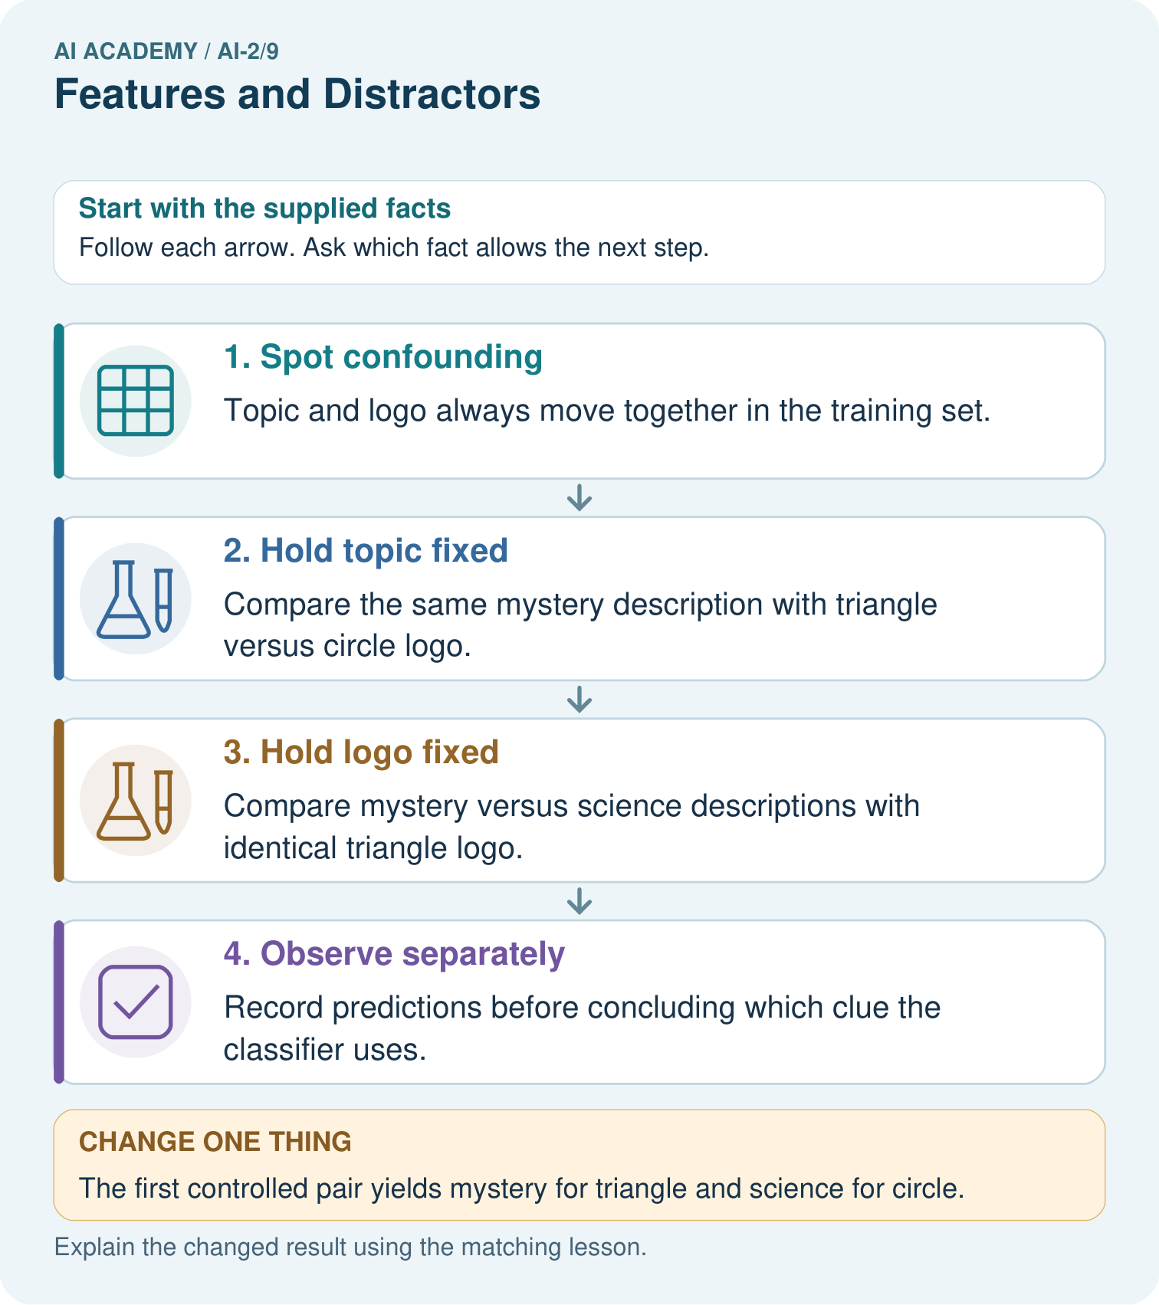

Read the picture one step at a time
Step | What happens and why
1. Spot confounding | Topic and logo always move together in the training set.
2. Hold topic fixed | Compare the same mystery description with triangle versus circle logo.
3. Hold logo fixed | Compare mystery versus science descriptions with identical triangle logo.
4. Observe separately | Record predictions before concluding which clue the classifier uses.
Match each pictured step to the supplied facts. This is a worked teaching case, not an independent assessment.

Why this result follows
Either subject information or logo could explain success on the old combinations. Controlled pairs separate their predictions by changing one aspect at a time. Designing the pair is not equivalent to observing the model’s response. Keep the descriptions identical when testing logo so differences do not have two possible causes.

What this example does not establish
Controlled observations support specific sensitivity claims; they do not reveal every internal feature a learned model uses.

07. Find and repair a mistake
ERROR DETECTIVE
Compare → Diagnose → Repair
Do not patch the answer. Find the earliest unsupported assumption, wrong step, or weak evidence.
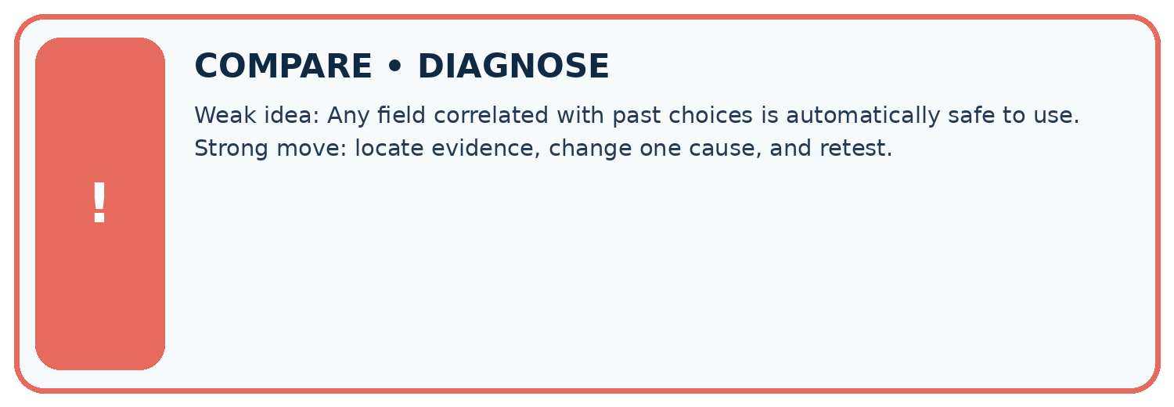
Evidence record | Expected | Actual | Likely cause / next test
normal case | works
boundary case | stated rule
missing input | safe response
fresh transfer | generalizes
Repair one cause. Why is this repair better than changing several things?

Write or draw your reasoning and evidence.
________________________________________________________________
________________________________________________________________
________________________________________________________________
________________________________________________________________
________________________________________________________________

A closer explanation
Before adopting a feature set, state the task, name the inputs with units, and ask whether two different answers can share the same input record. Construct such a pair if you can. Then check that each input is available at the time the answer is needed. These checks can reveal a broken representation before any model is trained.
For our known measurements and fixed orientation, length and width are sufficient to apply the paper rule exactly. That does not establish whether a real parcel will fit through a real opening: thickness, shape and measurement error were excluded. If the task changes, review the features again. More columns are not automatically better; each one needs a reason to be collected and used.

Someone claims that a model using only card colour is reliable because it matches every practice label. Give a new card that challenges this claim and explain what should be checked instead
________________________________________________________________
________________________________________________________________
________________________________________________________________
________________________________________________________________

08. Practise together
LOGIC STUDIO
Trace Before You Run
Block code, pseudocode, tables, and diagrams are different ways to expose the same reasoning.

SET evidence_record
PREDICT expected_result
RUN one normal case and one boundary case
COMPARE actual_result with expected_result
IF different: locate first cause; change one factor; RETEST
EXPLAIN result, limitation, and next safe step
Trace one input. Which line changes the state or chooses a path?

Write or draw your reasoning and evidence.
________________________________________________________________
________________________________________________________________
________________________________________________________________
________________________________________________________________
________________________________________________________________

A closer explanation
After measuring a card, a teacher adds a sticker saying fits or too large. A learner proposes using sticker text as an input to predict the label before that inspection. The sticker seems excellent in the completed records because it contains the answer. But it does not exist at the time of the intended prediction. This is leakage: development has used information the real task cannot provide.
Draw a line at the moment the system must answer. On the before side, put the permitted measurements available then. On the after side, put the final label sticker. Keep labels available for teaching and checking predictions, but do not feed the sticker back in as an input for this task.

A card is 12 cm long and its width is unreadable. Someone proposes using the label sticker that will be added after inspection. Which information is usable before inspection? Explain why it does not establish the label
________________________________________________________________
________________________________________________________________
________________________________________________________________
________________________________________________________________
________________________________________________________________
________________________________________________________________

Practise with less help: Prove that one measurement is insufficient
Use workbook W2 for the connected example “Features and useful distinctions”. First fill the input and rule boxes. Try the middle steps before asking for a hint. After a hint, try the next step yourself.
Plan | Do | Check
What is given? Which rule or procedure applies? | Record each intermediate step. | Does the result follow? What remains unknown?
Explain your trace to a partner. Your partner points to one step to check. Swap roles on the next case. Each person writes their own explanation.

Check your reasoning
Use the worked case for Features and useful distinctions. Proposed explanation: “A stronger model can always recover an omitted measurement”. Decide whether this explanation is supported. Point to the step or supplied fact that decides; explain your repair if needed.
Answer on your own before discussion. If you are unsure, say which step you need help with.

Explain the picture
Does this one pair prove the classifier always ignores subject? Explain a narrower claim.

My explanation using a pictured step and the given facts
________________________________________________________________
________________________________________________________________
________________________________________________________________
________________________________________________________________
This is supported practice. Keep the separately named independent case for an attempt before feedback.

09. Run the investigation
EVIDENCE LAB
Predict → Test → Record → Explain
Keep expected and actual results separate. Surprises are useful data when recorded honestly.
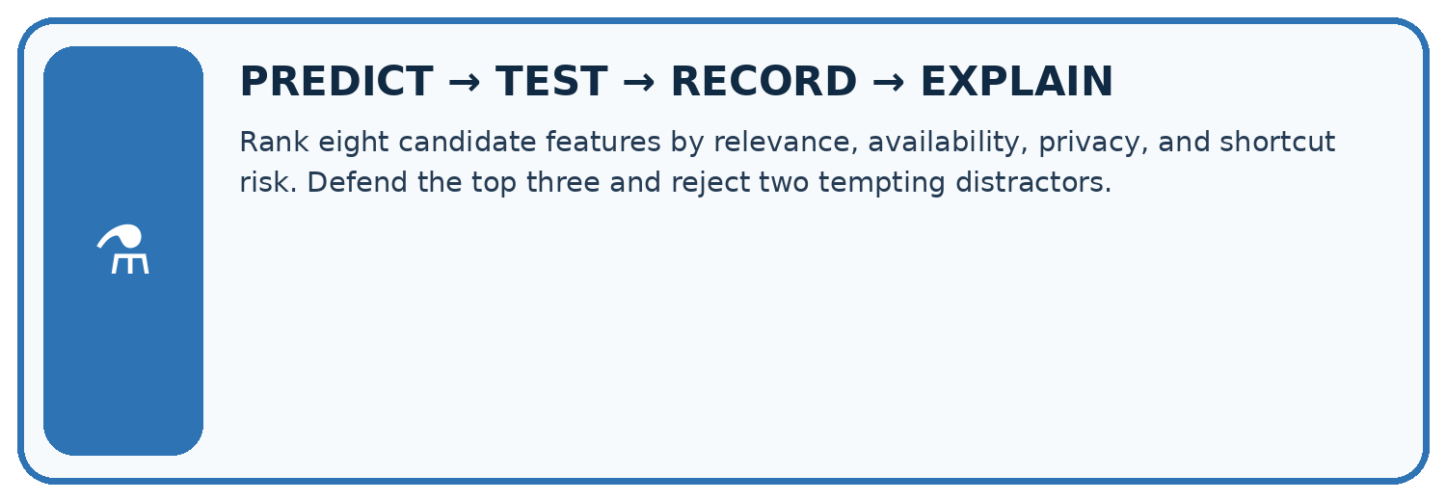
Rank eight candidate features by relevance, availability, privacy, and shortcut risk. Defend the top three and reject two tempting distractors.
Test / input | Prediction | Actual | Evidence / calculation | Change or keep?
normal
boundary
missing
fresh transfer
What did the hardest test teach you that the normal test did not?

Write or draw your reasoning and evidence.
________________________________________________________________
________________________________________________________________
________________________________________________________________
________________________________________________________________
________________________________________________________________

Plan → try → check
Before trying: what do I expect, and why? While trying: which step could first go wrong? Afterwards: what did I actually observe, and what should change? Keep “not run” if you only traced the procedure.

10. Build your understanding
MASTERY
From Knowing the Word to Owning the Idea
Move upward only when you can produce evidence without copying the worked example.

1 • NAME: Define the concept without repeating the textbook.
2 • TRACE: Show the information, state, branch, calculation, or evidence path.
3 • APPLY: Solve a different example independently.
4 • CHALLENGE: Find a boundary case, counterexample, or unfair outcome.
5 • EXPLAIN LIMITS: Say when the result should not be trusted or used alone.
My strongest evidence of independent understanding:

Write or draw your reasoning and evidence.
________________________________________________________________
________________________________________________________________
________________________________________________________________
________________________________________________________________
________________________________________________________________

11. Connect your project
CUMULATIVE PROJECT
Transparent Book Recommender
Every week adds one inspectable piece. The system must show how it reached a result.
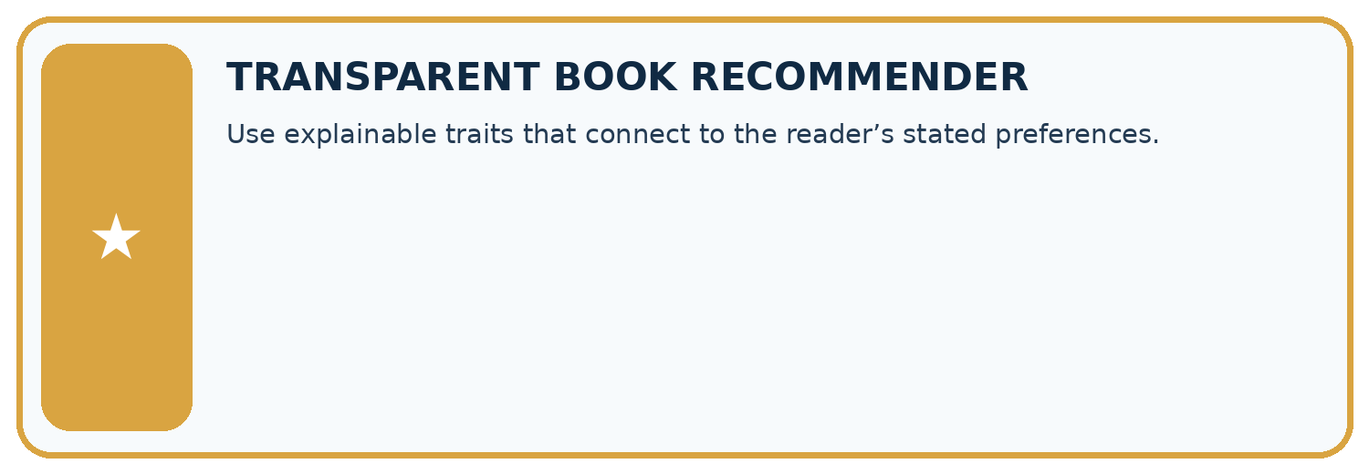
THIS WEEK’S CHECKPOINT Use explainable traits that connect to the reader’s stated preferences.
SYSTEM MAP Reader need → allowed inputs → transparent rule or score → ranked candidates → explanation → test record → human decision
What will you add, change, or verify in the project this week?

Write or draw your reasoning and evidence.
________________________________________________________________
________________________________________________________________
________________________________________________________________
________________________________________________________________
________________________________________________________________
What should remain under human control?

Write or draw your reasoning and evidence.
________________________________________________________________
________________________________________________________________
________________________________________________________________
________________________________________________________________
________________________________________________________________
RESPONSIBLE DESIGN Collect only necessary information. Show uncertainty and limits. Never confuse a ranking with a fact about a person.

Evidence for your project
Test recommender features for shortcuts, keeping relevant subject information separate from superficial catalogue styling.

12. Show what you know
INDEPENDENT MASTERY PROOF
Explain • Transfer • Test • Defend
Complete this page without copying the worked example. Your reasoning matters more than decoration.
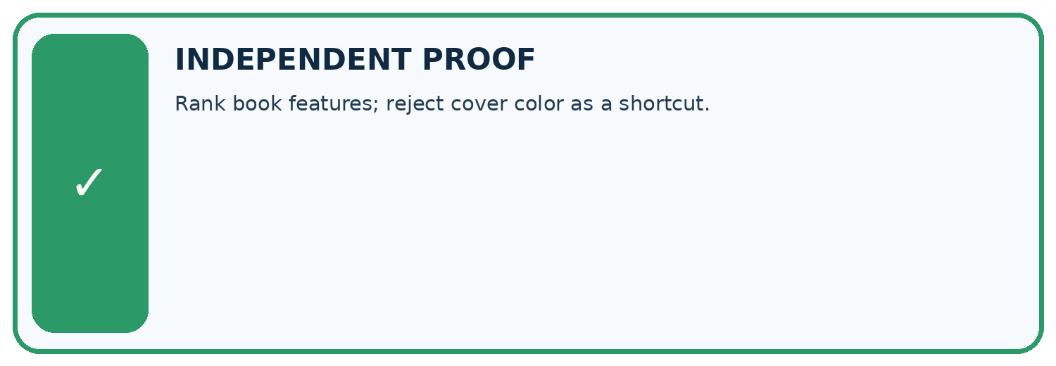
CHALLENGE Rank book features; reject cover color as a shortcut.
1. My fresh example, trace, calculation, or design:

Write or draw your reasoning and evidence.
________________________________________________________________
________________________________________________________________
________________________________________________________________
________________________________________________________________
________________________________________________________________
2. My evidence that it works (include a boundary or missing-data case):

Write or draw your reasoning and evidence.
________________________________________________________________
________________________________________________________________
________________________________________________________________
________________________________________________________________
________________________________________________________________
3. One limitation, fairness concern, or situation needing human review:

Write or draw your reasoning and evidence.
________________________________________________________________
________________________________________________________________
________________________________________________________________
________________________________________________________________
________________________________________________________________
SELF-CHECK □ I explained the mechanism □ I used evidence □ I tested a fresh case □ I named a limitation □ I can answer ‘why?’

13. Study a complete case

Week 9 Worked case
Use the supplied details to practise the weekly concept before attempting the independent question. This case extends the illustrated lesson.

The situation
Target: includes animal characters. Fields: animal tag, cover colour and shelf number.

The question
Choose useful evidence and possible distractions.

Worked explanation
An accurate animal tag directly addresses the target. Colour and shelf can produce accidental shortcuts. Test on new books.

Explain it in your own words
Which detail supports the answer, and why does it matter?

Write or draw your reasoning and evidence.
________________________________________________________________
________________________________________________________________
________________________________________________________________
________________________________________________________________
________________________________________________________________

Trace the supplied case visually

Useful evidence versus a shortcut
Evidence or stage | Value or result
Target | Contains animal characters
Animal tag | Relevant if accurate
Cover colour | Possible distraction
Shelf number | Possible accidental shortcut
Target: includes animal characters. Fields: animal tag, cover colour and shelf number.
Choose useful evidence and possible distractions.
An accurate animal tag directly addresses the target. Colour and shelf can produce accidental shortcuts. Test on new books.

14. Try a new case independently

Independent case: Changed independent case
Training covers show space books only on yellow backgrounds and animal books only on blue backgrounds. Design two controlled comparisons to test whether a classifier uses the intended subject.

My independent explanation, trace and limits
________________________________________________________________
________________________________________________________________
________________________________________________________________
________________________________________________________________
________________________________________________________________
________________________________________________________________
________________________________________________________________
Attempt this case before feedback. Record any help. Earlier examples below are further practice; a case already practised with feedback cannot establish fresh transfer.

Week 9 Independent application
Close the worked explanation. Apply the idea to this different question without copying.
Predict whether a book is short using page count and cover colour. Which feature directly supports the defined label? Give a counterexample to colour.
My answer, with a trace, calculation or supporting evidence

Write or draw your reasoning and evidence.
________________________________________________________________
________________________________________________________________
________________________________________________________________
________________________________________________________________
________________________________________________________________

Create and test
Change one relevant detail. Predict the result before testing. Include a boundary or missing-information case when it helps reveal a limit.
My changed input and expected result

Write or draw your reasoning and evidence.
________________________________________________________________
________________________________________________________________
________________________________________________________________
________________________________________________________________
________________________________________________________________

Connect to your project
Use explainable traits that connect to the reader’s stated preferences.
The evidence I will keep

Write or draw your reasoning and evidence.
________________________________________________________________
________________________________________________________________
________________________________________________________________
________________________________________________________________
________________________________________________________________
Your teacher has the independent answer and scoring criteria. Complete the matching workbook week to keep your practice evidence together.

Transfer practice from the original programme
All animal books in training have green covers. How could you test whether a recommender is using subject or cover colour? Supply two diagnostic test descriptions.

Explain the mechanism, evidence and one limit.
________________________________________________________________
________________________________________________________________
________________________________________________________________
________________________________________________________________
________________________________________________________________
________________________________________________________________
________________________________________________________________

Use feedback to improve
Attempt the independent case before hints. Record whether you worked alone, used a hint or followed a model. After feedback, fix the first unsupported step and explain why it changed. A later check uses a changed case, not a copied answer.

