AI ACADEMY · STUDENT · ai-2/14

Decision Trees
Project: Transparent Book Recommender

Before you start
Week 3: ordered questions route a case to one outcome.

01. Your mission

Your learning target
I can fit a root question and leaf predictions from training examples.
I can trace a new example through the learned tree.
I can compare a shallow tree with a baseline and state its limits.

Remember before reading
Close your notes first. A rough first answer helps us choose the right starting point; it is not a score for your ability.
Without opening the old lesson, explain one key idea from Types of Classification Error. Give an example and a mistake that the idea helps you avoid.
Without opening the old lesson, explain one key idea from Training and Testing. Give an example and a mistake that the idea helps you avoid.
Without opening the old lesson, explain one key idea from Operational Labels. Give an example and a mistake that the idea helps you avoid.
After trying, check the relevant lesson or ask your teacher. Change the part of your explanation that the evidence shows was wrong.
Week 14: Decision Trees
Each question partitions possibilities; question order affects efficiency.
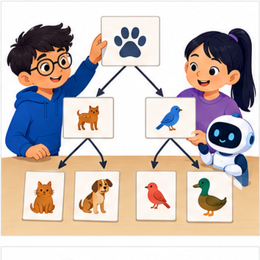
THINKER MISSION
Build a tree that identifies eight mystery animals.
Thinker name and date:

Write or draw your reasoning and evidence.
________________________________________________________________
________________________________________________________________
________________________________________________________________
________________________________________________________________
________________________________________________________________

Readiness for the connected explanation
Why does a cutoff with zero training errors still need validation on separate examples?

This week’s end goal
By the end, I can fit a one-question tree using training labels and an explicit candidate comparison.

02. Notice the evidence
PICTURE STORY
Notice → Predict → Explain
Begin with visible evidence. Do not explain more than the picture and information support.
MYSTERY
The learners must use decision trees to solve a problem. What information do they have? What decision or calculation do they make? What would count as evidence that it worked?
Three observations (what you can point to):

Write or draw your reasoning and evidence.
________________________________________________________________
________________________________________________________________
________________________________________________________________
________________________________________________________________
________________________________________________________________
My prediction and the clue supporting it:

Write or draw your reasoning and evidence.
________________________________________________________________
________________________________________________________________
________________________________________________________________
________________________________________________________________
________________________________________________________________

A closer explanation
A decision tree asks a feature question and follows a branch to a prediction. A tree with one question has depth one and is sometimes called a stump. Unlike Week 8, where the two output labels were fixed in advance, this week we fit both the question and the label stored at each leaf.
Our six fictional training rows have two binary sensor flags available before prediction: near and tall. A value of 1 means that flag is present; 0 means absent. The reviewed scene label is separate. Each row represents a different trip on a familiar route, including rows with identical values. Similar readings can have different scene labels. These are teaching examples, not robot control instructions.
Row | Near | Tall | Label
1 | 1 | 0 | blocked
2 | 1 | 1 | blocked
3 | 1 | 0 | blocked
4 | 0 | 1 | clear
5 | 0 | 0 | clear
6 | 0 | 1 | blocked
Try near first and tall second. For each question, group the training rows by 0 and 1, then predict each group’s majority label; choose clear for tied label counts. Count all training mistakes and keep the first question if scores tie. Stop after one question. This is our stated classroom fitting procedure.

03. See how it works
VISUAL MECHANISM
Input → Process → Output
Trace the information. At each stage, ask what changed and how you could test it.
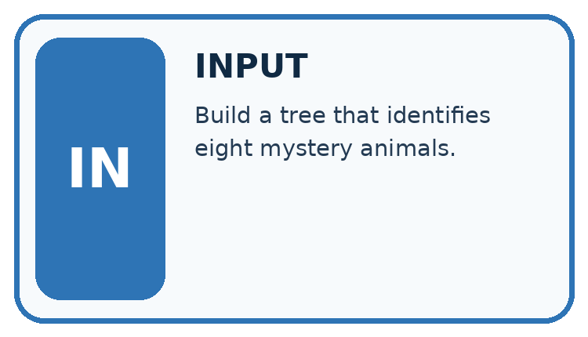
↓
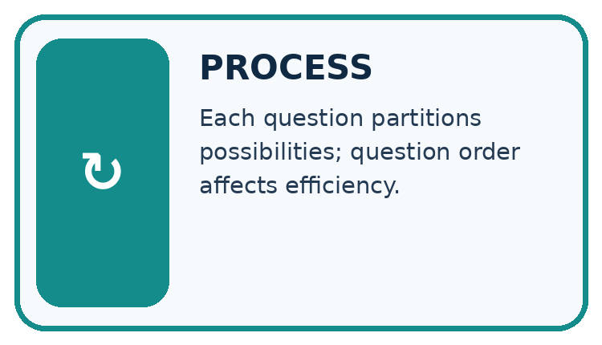
↓
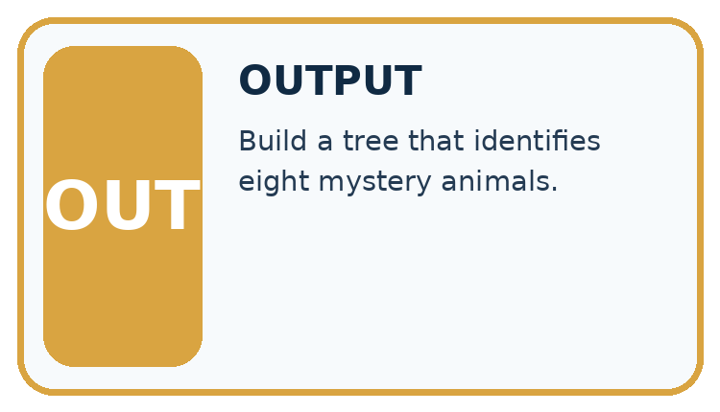
Which stage could fail even when the other two are correct? Explain:

Write or draw your reasoning and evidence.
________________________________________________________________
________________________________________________________________
________________________________________________________________
________________________________________________________________
________________________________________________________________

A closer explanation
rows = [(1, 0, "blocked"), (1, 1, "blocked"),
(1, 0, "blocked"), (0, 1, "clear"),
(0, 0, "clear"), (0, 1, "blocked")]
def majority(labels):
if labels.count("blocked") > labels.count("clear"):
return "blocked"
return "clear"
best_errors = len(rows) + 1
for feature in [0, 1]:
leaves = {}
for value in [0, 1]:
labels = [row[2] for row in rows
if row[feature] == value]
leaves[value] = majority(labels)
errors = 0
for row in rows:
if leaves[row[feature]] != row[2]:
errors = errors + 1
print(feature, errors)
if errors < best_errors:
best_errors = errors
tree = (feature, leaves)
print(tree[0], tree[1][0], tree[1][1])
Feature 0 is near; feature 1 is tall; row[2] is the label. Output is 0 1, then 1 2, then 0 clear blocked. Near makes one training mistake: near=0 contains two clear labels and one blocked, so that leaf predicts clear. Near=1 contains three blocked labels. Tall makes two mistakes because both its groups have a blocked majority.
The stored tree contains the chosen feature and its two learned leaves. The code assumes nonempty data, binary flags, allowed labels and examples on both branches of each candidate. An empty branch would need a declared fallback; this small example does not implement one. The score is total training mistakes, not an average giving small and large branches equal weight.
This is an explicitly limited depth-one learner. General tree algorithms can repeat split selection within branches and often use impurity criteria such as Gini. Our code does not implement that full procedure. Keeping the scope small lets you inspect every decision.

Connect the picture and the explanation
Point to the input, the deciding step and the result in this week’s visual. Explain the same step in ordinary words. A picture helps when you can say what each part represents.

04. Compare the cases
CASE GALLERY
Four Tests, Four Kinds of Evidence
A system is not understood until it survives more than one comfortable example.


NORMAL CASE: predict and name evidence. BOUNDARY CASE: predict and name evidence.


MISSING INFORMATION: predict and name evidence. TRANSFER CASE: predict and name evidence.
Which case is most likely to reveal a hidden assumption? Why?

Write or draw your reasoning and evidence.
________________________________________________________________
________________________________________________________________
________________________________________________________________
________________________________________________________________
________________________________________________________________

Change one thing in the pictured case
Change: New input becomes (0,1).
Prediction: The fitted tree predicts Yes.
Reason: It follows diagram=1; cover colour is not the selected question.

05. Words that unlock the idea
VOCABULARY LAB
Words You Can Use to Reason
A definition matters when you can recognize the idea, use it, and contrast it with a near-miss.
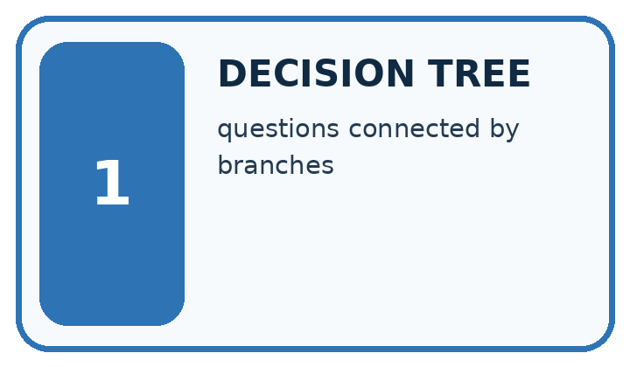
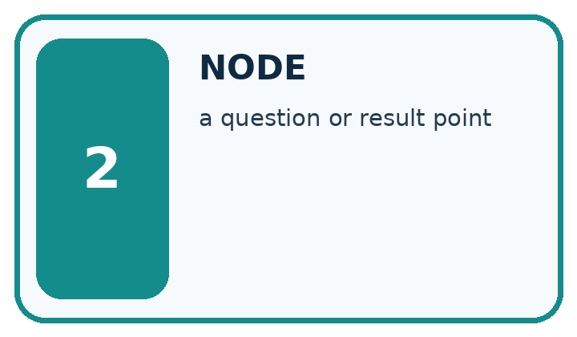
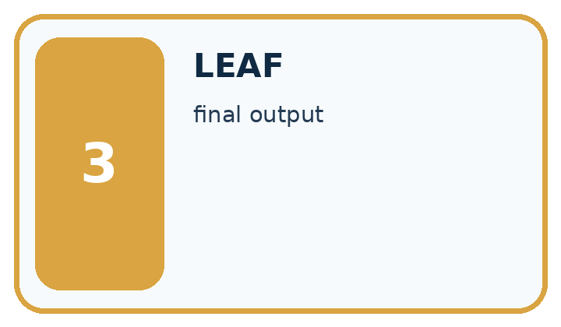
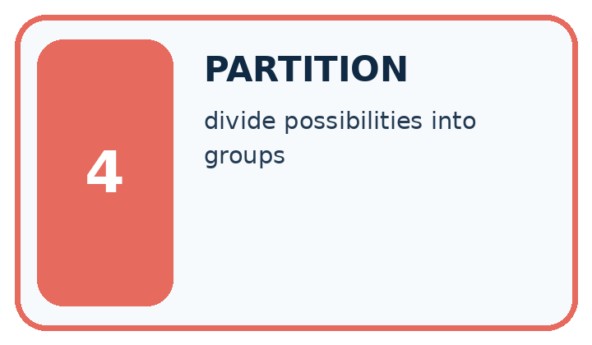
Word | My own example | Not this / boundary
decision tree | A sequence of branching questions that routes an input to an output at a leaf.
node | A point in a graph or tree representing a state, question or result.
leaf | A final node of a decision tree that supplies an output rather than another question.
partition | One separated portion of a dataset, such as training, validation or test data.

Words used in the closer explanation
Word | Meaning
Root | The first question asked by a tree
Branch | A path selected by the answer to a question
Depth | The largest number of question steps from root to leaf

06. Follow a worked example
WORKED EVIDENCE
Reason Step by Step
Predict first. Then check each step. A correct answer without visible reasoning is incomplete evidence.
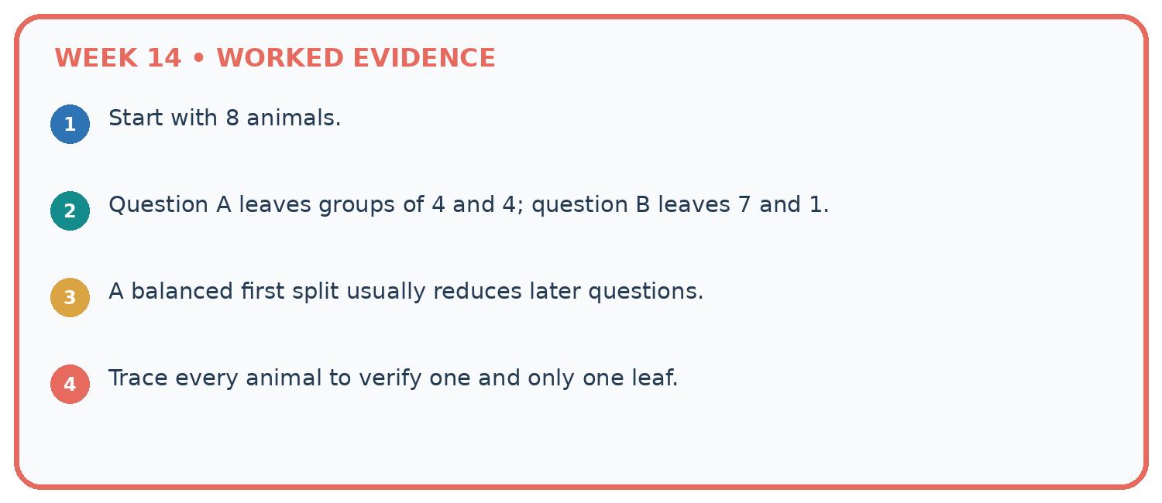
1. Start with 8 animals.
2. Question A leaves groups of 4 and 4; question B leaves 7 and 1.
3. A balanced first split usually reduces later questions.
4. Trace every animal to verify one and only one leaf.
Recalculate, retrace, or restate the reasoning in your own representation:

Write or draw your reasoning and evidence.
________________________________________________________________
________________________________________________________________
________________________________________________________________
________________________________________________________________
________________________________________________________________
CHECK Did the evidence answer the exact question? Did the total, path, or source record stay consistent?

A closer explanation

Two paths through the learned tree
Root question | Branch answer | Learned leaf
Is near equal to 1 | No near is 0 | Predict clear
Is near equal to 1 | Yes near is 1 | Predict blocked
Both paths start at the same root. Tall is not used by this fitted tree; the leaf labels came from training counts.
Validation rows are (near=1,tall=1,blocked), (0,0,clear), (0,1,blocked), (1,0,clear). Follow only near: predictions are blocked, clear, clear, blocked. Two of four match. The training-majority baseline predicts blocked, since training has four blocked and two clear; it also matches two of four validation labels.

Which validation rows does the tree miss, and which does the baseline miss? Explain why the tall value cannot change this tree’s prediction.
________________________________________________________________
________________________________________________________________
________________________________________________________________
________________________________________________________________
Keep the fitted root and leaves unchanged while scoring. Equal accuracy does not mean identical errors, and five correct training predictions out of six is not the validation result.

Learn from the worked case
Cover the result before checking it. Say what is given, choose the procedure, and follow one step at a time. Then uncover the result and explain your first mismatch. Ask why a step is allowed, not only what number it produces.

A pictorial worked case: Decision Trees
A fictional toy classifier predicts whether a book needs an illustration label.

The facts we will use
Training rows (colour_cover,diagram_inside,label): (1,1,Yes),(1,0,No),(0,1,Yes),(0,0,No).
Candidates ask colour_cover or diagram_inside; each leaf uses its training majority. A leaf tie chooses No. Select fewer training errors.
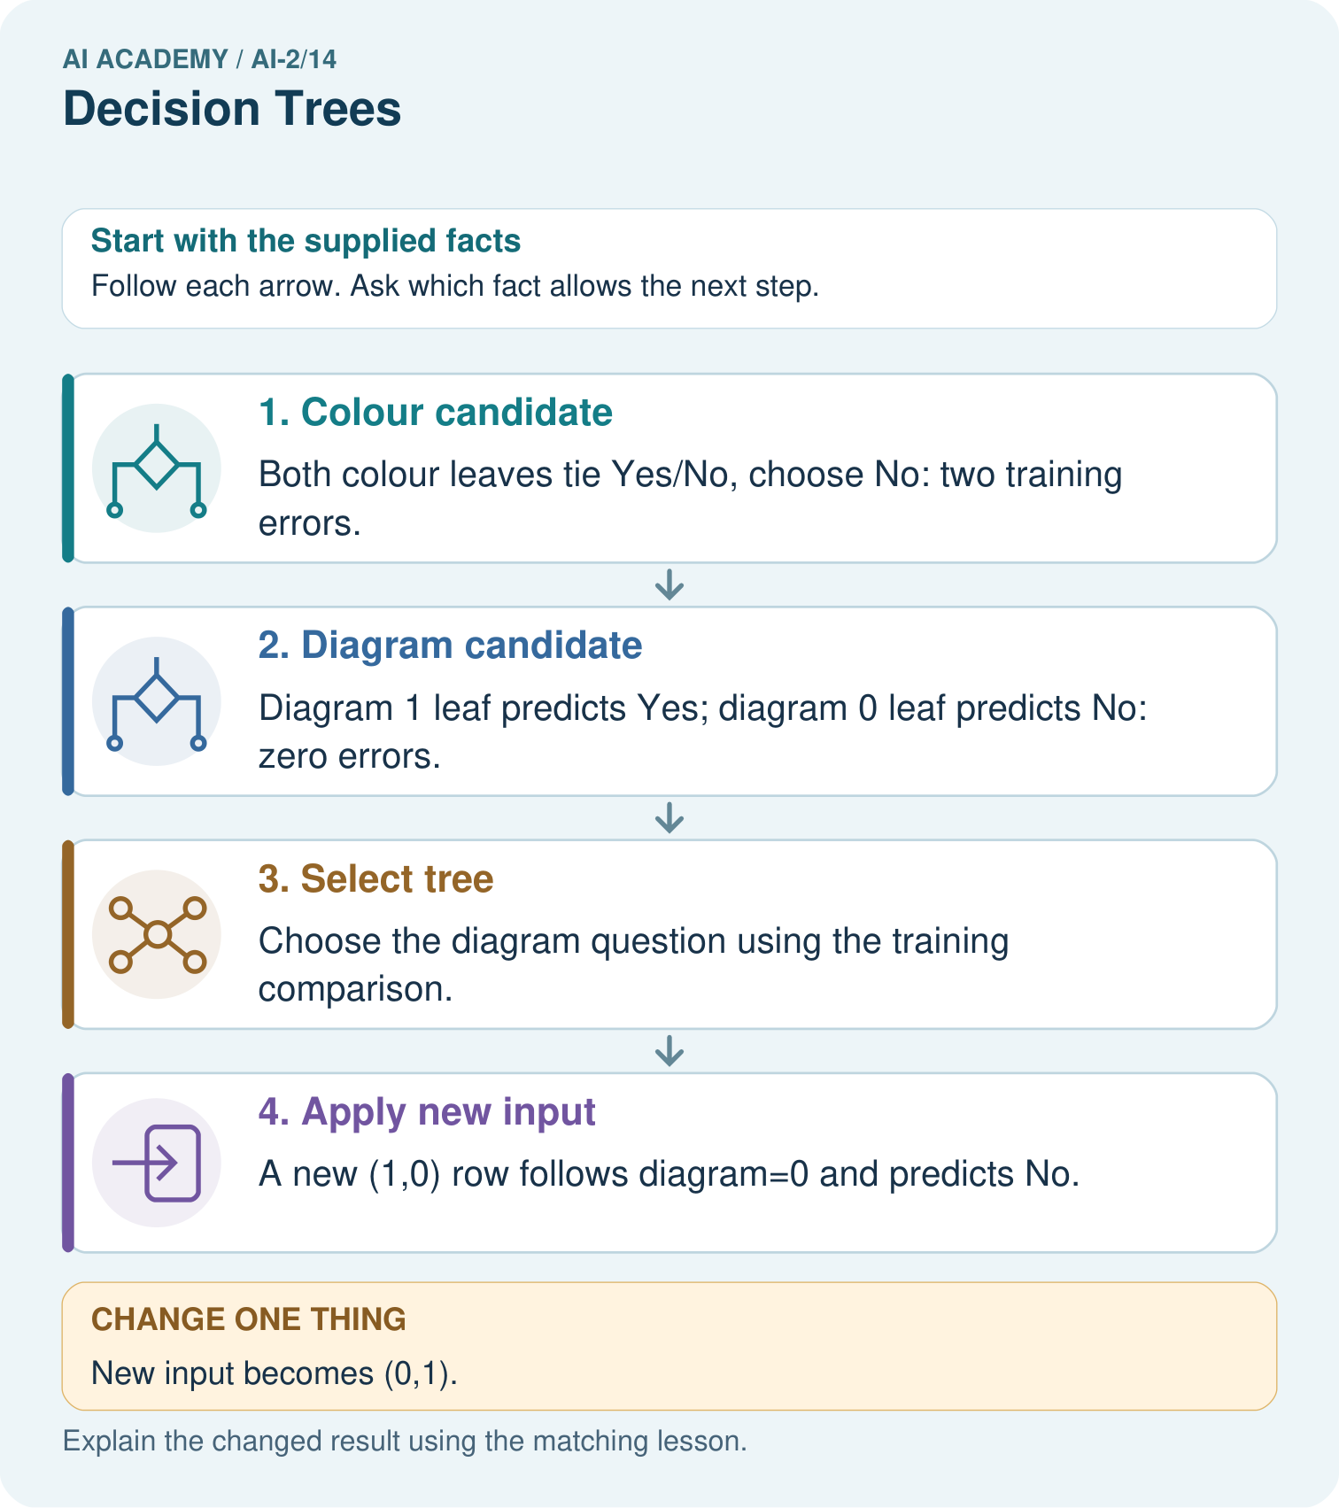

Read the picture one step at a time
Step | What happens and why
1. Colour candidate | Both colour leaves tie Yes/No, choose No: two training errors.
2. Diagram candidate | Diagram 1 leaf predicts Yes; diagram 0 leaf predicts No: zero errors.
3. Select tree | Choose the diagram question using the training comparison.
4. Apply new input | A new (1,0) row follows diagram=0 and predicts No.
Match each pictured step to the supplied facts. This is a worked teaching case, not an independent assessment.

Why this result follows
A question becomes a fitted tree only after its leaves and selection procedure are specified. The training comparison prefers the feature that separates these labels. Prediction follows the selected question; it does not reselect the tree using a new case’s answer. Save candidate leaves and errors so the choice can be repeated.

What this example does not establish
Zero errors on four toy examples do not establish that diagrams always determine a real book’s classification.

07. Find and repair a mistake
ERROR DETECTIVE
Compare → Diagnose → Repair
Do not patch the answer. Find the earliest unsupported assumption, wrong step, or weak evidence.
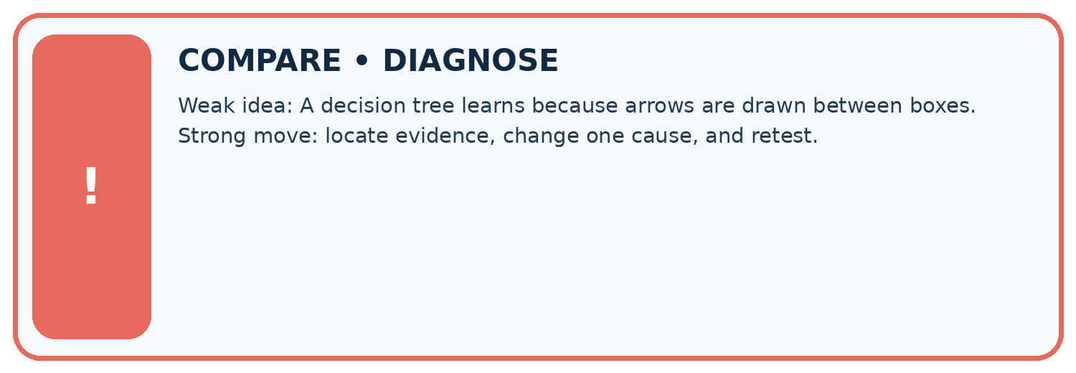
Evidence record | Expected | Actual | Likely cause / next test
normal case | works
boundary case | stated rule
missing input | safe response
fresh transfer | generalizes
Repair one cause. Why is this repair better than changing several things?

Write or draw your reasoning and evidence.
________________________________________________________________
________________________________________________________________
________________________________________________________________
________________________________________________________________
________________________________________________________________

A closer explanation
Record the two candidate questions, branch label counts, total errors, tie rules, depth limit, stored tree and validation predictions. Retain all rows, including the blocked example in the near=0 branch; removing a disagreement would change the evidence.
Our tree uses a single feature because that question scored better under this procedure. This neither establishes that near causes blockage nor that tall is useless in every dataset. Next week a nearest-neighbour method will predict by comparing examples instead of following learned questions.

A learner says the tree is reliable because near=1 has only blocked training labels. Rewrite this claim using the leaf evidence, validation score and one limitation.
________________________________________________________________
________________________________________________________________
________________________________________________________________
________________________________________________________________

08. Practise together
LOGIC STUDIO
Trace Before You Run
Block code, pseudocode, tables, and diagrams are different ways to expose the same reasoning.

SET evidence_record
PREDICT expected_result
RUN one normal case and one boundary case
COMPARE actual_result with expected_result
IF different: locate first cause; change one factor; RETEST
EXPLAIN result, limitation, and next safe step
Trace one input. Which line changes the state or chooses a path?

Write or draw your reasoning and evidence.
________________________________________________________________
________________________________________________________________
________________________________________________________________
________________________________________________________________
________________________________________________________________

A closer explanation
Do not assume near=1 must always predict blocked. If a new training set gives that branch a clear majority, this same learner will store clear there. A feature name is not the answer. Use the training labels belonging to that branch.
Adding more questions can fit finer training details but does not guarantee better new-case performance. Record any depth choice made during development, and keep final test data separate. A leaf majority describes this training group; it is not a promise about every future example.

Practise with less help: Verify the candidate scores
Use workbook W2 for the connected example “Fitting a decision tree”. First fill the input and rule boxes. Try the middle steps before asking for a hint. After a hint, try the next step yourself.
Plan | Do | Check
What is given? Which rule or procedure applies? | Record each intermediate step. | Does the result follow? What remains unknown?
Explain your trace to a partner. Your partner points to one step to check. Swap roles on the next case. Each person writes their own explanation.

Check your reasoning
Use the worked case for Fitting a decision tree. Proposed explanation: “A near branch must predict blocked”. Decide whether this explanation is supported. Point to the step or supplied fact that decides; explain your repair if needed.
Answer on your own before discussion. If you are unsure, say which step you need help with.

Explain the picture
Why does changing colour alone not change this tree’s prediction?

My explanation using a pictured step and the given facts
________________________________________________________________
________________________________________________________________
________________________________________________________________
________________________________________________________________
This is supported practice. Keep the separately named independent case for an attempt before feedback.

09. Run the investigation
EVIDENCE LAB
Predict → Test → Record → Explain
Keep expected and actual results separate. Surprises are useful data when recorded honestly.
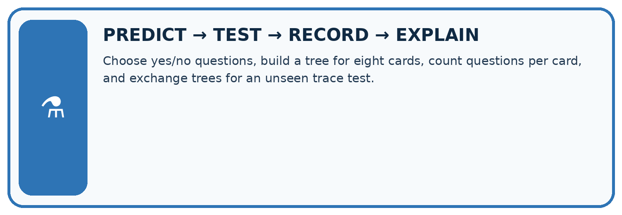
Choose yes/no questions, build a tree for eight cards, count questions per card, and exchange trees for an unseen trace test.
Test / input | Prediction | Actual | Evidence / calculation | Change or keep?
normal
boundary
missing
fresh transfer
What did the hardest test teach you that the normal test did not?

Write or draw your reasoning and evidence.
________________________________________________________________
________________________________________________________________
________________________________________________________________
________________________________________________________________
________________________________________________________________

Plan → try → check
Before trying: what do I expect, and why? While trying: which step could first go wrong? Afterwards: what did I actually observe, and what should change? Keep “not run” if you only traced the procedure.

10. Build your understanding
MASTERY
From Knowing the Word to Owning the Idea
Move upward only when you can produce evidence without copying the worked example.

1 • NAME: Define the concept without repeating the textbook.
2 • TRACE: Show the information, state, branch, calculation, or evidence path.
3 • APPLY: Solve a different example independently.
4 • CHALLENGE: Find a boundary case, counterexample, or unfair outcome.
5 • EXPLAIN LIMITS: Say when the result should not be trusted or used alone.
My strongest evidence of independent understanding:

Write or draw your reasoning and evidence.
________________________________________________________________
________________________________________________________________
________________________________________________________________
________________________________________________________________
________________________________________________________________

11. Connect your project
CUMULATIVE PROJECT
Transparent Book Recommender
Every week adds one inspectable piece. The system must show how it reached a result.
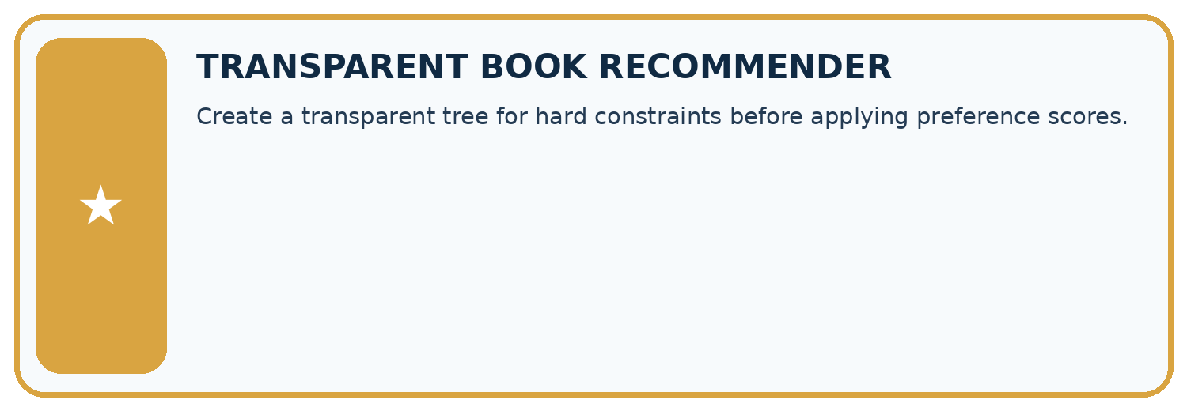
THIS WEEK’S CHECKPOINT Create a transparent tree for hard constraints before applying preference scores.
SYSTEM MAP Reader need → allowed inputs → transparent rule or score → ranked candidates → explanation → test record → human decision
What will you add, change, or verify in the project this week?

Write or draw your reasoning and evidence.
________________________________________________________________
________________________________________________________________
________________________________________________________________
________________________________________________________________
________________________________________________________________
What should remain under human control?

Write or draw your reasoning and evidence.
________________________________________________________________
________________________________________________________________
________________________________________________________________
________________________________________________________________
________________________________________________________________
RESPONSIBLE DESIGN Collect only necessary information. Show uncertainty and limits. Never confuse a ranking with a fact about a person.

Evidence for your project
Fit or hand-specify recommender classification rules transparently, retaining candidate definitions and training-only selection evidence.

12. Show what you know
INDEPENDENT MASTERY PROOF
Explain • Transfer • Test • Defend
Complete this page without copying the worked example. Your reasoning matters more than decoration.
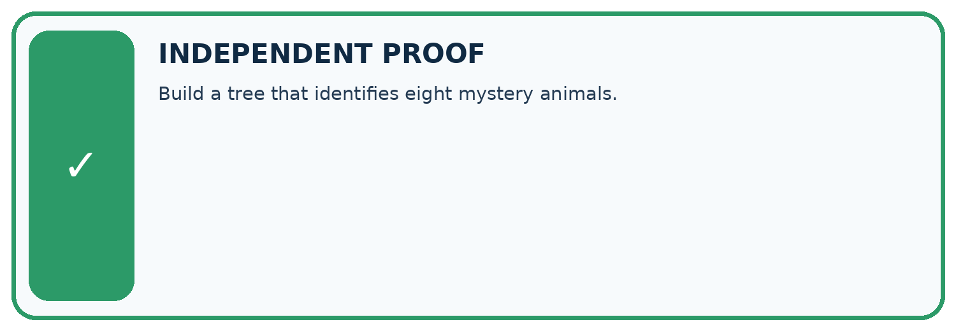
CHALLENGE Build a tree that identifies eight mystery animals.
1. My fresh example, trace, calculation, or design:

Write or draw your reasoning and evidence.
________________________________________________________________
________________________________________________________________
________________________________________________________________
________________________________________________________________
________________________________________________________________
2. My evidence that it works (include a boundary or missing-data case):

Write or draw your reasoning and evidence.
________________________________________________________________
________________________________________________________________
________________________________________________________________
________________________________________________________________
________________________________________________________________
3. One limitation, fairness concern, or situation needing human review:

Write or draw your reasoning and evidence.
________________________________________________________________
________________________________________________________________
________________________________________________________________
________________________________________________________________
________________________________________________________________
SELF-CHECK □ I explained the mechanism □ I used evidence □ I tested a fresh case □ I named a limitation □ I can answer ‘why?’

13. Study a complete case

Week 14 Worked case
Use the supplied details to practise the weekly concept before attempting the independent question. This case extends the illustrated lesson.

The situation
First ask animal book? If no, Other. If yes, ask pages<100; yes gives Short Animal, no gives Longer Animal.

The question
Trace 90-page animal and science books.

Worked explanation
The animal book reaches Short Animal; science reaches Other after the first question.

Explain it in your own words
Which detail supports the answer, and why does it matter?

Write or draw your reasoning and evidence.
________________________________________________________________
________________________________________________________________
________________________________________________________________
________________________________________________________________
________________________________________________________________

Trace the supplied case visually

A decision tree can stop early
Evidence or stage | Value or result
Not an animal book | Other
Animal and fewer than 100 pages | Short Animal
Animal and at least 100 pages | Longer Animal
First ask animal book? If no, Other. If yes, ask pages<100; yes gives Short Animal, no gives Longer Animal.
Trace 90-page animal and science books.
The animal book reaches Short Animal; science reaches Other after the first question.

14. Try a new case independently

Independent case: Fit a new tree independently
New training rows (near,tall,label) are (1,0,clear),(1,1,clear),(1,0,clear),(0,1,blocked),(0,0,blocked),(0,1,clear). Use the same candidate order and tie policies. Give both candidates’ leaves and errors, then select the tree. Validation rows are (1,1,clear),(0,0,blocked),(0,1,clear),(1,0,blocked). List tree predictions and compare accuracy with the training-majority baseline.

My independent explanation, trace and limits
________________________________________________________________
________________________________________________________________
________________________________________________________________
________________________________________________________________
________________________________________________________________
________________________________________________________________
________________________________________________________________
Attempt this case before feedback. Record any help. Earlier examples below are further practice; a case already practised with feedback cannot establish fresh transfer.

Week 14 Independent application
Close the worked explanation. Apply the idea to this different question without copying.
A tree asks topic is space, then pages at most 60. A space book has 70 pages. Trace both answers and explain why you cannot stop at the first question.
My answer, with a trace, calculation or supporting evidence

Write or draw your reasoning and evidence.
________________________________________________________________
________________________________________________________________
________________________________________________________________
________________________________________________________________
________________________________________________________________

Create and test
Change one relevant detail. Predict the result before testing. Include a boundary or missing-information case when it helps reveal a limit.
My changed input and expected result

Write or draw your reasoning and evidence.
________________________________________________________________
________________________________________________________________
________________________________________________________________
________________________________________________________________
________________________________________________________________

Connect to your project
Create a transparent tree for hard constraints before applying preference scores.
The evidence I will keep

Write or draw your reasoning and evidence.
________________________________________________________________
________________________________________________________________
________________________________________________________________
________________________________________________________________
________________________________________________________________
Your teacher has the independent answer and scoring criteria. Complete the matching workbook week to keep your practice evidence together.

Transfer practice from the original programme
Build a tree for science books: first ask science?; then, for yes, pages<=100? Trace science/100 and history/70. What should happen to science with missing pages?

Explain the mechanism, evidence and one limit.
________________________________________________________________
________________________________________________________________
________________________________________________________________
________________________________________________________________
________________________________________________________________
________________________________________________________________
________________________________________________________________

Use feedback to improve
Attempt the independent case before hints. Record whether you worked alone, used a hint or followed a model. After feedback, fix the first unsupported step and explain why it changed. A later check uses a changed case, not a copied answer.

