AI ACADEMY · STUDENT · ai-2/16

Overfitting Intuition
Project: Transparent Book Recommender

Before you start
Week 11: judge transfer on cases not used to choose the rule.

01. Your mission

Your learning target
I can compare training and validation evidence for model capacity.
I can explain overfitting without assuming every gap proves it.
I can use a declared selection rule instead of perfect training fit.

Remember before reading
Close your notes first. A rough first answer helps us choose the right starting point; it is not a score for your ability.
Without opening the old lesson, explain one key idea from Choose Informative Questions. Give an example and a mistake that the idea helps you avoid.
Without opening the old lesson, explain one key idea from Types of Classification Error. Give an example and a mistake that the idea helps you avoid.
Without opening the old lesson, explain one key idea from Human Classifier Simulation. Give an example and a mistake that the idea helps you avoid.
After trying, check the relevant lesson or ask your teacher. Change the part of your explanation that the evidence shows was wrong.
Week 16: Overfitting Intuition
A rule that memorizes examples may fail on new cases.
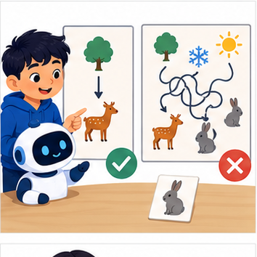
THINKER MISSION
Contrast a simple rule with a seven-exception rule.
Thinker name and date:

Write or draw your reasoning and evidence.
________________________________________________________________
________________________________________________________________
________________________________________________________________
________________________________________________________________
________________________________________________________________

Readiness for the connected explanation
Can a zero training error guarantee good validation performance?

This week’s end goal
By the end, I can use development performance rather than training fit alone to choose model complexity.

02. Notice the evidence
PICTURE STORY
Notice → Predict → Explain
Begin with visible evidence. Do not explain more than the picture and information support.
MYSTERY
The learners must use overfitting intuition to solve a problem. What information do they have? What decision or calculation do they make? What would count as evidence that it worked?
Three observations (what you can point to):

Write or draw your reasoning and evidence.
________________________________________________________________
________________________________________________________________
________________________________________________________________
________________________________________________________________
________________________________________________________________
My prediction and the clue supporting it:

Write or draw your reasoning and evidence.
________________________________________________________________
________________________________________________________________
________________________________________________________________
________________________________________________________________
________________________________________________________________

A closer explanation
A more flexible model can represent complicated relationships and accidental details. Capacity can help when there is enough relevant evidence, but perfect training performance is not the goal. Compare training and validation using the same metric while checking leakage and representativeness.
Use fictional classroom data throughout this investigation. Keep the task, units, reference labels and data split visible as you reason. Earlier weeks supplied the model-building process; this week examines overfitting and model capacity.

03. See how it works
VISUAL MECHANISM
Input → Process → Output
Trace the information. At each stage, ask what changed and how you could test it.
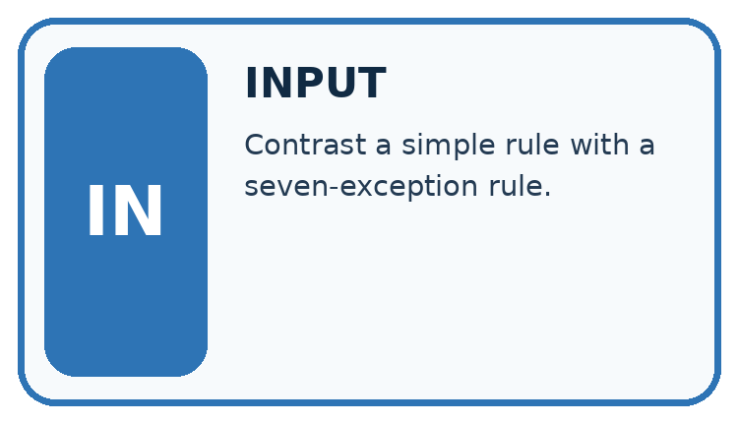
↓
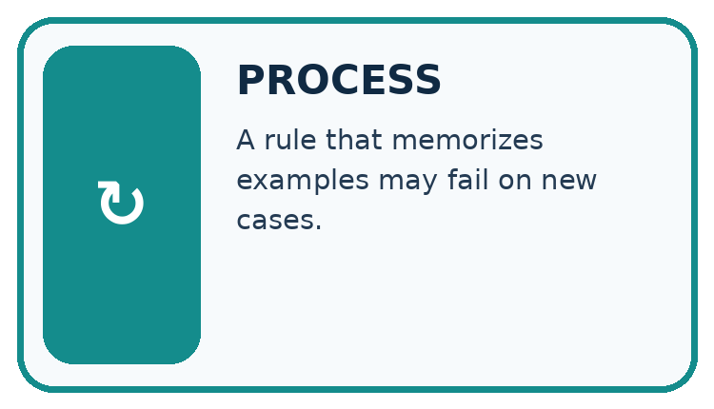
↓
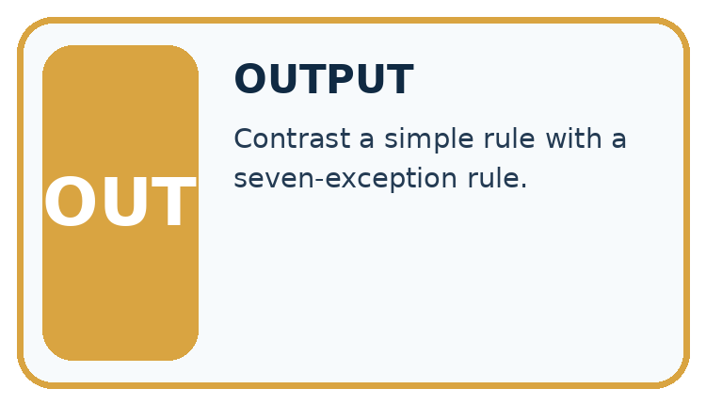
Which stage could fail even when the other two are correct? Explain:

Write or draw your reasoning and evidence.
________________________________________________________________
________________________________________________________________
________________________________________________________________
________________________________________________________________
________________________________________________________________

A closer explanation
On the same regression split, a constant has training MAE 5 and validation 6, a line has training 2 and validation 3, and a highly flexible curve has training 0 and validation 8. Under smallest validation MAE, choose the line. The curve has the lowest training loss but the worst validation result.
Before continuing, underline the decision rule and circle the evidence that supports the conclusion. Explain the example to a partner without replacing the counts or conditions with a stronger claim. Keep the distinction between an observed result and a proposed next step.

Connect the picture and the explanation
Point to the input, the deciding step and the result in this week’s visual. Explain the same step in ordinary words. A picture helps when you can say what each part represents.

04. Compare the cases
CASE GALLERY
Four Tests, Four Kinds of Evidence
A system is not understood until it survives more than one comfortable example.


NORMAL CASE: predict and name evidence. BOUNDARY CASE: predict and name evidence.


MISSING INFORMATION: predict and name evidence. TRANSFER CASE: predict and name evidence.
Which case is most likely to reveal a hidden assumption? Why?

Write or draw your reasoning and evidence.
________________________________________________________________
________________________________________________________________
________________________________________________________________
________________________________________________________________
________________________________________________________________

Change one thing in the pictured case
Change: Complex’s validation error becomes 2 on a newly documented, fair development comparison.
Prediction: The stated rule now selects Complex.
Reason: The rule compares validation errors; it does not ban complex models.

05. Words that unlock the idea
VOCABULARY LAB
Words You Can Use to Reason
A definition matters when you can recognize the idea, use it, and contrast it with a near-miss.
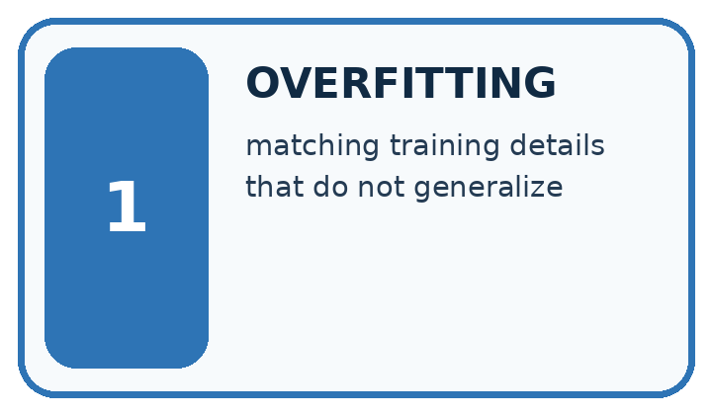
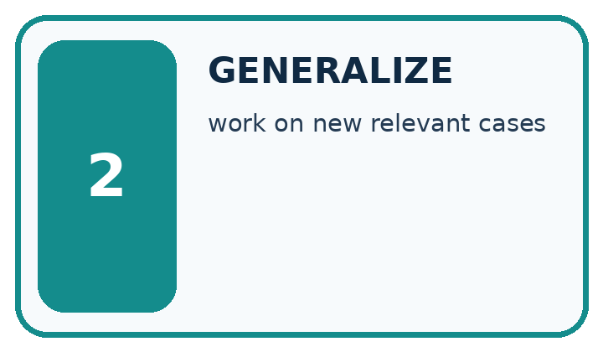
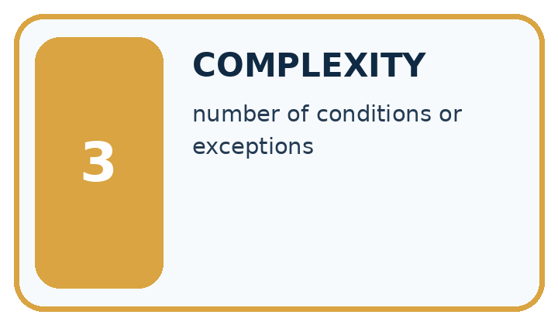
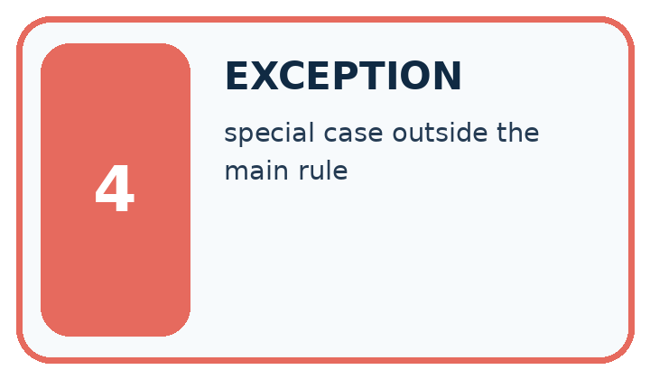
Word | My own example | Not this / boundary
overfitting | Adapting too closely to development examples so performance does not transfer well to new relevant cases.
generalize | Perform usefully on new relevant cases beyond those used to develop a system.
complexity | The amount of structure, work or resources a method requires, measured in a stated way.
exception | A condition that requires handling outside the usual path.

Words used in the closer explanation
Word | Meaning
Capacity | Flexibility of a model to represent patterns
Underfitting | Failing to capture useful structure
Generalization | Performance on relevant unseen examples

06. Follow a worked example
WORKED EVIDENCE
Reason Step by Step
Predict first. Then check each step. A correct answer without visible reasoning is incomplete evidence.
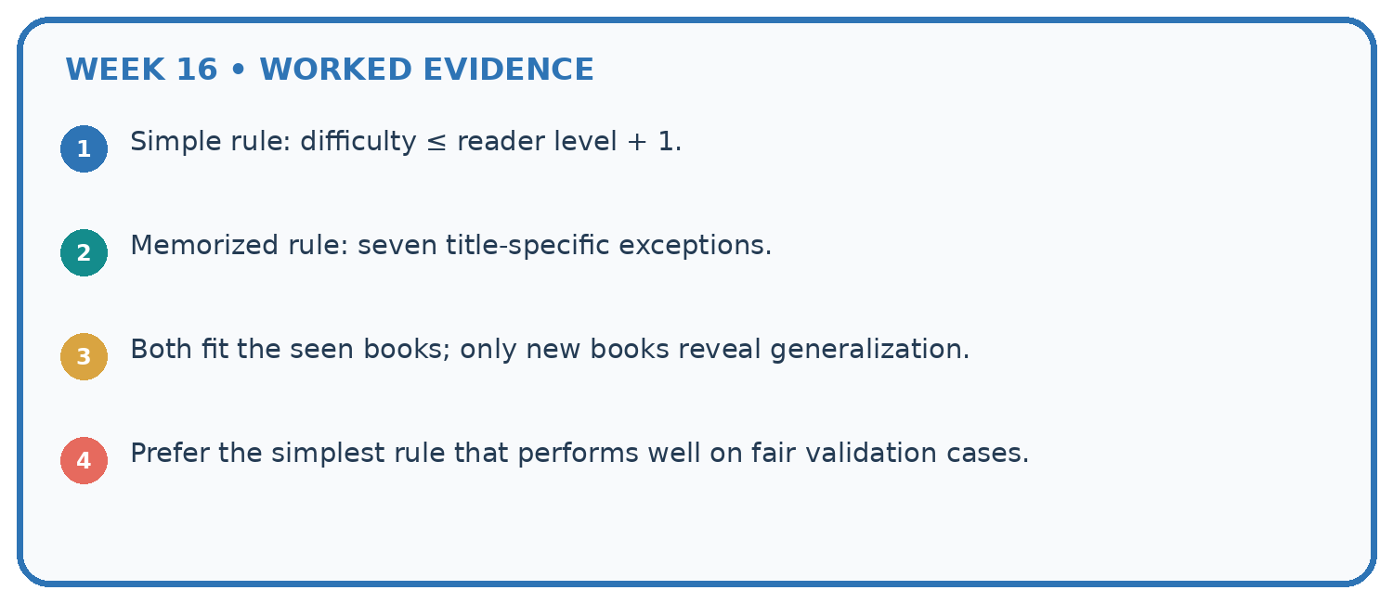
1. Simple rule: difficulty ≤ reader level + 1.
2. Memorized rule: seven title-specific exceptions.
3. Both fit the seen books; only new books reveal generalization.
4. Prefer the simplest rule that performs well on fair validation cases.
Recalculate, retrace, or restate the reasoning in your own representation:

Write or draw your reasoning and evidence.
________________________________________________________________
________________________________________________________________
________________________________________________________________
________________________________________________________________
________________________________________________________________
CHECK Did the evidence answer the exact question? Did the total, path, or source record stay consistent?

A closer explanation

Overfitting and model capacity at a glance
Part | Evidence or action | Interpretation
Constant | Training 5 | Validation 6
Line | Training 2 | Validation 3
Flexible curve | Training 0 | Validation 8
The curve result is consistent with overfitting, but a gap alone does not prove its cause. A changed population, bad labels or a split error could also produce a gap. Inspect the procedure before claiming a diagnosis. The constant may miss useful structure, but these numbers alone do not identify the true relationship.

Does a training-validation gap alone prove overfitting? Explain the steps or evidence behind your response.
________________________________________________________________
________________________________________________________________
________________________________________________________________
________________________________________________________________

Learn from the worked case
Cover the result before checking it. Say what is given, choose the procedure, and follow one step at a time. Then uncover the result and explain your first mismatch. Ask why a step is allowed, not only what number it produces.

A pictorial worked case: Overfitting Intuition
A fictional project compares three book-length prediction models on the same development sets.

The facts we will use
Mean absolute errors in pages: Simple training 5, validation 6; Medium training 2, validation 3; Complex training 0, validation 7.
Select lowest validation error; untouched final tests are not used for selection.
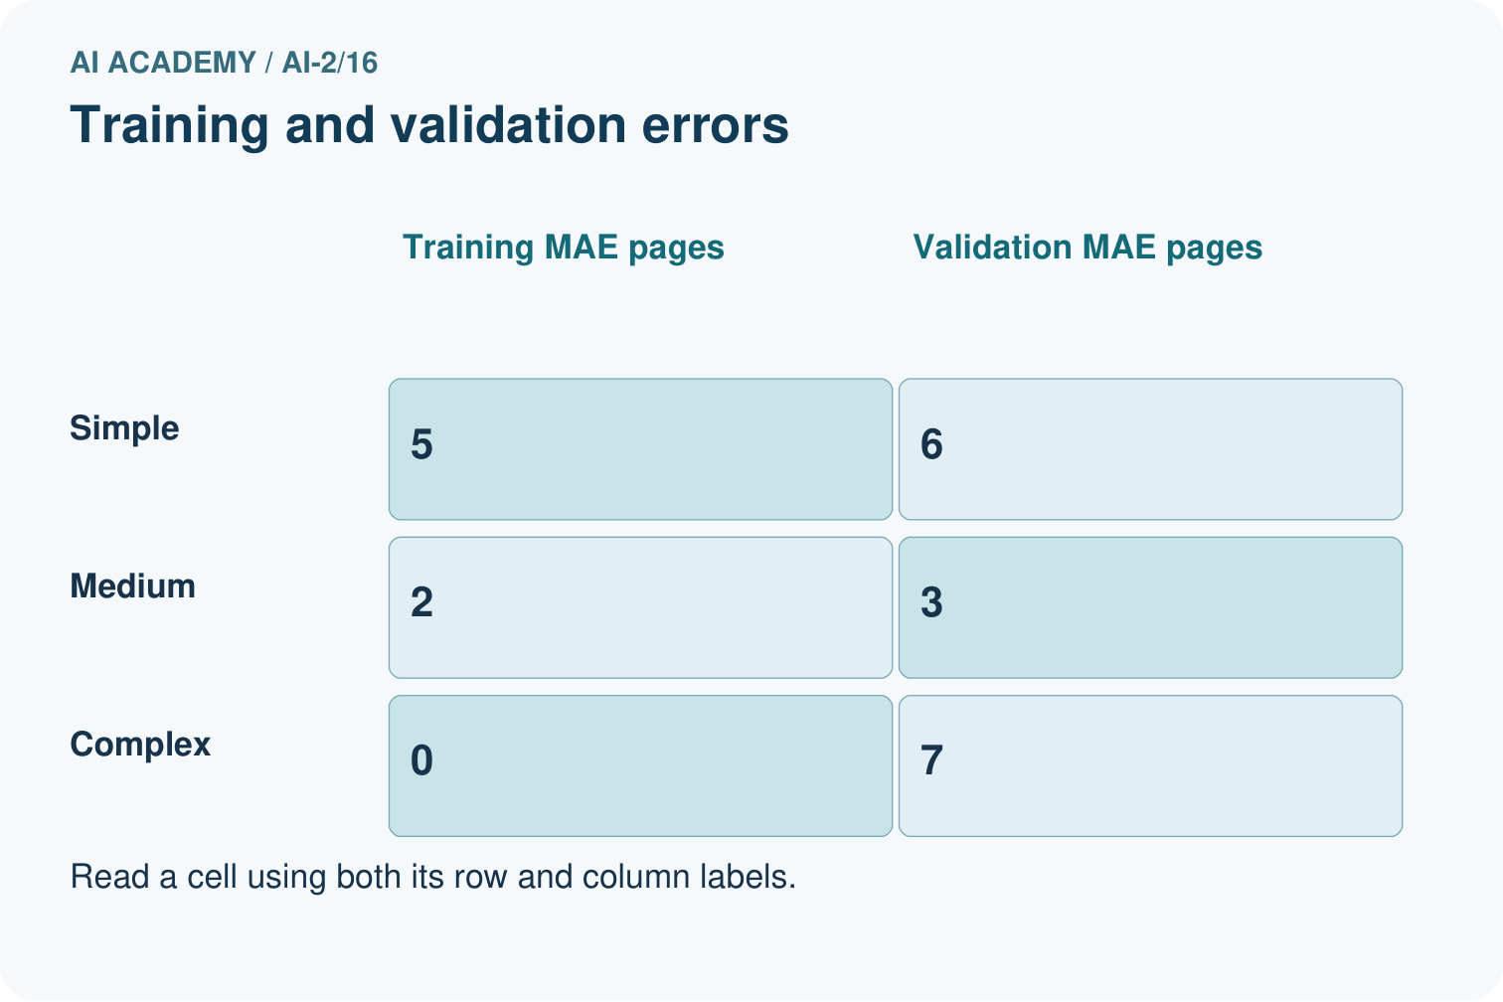
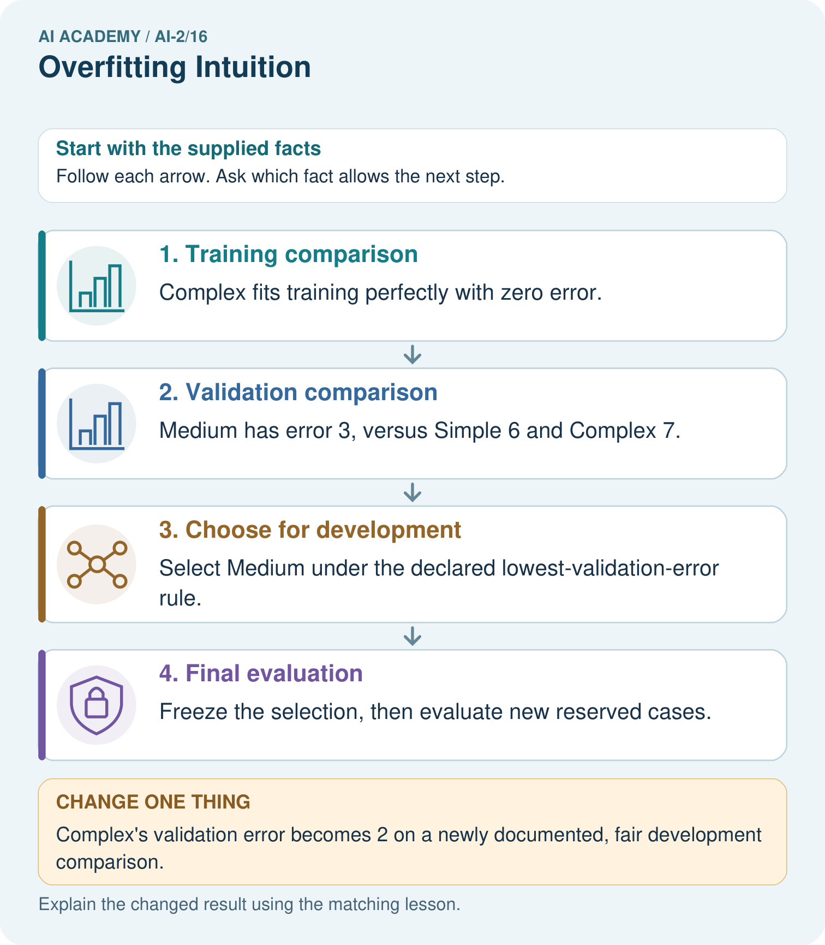

Read the picture one step at a time
Step | What happens and why
1. Training comparison | Complex fits training perfectly with zero error.
2. Validation comparison | Medium has error 3, versus Simple 6 and Complex 7.
3. Choose for development | Select Medium under the declared lowest-validation-error rule.
4. Final evaluation | Freeze the selection, then evaluate new reserved cases.
Match each pictured step to the supplied facts. This is a worked teaching case, not an independent assessment.

Why this result follows
A flexible model can fit quirks of its training set without predicting new examples well. Here Complex’s training success occur togethers with the worst validation error. The numbers are invented comparisons, not a claim that complexity always hurts. Choosing Medium uses development evidence; its validation score must not be advertised as an untouched final-test result.

What this example does not establish
A single small validation set may be noisy; selection evidence does not prove future population performance.

07. Find and repair a mistake
ERROR DETECTIVE
Compare → Diagnose → Repair
Do not patch the answer. Find the earliest unsupported assumption, wrong step, or weak evidence.
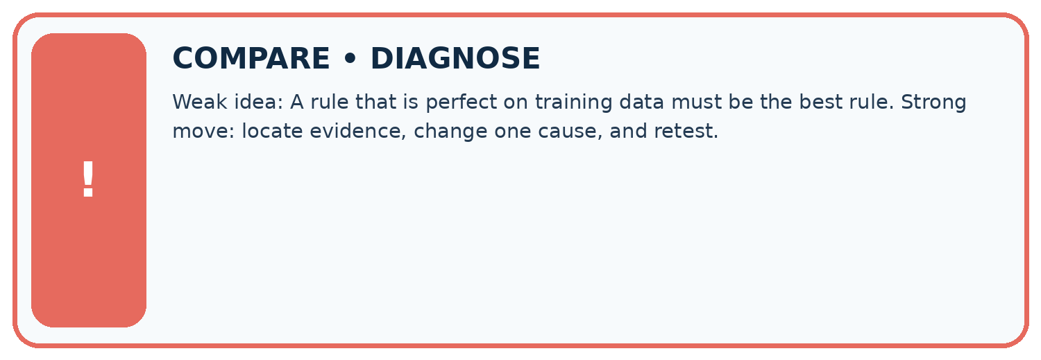
Evidence record | Expected | Actual | Likely cause / next test
normal case | works
boundary case | stated rule
missing input | safe response
fresh transfer | generalizes
Repair one cause. Why is this repair better than changing several things?

Write or draw your reasoning and evidence.
________________________________________________________________
________________________________________________________________
________________________________________________________________
________________________________________________________________
________________________________________________________________

A closer explanation
A simpler model is not always better. If a flexible candidate has better valid evidence under the declared rule, keep that evidence visible. Model capacity is one part of an experiment, alongside features, sample size, label quality and the split.

What extra evidence would you inspect before concluding a model memorized noise?
________________________________________________________________
________________________________________________________________
________________________________________________________________
________________________________________________________________

08. Practise together
LOGIC STUDIO
Trace Before You Run
Block code, pseudocode, tables, and diagrams are different ways to expose the same reasoning.

SET evidence_record
PREDICT expected_result
RUN one normal case and one boundary case
COMPARE actual_result with expected_result
IF different: locate first cause; change one factor; RETEST
EXPLAIN result, limitation, and next safe step
Trace one input. Which line changes the state or chooses a path?

Write or draw your reasoning and evidence.
________________________________________________________________
________________________________________________________________
________________________________________________________________
________________________________________________________________
________________________________________________________________

A closer explanation
Change one development factor at a time: simplify the candidate, improve data coverage or adjust a declared regularization setting. Refit on training and compare on validation. Do not remove difficult valid examples or repeatedly search the test for a favorable result.

Practise with less help: Interpret a gap
Use workbook W2 for the connected example “Overfitting and model capacity”. First fill the input and rule boxes. Try the middle steps before asking for a hint. After a hint, try the next step yourself.
Plan | Do | Check
What is given? Which rule or procedure applies? | Record each intermediate step. | Does the result follow? What remains unknown?
Explain your trace to a partner. Your partner points to one step to check. Swap roles on the next case. Each person writes their own explanation.

Check your reasoning
Use the worked case for Overfitting and model capacity. Proposed explanation: “A final answer is enough”. Decide whether this explanation is supported. Point to the step or supplied fact that decides; explain your repair if needed.
Answer on your own before discussion. If you are unsure, say which step you need help with.

Explain the picture
Does zero training error justify choosing Complex in the original record?

My explanation using a pictured step and the given facts
________________________________________________________________
________________________________________________________________
________________________________________________________________
________________________________________________________________
This is supported practice. Keep the separately named independent case for an attempt before feedback.

09. Run the investigation
EVIDENCE LAB
Predict → Test → Record → Explain
Keep expected and actual results separate. Surprises are useful data when recorded honestly.
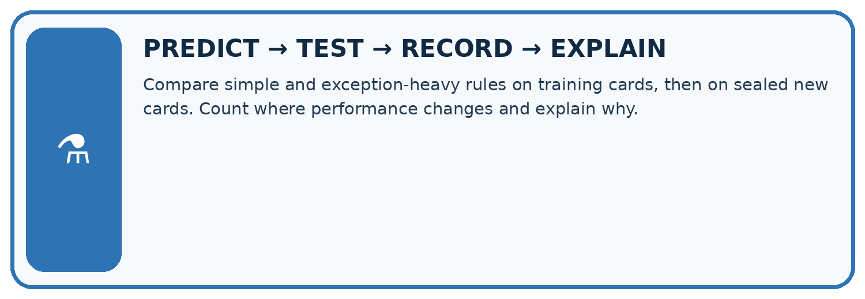
Compare simple and exception-heavy rules on training cards, then on sealed new cards. Count where performance changes and explain why.
Test / input | Prediction | Actual | Evidence / calculation | Change or keep?
normal
boundary
missing
fresh transfer
What did the hardest test teach you that the normal test did not?

Write or draw your reasoning and evidence.
________________________________________________________________
________________________________________________________________
________________________________________________________________
________________________________________________________________
________________________________________________________________

Plan → try → check
Before trying: what do I expect, and why? While trying: which step could first go wrong? Afterwards: what did I actually observe, and what should change? Keep “not run” if you only traced the procedure.

10. Build your understanding
MASTERY
From Knowing the Word to Owning the Idea
Move upward only when you can produce evidence without copying the worked example.

1 • NAME: Define the concept without repeating the textbook.
2 • TRACE: Show the information, state, branch, calculation, or evidence path.
3 • APPLY: Solve a different example independently.
4 • CHALLENGE: Find a boundary case, counterexample, or unfair outcome.
5 • EXPLAIN LIMITS: Say when the result should not be trusted or used alone.
My strongest evidence of independent understanding:

Write or draw your reasoning and evidence.
________________________________________________________________
________________________________________________________________
________________________________________________________________
________________________________________________________________
________________________________________________________________

11. Connect your project
CUMULATIVE PROJECT
Transparent Book Recommender
Every week adds one inspectable piece. The system must show how it reached a result.
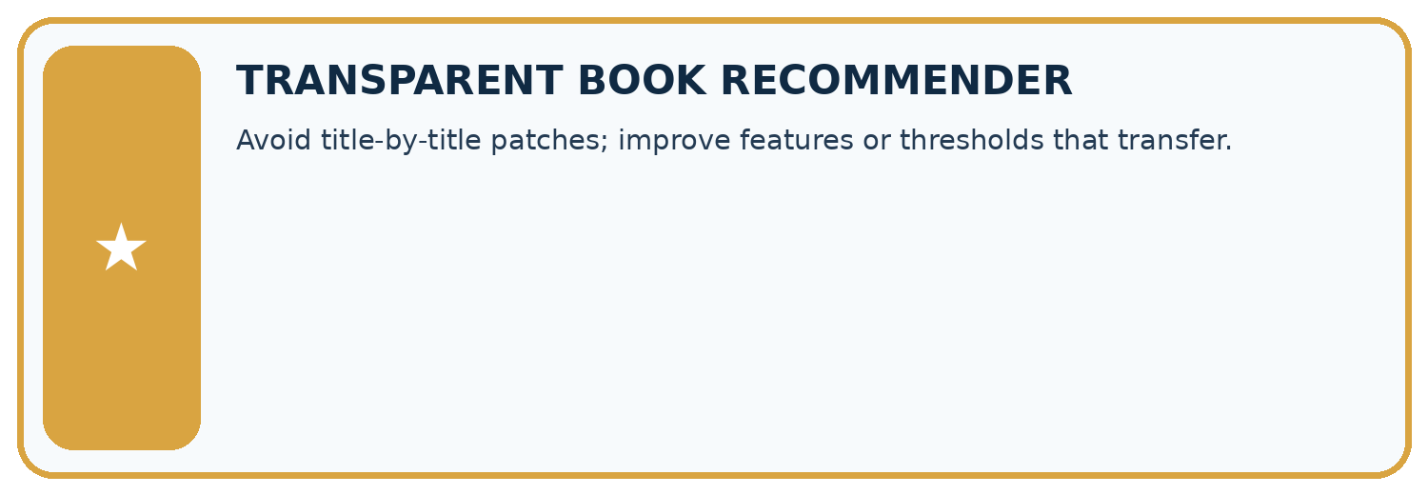
THIS WEEK’S CHECKPOINT Avoid title-by-title patches; improve features or thresholds that transfer.
SYSTEM MAP Reader need → allowed inputs → transparent rule or score → ranked candidates → explanation → test record → human decision
What will you add, change, or verify in the project this week?

Write or draw your reasoning and evidence.
________________________________________________________________
________________________________________________________________
________________________________________________________________
________________________________________________________________
________________________________________________________________
What should remain under human control?

Write or draw your reasoning and evidence.
________________________________________________________________
________________________________________________________________
________________________________________________________________
________________________________________________________________
________________________________________________________________
RESPONSIBLE DESIGN Collect only necessary information. Show uncertainty and limits. Never confuse a ranking with a fact about a person.

Evidence for your project
Compare recommender revisions on fixed development cases, reserving new cases for the final presentation.

12. Show what you know
INDEPENDENT MASTERY PROOF
Explain • Transfer • Test • Defend
Complete this page without copying the worked example. Your reasoning matters more than decoration.
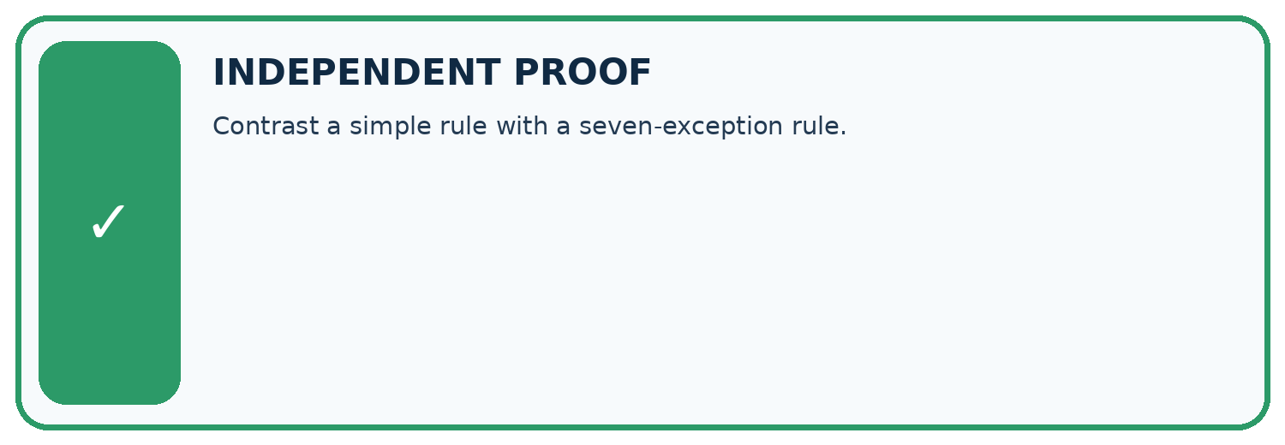
CHALLENGE Contrast a simple rule with a seven-exception rule.
1. My fresh example, trace, calculation, or design:

Write or draw your reasoning and evidence.
________________________________________________________________
________________________________________________________________
________________________________________________________________
________________________________________________________________
________________________________________________________________
2. My evidence that it works (include a boundary or missing-data case):

Write or draw your reasoning and evidence.
________________________________________________________________
________________________________________________________________
________________________________________________________________
________________________________________________________________
________________________________________________________________
3. One limitation, fairness concern, or situation needing human review:

Write or draw your reasoning and evidence.
________________________________________________________________
________________________________________________________________
________________________________________________________________
________________________________________________________________
________________________________________________________________
SELF-CHECK □ I explained the mechanism □ I used evidence □ I tested a fresh case □ I named a limitation □ I can answer ‘why?’

13. Study a complete case

Week 16 Worked case
Use the supplied details to practise the weekly concept before attempting the independent question. This case extends the illustrated lesson.

The situation
Rule A memorises six training book names. It scores 6/6 familiar and 2/6 new. Rule B uses relevant traits but is untested.

The question
What does the evidence support?

Worked explanation
A shows weak transfer. B might generalise better but requires testing; simplicity is not proof.

Explain it in your own words
Which detail supports the answer, and why does it matter?

Write or draw your reasoning and evidence.
________________________________________________________________
________________________________________________________________
________________________________________________________________
________________________________________________________________
________________________________________________________________

Trace the supplied case visually

Perfect recall can hide weak transfer
Evidence or stage | Value or result
Familiar books | 6/6
New books | 2/6
Rule A memorises six training book names. It scores 6/6 familiar and 2/6 new. Rule B uses relevant traits but is untested.
What does the evidence support?
A shows weak transfer. B might generalise better but requires testing; simplicity is not proof.

14. Try a new case independently

Independent case: Apply independently
Models A training 4 validation 5, B training 1 validation 2, C training 0 validation 2. Lowest validation MAE then simpler; B is simpler than C. Choose and justify.

My independent explanation, trace and limits
________________________________________________________________
________________________________________________________________
________________________________________________________________
________________________________________________________________
________________________________________________________________
________________________________________________________________
________________________________________________________________
Attempt this case before feedback. Record any help. Earlier examples below are further practice; a case already practised with feedback cannot establish fresh transfer.

Week 16 Independent application
Close the worked explanation. Apply the idea to this different question without copying.
Rule A memorises six training book IDs. Rule B uses a relevant topic feature. Why might A fail on a new ID? What test is needed?
My answer, with a trace, calculation or supporting evidence

Write or draw your reasoning and evidence.
________________________________________________________________
________________________________________________________________
________________________________________________________________
________________________________________________________________
________________________________________________________________

Create and test
Change one relevant detail. Predict the result before testing. Include a boundary or missing-information case when it helps reveal a limit.
My changed input and expected result

Write or draw your reasoning and evidence.
________________________________________________________________
________________________________________________________________
________________________________________________________________
________________________________________________________________
________________________________________________________________

Connect to your project
Avoid title-by-title patches; improve features or thresholds that transfer.
The evidence I will keep

Write or draw your reasoning and evidence.
________________________________________________________________
________________________________________________________________
________________________________________________________________
________________________________________________________________
________________________________________________________________
Your teacher has the independent answer and scoring criteria. Complete the matching workbook week to keep your practice evidence together.

Transfer practice from the original programme
Rule A memorises eight training IDs and gets 8/8 training, 2/8 validation. Rule B uses genre and gets 6/8 training, 6/8 validation. Which is preferable on this evidence, and what test remains?

Explain the mechanism, evidence and one limit.
________________________________________________________________
________________________________________________________________
________________________________________________________________
________________________________________________________________
________________________________________________________________
________________________________________________________________
________________________________________________________________

Use feedback to improve
Attempt the independent case before hints. Record whether you worked alone, used a hint or followed a model. After feedback, fix the first unsupported step and explain why it changed. A later check uses a changed case, not a copied answer.

