AI ACADEMY · STUDENT · ai-2/20

Repair Bias in Data
Project: Transparent Book Recommender

Before you start
Week 19: compare collected examples with intended users.

01. Your mission

Your learning target
I can identify selection and coverage bias.
I can compare groups before combining results.
I can explain why more biased data may not help.

Remember before reading
Close your notes first. A rough first answer helps us choose the right starting point; it is not a score for your ability.
Without opening the old lesson, explain one key idea from Sampling and Representation. Give an example and a mistake that the idea helps you avoid.
Without opening the old lesson, explain one key idea from Noise and Outliers. Give an example and a mistake that the idea helps you avoid.
Without opening the old lesson, explain one key idea from Decision Trees. Give an example and a mistake that the idea helps you avoid.
After trying, check the relevant lesson or ask your teacher. Change the part of your explanation that the evidence shows was wrong.
Week 20: Repair Bias in Data
Fairness work changes data, features, tests, or use conditions, then rechecks outcomes.
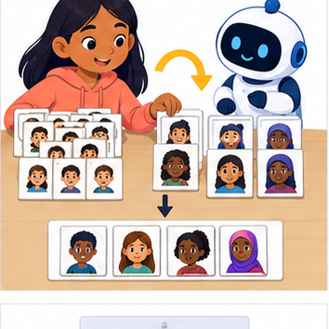
THINKER MISSION
Redesign an imbalanced speech dataset and specify retests.
Thinker name and date:

Write or draw your reasoning and evidence.
________________________________________________________________
________________________________________________________________
________________________________________________________________
________________________________________________________________
________________________________________________________________

Readiness for the connected explanation
What is the difference between a population and a sample?

This week’s end goal
By the end, I can distinguish a biased collection process from a mere small dataset.

02. Notice the evidence
PICTURE STORY
Notice → Predict → Explain
Begin with visible evidence. Do not explain more than the picture and information support.
MYSTERY
The learners must use repair bias in data to solve a problem. What information do they have? What decision or calculation do they make? What would count as evidence that it worked?
Three observations (what you can point to):

Write or draw your reasoning and evidence.
________________________________________________________________
________________________________________________________________
________________________________________________________________
________________________________________________________________
________________________________________________________________
My prediction and the clue supporting it:

Write or draw your reasoning and evidence.
________________________________________________________________
________________________________________________________________
________________________________________________________________
________________________________________________________________
________________________________________________________________

A closer explanation
A fictional poll has 8 Yes among 10 club respondents and 2 Yes among 10 other respondents. If only club members are surveyed, an 80 percent result misses a group with a different pattern. Examine who is included before treating a larger sample as better.

03. See how it works
VISUAL MECHANISM
Input → Process → Output
Trace the information. At each stage, ask what changed and how you could test it.
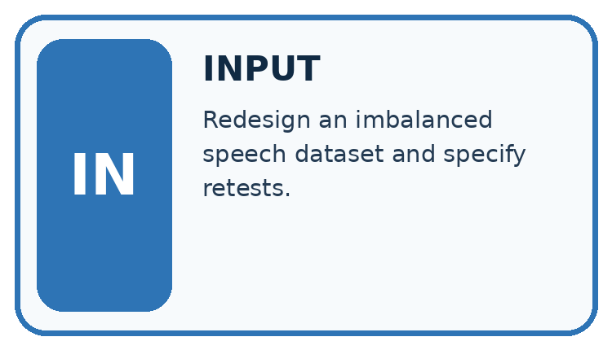
↓
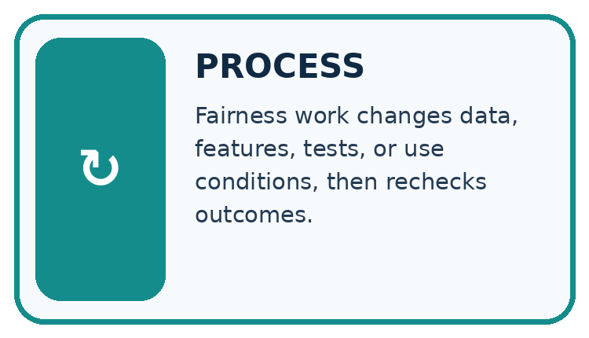
↓
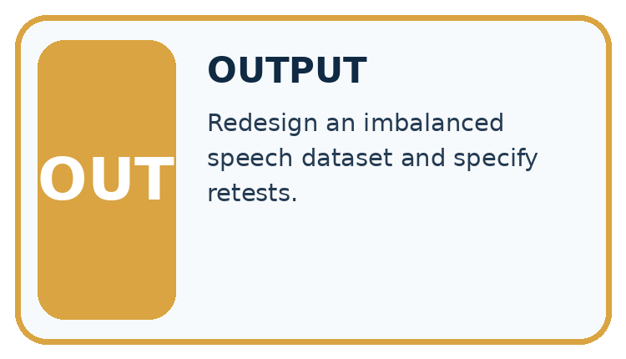
Which stage could fail even when the other two are correct? Explain:

Write or draw your reasoning and evidence.
________________________________________________________________
________________________________________________________________
________________________________________________________________
________________________________________________________________
________________________________________________________________

A closer explanation
club_yes, club_n = 8, 10
other_yes, other_n = 2, 10
print(club_yes / club_n)
print(other_yes / other_n)
print((club_yes + other_yes) / (club_n + other_n))

Follow the evidence
Step or case | Evidence | Meaning
Club sample | 8 of 10 | 80 percent
Other sample | 2 of 10 | 20 percent
Combined sample | 10 of 20 | 50 percent
Read each row from left to right and connect the evidence to the stated rule.
The combined observed sample has 50 percent Yes. This is not automatically a population estimate: we also need to know how the groups were selected and how many people each represents. Do not average percentages without considering their denominators.

Combine counts, not just percentages
The club has 8 Yes out of 10, and the other group has 2 Yes out of 10. Combine the Yes counts to get 10 and combine the response counts to get 20; the combined observed rate is 10 divided by 20, or 50 percent. When group sizes differ, simply averaging their percentages can give the wrong combined rate. A correct combined calculation still describes the collected sample, not automatically the whole school.

Connect the picture and the explanation
Point to the input, the deciding step and the result in this week’s visual. Explain the same step in ordinary words. A picture helps when you can say what each part represents.

04. Compare the cases
CASE GALLERY
Four Tests, Four Kinds of Evidence
A system is not understood until it survives more than one comfortable example.


NORMAL CASE: predict and name evidence. BOUNDARY CASE: predict and name evidence.


MISSING INFORMATION: predict and name evidence. TRANSFER CASE: predict and name evidence.
Which case is most likely to reveal a hidden assumption? Why?

Write or draw your reasoning and evidence.
________________________________________________________________
________________________________________________________________
________________________________________________________________
________________________________________________________________
________________________________________________________________

Change one thing in the pictured case
Change: Recruit more club volunteers only.
Prediction: Sample size increases without fixing missing representation of other learners.
Reason: The added respondents come from the already overrepresented group.

05. Words that unlock the idea
VOCABULARY LAB
Words You Can Use to Reason
A definition matters when you can recognize the idea, use it, and contrast it with a near-miss.
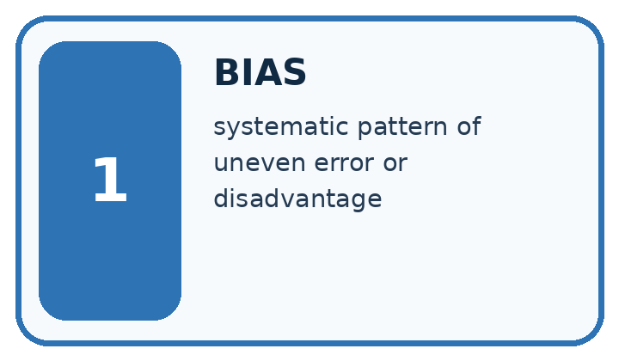
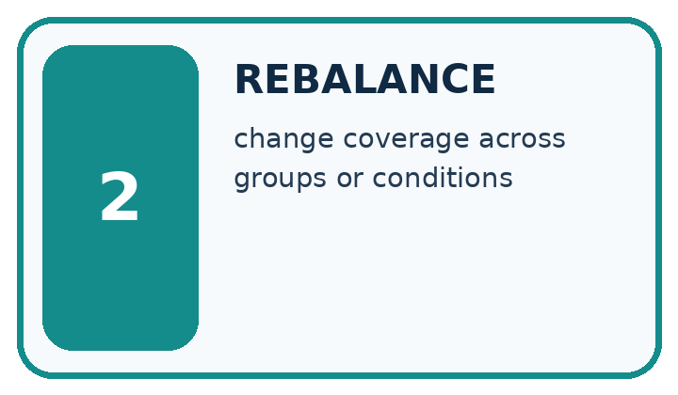
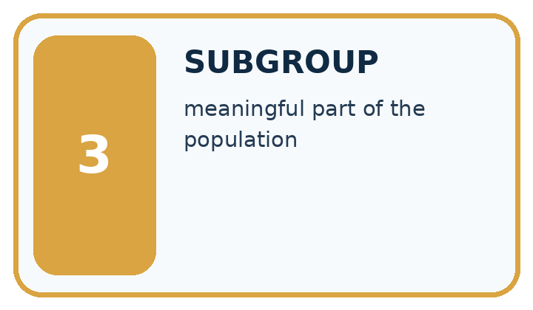
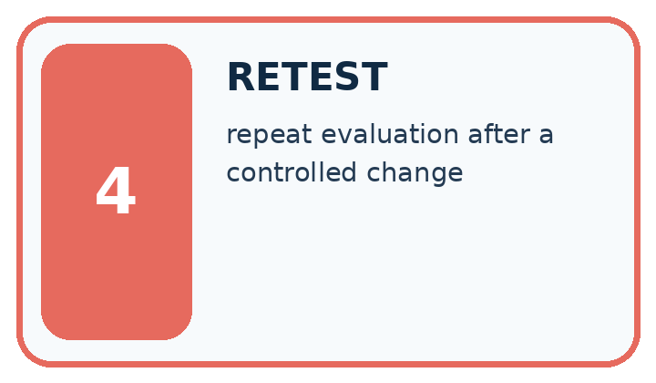
Word | My own example | Not this / boundary
bias | A systematic tendency in data, decisions or outcomes that can distort a result or disadvantage people.
rebalance | Change the relative representation of groups or classes in data using a stated method.
subgroup | A defined subset of cases considered separately in analysis.
retest | Run a test again after a change or under specified new conditions.

Words used in the closer explanation
Word | Meaning
Selection bias | Systematic distortion caused by who enters the data
Undercoverage | Leaving part of the target group out of selection
Nonresponse | A selected participant does not respond

06. Follow a worked example
WORKED EVIDENCE
Reason Step by Step
Predict first. Then check each step. A correct answer without visible reasoning is incomplete evidence.
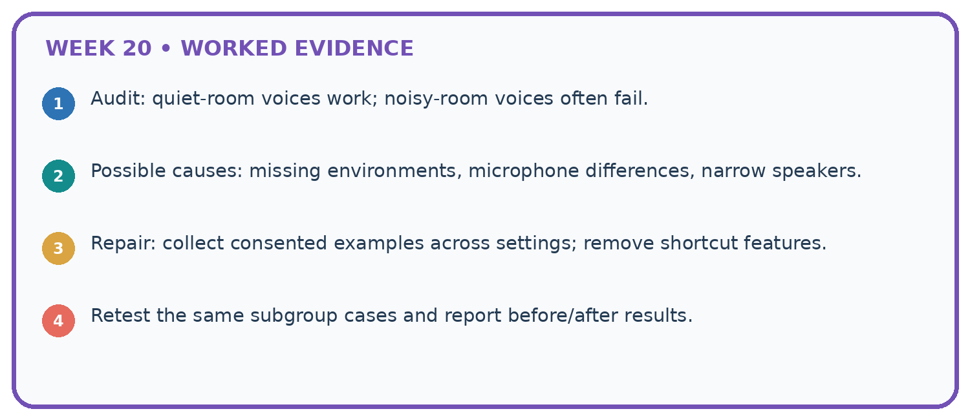
1. Audit: quiet-room voices work; noisy-room voices often fail.
2. Possible causes: missing environments, microphone differences, narrow speakers.
3. Repair: collect consented examples across settings; remove shortcut features.
4. Retest the same subgroup cases and report before/after results.
Recalculate, retrace, or restate the reasoning in your own representation:

Write or draw your reasoning and evidence.
________________________________________________________________
________________________________________________________________
________________________________________________________________
________________________________________________________________
________________________________________________________________
CHECK Did the evidence answer the exact question? Did the total, path, or source record stay consistent?

A closer explanation

Suppose 90 club respondents give 72 Yes and 10 others give 2 Yes. What is the combined observed proportion?
________________________________________________________________
________________________________________________________________
________________________________________________________________
________________________________________________________________
________________________________________________________________
________________________________________________________________

Learn from the worked case
Cover the result before checking it. Say what is given, choose the procedure, and follow one step at a time. Then uncover the result and explain your first mismatch. Ask why a step is allowed, not only what number it produces.

A pictorial worked case: Repair Bias in Data
A fictional school polls learners about adding comic recommendations.

The facts we will use
Library-club respondents: 12 Yes out of 15. Other respondents: 3 Yes out of 15.
The full grade has 30 club members and 90 others. These respondents were volunteers, not random selections.
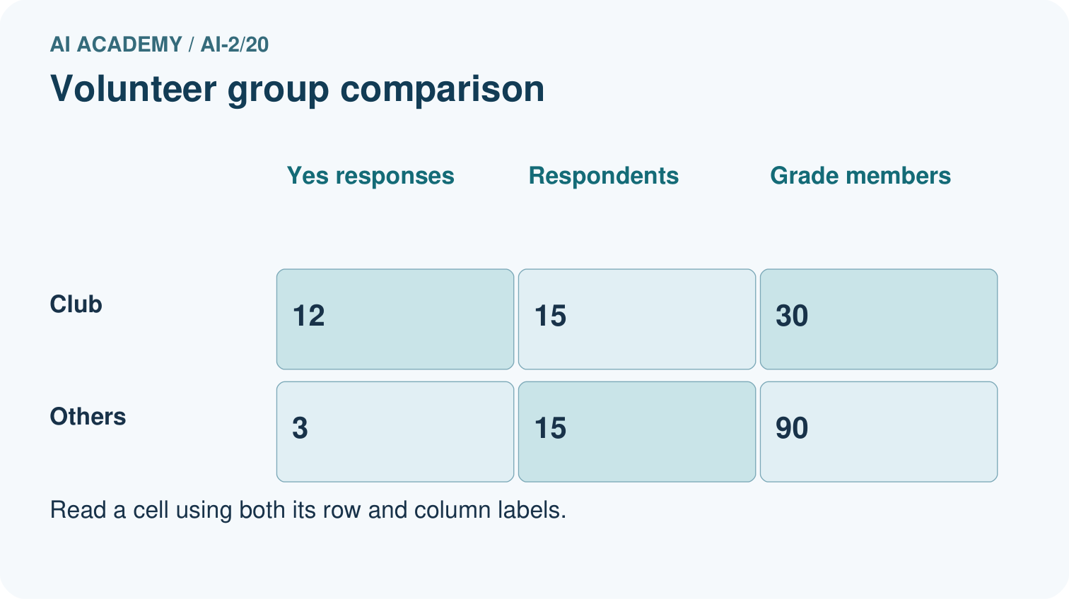
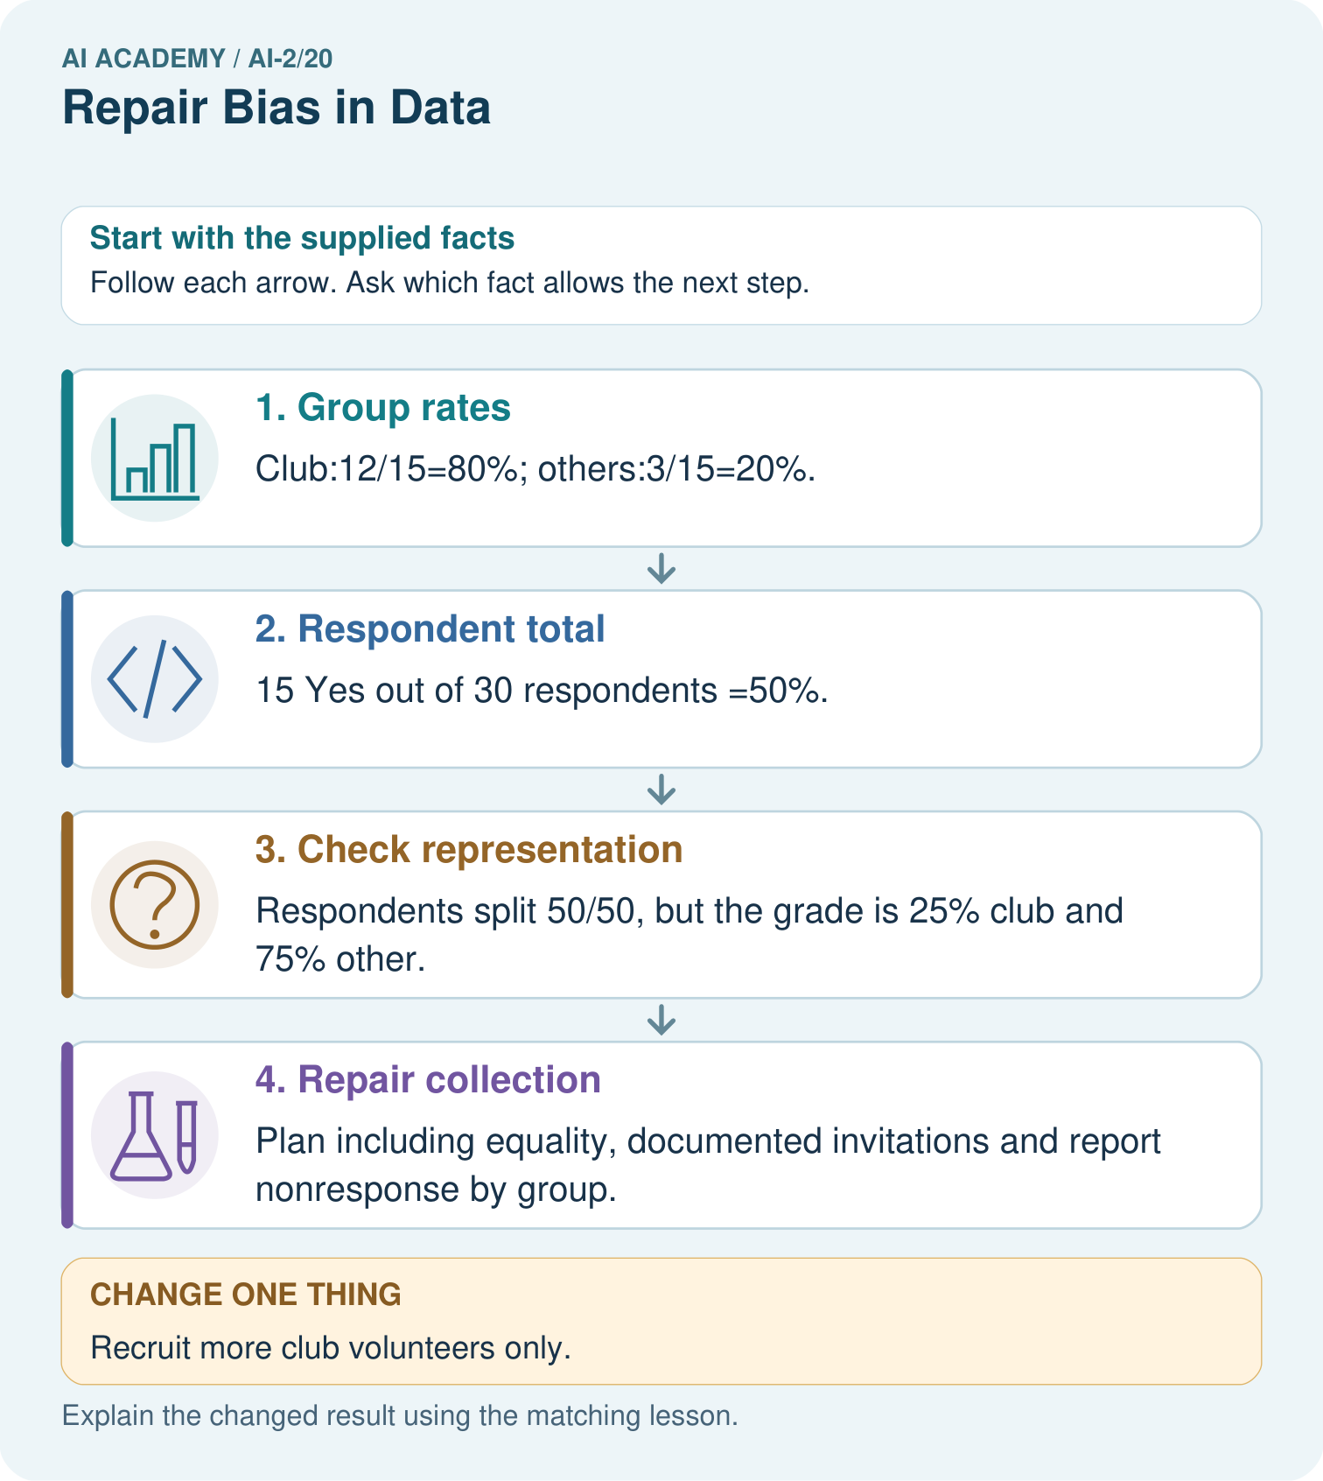

Read the picture one step at a time
Step | What happens and why
1. Group rates | Club:12/15=80%; others:3/15=20%.
2. Respondent total | 15 Yes out of 30 respondents =50%.
3. Check representation | Respondents split 50/50, but the grade is 25% club and 75% other.
4. Repair collection | Plan including equality, documented invitations and report nonresponse by group.
Match each pictured step to the supplied facts. This is a worked teaching case, not an independent assessment.

Why this result follows
The combined respondent result gives club members more influence than their share of the grade. A weighted illustration using 25% and 75% gives 0.25×80%+0.75×20%=35%, but volunteers may differ within each group, so weighting alone does not establish the true grade preference. Improve the collection process rather than announcing the weighted number as fact.

What this example does not establish
Neither raw nor weighted volunteer rates prove the whole grade’s opinion; privacy and consent rules still apply.

07. Find and repair a mistake
ERROR DETECTIVE
Compare → Diagnose → Repair
Do not patch the answer. Find the earliest unsupported assumption, wrong step, or weak evidence.
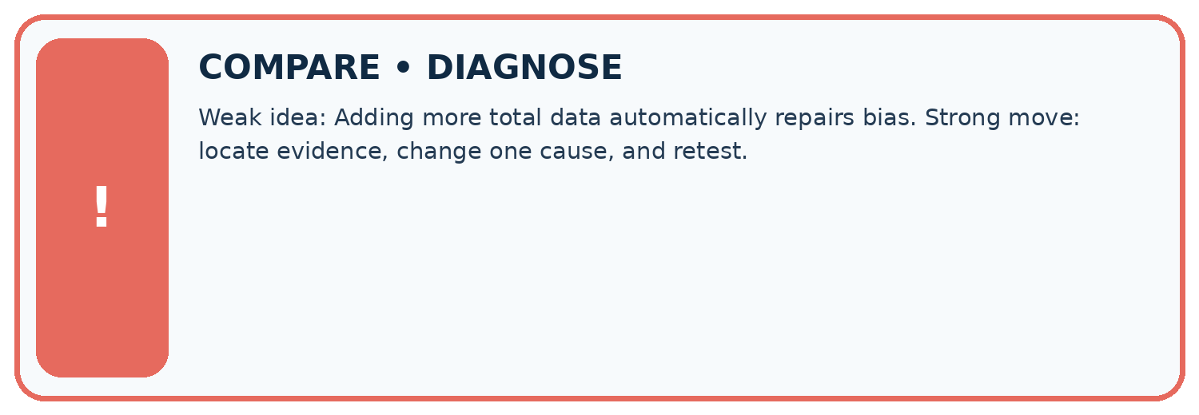
Evidence record | Expected | Actual | Likely cause / next test
normal case | works
boundary case | stated rule
missing input | safe response
fresh transfer | generalizes
Repair one cause. Why is this repair better than changing several things?

Write or draw your reasoning and evidence.
________________________________________________________________
________________________________________________________________
________________________________________________________________
________________________________________________________________
________________________________________________________________

A closer explanation
Group differences suggest that coverage matters, but do not explain why choices differ. Small group counts also make percentages unstable. Use neutral group labels in fictional data rather than personal or sensitive attributes.

Club members favor coding more often. Does club membership necessarily cause that preference?
________________________________________________________________
________________________________________________________________
________________________________________________________________
________________________________________________________________
________________________________________________________________
________________________________________________________________

08. Practise together
LOGIC STUDIO
Trace Before You Run
Block code, pseudocode, tables, and diagrams are different ways to expose the same reasoning.

SET evidence_record
PREDICT expected_result
RUN one normal case and one boundary case
COMPARE actual_result with expected_result
IF different: locate first cause; change one factor; RETEST
EXPLAIN result, limitation, and next safe step
Trace one input. Which line changes the state or chooses a path?

Write or draw your reasoning and evidence.
________________________________________________________________
________________________________________________________________
________________________________________________________________
________________________________________________________________
________________________________________________________________

A closer explanation
Surveying another 100 people from the same undercovered source may make the sample larger without fixing the selection problem. Improve access to missing groups and record nonresponse; do not simply duplicate existing rows.

Practise with less help: Combine counts
Use workbook W2 for the connected example “Selection bias and coverage”. First fill the input and rule boxes. Try the middle steps before asking for a hint. After a hint, try the next step yourself.
Plan | Do | Check
What is given? Which rule or procedure applies? | Record each intermediate step. | Does the result follow? What remains unknown?
Explain your trace to a partner. Your partner points to one step to check. Swap roles on the next case. Each person writes their own explanation.

Check your reasoning
Use the worked case for Selection bias and coverage. Proposed explanation: “A successful run proves the conclusion”. Decide whether this explanation is supported. Point to the step or supplied fact that decides; explain your repair if needed.
Answer on your own before discussion. If you are unsure, say which step you need help with.

Explain the picture
Why must 35% be labelled an illustration rather than the measured grade-wide Yes rate?

My explanation using a pictured step and the given facts
________________________________________________________________
________________________________________________________________
________________________________________________________________
________________________________________________________________
This is supported practice. Keep the separately named independent case for an attempt before feedback.

09. Run the investigation
EVIDENCE LAB
Predict → Test → Record → Explain
Keep expected and actual results separate. Surprises are useful data when recorded honestly.
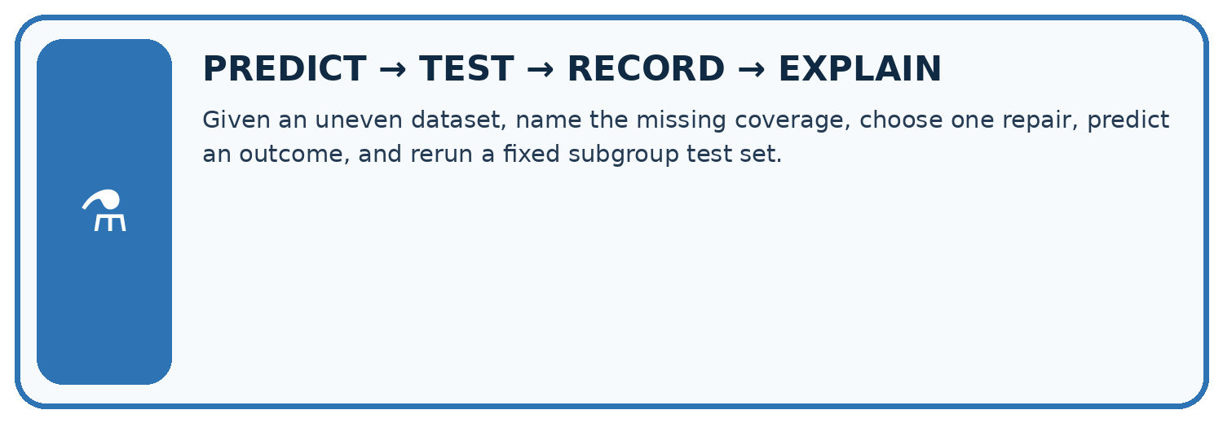
Given an uneven dataset, name the missing coverage, choose one repair, predict an outcome, and rerun a fixed subgroup test set.
Test / input | Prediction | Actual | Evidence / calculation | Change or keep?
normal
boundary
missing
fresh transfer
What did the hardest test teach you that the normal test did not?

Write or draw your reasoning and evidence.
________________________________________________________________
________________________________________________________________
________________________________________________________________
________________________________________________________________
________________________________________________________________

Plan → try → check
Before trying: what do I expect, and why? While trying: which step could first go wrong? Afterwards: what did I actually observe, and what should change? Keep “not run” if you only traced the procedure.

10. Build your understanding
MASTERY
From Knowing the Word to Owning the Idea
Move upward only when you can produce evidence without copying the worked example.

1 • NAME: Define the concept without repeating the textbook.
2 • TRACE: Show the information, state, branch, calculation, or evidence path.
3 • APPLY: Solve a different example independently.
4 • CHALLENGE: Find a boundary case, counterexample, or unfair outcome.
5 • EXPLAIN LIMITS: Say when the result should not be trusted or used alone.
My strongest evidence of independent understanding:

Write or draw your reasoning and evidence.
________________________________________________________________
________________________________________________________________
________________________________________________________________
________________________________________________________________
________________________________________________________________

11. Connect your project
CUMULATIVE PROJECT
Transparent Book Recommender
Every week adds one inspectable piece. The system must show how it reached a result.
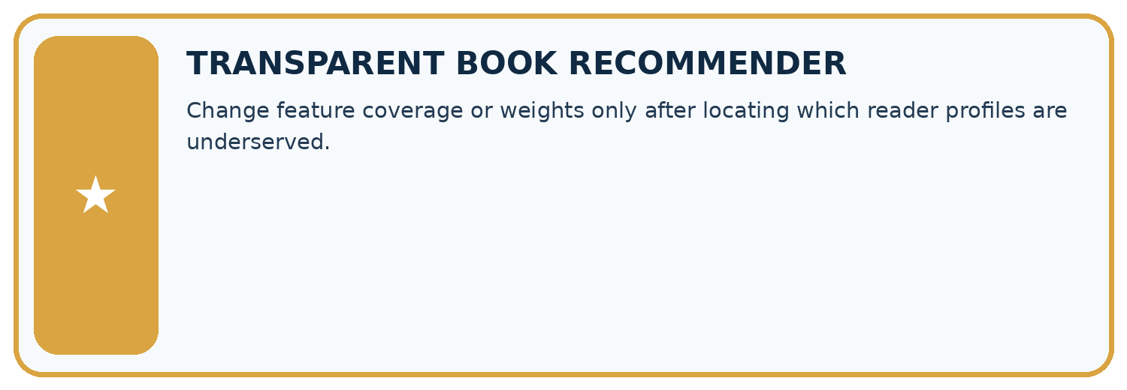
THIS WEEK’S CHECKPOINT Change feature coverage or weights only after locating which reader profiles are underserved.
SYSTEM MAP Reader need → allowed inputs → transparent rule or score → ranked candidates → explanation → test record → human decision
What will you add, change, or verify in the project this week?

Write or draw your reasoning and evidence.
________________________________________________________________
________________________________________________________________
________________________________________________________________
________________________________________________________________
________________________________________________________________
What should remain under human control?

Write or draw your reasoning and evidence.
________________________________________________________________
________________________________________________________________
________________________________________________________________
________________________________________________________________
________________________________________________________________
RESPONSIBLE DESIGN Collect only necessary information. Show uncertainty and limits. Never confuse a ranking with a fact about a person.

Evidence for your project
Broaden recommender feedback collection and show respondent group coverage before making user-preference claims.

12. Show what you know
INDEPENDENT MASTERY PROOF
Explain • Transfer • Test • Defend
Complete this page without copying the worked example. Your reasoning matters more than decoration.
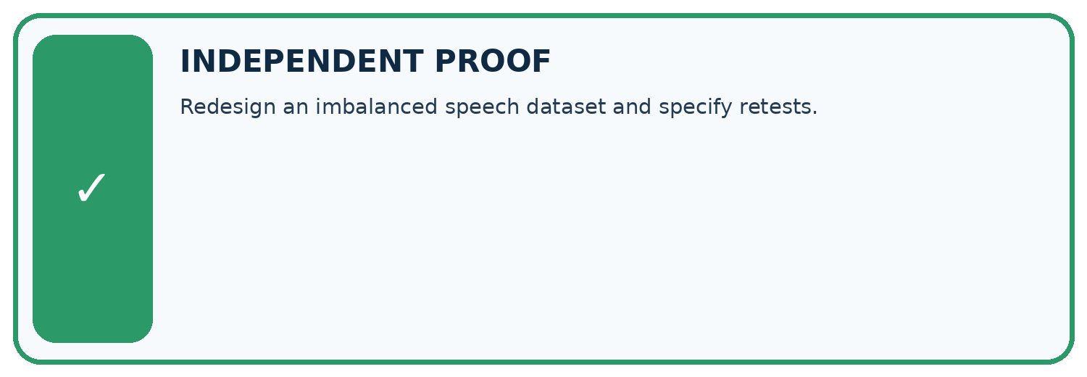
CHALLENGE Redesign an imbalanced speech dataset and specify retests.
1. My fresh example, trace, calculation, or design:

Write or draw your reasoning and evidence.
________________________________________________________________
________________________________________________________________
________________________________________________________________
________________________________________________________________
________________________________________________________________
2. My evidence that it works (include a boundary or missing-data case):

Write or draw your reasoning and evidence.
________________________________________________________________
________________________________________________________________
________________________________________________________________
________________________________________________________________
________________________________________________________________
3. One limitation, fairness concern, or situation needing human review:

Write or draw your reasoning and evidence.
________________________________________________________________
________________________________________________________________
________________________________________________________________
________________________________________________________________
________________________________________________________________
SELF-CHECK □ I explained the mechanism □ I used evidence □ I tested a fresh case □ I named a limitation □ I can answer ‘why?’

13. Study a complete case

Week 20 Worked case
Use the supplied details to practise the weekly concept before attempting the independent question. This case extends the illustrated lesson.

The situation
Training has eighteen adventure readers and two poetry readers; many intended users prefer poetry.

The question
Propose repair and evaluation.

Worked explanation
Collect varied relevant poetry examples with consistent labels. Compare both interests on separate evaluation cases before and after repair.

Explain it in your own words
Which detail supports the answer, and why does it matter?

Write or draw your reasoning and evidence.
________________________________________________________________
________________________________________________________________
________________________________________________________________
________________________________________________________________
________________________________________________________________

Trace the supplied case visually

Repair coverage with varied examples
Evidence or stage | Value or result
Adventure readers | 18
Poetry readers | 2
Training has eighteen adventure readers and two poetry readers; many intended users prefer poetry.
Propose repair and evaluation.
Collect varied relevant poetry examples with consistent labels. Compare both interests on separate evaluation cases before and after repair.

14. Try a new case independently

Independent case: Audit independently
A survey has 18 Yes of 20 club members and 2 Yes of 10 others. Compute both group rates and combined rate. Explain why 20/30 does not automatically describe the whole grade.

My independent explanation, trace and limits
________________________________________________________________
________________________________________________________________
________________________________________________________________
________________________________________________________________
________________________________________________________________
________________________________________________________________
________________________________________________________________
Attempt this case before feedback. Record any help. Earlier examples below are further practice; a case already practised with feedback cannot establish fresh transfer.

Week 20 Independent application
Close the worked explanation. Apply the idea to this different question without copying.
A dataset has 18 adventure readers and 2 poetry readers. A recommender ignores poetry preferences. What would you inspect and test after a repair?
My answer, with a trace, calculation or supporting evidence

Write or draw your reasoning and evidence.
________________________________________________________________
________________________________________________________________
________________________________________________________________
________________________________________________________________
________________________________________________________________

Create and test
Change one relevant detail. Predict the result before testing. Include a boundary or missing-information case when it helps reveal a limit.
My changed input and expected result

Write or draw your reasoning and evidence.
________________________________________________________________
________________________________________________________________
________________________________________________________________
________________________________________________________________
________________________________________________________________

Connect to your project
Change feature coverage or weights only after locating which reader profiles are underserved.
The evidence I will keep

Write or draw your reasoning and evidence.
________________________________________________________________
________________________________________________________________
________________________________________________________________
________________________________________________________________
________________________________________________________________
Your teacher has the independent answer and scoring criteria. Complete the matching workbook week to keep your practice evidence together.

Transfer practice from the original programme
A catalogue has 30 adventure titles and 2 poetry titles. A recommender rarely suggests poetry. Design a repair and an evaluation that distinguishes catalogue coverage from scoring preference.

Explain the mechanism, evidence and one limit.
________________________________________________________________
________________________________________________________________
________________________________________________________________
________________________________________________________________
________________________________________________________________
________________________________________________________________
________________________________________________________________

Use feedback to improve
Attempt the independent case before hints. Record whether you worked alone, used a hint or followed a model. After feedback, fix the first unsupported step and explain why it changed. A later check uses a changed case, not a copied answer.

