AI ACADEMY · STUDENT · ai-2/28

Prompt Experiments
Project: Transparent Book Recommender

Before you start
Week 12: use the same scoring rules for comparisons.

01. Your mission

Your learning target
I can explain the mechanism and terminology of controlled prompt experiments.
I can apply the stated procedure to a new case with a traceable result.
I can identify an assumption or limitation and design a revealing follow-up.

Remember before reading
Close your notes first. A rough first answer helps us choose the right starting point; it is not a score for your ability.
Without opening the old lesson, explain one key idea from Predictive vs Generative. Give an example and a mistake that the idea helps you avoid.
Without opening the old lesson, explain one key idea from Text as Pieces. Give an example and a mistake that the idea helps you avoid.
Without opening the old lesson, explain one key idea from Nearest Neighbor Reasoning. Give an example and a mistake that the idea helps you avoid.
After trying, check the relevant lesson or ask your teacher. Change the part of your explanation that the evidence shows was wrong.
Week 28: Prompt Experiments
Prompt quality is evaluated by controlled comparisons and success criteria.
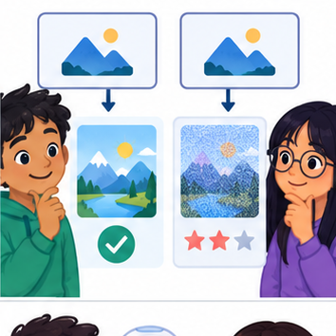
THINKER MISSION
Change one prompt variable at a time and score results.
Thinker name and date:

Write or draw your reasoning and evidence.
________________________________________________________________
________________________________________________________________
________________________________________________________________
________________________________________________________________
________________________________________________________________

Readiness for the connected explanation
Recall Structured outputs and validation. Explain why a recorded result needs its input conditions and evidence source before it can support a claim.

This week’s end goal
By the end, I can compare prompts on paired cases and inspect a subgroup before choosing.

02. Notice the evidence
PICTURE STORY
Notice → Predict → Explain
Begin with visible evidence. Do not explain more than the picture and information support.
MYSTERY
The learners must use prompt experiments to solve a problem. What information do they have? What decision or calculation do they make? What would count as evidence that it worked?
Three observations (what you can point to):

Write or draw your reasoning and evidence.
________________________________________________________________
________________________________________________________________
________________________________________________________________
________________________________________________________________
________________________________________________________________
My prediction and the clue supporting it:

Write or draw your reasoning and evidence.
________________________________________________________________
________________________________________________________________
________________________________________________________________
________________________________________________________________
________________________________________________________________

A closer explanation
A prompt experiment compares complete specifications using the same task cases. Define success before inspecting outputs; change one intended instruction and preserve other settings.
Begin by writing the question the procedure is intended to answer. Identify the information already supplied, the information it will produce and the information still missing. These are constructed classroom examples; they do not require live accounts, private records or an external service. Do not treat a plausible explanation as a measured outcome.

03. See how it works
VISUAL MECHANISM
Input → Process → Output
Trace the information. At each stage, ask what changed and how you could test it.
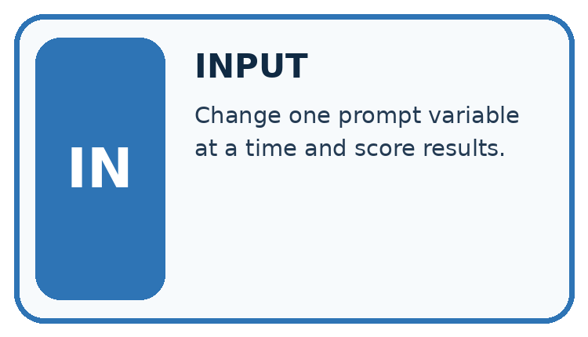
↓
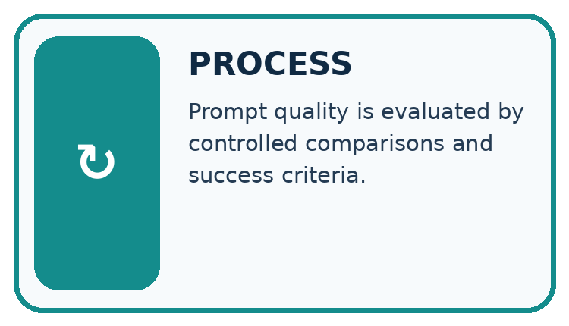
↓
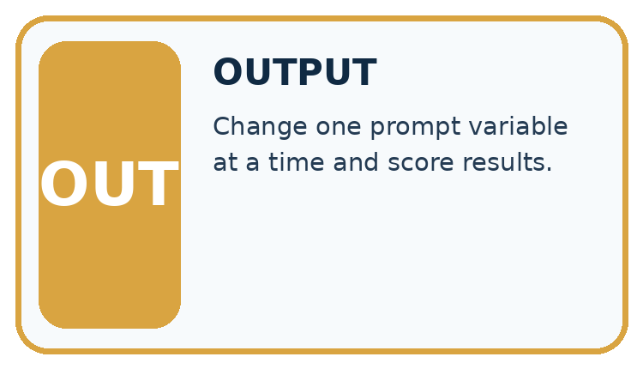
Which stage could fail even when the other two are correct? Explain:

Write or draw your reasoning and evidence.
________________________________________________________________
________________________________________________________________
________________________________________________________________
________________________________________________________________
________________________________________________________________

A closer explanation
Evaluate both prompts on paired cases with fixed model/version, source records, output contract and scoring rubric. Use development results for selection, then reserve new final cases. Score each case rather than counting attractive sentences.

Controlled prompt experiments — evidence trace
Input and scope | Check or calculation | Conclusion and limit
On six development cases P passes cases 1, 2, 3, 4; Q passes 1, 2, 3, 5, 6. Missing-approval cases are 4 and 6. Compare totals and condition results. | Evaluate both prompts on paired cases with fixed model/version, source records, output contract and scoring rubric. | P passes 4/6 and Q 5/6. P passes one of two missing-approval cases, Q also one of two.
The figure connects this chapter's worked input, declared procedure and result. Read the complete worked reasoning for qualifiers and intermediate steps; the abbreviated labels do not replace that reasoning.
Before applying the procedure, write its units, denominator or decision boundary where relevant. A partner should be able to repeat each step using the same inputs. If a required input is absent or violates the stated contract, record that condition explicitly instead of quietly replacing it with a convenient value.

Connect the picture and the explanation
Point to the input, the deciding step and the result in this week’s visual. Explain the same step in ordinary words. A picture helps when you can say what each part represents.

04. Compare the cases
CASE GALLERY
Four Tests, Four Kinds of Evidence
A system is not understood until it survives more than one comfortable example.


NORMAL CASE: predict and name evidence. BOUNDARY CASE: predict and name evidence.


MISSING INFORMATION: predict and name evidence. TRANSFER CASE: predict and name evidence.
Which case is most likely to reveal a hidden assumption? Why?

Write or draw your reasoning and evidence.
________________________________________________________________
________________________________________________________________
________________________________________________________________
________________________________________________________________
________________________________________________________________

Change one thing in the pictured case
Change: Make missing-source correctness a required selection gate.
Prediction: Neither prompt clears a 2/2 gate on these records.
Reason: P fails 7 and Q fails both 4 and 7; both need revision.

05. Words that unlock the idea
VOCABULARY LAB
Words You Can Use to Reason
A definition matters when you can recognize the idea, use it, and contrast it with a near-miss.
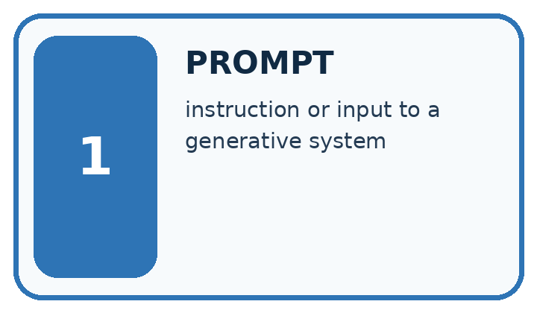
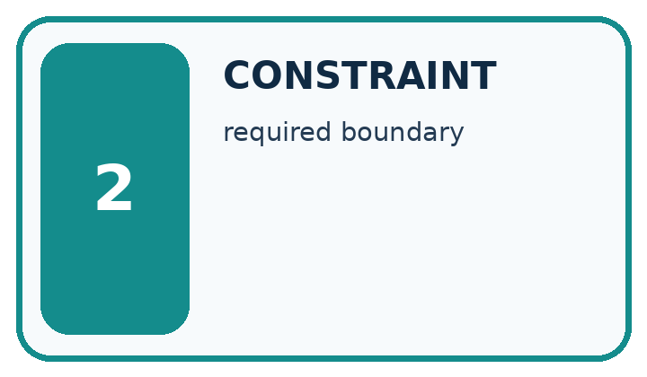
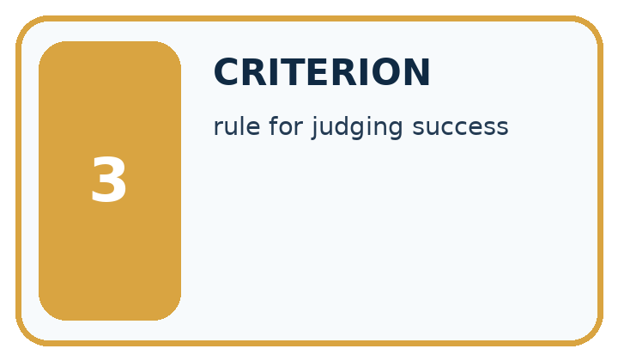
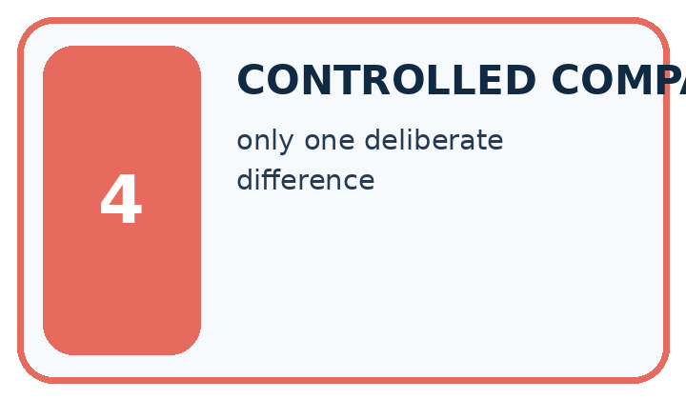
Word | My own example | Not this / boundary
prompt | Input instructions and context supplied to a generative system.
constraint | A condition that a valid solution must satisfy.
criterion | One stated standard used to judge a result.
controlled comparison | A comparison designed to keep relevant conditions alike except for the factor being studied.

Words used in the closer explanation
Word | Meaning
Paired case | The same case evaluated under each compared procedure
Rubric | Prespecified criteria for judging an output
Regression | A previously passing condition that fails after a change

06. Follow a worked example
WORKED EVIDENCE
Reason Step by Step
Predict first. Then check each step. A correct answer without visible reasoning is incomplete evidence.
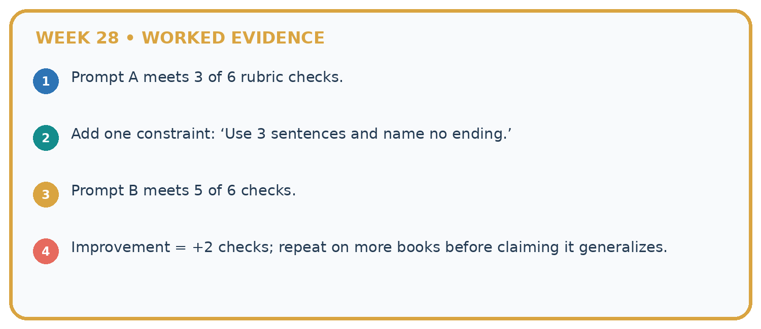
1. Prompt A meets 3 of 6 rubric checks.
2. Add one constraint: ‘Use 3 sentences and name no ending.’
3. Prompt B meets 5 of 6 checks.
4. Improvement = +2 checks; repeat on more books before claiming it generalizes.
Recalculate, retrace, or restate the reasoning in your own representation:

Write or draw your reasoning and evidence.
________________________________________________________________
________________________________________________________________
________________________________________________________________
________________________________________________________________
________________________________________________________________
CHECK Did the evidence answer the exact question? Did the total, path, or source record stay consistent?

A closer explanation
On six development cases P passes cases 1, 2, 3, 4; Q passes 1, 2, 3, 5, 6. Missing-approval cases are 4 and 6. Compare totals and condition results.
P passes 4/6 and Q 5/6. P passes one of two missing-approval cases, Q also one of two. Q improves the aggregate while leaving this condition unchanged.
Compare the intermediate evidence with the final statement. Explain why each number or decision follows from the stated inputs. The conclusion belongs to this scenario and procedure; changing the inputs, evaluation population or authority can change what it establishes. Retain the raw record so a later revision can be compared honestly.

Learn from the worked case
Cover the result before checking it. Say what is given, choose the procedure, and follow one step at a time. Then uncover the result and explain your first mismatch. Ask why a step is allowed, not only what number it produces.

A pictorial worked case: Prompt Experiments
A fictional book-help project tests two prompt versions on seven shared development cases.

The facts we will use
P passes cases 1,2,3,4. Q passes 1,2,3,5,6. Cases 4 and 7 involve missing sources.
Same inputs, system configuration and rubric; only the prompt changes. These are invented records.
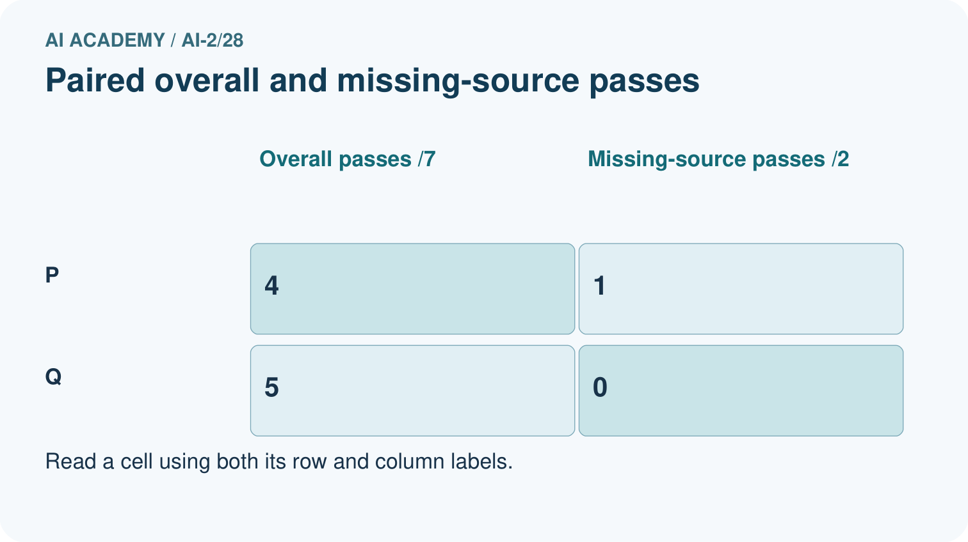
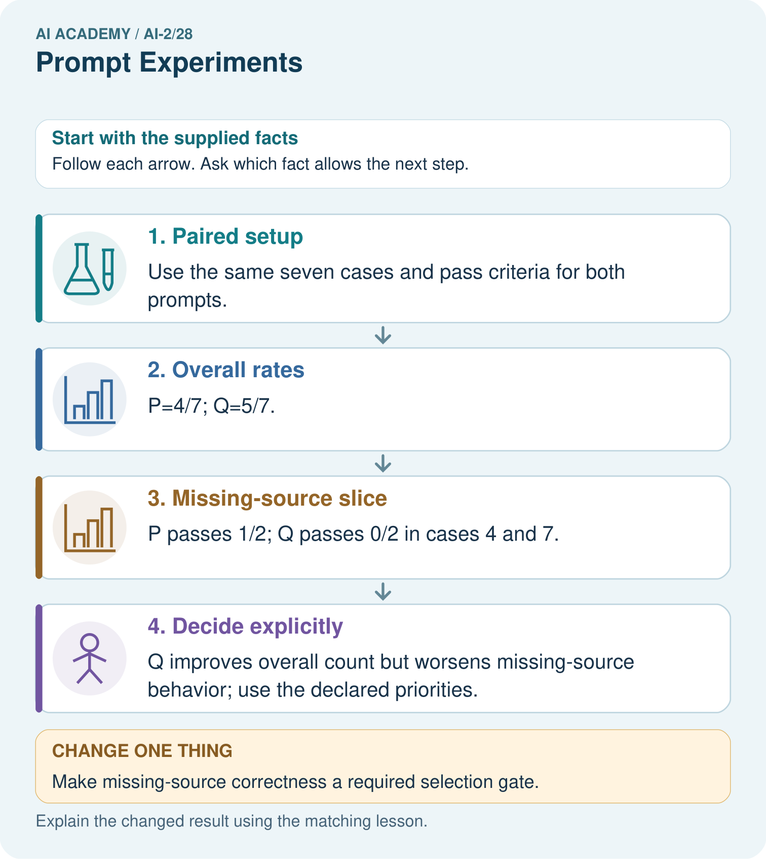

Read the picture one step at a time
Step | What happens and why
1. Paired setup | Use the same seven cases and pass criteria for both prompts.
2. Overall rates | P=4/7; Q=5/7.
3. Missing-source slice | P passes 1/2; Q passes 0/2 in cases 4 and 7.
4. Decide explicitly | Q improves overall count but worsens missing-source behavior; use the declared priorities.
Match each pictured step to the supplied facts. This is a worked teaching case, not an independent assessment.

Why this result follows
A larger total can conceal a more serious failure category. Paired records show which cases changed, not just how many passed. If refusing unsupported claims is mandatory, Q’s overall advantage may not justify selection. Keep the failing examples for development and obtain fresh cases after choosing a final version.

What this example does not establish
Seven development cases cannot establish causal learning benefits or untouched final performance; repeated generation may also vary.

07. Find and repair a mistake
ERROR DETECTIVE
Compare → Diagnose → Repair
Do not patch the answer. Find the earliest unsupported assumption, wrong step, or weak evidence.
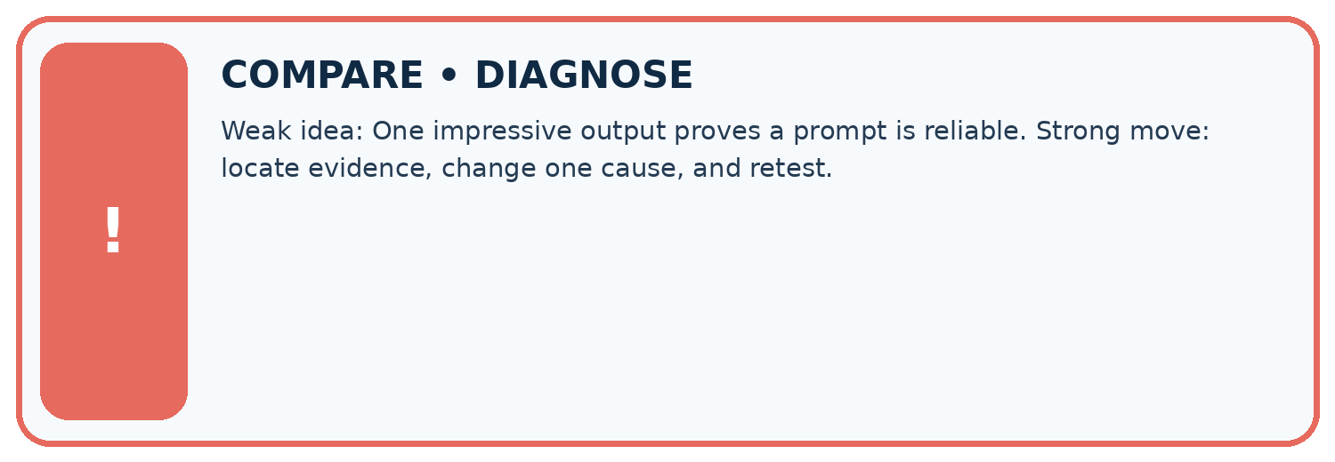
Evidence record | Expected | Actual | Likely cause / next test
normal case | works
boundary case | stated rule
missing input | safe response
fresh transfer | generalizes
Repair one cause. Why is this repair better than changing several things?

Write or draw your reasoning and evidence.
________________________________________________________________
________________________________________________________________
________________________________________________________________
________________________________________________________________
________________________________________________________________

A closer explanation
Complete the supported workbook tasks before attempting W4 independently. Record any hints or help used. After feedback, use the teacher's fresh retry rather than copying the earlier answer. For a project, select a relevant new case, predict the outcome from the declared rule and preserve the result alongside any revision.

Exit: propose one revealing change to the worked scenario. State the expected outcome and the evidence that would make you revise your explanation.
________________________________________________________________
________________________________________________________________
________________________________________________________________
________________________________________________________________
________________________________________________________________

08. Practise together
LOGIC STUDIO
Trace Before You Run
Block code, pseudocode, tables, and diagrams are different ways to expose the same reasoning.

SET evidence_record
PREDICT expected_result
RUN one normal case and one boundary case
COMPARE actual_result with expected_result
IF different: locate first cause; change one factor; RETEST
EXPLAIN result, limitation, and next safe step
Trace one input. Which line changes the state or chooses a path?

Write or draw your reasoning and evidence.
________________________________________________________________
________________________________________________________________
________________________________________________________________
________________________________________________________________
________________________________________________________________

A closer explanation
Prompt selection on development cases cannot be reported as independent final performance.
A useful check asks what would make the reasoning fail. Distinguish a failure to execute the declared procedure from a weakness in the procedure itself. The first may require a correction; the second requires an explicitly revised method and new evidence. Preserve unsuccessful cases so an improved result cannot hide the original problem.

Guided: restate the worked result, then name the assumption or limitation that prevents a broader conclusion.
________________________________________________________________
________________________________________________________________
________________________________________________________________
________________________________________________________________
________________________________________________________________

Practise with less help: Trace the worked case
Use workbook W2 for the connected example “Controlled prompt experiments”. First fill the input and rule boxes. Try the middle steps before asking for a hint. After a hint, try the next step yourself.
Plan | Do | Check
What is given? Which rule or procedure applies? | Record each intermediate step. | Does the result follow? What remains unknown?
Explain your trace to a partner. Your partner points to one step to check. Swap roles on the next case. Each person writes their own explanation.

Check your reasoning
Use the worked case for Controlled prompt experiments. Proposed explanation: “The worked result establishes every future case”. Decide whether this explanation is supported. Point to the step or supplied fact that decides; explain your repair if needed.
Answer on your own before discussion. If you are unsure, say which step you need help with.

Explain the picture
Name the case P passes and Q fails, and explain why it matters.

My explanation using a pictured step and the given facts
________________________________________________________________
________________________________________________________________
________________________________________________________________
________________________________________________________________
This is supported practice. Keep the separately named independent case for an attempt before feedback.

09. Run the investigation
EVIDENCE LAB
Predict → Test → Record → Explain
Keep expected and actual results separate. Surprises are useful data when recorded honestly.
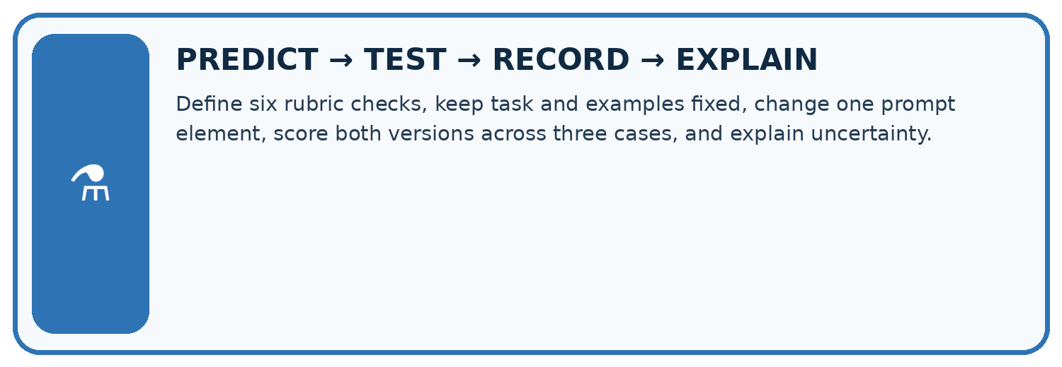
Define six rubric checks, keep task and examples fixed, change one prompt element, score both versions across three cases, and explain uncertainty.
Test / input | Prediction | Actual | Evidence / calculation | Change or keep?
normal
boundary
missing
fresh transfer
What did the hardest test teach you that the normal test did not?

Write or draw your reasoning and evidence.
________________________________________________________________
________________________________________________________________
________________________________________________________________
________________________________________________________________
________________________________________________________________

Plan → try → check
Before trying: what do I expect, and why? While trying: which step could first go wrong? Afterwards: what did I actually observe, and what should change? Keep “not run” if you only traced the procedure.

10. Build your understanding
MASTERY
From Knowing the Word to Owning the Idea
Move upward only when you can produce evidence without copying the worked example.

1 • NAME: Define the concept without repeating the textbook.
2 • TRACE: Show the information, state, branch, calculation, or evidence path.
3 • APPLY: Solve a different example independently.
4 • CHALLENGE: Find a boundary case, counterexample, or unfair outcome.
5 • EXPLAIN LIMITS: Say when the result should not be trusted or used alone.
My strongest evidence of independent understanding:

Write or draw your reasoning and evidence.
________________________________________________________________
________________________________________________________________
________________________________________________________________
________________________________________________________________
________________________________________________________________

11. Connect your project
CUMULATIVE PROJECT
Transparent Book Recommender
Every week adds one inspectable piece. The system must show how it reached a result.
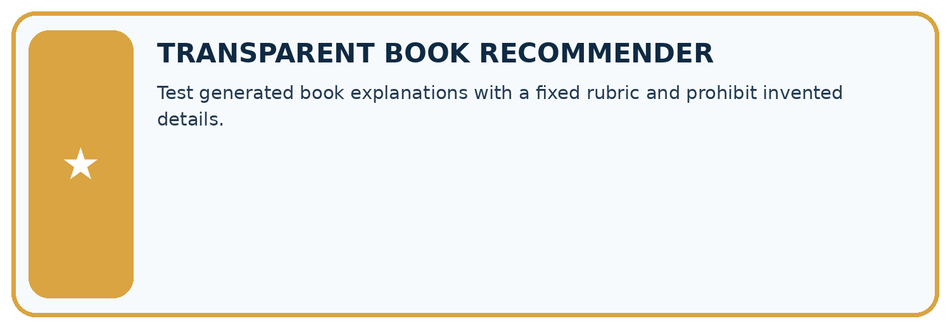
THIS WEEK’S CHECKPOINT Test generated book explanations with a fixed rubric and prohibit invented details.
SYSTEM MAP Reader need → allowed inputs → transparent rule or score → ranked candidates → explanation → test record → human decision
What will you add, change, or verify in the project this week?

Write or draw your reasoning and evidence.
________________________________________________________________
________________________________________________________________
________________________________________________________________
________________________________________________________________
________________________________________________________________
What should remain under human control?

Write or draw your reasoning and evidence.
________________________________________________________________
________________________________________________________________
________________________________________________________________
________________________________________________________________
________________________________________________________________
RESPONSIBLE DESIGN Collect only necessary information. Show uncertainty and limits. Never confuse a ranking with a fact about a person.

Evidence for your project
Run controlled recommender explanation experiments with paired cases and report important failure conditions separately.

12. Show what you know
INDEPENDENT MASTERY PROOF
Explain • Transfer • Test • Defend
Complete this page without copying the worked example. Your reasoning matters more than decoration.
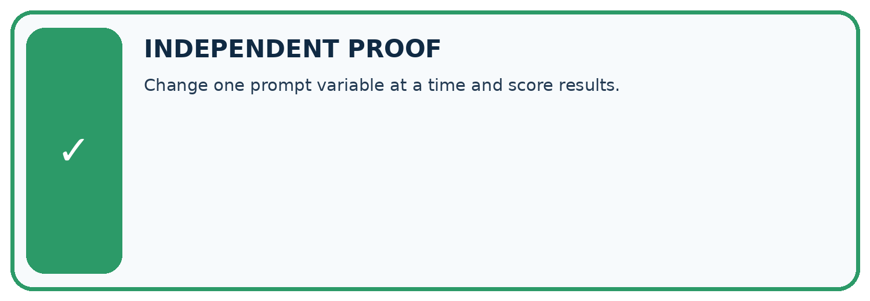
CHALLENGE Change one prompt variable at a time and score results.
1. My fresh example, trace, calculation, or design:

Write or draw your reasoning and evidence.
________________________________________________________________
________________________________________________________________
________________________________________________________________
________________________________________________________________
________________________________________________________________
2. My evidence that it works (include a boundary or missing-data case):

Write or draw your reasoning and evidence.
________________________________________________________________
________________________________________________________________
________________________________________________________________
________________________________________________________________
________________________________________________________________
3. One limitation, fairness concern, or situation needing human review:

Write or draw your reasoning and evidence.
________________________________________________________________
________________________________________________________________
________________________________________________________________
________________________________________________________________
________________________________________________________________
SELF-CHECK □ I explained the mechanism □ I used evidence □ I tested a fresh case □ I named a limitation □ I can answer ‘why?’

13. Study a complete case

Week 28 Worked case
Use the supplied details to practise the weekly concept before attempting the independent question. This case extends the illustrated lesson.

The situation
Prompt B adds under 100 pages and explain the match to Prompt A. Both use a catalogue.

The question
Design a fair comparison.

Worked explanation
Use identical requests, catalogue and scoring criteria. Check constraint compliance and supported explanation; repeat stochastic outputs when relevant.

Explain it in your own words
Which detail supports the answer, and why does it matter?

Write or draw your reasoning and evidence.
________________________________________________________________
________________________________________________________________
________________________________________________________________
________________________________________________________________
________________________________________________________________

Trace the supplied case visually

Compare prompts under the same conditions
Evidence or stage | Value or result
Prompt A | Original catalogue request
Prompt B | Add under 100 pages and explain the match
Hold fixed | Catalogue, requests and scoring
Check | Constraint compliance and supported explanation
Prompt B adds under 100 pages and explain the match to Prompt A. Both use a catalogue.
Design a fair comparison.
Use identical requests, catalogue and scoring criteria. Check constraint compliance and supported explanation; repeat stochastic outputs when relevant.

14. Try a new case independently

Independent case: Apply a new case independently
On eight paired cases A passes 1–5; B passes 1–4, 6, 7. Special cases are 5 and 8. Compare overall and special-case results; select by total passes.

My independent explanation, trace and limits
________________________________________________________________
________________________________________________________________
________________________________________________________________
________________________________________________________________
________________________________________________________________
________________________________________________________________
________________________________________________________________
Attempt this case before feedback. Record any help. Earlier examples below are further practice; a case already practised with feedback cannot establish fresh transfer.

Week 28 Independent application
Close the worked explanation. Apply the idea to this different question without copying.
Prompt A and B are tested on different questions. B scores higher. Can wording alone explain the difference? Design a controlled comparison.
My answer, with a trace, calculation or supporting evidence

Write or draw your reasoning and evidence.
________________________________________________________________
________________________________________________________________
________________________________________________________________
________________________________________________________________
________________________________________________________________

Create and test
Change one relevant detail. Predict the result before testing. Include a boundary or missing-information case when it helps reveal a limit.
My changed input and expected result

Write or draw your reasoning and evidence.
________________________________________________________________
________________________________________________________________
________________________________________________________________
________________________________________________________________
________________________________________________________________

Connect to your project
Test generated book explanations with a fixed rubric and prohibit invented details.
The evidence I will keep

Write or draw your reasoning and evidence.
________________________________________________________________
________________________________________________________________
________________________________________________________________
________________________________________________________________
________________________________________________________________
Your teacher has the independent answer and scoring criteria. Complete the matching workbook week to keep your practice evidence together.

Transfer practice from the original programme
Prompt A is tested on easy requests and B on requests with missing data. B scores lower. Design a fair comparison and specify what to do when outputs vary across runs.

Explain the mechanism, evidence and one limit.
________________________________________________________________
________________________________________________________________
________________________________________________________________
________________________________________________________________
________________________________________________________________
________________________________________________________________
________________________________________________________________

Use feedback to improve
Attempt the independent case before hints. Record whether you worked alone, used a hint or followed a model. After feedback, fix the first unsupported step and explain why it changed. A later check uses a changed case, not a copied answer.

