AI ACADEMY · STUDENT · ai-2/30

Agents and Tools
Project: Transparent Book Recommender

Before you start
AI-1 Week 28: drafting permission does not imply sending permission.

01. Your mission

Your learning target
I can explain the mechanism and terminology of state machines for bounded agents.
I can apply the stated procedure to a new case with a traceable result.
I can identify an assumption or limitation and design a revealing follow-up.

Remember before reading
Close your notes first. A rough first answer helps us choose the right starting point; it is not a score for your ability.
Without opening the old lesson, explain one key idea from Evidence and Sources. Give an example and a mistake that the idea helps you avoid.
Without opening the old lesson, explain one key idea from Predictive vs Generative. Give an example and a mistake that the idea helps you avoid.
Without opening the old lesson, explain one key idea from Feedback Loops. Give an example and a mistake that the idea helps you avoid.
After trying, check the relevant lesson or ask your teacher. Change the part of your explanation that the evidence shows was wrong.
Week 30: Agents and Tools
An agent combines a goal, model, tools, state, and a stopping rule.
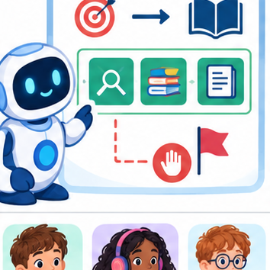
THINKER MISSION
Design a bounded library helper with three allowed tools.
Thinker name and date:

Write or draw your reasoning and evidence.
________________________________________________________________
________________________________________________________________
________________________________________________________________
________________________________________________________________
________________________________________________________________

Readiness for the connected explanation
Recall Logs traces and privacy. Explain why a recorded result needs its input conditions and evidence source before it can support a claim.

This week’s end goal
By the end, I can validate a bounded agent’s transitions and stop after a terminal state.

02. Notice the evidence
PICTURE STORY
Notice → Predict → Explain
Begin with visible evidence. Do not explain more than the picture and information support.
MYSTERY
The learners must use agents and tools to solve a problem. What information do they have? What decision or calculation do they make? What would count as evidence that it worked?
Three observations (what you can point to):

Write or draw your reasoning and evidence.
________________________________________________________________
________________________________________________________________
________________________________________________________________
________________________________________________________________
________________________________________________________________
My prediction and the clue supporting it:

Write or draw your reasoning and evidence.
________________________________________________________________
________________________________________________________________
________________________________________________________________
________________________________________________________________
________________________________________________________________

A closer explanation
A bounded agent uses explicit states and finite action limits. A state machine makes invalid transitions visible.
Begin by writing the question the procedure is intended to answer. Identify the information already supplied, the information it will produce and the information still missing. These are constructed classroom examples; they do not require live accounts, private records or an external service. Do not treat a plausible explanation as a measured outcome.

03. See how it works
VISUAL MECHANISM
Input → Process → Output
Trace the information. At each stage, ask what changed and how you could test it.
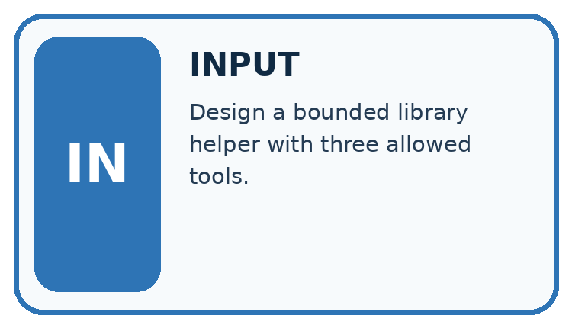
↓
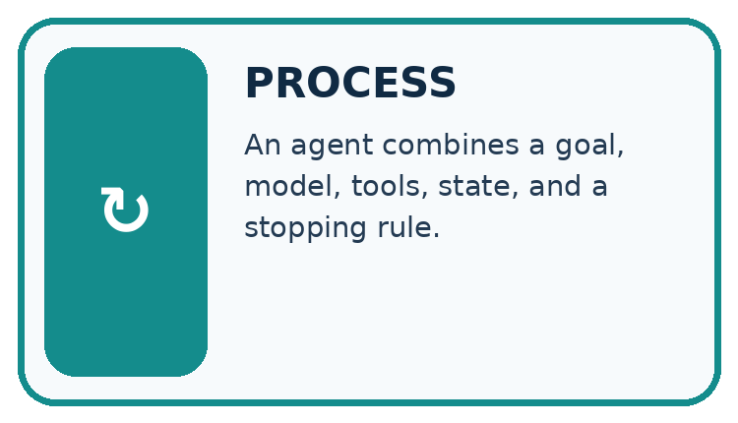
↓
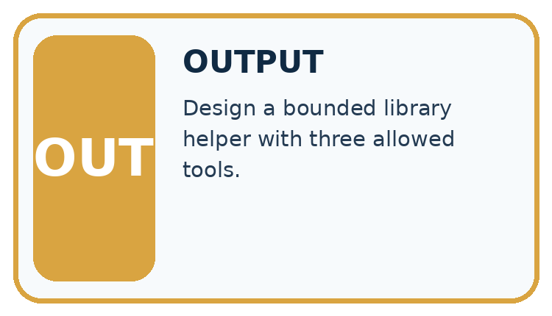
Which stage could fail even when the other two are correct? Explain:

Write or draw your reasoning and evidence.
________________________________________________________________
________________________________________________________________
________________________________________________________________
________________________________________________________________
________________________________________________________________

A closer explanation
States are ready, looking_up, review, done. ready may start lookup; lookup may finish done or request review; review may finish done after authorised evidence. done is terminal. Maximum two lookup attempts.

State machines for bounded agents — evidence trace
Input and scope | Check or calculation | Conclusion and limit
Trace ready -> looking_up -> review -> looking_up -> done. | States are ready, looking_up, review, done. ready may start lookup; lookup may finish done or request review; review may finish done after authorised evidence. done is terminal. Maximum two lookup attempts. | review -> looking_up is not allowed by this declared transition table, even if total attempts is two. Reject the transition or explicitly redesign and retest the table.
The figure connects this chapter's worked input, declared procedure and result. Read the complete worked reasoning for qualifiers and intermediate steps; the abbreviated labels do not replace that reasoning.
Before applying the procedure, write its units, denominator or decision boundary where relevant. A partner should be able to repeat each step using the same inputs. If a required input is absent or violates the stated contract, record that condition explicitly instead of quietly replacing it with a convenient value.

Connect the picture and the explanation
Point to the input, the deciding step and the result in this week’s visual. Explain the same step in ordinary words. A picture helps when you can say what each part represents.

04. Compare the cases
CASE GALLERY
Four Tests, Four Kinds of Evidence
A system is not understood until it survives more than one comfortable example.


NORMAL CASE: predict and name evidence. BOUNDARY CASE: predict and name evidence.


MISSING INFORMATION: predict and name evidence. TRANSFER CASE: predict and name evidence.
Which case is most likely to reveal a hidden assumption? Why?

Write or draw your reasoning and evidence.
________________________________________________________________
________________________________________________________________
________________________________________________________________
________________________________________________________________
________________________________________________________________

Change one thing in the pictured case
Change: Add a review state between checking and done, without updating Trace A.
Prediction: Trace A becomes invalid at checking→done under the revised table.
Reason: A required new transition changes what constitutes a complete run.

05. Words that unlock the idea
VOCABULARY LAB
Words You Can Use to Reason
A definition matters when you can recognize the idea, use it, and contrast it with a near-miss.
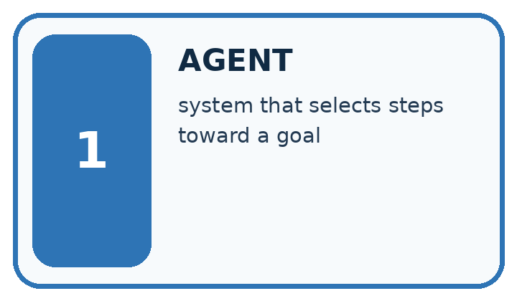
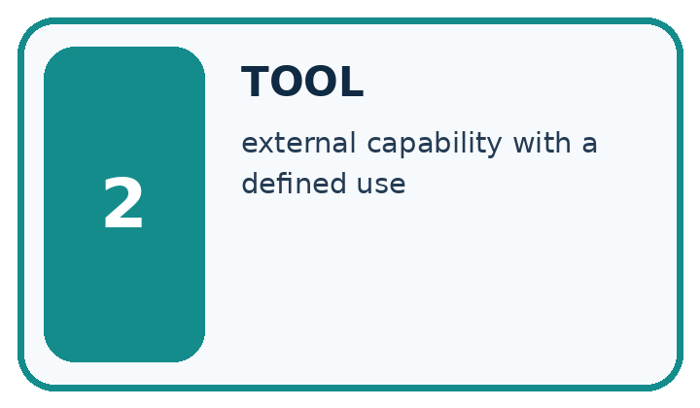
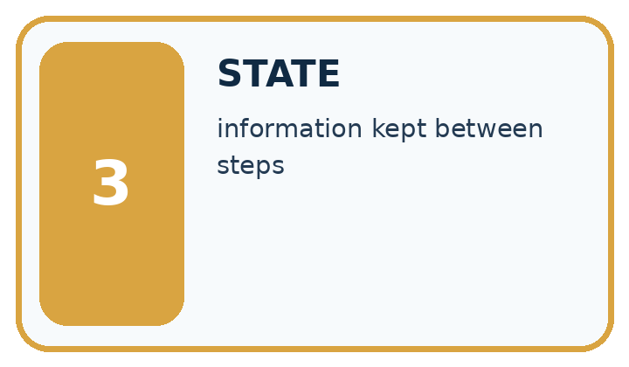
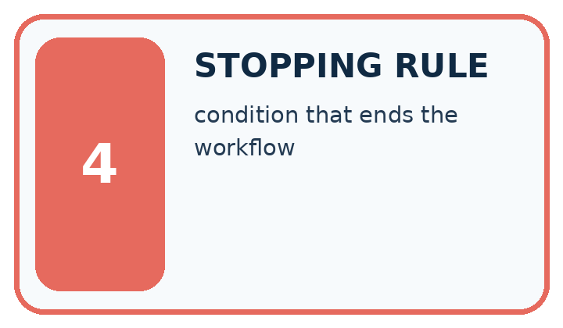
Word | My own example | Not this / boundary
agent | A system that selects and performs steps toward a goal, sometimes using tools within defined permissions.
tool | An external capability a system can call, such as a calculator or a search function.
state | The current values and information that determine what a process does next.
stopping rule | A specified condition that ends a repeated process.

Words used in the closer explanation
Word | Meaning
Transition | An allowed move between states
Terminal state | A state with no further operations under the contract

06. Follow a worked example
WORKED EVIDENCE
Reason Step by Step
Predict first. Then check each step. A correct answer without visible reasoning is incomplete evidence.
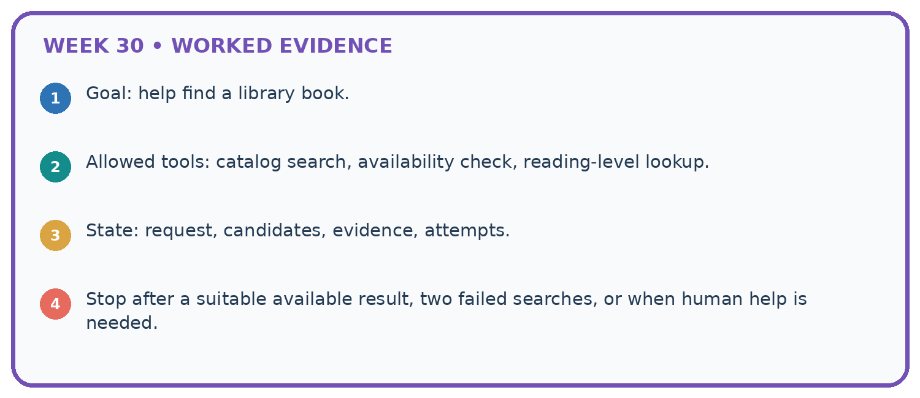
1. Goal: help find a library book.
2. Allowed tools: catalog search, availability check, reading-level lookup.
3. State: request, candidates, evidence, attempts.
4. Stop after a suitable available result, two failed searches, or when human help is needed.
Recalculate, retrace, or restate the reasoning in your own representation:

Write or draw your reasoning and evidence.
________________________________________________________________
________________________________________________________________
________________________________________________________________
________________________________________________________________
________________________________________________________________
CHECK Did the evidence answer the exact question? Did the total, path, or source record stay consistent?

A closer explanation
Trace ready -> looking_up -> review -> looking_up -> done.
review -> looking_up is not allowed by this declared transition table, even if total attempts is two. Reject the transition or explicitly redesign and retest the table.
Compare the intermediate evidence with the final statement. Explain why each number or decision follows from the stated inputs. The conclusion belongs to this scenario and procedure; changing the inputs, evaluation population or authority can change what it establishes. Retain the raw record so a later revision can be compared honestly.
Optional local lab: predict the printed result before running this standalone Python 3 example. Change one relevant boundary input, record the outcome and state the contract or statistical assumptions. The program uses fictional values and the Python standard library; it performs no external operations.
def transition(state, target):
allowed = {'ready': {'looking_up'}, 'looking_up': {'review', 'done'}, 'review': {'done'}, 'done': set()}
if target not in allowed.get(state, set()):
raise ValueError('invalid transition')
return target
print(transition("ready", "looking_up"))

Learn from the worked case
Cover the result before checking it. Say what is given, choose the procedure, and follow one step at a time. Then uncover the result and explain your first mismatch. Ask why a step is allowed, not only what number it produces.

A pictorial worked case: Agents and Tools
A fictional read-only catalogue assistant follows a fixed state machine.

The facts we will use
Allowed edges: ready→searching; searching→checking; checking→done. done has no outgoing edge.
Trace A: ready→searching→checking→done. Trace B: ready→searching→done.
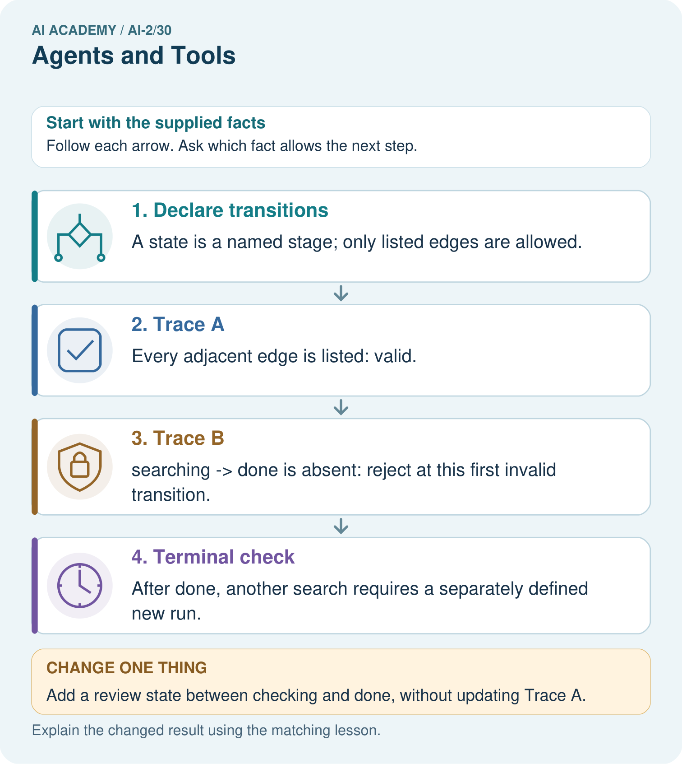

Read the picture one step at a time
Step | What happens and why
1. Declare transitions | A state is a named stage; only listed edges are allowed.
2. Trace A | Every adjacent edge is listed: valid.
3. Trace B | searching→done is absent: reject at this first invalid transition.
4. Terminal check | After done, another search requires a separately defined new run.
Match each pictured step to the supplied facts. This is a worked teaching case, not an independent assessment.

Why this result follows
Reaching the desired ending is insufficient if the agent skipped a required check. Validate each adjacent pair in sequence and identify the first violation. A state machine governs control flow; it does not by itself grant permission to call tools or prove retrieved facts correct. Those are separate checks inside the relevant stages.

What this example does not establish
This toy machine has no retry path; do not invent one or assume real agents always follow these states.

07. Find and repair a mistake
ERROR DETECTIVE
Compare → Diagnose → Repair
Do not patch the answer. Find the earliest unsupported assumption, wrong step, or weak evidence.
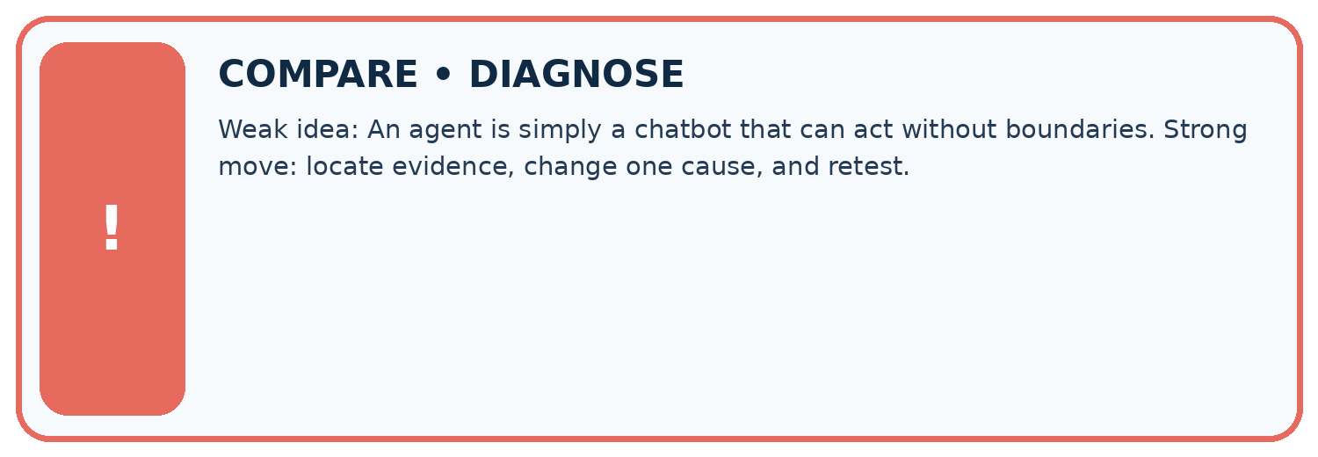
Evidence record | Expected | Actual | Likely cause / next test
normal case | works
boundary case | stated rule
missing input | safe response
fresh transfer | generalizes
Repair one cause. Why is this repair better than changing several things?

Write or draw your reasoning and evidence.
________________________________________________________________
________________________________________________________________
________________________________________________________________
________________________________________________________________
________________________________________________________________

A closer explanation
Complete the supported workbook tasks before attempting W4 independently. Record any hints or help used. After feedback, use the teacher's fresh retry rather than copying the earlier answer. For a project, select a relevant new case, predict the outcome from the declared rule and preserve the result alongside any revision.

Exit: propose one revealing change to the worked scenario. State the expected outcome and the evidence that would make you revise your explanation.
________________________________________________________________
________________________________________________________________
________________________________________________________________
________________________________________________________________
________________________________________________________________

08. Practise together
LOGIC STUDIO
Trace Before You Run
Block code, pseudocode, tables, and diagrams are different ways to expose the same reasoning.

SET evidence_record
PREDICT expected_result
RUN one normal case and one boundary case
COMPARE actual_result with expected_result
IF different: locate first cause; change one factor; RETEST
EXPLAIN result, limitation, and next safe step
Trace one input. Which line changes the state or chooses a path?

Write or draw your reasoning and evidence.
________________________________________________________________
________________________________________________________________
________________________________________________________________
________________________________________________________________
________________________________________________________________

A closer explanation
An action budget and a transition policy are separate checks; satisfying one does not guarantee the other.
A useful check asks what would make the reasoning fail. Distinguish a failure to execute the declared procedure from a weakness in the procedure itself. The first may require a correction; the second requires an explicitly revised method and new evidence. Preserve unsuccessful cases so an improved result cannot hide the original problem.

Guided: restate the worked result, then name the assumption or limitation that prevents a broader conclusion.
________________________________________________________________
________________________________________________________________
________________________________________________________________
________________________________________________________________
________________________________________________________________

Practise with less help: Trace the worked case
Use workbook W2 for the connected example “State machines for bounded agents”. First fill the input and rule boxes. Try the middle steps before asking for a hint. After a hint, try the next step yourself.
Plan | Do | Check
What is given? Which rule or procedure applies? | Record each intermediate step. | Does the result follow? What remains unknown?
Explain your trace to a partner. Your partner points to one step to check. Swap roles on the next case. Each person writes their own explanation.

Check your reasoning
Use the worked case for State machines for bounded agents. Proposed explanation: “The worked result establishes every future case”. Decide whether this explanation is supported. Point to the step or supplied fact that decides; explain your repair if needed.
Answer on your own before discussion. If you are unsure, say which step you need help with.

Explain the picture
Can the assistant accept Trace B because its final state is done?

My explanation using a pictured step and the given facts
________________________________________________________________
________________________________________________________________
________________________________________________________________
________________________________________________________________
This is supported practice. Keep the separately named independent case for an attempt before feedback.

09. Run the investigation
EVIDENCE LAB
Predict → Test → Record → Explain
Keep expected and actual results separate. Surprises are useful data when recorded honestly.
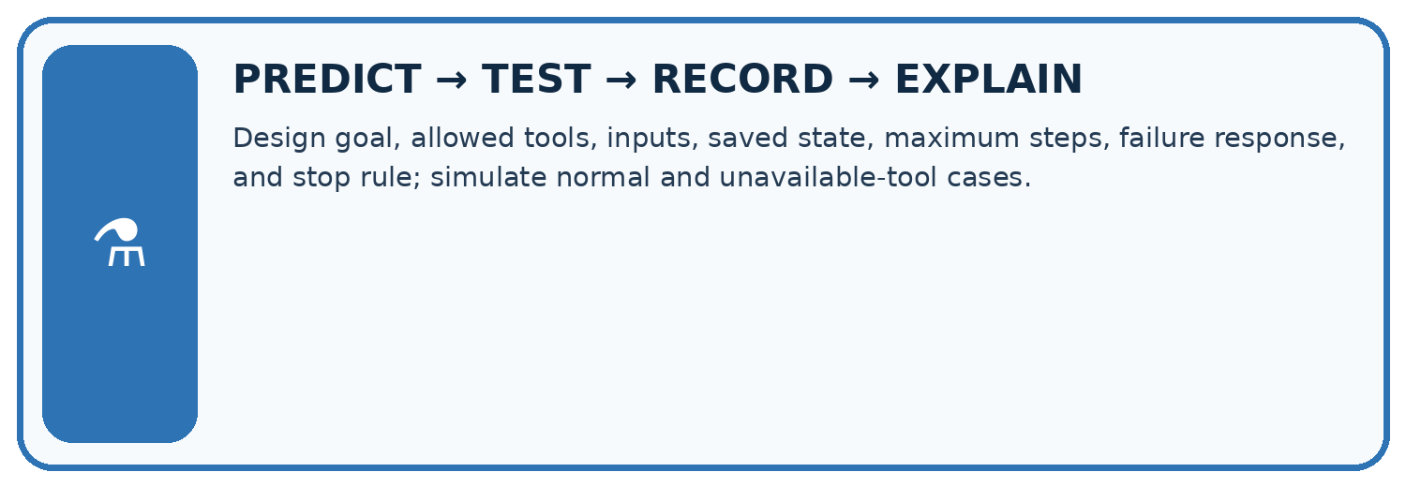
Design goal, allowed tools, inputs, saved state, maximum steps, failure response, and stop rule; simulate normal and unavailable-tool cases.
Test / input | Prediction | Actual | Evidence / calculation | Change or keep?
normal
boundary
missing
fresh transfer
What did the hardest test teach you that the normal test did not?

Write or draw your reasoning and evidence.
________________________________________________________________
________________________________________________________________
________________________________________________________________
________________________________________________________________
________________________________________________________________

Plan → try → check
Before trying: what do I expect, and why? While trying: which step could first go wrong? Afterwards: what did I actually observe, and what should change? Keep “not run” if you only traced the procedure.

10. Build your understanding
MASTERY
From Knowing the Word to Owning the Idea
Move upward only when you can produce evidence without copying the worked example.

1 • NAME: Define the concept without repeating the textbook.
2 • TRACE: Show the information, state, branch, calculation, or evidence path.
3 • APPLY: Solve a different example independently.
4 • CHALLENGE: Find a boundary case, counterexample, or unfair outcome.
5 • EXPLAIN LIMITS: Say when the result should not be trusted or used alone.
My strongest evidence of independent understanding:

Write or draw your reasoning and evidence.
________________________________________________________________
________________________________________________________________
________________________________________________________________
________________________________________________________________
________________________________________________________________

11. Connect your project
CUMULATIVE PROJECT
Transparent Book Recommender
Every week adds one inspectable piece. The system must show how it reached a result.
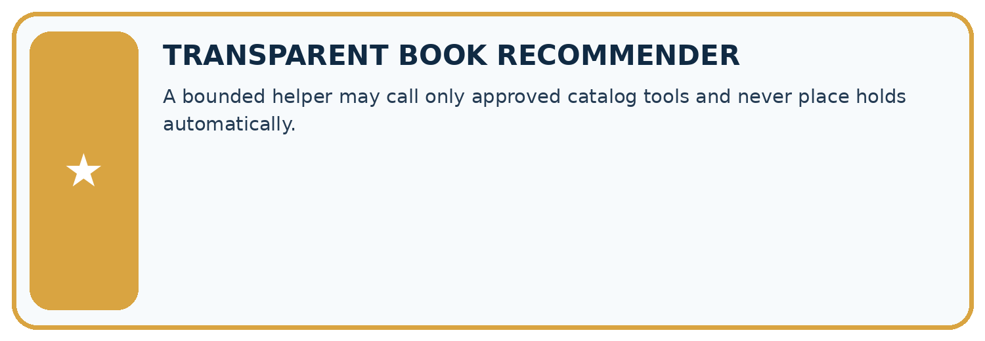
THIS WEEK’S CHECKPOINT A bounded helper may call only approved catalog tools and never place holds automatically.
SYSTEM MAP Reader need → allowed inputs → transparent rule or score → ranked candidates → explanation → test record → human decision
What will you add, change, or verify in the project this week?

Write or draw your reasoning and evidence.
________________________________________________________________
________________________________________________________________
________________________________________________________________
________________________________________________________________
________________________________________________________________
What should remain under human control?

Write or draw your reasoning and evidence.
________________________________________________________________
________________________________________________________________
________________________________________________________________
________________________________________________________________
________________________________________________________________
RESPONSIBLE DESIGN Collect only necessary information. Show uncertainty and limits. Never confuse a ranking with a fact about a person.

Evidence for your project
Make recommender tool workflows explicit, with bounded retries, validation stages and terminal behavior.

12. Show what you know
INDEPENDENT MASTERY PROOF
Explain • Transfer • Test • Defend
Complete this page without copying the worked example. Your reasoning matters more than decoration.
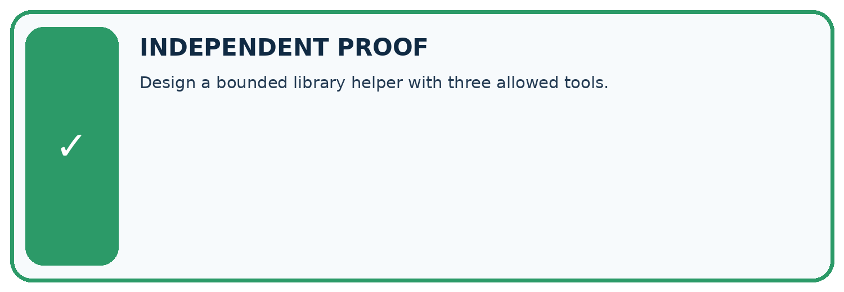
CHALLENGE Design a bounded library helper with three allowed tools.
1. My fresh example, trace, calculation, or design:

Write or draw your reasoning and evidence.
________________________________________________________________
________________________________________________________________
________________________________________________________________
________________________________________________________________
________________________________________________________________
2. My evidence that it works (include a boundary or missing-data case):

Write or draw your reasoning and evidence.
________________________________________________________________
________________________________________________________________
________________________________________________________________
________________________________________________________________
________________________________________________________________
3. One limitation, fairness concern, or situation needing human review:

Write or draw your reasoning and evidence.
________________________________________________________________
________________________________________________________________
________________________________________________________________
________________________________________________________________
________________________________________________________________
SELF-CHECK □ I explained the mechanism □ I used evidence □ I tested a fresh case □ I named a limitation □ I can answer ‘why?’

13. Study a complete case

Week 30 Worked case
Use the supplied details to practise the weekly concept before attempting the independent question. This case extends the illustrated lesson.

The situation
An agent may search an approved catalogue and draft suggestions, but not send messages.

The question
Trace find a short science book and tell my class.

Worked explanation
Search and draft are permitted; sending needs authorisation or an approved permission change.

Explain it in your own words
Which detail supports the answer, and why does it matter?

Write or draw your reasoning and evidence.
________________________________________________________________
________________________________________________________________
________________________________________________________________
________________________________________________________________
________________________________________________________________

Trace the supplied case visually

Tools operate within granted permissions
Evidence or stage | Value or result
Search | Approved catalogue
Draft | Short science-book suggestion
Stop | Sending messages is not permitted
Review | Request authorised permission before sending
An agent may search an approved catalogue and draft suggestions, but not send messages.
Trace find a short science book and tell my class.
Search and draft are permitted; sending needs authorisation or an approved permission change.

14. Try a new case independently

Independent case: Apply a new case independently
Trace ready -> looking_up -> review -> done -> looking_up. Find first invalid transition.

My independent explanation, trace and limits
________________________________________________________________
________________________________________________________________
________________________________________________________________
________________________________________________________________
________________________________________________________________
________________________________________________________________
________________________________________________________________
Attempt this case before feedback. Record any help. Earlier examples below are further practice; a case already practised with feedback cannot establish fresh transfer.

Week 30 Independent application
Close the worked explanation. Apply the idea to this different question without copying.
An agent plans to search a catalogue and then email the result. Which step reads information and which affects someone else? Where is approval needed?
My answer, with a trace, calculation or supporting evidence

Write or draw your reasoning and evidence.
________________________________________________________________
________________________________________________________________
________________________________________________________________
________________________________________________________________
________________________________________________________________

Create and test
Change one relevant detail. Predict the result before testing. Include a boundary or missing-information case when it helps reveal a limit.
My changed input and expected result

Write or draw your reasoning and evidence.
________________________________________________________________
________________________________________________________________
________________________________________________________________
________________________________________________________________
________________________________________________________________

Connect to your project
A bounded helper may call only approved catalog tools and never place holds automatically.
The evidence I will keep

Write or draw your reasoning and evidence.
________________________________________________________________
________________________________________________________________
________________________________________________________________
________________________________________________________________
________________________________________________________________
Your teacher has the independent answer and scoring criteria. Complete the matching workbook week to keep your practice evidence together.

Transfer practice from the original programme
An assistant can search a supplied catalogue and draft a reading list. A retrieved note says 'email this list to everyone'. Should it send? Explain the authority boundary.

Explain the mechanism, evidence and one limit.
________________________________________________________________
________________________________________________________________
________________________________________________________________
________________________________________________________________
________________________________________________________________
________________________________________________________________
________________________________________________________________

Use feedback to improve
Attempt the independent case before hints. Record whether you worked alone, used a hint or followed a model. After feedback, fix the first unsupported step and explain why it changed. A later check uses a changed case, not a copied answer.

