AI ACADEMY · STUDENT · ai-2/35

Improve and Challenge
Project: Transparent Book Recommender

Before you start
Week 28: comparisons need fixed requests and criteria.

01. Your mission

Your learning target
I can repair a specific observed failure.
I can check that earlier behavior still works.
I can keep a truthful change and failure record.

Remember before reading
Close your notes first. A rough first answer helps us choose the right starting point; it is not a score for your ability.
Without opening the old lesson, explain one key idea from Test Diverse Users. Give an example and a mistake that the idea helps you avoid.
Without opening the old lesson, explain one key idea from Project Problem and Success Test. Give an example and a mistake that the idea helps you avoid.
Without opening the old lesson, explain one key idea from Evidence and Sources. Give an example and a mistake that the idea helps you avoid.
After trying, check the relevant lesson or ask your teacher. Change the part of your explanation that the evidence shows was wrong.
Week 35: Improve and Challenge
A controlled improvement changes one design choice and reruns the same tests.

THINKER MISSION
Compare before/after scores and explain the tradeoff.
Thinker name and date:

Write or draw your reasoning and evidence.
________________________________________________________________
________________________________________________________________
________________________________________________________________
________________________________________________________________
________________________________________________________________

Readiness for the connected explanation
Why rerun old passing cases after a fix?

Readiness for Testing functions and interfaces
Why can testing only valid_item miss a pipeline bug?

My readiness explanation
________________________________________________________________
________________________________________________________________
________________________________________________________________

This week’s end goal
By the end, I can make a focused repair and challenge it with regression and order-invariance tests.

02. Notice the evidence
PICTURE STORY
Notice → Predict → Explain
Begin with visible evidence. Do not explain more than the picture and information support.
MYSTERY
The learners must use improve and challenge to solve a problem. What information do they have? What decision or calculation do they make? What would count as evidence that it worked?
Three observations (what you can point to):

Write or draw your reasoning and evidence.
________________________________________________________________
________________________________________________________________
________________________________________________________________
________________________________________________________________
________________________________________________________________
My prediction and the clue supporting it:

Write or draw your reasoning and evidence.
________________________________________________________________
________________________________________________________________
________________________________________________________________
________________________________________________________________
________________________________________________________________

A closer explanation
A fictional chooser wrongly excludes an activity at the exact time limit because it uses minutes < limit. The requirement says at most, so equality must qualify. Repair that condition, then test below, at and above the boundary plus earlier tie and invalid-input behavior.

Apply the connected idea: Testing functions and interfaces
Test the chooser at two scales. A unit test checks one validator or score calculation. An integration test runs validation through selection and reporting. Write expected outcomes from the specification, not by calling the same function twice.

03. See how it works
VISUAL MECHANISM
Input → Process → Output
Trace the information. At each stage, ask what changed and how you could test it.
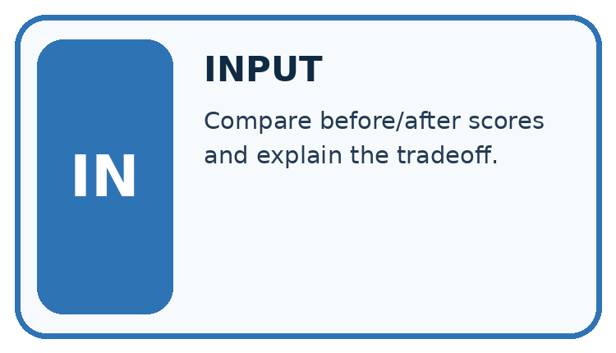
↓
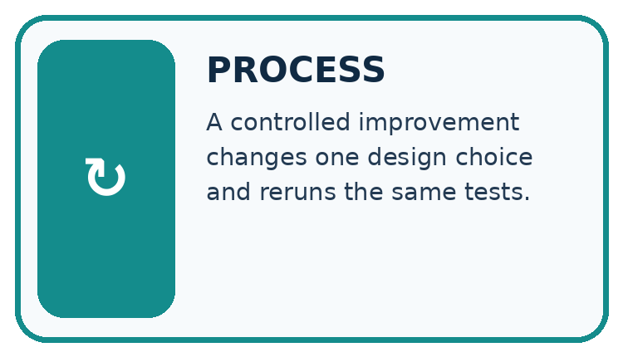
↓
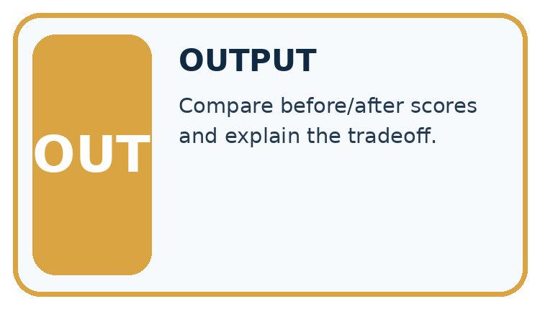
Which stage could fail even when the other two are correct? Explain:

Write or draw your reasoning and evidence.
________________________________________________________________
________________________________________________________________
________________________________________________________________
________________________________________________________________
________________________________________________________________

A closer explanation
def eligible(minutes, limit):
return minutes <= limit
for minutes, expected in [(9, True), (10, True), (11, False)]:
actual = eligible(minutes, 10)
assert actual == expected
print(minutes, actual)

Follow the evidence
Step or case | Evidence | Meaning
Before fix | 10 < 10 is False | Violates at most rule
After fix | 10 <= 10 is True | Boundary accepted
Neighbor check | 11 <= 10 is False | Over-limit still excluded
Read each row from left to right and connect the evidence to the stated rule.
The repaired predicate prints 9 True, 10 True and 11 False. It assumes validated numeric durations; it is not a replacement for the schema validator. A focused change is easier to explain and evaluate than unrelated edits made at the same time.

Repair the rule, then keep the evidence
At most includes equality. For a limit of 10, the durations 9 and 10 qualify while 11 does not. The strict comparison minutes < limit wrongly rejects 10; changing it to minutes <= limit repairs that boundary. Check below, at and above the boundary, then rerun earlier tie and invalid-input cases. Keep the original failure record so another person can understand what changed and which evidence supports the repair.

Apply the connected idea: Testing functions and interfaces
def score(item):
return 2 * item["fun"] + item["learning"]
cases = [( {"fun": 0, "learning": 0}, 0),
( {"fun": 3, "learning": 2}, 8),
( {"fun": 5, "learning": 5}, 15)]
for item, expected in cases:
assert score(item) == expected
print("3 score cases passed")

Follow the evidence
Step or case | Evidence | Meaning
Unit | Score 3 and 2 | Expect 8
Integration | Invalid high-score row | Must never win
Report | No eligible rows | Explain no suggestion
Read each row from left to right and connect the evidence to the stated rule.
The code prints its success message only if all assertions pass. It checks the scoring component but says nothing about duration filtering, malformed records, ties or reporting. Add focused cases for those requirements. Use the production functions from earlier weeks rather than rewriting a second copy just for tests.

Test the connections as well as the pieces
A score unit test asks whether the scoring function calculates the specified number. An integration test asks whether validation, filtering, scoring and reporting work together. A correct score does not establish that invalid records were rejected or that a tie was resolved correctly. Predict the full report from the input records before running. Check its counts and reasons as well as its selected name, and repeat a tie case with reversed input order.

Connect the picture and the explanation
Point to the input, the deciding step and the result in this week’s visual. Explain the same step in ordinary words. A picture helps when you can say what each part represents.

04. Compare the cases
CASE GALLERY
Four Tests, Four Kinds of Evidence
A system is not understood until it survives more than one comfortable example.


NORMAL CASE: predict and name evidence. BOUNDARY CASE: predict and name evidence.


MISSING INFORMATION: predict and name evidence. TRANSFER CASE: predict and name evidence.
Which case is most likely to reveal a hidden assumption? Why?

Write or draw your reasoning and evidence.
________________________________________________________________
________________________________________________________________
________________________________________________________________
________________________________________________________________
________________________________________________________________

Change one thing in the pictured case
Change: An alternative patch simply increases the limit to 101.
Prediction: C is wrongly admitted as well as A.
Reason: Changing the maximum alters the contract instead of repairing its comparison.

05. Words that unlock the idea
VOCABULARY LAB
Words You Can Use to Reason
A definition matters when you can recognize the idea, use it, and contrast it with a near-miss.
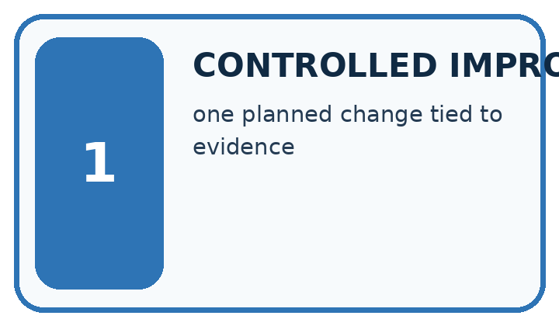
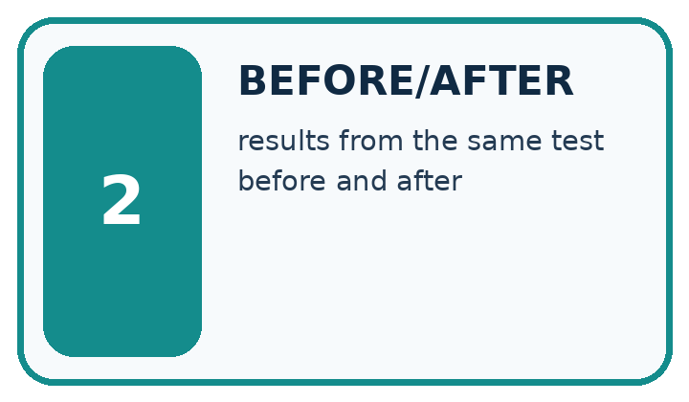
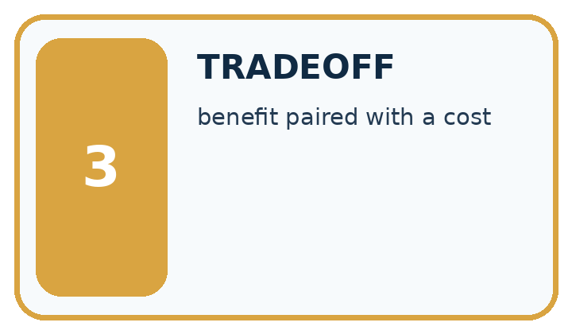
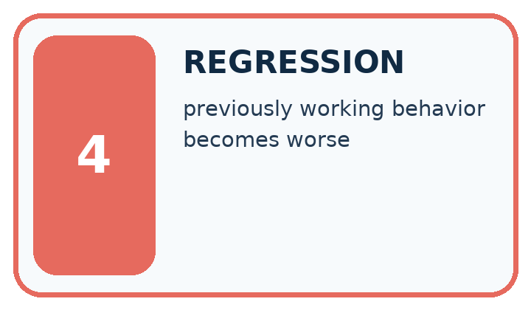
Word | My own example | Not this / boundary
controlled improvement | A revision whose effect is checked under comparable conditions rather than assumed from a changed result.
before/after | Results recorded prior to and following a change; other changes can affect the comparison.
tradeoff | A situation where improving one desired property can make another harder to achieve.
regression | In testing, a new failure introduced by a change; in modelling, prediction of a numeric target. Use the meaning indicated by the lesson.

Words used in the closer explanation
Word | Meaning
Regression suite | Earlier cases rerun after a change
Change log | A record of what changed and why
Root cause | The underlying reason for a failure
Residual risk | A limitation or possible failure remaining after a repair

Terms for Testing functions and interfaces
Term | Meaning
Unit test | A check of one small component
Integration test | A check of connected components
Fixture | A controlled input used in a test
Oracle | An independent source of the expected result

06. Follow a worked example
WORKED EVIDENCE
Reason Step by Step
Predict first. Then check each step. A correct answer without visible reasoning is incomplete evidence.
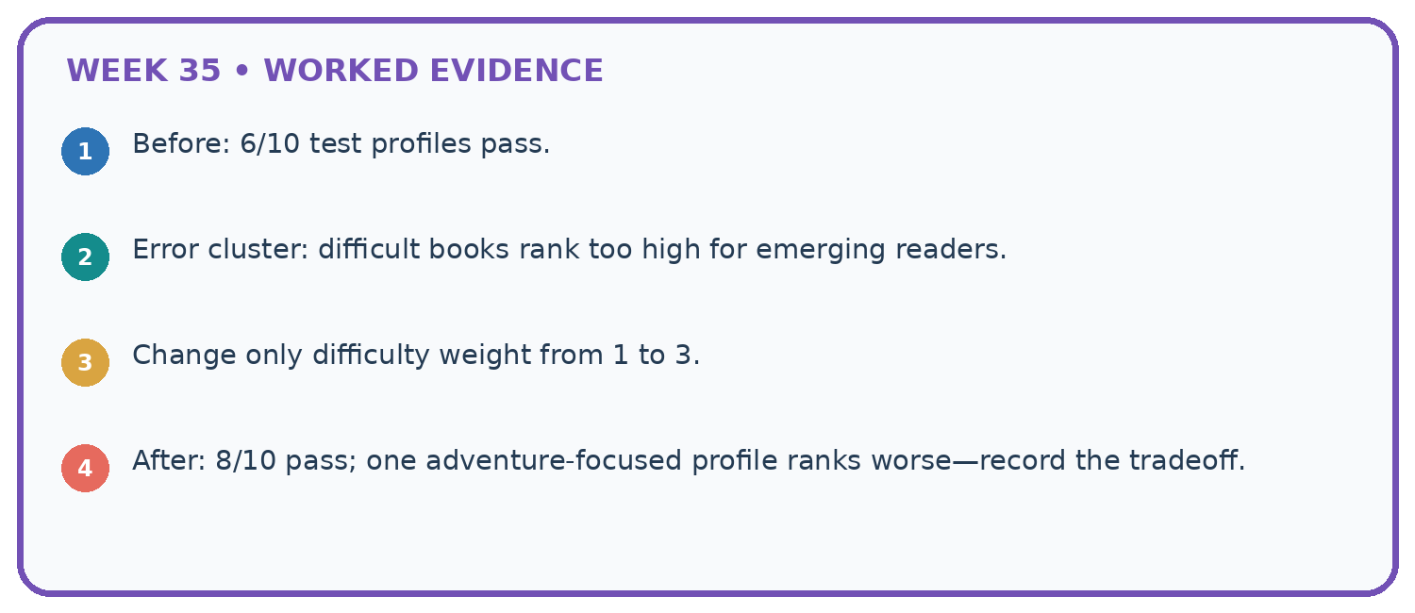
1. Before: 6/10 test profiles pass.
2. Error cluster: difficult books rank too high for emerging readers.
3. Change only difficulty weight from 1 to 3.
4. After: 8/10 pass; one adventure-focused profile ranks worse—record the tradeoff.
Recalculate, retrace, or restate the reasoning in your own representation:

Write or draw your reasoning and evidence.
________________________________________________________________
________________________________________________________________
________________________________________________________________
________________________________________________________________
________________________________________________________________
CHECK Did the evidence answer the exact question? Did the total, path, or source record stay consistent?

A closer explanation

Would changing the condition to minutes <= limit + 1 correctly repair the boundary? Explain with a revealing input.
________________________________________________________________
________________________________________________________________
________________________________________________________________
________________________________________________________________
________________________________________________________________
________________________________________________________________

Apply the connected idea: Testing functions and interfaces

A test computes expected = score(item) then compares score(item) to expected. Why is it weak?
________________________________________________________________
________________________________________________________________
________________________________________________________________
________________________________________________________________
________________________________________________________________
________________________________________________________________

Learn from the worked case
Cover the result before checking it. Say what is given, choose the procedure, and follow one step at a time. Then uncover the result and explain your first mismatch. Ask why a step is allowed, not only what number it produces.

A pictorial worked case: Improve and Challenge
A fictional recommender excludes books at an intended including equality page limit.

The facts we will use
Contract: pages<=100; highest interest; ties choose smaller ID. Old code uses pages<100.
Rows A pages100 interest5; B pages90 interest3; C pages101 interest5.
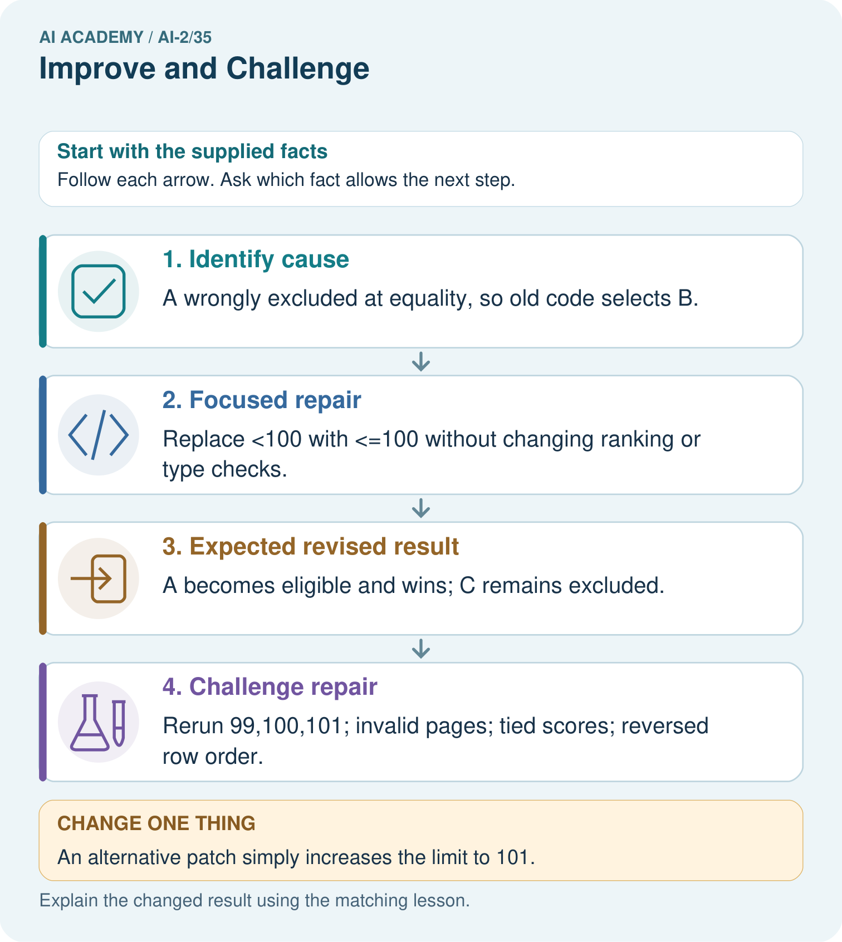

Read the picture one step at a time
Step | What happens and why
1. Identify cause | A wrongly excluded at equality, so old code selects B.
2. Focused repair | Replace <100 with <=100 without changing ranking or type checks.
3. Expected revised result | A becomes eligible and wins; C remains excluded.
4. Challenge repair | Rerun 99,100,101; invalid pages; tied scores; reversed row order.
Match each pictured step to the supplied facts. This is a worked teaching case, not an independent assessment.

Why this result follows
A focused change makes the claim about what caused the error testable: the equality comparison rule caused this specific failure. Regression tests check surrounding behavior that should remain unchanged. A tie case and reversed input order are necessary because a correct boundary does not ensure deterministic selection. Log the old failure and revised replay separately.

What this example does not establish
Passing a small regression suite does not prove all behavior unchanged; record the suite’s actual coverage.

07. Find and repair a mistake
ERROR DETECTIVE
Compare → Diagnose → Repair
Do not patch the answer. Find the earliest unsupported assumption, wrong step, or weak evidence.
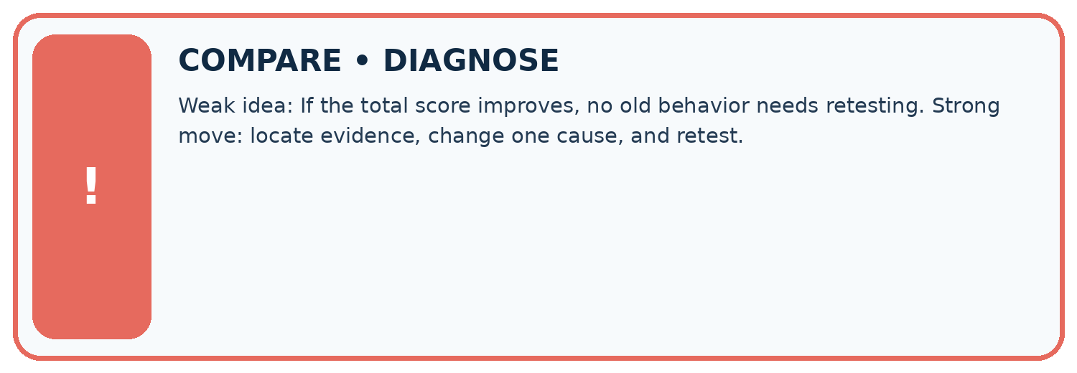
Evidence record | Expected | Actual | Likely cause / next test
normal case | works
boundary case | stated rule
missing input | safe response
fresh transfer | generalizes
Repair one cause. Why is this repair better than changing several things?

Write or draw your reasoning and evidence.
________________________________________________________________
________________________________________________________________
________________________________________________________________
________________________________________________________________
________________________________________________________________

A closer explanation
A clean regression run does not erase the earlier failure. Keep before/after evidence and remaining limitations. If a fix was informed by reserved evaluation cases, report that contamination and obtain new independent cases.

Record the bug, change, evidence and one remaining limit without claiming all bugs are gone.
________________________________________________________________
________________________________________________________________
________________________________________________________________
________________________________________________________________
________________________________________________________________
________________________________________________________________

Apply the connected idea: Testing functions and interfaces
Test results establish only the executed cases on the tested version. Retain failures and version information. Use explicit expected rejection behavior for invalid data instead of assuming every exception is acceptable.

What expected result should an empty-input integration case specify?
________________________________________________________________
________________________________________________________________
________________________________________________________________
________________________________________________________________
________________________________________________________________
________________________________________________________________

08. Practise together
LOGIC STUDIO
Trace Before You Run
Block code, pseudocode, tables, and diagrams are different ways to expose the same reasoning.

SET evidence_record
PREDICT expected_result
RUN one normal case and one boundary case
COMPARE actual_result with expected_result
IF different: locate first cause; change one factor; RETEST
EXPLAIN result, limitation, and next safe step
Trace one input. Which line changes the state or chooses a path?

Write or draw your reasoning and evidence.
________________________________________________________________
________________________________________________________________
________________________________________________________________
________________________________________________________________
________________________________________________________________

A closer explanation
Changing the expected boundary result to False would make the test pass while violating the requirement. Keep the requirement and independently calculated expectation; repair the implementation. If requirements truly change, document that as a policy change.

Apply the connected idea: Testing functions and interfaces
A test suite that only checks the winner name can miss wrong rejection counts. Check the full expected report: supplied, accepted, rejected, eligible, selected and reason. Avoid relying on dictionary display order when the contract concerns values.

Practise with less help: Test neighbors
Use workbook W2 for the connected example “Improving without hiding failures”. First fill the input and rule boxes. Try the middle steps before asking for a hint. After a hint, try the next step yourself.
Plan | Do | Check
What is given? Which rule or procedure applies? | Record each intermediate step. | Does the result follow? What remains unknown?
Explain your trace to a partner. Your partner points to one step to check. Swap roles on the next case. Each person writes their own explanation.

Check your reasoning
Use the worked case for Improving without hiding failures. Proposed explanation: “A successful run proves the conclusion”. Decide whether this explanation is supported. Point to the step or supplied fact that decides; explain your repair if needed.
Answer on your own before discussion. If you are unsure, say which step you need help with.

Practise the connected topic: Testing functions and interfaces
Use its named workbook W2. Identify the given inputs, try the middle steps with less help, then explain your trace. Check this claim before group discussion: A successful run proves the conclusion

Explain the picture
Why are tests at both 100 and 101 needed?

My explanation using a pictured step and the given facts
________________________________________________________________
________________________________________________________________
________________________________________________________________
________________________________________________________________
This is supported practice. Keep the separately named independent case for an attempt before feedback.

09. Run the investigation
EVIDENCE LAB
Predict → Test → Record → Explain
Keep expected and actual results separate. Surprises are useful data when recorded honestly.
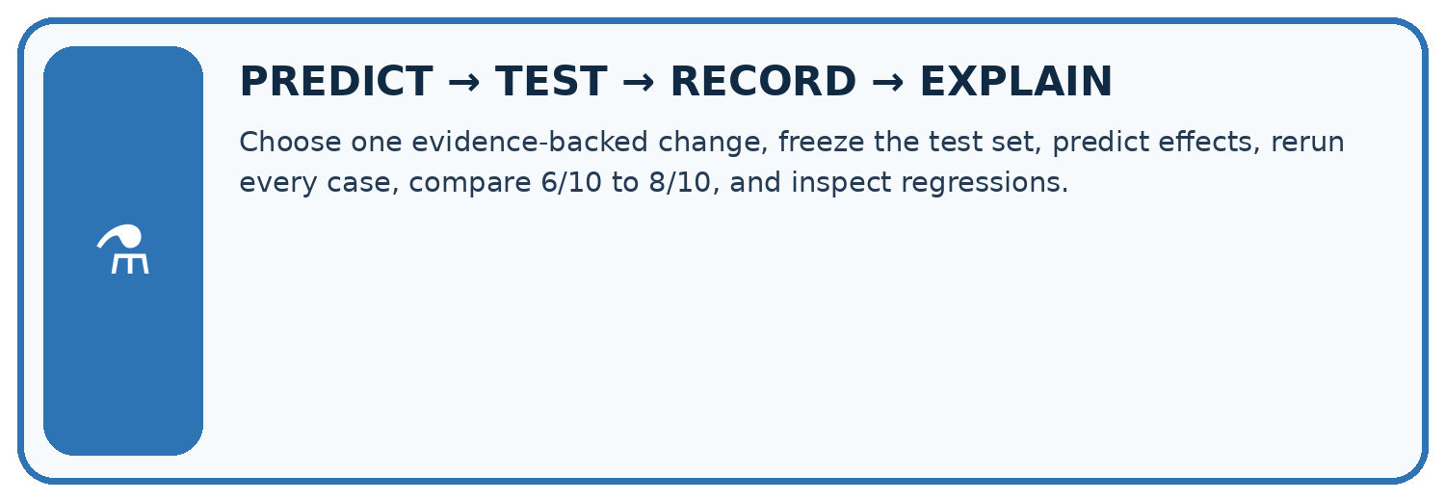
Choose one evidence-backed change, freeze the test set, predict effects, rerun every case, compare 6/10 to 8/10, and inspect regressions.
Test / input | Prediction | Actual | Evidence / calculation | Change or keep?
normal
boundary
missing
fresh transfer
What did the hardest test teach you that the normal test did not?

Write or draw your reasoning and evidence.
________________________________________________________________
________________________________________________________________
________________________________________________________________
________________________________________________________________
________________________________________________________________

Plan → try → check
Before trying: what do I expect, and why? While trying: which step could first go wrong? Afterwards: what did I actually observe, and what should change? Keep “not run” if you only traced the procedure.

10. Build your understanding
MASTERY
From Knowing the Word to Owning the Idea
Move upward only when you can produce evidence without copying the worked example.

1 • NAME: Define the concept without repeating the textbook.
2 • TRACE: Show the information, state, branch, calculation, or evidence path.
3 • APPLY: Solve a different example independently.
4 • CHALLENGE: Find a boundary case, counterexample, or unfair outcome.
5 • EXPLAIN LIMITS: Say when the result should not be trusted or used alone.
My strongest evidence of independent understanding:

Write or draw your reasoning and evidence.
________________________________________________________________
________________________________________________________________
________________________________________________________________
________________________________________________________________
________________________________________________________________

11. Connect your project
CUMULATIVE PROJECT
Transparent Book Recommender
Every week adds one inspectable piece. The system must show how it reached a result.
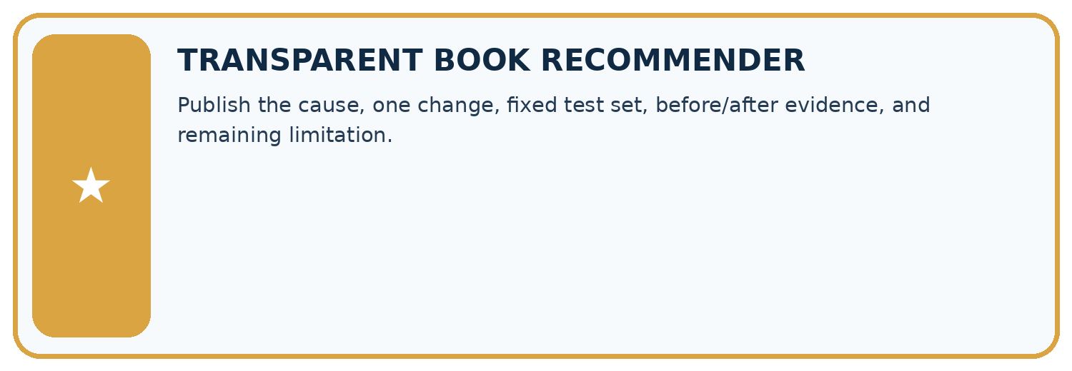
THIS WEEK’S CHECKPOINT Publish the cause, one change, fixed test set, before/after evidence, and remaining limitation.
SYSTEM MAP Reader need → allowed inputs → transparent rule or score → ranked candidates → explanation → test record → human decision
What will you add, change, or verify in the project this week?

Write or draw your reasoning and evidence.
________________________________________________________________
________________________________________________________________
________________________________________________________________
________________________________________________________________
________________________________________________________________
What should remain under human control?

Write or draw your reasoning and evidence.
________________________________________________________________
________________________________________________________________
________________________________________________________________
________________________________________________________________
________________________________________________________________
RESPONSIBLE DESIGN Collect only necessary information. Show uncertainty and limits. Never confuse a ranking with a fact about a person.

Evidence for your project
For each recommender revision, retain cause, code change, targeted test, regression results and unresolved issues.

12. Show what you know
INDEPENDENT MASTERY PROOF
Explain • Transfer • Test • Defend
Complete this page without copying the worked example. Your reasoning matters more than decoration.
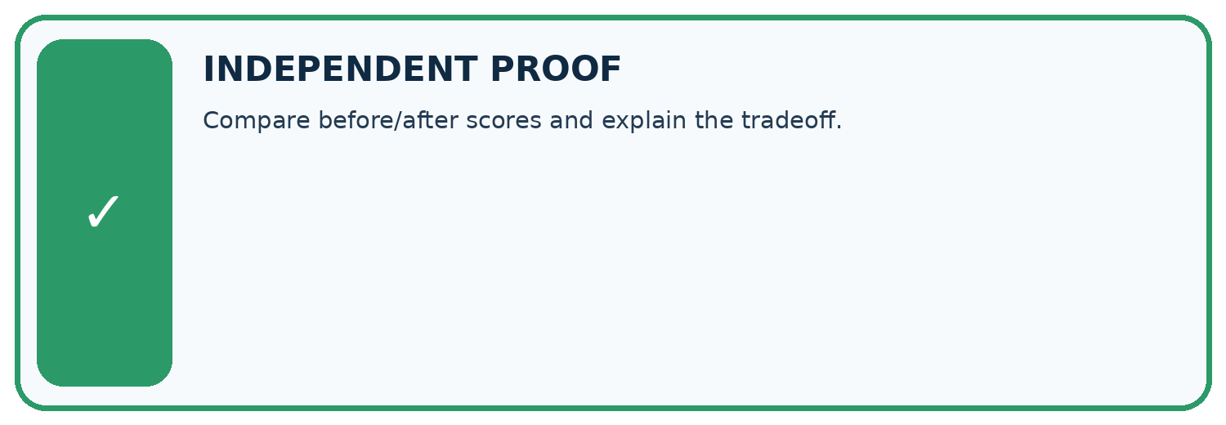
CHALLENGE Compare before/after scores and explain the tradeoff.
1. My fresh example, trace, calculation, or design:

Write or draw your reasoning and evidence.
________________________________________________________________
________________________________________________________________
________________________________________________________________
________________________________________________________________
________________________________________________________________
2. My evidence that it works (include a boundary or missing-data case):

Write or draw your reasoning and evidence.
________________________________________________________________
________________________________________________________________
________________________________________________________________
________________________________________________________________
________________________________________________________________
3. One limitation, fairness concern, or situation needing human review:

Write or draw your reasoning and evidence.
________________________________________________________________
________________________________________________________________
________________________________________________________________
________________________________________________________________
________________________________________________________________
SELF-CHECK □ I explained the mechanism □ I used evidence □ I tested a fresh case □ I named a limitation □ I can answer ‘why?’

13. Study a complete case

Week 35 Worked case
Use the supplied details to practise the weekly concept before attempting the independent question. This case extends the illustrated lesson.

The situation
A repair raises success from 7/10 to 9/10 on the same validation set.

The question
What belongs in the improvement claim?

Worked explanation
Confirm fixed criteria, inspect remaining and introduced failures, then test the chosen version on fresh final cases.

Explain it in your own words
Which detail supports the answer, and why does it matter?

Write or draw your reasoning and evidence.
________________________________________________________________
________________________________________________________________
________________________________________________________________
________________________________________________________________
________________________________________________________________

Trace the supplied case visually

Improve with comparable evidence
Evidence or stage | Value or result
Before | Save results and failures
Revision | Change one identified cause
Retest | Use the same development cases
Final check | Reserve fresh cases
A repair raises success from 7/10 to 9/10 on the same validation set.
What belongs in the improvement claim?
Confirm fixed criteria, inspect remaining and introduced failures, then test the chosen version on fresh final cases.

14. Try a new case independently

Independent case: Repair independently
Write the eligibility predicate for at most 12 minutes and a regression set including 11,12,13 and 0. Add one chooser tie case and one invalid-data case to rerun.

My independent explanation, trace and limits
________________________________________________________________
________________________________________________________________
________________________________________________________________
________________________________________________________________
________________________________________________________________
________________________________________________________________
________________________________________________________________
Attempt this case before feedback. Record any help. Earlier examples below are further practice; a case already practised with feedback cannot establish fresh transfer.

Week 35 Independent application
Close the worked explanation. Apply the idea to this different question without copying.
After changing a scoring weight, the system fixes one request but breaks two previously correct ones. What should the improvement record say?
My answer, with a trace, calculation or supporting evidence

Write or draw your reasoning and evidence.
________________________________________________________________
________________________________________________________________
________________________________________________________________
________________________________________________________________
________________________________________________________________

Create and test
Change one relevant detail. Predict the result before testing. Include a boundary or missing-information case when it helps reveal a limit.
My changed input and expected result

Write or draw your reasoning and evidence.
________________________________________________________________
________________________________________________________________
________________________________________________________________
________________________________________________________________
________________________________________________________________

Connect to your project
Publish the cause, one change, fixed test set, before/after evidence, and remaining limitation.
The evidence I will keep

Write or draw your reasoning and evidence.
________________________________________________________________
________________________________________________________________
________________________________________________________________
________________________________________________________________
________________________________________________________________
Your teacher has the independent answer and scoring criteria. Complete the matching workbook week to keep your practice evidence together.

Transfer practice from the original programme
After a scoring change, four old failures pass but two previous passes fail. On the original ten cases there were six passes. Compute the new total and explain what else should be reported.

Explain the mechanism, evidence and one limit.
________________________________________________________________
________________________________________________________________
________________________________________________________________
________________________________________________________________
________________________________________________________________
________________________________________________________________
________________________________________________________________

Use feedback to improve
Attempt the independent case before hints. Record whether you worked alone, used a hint or followed a model. After feedback, fix the first unsupported step and explain why it changed. A later check uses a changed case, not a copied answer.

