AI ACADEMY · STUDENT · ai-3/3

Tokens and Context
Project: Verified Study Buddy

Before you start
AI-2 Week 25: tokenizer units need not equal words.

01. Your mission

Your learning target
I can account for fixed text, evidence and reserved output under a toy budget.
I can select complete evidence for a stated question.
I can handle insufficient or conflicting evidence explicitly.

Remember before reading
Close your notes first. A rough first answer helps us choose the right starting point; it is not a score for your ability.
Without opening the old lesson, explain one key idea from A Distribution of Possibilities. Give an example and a mistake that the idea helps you avoid.
After trying, check the relevant lesson or ask your teacher. Change the part of your explanation that the evidence shows was wrong.
Week 3: Tokens and Context
Models operate on tokens within a limited context window.

CREATOR MISSION
Tokenize text, remove context, and predict failure changes.
Creator name and date:

Write or draw your reasoning and evidence.
________________________________________________________________
________________________________________________________________
________________________________________________________________
________________________________________________________________
________________________________________________________________

Readiness for the connected explanation
Does lower next-token loss guarantee supported factual answers?

Readiness for Attention as weighted information selection
Why can equal row sums conceal different sequences?

My readiness explanation
________________________________________________________________
________________________________________________________________
________________________________________________________________

This week’s end goal
By the end, I can budget context and preserve evidence needed to interpret a requested fact.

02. Notice the evidence
PICTURE STORY
Notice → Predict → Explain
Begin with visible evidence. Do not explain more than the picture and information support.
MYSTERY
The learners must use tokens and context to solve a problem. What information do they have? What decision or calculation do they make? What would count as evidence that it worked?
Three observations (what you can point to):

Write or draw your reasoning and evidence.
________________________________________________________________
________________________________________________________________
________________________________________________________________
________________________________________________________________
________________________________________________________________
My prediction and the clue supporting it:

Write or draw your reasoning and evidence.
________________________________________________________________
________________________________________________________________
________________________________________________________________
________________________________________________________________
________________________________________________________________

A closer explanation
For this lesson only, a fictional system allows 100 total token units for input plus reserved output. Its fixed instructions use 20 units, question 10 and output reserve 20. That leaves 50 units for evidence. These are supplied counts, not word counts or a claim about any deployed model. Other systems can use different input/output accounting, so read their exact contract.
The question is: “Which room is approved for the robotics meeting, and what is its capacity?” Evidence A, a current approval notice, costs 30 units and names room B. Evidence B, the current room register, costs 20 and gives room B capacity 12. Evidence C, an old approval notice, costs 25 and names room A.

Apply the connected idea: Attention as weighted information selection
Attention computes a weighted combination of value vectors, with weights derived from query-key compatibility. Queries, keys and values are distinct roles even when they come from the same sequence. A weight is a numerical contribution in this computation, not proof of the source’s truth or permission. This week supplies weights directly; Week 7 calculates them from scores.
Use three values V1=[2,0], V2=[0,4], V3=[4,2] with weights 0.5,0.25,0.25. Values have equal width and weights are nonnegative with sum 1. Compute each coordinate separately. No token is literally copied by this combination.

03. See how it works
VISUAL MECHANISM
Input → Process → Output
Trace the information. At each stage, ask what changed and how you could test it.
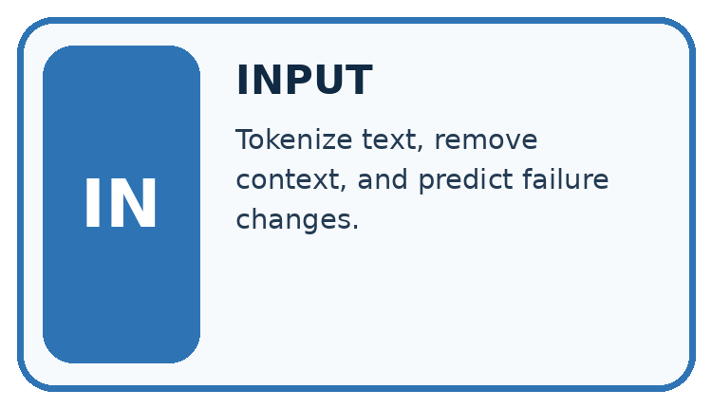
↓
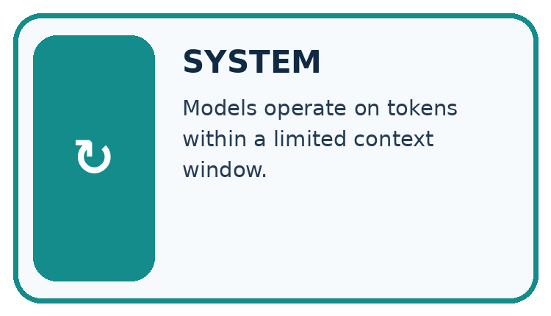
↓
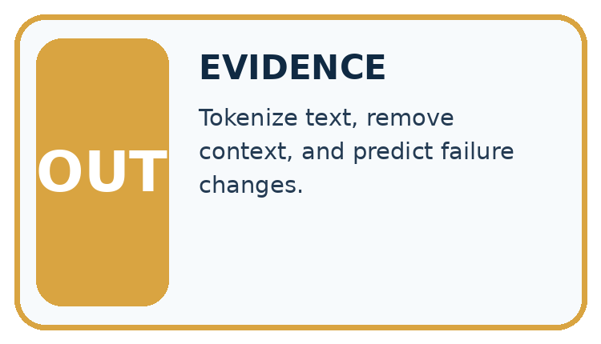
Which stage could fail even when the other two are correct? Explain:

Write or draw your reasoning and evidence.
________________________________________________________________
________________________________________________________________
________________________________________________________________
________________________________________________________________
________________________________________________________________

A closer explanation
Evidence | Cost | What it supports
A: current approval | 30 | Approved room B
B: current register | 20 | Room B capacity 12
C: superseded approval | 25 | Old room A approval
A+B costs 50 and fits exactly. Together they support both requested claims. A+C costs 55 and exceeds the evidence budget, while C+B fits at 45 but supplies an outdated room decision. A cheap set is not necessarily an adequate set. Preserve document IDs, versions and dates alongside content.

Keep the evidence roles separate
Plan or input | Procedure | Permitted conclusion
100 total units | Subtract 20+10+20 | 50 evidence units
A 30 plus B 20 | Exactly 50 evidence units | Supports both requested claims
Insufficient evidence | Ask or abstain | Do not invent the missing fact
Arithmetic fit and evidential adequacy are separate checks.

Apply the connected idea: Attention as weighted information selection
Value | Weight | Weighted vector
[2,0] | 0.5 | [1,0]
[0,4] | 0.25 | [0,1]
[4,2] | 0.25 | [1,0.5]
Adding the weighted vectors gives [2,1.5]. The same weights applied to different values can give a different result; the same values with different weights can also change it. For example weights 0,1,0 yield V2=[0,4]. The result is a representation to be used by later operations, not automatically a generated word.

Keep the evidence roles separate
Plan or input | Procedure | Permitted conclusion
Values with equal width | Multiply by .5, .25, .25 | Contributions [1,0], [0,1], [1,.5]
Weighted contributions | Add corresponding coordinates | Output [2,1.5]
Mask excludes V3 | Renormalise V1 and V2 | Output [4/3,4/3]
The mask changes the eligible positions and therefore the probability mass assigned to the remaining values.

Connect the picture and the explanation
Point to the input, the deciding step and the result in this week’s visual. Explain the same step in ordinary words. A picture helps when you can say what each part represents.

04. Compare the cases
CASE GALLERY
Four Tests, Four Kinds of Evidence
A system is not understood until it survives more than one comfortable example.


NORMAL CASE: predict and name evidence. BOUNDARY CASE: predict and name evidence.


MISSING INFORMATION: predict and name evidence. TRANSFER CASE: predict and name evidence.
Which case is most likely to reveal a hidden assumption? Why?

Write or draw your reasoning and evidence.
________________________________________________________________
________________________________________________________________
________________________________________________________________
________________________________________________________________
________________________________________________________________

Change one thing in the pictured case
Change: Increase B’s cost to 30 with all other costs fixed.
Prediction: A+B costs 48 and no longer fits the 45-token evidence capacity.
Reason: Do not silently omit the exception; use an approved source-preserving summary, another retrieval step or an honest incomplete-evidence response.

05. Words that unlock the idea
VOCABULARY LAB
Words You Can Use to Reason
A definition matters when you can recognize the idea, use it, and contrast it with a near-miss.
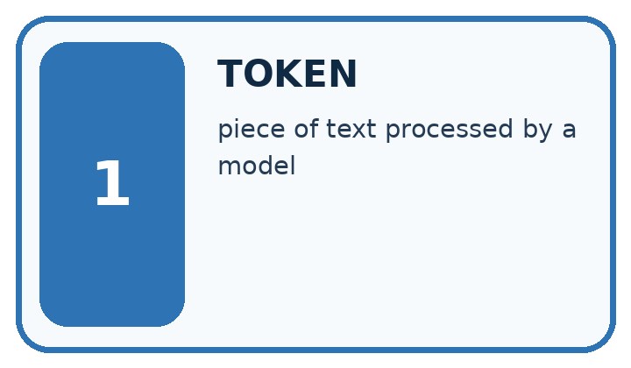
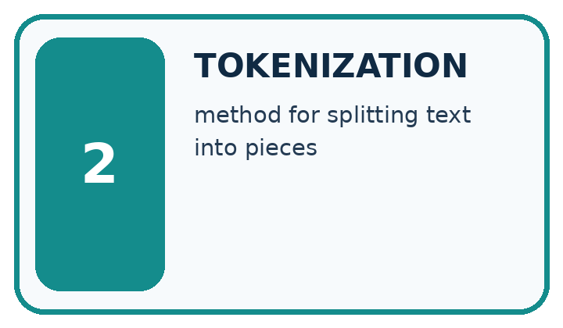
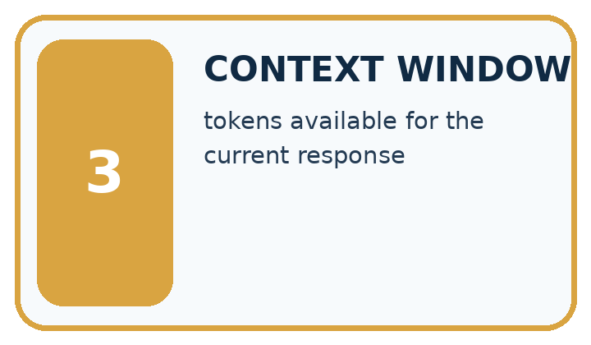
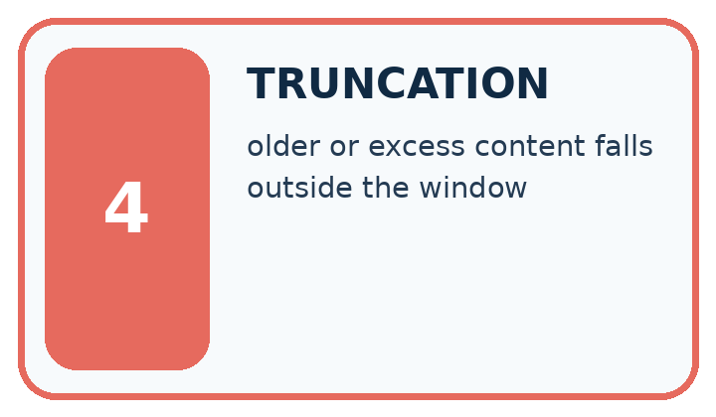
Word | My own example | Not this / boundary
token | A unit of encoded text processed by a language model, which may be a word, part of a word or punctuation.
tokenization | Converting text into the token units of a particular tokenizer.
context window | The bounded amount of token information a model can process together in a particular use.
truncation | Removing part of information, often because it exceeds a length or context limit.

Words used in the closer explanation
Word | Meaning
Context budget | The permitted input and output allocation under a stated model or classroom contract
Evidence selection | Choosing source material relevant to the requested claim
Reserved output | Capacity deliberately kept available for the response

Terms for Attention as weighted information selection
Term | Meaning
Query | A vector used to compare available keys for the current calculation
Key | A vector used to determine compatibility with a query
Value | A vector combined using the resulting attention weights
Mask | A rule excluding specified positions from a calculation

06. Follow a worked example
WORKED EVIDENCE
Reason Step by Step
Predict first. Then check each step. A correct answer without visible reasoning is incomplete evidence.
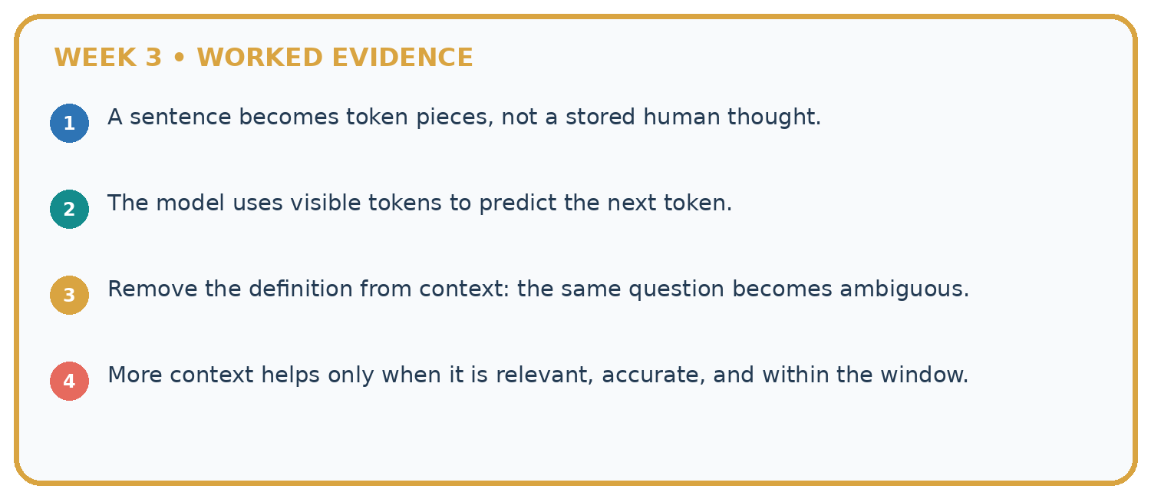
1. A sentence becomes token pieces, not a stored human thought.
2. The model uses visible tokens to predict the next token.
3. Remove the definition from context: the same question becomes ambiguous.
4. More context helps only when it is relevant, accurate, and within the window.
Recalculate, retrace, or restate the reasoning in your own representation:

Write or draw your reasoning and evidence.
________________________________________________________________
________________________________________________________________
________________________________________________________________
________________________________________________________________
________________________________________________________________
CHECK Did the evidence answer the exact question? Did the total, path, or source record stay consistent?

A closer explanation
A source may contain an exception after a general statement. Cutting off the last paragraph can reverse its practical meaning. Selection should preserve the passages needed to interpret the requested fact, including scope, version and exceptions. If complete relevant evidence cannot fit, retrieve a smaller authoritative passage or request clarification rather than silently remove a qualifying condition.
Including a document in context does not prove the generated answer uses it correctly. After generation, check each claim against its source. A source’s instruction-like content also does not acquire authority just because it fits in the evidence budget.

Apply the connected idea: Attention as weighted information selection
Suppose V3 is a future position unavailable to the current autoregressive step. The mask excludes it. For this supplied-weight example, renormalise the permitted weights 0.5 and 0.25 by their total 0.75, giving 2/3 and 1/3. The result becomes [4/3,4/3]. Merely setting V3’s contribution to zero while keeping the old weights produces [1,1], whose retained weights sum to 0.75; that is not the specified normalised combination.
If every position is excluded, the permitted total is zero. This contract reports no available value rather than dividing by zero or silently using a future position. A real implementation needs its own documented handling for empty masks. A causal mask restricts information paths; it does not make retrieved content factually trustworthy.

Learn from the worked case
Cover the result before checking it. Say what is given, choose the procedure, and follow one step at a time. Then uncover the result and explain your first mismatch. Ask why a step is allowed, not only what number it produces.

A pictorial worked case: Tokens and Context
A fictional assistant has a small context budget for answering an event-capacity question.

The facts we will use
Total budget 100 toy tokens; instructions 20, question 10, output reserve 25. Evidence capacity is the remainder.
Current capacity record A costs 18; its safety exception B costs 20; unrelated slogan C costs 12. A says 20 seats; B caps this event at 12.
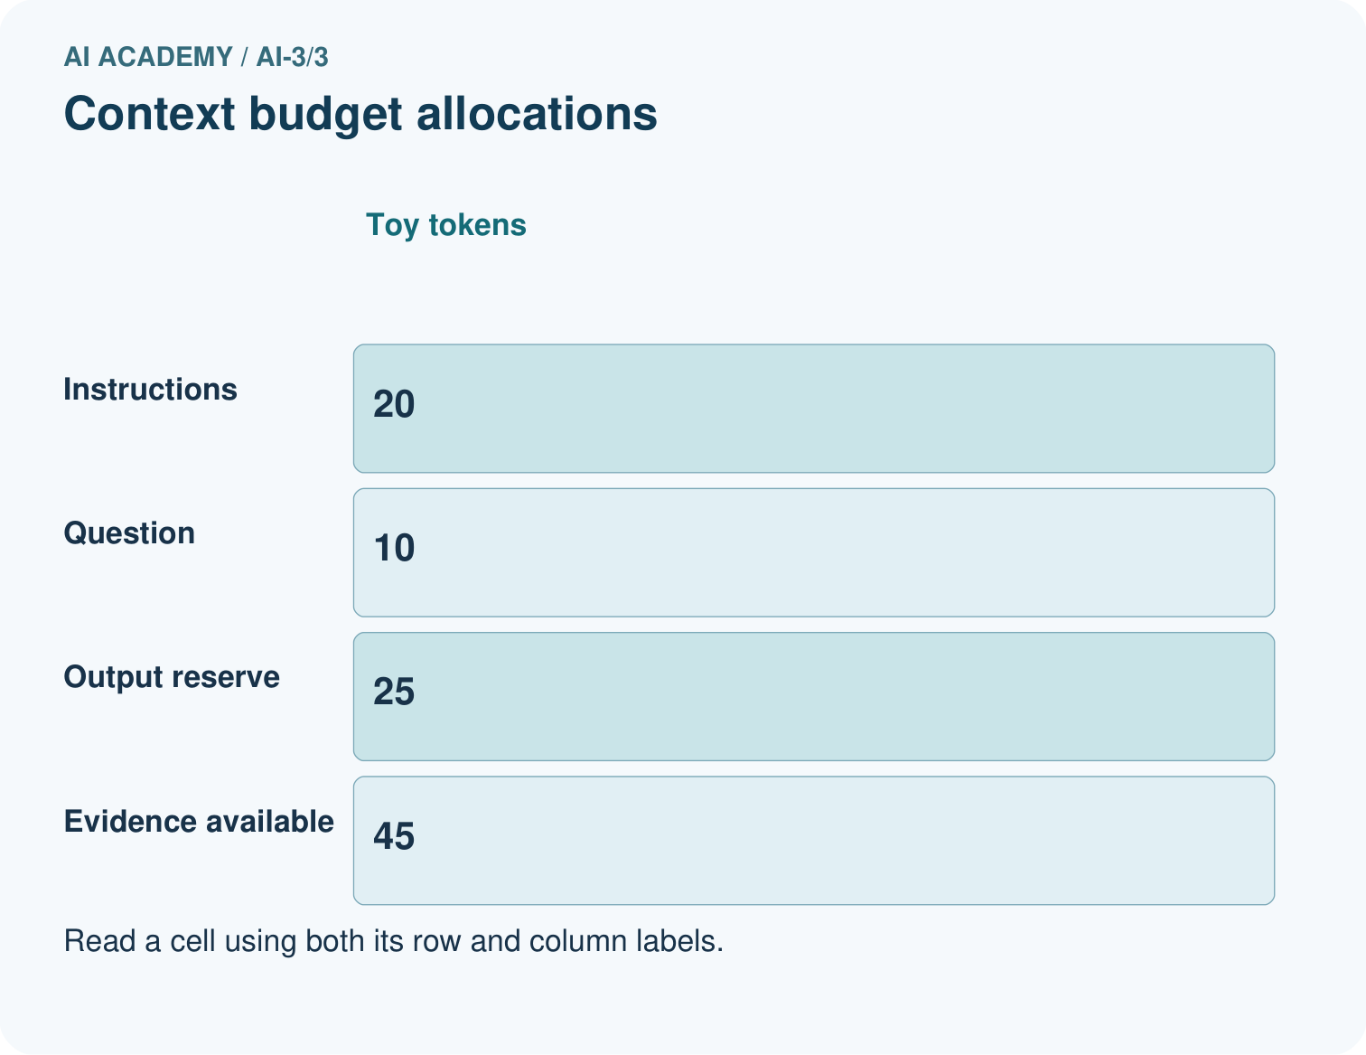
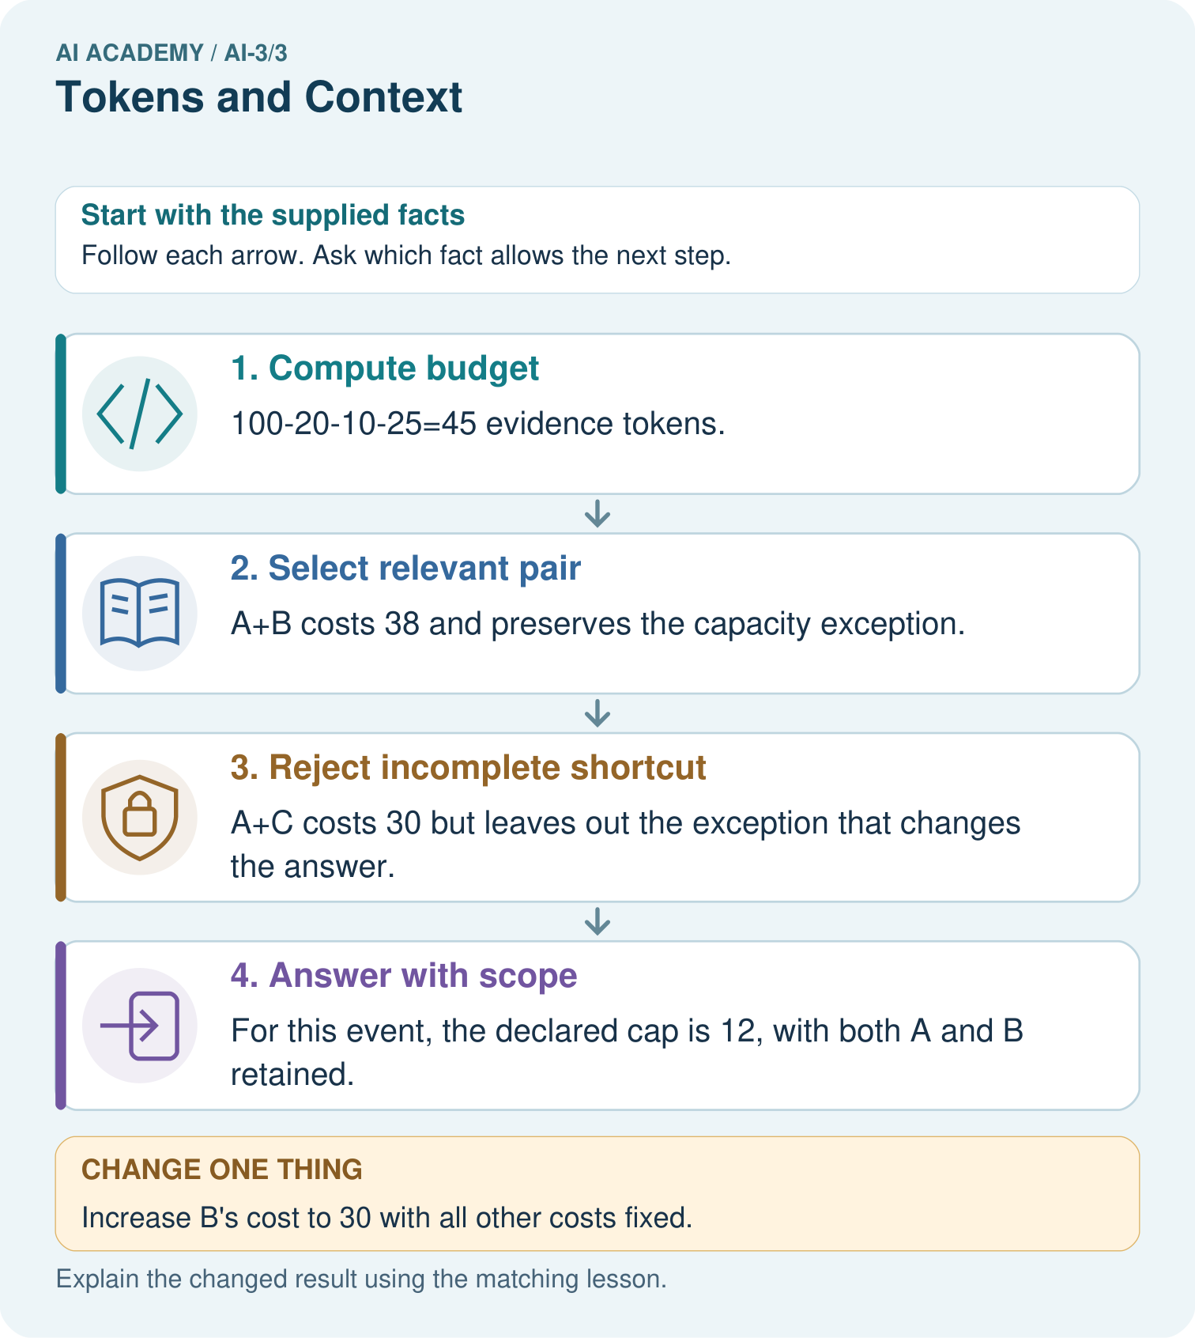

Read the picture one step at a time
Step | What happens and why
1. Compute budget | 100−20−10−25=45 evidence tokens.
2. Select relevant pair | A+B costs 38 and preserves the capacity exception.
3. Reject incomplete shortcut | A+C costs 30 but leaves out the exception that changes the answer.
4. Answer with scope | For this event, the declared cap is 12, with both A and B retained.
Match each pictured step to the supplied facts. This is a worked teaching case, not an independent assessment.

Why this result follows
A context window limits how much information is available in one model call. Selecting the shortest passage is not always sufficient: an exception can change the meaning of a general statement. Keep the relevant source relationship visible. Toy token costs are supplied here; real token counts depend on the model’s tokenizer.

What this example does not establish
Fitting in context does not guarantee attention, correct interpretation or accurate generation.

07. Find and repair a mistake
ERROR DETECTIVE
Compare → Diagnose → Repair
Do not patch the answer. Find the earliest unsupported assumption, wrong step, or weak evidence.
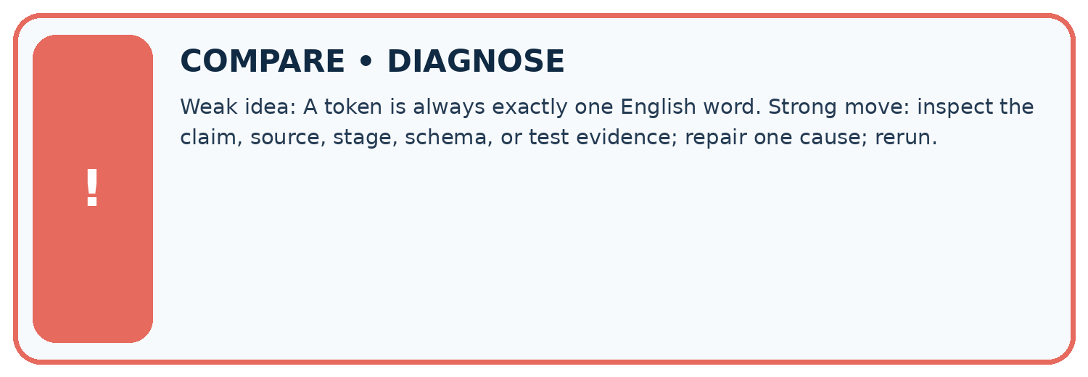
Evidence record | Expected | Actual | Likely cause / next test
normal case | works
boundary case | stated rule
missing input | safe response
fresh transfer | generalizes
Repair one cause. Why is this repair better than changing several things?

Write or draw your reasoning and evidence.
________________________________________________________________
________________________________________________________________
________________________________________________________________
________________________________________________________________
________________________________________________________________

A closer explanation
If room approval is missing, do not infer it from capacity. If sources conflict without a documented current version, report the conflict or ask the responsible person. Keep the requested claim, budget calculation, selected source IDs and unresolved facts in the record. This classroom accounting develops the reasoning without needing a live model.

Exit: A is unavailable and B gives only room capacity. Write a response that reports the supported fact without claiming the meeting is approved there.
________________________________________________________________
________________________________________________________________
________________________________________________________________
________________________________________________________________
________________________________________________________________

Apply the connected idea: Attention as weighted information selection
A large weight means a large coefficient in this particular weighted sum. It is not a complete explanation of the whole network, which may contain other heads, transformations and residual paths. It also does not establish that the high-weight source is true. Trace the actual values and downstream use before making a broader claim.

Exit: a team says a 0.9 attention weight proves a document is correct and allows following its instructions. Explain the two unsupported inferences.
________________________________________________________________
________________________________________________________________
________________________________________________________________
________________________________________________________________
________________________________________________________________

08. Practise together
LOGIC STUDIO
Specify Before You Run
Prompts, schemas, retrieval, tool calls, and code are inspectable parts of one AI product.

SET task, audience, constraints, output_schema
LOAD approved_context or retrieval_result
CALL model or allowed_tool
VALIDATE fields, claims, citations, and safety
IF evidence missing: ask, retrieve, or abstain
RETURN useful output + source trail + limitations
Trace one input. Which line changes the state or chooses a path?

Write or draw your reasoning and evidence.
________________________________________________________________
________________________________________________________________
________________________________________________________________
________________________________________________________________
________________________________________________________________

A closer explanation
Supported total 80, fixed instructions 15, question 10 and reserved output 15 leave 40 units. Two complete relevant passages cost 18 and 22, fitting exactly. A third irrelevant passage costs 8; adding it would exceed the stated total. A short summary can reduce size but must retain claim-supporting qualifiers and be checked against the original.

Guided: calculate the available evidence units and explain why exact fit does not prove answer correctness.
________________________________________________________________
________________________________________________________________
________________________________________________________________
________________________________________________________________
________________________________________________________________

Apply the connected idea: Attention as weighted information selection
Supported values A=[6,0], B=[0,3], weights 1/3 and 2/3. Their weighted combination is [2,2]. Masking B leaves A with normalised weight 1 and result [6,0]. This is a different information set, not a numerical repair to the original result.

Guided: compute both results and explain why a masked-out source must not influence the combination.
________________________________________________________________
________________________________________________________________
________________________________________________________________
________________________________________________________________
________________________________________________________________

Practise with less help: Choose complete support
Use workbook W2 for the connected example “Context limits and evidence selection”. First fill the input and rule boxes. Try the middle steps before asking for a hint. After a hint, try the next step yourself.
Plan | Do | Check
What is given? Which rule or procedure applies? | Record each intermediate step. | Does the result follow? What remains unknown?
Explain your trace to a partner. Your partner points to one step to check. Swap roles on the next case. Each person writes their own explanation.

Check your reasoning
Use the worked case for Context limits and evidence selection. Proposed explanation: “Token count equals word count”. Decide whether this explanation is supported. Point to the step or supplied fact that decides; explain your repair if needed.
Answer on your own before discussion. If you are unsure, say which step you need help with.

Practise the connected topic: Attention as weighted information selection
Use its named workbook W2. Identify the given inputs, try the middle steps with less help, then explain your trace. Check this claim before group discussion: Attention copies the highest-weight token

Explain the picture
Can A alone justify answering 20 seats after the exception is known?

My explanation using a pictured step and the given facts
________________________________________________________________
________________________________________________________________
________________________________________________________________
________________________________________________________________
This is supported practice. Keep the separately named independent case for an attempt before feedback.

09. Run the investigation
EVIDENCE LAB
Predict → Test → Record → Explain
Keep expected and actual results separate. Surprises are useful data when recorded honestly.
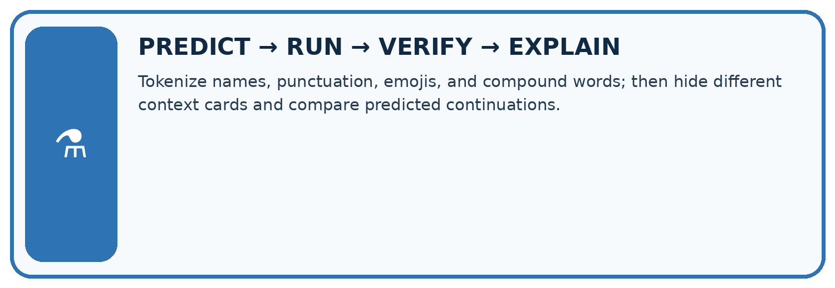
Tokenize names, punctuation, emojis, and compound words; then hide different context cards and compare predicted continuations.
Test / input | Prediction | Actual | Evidence / calculation | Change or keep?
normal
boundary
missing
fresh transfer
What did the hardest test teach you that the normal test did not?

Write or draw your reasoning and evidence.
________________________________________________________________
________________________________________________________________
________________________________________________________________
________________________________________________________________
________________________________________________________________

Plan → try → check
Before trying: what do I expect, and why? While trying: which step could first go wrong? Afterwards: what did I actually observe, and what should change? Keep “not run” if you only traced the procedure.

10. Build your understanding
MASTERY
From Knowing the Word to Owning the Idea
Move upward only when you can produce evidence without copying the worked example.

1 • NAME: Define the concept without repeating the textbook.
2 • TRACE: Show the information, state, branch, calculation, or evidence path.
3 • APPLY: Solve a different example independently.
4 • CHALLENGE: Find a boundary case, counterexample, or unfair outcome.
5 • EXPLAIN LIMITS: Say when the result should not be trusted or used alone.
My strongest evidence of independent understanding:

Write or draw your reasoning and evidence.
________________________________________________________________
________________________________________________________________
________________________________________________________________
________________________________________________________________
________________________________________________________________

11. Connect your project
CUMULATIVE PROJECT
Verified Study Buddy
Every week adds one inspectable piece. The system must show how it reached a result.
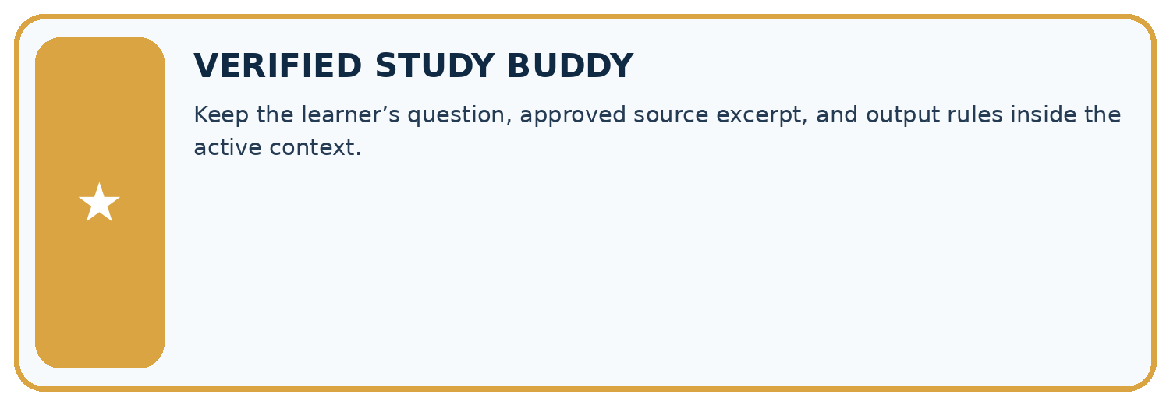
THIS WEEK’S CHECKPOINT Keep the learner’s question, approved source excerpt, and output rules inside the active context.
SYSTEM MAP Learner need → prompt/schema → approved sources/retrieval → model/tool → structured answer → verification → human decision
What will you add, change, or verify in the project this week?

Write or draw your reasoning and evidence.
________________________________________________________________
________________________________________________________________
________________________________________________________________
________________________________________________________________
________________________________________________________________
What should remain under human control?

Write or draw your reasoning and evidence.
________________________________________________________________
________________________________________________________________
________________________________________________________________
________________________________________________________________
________________________________________________________________
RESPONSIBLE DESIGN Collect only necessary information. Show uncertainty and limits. Never confuse fluent output with verified truth.

Evidence for your project
Design Study Buddy retrieval to preserve current facts, exceptions and source identity within its context budget.

12. Show what you know
INDEPENDENT MASTERY PROOF
Explain • Transfer • Test • Defend
Complete this page without copying the worked example. Your reasoning matters more than decoration.
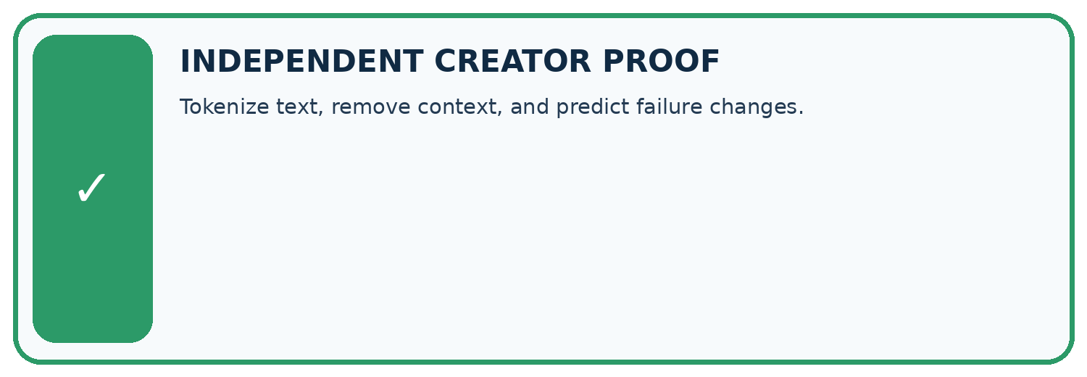
CHALLENGE Tokenize text, remove context, and predict failure changes.
1. My fresh example, trace, calculation, or design:

Write or draw your reasoning and evidence.
________________________________________________________________
________________________________________________________________
________________________________________________________________
________________________________________________________________
________________________________________________________________
2. My evidence that it works (include a boundary or missing-data case):

Write or draw your reasoning and evidence.
________________________________________________________________
________________________________________________________________
________________________________________________________________
________________________________________________________________
________________________________________________________________
3. One limitation, fairness concern, or situation needing human review:

Write or draw your reasoning and evidence.
________________________________________________________________
________________________________________________________________
________________________________________________________________
________________________________________________________________
________________________________________________________________
SELF-CHECK □ I explained the mechanism □ I used evidence □ I tested a fresh case □ I named a limitation □ I can answer ‘why?’

13. Study a complete case

Week 3 Worked case
Use the supplied details to practise the weekly concept before attempting the independent question. This case extends the illustrated lesson.

The situation
A toy window holds eight tokens; prompt uses six and quotation uses three.

The question
Does it fit? What should be preserved?

Worked explanation
Nine exceeds eight. Shorten or select material while preserving essential instructions and evidence. Real systems also have output-budget rules.

Explain it in your own words
Which detail supports the answer, and why does it matter?

Write or draw your reasoning and evidence.
________________________________________________________________
________________________________________________________________
________________________________________________________________
________________________________________________________________
________________________________________________________________

Trace the supplied case visually

Nine requested tokens exceed eight spaces
Evidence or stage | Value or result
Prompt | 6
Quotation | 3
Capacity | 8
A toy window holds eight tokens; prompt uses six and quotation uses three.
Does it fit? What should be preserved?
Nine exceeds eight. Shorten or select material while preserving essential instructions and evidence. Real systems also have output-budget rules.

14. Try a new case independently

Independent case: Budget new evidence independently
Total 120, instructions 25, question 15, output reserve 30. Source D is current approval, cost 28; E is current capacity, cost 22; F is old approval, cost 18. Compute capacity, compare D+E and E+F, and state an honest fallback if D is missing.

My independent explanation, trace and limits
________________________________________________________________
________________________________________________________________
________________________________________________________________
________________________________________________________________
________________________________________________________________
________________________________________________________________
________________________________________________________________
Attempt this case before feedback. Record any help. Earlier examples below are further practice; a case already practised with feedback cannot establish fresh transfer.

Week 3 Independent application
Close the worked explanation. Apply the idea to this different question without copying.
A system can use only the last two messages. Message 1 says use centimetres; messages 2 and 3 discuss plants. What instruction may be lost, and how can the next request repair this?
My answer, with a trace, calculation or supporting evidence

Write or draw your reasoning and evidence.
________________________________________________________________
________________________________________________________________
________________________________________________________________
________________________________________________________________
________________________________________________________________

Create and test
Change one relevant detail. Predict the result before testing. Include a boundary or missing-information case when it helps reveal a limit.
My changed input and expected result

Write or draw your reasoning and evidence.
________________________________________________________________
________________________________________________________________
________________________________________________________________
________________________________________________________________
________________________________________________________________

Connect to your project
Keep the learner’s question, approved source excerpt, and output rules inside the active context.
The evidence I will keep

Write or draw your reasoning and evidence.
________________________________________________________________
________________________________________________________________
________________________________________________________________
________________________________________________________________
________________________________________________________________
Your teacher has the independent answer and scoring criteria. Complete the matching workbook week to keep your practice evidence together.

Transfer practice from the original programme
A toy system allows 12 tokens total for input and reserved output. Instructions use 3, a source uses 7 and the planned answer needs 4. Compute the excess and propose a revision that preserves evidence.

Explain the mechanism, evidence and one limit.
________________________________________________________________
________________________________________________________________
________________________________________________________________
________________________________________________________________
________________________________________________________________
________________________________________________________________
________________________________________________________________

Use feedback to improve
Attempt the independent case before hints. Record whether you worked alone, used a hint or followed a model. After feedback, fix the first unsupported step and explain why it changed. A later check uses a changed case, not a copied answer.

