AI ACADEMY · STUDENT · ai-3/17

Model Memory vs Retrieval
Project: Verified Study Buddy

Before you start
Week 15: a source must be current and relevant to the claim.

01. Your mission

Your learning target
I can explain the mechanism and terminology of retrieval and indexing.
I can apply the stated procedure to a new case with a traceable result.
I can identify an assumption or limitation and design a revealing follow-up.

Remember before reading
Close your notes first. A rough first answer helps us choose the right starting point; it is not a score for your ability.
Without opening the old lesson, explain one key idea from Verify Numbers and Dates. Give an example and a mistake that the idea helps you avoid.
Without opening the old lesson, explain one key idea from Hallucination Failure Types. Give an example and a mistake that the idea helps you avoid.
Without opening the old lesson, explain one key idea from Visual Composition. Give an example and a mistake that the idea helps you avoid.
After trying, check the relevant lesson or ask your teacher. Change the part of your explanation that the evidence shows was wrong.
Week 17: Model Memory vs Retrieval
Learned parameters are not a searchable source library.
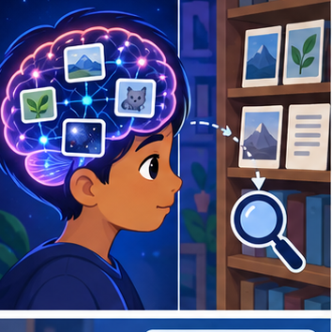
CREATOR MISSION
Decide when to answer, retrieve, calculate, or abstain.
Creator name and date:

Write or draw your reasoning and evidence.
________________________________________________________________
________________________________________________________________
________________________________________________________________
________________________________________________________________
________________________________________________________________

Readiness for the connected explanation
Recall Speech pipelines and multimodal evidence. Explain why a recorded result needs its input conditions and evidence source before it can support a claim.

This week’s end goal
By the end, I can explain model memory vs retrieval using a traced example and a stated limitation.

02. Notice the evidence
PICTURE STORY
Notice → Predict → Explain
Begin with visible evidence. Do not explain more than the picture and information support.
MYSTERY
The learners must use model memory vs retrieval to solve a problem. What information do they have? What decision or calculation do they make? What would count as evidence that it worked?
Three observations (what you can point to):

Write or draw your reasoning and evidence.
________________________________________________________________
________________________________________________________________
________________________________________________________________
________________________________________________________________
________________________________________________________________
My prediction and the clue supporting it:

Write or draw your reasoning and evidence.
________________________________________________________________
________________________________________________________________
________________________________________________________________
________________________________________________________________
________________________________________________________________

A closer explanation
Retrieval returns stored records selected for a query. An index is a searchable representation of a versioned corpus; generated wording is a later operation.
Begin by writing the question the procedure is intended to answer. Identify the information already supplied, the information it will produce and the information still missing. These are constructed classroom examples; they do not require live accounts, private records or an external service. Do not treat a plausible explanation as a measured outcome.

03. See how it works
VISUAL MECHANISM
Input → Process → Output
Trace the information. At each stage, ask what changed and how you could test it.
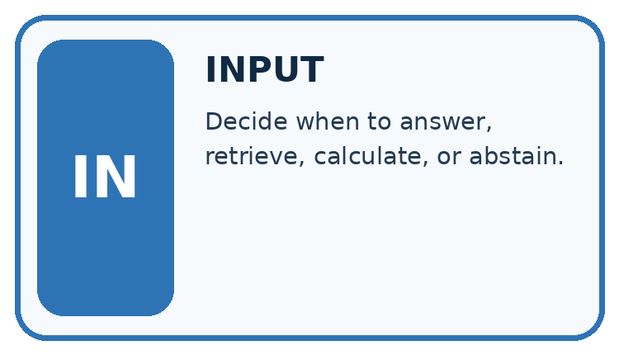
↓
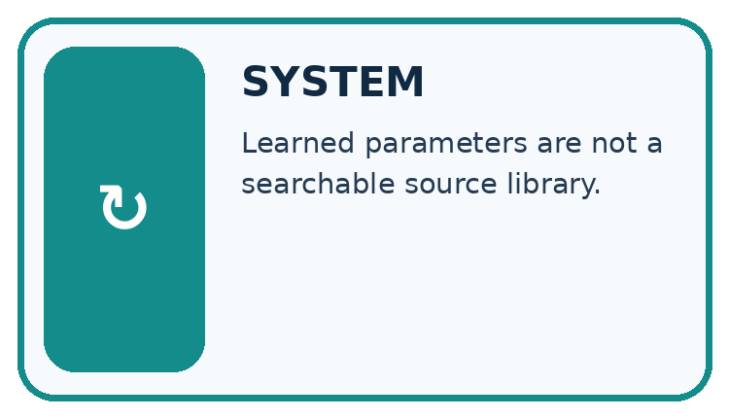
↓
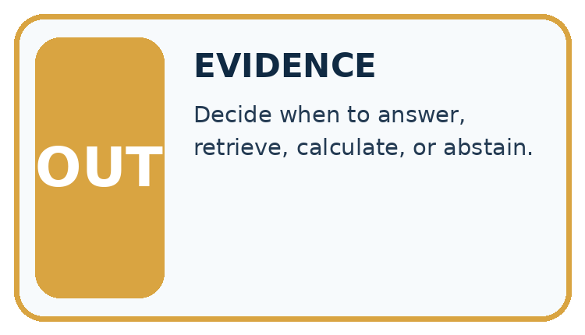
Which stage could fail even when the other two are correct? Explain:

Write or draw your reasoning and evidence.
________________________________________________________________
________________________________________________________________
________________________________________________________________
________________________________________________________________
________________________________________________________________

A closer explanation
Assign stable document IDs, versions and permitted access before indexing. Retrieve only authorised records. Preserve source references and define behaviour when a document is missing, outdated or access-restricted.

Retrieval and indexing — evidence trace
Input and scope | Check or calculation | Conclusion and limit
Index v1 contains notice N1 for room A. Corpus v2 supersedes it with N2 for room B, but the query still returns N1. What can be reported? | Assign stable document IDs, versions and permitted access before indexing. Retrieve only authorised records. Preserve source references and define behaviour when a document is missing, outdated or access-restricted. | The stale index returns old evidence. It cannot establish current room approval; refresh against authorised corpus v2 or report unresolved freshness.
The figure connects this chapter's worked input, declared procedure and result. Read the complete worked reasoning for qualifiers and intermediate steps; the abbreviated labels do not replace that reasoning.
Before applying the procedure, write its units, denominator or decision boundary where relevant. A partner should be able to repeat each step using the same inputs. If a required input is absent or violates the stated contract, record that condition explicitly instead of quietly replacing it with a convenient value.

Connect the picture and the explanation
Point to the input, the deciding step and the result in this week’s visual. Explain the same step in ordinary words. A picture helps when you can say what each part represents.

04. Compare the cases
CASE GALLERY
Four Tests, Four Kinds of Evidence
A system is not understood until it survives more than one comfortable example.


NORMAL CASE: predict and name evidence. BOUNDARY CASE: predict and name evidence.


MISSING INFORMATION: predict and name evidence. TRANSFER CASE: predict and name evidence.
Which case is most likely to reveal a hidden assumption? Why?

Write or draw your reasoning and evidence.
________________________________________________________________
________________________________________________________________
________________________________________________________________
________________________________________________________________
________________________________________________________________

Change one thing in the pictured case
Change: LIB-v = 2 is unavailable.
Prediction: Report that the current time cannot be verified.
Reason: The unsupported old guess does not become current evidence when retrieval fails.

05. Words that unlock the idea
VOCABULARY LAB
Words You Can Use to Reason
A definition matters when you can recognize the idea, use it, and contrast it with a near-miss.
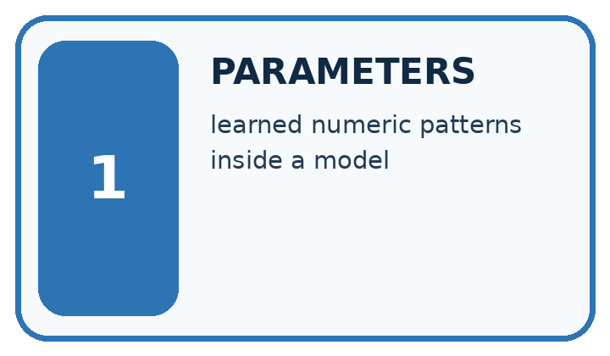
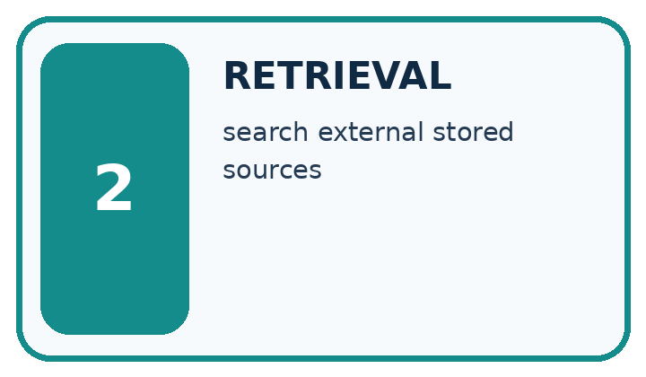
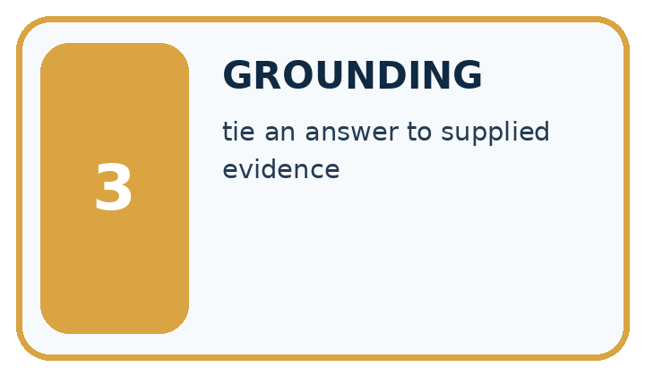
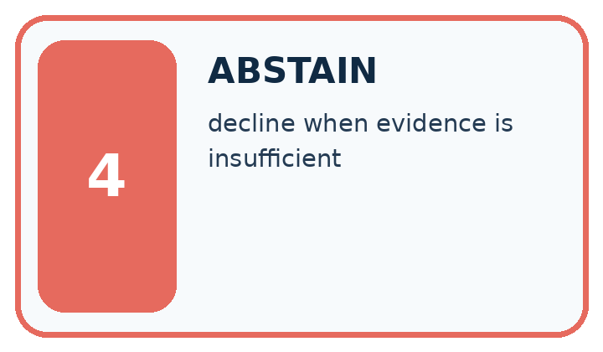
Word | My own example | Not this / boundary
parameters | Values within a model adjusted during training; distinguish them from settings chosen by a developer.
retrieval | Finding and returning existing information from a source or collection.
grounding | Connecting an answer or action to specified evidence or observations.
abstain | Decline to make a prediction when the available evidence does not meet the decision rule.

Words used in the closer explanation
Word | Meaning
Corpus | The collection of records available for a task
Index | A searchable representation of that collection
Freshness | Whether a record is current for the requested time

06. Follow a worked example
WORKED EVIDENCE
Reason Step by Step
Predict first. Then check each step. A correct answer without visible reasoning is incomplete evidence.
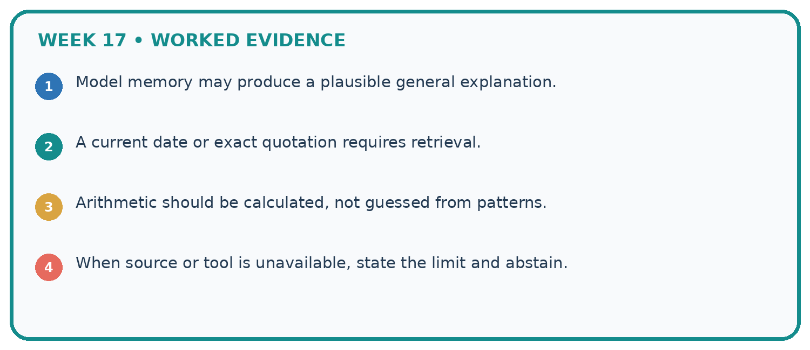
1. Model memory may produce a plausible general explanation.
2. A current date or exact quotation requires retrieval.
3. Arithmetic should be calculated, not guessed from patterns.
4. When source or tool is unavailable, state the limit and abstain.
Recalculate, retrace, or restate the reasoning in your own representation:

Write or draw your reasoning and evidence.
________________________________________________________________
________________________________________________________________
________________________________________________________________
________________________________________________________________
________________________________________________________________
CHECK Did the evidence answer the exact question? Did the total, path, or source record stay consistent?

A closer explanation
Index v1 contains notice N1 for room A. Corpus v2 supersedes it with N2 for room B, but the query still returns N1. What can be reported?
The stale index returns old evidence. It cannot establish current room approval; refresh against authorised corpus v2 or report unresolved freshness.
Compare the intermediate evidence with the final statement. Explain why each number or decision follows from the stated inputs. The conclusion belongs to this scenario and procedure; changing the inputs, evaluation population or authority can change what it establishes. Retain the raw record so a later revision can be compared honestly.

Learn from the worked case
Cover the result before checking it. Say what is given, choose the procedure, and follow one step at a time. Then uncover the result and explain your first mismatch. Ask why a step is allowed, not only what number it produces.

A pictorial worked case: Model Memory vs Retrieval
The library assistant remembers an old opening time, but a current notice can be retrieved.

The facts we will use
Approved notice LIB-v = 2 says Wednesday closes at 16: 00; the model previously produced 15: 00. The question asks the current Wednesday closing time.
All inputs and outcomes in this worked example are invented classroom data; no real model run is claimed.
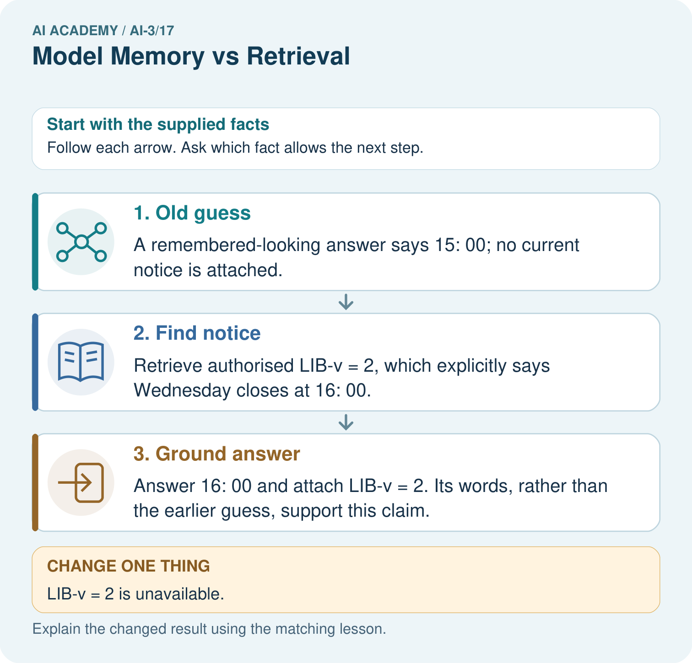

Read the picture one step at a time
Step | What happens and why
1. Old guess | A remembered-looking answer says 15: 00; no current notice is attached.
2. Find notice | Retrieve authorised LIB-v = 2, which explicitly says Wednesday closes at 16: 00.
3. Ground answer | Answer 16: 00 and attach LIB-v = 2. Its words, rather than the earlier guess, support this claim.
Match each pictured step to the supplied facts. This is a worked teaching case, not an independent assessment.

Why this result follows
Read the picture in order. Answer 16: 00 and attach LIB-v = 2. Its words, rather than the earlier guess, support this claim. The arrows show which recorded input or intermediate result each decision uses. Explain the deciding step aloud before checking the changed case; pointing to the final answer alone does not show how it follows.

What this example does not establish
A retrieved document can itself be wrong or outdated; source approval, date and scope still need checking.

07. Find and repair a mistake
ERROR DETECTIVE
Compare → Diagnose → Repair
Do not patch the answer. Find the earliest unsupported assumption, wrong step, or weak evidence.
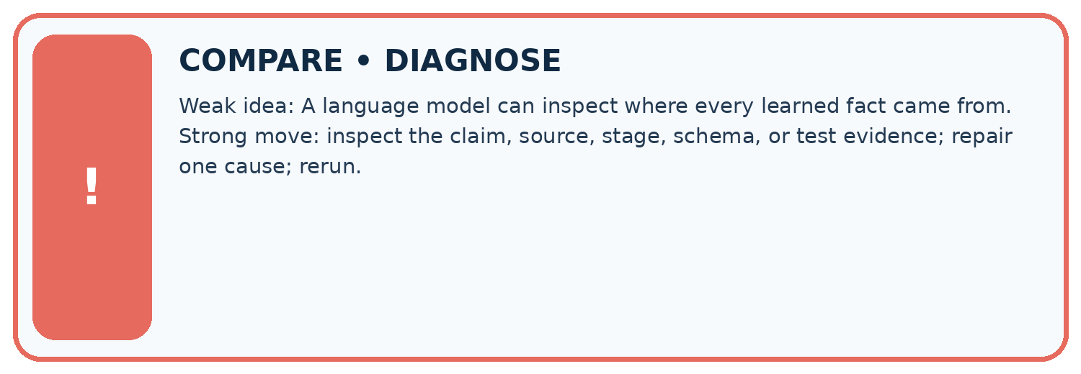
Evidence record | Expected | Actual | Likely cause / next test
normal case | works
boundary case | stated rule
missing input | safe response
fresh transfer | generalizes
Repair one cause. Why is this repair better than changing several things?

Write or draw your reasoning and evidence.
________________________________________________________________
________________________________________________________________
________________________________________________________________
________________________________________________________________
________________________________________________________________

A closer explanation
Complete the supported workbook tasks before attempting W4 independently. Record any hints or help used. After feedback, use the teacher's fresh retry rather than copying the earlier answer. For a project, select a relevant new case, predict the outcome from the declared rule and preserve the result alongside any revision.

Exit: propose one revealing change to the worked scenario. State the expected outcome and the evidence that would make you revise your explanation.
________________________________________________________________
________________________________________________________________
________________________________________________________________
________________________________________________________________
________________________________________________________________

08. Practise together
LOGIC STUDIO
Specify Before You Run
Prompts, schemas, retrieval, tool calls, and code are inspectable parts of one AI product.

SET task, audience, constraints, output_schema
LOAD approved_context or retrieval_result
CALL model or allowed_tool
VALIDATE fields, claims, citations, and safety
IF evidence missing: ask, retrieve, or abstain
RETURN useful output + source trail + limitations
Trace one input. Which line changes the state or chooses a path?

Write or draw your reasoning and evidence.
________________________________________________________________
________________________________________________________________
________________________________________________________________
________________________________________________________________
________________________________________________________________

A closer explanation
High retrieval similarity does not override permissions or make an obsolete source current.
A useful check asks what would make the reasoning fail. Distinguish a failure to execute the declared procedure from a weakness in the procedure itself. The first may require a correction; the second requires an explicitly revised method and new evidence. Preserve unsuccessful cases so an improved result cannot hide the original problem.

Guided: restate the worked result, then name the assumption or limitation that prevents a broader conclusion.
________________________________________________________________
________________________________________________________________
________________________________________________________________
________________________________________________________________
________________________________________________________________

Practise with less help: Trace the worked case
Use workbook W2 for the connected example “Retrieval and indexing”. First fill the input and rule boxes. Try the middle steps before asking for a hint. After a hint, try the next step yourself.
Plan | Do | Check
What is given? Which rule or procedure applies? | Record each intermediate step. | Does the result follow? What remains unknown?
Explain your trace to a partner. Your partner points to one step to check. Swap roles on the next case. Each person writes their own explanation.

Check your reasoning
Use the worked case for Retrieval and indexing. Proposed explanation: “The worked result establishes every future case”. Decide whether this explanation is supported. Point to the step or supplied fact that decides; explain your repair if needed.
Answer on your own before discussion. If you are unsure, say which step you need help with.

Explain the picture
Why can the assistant not certify 15: 00 when the notice is missing? Point to the relevant step in the picture, then write the changed result and the rule or evidence that supports it.

My explanation using a pictured step and the given facts
________________________________________________________________
________________________________________________________________
________________________________________________________________
________________________________________________________________
This is supported practice. Keep the separately named independent case for an attempt before feedback.

09. Run the investigation
EVIDENCE LAB
Predict → Test → Record → Explain
Keep expected and actual results separate. Surprises are useful data when recorded honestly.
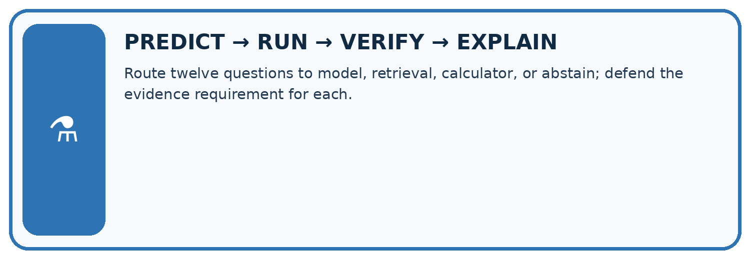
Route twelve questions to model, retrieval, calculator, or abstain; defend the evidence requirement for each.
Test / input | Prediction | Actual | Evidence / calculation | Change or keep?
normal
boundary
missing
fresh transfer
What did the hardest test teach you that the normal test did not?

Write or draw your reasoning and evidence.
________________________________________________________________
________________________________________________________________
________________________________________________________________
________________________________________________________________
________________________________________________________________

Plan → try → check
Before trying: what do I expect, and why? While trying: which step could first go wrong? Afterwards: what did I actually observe, and what should change? Keep “not run” if you only traced the procedure.

10. Build your understanding
MASTERY
From Knowing the Word to Owning the Idea
Move upward only when you can produce evidence without copying the worked example.

1 • NAME: Define the concept without repeating the textbook.
2 • TRACE: Show the information, state, branch, calculation, or evidence path.
3 • APPLY: Solve a different example independently.
4 • CHALLENGE: Find a boundary case, counterexample, or unfair outcome.
5 • EXPLAIN LIMITS: Say when the result should not be trusted or used alone.
My strongest evidence of independent understanding:

Write or draw your reasoning and evidence.
________________________________________________________________
________________________________________________________________
________________________________________________________________
________________________________________________________________
________________________________________________________________

11. Connect your project
CUMULATIVE PROJECT
Verified Study Buddy
Every week adds one inspectable piece. The system must show how it reached a result.
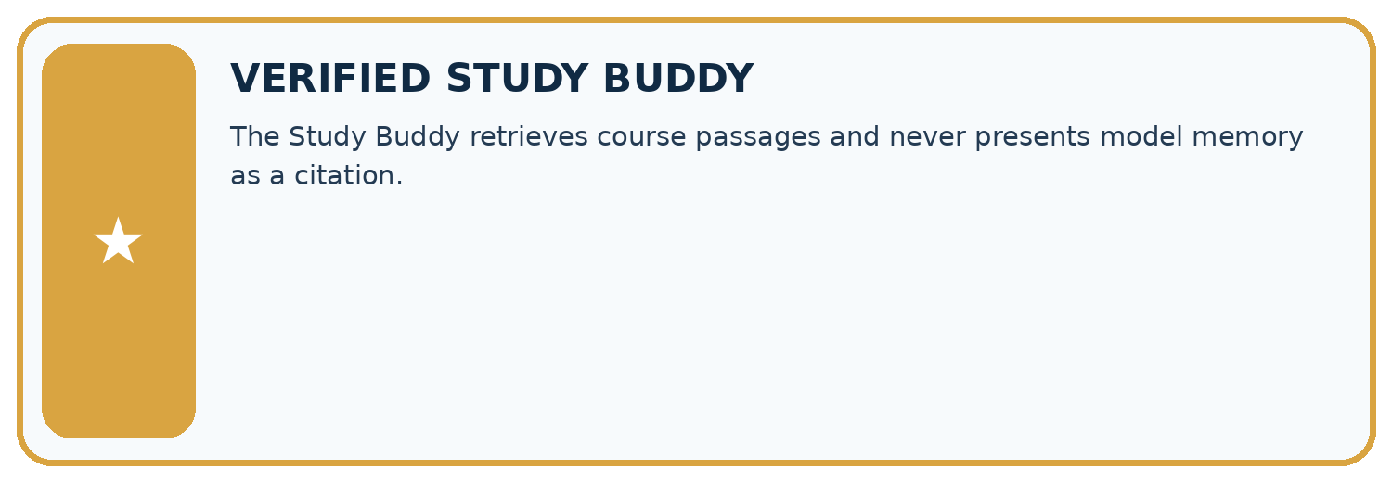
THIS WEEK’S CHECKPOINT The Study Buddy retrieves course passages and never presents model memory as a citation.
SYSTEM MAP Learner need → prompt/schema → approved sources/retrieval → model/tool → structured answer → verification → human decision
What will you add, change, or verify in the project this week?

Write or draw your reasoning and evidence.
________________________________________________________________
________________________________________________________________
________________________________________________________________
________________________________________________________________
________________________________________________________________
What should remain under human control?

Write or draw your reasoning and evidence.
________________________________________________________________
________________________________________________________________
________________________________________________________________
________________________________________________________________
________________________________________________________________
RESPONSIBLE DESIGN Collect only necessary information. Show uncertainty and limits. Never confuse fluent output with verified truth.

Evidence for your project
For your Verified Study Buddy, save the input, procedure, observed result and limitation of this check. Label this worked example as practice; use a different, previously unreviewed case when checking independent understanding.

12. Show what you know
INDEPENDENT MASTERY PROOF
Explain • Transfer • Test • Defend
Complete this page without copying the worked example. Your reasoning matters more than decoration.
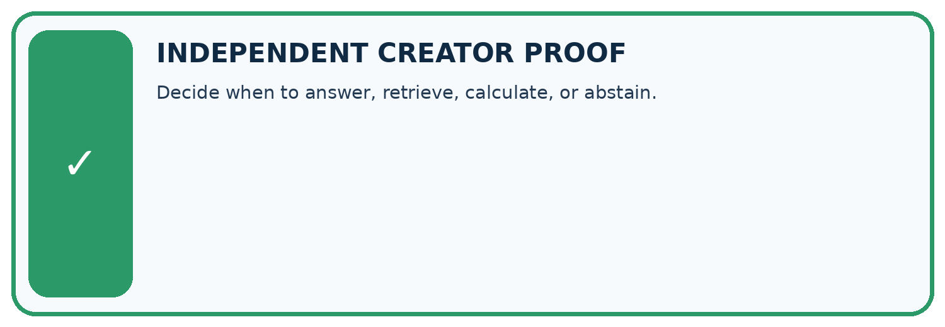
CHALLENGE Decide when to answer, retrieve, calculate, or abstain.
1. My fresh example, trace, calculation, or design:

Write or draw your reasoning and evidence.
________________________________________________________________
________________________________________________________________
________________________________________________________________
________________________________________________________________
________________________________________________________________
2. My evidence that it works (include a boundary or missing-data case):

Write or draw your reasoning and evidence.
________________________________________________________________
________________________________________________________________
________________________________________________________________
________________________________________________________________
________________________________________________________________
3. One limitation, fairness concern, or situation needing human review:

Write or draw your reasoning and evidence.
________________________________________________________________
________________________________________________________________
________________________________________________________________
________________________________________________________________
________________________________________________________________
SELF-CHECK □ I explained the mechanism □ I used evidence □ I tested a fresh case □ I named a limitation □ I can answer ‘why?’

13. Study a complete case

Week 17 Worked case
Use the supplied details to practise the weekly concept before attempting the independent question. This case extends the illustrated lesson.

The situation
One assistant answers without search; another retrieves a handbook paragraph.

The question
Compare evidence trails.

Worked explanation
The first uses learned patterns without an inspected source. The second supplies a passage that can be checked. Retrieval still does not guarantee correct use.

Explain it in your own words
Which detail supports the answer, and why does it matter?

Write or draw your reasoning and evidence.
________________________________________________________________
________________________________________________________________
________________________________________________________________
________________________________________________________________
________________________________________________________________

Trace the supplied case visually

Retrieval creates an inspectable evidence trail
Evidence or stage | Value or result
No retrieval | Answer from learned patterns
Retrieval | Inspect a handbook paragraph
Verification | Check the paragraph supports the answer
One assistant answers without search; another retrieves a handbook paragraph.
Compare evidence trails.
The first uses learned patterns without an inspected source. The second supplies a passage that can be checked. Retrieval still does not guarantee correct use.

14. Try a new case independently

Independent case: Apply a new case independently
Corpus has public P, teacher-only T and withdrawn W. A student search returns all three. Identify the filtering defect and whether hiding T after generation is sufficient.

My independent explanation, trace and limits
________________________________________________________________
________________________________________________________________
________________________________________________________________
________________________________________________________________
________________________________________________________________
________________________________________________________________
________________________________________________________________
Attempt this case before feedback. Record any help. Earlier examples below are further practice; a case already practised with feedback cannot establish fresh transfer.

Week 17 Independent application
Close the worked explanation. Apply the idea to this different question without copying.
A model recalls last year's opening hours; a retrieved current notice gives different hours. How should the answer use this evidence?
My answer, with a trace, calculation or supporting evidence

Write or draw your reasoning and evidence.
________________________________________________________________
________________________________________________________________
________________________________________________________________
________________________________________________________________
________________________________________________________________

Create and test
Change one relevant detail. Predict the result before testing. Include a boundary or missing-information case when it helps reveal a limit.
My changed input and expected result

Write or draw your reasoning and evidence.
________________________________________________________________
________________________________________________________________
________________________________________________________________
________________________________________________________________
________________________________________________________________

Connect to your project
The Study Buddy retrieves course passages and never presents model memory as a citation.
The evidence I will keep

Write or draw your reasoning and evidence.
________________________________________________________________
________________________________________________________________
________________________________________________________________
________________________________________________________________
________________________________________________________________
Your teacher has the independent answer and scoring criteria. Complete the matching workbook week to keep your practice evidence together.

Transfer practice from the original programme
A model states the library opens at 8 from learned patterns. A supplied current notice says 9. Explain the stronger answer and one remaining check.

Explain the mechanism, evidence and one limit.
________________________________________________________________
________________________________________________________________
________________________________________________________________
________________________________________________________________
________________________________________________________________
________________________________________________________________
________________________________________________________________

Use feedback to improve
Attempt the independent case before hints. Record whether you worked alone, used a hint or followed a model. After feedback, fix the first unsupported step and explain why it changed. A later check uses a changed case, not a copied answer.

