AI ACADEMY · STUDENT · ai-3/23

Block to Python Bridge
Project: Verified Study Buddy

Before you start
AI-2 Weeks 4–5: trace assignment and loops before translating syntax.

01. Your mission

Your learning target
I can translate a short paper calculation into a Python script.
I can predict and explain the order of executed statements.
I can keep expected and observed output separate when checking a program.

Remember before reading
Close your notes first. A rough first answer helps us choose the right starting point; it is not a score for your ability.
Without opening the old lesson, explain one key idea from Requests Responses and JSON. Give an example and a mistake that the idea helps you avoid.
Without opening the old lesson, explain one key idea from Conversation State and Memory. Give an example and a mistake that the idea helps you avoid.
Without opening the old lesson, explain one key idea from Model Memory vs Retrieval. Give an example and a mistake that the idea helps you avoid.
After trying, check the relevant lesson or ask your teacher. Change the part of your explanation that the evidence shows was wrong.
Week 23: Block-to-Python Bridge
Variables, conditions, lists, loops, and functions carry the same logic across representations.
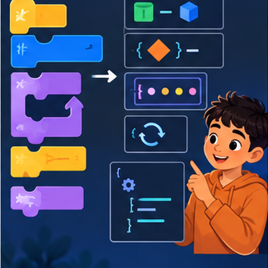
CREATOR MISSION
Translate a block workflow into readable Python.
Creator name and date:

Write or draw your reasoning and evidence.
________________________________________________________________
________________________________________________________________
________________________________________________________________
________________________________________________________________
________________________________________________________________

Readiness for the connected explanation
Four packs contain six counters each. What steps find and show the total?

This week’s end goal
By the end, I can explain block to python bridge using a traced example and a stated limitation.

02. Notice the evidence
PICTURE STORY
Notice → Predict → Explain
Begin with visible evidence. Do not explain more than the picture and information support.
MYSTERY
The learners must use block-to-python bridge to solve a problem. What information do they have? What decision or calculation do they make? What would count as evidence that it worked?
Three observations (what you can point to):

Write or draw your reasoning and evidence.
________________________________________________________________
________________________________________________________________
________________________________________________________________
________________________________________________________________
________________________________________________________________
My prediction and the clue supporting it:

Write or draw your reasoning and evidence.
________________________________________________________________
________________________________________________________________
________________________________________________________________
________________________________________________________________
________________________________________________________________

A closer explanation
In Grade 6 you traced rules on paper. Now you will write a small Python program and check what it actually does. Begin with a counter-packing calculation, not the whole activity adviser. The requirement is to find the total counters in equal packs and display that total. For this first program, the supplied quantities are whole, nonnegative numbers; it does not yet validate typed input.
Use a teacher-prepared Python 3 editor that can run a saved .py file. Open a new file called counters.py, type the code exactly as shown in the next section, save it, and use the editor’s Run command. Read the output area separately from the source editor. No account, AI tool, package installation or personal data is needed. If a device is unavailable, trace on paper and label the result predicted rather than executed.

03. See how it works
VISUAL MECHANISM
Input → Process → Output
Trace the information. At each stage, ask what changed and how you could test it.
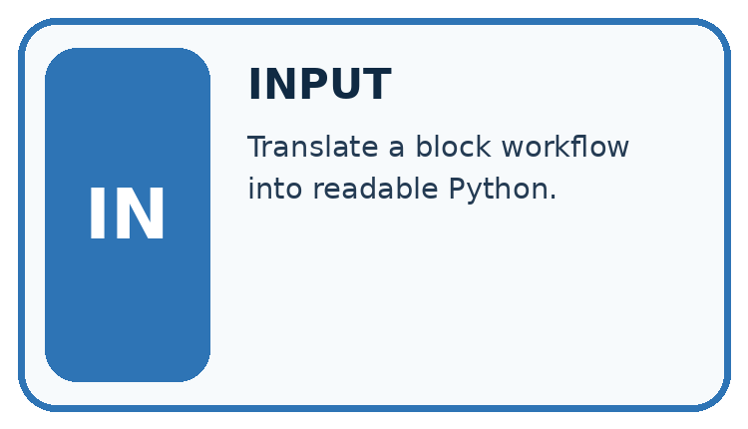
↓
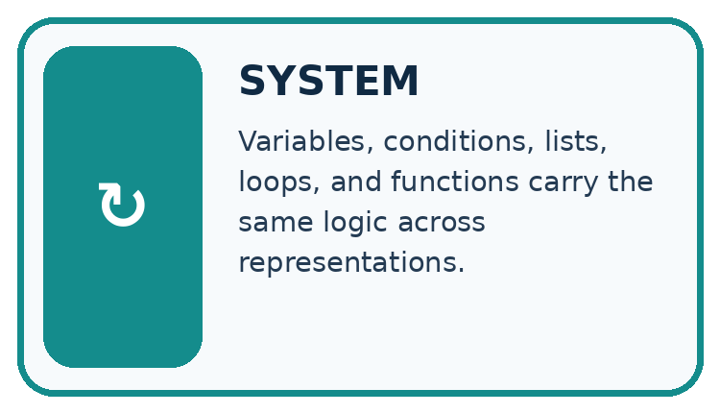
↓
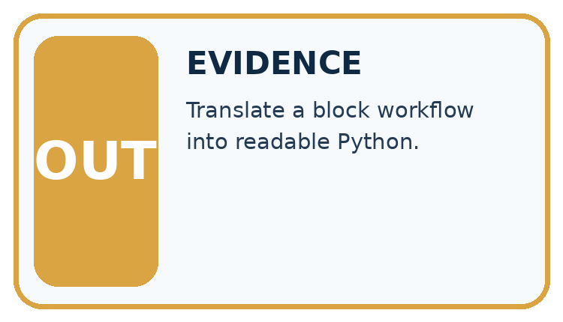
Which stage could fail even when the other two are correct? Explain:

Write or draw your reasoning and evidence.
________________________________________________________________
________________________________________________________________
________________________________________________________________
________________________________________________________________
________________________________________________________________

A closer explanation

A calculation from paper to output
Paper step | Python instruction | Effect
Record pack count | packs = 4 | Name holds 4
Multiply two quantities | total = packs * per_pack | Name holds product
Show the answer | print(total) | Displays the value
Assign per_pack before the multiplication. This diagram summarises the steps; the complete script below includes that assignment.
packs = 4
per_pack = 6
total = packs * per_pack
print(total)
Read the script from top to bottom. The equals sign assigns the value on its right to the name on its left. The star means multiplication. print(total) displays the value of total; it does not display the letters in the name. Type ordinary straight characters and keep the parentheses. The Python prompt symbols >>> are not part of this saved script.

Connect the picture and the explanation
Point to the input, the deciding step and the result in this week’s visual. Explain the same step in ordinary words. A picture helps when you can say what each part represents.

04. Compare the cases
CASE GALLERY
Four Tests, Four Kinds of Evidence
A system is not understood until it survives more than one comfortable example.


NORMAL CASE: predict and name evidence. BOUNDARY CASE: predict and name evidence.


MISSING INFORMATION: predict and name evidence. TRANSFER CASE: predict and name evidence.
Which case is most likely to reveal a hidden assumption? Why?

Write or draw your reasoning and evidence.
________________________________________________________________
________________________________________________________________
________________________________________________________________
________________________________________________________________
________________________________________________________________

Change one thing in the pictured case
Change: Replace the last page count 90 with 100.
Prediction: The final count becomes 1.
Reason: The comparison is strictly less than 100, so the boundary value does not qualify.

05. Words that unlock the idea
VOCABULARY LAB
Words You Can Use to Reason
A definition matters when you can recognize the idea, use it, and contrast it with a near-miss.
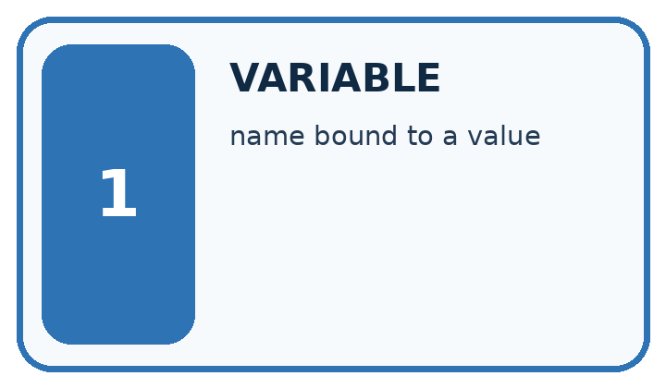
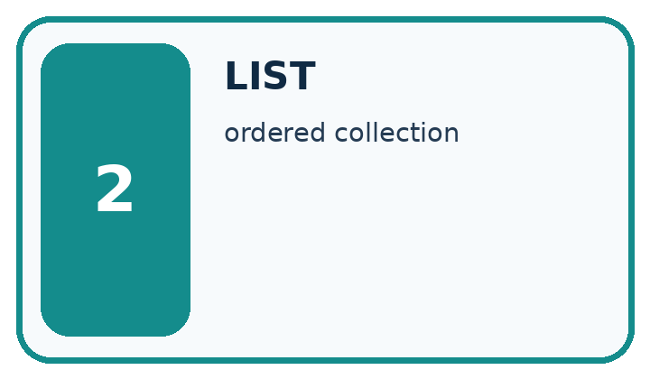
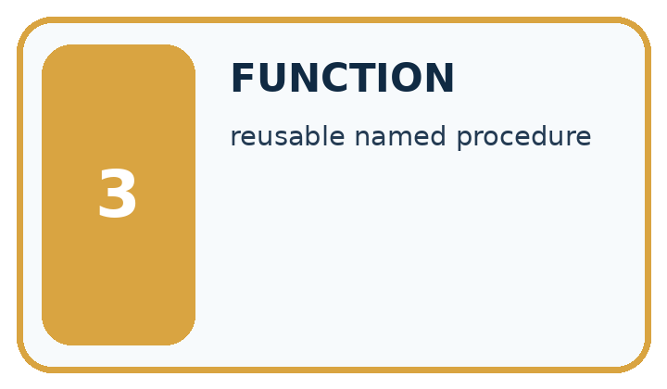
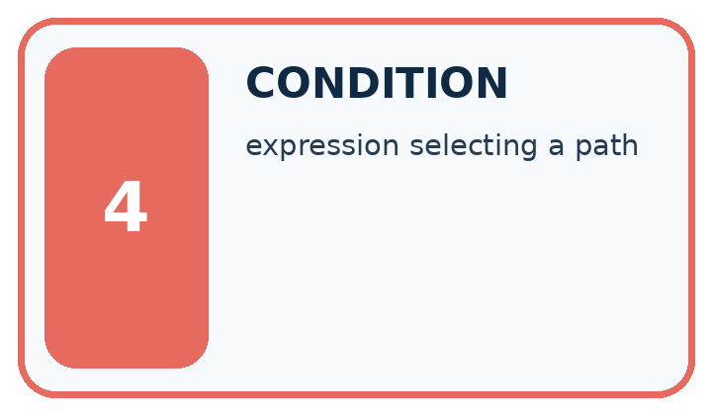
Word | My own example | Not this / boundary
variable | A named reference to a value that can be used or changed in a program.
list | An ordered collection of items.
function | A named unit of code that performs a task, optionally receiving arguments and returning a value.
condition | A statement evaluated as true or false to help select an action.

Words used in the closer explanation
Word | Meaning
Algorithm | An ordered procedure for solving a stated problem
Program | Instructions written in a language a computer can execute
Interpreter | Software that executes Python instructions
Assignment | Binding a name to the value of an expression
Output | Information a program displays or returns

06. Follow a worked example
WORKED EVIDENCE
Reason Step by Step
Predict first. Then check each step. A correct answer without visible reasoning is incomplete evidence.
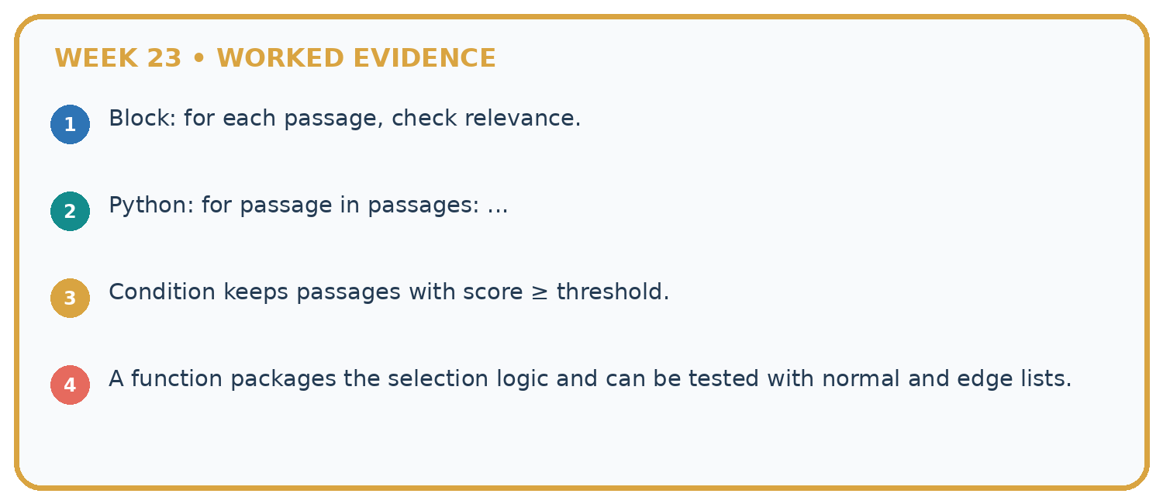
1. Block: for each passage, check relevance.
2. Python: for passage in passages: ...
3. Condition keeps passages with score ≥ threshold.
4. A function packages the selection logic and can be tested with normal and edge lists.
Recalculate, retrace, or restate the reasoning in your own representation:

Write or draw your reasoning and evidence.
________________________________________________________________
________________________________________________________________
________________________________________________________________
________________________________________________________________
________________________________________________________________
CHECK Did the evidence answer the exact question? Did the total, path, or source record stay consistent?

A closer explanation
After line | Names and values | Displayed output
packs = 4 | packs is 4 | Nothing yet
per_pack = 6 | packs is 4; per_pack is 6 | Nothing yet
total = packs * per_pack | total is 24 | Nothing yet
print(total) | Values are unchanged | 24
Write 24 as the expected output before running. Then copy the actual output into a separate column. A matching result supports this case, not every possible input. A saved file may contain an old edit: save again and rerun the whole script. Do not type the expected number into the output record without running.

Why is there no displayed output after the third line? What changes if print(total) is placed first in a fresh run, before any assignment? Explain using which names exist.
________________________________________________________________
________________________________________________________________
________________________________________________________________
________________________________________________________________
________________________________________________________________

Learn from the worked case
Cover the result before checking it. Say what is given, choose the procedure, and follow one step at a time. Then uncover the result and explain your first mismatch. Ask why a step is allowed, not only what number it produces.

A pictorial worked case: Block to Python Bridge
Translate a “count qualifying books” paper procedure into a Python-style trace.

The facts we will use
Page counts are [80, 150, 90]. Start count=0; for each pages value, add 1 only when pages<100.
All inputs and outcomes in this worked example are invented classroom data; no real model run is claimed.
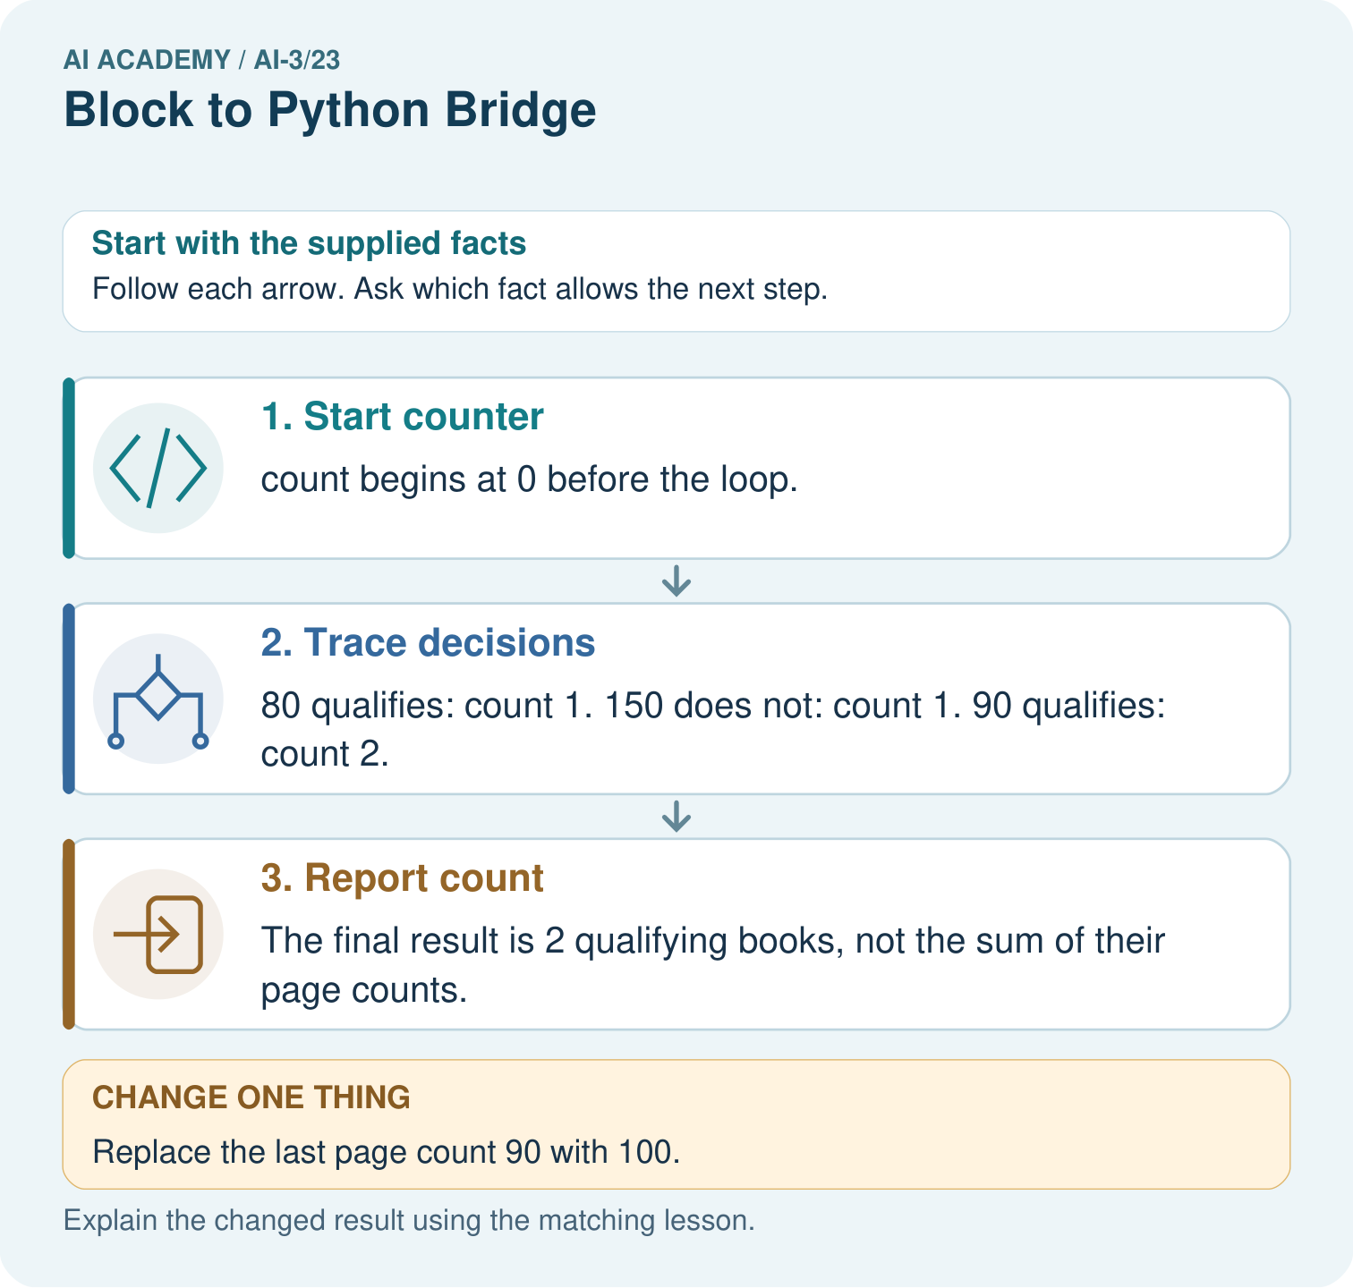

Read the picture one step at a time
Step | What happens and why
1. Start counter | count begins at 0 before the loop.
2. Trace decisions | 80 qualifies: count 1. 150 does not: count 1. 90 qualifies: count 2.
3. Report count | The final result is 2 qualifying books, not the sum of their page counts.
Match each pictured step to the supplied facts. This is a worked teaching case, not an independent assessment.

Why this result follows
Read the picture in order. The final result is 2 qualifying books, not the sum of their page counts. The arrows show which recorded input or intermediate result each decision uses. Explain the deciding step aloud before checking the changed case; pointing to the final answer alone does not show how it follows.

What this example does not establish
This deterministic loop counts a stated condition; it neither trains a model nor measures whether the books suit a reader.

07. Find and repair a mistake
ERROR DETECTIVE
Compare → Diagnose → Repair
Do not patch the answer. Find the earliest unsupported assumption, wrong step, or weak evidence.
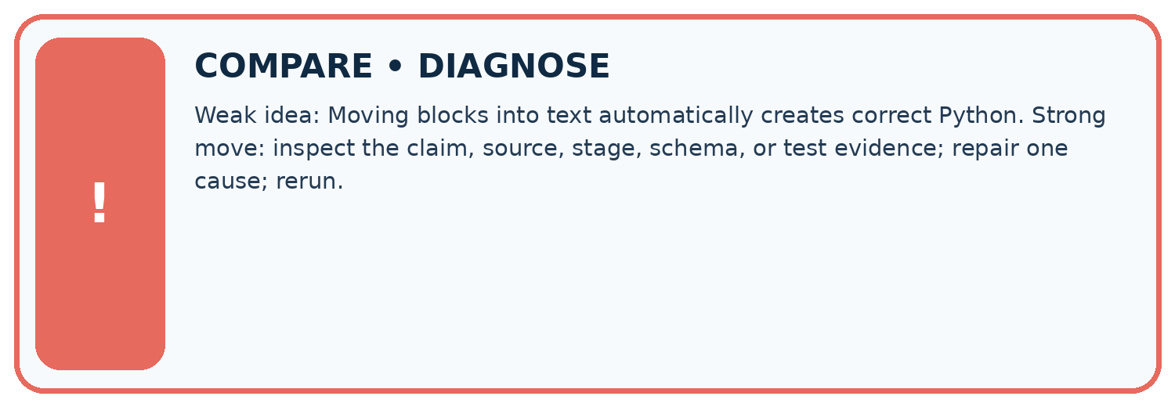
Evidence record | Expected | Actual | Likely cause / next test
normal case | works
boundary case | stated rule
missing input | safe response
fresh transfer | generalizes
Repair one cause. Why is this repair better than changing several things?

Write or draw your reasoning and evidence.
________________________________________________________________
________________________________________________________________
________________________________________________________________
________________________________________________________________
________________________________________________________________

A closer explanation
Save the file with the input values, expected and observed outputs, and a short explanation. This program follows a written multiplication rule. It has not trained a model, predicted somebody’s preferences or checked that real packs contain the stated number. Its conclusion depends on the supplied data. Week 2 examines the values and types behind these names.

A script runs without an error and displays 11 for five packs of six. Is it correct for the stated requirement? Give the required result, the likely wrong operation and one check after repair. State whether your evidence came from a device run or a paper trace.
________________________________________________________________
________________________________________________________________
________________________________________________________________
________________________________________________________________
________________________________________________________________

08. Practise together
LOGIC STUDIO
Specify Before You Run
Prompts, schemas, retrieval, tool calls, and code are inspectable parts of one AI product.

SET task, audience, constraints, output_schema
LOAD approved_context or retrieval_result
CALL model or allowed_tool
VALIDATE fields, claims, citations, and safety
IF evidence missing: ask, retrieve, or abstain
RETURN useful output + source trail + limitations
Trace one input. Which line changes the state or chooses a path?

Write or draw your reasoning and evidence.
________________________________________________________________
________________________________________________________________
________________________________________________________________
________________________________________________________________
________________________________________________________________

A closer explanation
Change only packs to 5. Predict the result from five groups of six, save, then run the entire file again. The expected output is 30. Keep the original four-pack result beside the new one and label the changed input. A comment can explain an instruction: Python ignores text after # outside a string. A comment does not change the calculation.
packs = 5 # five equal packs
per_pack = 6
total = packs * per_pack
print(total)
A program can run successfully and still solve the wrong problem. Replacing * with + would display 11 for this input, but addition does not count five groups of six. Use the requirement and a paper calculation to check meaning; the absence of an error message is not proof of correctness.

Practise with less help: Predict then observe
Use workbook W2 for the connected example “From a paper algorithm to Python”. First fill the input and rule boxes. Try the middle steps before asking for a hint. After a hint, try the next step yourself.
Plan | Do | Check
What is given? Which rule or procedure applies? | Record each intermediate step. | Does the result follow? What remains unknown?
Explain your trace to a partner. Your partner points to one step to check. Swap roles on the next case. Each person writes their own explanation.

Check your reasoning
Use the worked case for From a paper algorithm to Python. Proposed explanation: “An equals sign displays the answer”. Decide whether this explanation is supported. Point to the step or supplied fact that decides; explain your repair if needed.
Answer on your own before discussion. If you are unsure, say which step you need help with.

Explain the picture
Trace the changed list and identify where the result differs. Point to the relevant step in the picture, then write the changed result and the rule or evidence that supports it.

My explanation using a pictured step and the given facts
________________________________________________________________
________________________________________________________________
________________________________________________________________
________________________________________________________________
This is supported practice. Keep the separately named independent case for an attempt before feedback.

09. Run the investigation
EVIDENCE LAB
Predict → Test → Record → Explain
Keep expected and actual results separate. Surprises are useful data when recorded honestly.
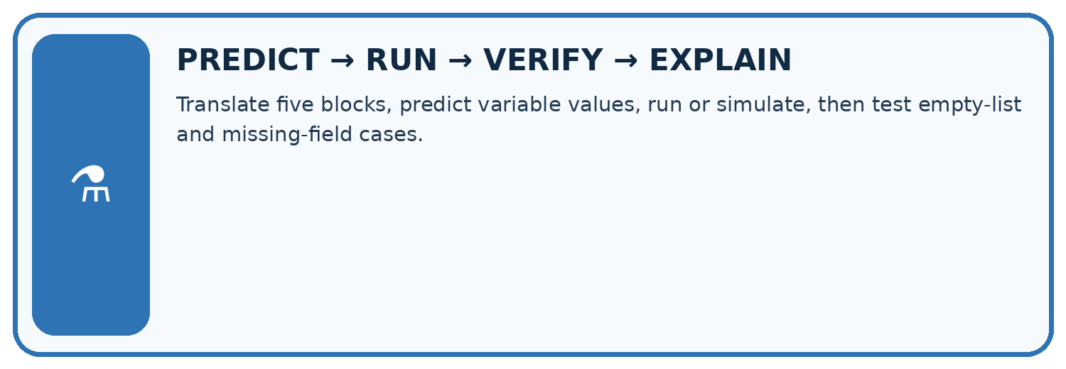
Translate five blocks, predict variable values, run or simulate, then test empty-list and missing-field cases.
Test / input | Prediction | Actual | Evidence / calculation | Change or keep?
normal
boundary
missing
fresh transfer
What did the hardest test teach you that the normal test did not?

Write or draw your reasoning and evidence.
________________________________________________________________
________________________________________________________________
________________________________________________________________
________________________________________________________________
________________________________________________________________

Plan → try → check
Before trying: what do I expect, and why? While trying: which step could first go wrong? Afterwards: what did I actually observe, and what should change? Keep “not run” if you only traced the procedure.

10. Build your understanding
MASTERY
From Knowing the Word to Owning the Idea
Move upward only when you can produce evidence without copying the worked example.

1 • NAME: Define the concept without repeating the textbook.
2 • TRACE: Show the information, state, branch, calculation, or evidence path.
3 • APPLY: Solve a different example independently.
4 • CHALLENGE: Find a boundary case, counterexample, or unfair outcome.
5 • EXPLAIN LIMITS: Say when the result should not be trusted or used alone.
My strongest evidence of independent understanding:

Write or draw your reasoning and evidence.
________________________________________________________________
________________________________________________________________
________________________________________________________________
________________________________________________________________
________________________________________________________________

11. Connect your project
CUMULATIVE PROJECT
Verified Study Buddy
Every week adds one inspectable piece. The system must show how it reached a result.
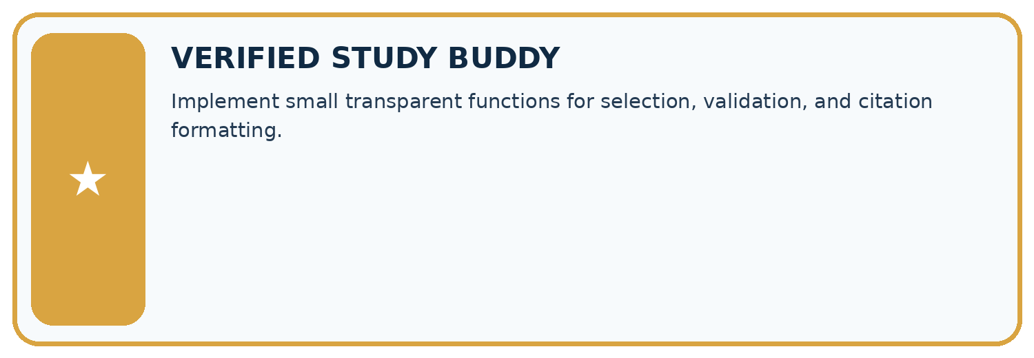
THIS WEEK’S CHECKPOINT Implement small transparent functions for selection, validation, and citation formatting.
SYSTEM MAP Learner need → prompt/schema → approved sources/retrieval → model/tool → structured answer → verification → human decision
What will you add, change, or verify in the project this week?

Write or draw your reasoning and evidence.
________________________________________________________________
________________________________________________________________
________________________________________________________________
________________________________________________________________
________________________________________________________________
What should remain under human control?

Write or draw your reasoning and evidence.
________________________________________________________________
________________________________________________________________
________________________________________________________________
________________________________________________________________
________________________________________________________________
RESPONSIBLE DESIGN Collect only necessary information. Show uncertainty and limits. Never confuse fluent output with verified truth.

Evidence for your project
For your Verified Study Buddy, save the input, procedure, observed result and limitation of this check. Label this worked example as practice; use a different, previously unreviewed case when checking independent understanding.

12. Show what you know
INDEPENDENT MASTERY PROOF
Explain • Transfer • Test • Defend
Complete this page without copying the worked example. Your reasoning matters more than decoration.
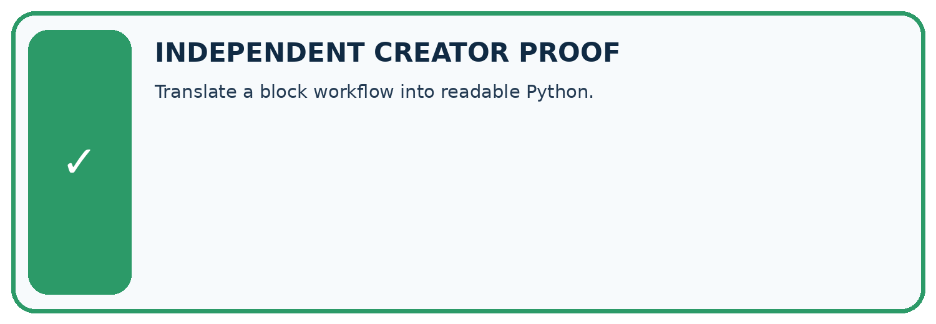
CHALLENGE Translate a block workflow into readable Python.
1. My fresh example, trace, calculation, or design:

Write or draw your reasoning and evidence.
________________________________________________________________
________________________________________________________________
________________________________________________________________
________________________________________________________________
________________________________________________________________
2. My evidence that it works (include a boundary or missing-data case):

Write or draw your reasoning and evidence.
________________________________________________________________
________________________________________________________________
________________________________________________________________
________________________________________________________________
________________________________________________________________
3. One limitation, fairness concern, or situation needing human review:

Write or draw your reasoning and evidence.
________________________________________________________________
________________________________________________________________
________________________________________________________________
________________________________________________________________
________________________________________________________________
SELF-CHECK □ I explained the mechanism □ I used evidence □ I tested a fresh case □ I named a limitation □ I can answer ‘why?’

13. Study a complete case

Week 23 Worked case
Use the supplied details to practise the weekly concept before attempting the independent question. This case extends the illustrated lesson.

The situation
A block program sets total=0 and adds each value in [2,4,6].

The question
Translate and trace.

Worked explanation
Python uses total=0, then an indented total += value inside for value in [2,4,6]. Totals are 2,6,12.

Explain it in your own words
Which detail supports the answer, and why does it matter?

Write or draw your reasoning and evidence.
________________________________________________________________
________________________________________________________________
________________________________________________________________
________________________________________________________________
________________________________________________________________

Trace the supplied case visually

Trace the accumulator inside the loop
Evidence or stage | Value or result
Start total | 0
Add 2 | 2
Add 4 | 6
Add 6 | 12
A block program sets total=0 and adds each value in [2,4,6].
Translate and trace.
Python uses total=0, then an indented total += value inside for value in [2,4,6]. Totals are 2,6,12.

14. Try a new case independently

Independent case: Changed independent case
Set total=0, then for values2,4,9 perform total=total+value. Trace the result. What changes if total=0 moves inside the loop before that addition?

My independent explanation, trace and limits
________________________________________________________________
________________________________________________________________
________________________________________________________________
________________________________________________________________
________________________________________________________________
________________________________________________________________
________________________________________________________________
Attempt this case before feedback. Record any help. Earlier examples below are further practice; a case already practised with feedback cannot establish fresh transfer.

Week 23 Independent application
Close the worked explanation. Apply the idea to this different question without copying.
Trace this Python: score = 2; then if score >= 2: score = score + 3. What is the final value, and what changes if the condition becomes score > 2?
My answer, with a trace, calculation or supporting evidence

Write or draw your reasoning and evidence.
________________________________________________________________
________________________________________________________________
________________________________________________________________
________________________________________________________________
________________________________________________________________

Create and test
Change one relevant detail. Predict the result before testing. Include a boundary or missing-information case when it helps reveal a limit.
My changed input and expected result

Write or draw your reasoning and evidence.
________________________________________________________________
________________________________________________________________
________________________________________________________________
________________________________________________________________
________________________________________________________________

Connect to your project
Implement small transparent functions for selection, validation, and citation formatting.
The evidence I will keep

Write or draw your reasoning and evidence.
________________________________________________________________
________________________________________________________________
________________________________________________________________
________________________________________________________________
________________________________________________________________
Your teacher has the independent answer and scoring criteria. Complete the matching workbook week to keep your practice evidence together.

Transfer practice from the original programme
Write Python that totals [3,5,7], then trace each total. Explain how indenting 'total=0' inside the loop changes the result.

Explain the mechanism, evidence and one limit.
________________________________________________________________
________________________________________________________________
________________________________________________________________
________________________________________________________________
________________________________________________________________
________________________________________________________________
________________________________________________________________

Use feedback to improve
Attempt the independent case before hints. Record whether you worked alone, used a hint or followed a model. After feedback, fix the first unsupported step and explain why it changed. A later check uses a changed case, not a copied answer.

