AI ACADEMY · STUDENT · ai-3/24

Prototype a Grounded Assistant
Project: Verified Study Buddy

Before you start
Week 18: missing evidence needs an explicit fallback.

01. Your mission

Your learning target
I can explain the mechanism and terminology of capstone grounded assistant.
I can apply the stated procedure to a new case with a traceable result.
I can identify an assumption or limitation and design a revealing follow-up.

Remember before reading
Close your notes first. A rough first answer helps us choose the right starting point; it is not a score for your ability.
Without opening the old lesson, explain one key idea from Block to Python Bridge. Give an example and a mistake that the idea helps you avoid.
Without opening the old lesson, explain one key idea from Tools and APIs. Give an example and a mistake that the idea helps you avoid.
Without opening the old lesson, explain one key idea from Retrieval Augmented Generation. Give an example and a mistake that the idea helps you avoid.
After trying, check the relevant lesson or ask your teacher. Change the part of your explanation that the evidence shows was wrong.
Week 24: Prototype a Grounded Assistant
A smallest working product connects prompt, references, interaction, and output.
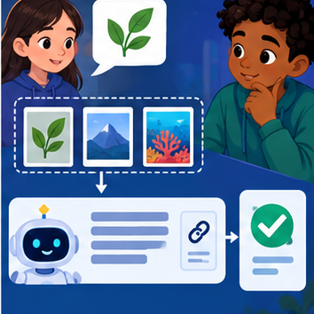
CREATOR MISSION
Build one end-to-end Study Buddy path.
Creator name and date:

Write or draw your reasoning and evidence.
________________________________________________________________
________________________________________________________________
________________________________________________________________
________________________________________________________________
________________________________________________________________

Readiness for the connected explanation
Recall Capstone requirements and corpus. Explain why a recorded result needs its input conditions and evidence source before it can support a claim.

This week’s end goal
By the end, I can explain prototype a grounded assistant using a traced example and a stated limitation.

02. Notice the evidence
PICTURE STORY
Notice → Predict → Explain
Begin with visible evidence. Do not explain more than the picture and information support.
MYSTERY
The learners must use prototype a grounded assistant to solve a problem. What information do they have? What decision or calculation do they make? What would count as evidence that it worked?
Three observations (what you can point to):

Write or draw your reasoning and evidence.
________________________________________________________________
________________________________________________________________
________________________________________________________________
________________________________________________________________
________________________________________________________________
My prediction and the clue supporting it:

Write or draw your reasoning and evidence.
________________________________________________________________
________________________________________________________________
________________________________________________________________
________________________________________________________________
________________________________________________________________

A closer explanation
Build the assistant as a sequence of testable stages: validate request, retrieve authorised evidence, decide answerability, draft, validate and return. Avoid merging all errors into one model score.
Begin by writing the question the procedure is intended to answer. Identify the information already supplied, the information it will produce and the information still missing. These are constructed classroom examples; they do not require live accounts, private records or an external service. Do not treat a plausible explanation as a measured outcome.

03. See how it works
VISUAL MECHANISM
Input → Process → Output
Trace the information. At each stage, ask what changed and how you could test it.
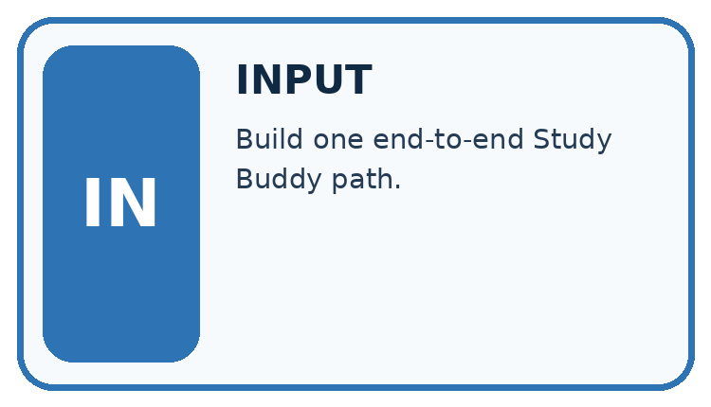
↓
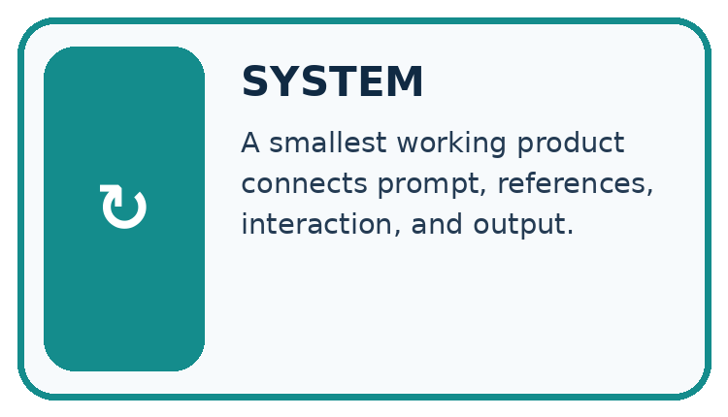
↓
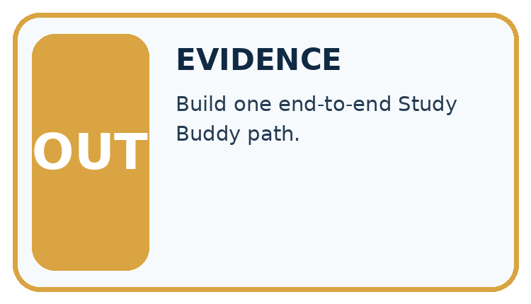
Which stage could fail even when the other two are correct? Explain:

Write or draw your reasoning and evidence.
________________________________________________________________
________________________________________________________________
________________________________________________________________
________________________________________________________________
________________________________________________________________

A closer explanation
A supported response requires current matching approval and register records. Any retrieval or validation failure gives needs_review with null claims. The classroom implementation performs no booking or external action.

Capstone grounded assistant — evidence trace
Input and scope | Check or calculation | Conclusion and limit
Request room B; retrieved approval names B but register names C. Draft gives capacity 10 from C. | A supported response requires current matching approval and register records. Any retrieval or validation failure gives needs_review with null claims. The classroom implementation performs no booking or external action. | Same-room support fails before or during semantic validation. Return needs_review with null claims; the draft capacity is unsupported for B.
The figure connects this chapter's worked input, declared procedure and result. Read the complete worked reasoning for qualifiers and intermediate steps; the abbreviated labels do not replace that reasoning.
Before applying the procedure, write its units, denominator or decision boundary where relevant. A partner should be able to repeat each step using the same inputs. If a required input is absent or violates the stated contract, record that condition explicitly instead of quietly replacing it with a convenient value.

Connect the picture and the explanation
Point to the input, the deciding step and the result in this week’s visual. Explain the same step in ordinary words. A picture helps when you can say what each part represents.

04. Compare the cases
CASE GALLERY
Four Tests, Four Kinds of Evidence
A system is not understood until it survives more than one comfortable example.


NORMAL CASE: predict and name evidence. BOUNDARY CASE: predict and name evidence.


MISSING INFORMATION: predict and name evidence. TRANSFER CASE: predict and name evidence.
Which case is most likely to reveal a hidden assumption? Why?

Write or draw your reasoning and evidence.
________________________________________________________________
________________________________________________________________
________________________________________________________________
________________________________________________________________
________________________________________________________________

Change one thing in the pictured case
Change: PL3 is absent while PL2 remains.
Prediction: Explain that the daily check is not specified in the available source.
Reason: The remaining general water fact does not establish this activity’s schedule.

05. Words that unlock the idea
VOCABULARY LAB
Words You Can Use to Reason
A definition matters when you can recognize the idea, use it, and contrast it with a near-miss.
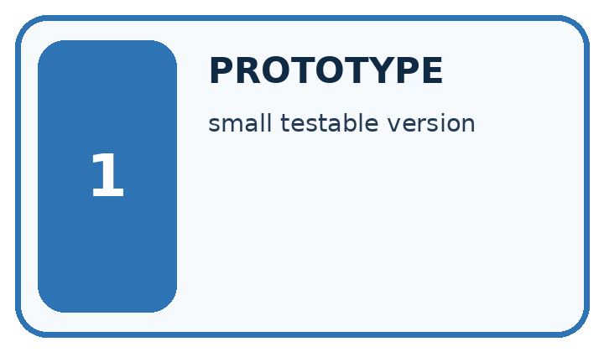
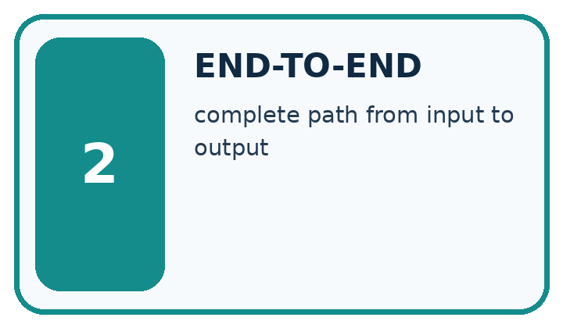
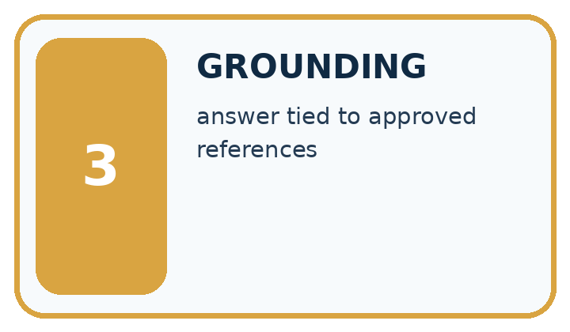
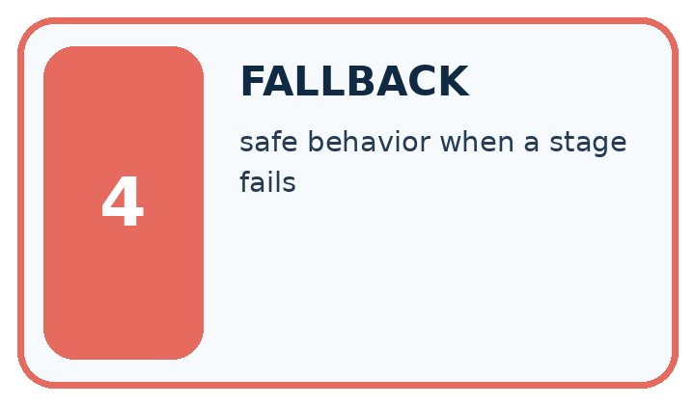
Word | My own example | Not this / boundary
prototype | An early working or simulated version used to test assumptions about a design.
end-to-end | Covering the entire process from original input to final output.
grounding | Connecting an answer or action to specified evidence or observations.
fallback | A predefined alternative action used when the usual path cannot be completed reliably.

Words used in the closer explanation
Word | Meaning
Pipeline stage | One operation with defined inputs and failure handling
Answerability gate | A check for sufficient evidence before answering
Semantic validator | A check that claims match task evidence

06. Follow a worked example
WORKED EVIDENCE
Reason Step by Step
Predict first. Then check each step. A correct answer without visible reasoning is incomplete evidence.
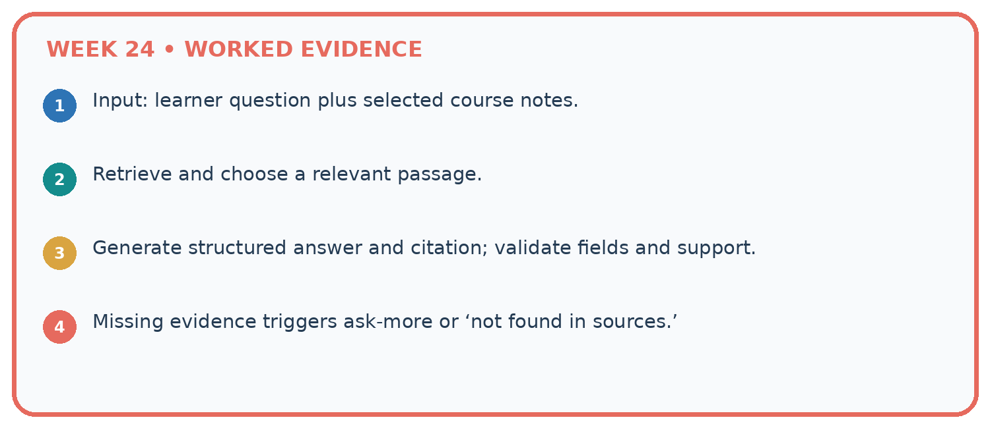
1. Input: learner question plus selected course notes.
2. Retrieve and choose a relevant passage.
3. Generate structured answer and citation; validate fields and support.
4. Missing evidence triggers ask-more or ‘not found in sources.’
Recalculate, retrace, or restate the reasoning in your own representation:

Write or draw your reasoning and evidence.
________________________________________________________________
________________________________________________________________
________________________________________________________________
________________________________________________________________
________________________________________________________________
CHECK Did the evidence answer the exact question? Did the total, path, or source record stay consistent?

A closer explanation
Request room B; retrieved approval names B but register names C. Draft gives capacity 10 from C.
Same-room support fails before or during semantic validation. Return needs_review with null claims; the draft capacity is unsupported for B.
Compare the intermediate evidence with the final statement. Explain why each number or decision follows from the stated inputs. The conclusion belongs to this scenario and procedure; changing the inputs, evaluation population or authority can change what it establishes. Retain the raw record so a later revision can be compared honestly.

Learn from the worked case
Cover the result before checking it. Say what is given, choose the procedure, and follow one step at a time. Then uncover the result and explain your first mismatch. Ask why a step is allowed, not only what number it produces.

A pictorial worked case: Prototype a Grounded Assistant
Build a minimal grounded study answer with checks between retrieval and display.

The facts we will use
Source PL2: seedlings need water. Source PL3: this activity checks soil daily. Question: what does this activity check daily?
All inputs and outcomes in this worked example are invented classroom data; no real model run is claimed.
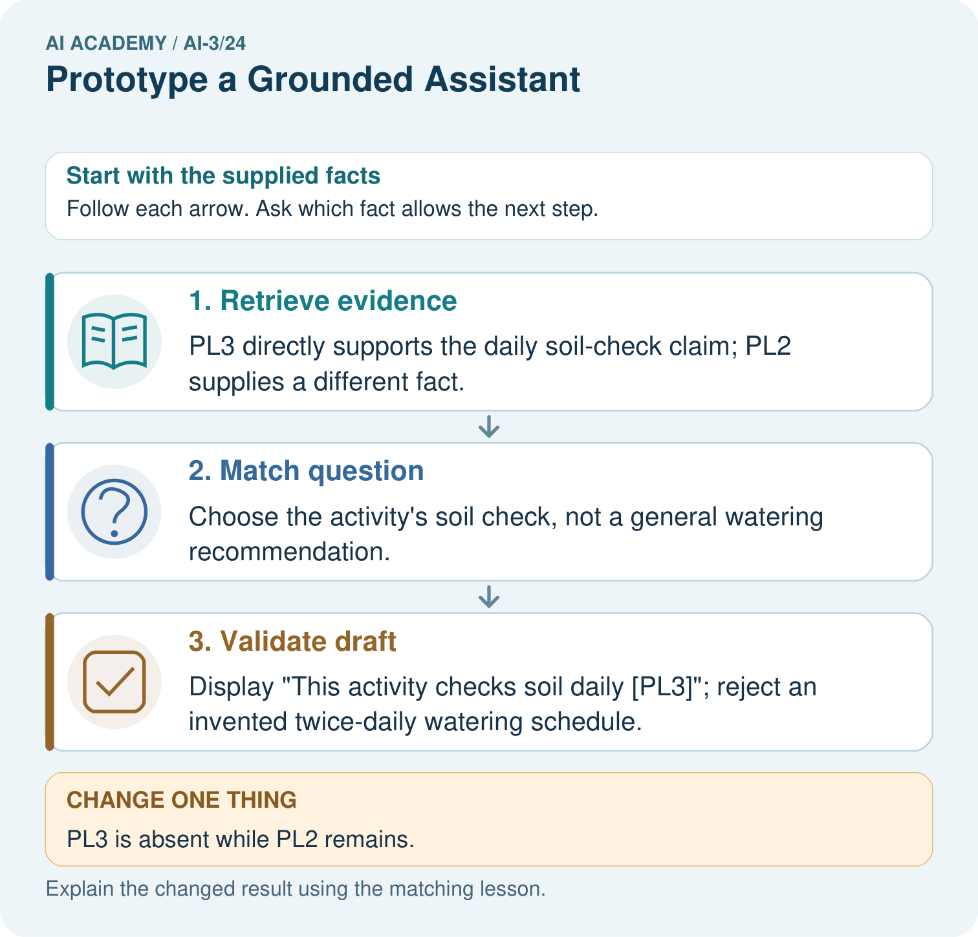

Read the picture one step at a time
Step | What happens and why
1. Retrieve evidence | PL3 directly supports the daily soil-check claim; PL2 supplies a different fact.
2. Match question | Choose the activity’s soil check, not a general watering recommendation.
3. Validate draft | Display “This activity checks soil daily [PL3]”; reject an invented twice-daily watering schedule.
Match each pictured step to the supplied facts. This is a worked teaching case, not an independent assessment.

Why this result follows
Read the picture in order. Display “This activity checks soil daily [PL3]”; reject an invented twice-daily watering schedule. The arrows show which recorded input or intermediate result each decision uses. Explain the deciding step aloud before checking the changed case; pointing to the final answer alone does not show how it follows.

What this example does not establish
A grounded prototype still needs an evaluation set and permission checks before anyone relies on it.

07. Find and repair a mistake
ERROR DETECTIVE
Compare → Diagnose → Repair
Do not patch the answer. Find the earliest unsupported assumption, wrong step, or weak evidence.
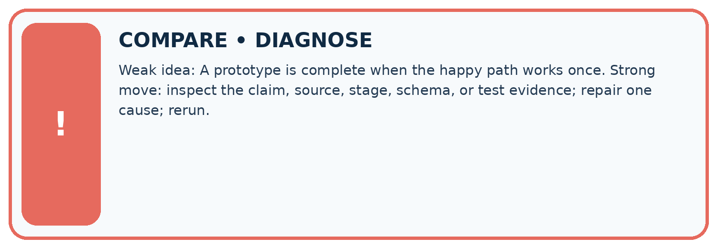
Evidence record | Expected | Actual | Likely cause / next test
normal case | works
boundary case | stated rule
missing input | safe response
fresh transfer | generalizes
Repair one cause. Why is this repair better than changing several things?

Write or draw your reasoning and evidence.
________________________________________________________________
________________________________________________________________
________________________________________________________________
________________________________________________________________
________________________________________________________________

A closer explanation
Complete the supported workbook tasks before attempting W4 independently. Record any hints or help used. After feedback, use the teacher's fresh retry rather than copying the earlier answer. For a project, select a relevant new case, predict the outcome from the declared rule and preserve the result alongside any revision.

Exit: propose one revealing change to the worked scenario. State the expected outcome and the evidence that would make you revise your explanation.
________________________________________________________________
________________________________________________________________
________________________________________________________________
________________________________________________________________
________________________________________________________________

08. Practise together
LOGIC STUDIO
Specify Before You Run
Prompts, schemas, retrieval, tool calls, and code are inspectable parts of one AI product.

SET task, audience, constraints, output_schema
LOAD approved_context or retrieval_result
CALL model or allowed_tool
VALIDATE fields, claims, citations, and safety
IF evidence missing: ask, retrieve, or abstain
RETURN useful output + source trail + limitations
Trace one input. Which line changes the state or chooses a path?

Write or draw your reasoning and evidence.
________________________________________________________________
________________________________________________________________
________________________________________________________________
________________________________________________________________
________________________________________________________________

A closer explanation
A correct happy path does not establish fallback, access control or side-effect safety.
A useful check asks what would make the reasoning fail. Distinguish a failure to execute the declared procedure from a weakness in the procedure itself. The first may require a correction; the second requires an explicitly revised method and new evidence. Preserve unsuccessful cases so an improved result cannot hide the original problem.

Guided: restate the worked result, then name the assumption or limitation that prevents a broader conclusion.
________________________________________________________________
________________________________________________________________
________________________________________________________________
________________________________________________________________
________________________________________________________________

Practise with less help: Trace the worked case
Use workbook W2 for the connected example “Capstone grounded assistant”. First fill the input and rule boxes. Try the middle steps before asking for a hint. After a hint, try the next step yourself.
Plan | Do | Check
What is given? Which rule or procedure applies? | Record each intermediate step. | Does the result follow? What remains unknown?
Explain your trace to a partner. Your partner points to one step to check. Swap roles on the next case. Each person writes their own explanation.

Check your reasoning
Use the worked case for Capstone grounded assistant. Proposed explanation: “The worked result establishes every future case”. Decide whether this explanation is supported. Point to the step or supplied fact that decides; explain your repair if needed.
Answer on your own before discussion. If you are unsure, say which step you need help with.

Explain the picture
Can PL2 alone support “check the soil daily”? Point to the relevant step in the picture, then write the changed result and the rule or evidence that supports it.

My explanation using a pictured step and the given facts
________________________________________________________________
________________________________________________________________
________________________________________________________________
________________________________________________________________
This is supported practice. Keep the separately named independent case for an attempt before feedback.

09. Run the investigation
EVIDENCE LAB
Predict → Test → Record → Explain
Keep expected and actual results separate. Surprises are useful data when recorded honestly.
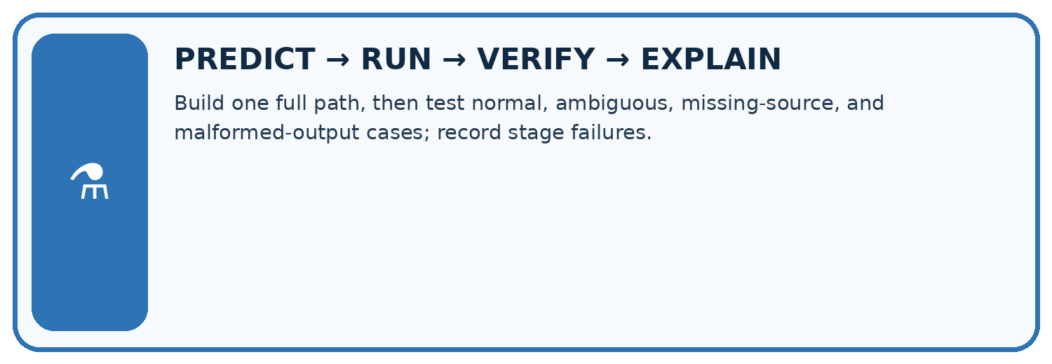
Build one full path, then test normal, ambiguous, missing-source, and malformed-output cases; record stage failures.
Test / input | Prediction | Actual | Evidence / calculation | Change or keep?
normal
boundary
missing
fresh transfer
What did the hardest test teach you that the normal test did not?

Write or draw your reasoning and evidence.
________________________________________________________________
________________________________________________________________
________________________________________________________________
________________________________________________________________
________________________________________________________________

Plan → try → check
Before trying: what do I expect, and why? While trying: which step could first go wrong? Afterwards: what did I actually observe, and what should change? Keep “not run” if you only traced the procedure.

10. Build your understanding
MASTERY
From Knowing the Word to Owning the Idea
Move upward only when you can produce evidence without copying the worked example.

1 • NAME: Define the concept without repeating the textbook.
2 • TRACE: Show the information, state, branch, calculation, or evidence path.
3 • APPLY: Solve a different example independently.
4 • CHALLENGE: Find a boundary case, counterexample, or unfair outcome.
5 • EXPLAIN LIMITS: Say when the result should not be trusted or used alone.
My strongest evidence of independent understanding:

Write or draw your reasoning and evidence.
________________________________________________________________
________________________________________________________________
________________________________________________________________
________________________________________________________________
________________________________________________________________

11. Connect your project
CUMULATIVE PROJECT
Verified Study Buddy
Every week adds one inspectable piece. The system must show how it reached a result.
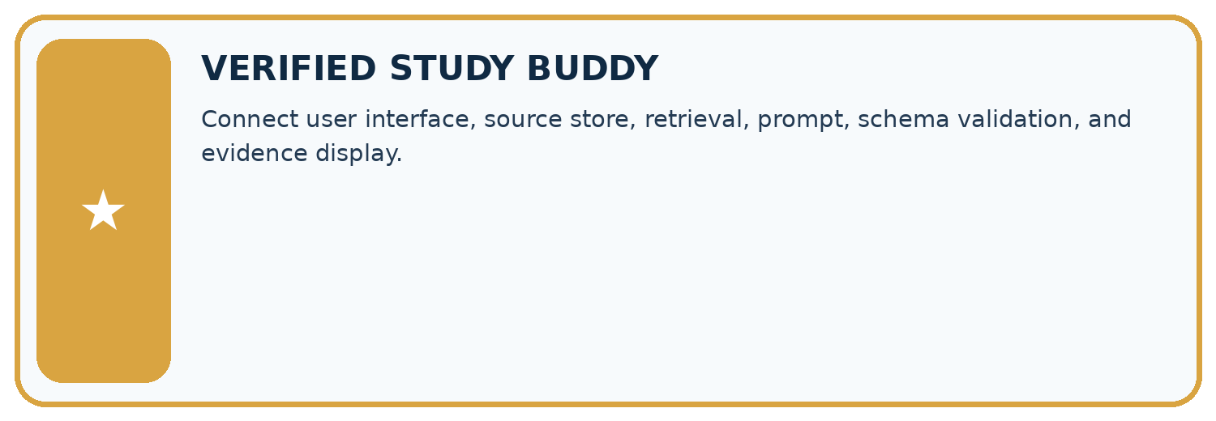
THIS WEEK’S CHECKPOINT Connect user interface, source store, retrieval, prompt, schema validation, and evidence display.
SYSTEM MAP Learner need → prompt/schema → approved sources/retrieval → model/tool → structured answer → verification → human decision
What will you add, change, or verify in the project this week?

Write or draw your reasoning and evidence.
________________________________________________________________
________________________________________________________________
________________________________________________________________
________________________________________________________________
________________________________________________________________
What should remain under human control?

Write or draw your reasoning and evidence.
________________________________________________________________
________________________________________________________________
________________________________________________________________
________________________________________________________________
________________________________________________________________
RESPONSIBLE DESIGN Collect only necessary information. Show uncertainty and limits. Never confuse fluent output with verified truth.

Evidence for your project
For your Verified Study Buddy, save the input, procedure, observed result and limitation of this check. Label this worked example as practice; use a different, previously unreviewed case when checking independent understanding.

12. Show what you know
INDEPENDENT MASTERY PROOF
Explain • Transfer • Test • Defend
Complete this page without copying the worked example. Your reasoning matters more than decoration.
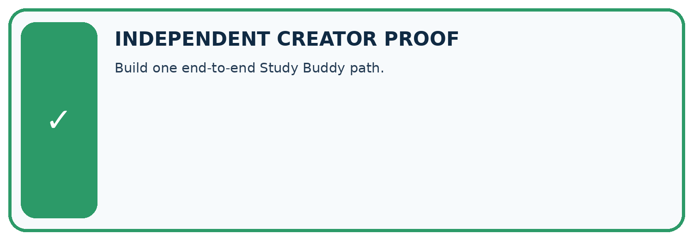
CHALLENGE Build one end-to-end Study Buddy path.
1. My fresh example, trace, calculation, or design:

Write or draw your reasoning and evidence.
________________________________________________________________
________________________________________________________________
________________________________________________________________
________________________________________________________________
________________________________________________________________
2. My evidence that it works (include a boundary or missing-data case):

Write or draw your reasoning and evidence.
________________________________________________________________
________________________________________________________________
________________________________________________________________
________________________________________________________________
________________________________________________________________
3. One limitation, fairness concern, or situation needing human review:

Write or draw your reasoning and evidence.
________________________________________________________________
________________________________________________________________
________________________________________________________________
________________________________________________________________
________________________________________________________________
SELF-CHECK □ I explained the mechanism □ I used evidence □ I tested a fresh case □ I named a limitation □ I can answer ‘why?’

13. Study a complete case

Week 24 Worked case
Use the supplied details to practise the weekly concept before attempting the independent question. This case extends the illustrated lesson.

The situation
Approved notes say plants need light and roots take up water. Ask how roots help.

The question
Specify the minimum grounded path.

Worked explanation
Retrieve the roots note, answer that roots take up water and reference it. Validate support and avoid unrelated claims.

Explain it in your own words
Which detail supports the answer, and why does it matter?

Write or draw your reasoning and evidence.
________________________________________________________________
________________________________________________________________
________________________________________________________________
________________________________________________________________
________________________________________________________________

Trace the supplied case visually

Build the smallest grounded path
Evidence or stage | Value or result
Question | How do roots help?
Retrieve | Roots take up water
Answer | Explain water uptake
Check | Reference and verify the roots note
Approved notes say plants need light and roots take up water. Ask how roots help.
Specify the minimum grounded path.
Retrieve the roots note, answer that roots take up water and reference it. Validate support and avoid unrelated claims.

14. Try a new case independently

Independent case: Apply a new case independently
Request room J; approval and register both J capacity 0. Draft is well-formed with J/0 and correct sources. Trace stages and distinguish zero from missing.

My independent explanation, trace and limits
________________________________________________________________
________________________________________________________________
________________________________________________________________
________________________________________________________________
________________________________________________________________
________________________________________________________________
________________________________________________________________
Attempt this case before feedback. Record any help. Earlier examples below are further practice; a case already practised with feedback cannot establish fresh transfer.

Week 24 Independent application
Close the worked explanation. Apply the idea to this different question without copying.
A study assistant has a supplied passage about roots. A user asks a question about planets. What should the prototype do within a passage-only boundary?
My answer, with a trace, calculation or supporting evidence

Write or draw your reasoning and evidence.
________________________________________________________________
________________________________________________________________
________________________________________________________________
________________________________________________________________
________________________________________________________________

Create and test
Change one relevant detail. Predict the result before testing. Include a boundary or missing-information case when it helps reveal a limit.
My changed input and expected result

Write or draw your reasoning and evidence.
________________________________________________________________
________________________________________________________________
________________________________________________________________
________________________________________________________________
________________________________________________________________

Connect to your project
Connect user interface, source store, retrieval, prompt, schema validation, and evidence display.
The evidence I will keep

Write or draw your reasoning and evidence.
________________________________________________________________
________________________________________________________________
________________________________________________________________
________________________________________________________________
________________________________________________________________
Your teacher has the independent answer and scoring criteria. Complete the matching workbook week to keep your practice evidence together.

Transfer practice from the original programme
Build a paper assistant from notes A='Roots take up water' and B='Leaves use light'. Answer 'Which part takes up water?' and 'How tall is this plant?' with references or fallback.

Explain the mechanism, evidence and one limit.
________________________________________________________________
________________________________________________________________
________________________________________________________________
________________________________________________________________
________________________________________________________________
________________________________________________________________
________________________________________________________________

Use feedback to improve
Attempt the independent case before hints. Record whether you worked alone, used a hint or followed a model. After feedback, fix the first unsupported step and explain why it changed. A later check uses a changed case, not a copied answer.

