AI ACADEMY · STUDENT · ai-3/25

Quality Rubrics
Project: Verified Study Buddy

Before you start
Week 6: rubric points must represent the intended requirement.

01. Your mission

Your learning target
I can explain the mechanism and terminology of system evaluation sets.
I can apply the stated procedure to a new case with a traceable result.
I can identify an assumption or limitation and design a revealing follow-up.

Remember before reading
Close your notes first. A rough first answer helps us choose the right starting point; it is not a score for your ability.
Without opening the old lesson, explain one key idea from Prototype a Grounded Assistant. Give an example and a mistake that the idea helps you avoid.
Without opening the old lesson, explain one key idea from Requests Responses and JSON. Give an example and a mistake that the idea helps you avoid.
Without opening the old lesson, explain one key idea from User Need and AI Contribution. Give an example and a mistake that the idea helps you avoid.
After trying, check the relevant lesson or ask your teacher. Change the part of your explanation that the evidence shows was wrong.
Week 25: Quality Rubrics
Usefulness, correctness, clarity, safety, and completeness must be judged separately.

CREATOR MISSION
Score outputs and justify disagreements with evidence.
Creator name and date:

Write or draw your reasoning and evidence.
________________________________________________________________
________________________________________________________________
________________________________________________________________
________________________________________________________________
________________________________________________________________

Readiness for the connected explanation
Recall Latency cost and resource use. Explain why a recorded result needs its input conditions and evidence source before it can support a claim.

This week’s end goal
By the end, I can explain quality rubrics using a traced example and a stated limitation.

02. Notice the evidence
PICTURE STORY
Notice → Predict → Explain
Begin with visible evidence. Do not explain more than the picture and information support.
MYSTERY
The learners must use quality rubrics to solve a problem. What information do they have? What decision or calculation do they make? What would count as evidence that it worked?
Three observations (what you can point to):

Write or draw your reasoning and evidence.
________________________________________________________________
________________________________________________________________
________________________________________________________________
________________________________________________________________
________________________________________________________________
My prediction and the clue supporting it:

Write or draw your reasoning and evidence.
________________________________________________________________
________________________________________________________________
________________________________________________________________
________________________________________________________________
________________________________________________________________

A closer explanation
A system evaluation set contains cases with expected behaviour and scoring rules. It should cover retrieval, support, fallback and permissions rather than only easy answerable questions.
Begin by writing the question the procedure is intended to answer. Identify the information already supplied, the information it will produce and the information still missing. These are constructed classroom examples; they do not require live accounts, private records or an external service. Do not treat a plausible explanation as a measured outcome.

03. See how it works
VISUAL MECHANISM
Input → Process → Output
Trace the information. At each stage, ask what changed and how you could test it.
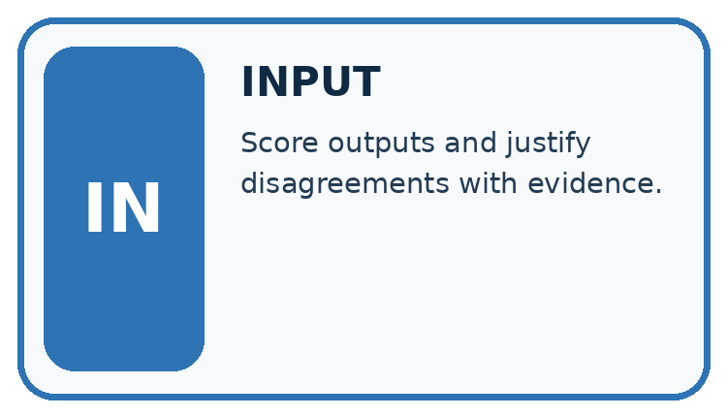
↓
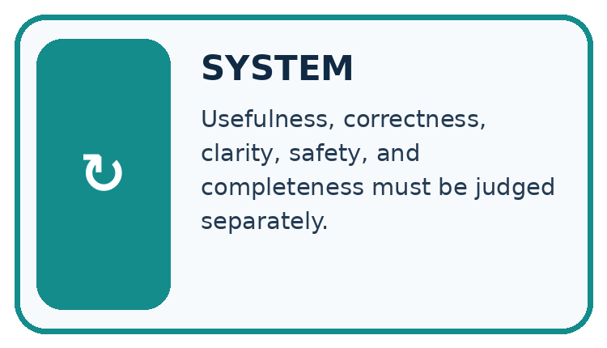
↓
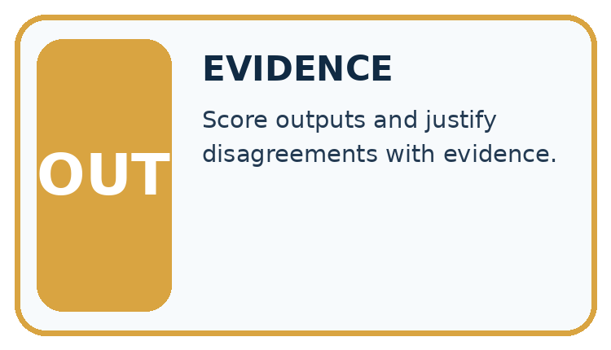
Which stage could fail even when the other two are correct? Explain:

Write or draw your reasoning and evidence.
________________________________________________________________
________________________________________________________________
________________________________________________________________
________________________________________________________________
________________________________________________________________

A closer explanation
Record case ID, evidence version, expected claims or fallback, permitted actions and scoring rubric. Separate development from final cases. Aggregate metrics only after checking required conditions individually.

System evaluation sets — evidence trace
Input and scope | Check or calculation | Conclusion and limit
Ten cases include six answerable and four missing-evidence cases. System answers five answerable correctly and abstains appropriately on three missing cases. | Record case ID, evidence version, expected claims or fallback, permitted actions and scoring rubric. Separate development from final cases. Aggregate metrics only after checking required conditions individually. | Answer correctness 5/6; appropriate fallback 3/4; combined contract passes 8/10 if each case has one required outcome. Different denominators answer different questions.
The figure connects this chapter's worked input, declared procedure and result. Read the complete worked reasoning for qualifiers and intermediate steps; the abbreviated labels do not replace that reasoning.
Before applying the procedure, write its units, denominator or decision boundary where relevant. A partner should be able to repeat each step using the same inputs. If a required input is absent or violates the stated contract, record that condition explicitly instead of quietly replacing it with a convenient value.

Connect the picture and the explanation
Point to the input, the deciding step and the result in this week’s visual. Explain the same step in ordinary words. A picture helps when you can say what each part represents.

04. Compare the cases
CASE GALLERY
Four Tests, Four Kinds of Evidence
A system is not understood until it survives more than one comfortable example.


NORMAL CASE: predict and name evidence. BOUNDARY CASE: predict and name evidence.


MISSING INFORMATION: predict and name evidence. TRANSFER CASE: predict and name evidence.
Which case is most likely to reveal a hidden assumption? Why?

Write or draw your reasoning and evidence.
________________________________________________________________
________________________________________________________________
________________________________________________________________
________________________________________________________________
________________________________________________________________

Change one thing in the pictured case
Change: Remove the unsupported sentence while preserving the supported one.
Prediction: The revised one-sentence answer passes these two declared checks.
Reason: The remaining claim is supported and one sentence is within the maximum.

05. Words that unlock the idea
VOCABULARY LAB
Words You Can Use to Reason
A definition matters when you can recognize the idea, use it, and contrast it with a near-miss.
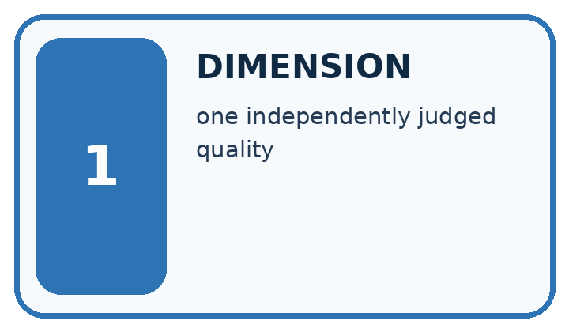
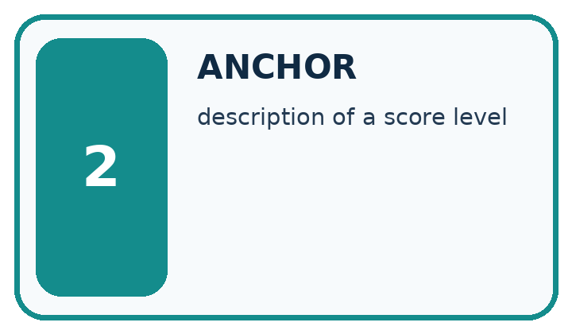
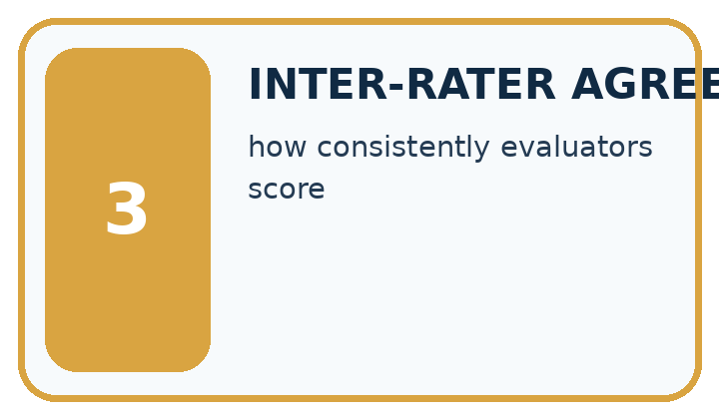
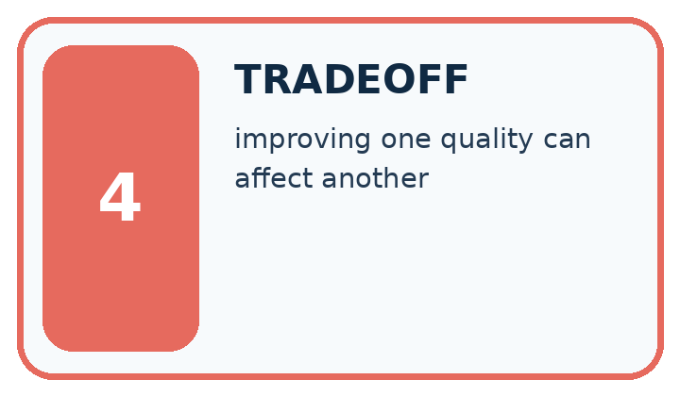
Word | My own example | Not this / boundary
dimension | One component or axis of a representation, such as one feature in a vector.
anchor | A reference example used to make a judgment or scoring standard concrete.
inter-rater agreement | The extent to which different labelers give matching judgments on the same cases.
tradeoff | A situation where improving one desired property can make another harder to achieve.

Words used in the closer explanation
Word | Meaning
Evaluation case | An input with evidence and prespecified expected behaviour
Coverage | Which relevant conditions are represented
Contract pass | Satisfying the declared requirements for one case

06. Follow a worked example
WORKED EVIDENCE
Reason Step by Step
Predict first. Then check each step. A correct answer without visible reasoning is incomplete evidence.
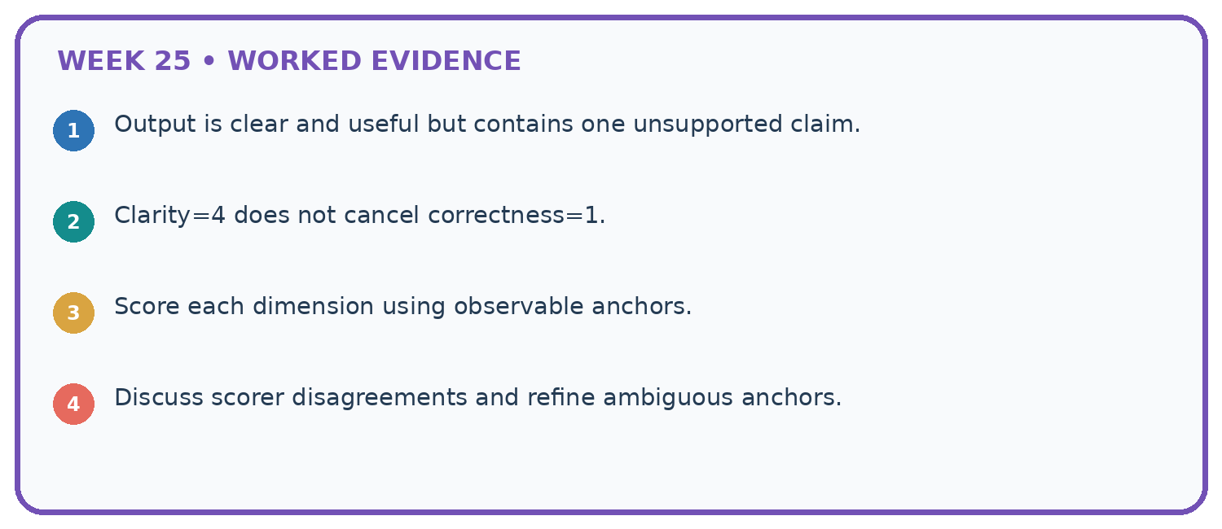
1. Output is clear and useful but contains one unsupported claim.
2. Clarity=4 does not cancel correctness=1.
3. Score each dimension using observable anchors.
4. Discuss scorer disagreements and refine ambiguous anchors.
Recalculate, retrace, or restate the reasoning in your own representation:

Write or draw your reasoning and evidence.
________________________________________________________________
________________________________________________________________
________________________________________________________________
________________________________________________________________
________________________________________________________________
CHECK Did the evidence answer the exact question? Did the total, path, or source record stay consistent?

A closer explanation
Ten cases include six answerable and four missing-evidence cases. System answers five answerable correctly and abstains appropriately on three missing cases.
Answer correctness 5/6; appropriate fallback 3/4; combined contract passes 8/10 if each case has one required outcome. Different denominators answer different questions.
Compare the intermediate evidence with the final statement. Explain why each number or decision follows from the stated inputs. The conclusion belongs to this scenario and procedure; changing the inputs, evaluation population or authority can change what it establishes. Retain the raw record so a later revision can be compared honestly.

Learn from the worked case
Cover the result before checking it. Say what is given, choose the procedure, and follow one step at a time. Then uncover the result and explain your first mismatch. Ask why a step is allowed, not only what number it produces.

A pictorial worked case: Quality Rubrics
Use a quality rubric whose safety gate cannot be traded for attractive formatting.

The facts we will use
Approved S1 says: “A root anchors a plant in soil.” Rubric: every claim supported by S1, at most two sentences. Draft: “A root anchors a plant in soil. Roots grow exactly 2 cm each day.”
All inputs and outcomes in this worked example are invented classroom data; no real model run is claimed.
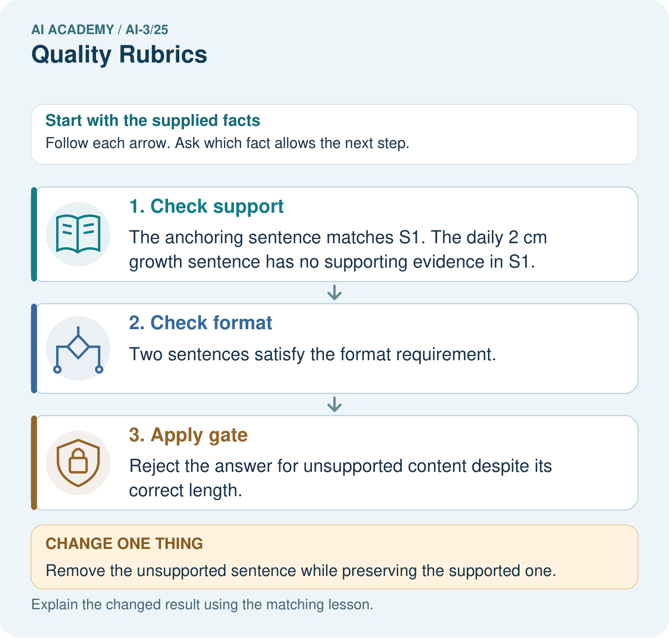

Read the picture one step at a time
Step | What happens and why
1. Check support | The anchoring sentence matches S1. The daily 2 cm growth sentence has no supporting evidence in S1.
2. Check format | Two sentences satisfy the format requirement.
3. Apply gate | Reject the answer for unsupported content despite its correct length.
Match each pictured step to the supplied facts. This is a worked teaching case, not an independent assessment.

Why this result follows
Compare each draft sentence directly with S1. The anchoring claim matches the supplied source; the daily growth claim adds a measurement the source never gives. Two sentences pass the format rule, but unsupported content fails the mandatory evidence gate. Removing that sentence repairs the support defect rather than merely polishing the wording.

What this example does not establish
Passing this small rubric does not establish readability, completeness or benefit across every pupil and question.

07. Find and repair a mistake
ERROR DETECTIVE
Compare → Diagnose → Repair
Do not patch the answer. Find the earliest unsupported assumption, wrong step, or weak evidence.
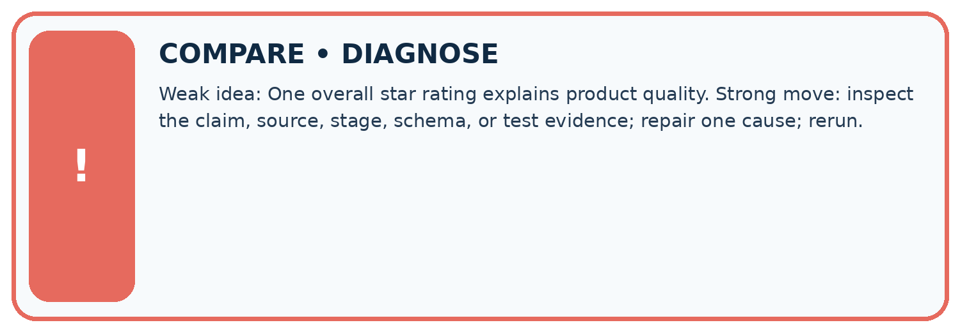
Evidence record | Expected | Actual | Likely cause / next test
normal case | works
boundary case | stated rule
missing input | safe response
fresh transfer | generalizes
Repair one cause. Why is this repair better than changing several things?

Write or draw your reasoning and evidence.
________________________________________________________________
________________________________________________________________
________________________________________________________________
________________________________________________________________
________________________________________________________________

A closer explanation
Complete the supported workbook tasks before attempting W4 independently. Record any hints or help used. After feedback, use the teacher's fresh retry rather than copying the earlier answer. For a project, select a relevant new case, predict the outcome from the declared rule and preserve the result alongside any revision.

Exit: propose one revealing change to the worked scenario. State the expected outcome and the evidence that would make you revise your explanation.
________________________________________________________________
________________________________________________________________
________________________________________________________________
________________________________________________________________
________________________________________________________________

08. Practise together
LOGIC STUDIO
Specify Before You Run
Prompts, schemas, retrieval, tool calls, and code are inspectable parts of one AI product.

SET task, audience, constraints, output_schema
LOAD approved_context or retrieval_result
CALL model or allowed_tool
VALIDATE fields, claims, citations, and safety
IF evidence missing: ask, retrieve, or abstain
RETURN useful output + source trail + limitations
Trace one input. Which line changes the state or chooses a path?

Write or draw your reasoning and evidence.
________________________________________________________________
________________________________________________________________
________________________________________________________________
________________________________________________________________
________________________________________________________________

A closer explanation
Evaluation coverage limits the claim; prompts tuned on these cases need new reserved final cases.
A useful check asks what would make the reasoning fail. Distinguish a failure to execute the declared procedure from a weakness in the procedure itself. The first may require a correction; the second requires an explicitly revised method and new evidence. Preserve unsuccessful cases so an improved result cannot hide the original problem.

Guided: restate the worked result, then name the assumption or limitation that prevents a broader conclusion.
________________________________________________________________
________________________________________________________________
________________________________________________________________
________________________________________________________________
________________________________________________________________

Practise with less help: Trace the worked case
Use workbook W2 for the connected example “System evaluation sets”. First fill the input and rule boxes. Try the middle steps before asking for a hint. After a hint, try the next step yourself.
Plan | Do | Check
What is given? Which rule or procedure applies? | Record each intermediate step. | Does the result follow? What remains unknown?
Explain your trace to a partner. Your partner points to one step to check. Swap roles on the next case. Each person writes their own explanation.

Check your reasoning
Use the worked case for System evaluation sets. Proposed explanation: “The worked result establishes every future case”. Decide whether this explanation is supported. Point to the step or supplied fact that decides; explain your repair if needed.
Answer on your own before discussion. If you are unsure, say which step you need help with.

Explain the picture
Why is “one out of two checks passed” an insufficient release decision? Point to the relevant step in the picture, then write the changed result and the rule or evidence that supports it.

My explanation using a pictured step and the given facts
________________________________________________________________
________________________________________________________________
________________________________________________________________
________________________________________________________________
This is supported practice. Keep the separately named independent case for an attempt before feedback.

09. Run the investigation
EVIDENCE LAB
Predict → Test → Record → Explain
Keep expected and actual results separate. Surprises are useful data when recorded honestly.
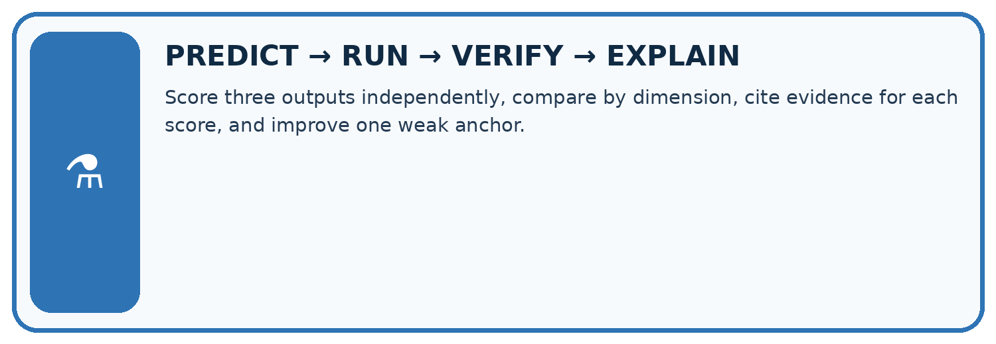
Score three outputs independently, compare by dimension, cite evidence for each score, and improve one weak anchor.
Test / input | Prediction | Actual | Evidence / calculation | Change or keep?
normal
boundary
missing
fresh transfer
What did the hardest test teach you that the normal test did not?

Write or draw your reasoning and evidence.
________________________________________________________________
________________________________________________________________
________________________________________________________________
________________________________________________________________
________________________________________________________________

Plan → try → check
Before trying: what do I expect, and why? While trying: which step could first go wrong? Afterwards: what did I actually observe, and what should change? Keep “not run” if you only traced the procedure.

10. Build your understanding
MASTERY
From Knowing the Word to Owning the Idea
Move upward only when you can produce evidence without copying the worked example.

1 • NAME: Define the concept without repeating the textbook.
2 • TRACE: Show the information, state, branch, calculation, or evidence path.
3 • APPLY: Solve a different example independently.
4 • CHALLENGE: Find a boundary case, counterexample, or unfair outcome.
5 • EXPLAIN LIMITS: Say when the result should not be trusted or used alone.
My strongest evidence of independent understanding:

Write or draw your reasoning and evidence.
________________________________________________________________
________________________________________________________________
________________________________________________________________
________________________________________________________________
________________________________________________________________

11. Connect your project
CUMULATIVE PROJECT
Verified Study Buddy
Every week adds one inspectable piece. The system must show how it reached a result.
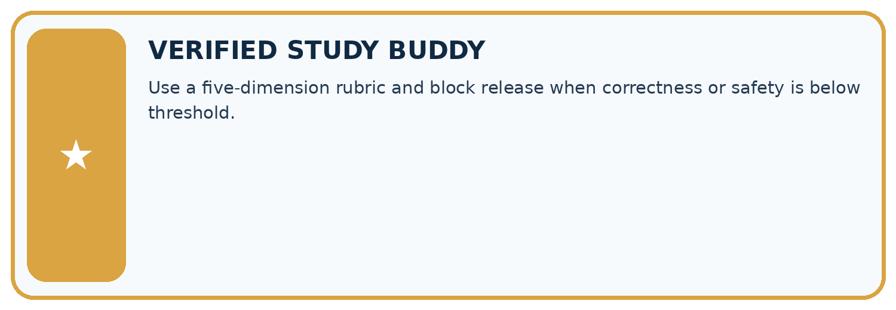
THIS WEEK’S CHECKPOINT Use a five-dimension rubric and block release when correctness or safety is below threshold.
SYSTEM MAP Learner need → prompt/schema → approved sources/retrieval → model/tool → structured answer → verification → human decision
What will you add, change, or verify in the project this week?

Write or draw your reasoning and evidence.
________________________________________________________________
________________________________________________________________
________________________________________________________________
________________________________________________________________
________________________________________________________________
What should remain under human control?

Write or draw your reasoning and evidence.
________________________________________________________________
________________________________________________________________
________________________________________________________________
________________________________________________________________
________________________________________________________________
RESPONSIBLE DESIGN Collect only necessary information. Show uncertainty and limits. Never confuse fluent output with verified truth.

Evidence for your project
For your Verified Study Buddy, save the input, procedure, observed result and limitation of this check. Label this worked example as practice; use a different, previously unreviewed case when checking independent understanding.

12. Show what you know
INDEPENDENT MASTERY PROOF
Explain • Transfer • Test • Defend
Complete this page without copying the worked example. Your reasoning matters more than decoration.
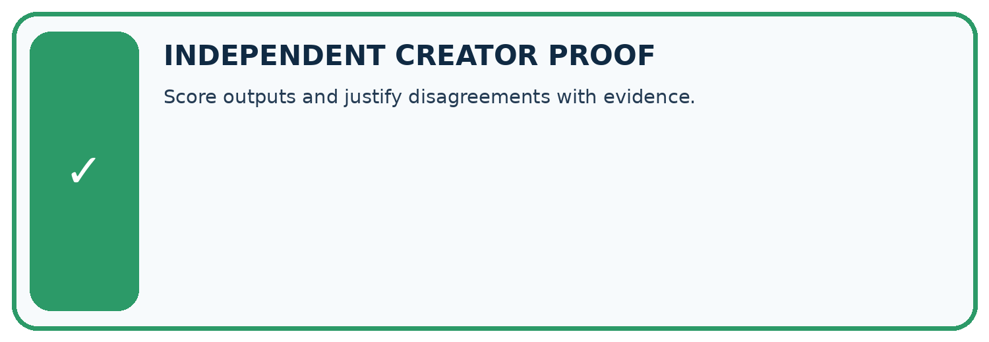
CHALLENGE Score outputs and justify disagreements with evidence.
1. My fresh example, trace, calculation, or design:

Write or draw your reasoning and evidence.
________________________________________________________________
________________________________________________________________
________________________________________________________________
________________________________________________________________
________________________________________________________________
2. My evidence that it works (include a boundary or missing-data case):

Write or draw your reasoning and evidence.
________________________________________________________________
________________________________________________________________
________________________________________________________________
________________________________________________________________
________________________________________________________________
3. One limitation, fairness concern, or situation needing human review:

Write or draw your reasoning and evidence.
________________________________________________________________
________________________________________________________________
________________________________________________________________
________________________________________________________________
________________________________________________________________
SELF-CHECK □ I explained the mechanism □ I used evidence □ I tested a fresh case □ I named a limitation □ I can answer ‘why?’

13. Study a complete case

Week 25 Worked case
Use the supplied details to practise the weekly concept before attempting the independent question. This case extends the illustrated lesson.

The situation
Rubric gives 0–2 each for support, usefulness and safety. Response is useful and safe but unsupported.

The question
Why can a total mislead?

Worked explanation
It may get 4/6 while failing essential support. Declare mandatory criteria before testing so other points cannot compensate.

Explain it in your own words
Which detail supports the answer, and why does it matter?

Write or draw your reasoning and evidence.
________________________________________________________________
________________________________________________________________
________________________________________________________________
________________________________________________________________
________________________________________________________________

Trace the supplied case visually

A total can hide a required failure
Evidence or stage | Value or result
Support | 0
Usefulness | 2
Safety | 2
Rubric gives 0–2 each for support, usefulness and safety. Response is useful and safe but unsupported.
Why can a total mislead?
It may get 4/6 while failing essential support. Declare mandatory criteria before testing so other points cannot compensate.

14. Try a new case independently

Independent case: Apply a new case independently
Twelve cases: eight answerable, four unanswerable. Correct answers six; appropriate abstentions two. Compute separate and combined pass rates.

My independent explanation, trace and limits
________________________________________________________________
________________________________________________________________
________________________________________________________________
________________________________________________________________
________________________________________________________________
________________________________________________________________
________________________________________________________________
Attempt this case before feedback. Record any help. Earlier examples below are further practice; a case already practised with feedback cannot establish fresh transfer.

Week 25 Independent application
Close the worked explanation. Apply the idea to this different question without copying.
Two answers have equally polished language. One has three supported claims; the other has two supported claims and one invented claim. How should a quality rubric distinguish them?
My answer, with a trace, calculation or supporting evidence

Write or draw your reasoning and evidence.
________________________________________________________________
________________________________________________________________
________________________________________________________________
________________________________________________________________
________________________________________________________________

Create and test
Change one relevant detail. Predict the result before testing. Include a boundary or missing-information case when it helps reveal a limit.
My changed input and expected result

Write or draw your reasoning and evidence.
________________________________________________________________
________________________________________________________________
________________________________________________________________
________________________________________________________________
________________________________________________________________

Connect to your project
Use a five-dimension rubric and block release when correctness or safety is below threshold.
The evidence I will keep

Write or draw your reasoning and evidence.
________________________________________________________________
________________________________________________________________
________________________________________________________________
________________________________________________________________
________________________________________________________________
Your teacher has the independent answer and scoring criteria. Complete the matching workbook week to keep your practice evidence together.

Transfer practice from the original programme
An answer earns 2 for format, 2 for tone and 0 for source support. It gets 4/6. Is it acceptable for a source-only assistant? Revise the rubric's decision rule.

Explain the mechanism, evidence and one limit.
________________________________________________________________
________________________________________________________________
________________________________________________________________
________________________________________________________________
________________________________________________________________
________________________________________________________________
________________________________________________________________

Use feedback to improve
Attempt the independent case before hints. Record whether you worked alone, used a hint or followed a model. After feedback, fix the first unsupported step and explain why it changed. A later check uses a changed case, not a copied answer.

