AI ACADEMY · STUDENT · ai-4/3

Classification or Regression?
Project: Responsible Plant Classifier

Before you start
AI-2 Week 7: a numeric data type does not determine task meaning.

01. Your mission

Your learning target
I can identify a task from the meaning of its target.
I can distinguish category agreement from numerical error.
I can specify outputs and checks that match a user need.

Remember before reading
Close your notes first. A rough first answer helps us choose the right starting point; it is not a score for your ability.
Without opening the old lesson, explain one key idea from Features, Labels, Targets. Give an example and a mistake that the idea helps you avoid.
After trying, check the relevant lesson or ask your teacher. Change the part of your explanation that the evidence shows was wrong.
Classification predicts a category; regression predicts a numerical quantity. The target—not the input format—determines the task type.
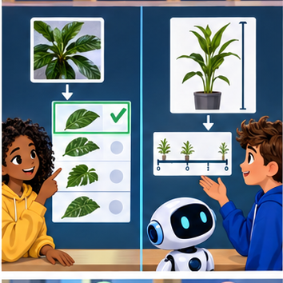
LEARNING TARGET System A predicts class codes 0=oak,1=maple. System B predicts leaf area in cm². Name the task types and explain why code 1 is not 'one more species' than code 0.
Builder name and experiment date:

Readiness for the connected explanation
At dispatch, may the observed arrival duration be used as an input to predict that same trip duration? Explain.

This week’s end goal
By the end, I can explain classification or regression? using a traced example and a stated limitation.

02. Notice the evidence
PICTURE ENTRY

Notice → Predict → Explain
Begin with visible evidence; do not explain more than the picture and information support.
MYSTERY The team must use classification or regression? to solve a model-building problem. What information do they have? What important evidence is still missing?
Name three visible details without interpreting them.
Predict the data, model, or evaluation decision being made.
Identify one hidden assumption that could change the result.
State what evidence would confirm or reject your prediction.
My prediction and supporting evidence:

A closer explanation
At robot dispatch, we can ask two questions about the same fictional trip. Will it take more than 10 minutes? Or how many minutes will it take? The first asks for a category. The second asks for an amount with units. The target question determines the task, even if both models would use the same dispatch-time inputs.
Question | Target meaning | Task
Will the trip exceed 10 minutes? | 0 for no and 1 for yes | Classification
How long will the trip take? | Elapsed duration in minutes | Regression
Which route type will be used? | Indoor or outdoor | Classification
Classification predicts a category from a defined set. Regression estimates a numerical quantity for which differences have meaning. A category may be coded with numbers: 0 and 1 here are names for no and yes, not travel times. Conversely, a duration recorded as a whole number of minutes can still be a regression target. Decimal points do not decide the task.
Keep Week 2's prediction time: route length and the saved queue may exist at dispatch, while the observed duration is available later for training or evaluation. Do not feed that observed duration into an earlier dispatch prediction.

03. See how it works
ML MECHANISM

Input → Model → Evidence
Trace the information, fitted behavior, and evaluation proof separately.
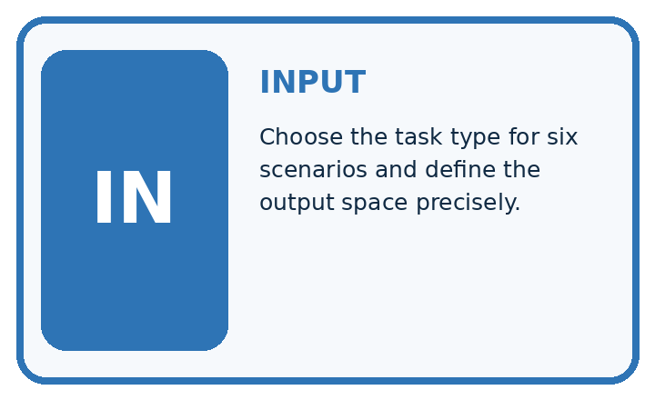
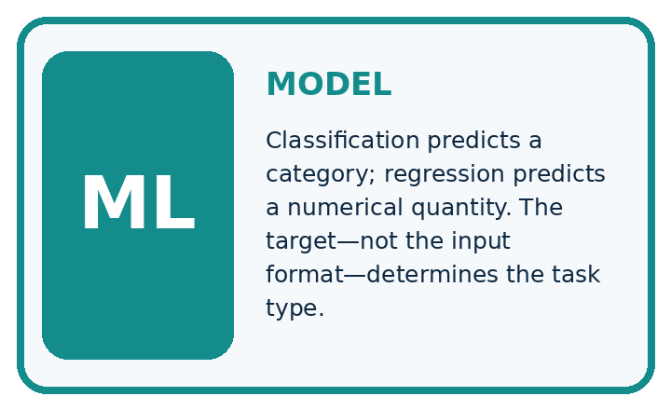
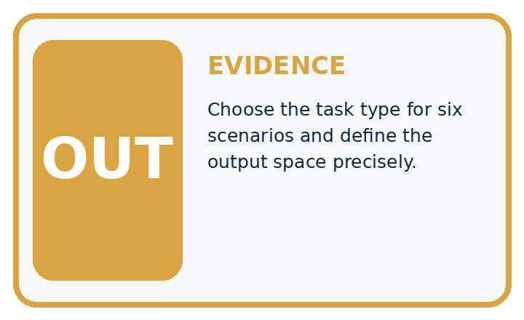
QUESTION Choose the task type for six scenarios and define the output space precisely.
MODEL IDEA Classification predicts a category; regression predicts a numerical quantity. The target—not the input format—determines the task type.
PROOF NEEDED Use an unseen case, visible calculation, error analysis, and a stated limitation.
UNDER THE HOOD Predict plant species from a photo: target is a category, so classification. Predict plant height next week: target is centimeters, so regression.
Draw a fresh data → model → prediction → evaluation trace:

A closer explanation
The following predictions are supplied for practice; no model is fitted here. Each estimate was written before revealing its matching observed duration. We compare duration error with a category decision made from that estimate. Predict slow when the estimated duration is greater than 10 minutes; exactly 10 is not slow. A classifier could also predict categories directly, but this example uses a threshold on estimates.
actual_minutes = [8, 10, 14]
estimated_minutes = [9, 11, 12]
correct = 0
errors = []
for actual, estimate in zip(actual_minutes, estimated_minutes):
actual_slow = int(actual > 10)
predicted_slow = int(estimate > 10)
correct = correct + int(actual_slow == predicted_slow)
errors.append(abs(estimate - actual))
print(correct, len(actual_minutes))
print(errors)
zip pairs the lists in order. They must have equal lengths and refer to the same trips; otherwise this loop is not a valid evaluation. abs gives the distance from zero, so both a one-minute overestimate and a one-minute underestimate have absolute error 1. The output is 2 3 followed by [1, 1, 2]. The mean absolute error is (1 + 1 + 2) / 3 = 4/3 minutes, about 1.33 minutes.

Read both kinds of evidence
Actual and estimate | Duration error | Category match
8 and 9 minutes | 1 minute | No and no match
10 and 11 minutes | 1 minute | No and yes differ
14 and 12 minutes | 2 minutes | Yes and yes match
All three rows use the same greater-than-10 boundary. A small duration error can cross that boundary; a larger error can stay on the same side.

Connect the picture and the explanation
Point to the input, the deciding step and the result in this week’s visual. Explain the same step in ordinary words. A picture helps when you can say what each part represents.

04. Compare the cases
EVALUATION DESIGN

Four Tests, Four Kinds of Evidence
A system is not understood until it survives more than one comfortable example.




NORMAL Expected data and expected behavior.
BOUNDARY Value close to a threshold, ambiguous label, or uncertain prediction.
MISSING Necessary field, label, source, or measurement is unavailable.
SHIFTED New lighting, species, device, subgroup, or time condition.
RELEASE RULE Passing one case never proves generalization. Predefine expected behavior for all four categories.
Which case most threatens today's claim, and why?

Change one thing in the pictured case
Change: Change the category boundary to strictly greater than 7 cm.
Prediction: Actual and estimated categories both become short, short, tall: 3/3 correct.
Reason: The numerical estimates did not improve; the decision definition changed.

05. Words that unlock the idea
VOCABULARY

Words You Can Calculate and Defend
A definition matters when it lets you interpret a new dataset, model, or result.
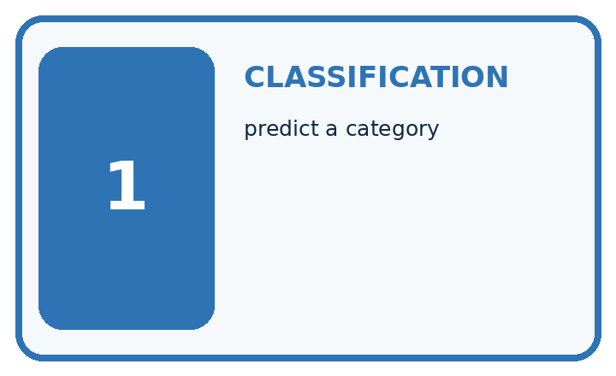
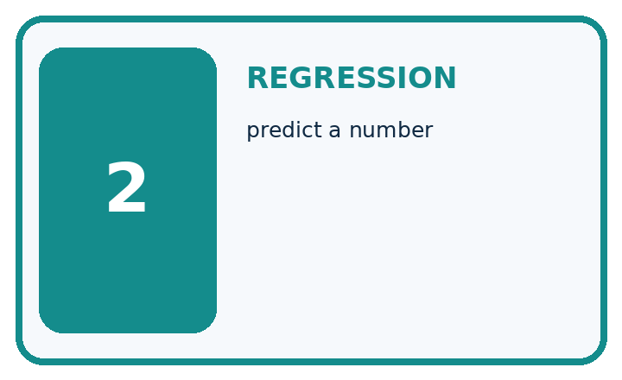
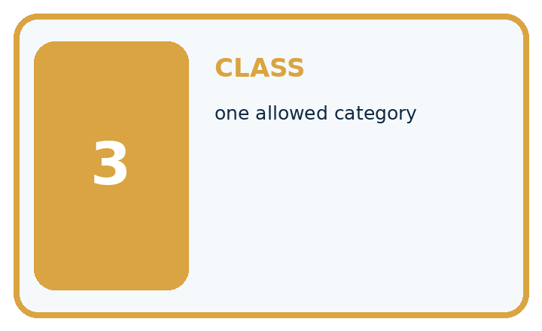
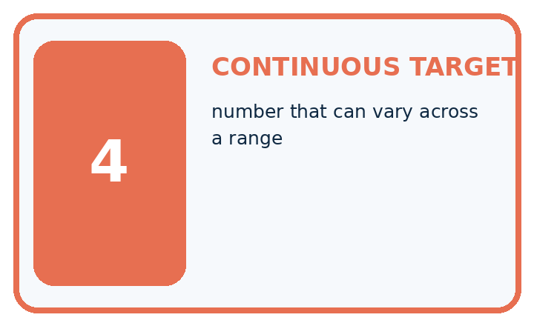
Term | Precise meaning | My ML example
classification | predict a category
regression | predict a number
class | one allowed category
continuous target | number that can vary across a range
MISCONCEPTION TO REPAIR A photograph always means classification and a table always means regression.
Repair the claim using a definition, calculation, or test record:

Words used in the closer explanation
Word | Meaning
Classification | Predicting a category from a defined set
Regression | Estimating a numerical quantity with meaningful differences
Threshold | A boundary used to turn a value into a decision
Absolute error | The nonnegative distance between an estimate and an observation

06. Follow a worked example
WORKED EVIDENCE

Reason Step by Step
Predict first. Then check each step. A correct answer without visible evidence cannot be audited.
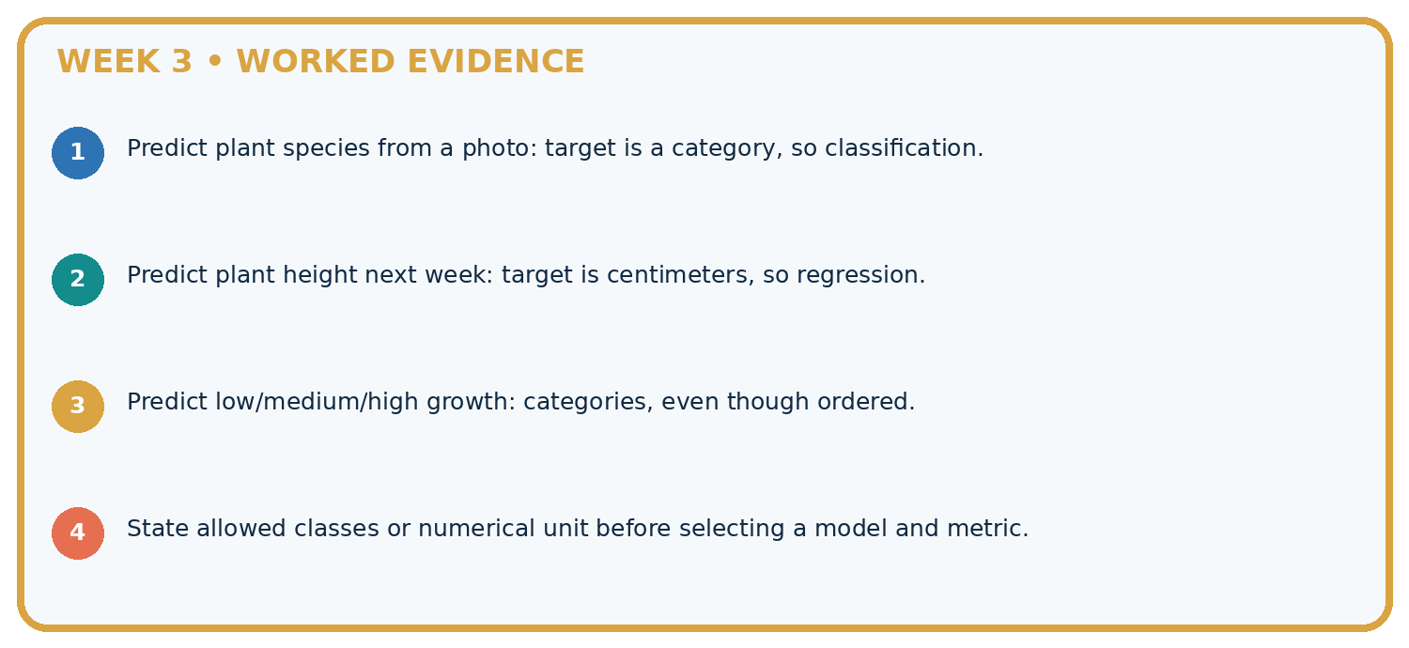
STEP 1 Predict plant species from a photo: target is a category, so classification.
STEP 2 Predict plant height next week: target is centimeters, so regression.
STEP 3 Predict low/medium/high growth: categories, even though ordered.
STEP 4 State allowed classes or numerical unit before selecting a model and metric.
CHECK Verify the denominator, unit, split, class definition, and data version before interpreting a score.
Recalculate, retrace, or restate the evidence independently:

A closer explanation
The 14-minute trip has the largest duration error in our example, yet its slow category is correct. The 10-minute trip has only a one-minute error but the category is wrong. These checks answer different questions. Report 2 correct out of 3 category decisions separately from a mean absolute error of about 1.33 minutes. Do not compare a fraction directly with minutes.

A trip actually takes 10 minutes and its estimate is 10.5 minutes. At the greater-than-10 boundary, give the actual category, predicted category and absolute duration error. Is the category decision correct?
________________________________________________________________
________________________________________________________________
________________________________________________________________
________________________________________________________________
________________________________________________________________

Learn from the worked case
Cover the result before checking it. Say what is given, choose the procedure, and follow one step at a time. Then uncover the result and explain your first mismatch. Ask why a step is allowed, not only what number it produces.

A pictorial worked case: Classification or Regression?
Distinguish predicting growth height from predicting a growth category.

The facts we will use
Actual heights are [4, 7, 9] cm; estimates are [5, 6, 10] cm. Tall means strictly greater than 6 cm.
All inputs and outcomes in this worked example are invented classroom data; no real model run is claimed.
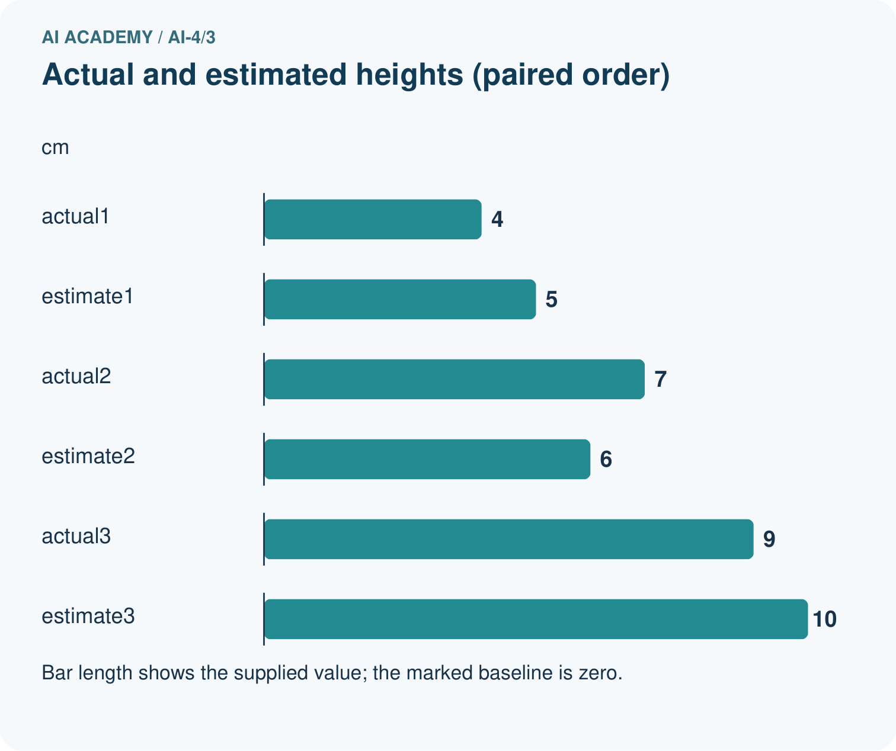
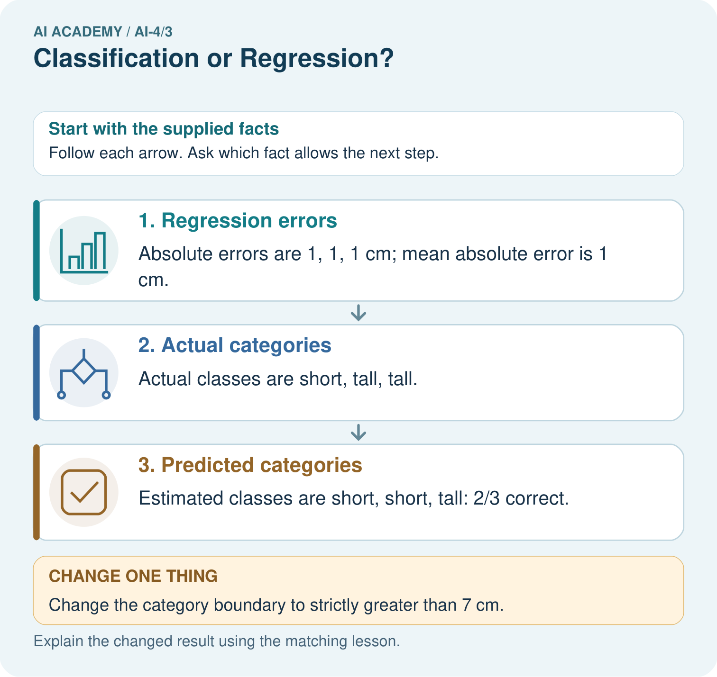

Read the picture one step at a time
Step | What happens and why
1. Regression errors | Absolute errors are 1, 1, 1 cm; mean absolute error is 1 cm.
2. Actual categories | Actual classes are short, tall, tall.
3. Predicted categories | Estimated classes are short, short, tall: 2/3 correct.
Match each pictured step to the supplied facts. This is a worked teaching case, not an independent assessment.

Why this result follows
Read the picture in order. Estimated classes are short, short, tall: 2/3 correct. The arrows show which recorded input or intermediate result each decision uses. Explain the deciding step aloud before checking the changed case; pointing to the final answer alone does not show how it follows.

What this example does not establish
Regression error and category accuracy measure different targets; neither alone covers every use consequence.

07. Find and repair a mistake
ERROR DETECTIVE

Compare → Diagnose → Repair
Do not patch the answer. Find the earliest unsupported assumption, data problem, or experiment error.
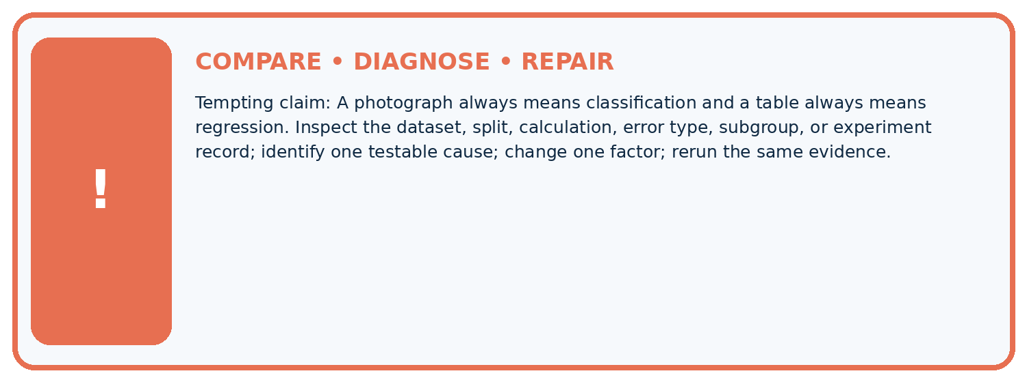
Evidence record | Expected | Actual | Likely cause / next test
normal case | passes
boundary case | defined behavior
missing case | safe fallback
shifted case | measured limit
CLAIM TO CHALLENGE A photograph always means classification and a table always means regression.
Diagnose one cause and name the cleanest next experiment:

A closer explanation
A task specification should name the prediction moment, permitted inputs, target meaning and how predictions will be checked. Classification checks compare category decisions with observed categories. Regression checks measure numerical error with stated units. Later weeks examine additional metrics and why the consequences of different errors matter.
A correct category does not imply an exact quantity, and low numerical error does not guarantee every threshold decision is right. Three supplied examples establish only these calculations. They do not establish a trained model's reliability or show that a robot should act without review.

A team needs an estimated arrival duration in minutes. State the task type and a suitable error check. Explain why reporting only the fraction of correct slow or not-slow decisions leaves its main question unanswered.
________________________________________________________________
________________________________________________________________
________________________________________________________________
________________________________________________________________
________________________________________________________________

08. Practise together
ML STUDIO

Specify Before You Run
A trustworthy result can be reproduced from the recorded data, code, settings, and evaluation rule.


Experiment record
QUESTION + intended use + success threshold
DATA version + grouped split + leakage check
CODE/preprocessing + features + model + settings + seed
METRICS + positive class + units + denominators
PREDICTIONS + errors + subgroup slices + limitations
HUMAN reviewer + release, revise, limit, or stop decision
Write the minimum record needed to reproduce today's result:

A closer explanation
A learner says that predicting route type is regression because indoor is encoded as 1 and outdoor as 2. The numbers are category codes: their difference does not measure travel time or another meaningful amount. Treat this as classification and judge the predicted category. Changing the codes must not change the meaning of the task.
Another learner puts durations into short and long bins, then claims to predict exact minutes. Binning creates a classification target and loses within-bin detail. If the user needs minutes, keep a quantity target and evaluate error in minutes. If the user needs a threshold decision, define the boundary and relevant consequences. Neither task is automatically better.

Practise with less help: Trace both checks
Use workbook W2 for the connected example “Classification and regression”. First fill the input and rule boxes. Try the middle steps before asking for a hint. After a hint, try the next step yourself.
Plan | Do | Check
What is given? Which rule or procedure applies? | Record each intermediate step. | Does the result follow? What remains unknown?
Explain your trace to a partner. Your partner points to one step to check. Swap roles on the next case. Each person writes their own explanation.

Check your reasoning
Use the worked case for Classification and regression. Proposed explanation: “Numbers always mean regression”. Decide whether this explanation is supported. Point to the step or supplied fact that decides; explain your repair if needed.
Answer on your own before discussion. If you are unsure, say which step you need help with.

Explain the picture
Did regression MAE improve when the boundary changed? Point to the relevant step in the picture, then write the changed result and the rule or evidence that supports it.

My explanation using a pictured step and the given facts
________________________________________________________________
________________________________________________________________
________________________________________________________________
________________________________________________________________
This is supported practice. Keep the separately named independent case for an attempt before feedback.

09. Run the investigation
EVIDENCE LAB

Predict → Run → Calculate → Interpret
Keep the test conditions fixed, record every result, and change only one planned factor.
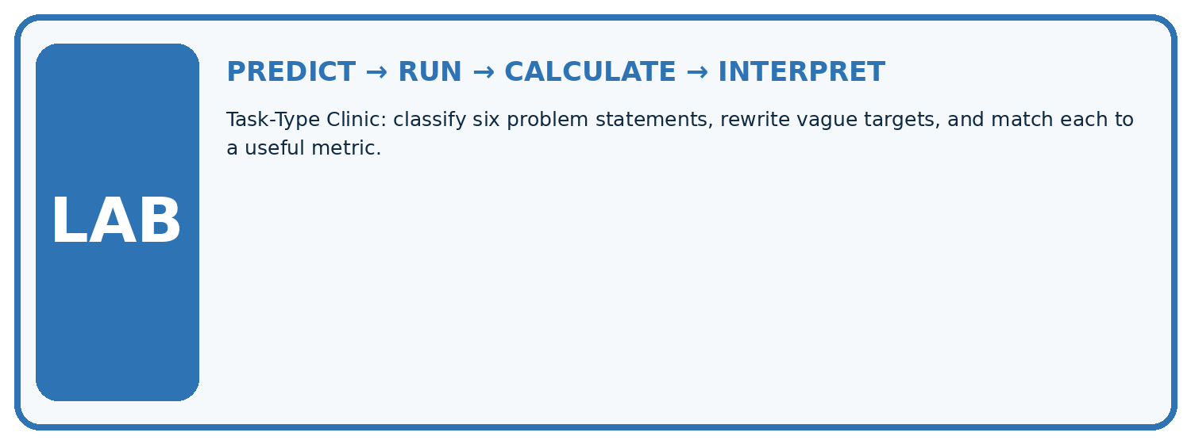
1. Write the hypothesis and expected evidence before running.
2. Task-Type Clinic: classify six problem statements, rewrite vague targets, and match each to a useful metric.
3. Run one normal, one boundary, one missing, and one shifted case.
4. Calculate the metric from raw counts or row-level errors.
5. Interpret what changed, what did not, and what remains unsafe or unknown.
Case | Prediction | Actual | Calculation / evidence | Meaning / next test
Normal
Boundary
Missing
Shifted

Plan → try → check
Before trying: what do I expect, and why? While trying: which step could first go wrong? Afterwards: what did I actually observe, and what should change? Keep “not run” if you only traced the procedure.

10. Build your understanding
MASTERY

From Knowing the Word to Owning the Idea
Move upward only when you can produce evidence without copying the example.

DEFINE Use all four terms precisely: classification, regression, class, continuous target.
CALCULATE Reproduce the worked evidence with units and denominator.
TRACE Explain the data, code or decision path.
DIAGNOSE A photograph always means classification and a table always means regression.
TRANSFER Solve a fresh dataset or model case.
IMPROVE Change one cause and rerun fixed evidence.
DEFEND State intended use, metric, limitation, and human responsibility.
MASTERY RULE A coached calculation becomes mastery only after a different case is completed independently.

11. Connect your project
CUMULATIVE PROJECT

Responsible Plant Classifier
Every week adds one reviewable artifact to the same evidence-based capstone.
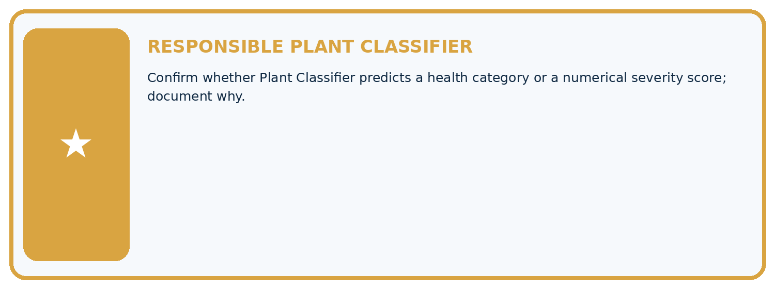
THIS WEEK'S CHECKPOINT Confirm whether Plant Classifier predicts a health category or a numerical severity score; document why.
Which requirement or risk does this artifact address?
Which dataset, split, code, and metric version does it use?
What normal and shifted cases were tested?
What remains uncertain or weak?
What decision still belongs to a teacher or qualified human?
RESPONSIBLE RELEASE Never use this classroom prototype for medical, pesticide, agricultural, or other consequential decisions.
My evidence-linked project decision:

Evidence for your project
For your Responsible Plant Classifier, save the input, procedure, observed result and limitation of this check. Label this worked example as practice; use a different, previously unreviewed case when checking independent understanding.

12. Show what you know
INDEPENDENT PROOF

Explain • Calculate • Transfer • Defend
Complete this with a fresh case after guided practice and compare it with the mastery criteria.
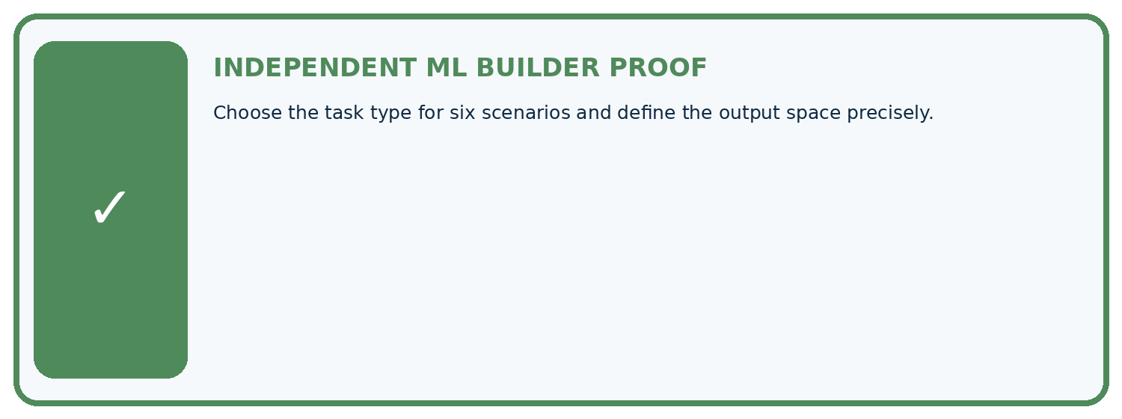
REQUIRED PROOF Choose the task type for six scenarios and define the output space precisely.
□ Define the task, feature/target roles, and intended-use boundary.
□ Show the calculation, code trace, or experiment record.
□ Test a normal case and one revealing boundary, missing, or shifted case.
□ Diagnose one failure without changing several factors at once.
□ Name a limitation, fairness concern, and the human-review action.
Independent evidence and defense:
My level: □ Not yet □ With one hint □ Independently □ I can teach and defend it
NEXT BRIDGE Carry the experiment evidence into: Python and Table Readiness.

13. Study a complete case

Week 3 Worked case
Use the supplied details to practise the weekly concept before attempting the independent question. This case extends the illustrated lesson.

The situation
Task A predicts healthy/spotted; B predicts next week's height in cm.

The question
Choose task and output types.

Worked explanation
A is classification with categorical output; B is regression with numeric output and units. Numeric class codes do not make classification regression.

Explain it in your own words
Which detail supports the answer, and why does it matter?

Write or draw your reasoning and evidence.
________________________________________________________________
________________________________________________________________
________________________________________________________________
________________________________________________________________
________________________________________________________________

Trace the supplied case visually

Choose the task by the meaning of the output
Evidence or stage | Value or result
Healthy or spotted | Classification, category
Height next week | Regression, numeric cm
Class code 0 or 1 | Still a category
Task A predicts healthy/spotted; B predicts next week's height in cm.
Choose task and output types.
A is classification with categorical output; B is regression with numeric output and units. Numeric class codes do not make classification regression.

14. Try a new case independently

Independent case: Compare new evidence independently
For three fictional print jobs, actual completion times are 4, 5 and 9 minutes; estimates are 6, 5 and 8 minutes in matching order. Slow means more than 5 minutes. Write actual and predicted category lists, count correct categories, calculate each absolute error and the mean error in minutes. State what each result measures.

My independent explanation, trace and limits
________________________________________________________________
________________________________________________________________
________________________________________________________________
________________________________________________________________
________________________________________________________________
________________________________________________________________
________________________________________________________________
Attempt this case before feedback. Record any help. Earlier examples below are further practice; a case already practised with feedback cannot establish fresh transfer.

Week 3 Independent application
Close the worked explanation. Apply the idea to this different question without copying.
Task A predicts whether a plant is fern or grass. Task B predicts its height in centimetres. Which is classification and which is regression?
My answer, with a trace, calculation or supporting evidence

Write or draw your reasoning and evidence.
________________________________________________________________
________________________________________________________________
________________________________________________________________
________________________________________________________________
________________________________________________________________

Create and test
Change one relevant detail. Predict the result before testing. Include a boundary or missing-information case when it helps reveal a limit.
My changed input and expected result

Write or draw your reasoning and evidence.
________________________________________________________________
________________________________________________________________
________________________________________________________________
________________________________________________________________
________________________________________________________________

Connect to your project
Confirm whether Plant Classifier predicts a health category or a numerical severity score; document why.
The evidence I will keep

Write or draw your reasoning and evidence.
________________________________________________________________
________________________________________________________________
________________________________________________________________
________________________________________________________________
________________________________________________________________
Your teacher has the independent answer and scoring criteria. Complete the matching workbook week to keep your practice evidence together.

Transfer practice from the original programme
System A predicts class codes 0=oak,1=maple. System B predicts leaf area in cm². Name the task types and explain why code 1 is not 'one more species' than code 0.

Explain the mechanism, evidence and one limit.
________________________________________________________________
________________________________________________________________
________________________________________________________________
________________________________________________________________
________________________________________________________________
________________________________________________________________
________________________________________________________________

Use feedback to improve
Attempt the independent case before hints. Record whether you worked alone, used a hint or followed a model. After feedback, fix the first unsupported step and explain why it changed. A later check uses a changed case, not a copied answer.

