AI ACADEMY · STUDENT · ai-4/16

Accuracy and Imbalance
Project: Responsible Plant Classifier

Before you start
Week 10: a majority baseline may miss every rare positive.

01. Your mission

Your learning target
I can explain why overall accuracy can hide failure on a less common class.
I can compare a training-majority baseline with class-specific results.
I can calculate an equal-class average and report its limits alongside the confusion matrix.

Remember before reading
Close your notes first. A rough first answer helps us choose the right starting point; it is not a score for your ability.
Without opening the old lesson, explain one key idea from Confusion Matrix. Give an example and a mistake that the idea helps you avoid.
Without opening the old lesson, explain one key idea from Train a Classifier. Give an example and a mistake that the idea helps you avoid.
Without opening the old lesson, explain one key idea from Baselines First. Give an example and a mistake that the idea helps you avoid.
After trying, check the relevant lesson or ask your teacher. Change the part of your explanation that the evidence shows was wrong.
Accuracy can be dominated by a common class and hide failure on a rare but important class.

LEARNING TARGET Model A is always healthy on 96 healthy and 4 spotted leaves. Model B finds 3 spotted but falsely flags 5 healthy. Compare accuracy and spotted detection.
Builder name and experiment date:

Readiness for the connected explanation
With reference rows and prediction columns ordered clear then blocked, where are false negatives when blocked is positive?

This week’s end goal
By the end, I can explain accuracy and imbalance using a traced example and a stated limitation.

02. Notice the evidence
PICTURE ENTRY

Notice → Predict → Explain
Begin with visible evidence; do not explain more than the picture and information support.
MYSTERY The team must use accuracy and imbalance to solve a model-building problem. What information do they have? What important evidence is still missing?
Name three visible details without interpreting them.
Predict the data, model, or evaluation decision being made.
Identify one hidden assumption that could change the result.
State what evidence would confirm or reject your prediction.
My prediction and supporting evidence:

A closer explanation
Accuracy counts all correct predictions and divides by all evaluated examples. Each example has equal weight, so a common class contributes more to the score. A high result can hide failure on a rare class. This week keeps the confusion matrix visible and checks both classes separately.
New fictional training data has 16 clear and 4 blocked labels. Its majority baseline predicts clear for every query; choose that rule from training, not evaluation labels. A separate evaluation set also contains 16 clear and 4 blocked cases. A frozen candidate and the baseline are evaluated on the same 20 records.
Method and reference row | Predicted clear | Predicted blocked
Baseline reference clear | 16 | 0
Baseline reference blocked | 4 | 0
Candidate reference clear | 12 | 4
Candidate reference blocked | 0 | 4
Rows are references and columns are predictions, ordered clear then blocked. Blocked is positive. Both methods get 16/20=80 percent accuracy. The baseline misses all four blocked cases. The candidate finds all four but falsely flags four clear cases. The same score conceals a different tradeoff.

03. See how it works
ML MECHANISM

Input → Model → Evidence
Trace the information, fitted behavior, and evaluation proof separately.
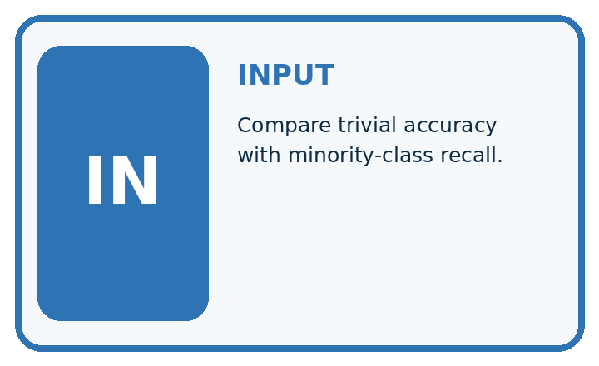
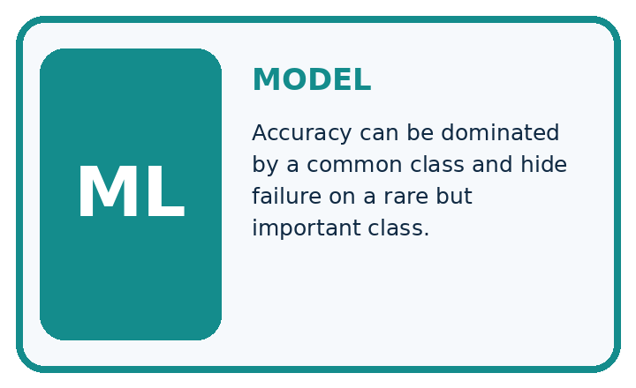
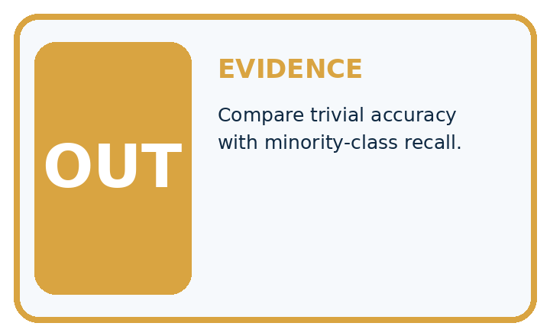
QUESTION Compare trivial accuracy with minority-class recall.
MODEL IDEA Accuracy can be dominated by a common class and hide failure on a rare but important class.
PROOF NEEDED Use an unseen case, visible calculation, error analysis, and a stated limitation.
UNDER THE HOOD Test set has 95 healthy and 5 diseased leaves. Always predicting healthy gives 95 ÷ 100 = 95% accuracy.
Draw a fresh data → model → prediction → evaluation trace:

A closer explanation
def scores(counts):
clear_n = sum(counts[0])
blocked_n = sum(counts[1])
if clear_n == 0 or blocked_n == 0:
raise ValueError("Need evaluation examples of both classes")
correct = counts[0][0] + counts[1][1]
accuracy = correct / (clear_n + blocked_n)
clear_fraction = counts[0][0] / clear_n
blocked_fraction = counts[1][1] / blocked_n
balanced = (clear_fraction + blocked_fraction) / 2
return accuracy, balanced
baseline = [[16, 0], [4, 0]]
candidate = [[12, 4], [0, 4]]
for name, counts in [("baseline", baseline), ("candidate", candidate)]:
accuracy, balanced = scores(counts)
print(name, round(100 * accuracy, 1), round(100 * balanced, 1))
The output is baseline 80.0 50.0, then candidate 80.0 87.5. In each output line the first percentage is ordinary accuracy and the second is balanced accuracy. For the candidate, the clear-class correct fraction is 12/16=75 percent and the blocked-class fraction is 4/4=100 percent. Their equal average is 87.5 percent.
For the baseline, those fractions are 16/16=100 percent and 0/4=0 percent, averaging 50 percent. The code assumes a two-by-two table of nonnegative integer counts in the stated order. It stops when either reference class is absent. Then report the observed counts and the unavailable class result; do not invent a denominator or silently substitute zero.

Connect the picture and the explanation
Point to the input, the deciding step and the result in this week’s visual. Explain the same step in ordinary words. A picture helps when you can say what each part represents.

04. Compare the cases
EVALUATION DESIGN

Four Tests, Four Kinds of Evidence
A system is not understood until it survives more than one comfortable example.




NORMAL Expected data and expected behavior.
BOUNDARY Value close to a threshold, ambiguous label, or uncertain prediction.
MISSING Necessary field, label, source, or measurement is unavailable.
SHIFTED New lighting, species, device, subgroup, or time condition.
RELEASE RULE Passing one case never proves generalization. Predefine expected behavior for all four categories.
Which case most threatens today's claim, and why?

Change one thing in the pictured case
Change: The candidate’s three false alarms are corrected without changing its detections.
Prediction: Candidate accuracy becomes20/20 with spotted recall still100% in this toy set.
Reason: False alarms move from FP to TN; neither TP nor FN changes.

05. Words that unlock the idea
VOCABULARY

Words You Can Calculate and Defend
A definition matters when it lets you interpret a new dataset, model, or result.
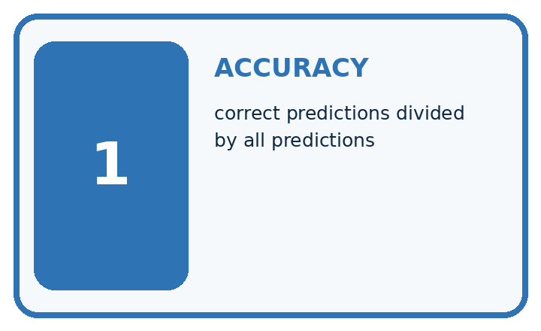
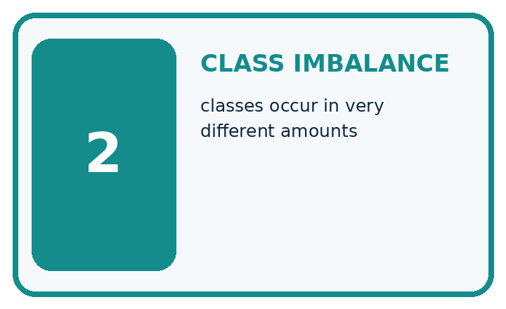
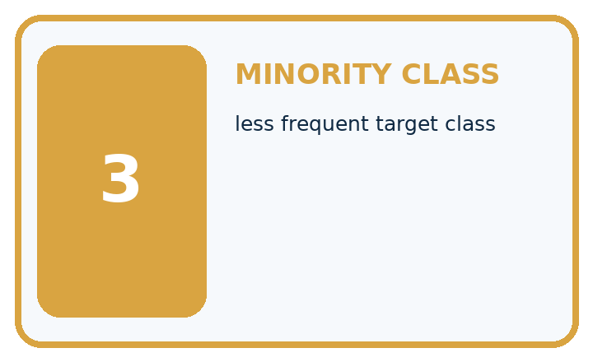
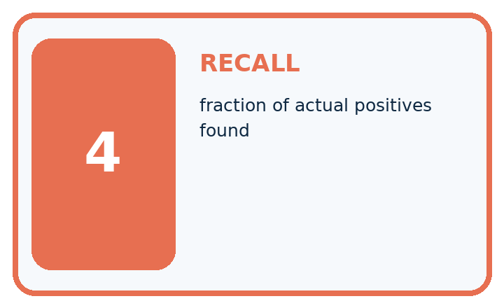
Term | Precise meaning | My ML example
accuracy | correct predictions divided by all predictions
class imbalance | classes occur in very different amounts
minority class | less frequent target class
recall | fraction of actual positives found
MISCONCEPTION TO REPAIR A classifier with 95% accuracy is excellent in every practical situation.
Repair the claim using a definition, calculation, or test record:

Words used in the closer explanation
Word | Meaning
Class imbalance | Unequal numbers of examples in different classes
Majority baseline | A rule that always predicts the most common training label
Class-specific correct fraction | Correct predictions for one reference class divided by the number of examples of that class
Balanced accuracy | The average of the class-specific correct fractions with equal weight for each class

06. Follow a worked example
WORKED EVIDENCE

Reason Step by Step
Predict first. Then check each step. A correct answer without visible evidence cannot be audited.
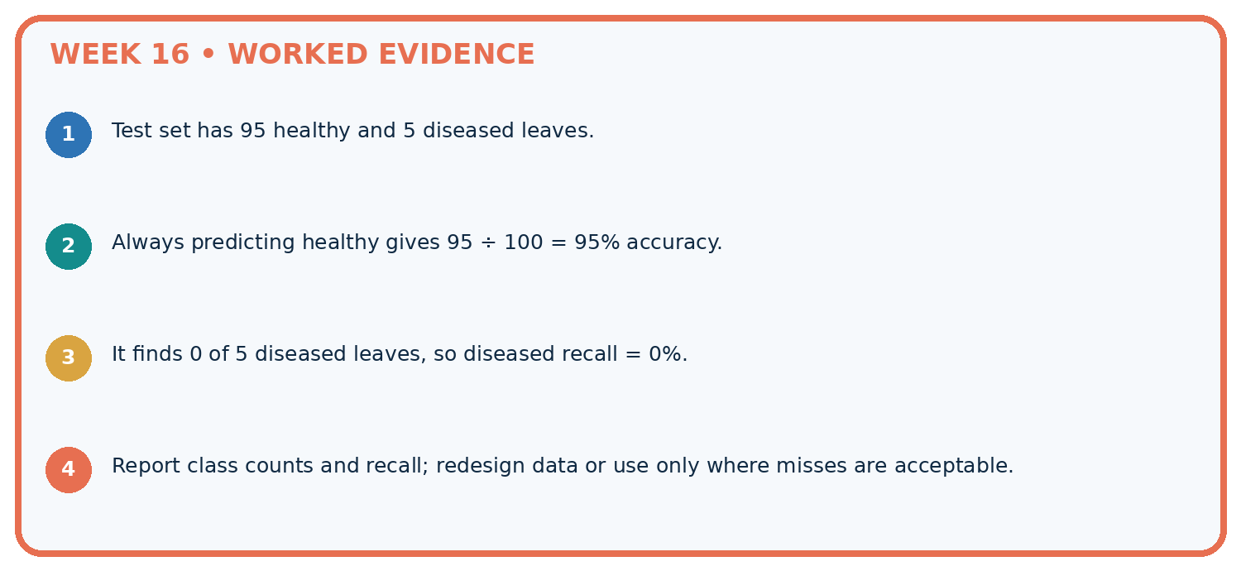
STEP 1 Test set has 95 healthy and 5 diseased leaves.
STEP 2 Always predicting healthy gives 95 ÷ 100 = 95% accuracy.
STEP 3 It finds 0 of 5 diseased leaves, so diseased recall = 0%.
STEP 4 Report class counts and recall; redesign data or use only where misses are acceptable.
CHECK Verify the denominator, unit, split, class definition, and data version before interpreting a score.
Recalculate, retrace, or restate the evidence independently:

A closer explanation

Same overall score different class results
Summary | Always clear baseline | Frozen candidate
Overall correct | 16 of 20 is 80 percent | 16 of 20 is 80 percent
Reference clear correct | 16 of 16 is 100 percent | 12 of 16 is 75 percent
Reference blocked correct | 0 of 4 is 0 percent | 4 of 4 is 100 percent
Overall accuracy weights classes by their number of evaluation examples. Balanced accuracy gives the two class-specific fractions equal weight.

Both methods score 80 percent. Explain which cases the baseline fails, how the candidate changes the errors, and why their balanced accuracies differ.
________________________________________________________________
________________________________________________________________
________________________________________________________________
________________________________________________________________
Balanced accuracy is a metric choice, not a repair to the classifier or a guarantee of safety. It gives classes equal influence in this summary; it does not encode the actual consequences of false alarms and missed cases. Four blocked evaluation examples are also too few for a strong general claim.

Learn from the worked case
Cover the result before checking it. Say what is given, choose the procedure, and follow one step at a time. Then uncover the result and explain your first mismatch. Ask why a step is allowed, not only what number it produces.

A pictorial worked case: Accuracy and Imbalance
Show how a common healthy class can hide complete failure to detect spotted leaves.

The facts we will use
Toy evaluation has 18 healthy and 2 spotted leaves. Always-healthy predicts all healthy. A candidate hasTP2, FN 0, FP 3, TN 15.
All inputs and outcomes in this worked example are invented classroom data; no real model run is claimed.
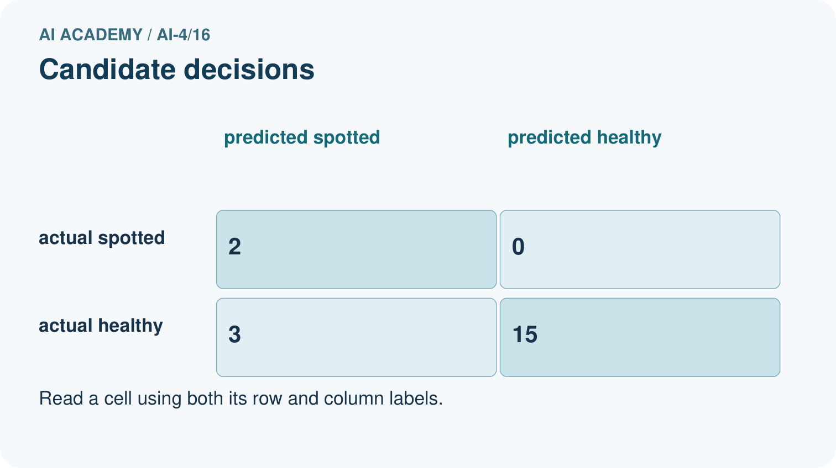
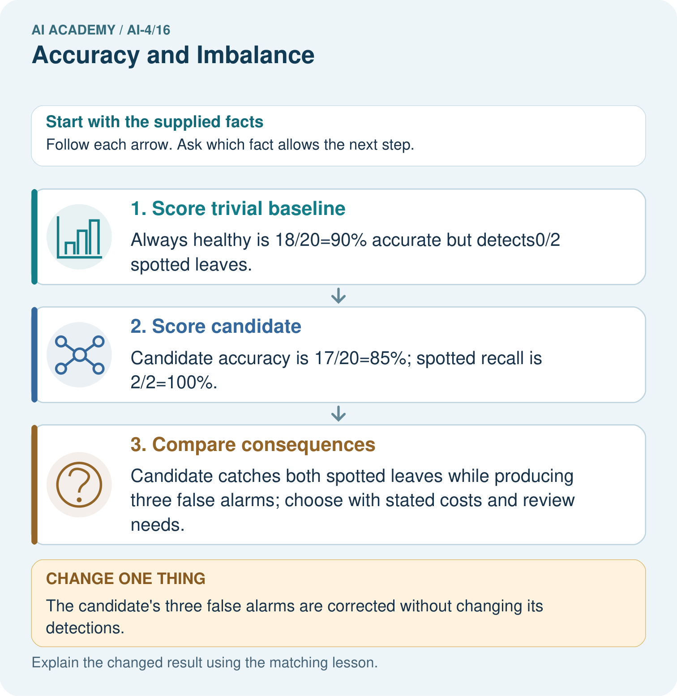

Read the picture one step at a time
Step | What happens and why
1. Score trivial baseline | Always healthy is 18/20=90% accurate but detects0/2 spotted leaves.
2. Score candidate | Candidate accuracy is 17/20=85%; spotted recall is 2/2=100%.
3. Compare consequences | Candidate catches both spotted leaves while producing three false alarms; choose with stated costs and review needs.
Match each pictured step to the supplied facts. This is a worked teaching case, not an independent assessment.

Why this result follows
Read the picture in order. Candidate catches both spotted leaves while producing three false alarms; choose with stated costs and review needs. The arrows show which recorded input or intermediate result each decision uses. Explain the deciding step aloud before checking the changed case; pointing to the final answer alone does not show how it follows.

What this example does not establish
Perfect performance on twenty supplied cases does not demonstrate dependable detection in other plants or settings.

07. Find and repair a mistake
ERROR DETECTIVE

Compare → Diagnose → Repair
Do not patch the answer. Find the earliest unsupported assumption, data problem, or experiment error.
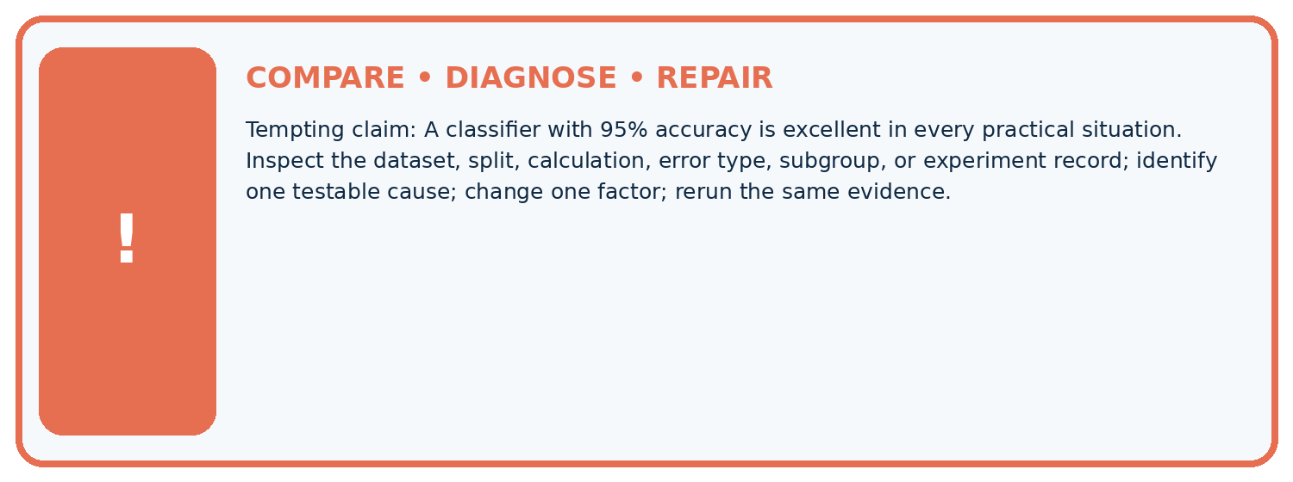
Evidence record | Expected | Actual | Likely cause / next test
normal case | passes
boundary case | defined behavior
missing case | safe fallback
shifted case | measured limit
CLAIM TO CHALLENGE A classifier with 95% accuracy is excellent in every practical situation.
Diagnose one cause and name the cleanest next experiment:

A closer explanation
Compare methods on the same appropriate evaluation examples and report the training-derived baseline. Include ordinary accuracy, each class denominator, false positives and false negatives. An equal-class summary adds information but cannot choose the acceptable tradeoff for the task. Keep development decisions separate from a final test.
A result of 4/4 correct blocked cases is 100 percent on those four examples, not proof of perfect future detection. If the evaluated set contains no blocked cases, it cannot measure blocked-case performance at all. Next week separates precision and recall by asking which denominator answers each question.

A team advertises 80 percent accuracy but its classifier predicts clear on every record. What additional evidence would you request, and what can you already conclude about the four blocked cases in our worked evaluation?
________________________________________________________________
________________________________________________________________
________________________________________________________________
________________________________________________________________

08. Practise together
ML STUDIO

Specify Before You Run
A trustworthy result can be reproduced from the recorded data, code, settings, and evaluation rule.


Experiment record
QUESTION + intended use + success threshold
DATA version + grouped split + leakage check
CODE/preprocessing + features + model + settings + seed
METRICS + positive class + units + denominators
PREDICTIONS + errors + subgroup slices + limitations
HUMAN reviewer + release, revise, limit, or stop decision
Write the minimum record needed to reproduce today's result:

A closer explanation
Consider a separate illustrative set with 8 clear and 8 blocked cases. Suppose the same within-class fractions hold: the baseline matrix is [[8,0],[8,0]] and the candidate matrix is [[6,2],[0,8]]. Ordinary accuracy is now 50 percent versus 87.5 percent. Balanced accuracy remains 50 percent versus 87.5 percent. The class mix changed the overall score even though the within-class fractions stayed fixed.
This is an arithmetic comparison, not proof that a real classifier keeps the same behavior after a population change. Report sample size, class counts, full matrix and how the evaluation data was chosen. Do not remove inconvenient cases or duplicate rare evaluation cases just to improve a headline number. If training is resampled, keep that separate from evaluation and document it.

Practise with less help: Compare both class fractions
Use workbook W2 for the connected example “Accuracy and class imbalance”. First fill the input and rule boxes. Try the middle steps before asking for a hint. After a hint, try the next step yourself.
Plan | Do | Check
What is given? Which rule or procedure applies? | Record each intermediate step. | Does the result follow? What remains unknown?
Explain your trace to a partner. Your partner points to one step to check. Swap roles on the next case. Each person writes their own explanation.

Check your reasoning
Use the worked case for Accuracy and class imbalance. Proposed explanation: “High accuracy means both classes work well”. Decide whether this explanation is supported. Point to the step or supplied fact that decides; explain your repair if needed.
Answer on your own before discussion. If you are unsure, say which step you need help with.

Explain the picture
Why can the 90% baseline still be unsuitable for a detection task? Point to the relevant step in the picture, then write the changed result and the rule or evidence that supports it.

My explanation using a pictured step and the given facts
________________________________________________________________
________________________________________________________________
________________________________________________________________
________________________________________________________________
This is supported practice. Keep the separately named independent case for an attempt before feedback.

09. Run the investigation
EVIDENCE LAB

Predict → Run → Calculate → Interpret
Keep the test conditions fixed, record every result, and change only one planned factor.
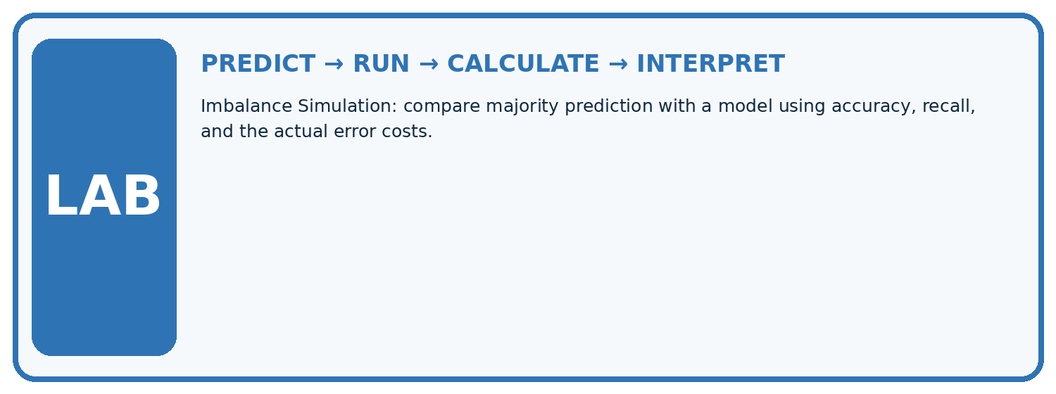
1. Write the hypothesis and expected evidence before running.
2. Imbalance Simulation: compare majority prediction with a model using accuracy, recall, and the actual error costs.
3. Run one normal, one boundary, one missing, and one shifted case.
4. Calculate the metric from raw counts or row-level errors.
5. Interpret what changed, what did not, and what remains unsafe or unknown.
Case | Prediction | Actual | Calculation / evidence | Meaning / next test
Normal
Boundary
Missing
Shifted

Plan → try → check
Before trying: what do I expect, and why? While trying: which step could first go wrong? Afterwards: what did I actually observe, and what should change? Keep “not run” if you only traced the procedure.

10. Build your understanding
MASTERY

From Knowing the Word to Owning the Idea
Move upward only when you can produce evidence without copying the example.

DEFINE Use all four terms precisely: accuracy, class imbalance, minority class, recall.
CALCULATE Reproduce the worked evidence with units and denominator.
TRACE Explain the data, code or decision path.
DIAGNOSE A classifier with 95% accuracy is excellent in every practical situation.
TRANSFER Solve a fresh dataset or model case.
IMPROVE Change one cause and rerun fixed evidence.
DEFEND State intended use, metric, limitation, and human responsibility.
MASTERY RULE A coached calculation becomes mastery only after a different case is completed independently.

11. Connect your project
CUMULATIVE PROJECT

Responsible Plant Classifier
Every week adds one reviewable artifact to the same evidence-based capstone.
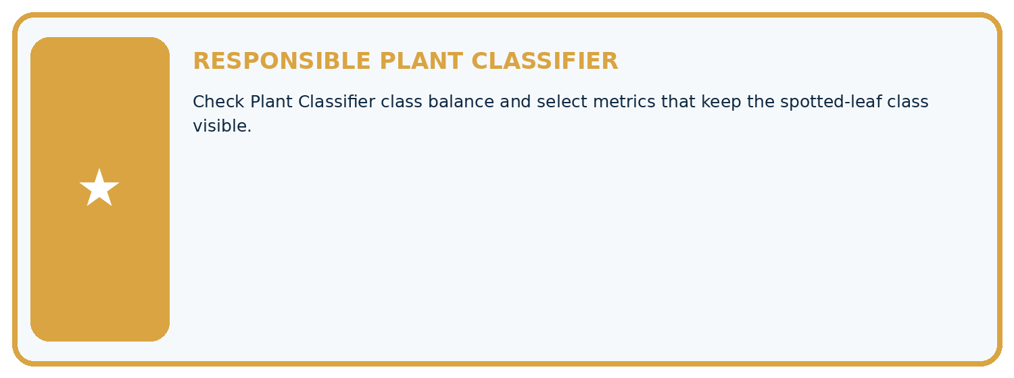
THIS WEEK'S CHECKPOINT Check Plant Classifier class balance and select metrics that keep the spotted-leaf class visible.
Which requirement or risk does this artifact address?
Which dataset, split, code, and metric version does it use?
What normal and shifted cases were tested?
What remains uncertain or weak?
What decision still belongs to a teacher or qualified human?
RESPONSIBLE RELEASE Never use this classroom prototype for medical, pesticide, agricultural, or other consequential decisions.
My evidence-linked project decision:

Evidence for your project
For your Responsible Plant Classifier, save the input, procedure, observed result and limitation of this check. Label this worked example as practice; use a different, previously unreviewed case when checking independent understanding.

12. Show what you know
INDEPENDENT PROOF

Explain • Calculate • Transfer • Defend
Complete this with a fresh case after guided practice and compare it with the mastery criteria.
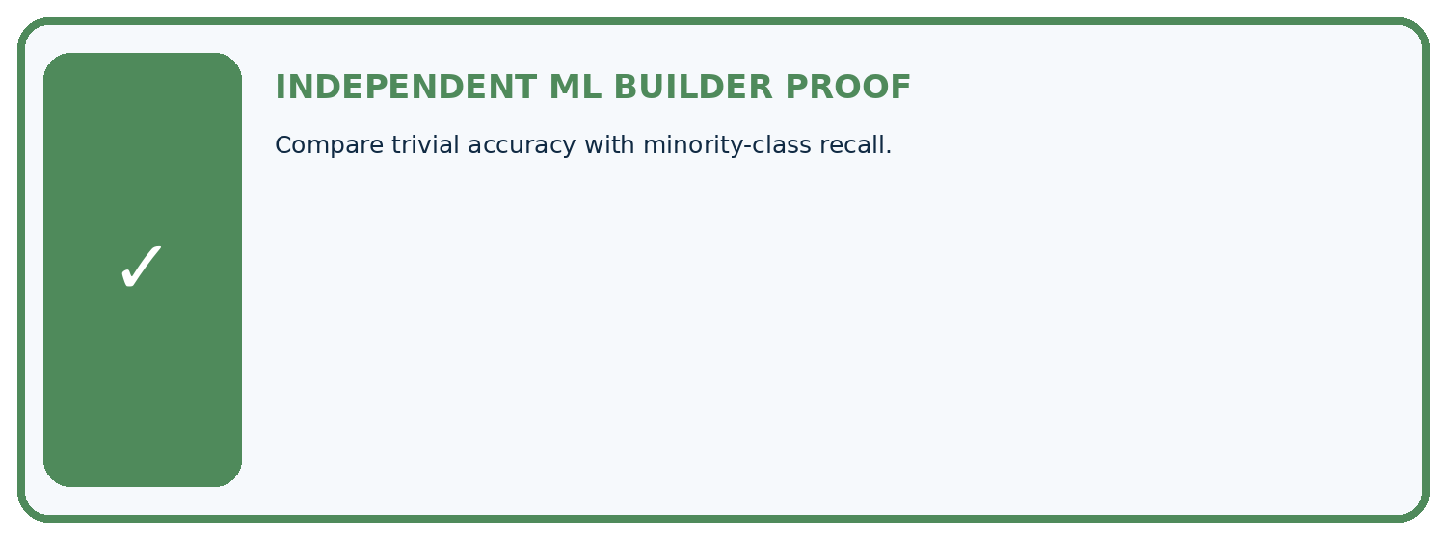
REQUIRED PROOF Compare trivial accuracy with minority-class recall.
□ Define the task, feature/target roles, and intended-use boundary.
□ Show the calculation, code trace, or experiment record.
□ Test a normal case and one revealing boundary, missing, or shifted case.
□ Diagnose one failure without changing several factors at once.
□ Name a limitation, fairness concern, and the human-review action.
Independent evidence and defense:
My level: □ Not yet □ With one hint □ Independently □ I can teach and defend it
NEXT BRIDGE Carry the experiment evidence into: Precision and Recall.

13. Study a complete case

Week 16 Worked case
Use the supplied details to practise the weekly concept before attempting the independent question. This case extends the illustrated lesson.

The situation
A dataset has 95 healthy and 5 spotted. Model predicts healthy for all.

The question
Calculate and critique accuracy.

Worked explanation
95/100=95%, but spotted recall=0/5=0%. Majority performance hides the detection failure.

Explain it in your own words
Which detail supports the answer, and why does it matter?

Write or draw your reasoning and evidence.
________________________________________________________________
________________________________________________________________
________________________________________________________________
________________________________________________________________
________________________________________________________________

Trace the supplied case visually

The majority can hide a detection failure
Evidence or stage | Value or result
Healthy, predicted healthy | 95
Spotted, predicted healthy | 5
A dataset has 95 healthy and 5 spotted. Model predicts healthy for all.
Calculate and critique accuracy.
95/100=95%, but spotted recall=0/5=0%. Majority performance hides the detection failure.

14. Try a new case independently

Independent case: Changed independent case
Validation has90 healthy and10 spotted cases. Always-healthy predicts all healthy. Another model has TP7,FN3,FP8,TN82. Compare accuracy and spotted recall.

My independent explanation, trace and limits
________________________________________________________________
________________________________________________________________
________________________________________________________________
________________________________________________________________
________________________________________________________________
________________________________________________________________
________________________________________________________________
Attempt this case before feedback. Record any help. Earlier examples below are further practice; a case already practised with feedback cannot establish fresh transfer.

Week 16 Independent application
Close the worked explanation. Apply the idea to this different question without copying.
A classifier predicts healthy for all 100 plants; 95 are healthy and 5 diseased. Compute accuracy and diseased recall.
My answer, with a trace, calculation or supporting evidence

Write or draw your reasoning and evidence.
________________________________________________________________
________________________________________________________________
________________________________________________________________
________________________________________________________________
________________________________________________________________

Create and test
Change one relevant detail. Predict the result before testing. Include a boundary or missing-information case when it helps reveal a limit.
My changed input and expected result

Write or draw your reasoning and evidence.
________________________________________________________________
________________________________________________________________
________________________________________________________________
________________________________________________________________
________________________________________________________________

Connect to your project
Check Plant Classifier class balance and select metrics that keep the spotted-leaf class visible.
The evidence I will keep

Write or draw your reasoning and evidence.
________________________________________________________________
________________________________________________________________
________________________________________________________________
________________________________________________________________
________________________________________________________________
Your teacher has the independent answer and scoring criteria. Complete the matching workbook week to keep your practice evidence together.

Transfer practice from the original programme
Model A is always healthy on 96 healthy and 4 spotted leaves. Model B finds 3 spotted but falsely flags 5 healthy. Compare accuracy and spotted detection.

Explain the mechanism, evidence and one limit.
________________________________________________________________
________________________________________________________________
________________________________________________________________
________________________________________________________________
________________________________________________________________
________________________________________________________________
________________________________________________________________

Use feedback to improve
Attempt the independent case before hints. Record whether you worked alone, used a hint or followed a model. After feedback, fix the first unsupported step and explain why it changed. A later check uses a changed case, not a copied answer.

