AI ACADEMY · STUDENT · ai-4/19

Regression and Residuals
Project: Responsible Plant Classifier

Before you start
Use signed subtraction: 7−10=-3.

01. Your mission

Your learning target
I can distinguish numeric prediction from classification.
I can calculate signed residuals with a stated convention.
I can use residual patterns to question a model.

Remember before reading
Close your notes first. A rough first answer helps us choose the right starting point; it is not a score for your ability.
Without opening the old lesson, explain one key idea from Error Analysis. Give an example and a mistake that the idea helps you avoid.
Without opening the old lesson, explain one key idea from Accuracy and Imbalance. Give an example and a mistake that the idea helps you avoid.
Without opening the old lesson, explain one key idea from Train a Classifier. Give an example and a mistake that the idea helps you avoid.
After trying, check the relevant lesson or ask your teacher. Change the part of your explanation that the evidence shows was wrong.
Regression predicts a number; a residual records signed error and reveals direction as well as size.
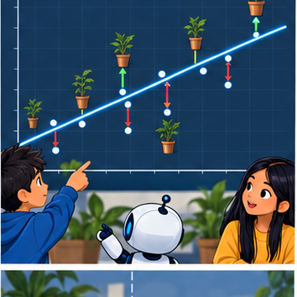
LEARNING TARGET Actual leaf length is 7 cm and prediction is 10 cm. Using residual=actual−predicted, calculate residual and absolute error. Interpret the sign.
Builder name and experiment date:

Readiness for the connected explanation
What does a class label predict?

This week’s end goal
By the end, I can explain regression and residuals using a traced example and a stated limitation.

02. Notice the evidence
PICTURE ENTRY

Notice → Predict → Explain
Begin with visible evidence; do not explain more than the picture and information support.
MYSTERY The team must use regression and residuals to solve a model-building problem. What information do they have? What important evidence is still missing?
Name three visible details without interpreting them.
Predict the data, model, or evaluation decision being made.
Identify one hidden assumption that could change the result.
State what evidence would confirm or reject your prediction.
My prediction and supporting evidence:

A closer explanation
A school garden example predicts plant height in cm from recorded conditions. The target is numeric, so a prediction can be too high or too low by different amounts. Define residual as observed minus predicted. Keep units and the sign convention visible; some software uses the opposite error convention.
Use fictional classroom data throughout this investigation. Keep the task, units, reference labels and data split visible as you reason. Earlier weeks supplied the model-building process; this week examines regression and residuals.

03. See how it works
ML MECHANISM

Input → Model → Evidence
Trace the information, fitted behavior, and evaluation proof separately.
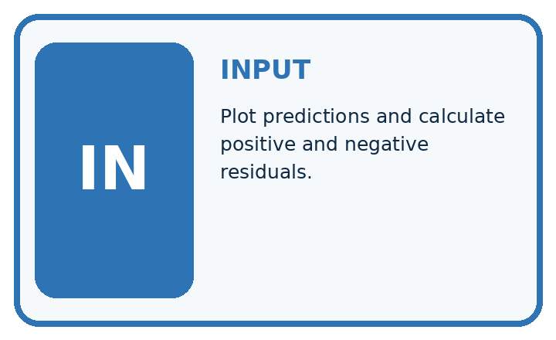
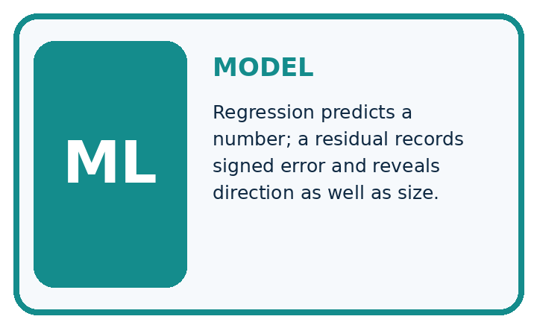
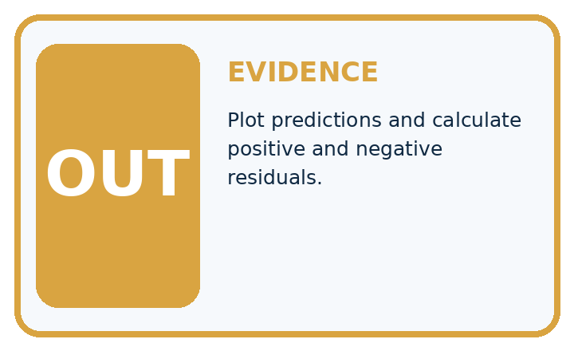
QUESTION Plot predictions and calculate positive and negative residuals.
MODEL IDEA Regression predicts a number; a residual records signed error and reveals direction as well as size.
PROOF NEEDED Use an unseen case, visible calculation, error analysis, and a stated limitation.
UNDER THE HOOD Actual plant height is 30 cm; prediction is 27 cm. Residual = actual − predicted = 30 − 27 = +3 cm.
Draw a fresh data → model → prediction → evaluation trace:

A closer explanation
Observed heights [4, 7, 9] cm and predictions [5, 6, 9] cm give residuals [-1, 1, 0] cm. The first prediction is too high, the second too low and the third exact. Mean signed residual is zero, yet two predictions are wrong. Opposite errors can cancel.
observed = [4, 7, 9]
predicted = [5, 6, 9]
residuals = [y - p for y, p in zip(observed, predicted)]
print(residuals)
print(sum(residuals) / len(residuals))
# Output: [-1, 1, 0] and 0.0.
# Opposite signed errors can cancel.
Trace the calculation on paper before running this optional Python check. Use the stated fictional inputs and compare intermediate values. The code checks this example; your independent workbook case uses different evidence.

Connect the picture and the explanation
Point to the input, the deciding step and the result in this week’s visual. Explain the same step in ordinary words. A picture helps when you can say what each part represents.

04. Compare the cases
EVALUATION DESIGN

Four Tests, Four Kinds of Evidence
A system is not understood until it survives more than one comfortable example.




NORMAL Expected data and expected behavior.
BOUNDARY Value close to a threshold, ambiguous label, or uncertain prediction.
MISSING Necessary field, label, source, or measurement is unavailable.
SHIFTED New lighting, species, device, subgroup, or time condition.
RELEASE RULE Passing one case never proves generalization. Predefine expected behavior for all four categories.
Which case most threatens today's claim, and why?

Change one thing in the pictured case
Change: Raise all predictions by1 cm.
Prediction: Residuals become [-3, 0, 1]; mean=-2/3 cm and MAE=4/3 cm.
Reason: Each residual decreases by1 under the observed-minus-predicted convention.

05. Words that unlock the idea
VOCABULARY

Words You Can Calculate and Defend
A definition matters when it lets you interpret a new dataset, model, or result.
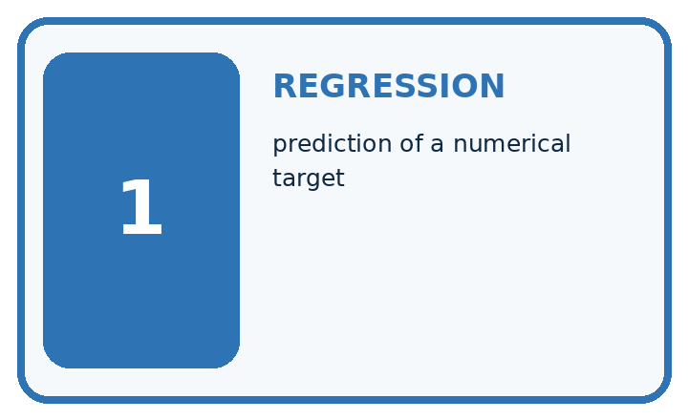
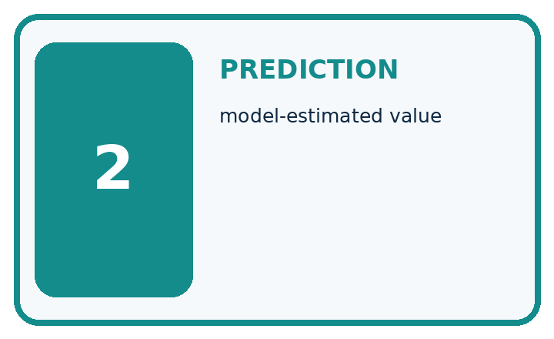
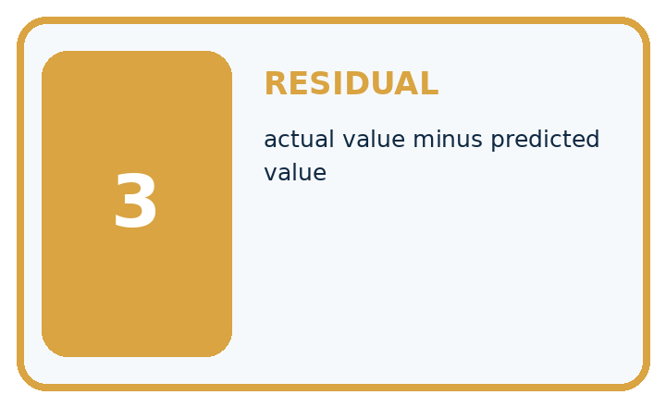
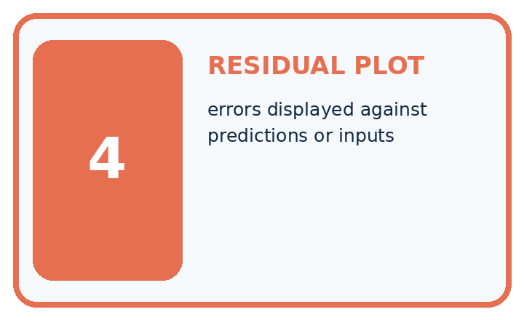
Term | Precise meaning | My ML example
regression | prediction of a numerical target
prediction | model-estimated value
residual | actual value minus predicted value
residual plot | errors displayed against predictions or inputs
MISCONCEPTION TO REPAIR Positive and negative residuals cancel, so their average proves accuracy.
Repair the claim using a definition, calculation, or test record:

Words used in the closer explanation
Word | Meaning
Regression | Prediction of a numeric target
Residual | Observed target minus predicted target in this course
Underprediction | A prediction below the observed value
Overprediction | A prediction above the observed value

06. Follow a worked example
WORKED EVIDENCE

Reason Step by Step
Predict first. Then check each step. A correct answer without visible evidence cannot be audited.
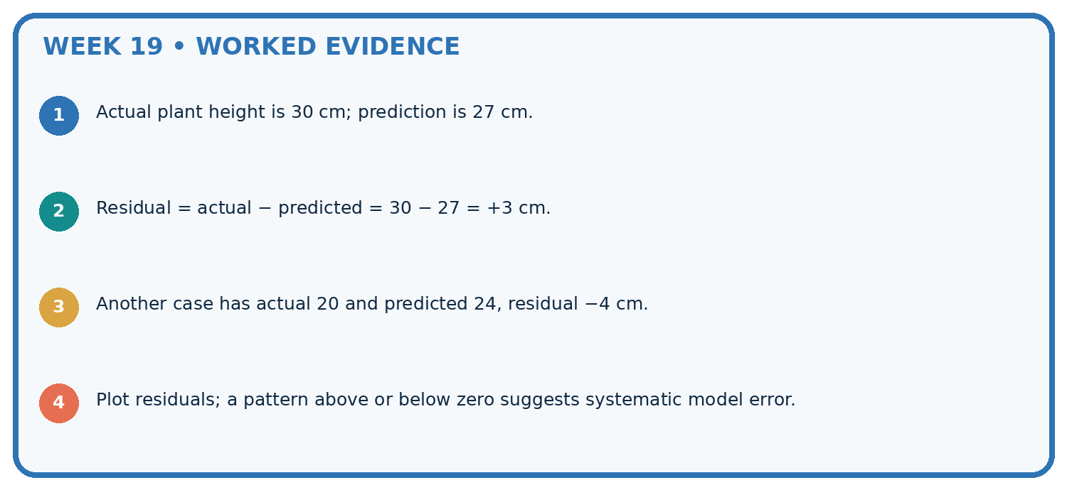
STEP 1 Actual plant height is 30 cm; prediction is 27 cm.
STEP 2 Residual = actual − predicted = 30 − 27 = +3 cm.
STEP 3 Another case has actual 20 and predicted 24, residual −4 cm.
STEP 4 Plot residuals; a pattern above or below zero suggests systematic model error.
CHECK Verify the denominator, unit, split, class definition, and data version before interpreting a score.
Recalculate, retrace, or restate the evidence independently:

A closer explanation

Regression and residuals at a glance
Part | Evidence or action | Interpretation
Observed 4 predicted 5 | Residual minus 1 | Overprediction
Observed 7 predicted 6 | Residual plus 1 | Underprediction
Observed 9 predicted 9 | Residual zero | Exact on this record
To inspect a residual plot, place a feature or prediction on the horizontal axis and residual on the vertical axis. A trend can suggest a missed relationship. It does not by itself identify the cause or validate a new model. Use development data for analysis and preserve an independent final test.

Why does mean residual zero not imply perfect predictions? Explain the steps or evidence behind your response.
________________________________________________________________
________________________________________________________________
________________________________________________________________
________________________________________________________________

Learn from the worked case
Cover the result before checking it. Say what is given, choose the procedure, and follow one step at a time. Then uncover the result and explain your first mismatch. Ask why a step is allowed, not only what number it produces.

A pictorial worked case: Regression and Residuals
Use residual signs to say whether each plant-height estimate is too high or low.

The facts we will use
Residual=observed-predicted. Observed heights [5, 8, 12] cm; predicted [7, 7, 10] cm.
All inputs and outcomes in this worked example are invented classroom data; no real model run is claimed.
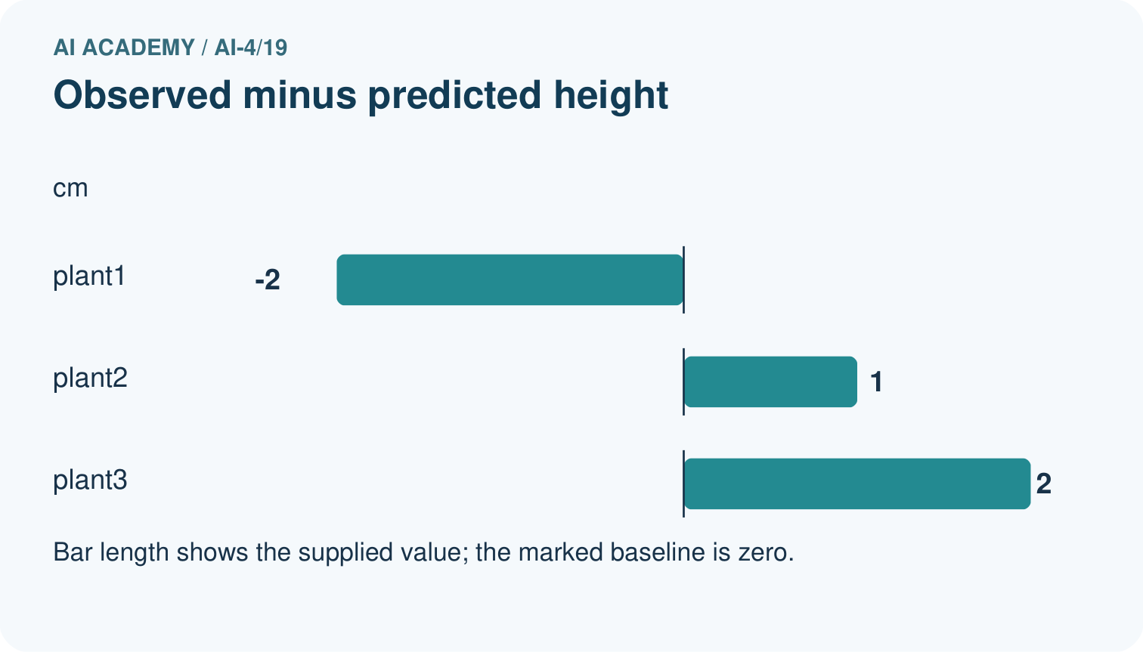
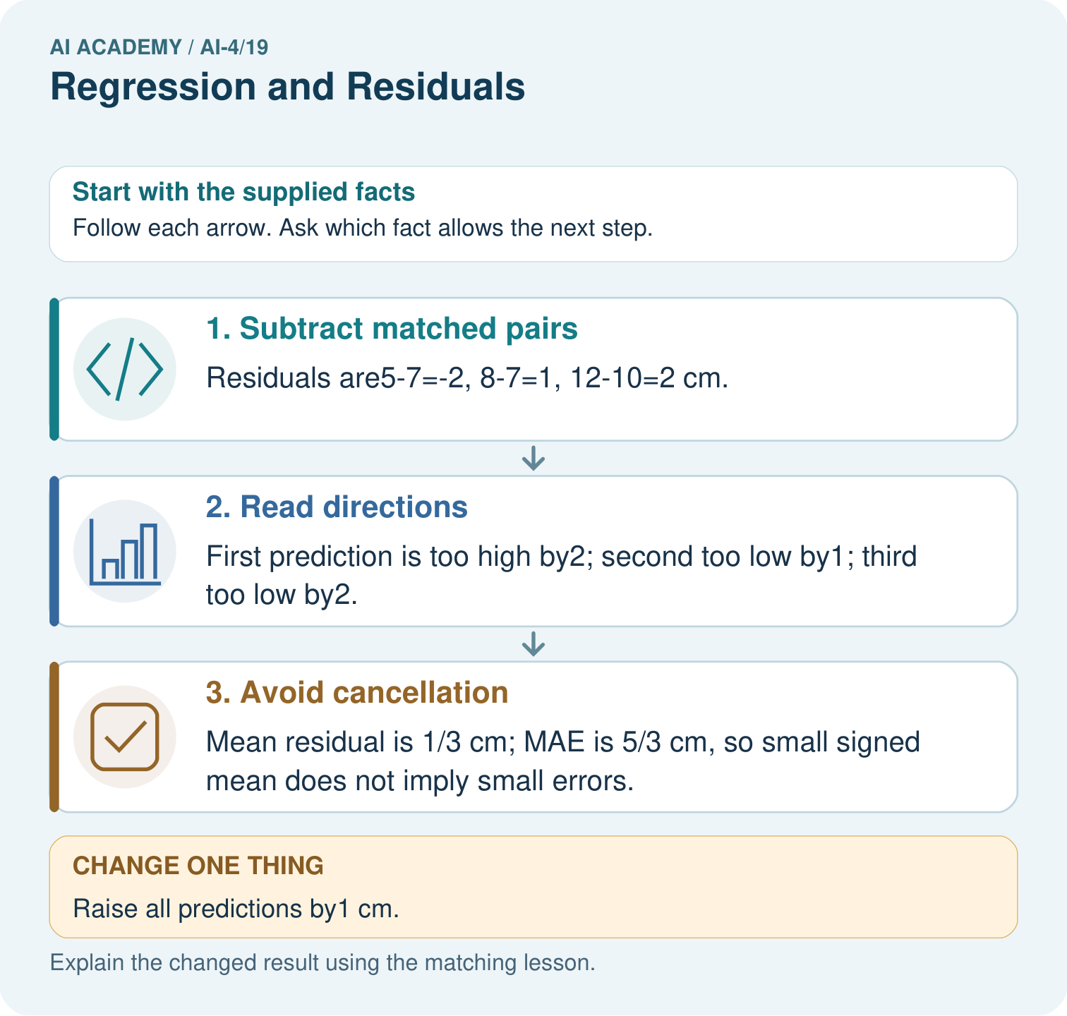

Read the picture one step at a time
Step | What happens and why
1. Subtract matched pairs | Residuals are5-7=-2, 8-7=1, 12-10=2 cm.
2. Read directions | First prediction is too high by2; second too low by1; third too low by2.
3. Avoid cancellation | Mean residual is 1/3 cm; MAE is 5/3 cm, so small signed mean does not imply small errors.
Match each pictured step to the supplied facts. This is a worked teaching case, not an independent assessment.

Why this result follows
Read the picture in order. Mean residual is 1/3 cm; MAE is 5/3 cm, so small signed mean does not imply small errors. The arrows show which recorded input or intermediate result each decision uses. Explain the deciding step aloud before checking the changed case; pointing to the final answer alone does not show how it follows.

What this example does not establish
Always declare the residual sign convention; some software uses predicted minus observed.

07. Find and repair a mistake
ERROR DETECTIVE

Compare → Diagnose → Repair
Do not patch the answer. Find the earliest unsupported assumption, data problem, or experiment error.
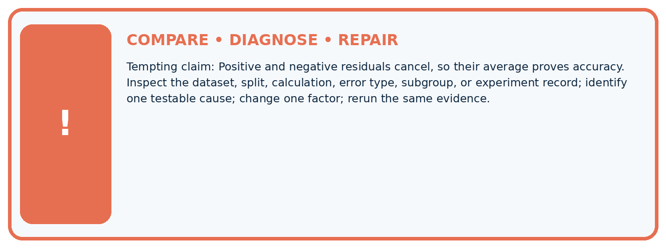
Evidence record | Expected | Actual | Likely cause / next test
normal case | passes
boundary case | defined behavior
missing case | safe fallback
shifted case | measured limit
CLAIM TO CHALLENGE Positive and negative residuals cancel, so their average proves accuracy.
Diagnose one cause and name the cleanest next experiment:

A closer explanation
A residual of zero is an agreement with the measured target, not proof that the measurement is perfect. Do not compare errors measured in cm directly with errors measured in metres. Keep the same row pairing, unit and sign convention throughout.

A report combines 2 cm and .02 m as if they were different magnitudes. Repair it.
________________________________________________________________
________________________________________________________________
________________________________________________________________
________________________________________________________________

08. Practise together
ML STUDIO

Specify Before You Run
A trustworthy result can be reproduced from the recorded data, code, settings, and evaluation rule.


Experiment record
QUESTION + intended use + success threshold
DATA version + grouped split + leakage check
CODE/preprocessing + features + model + settings + seed
METRICS + positive class + units + denominators
PREDICTIONS + errors + subgroup slices + limitations
HUMAN reviewer + release, revise, limit, or stop decision
Write the minimum record needed to reproduce today's result:

A closer explanation
If predictions for early, middle and late growth have residuals -2, 0, 3 cm, the model moves from overpredicting to underpredicting across those records. Investigate whether a straight-line assumption or a missing condition could explain it. Check measurement consistency before adding complexity.

Practise with less help: Explain cancellation
Use workbook W2 for the connected example “Regression and residuals”. First fill the input and rule boxes. Try the middle steps before asking for a hint. After a hint, try the next step yourself.
Plan | Do | Check
What is given? Which rule or procedure applies? | Record each intermediate step. | Does the result follow? What remains unknown?
Explain your trace to a partner. Your partner points to one step to check. Swap roles on the next case. Each person writes their own explanation.

Check your reasoning
Use the worked case for Regression and residuals. Proposed explanation: “A final answer is enough”. Decide whether this explanation is supported. Point to the step or supplied fact that decides; explain your repair if needed.
Answer on your own before discussion. If you are unsure, say which step you need help with.

Explain the picture
Which statistic reveals the size of errors without cancellation? Point to the relevant step in the picture, then write the changed result and the rule or evidence that supports it.

My explanation using a pictured step and the given facts
________________________________________________________________
________________________________________________________________
________________________________________________________________
________________________________________________________________
This is supported practice. Keep the separately named independent case for an attempt before feedback.

09. Run the investigation
EVIDENCE LAB

Predict → Run → Calculate → Interpret
Keep the test conditions fixed, record every result, and change only one planned factor.
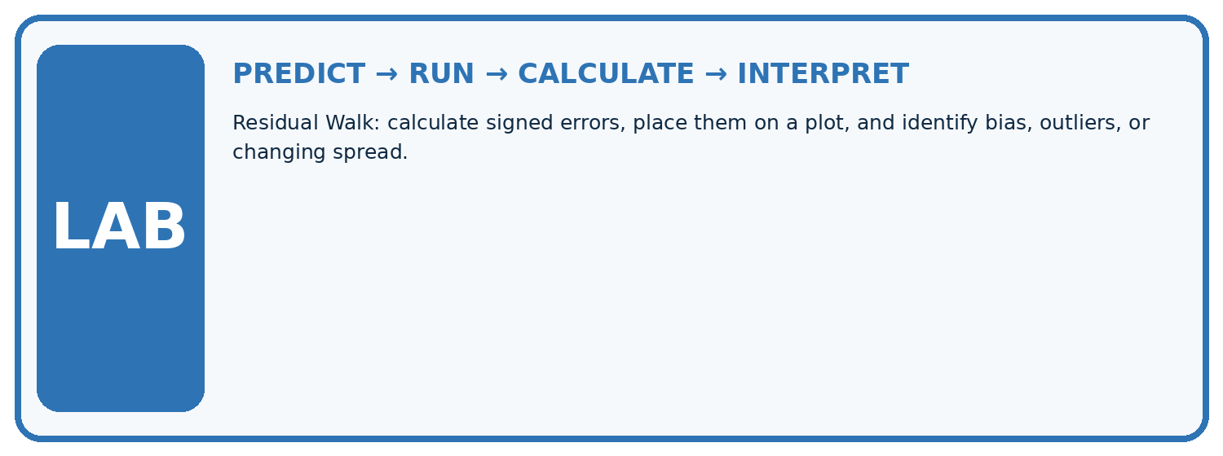
1. Write the hypothesis and expected evidence before running.
2. Residual Walk: calculate signed errors, place them on a plot, and identify bias, outliers, or changing spread.
3. Run one normal, one boundary, one missing, and one shifted case.
4. Calculate the metric from raw counts or row-level errors.
5. Interpret what changed, what did not, and what remains unsafe or unknown.
Case | Prediction | Actual | Calculation / evidence | Meaning / next test
Normal
Boundary
Missing
Shifted

Plan → try → check
Before trying: what do I expect, and why? While trying: which step could first go wrong? Afterwards: what did I actually observe, and what should change? Keep “not run” if you only traced the procedure.

10. Build your understanding
MASTERY

From Knowing the Word to Owning the Idea
Move upward only when you can produce evidence without copying the example.

DEFINE Use all four terms precisely: regression, prediction, residual, residual plot.
CALCULATE Reproduce the worked evidence with units and denominator.
TRACE Explain the data, code or decision path.
DIAGNOSE Positive and negative residuals cancel, so their average proves accuracy.
TRANSFER Solve a fresh dataset or model case.
IMPROVE Change one cause and rerun fixed evidence.
DEFEND State intended use, metric, limitation, and human responsibility.
MASTERY RULE A coached calculation becomes mastery only after a different case is completed independently.

11. Connect your project
CUMULATIVE PROJECT

Responsible Plant Classifier
Every week adds one reviewable artifact to the same evidence-based capstone.
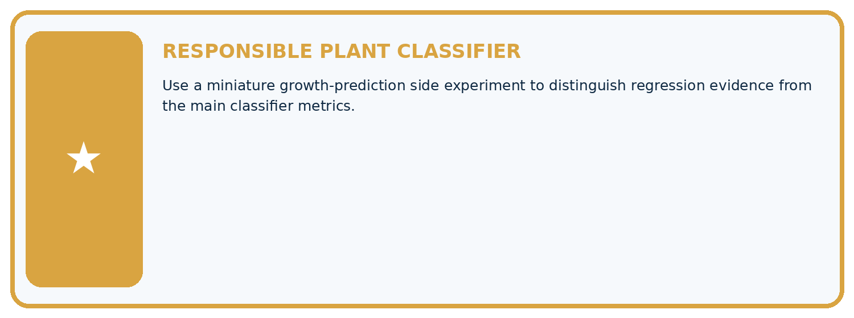
THIS WEEK'S CHECKPOINT Use a miniature growth-prediction side experiment to distinguish regression evidence from the main classifier metrics.
Which requirement or risk does this artifact address?
Which dataset, split, code, and metric version does it use?
What normal and shifted cases were tested?
What remains uncertain or weak?
What decision still belongs to a teacher or qualified human?
RESPONSIBLE RELEASE Never use this classroom prototype for medical, pesticide, agricultural, or other consequential decisions.
My evidence-linked project decision:

Evidence for your project
For your Responsible Plant Classifier, save the input, procedure, observed result and limitation of this check. Label this worked example as practice; use a different, previously unreviewed case when checking independent understanding.

12. Show what you know
INDEPENDENT PROOF

Explain • Calculate • Transfer • Defend
Complete this with a fresh case after guided practice and compare it with the mastery criteria.
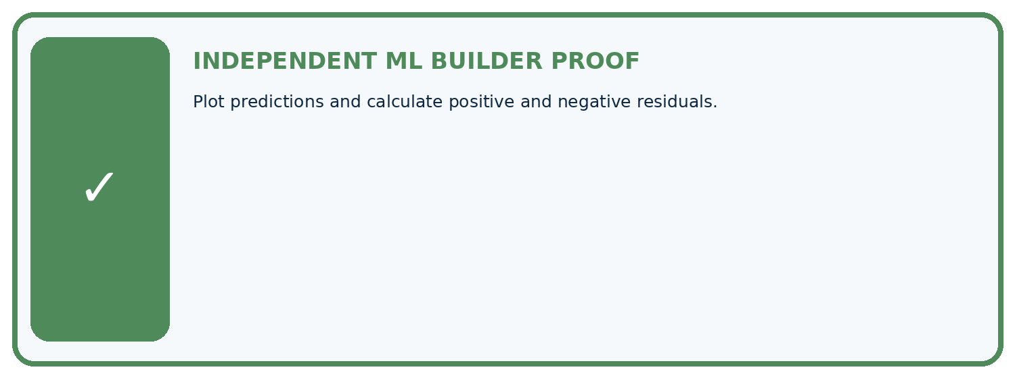
REQUIRED PROOF Plot predictions and calculate positive and negative residuals.
□ Define the task, feature/target roles, and intended-use boundary.
□ Show the calculation, code trace, or experiment record.
□ Test a normal case and one revealing boundary, missing, or shifted case.
□ Diagnose one failure without changing several factors at once.
□ Name a limitation, fairness concern, and the human-review action.
Independent evidence and defense:
My level: □ Not yet □ With one hint □ Independently □ I can teach and defend it
NEXT BRIDGE Carry the experiment evidence into: Mean, Median, and Baselines.

13. Study a complete case

Week 19 Worked case
Use the supplied details to practise the weekly concept before attempting the independent question. This case extends the illustrated lesson.

The situation
Actual height=12 cm, prediction=9 cm. Residual means actual minus predicted.

The question
Calculate and interpret.

Worked explanation
+3 cm means underprediction by 3 cm. State this sign convention consistently.

Explain it in your own words
Which detail supports the answer, and why does it matter?

Write or draw your reasoning and evidence.
________________________________________________________________
________________________________________________________________
________________________________________________________________
________________________________________________________________
________________________________________________________________

Trace the supplied case visually

Residual is actual minus predicted
Evidence or stage | Value or result
Prediction | 9
Actual | 12
Actual height=12 cm, prediction=9 cm. Residual means actual minus predicted.
Calculate and interpret.
+3 cm means underprediction by 3 cm. State this sign convention consistently.

14. Try a new case independently

Independent case: Apply independently
Observed [6, 10, 13], predicted [8, 9, 11] cm. Give residuals, mean residual and error directions.

My independent explanation, trace and limits
________________________________________________________________
________________________________________________________________
________________________________________________________________
________________________________________________________________
________________________________________________________________
________________________________________________________________
________________________________________________________________
Attempt this case before feedback. Record any help. Earlier examples below are further practice; a case already practised with feedback cannot establish fresh transfer.

Week 19 Independent application
Close the worked explanation. Apply the idea to this different question without copying.
Define residual as actual minus predicted. Actual height is 14 cm and prediction is 17 cm. Calculate residual and interpret its sign.
My answer, with a trace, calculation or supporting evidence

Write or draw your reasoning and evidence.
________________________________________________________________
________________________________________________________________
________________________________________________________________
________________________________________________________________
________________________________________________________________

Create and test
Change one relevant detail. Predict the result before testing. Include a boundary or missing-information case when it helps reveal a limit.
My changed input and expected result

Write or draw your reasoning and evidence.
________________________________________________________________
________________________________________________________________
________________________________________________________________
________________________________________________________________
________________________________________________________________

Connect to your project
Use a miniature growth-prediction side experiment to distinguish regression evidence from the main classifier metrics.
The evidence I will keep

Write or draw your reasoning and evidence.
________________________________________________________________
________________________________________________________________
________________________________________________________________
________________________________________________________________
________________________________________________________________
Your teacher has the independent answer and scoring criteria. Complete the matching workbook week to keep your practice evidence together.

Transfer practice from the original programme
Actual leaf length is 7 cm and prediction is 10 cm. Using residual=actual−predicted, calculate residual and absolute error. Interpret the sign.

Explain the mechanism, evidence and one limit.
________________________________________________________________
________________________________________________________________
________________________________________________________________
________________________________________________________________
________________________________________________________________
________________________________________________________________
________________________________________________________________

Use feedback to improve
Attempt the independent case before hints. Record whether you worked alone, used a hint or followed a model. After feedback, fix the first unsupported step and explain why it changed. A later check uses a changed case, not a copied answer.

