AI ACADEMY · STUDENT · ai-4/22

Train a Regression Model
Project: Responsible Plant Classifier

Before you start
Weeks 20–21: evaluate candidate models with a stated loss.

01. Your mission

Your learning target
I can fit a line from a declared training candidate set.
I can separate training loss from validation comparison.
I can interpret slope and intercept with units.

Remember before reading
Close your notes first. A rough first answer helps us choose the right starting point; it is not a score for your ability.
Without opening the old lesson, explain one key idea from Absolute Error and MAE. Give an example and a mistake that the idea helps you avoid.
Without opening the old lesson, explain one key idea from Regression and Residuals. Give an example and a mistake that the idea helps you avoid.
Without opening the old lesson, explain one key idea from Accuracy and Imbalance. Give an example and a mistake that the idea helps you avoid.
After trying, check the relevant lesson or ask your teacher. Change the part of your explanation that the evidence shows was wrong.
A fitted relationship should be interpreted, tested on unseen values, and compared with a simple baseline.

LEARNING TARGET Training points (x,y)=(1,3),(2,5),(3,7). Compare y=x+1 and y=2x+1 by training MAE; select one, then predict held-out x=4, actual=10. Explain what was fitted.
Builder name and experiment date:

Readiness for the connected explanation
How is MSE calculated?

This week’s end goal
By the end, I can explain train a regression model using a traced example and a stated limitation.

02. Notice the evidence
PICTURE ENTRY

Notice → Predict → Explain
Begin with visible evidence; do not explain more than the picture and information support.
MYSTERY The team must use train a regression model to solve a model-building problem. What information do they have? What important evidence is still missing?
Name three visible details without interpreting them.
Predict the data, model, or evaluation decision being made.
Identify one hidden assumption that could change the result.
State what evidence would confirm or reject your prediction.
My prediction and supporting evidence:

A closer explanation
A line predicts y as m*x+b. In this classroom search we compare a small declared set of slopes and intercepts; this is not a full least-squares solver over all possible lines. Use training error to choose a candidate, then freeze it before validation.
Use fictional classroom data throughout this investigation. Keep the task, units, reference labels and data split visible as you reason. Earlier weeks supplied the model-building process; this week examines fitting a line.

03. See how it works
ML MECHANISM

Input → Model → Evidence
Trace the information, fitted behavior, and evaluation proof separately.
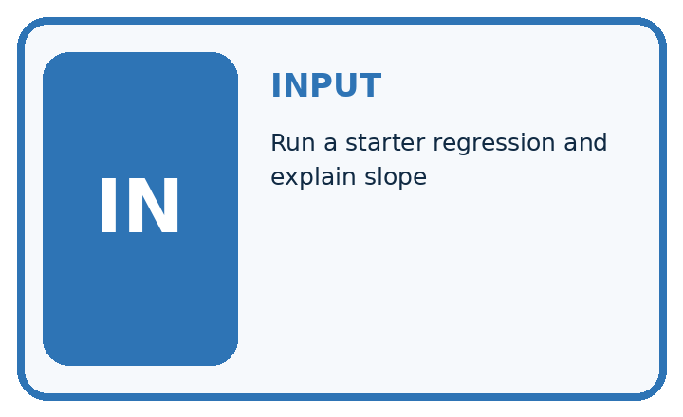
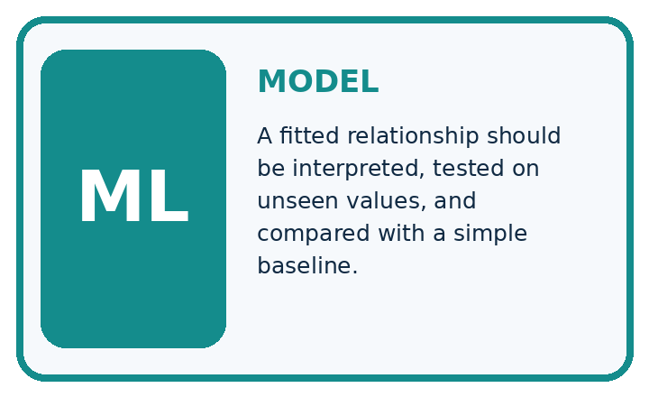
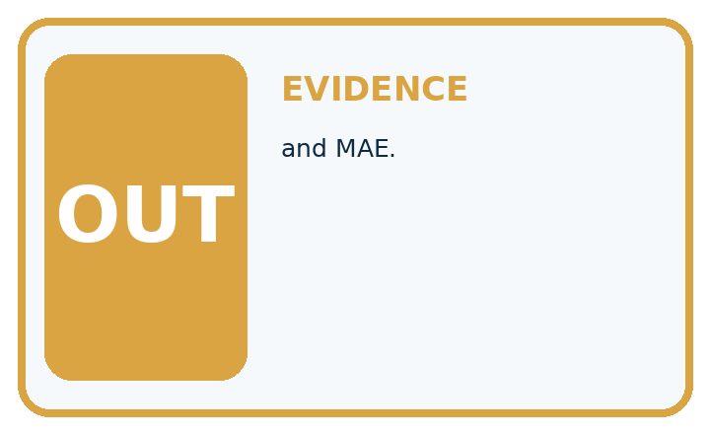
QUESTION Run a starter regression and explain slope, prediction, residual, and MAE.
MODEL IDEA A fitted relationship should be interpreted, tested on unseen values, and compared with a simple baseline.
PROOF NEEDED Use an unseen case, visible calculation, error analysis, and a stated limitation.
UNDER THE HOOD Model predicts height = 4 + 2 × weeks. Slope 2 means two predicted centimeters per additional week in this data range.
Draw a fresh data → model → prediction → evaluation trace:

A closer explanation
Training pairs are (0, 1),(1, 3),(2, 5). Candidate A has m 1 b 1, B m 2 b 0, C m 2 b 1. Predictions are A [1, 2, 3], B [0, 2, 4], C [1, 3, 5]. Training squared-error sums are 5, 3, 0 respectively, so choose C. Ties would use the earlier listed candidate.
training = [(0, 1), (1, 3), (2, 5)]
candidates = [(1, 1), (2, 0), (2, 1)]
def sse(line):
m, b = line
return sum((y - (m * x + b)) ** 2 for x, y in training)
chosen = min(candidates, key=sse)
print([sse(line) for line in candidates])
print(chosen)
# [5, 3, 0], then (2, 1); first candidate wins ties.
Trace the calculation on paper before running this optional Python check. Use the stated fictional inputs and compare intermediate values. The code checks this example; your independent workbook case uses different evidence.

Connect the picture and the explanation
Point to the input, the deciding step and the result in this week’s visual. Explain the same step in ordinary words. A picture helps when you can say what each part represents.

04. Compare the cases
EVALUATION DESIGN

Four Tests, Four Kinds of Evidence
A system is not understood until it survives more than one comfortable example.




NORMAL Expected data and expected behavior.
BOUNDARY Value close to a threshold, ambiguous label, or uncertain prediction.
MISSING Necessary field, label, source, or measurement is unavailable.
SHIFTED New lighting, species, device, subgroup, or time condition.
RELEASE RULE Passing one case never proves generalization. Predefine expected behavior for all four categories.
Which case most threatens today's claim, and why?

Change one thing in the pictured case
Change: Evaluation observation becomes8 instead of6.
Prediction: Absolute evaluation error stays1 cm, but residual changes from-1 to+1.
Reason: Prediction7 remains frozen; changed observation8 reverses the error direction.

05. Words that unlock the idea
VOCABULARY

Words You Can Calculate and Defend
A definition matters when it lets you interpret a new dataset, model, or result.
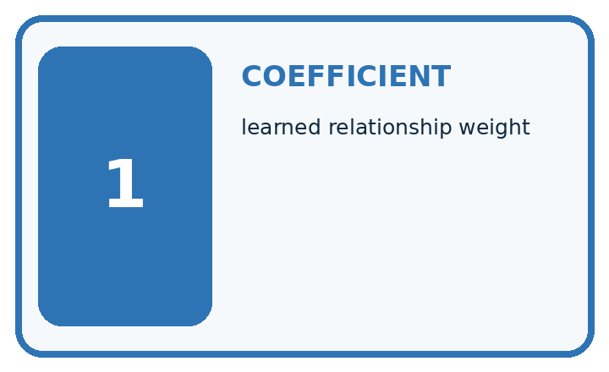
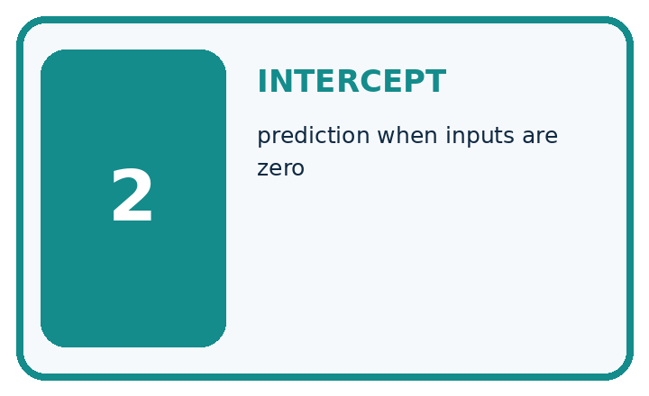
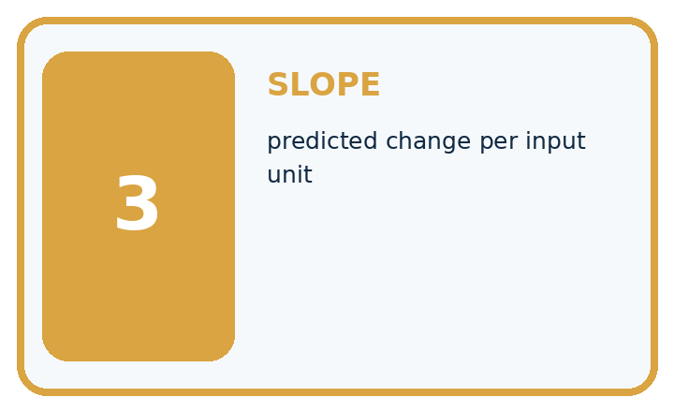
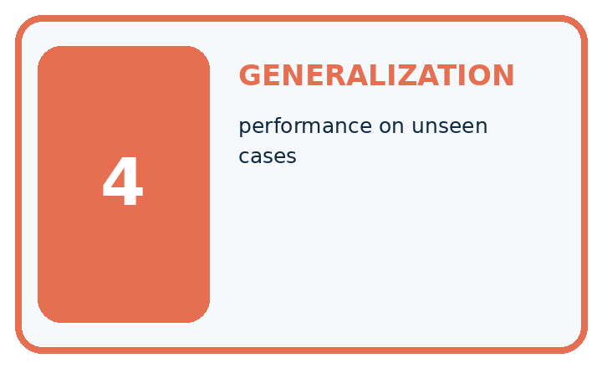
Term | Precise meaning | My ML example
coefficient | learned relationship weight
intercept | prediction when inputs are zero
slope | predicted change per input unit
generalization | performance on unseen cases
MISCONCEPTION TO REPAIR A positive slope proves one variable causes the other.
Repair the claim using a definition, calculation, or test record:

Words used in the closer explanation
Word | Meaning
Slope | Change in predicted target per unit change in x
Intercept | Predicted target when x is zero
Candidate set | The declared model choices searched
Fitting | Selecting model values using training evidence

06. Follow a worked example
WORKED EVIDENCE

Reason Step by Step
Predict first. Then check each step. A correct answer without visible evidence cannot be audited.
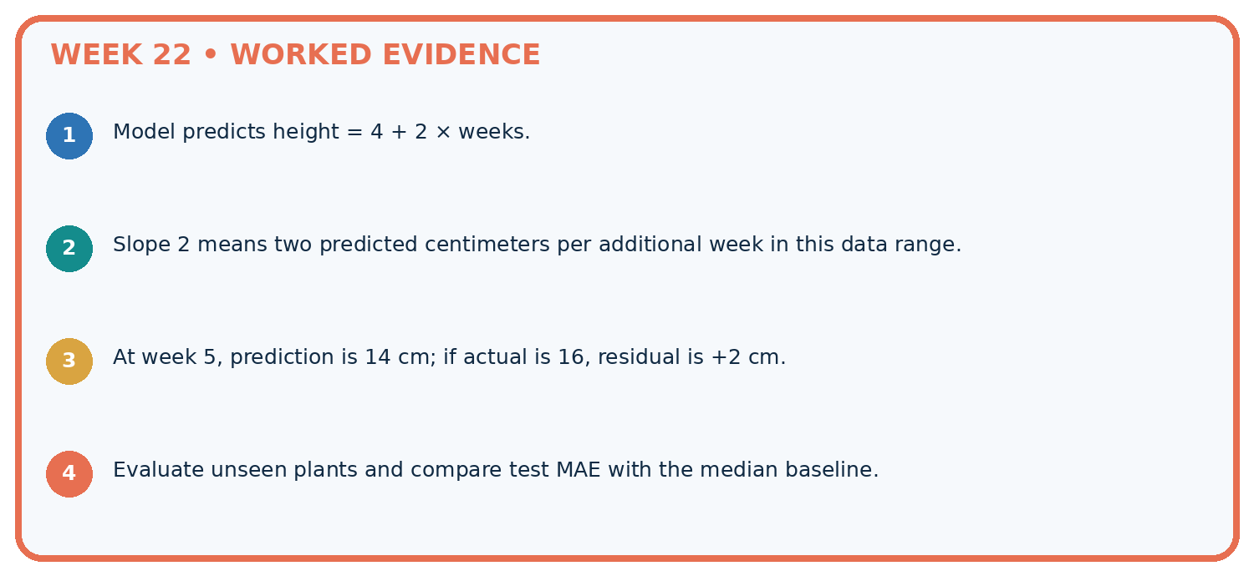
STEP 1 Model predicts height = 4 + 2 × weeks.
STEP 2 Slope 2 means two predicted centimeters per additional week in this data range.
STEP 3 At week 5, prediction is 14 cm; if actual is 16, residual is +2 cm.
STEP 4 Evaluate unseen plants and compare test MAE with the median baseline.
CHECK Verify the denominator, unit, split, class definition, and data version before interpreting a score.
Recalculate, retrace, or restate the evidence independently:

A closer explanation

Fitting a line at a glance
Part | Evidence or action | Interpretation
Line A | Slope 1 intercept 1 | Training SSE 5
Line B | Slope 2 intercept 0 | Training SSE 3
Line C | Slope 2 intercept 1 | Training SSE 0
For separate validation pairs (3, 6),(4, 10), C predicts [7, 9], giving residuals [-1, 1], MAE 1 and MSE 1. The training-mean constant baseline is 3 and gives residuals [3, 7], MAE 5 and MSE 29. The fitted line wins on this small evaluation, without proving performance elsewhere.

Predict at x 3 and x 4 and calculate MAE/MSE. Explain the steps or evidence behind your response.
________________________________________________________________
________________________________________________________________
________________________________________________________________
________________________________________________________________

Learn from the worked case
Cover the result before checking it. Say what is given, choose the procedure, and follow one step at a time. Then uncover the result and explain your first mismatch. Ask why a step is allowed, not only what number it produces.

A pictorial worked case: Train a Regression Model
Fit a toy growth line from training pairs, then leave evaluation labels out of fitting.

The facts we will use
Training(day, height):(0, 1),(1, 3),(2, 5). Candidates y=2x+1 and y=x+1. Evaluation pair:(3, 6).
All inputs and outcomes in this worked example are invented classroom data; no real model run is claimed.
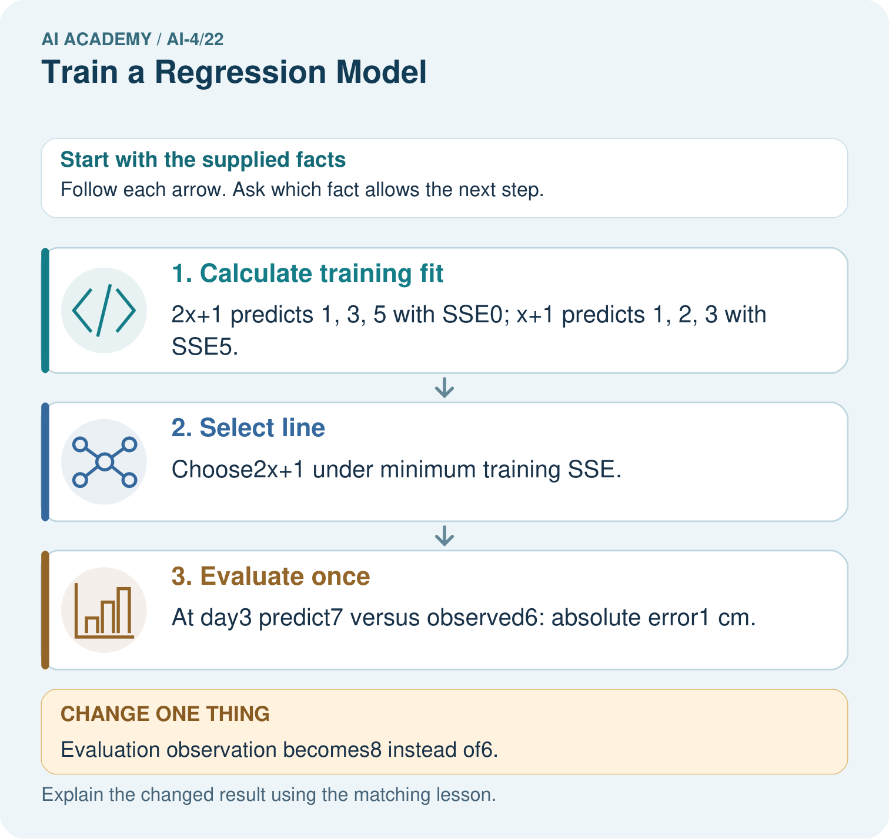

Read the picture one step at a time
Step | What happens and why
1. Calculate training fit | 2x+1 predicts 1, 3, 5 with SSE0; x+1 predicts 1, 2, 3 with SSE5.
2. Select line | Choose2x+1 under minimum training SSE.
3. Evaluate once | At day3 predict7 versus observed6: absolute error1 cm.
Match each pictured step to the supplied facts. This is a worked teaching case, not an independent assessment.

Why this result follows
Read the picture in order. At day3 predict7 versus observed6: absolute error1 cm. The arrows show which recorded input or intermediate result each decision uses. Explain the deciding step aloud before checking the changed case; pointing to the final answer alone does not show how it follows.

What this example does not establish
An exact fit to three toy pairs does not establish a biological growth law or justify long-range extrapolation.

07. Find and repair a mistake
ERROR DETECTIVE

Compare → Diagnose → Repair
Do not patch the answer. Find the earliest unsupported assumption, data problem, or experiment error.
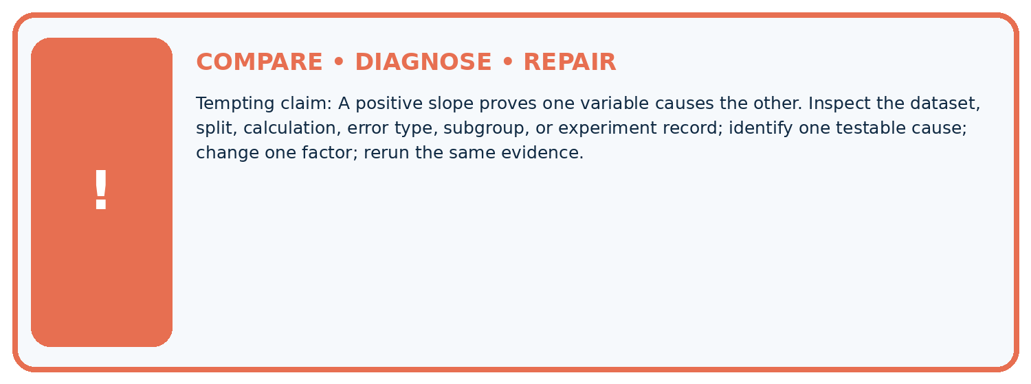
Evidence record | Expected | Actual | Likely cause / next test
normal case | passes
boundary case | defined behavior
missing case | safe fallback
shifted case | measured limit
CLAIM TO CHALLENGE A positive slope proves one variable causes the other.
Diagnose one cause and name the cleanest next experiment:

A closer explanation
Record candidates, training rows, tie policy and chosen parameters. Do not add a candidate after seeing validation and report it as if only the original search happened. A zero training loss can coexist with validation mistakes.

Why is an exact training line not proof of correct predictions at x 100?
________________________________________________________________
________________________________________________________________
________________________________________________________________
________________________________________________________________

08. Practise together
ML STUDIO

Specify Before You Run
A trustworthy result can be reproduced from the recorded data, code, settings, and evaluation rule.


Experiment record
QUESTION + intended use + success threshold
DATA version + grouped split + leakage check
CODE/preprocessing + features + model + settings + seed
METRICS + positive class + units + denominators
PREDICTIONS + errors + subgroup slices + limitations
HUMAN reviewer + release, revise, limit, or stop decision
Write the minimum record needed to reproduce today's result:

A closer explanation
If x measures days and y measures cm, slope 2 means two predicted cm per day and intercept 1 means one predicted cm at day zero. Predicting far outside the observed x range is extrapolation and may fail even when the training fit is exact.

Practise with less help: Score validation
Use workbook W2 for the connected example “Fitting a line”. First fill the input and rule boxes. Try the middle steps before asking for a hint. After a hint, try the next step yourself.
Plan | Do | Check
What is given? Which rule or procedure applies? | Record each intermediate step. | Does the result follow? What remains unknown?
Explain your trace to a partner. Your partner points to one step to check. Swap roles on the next case. Each person writes their own explanation.

Check your reasoning
Use the worked case for Fitting a line. Proposed explanation: “A final answer is enough”. Decide whether this explanation is supported. Point to the step or supplied fact that decides; explain your repair if needed.
Answer on your own before discussion. If you are unsure, say which step you need help with.

Explain the picture
May day3’s evaluation label choose the candidate line? Point to the relevant step in the picture, then write the changed result and the rule or evidence that supports it.

My explanation using a pictured step and the given facts
________________________________________________________________
________________________________________________________________
________________________________________________________________
________________________________________________________________
This is supported practice. Keep the separately named independent case for an attempt before feedback.

09. Run the investigation
EVIDENCE LAB

Predict → Run → Calculate → Interpret
Keep the test conditions fixed, record every result, and change only one planned factor.
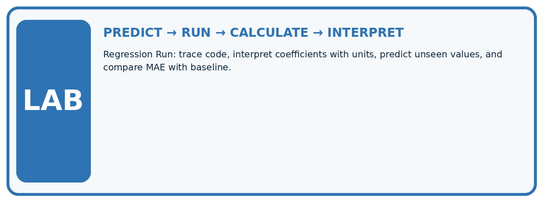
1. Write the hypothesis and expected evidence before running.
2. Regression Run: trace code, interpret coefficients with units, predict unseen values, and compare MAE with baseline.
3. Run one normal, one boundary, one missing, and one shifted case.
4. Calculate the metric from raw counts or row-level errors.
5. Interpret what changed, what did not, and what remains unsafe or unknown.
Case | Prediction | Actual | Calculation / evidence | Meaning / next test
Normal
Boundary
Missing
Shifted

Plan → try → check
Before trying: what do I expect, and why? While trying: which step could first go wrong? Afterwards: what did I actually observe, and what should change? Keep “not run” if you only traced the procedure.

10. Build your understanding
MASTERY

From Knowing the Word to Owning the Idea
Move upward only when you can produce evidence without copying the example.

DEFINE Use all four terms precisely: coefficient, intercept, slope, generalization.
CALCULATE Reproduce the worked evidence with units and denominator.
TRACE Explain the data, code or decision path.
DIAGNOSE A positive slope proves one variable causes the other.
TRANSFER Solve a fresh dataset or model case.
IMPROVE Change one cause and rerun fixed evidence.
DEFEND State intended use, metric, limitation, and human responsibility.
MASTERY RULE A coached calculation becomes mastery only after a different case is completed independently.

11. Connect your project
CUMULATIVE PROJECT

Responsible Plant Classifier
Every week adds one reviewable artifact to the same evidence-based capstone.
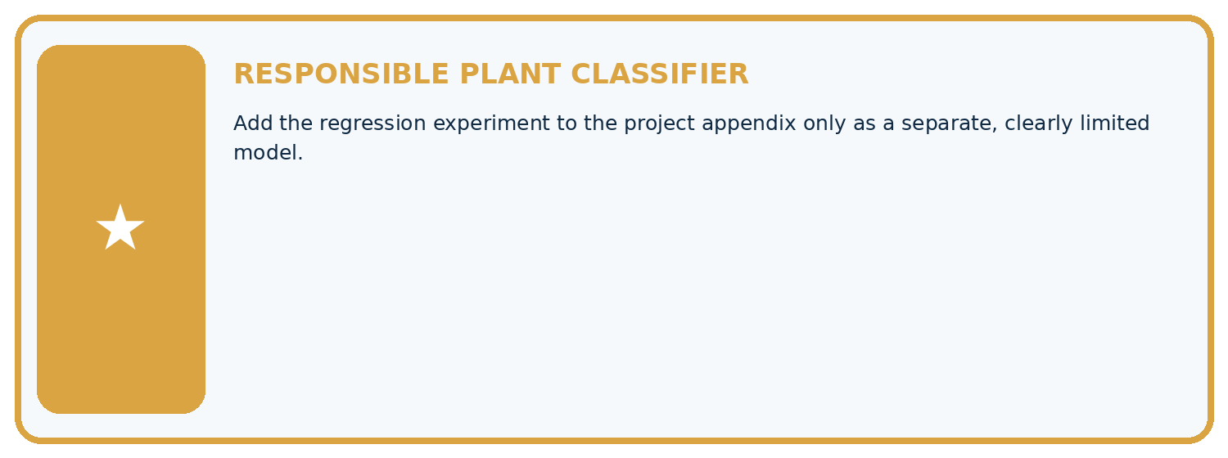
THIS WEEK'S CHECKPOINT Add the regression experiment to the project appendix only as a separate, clearly limited model.
Which requirement or risk does this artifact address?
Which dataset, split, code, and metric version does it use?
What normal and shifted cases were tested?
What remains uncertain or weak?
What decision still belongs to a teacher or qualified human?
RESPONSIBLE RELEASE Never use this classroom prototype for medical, pesticide, agricultural, or other consequential decisions.
My evidence-linked project decision:

Evidence for your project
For your Responsible Plant Classifier, save the input, procedure, observed result and limitation of this check. Label this worked example as practice; use a different, previously unreviewed case when checking independent understanding.

12. Show what you know
INDEPENDENT PROOF

Explain • Calculate • Transfer • Defend
Complete this with a fresh case after guided practice and compare it with the mastery criteria.
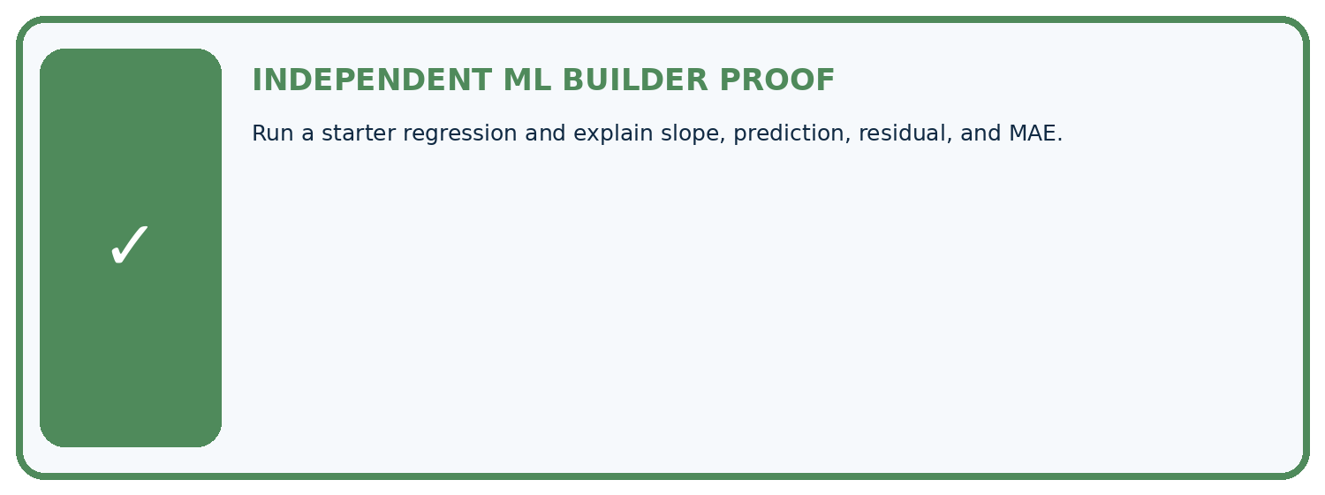
REQUIRED PROOF Run a starter regression and explain slope, prediction, residual, and MAE.
□ Define the task, feature/target roles, and intended-use boundary.
□ Show the calculation, code trace, or experiment record.
□ Test a normal case and one revealing boundary, missing, or shifted case.
□ Diagnose one failure without changing several factors at once.
□ Name a limitation, fairness concern, and the human-review action.
Independent evidence and defense:
My level: □ Not yet □ With one hint □ Independently □ I can teach and defend it
NEXT BRIDGE Carry the experiment evidence into: Hold Out Test Data.

13. Study a complete case

Week 22 Worked case
Use the supplied details to practise the weekly concept before attempting the independent question. This case extends the illustrated lesson.

The situation
Supplied fitted rule: height=2 times age+1. Held-out observations are (3,8),(4,9).

The question
Predict and evaluate; distinguish inference.

Worked explanation
Predictions 7,9; errors 1,0; MAE=.5 cm. Applying a supplied equation does not show how it was fitted.

Explain it in your own words
Which detail supports the answer, and why does it matter?

Write or draw your reasoning and evidence.
________________________________________________________________
________________________________________________________________
________________________________________________________________
________________________________________________________________
________________________________________________________________

Trace the supplied case visually

Apply the fitted equation, then evaluate
Evidence or stage | Value or result
Rule | height = 2 × age + 1
Age 3 | Predict 7, actual 8, absolute error 1
Age 4 | Predict 9, actual 9, absolute error 0
MAE | 0.5 cm
Supplied fitted rule: height=2 times age+1. Held-out observations are (3,8),(4,9).
Predict and evaluate; distinguish inference.
Predictions 7,9; errors 1,0; MAE=.5 cm. Applying a supplied equation does not show how it was fitted.

14. Try a new case independently

Independent case: Apply independently
Training (0, 2),(1, 5),(2, 8). Candidates m 2 b 2, m 3 b 1, m 3 b 2. Select by SSE, then score (3, 10),(4, 15) with MAE.

My independent explanation, trace and limits
________________________________________________________________
________________________________________________________________
________________________________________________________________
________________________________________________________________
________________________________________________________________
________________________________________________________________
________________________________________________________________
Attempt this case before feedback. Record any help. Earlier examples below are further practice; a case already practised with feedback cannot establish fresh transfer.

Week 22 Independent application
Close the worked explanation. Apply the idea to this different question without copying.
A regression model has validation MAE 2.4 cm; a training-mean baseline has validation MAE 2.0 cm on the same examples. Which performs better on this metric?
My answer, with a trace, calculation or supporting evidence

Write or draw your reasoning and evidence.
________________________________________________________________
________________________________________________________________
________________________________________________________________
________________________________________________________________
________________________________________________________________

Create and test
Change one relevant detail. Predict the result before testing. Include a boundary or missing-information case when it helps reveal a limit.
My changed input and expected result

Write or draw your reasoning and evidence.
________________________________________________________________
________________________________________________________________
________________________________________________________________
________________________________________________________________
________________________________________________________________

Connect to your project
Add the regression experiment to the project appendix only as a separate, clearly limited model.
The evidence I will keep

Write or draw your reasoning and evidence.
________________________________________________________________
________________________________________________________________
________________________________________________________________
________________________________________________________________
________________________________________________________________
Your teacher has the independent answer and scoring criteria. Complete the matching workbook week to keep your practice evidence together.

Transfer practice from the original programme
Training points (x,y)=(1,3),(2,5),(3,7). Compare y=x+1 and y=2x+1 by training MAE; select one, then predict held-out x=4, actual=10. Explain what was fitted.

Explain the mechanism, evidence and one limit.
________________________________________________________________
________________________________________________________________
________________________________________________________________
________________________________________________________________
________________________________________________________________
________________________________________________________________
________________________________________________________________

Use feedback to improve
Attempt the independent case before hints. Record whether you worked alone, used a hint or followed a model. After feedback, fix the first unsupported step and explain why it changed. A later check uses a changed case, not a copied answer.

15. Fit and test a straight-line regression model

Fit and test a straight-line regression model
Estimate slope and intercept from training pairs using least squares. Ages are weeks and heights are cm. Test targets are excluded from fitting; training ages must include distinct values.

Math bridge: fitting the line
A straight line predicts y = slope × x + intercept. Slope is the change in predicted height for one extra week; intercept is the prediction at x=0, which may lie outside the measured ages. You need means, subtraction, multiplication and squared numbers for this example; calculus is not required.
x (weeks) | y (cm) | x − mean x | y − mean y | Product | Squared x difference
1 | 3 | −1 | −2 | 2 | 1
2 | 5 | 0 | 0 | 0 | 0
3 | 7 | 1 | 2 | 2 | 1
Mean x=2 and mean y=5. Add the product column: 4. Add squared x differences: 2. Slope=4/2=2 cm per week. Intercept=5−2×2=1 cm. This least-squares formula chooses the line minimising squared training errors when the x values are not all identical. Compare its held-out error with a baseline; a good training fit alone is insufficient.
"""Fit a line to training pairs and evaluate a separate example."""
train = [(1, 3), (2, 5), (3, 7)]
if not train:
raise ValueError("Training examples are required")
n = len(train)
x_mean = sum(x for x, y in train) / n
y_mean = sum(y for x, y in train) / n
num = sum((x - x_mean) * (y - y_mean) for x, y in train)
den = sum((x - x_mean) ** 2 for x, y in train)
if den == 0:
raise ValueError("Distinct training ages are required")
slope = num / den
intercept = y_mean - slope * x_mean
test = [(4, 10)]
if not test:
raise ValueError("Test examples are required for MAE")
preds = [slope * x + intercept for x, y in test]
mae = sum(abs(y - pred) for pred, (x, y) in zip(preds, test)) / len(test)
print(slope, intercept, preds, mae)
Expected output: 2.0 1.0 [9.0] 1.0
The fitted line is height = 2 times age + 1. At four weeks it predicts 9 cm; the observed height of 10 cm gives an absolute error and one-case MAE of 1 cm. Fitting a line and applying a supplied line are different activities. One held-out case is very limited evidence.

Independent code change
Change the held-out height from 10 to 8 without changing the training data. Predict the fit, prediction and MAE.
My prediction and evidence

Write or draw your reasoning and evidence.
________________________________________________________________
________________________________________________________________
________________________________________________________________
________________________________________________________________
________________________________________________________________

